Thomas Street All Ages and Abilities Playground
Report on Consultation 2019

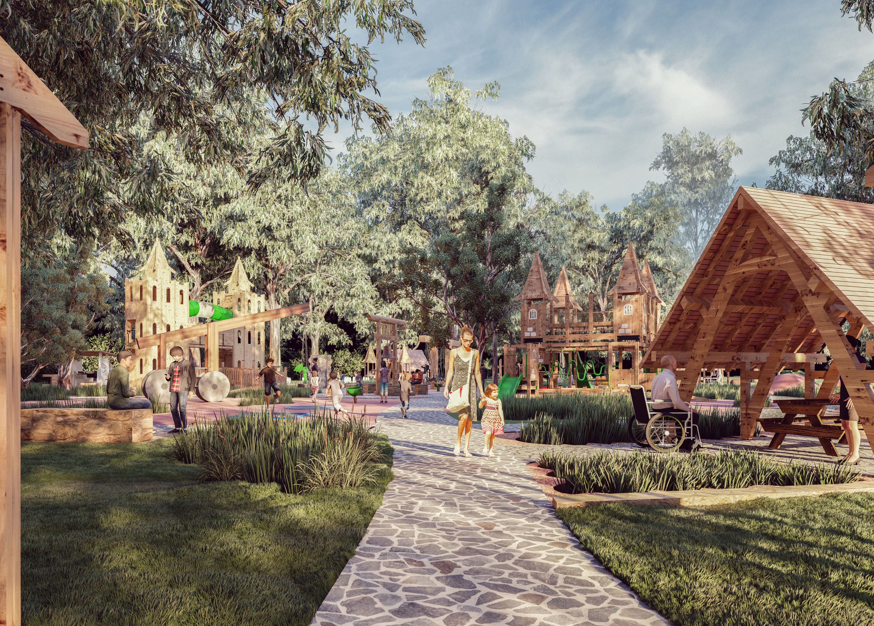

.

September 2019

Bayside City Council
Corporate Centre
76 Royal Avenue
SANDRINGHAM VIC 3191
T (03) 9899 4444
F (03) 9598 4474
www.bayside.vic.gov.au
.
Contents
Overview 3

1 Background 5
2 Definitions and scope 6
3 Consultation process 6
3.1 Consultation purpose 6
3.2 Consultation methodology 6
3.2.1 Gather Ideas phase - Recap 7
3.2.2 Draft Playground Plan - Consultation methodology .9
4 Consultation findings 11
4.1 Have Your Say feedback 11
4.2 On site feedback 12
4.3 Community Reference Group Networks 12
4.4 Support for Actions
4.5 Item-specific feedback 14
4.5.1 Toilet facilities 13
4.5.2 Walking path and exercise equipment 13
4.5.3 Picnic shelters 13
4.5.4 Wheelchair swing 13
4.5.5 Dogs on/off leash 14
4.5.6 Other activities 14
4.6 Error corrections 14
5 Project evaluation 15

Overview
The purpose of consultation has been to develop a plan for a new inclusive playground at Thomas Street Reserve in Hampton. The draft plans incorporate an inclusive playground, a senior adults exercise area, and a 500m loop path.
An eight member Community Reference Group was established through an expression of interest process to provide community perspectives and advice to Bayside City Council and has met at key points in the process. Council engaged experienced playground designer Ric Mcconaghy and Associates to develop the plan.
Consultation occurred in two major phases
- A Gather Ideas phase - February to March 2019, detailed in a previous report, which included six school workshops, an online survey with 60 responses and a drop-in day on-site.
- Consultation on a Draft Plan - August to September 2019

The first phase, Gather Ideas, was the critical phase for raising awareness of the project and an understanding of what types of play and other features that people want to see in a renewed playground and park. The second consultation phase aimed to check if the equipment and layout shown in the draft plan meets the needs and expectations articulated in the first phase.
Consultation on the draft plan included:
- Online, through Council’s Have Your Say page, which received 1,363 views of the page by 728 people, with 57 people participating in giving their feedback via an open-ended text field, three question survey
- Two on-site drop in sessions, with approximately 45 attendees in total
- Via a feedback box accompanying a display of plans at Hampton Library, with the same questions as the online Have Your Say
Overall feedback on the draft plan showed strong support for the playground plans, in particular in carrying forward the timber character and castle/fort theme. The concept of a seniors playground is still relatively new in Australia, but the draft plans received strong support from the Bayside Healthy Ageing Reference Group. That only 6% of people who viewed the plans made comments can be interpreted to mean that the majority of viewers were happy, or at least comfortable, with the proposals. A small number of respondents argued for retention of the existing, ageing play structure.
To summarise the online feedback to the three questions:
- What do you most like? - Variety of spaces for all ages, inclusive, water play
- Anything we’ve missed? - more slides and swings, skate park
- Anything else? - keep existing fort, ensure plenty of rubbish bins, ensure plenty of parking

Considerations
- Playground – the draft plans received strong support for the diversity of equipment and the focus on accessibility and inclusion, along with carrying forward the timber fort/castle character. In the feedback, there was a general satisfaction with the range and type of equipment.
- Toilet Facilities - The draft plan proposes replacing the existing, ageing toilets with new facilities appropriate to the inclusive playground, and the many people with a disability expected to use the park. The Community Reference Group has advocated strongly for incorporating an accessible adult change facility (Changing Places), which is considered contemporary best practice.

- Walking path and exercise equipment - The circuit path around the reserve received interest and support. Some residents who were in favour of the path were concerned about the introduction of more concrete. Residents of two properties adjacent to the park expressed concern about bringing more activity to the southern end of the park. Council will aim to work with the residents in siting tree planting to minimise the visual impact of the path.

- Wheelchair swing – Incorporating a wheelchair swing has been the subject of extensive discussion by the Community Reference Group, seeking a balance between opportunity, inclusion and safety concerns given the weight of a moving wheelchair swing. Council’s position is that, for public safety, the swing could only be included in a playground in Bayside if fitted with a lock (with a key available to families with a person with a disability). This impacts on the extent of inclusivity, being the only piece of equipment not freely accessible.

- Picnic shelters – overall the incorporation of sheltered seating and tables was very well received, as many people celebrate occasions at the park. Concern was expressed by a small number of respondents about the proposed picnic shelters being used for social gathering after daylight hours, generating additional noise. Note that it is not proposed that the shelters include lighting.

- Musical instruments – a small number of respondents had concerns about the proposed musical instruments interfering the peacefulness of the park and neighbourhood.

- Dogs – The reserve is a dog on-lead park. Whilst not the subject of this consultation, some respondents expressed concern about off-lead dogs and safety of the playground; others requested an off-lead area in the park. This information will be referred to Council’s Amenity Protection area.

- Other Activities – a number of respondents asked for a tennis wall, basketball half court, a skate park and bmx jumps. The more sporting pursuits of tennis wall and half court are enjoyed by older children and young adults and some could potentially be accommodated in the Thomas Street Reserve (north) when netball moves to a new home in Sandringham.

Next steps
The collated feedback from the consultation on the draft playground plan will be considered by the Community Reference Group and the (internal) Project Control Group. The Project Control Group will direct any required amendments to be made to the draft plan. Construction of the inclusive playground is budgeted for the 2020/21 financial year and the playground is expected to open in early 2021.

Background
This document provides a summary of stakeholder and community feedback on the draft plan for an All Abilities and Ages Playground at Thomas Street Reserve in Hampton. This is the second of two major phases in developing the playground plan. The first major phase, Gathering Ideas, occurred in March 2019. The draft plan grew out of the information and ideas collected in the Gathering Ideas phase.
Bayside City Council’s Playground Improvement Plan 2015 -2025 identifies the opportunity to create a regional-scale all-abilities playspace at Thomas Street (south) Reserve in Hampton.
The park is currently home to a much-loved wooden fort playground, which was developed via a community initiative in the late1980s. Led by local mother Bridie Murphy, the project involved many local people coming together over a three day period to construct the playground. The playground opened in November 1989.
The playground has reached the end of its useable life. The play structure was built with a 20 year life span, and in November 2019 will be 30 years old, which is a great community achievement. However it has aged and has become difficult to maintain to contemporary Australian safety standards, with hand and head entrapments now appearing. Its condition has declined to a point where repairs will soon outweigh the cost of a new playground. Issues with visibility, accessibility and character do not meet contemporary community needs and expectations.

Inclusive Playground
The need for renewal raises the exciting opportunity to develop a new regional-scale playspace that can be enjoyed by all, including children with a disability. Bayside City Council is committed to developing an accessible and inclusive community, where everyone can feel welcome and valued. Bayside currently has very little accessible play, but, like every community, has many families with children and adults with a disability and has a number of local schools catering for children with a disability. Play is a critical part of any child’s development and design for accessible play is now well understood.
Replacement also raises an opportunity to introduce some age-appropriate exercise equipment to encourage senior adults to be active at the park. Bayside has an ageing community, above the metropolitan average, and active ageing is particularly relevant to our community.
The playspace will include opportunities to extend the socialisation in the park, through improved picnic and barbecue facilities. The overall playspace setting will be an appealing place for families of all configurations to enjoy gathering and being active outdoors.

Definitions and scope

Within this document, reference is made to stakeholders, that is, people who may have a particular interest in the project. These stakeholders include:
- People who use the current Thomas Street Reserve and playground
- Families in the region with a child with a disability
- Senior residents who may be interested in using a seniors exercise park
- Neighbouring residents
Related Council documents and consultations
- Bayside City Council’s Playground Improvement Plan 2015 -2025
- Bayside City Council’s Health and Wellbeing for All Ages and Abilities Plan

Consultation process

Consultation purpose
The consultation was designed to provide stakeholders and the broader community with the opportunity to provide input into the design of an inclusive playground at Thomas Street Reserve in Hampton.

Consultation methodology
Consultation occurred in two major phases – Gather Ideas and Draft Playground Plan. 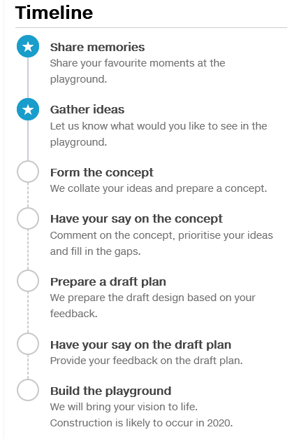

Recap on Share Your Memories
In late 2018 there was an invitation to the Bayside community to share memories of the existing playground and sixteen people contributed, with memories of building the playground; or playing there as children, and subsequently bringing their own children.
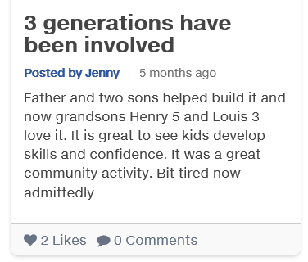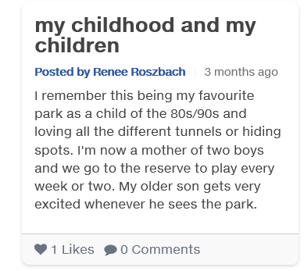
Recap on Gather Ideas
Details | Activity
8 members | Community Reference Group - through a call for expressions of interest, run from November 2018 to January 2019, an eight member Community Reference Group has been established. A field trip was held to view accessible playgrounds around Melbourne on Sunday 24 March 2019.
18 March – 28 Apr 2019  60 contributions | Have Your Say – a project page was established on Council’s website in November 2018. The initial phase outlined the redevelopment project and was an invitation to post memories of the existing playground. The “gathering ideas” phase ran from Monday 18 March to Sunday 28 April and over 60 contributions were received.
Sun 31 March 2019 | Community Information and Ideas Day – held at the park on Sunday 31 March 2019
28, 29 March | School workshops – held at:  Hampton Primary School (3) Fri 29 March  Berendale School Thursday 28 March  Bayside Special Developmental School Thurs 28 March
Bayside Healthy Ageing Reference Group
A field trip to an existing senior play area in Hoppers Crossing confirmed that the type of equipment and activities, which focus on balance and flexibility, are of interest to local seniors
Mar 2019 | Bush Kinder - An engagement session was held at Thomas Street playground with 16 four year olds from Bambini Kindergarten and three of their Educators.
Publicising the Gather Ideas phase
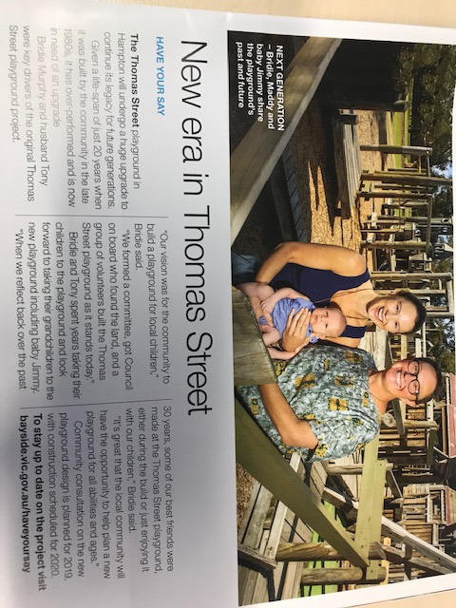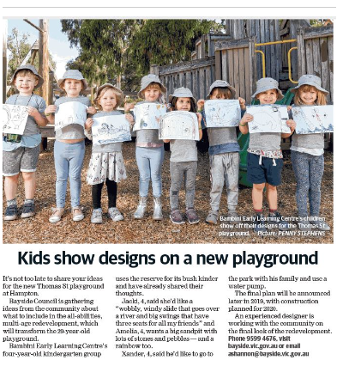

Summary of Feedback Received in Gather Ideas Phase
- There’s a strong attachment to the wooden character of the current play structure and a wish to see this character taken forward
- The explorative nature of the current fort structure is really valued, though there are concerns from parents about sightlines
- Kids want to climb and bounce
- Activities for older kids and teenagers are needed
- There’s a wish for more unstructured nature play to complement the structured playground
- Shade and shelter are highly valued
- The open, natural character of the park is a great compliment to the playground and is used in many ways
- There’s interest in creating a circuit walking path around the park from older adults, from people whose main form of exercise is walking, and from parents with children learning to cycle.

Recap – Form the Concept
From the information received in the gather phase, a concept plan was developed to provide an overview of the broad layout. People who had contributed to the Gather Ideas phase and signed up to “follow” the project were notified that the concept was available on the project website. The concept indicated the location of the playground, the seniors playground and the proposed loop path.

Draft Playground Plan – consultation methodology
The consultation period for the draft plan ran from Monday 29 July to Sunday 08 September 2019.

How We Communicated the Opportunity:
- Email to all people signed up to “follow” the project on the Have Your Say page of Council’s website
- Letterboxing of 200 neighbours to the reserve
- Leader newspaper advertisement
- Boosted posts on Bayside City Council Facebook page on 3 occasions – start, middle and towards end of consultation period
- Article in Let’s Talk Bayside, delivered to all homes in Bayside
- 750 copies of a postcard about the project were distributed through local channels including the cafe in Thomas Street

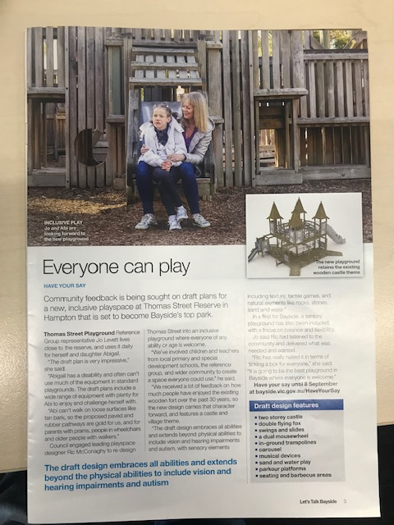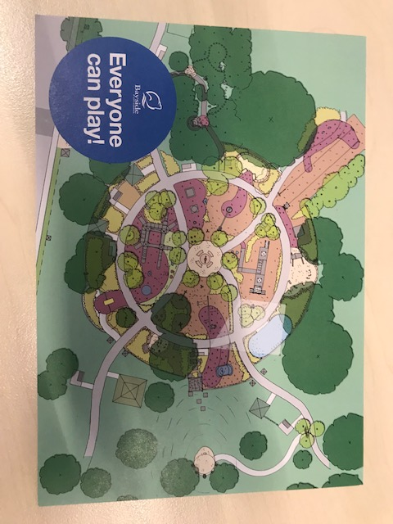

How we consulted:

Details | Activity
Fri 16 August 3.30- 5.30pm  Sat 17August  1.-00-3.00pm | Drop in consultation session in the park  The drop in sessions provided an opportunity for people to clarify any aspects of the plans and to express concerns about any of the proposals. Holding the sessions on site also helps to raise awareness with park visitors who may come from outside Bayside or may not previously have been aware of the planning.  Approximately 45 people had face to face discussions with project staff over the two sessions.
Mon 29 July to Sunday 8 September  Mon 29 July to Sun 8 September 2019 | Display in Hampton Library  Hampton Library is effectively at the end of Thomas Street and is the popular venue for local information. A large copy of the draft plan, along with posters illustrating the features, were provided in the library foyer and entrance. A Have Your Say box and feedback forms were provided in the foyer. Twenty forms were received.  Have Your Say  The online Have Your Say page is the most visible and accessible of the consultation means. We had 1,363 views of the page by 728 people, 57 people participated in giving their feedback on the draft.
Monday 26 August 2019  Friday 9 August 2019  Various | Bayside Healthy Aging Reference Group  Draft plan for the Seniors Exercise Area was considered  Immunisation session, Highett Childrens Centre  A staffed display at the immunisation session allowed parents who may otherwise be too busy to attend a session in the park or view the online information to ask questions and discuss concerns during the 15 min waiting period after immunisation. Approx 20 attendees.  Community Reference Group Networks  Members of the Community Reference Group actively shared the draft plan with people in their networks and initiated discussions.

Consultation findings
4.1 Have Your Say Feedback
Council’s Have Your Say page received, 363 views of the page by 728 people, 57 people participated in giving their feedback via an open-ended text field, three question survey.
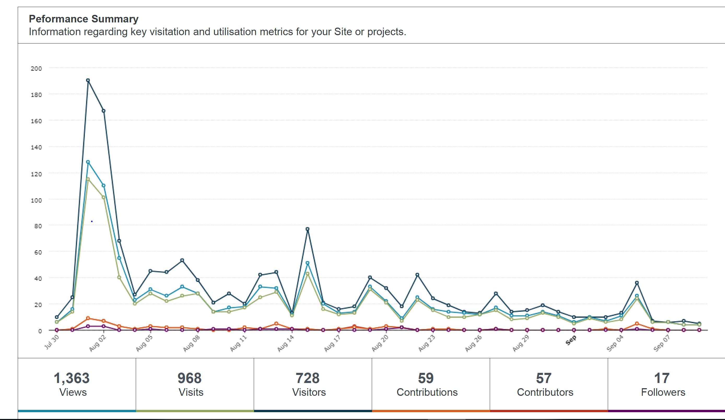

Q1 What do you most like?
Participants used a text field to talk about the elements that most appeal to them.
Element | mentions | Element | mentions
Variety of spaces for ages | 7 | BBQs | 2
Inclusive/accessible | 7 | Nature | 1
Water play | 6 | Parkour | 1
Shelters/ covered seating areas | 5 | Sandpit | 1
Seniors exercise area | 4 | Music | 1
Castle | 3 | Weaving loom | 1
Flying fox | 3 | In ground trampolines | 1
Toilet block upgrade | 2

Q2 Have we missed anything?
Element | mentions | Element | mentions
High slide | 3 | Scooter/skate park | 1
More swings | 3 | Dog off-lead area | 1
Wheelchair swing | 2 | Powerpoint to recharge phones | 1
Running water/stream | 1 | Irrigation | 1
Climbing spider frame | 1 | Low ropes course | 1
Basketball ring | 1 | Hiding spots | 1
Cycle parking | 1 | More shelter/shade | 1

Q3 Anything else you would like to tell us?
Thirty people chose to make additional comments. Five of these related to wishing to see the existing fort retained. The following provides a precis of some comments:
- Needs an extra flying fox, more swings
- Include local artists or a schools arts project
- Ensure plenty of rubbish bins
- If the toilet block is painted, use an Australian flora/fauna theme
- Ensure good, ongoing maintenance
- Ensure timber is not treated with unhealthy chemicals
- Ensure sufficient parking
- Multiple requests for a skate park and BMX track
- Reconsider musical instruments due to impact of peacefulness of park
4.2 On site consultation
A staffed display of the plans occurred at Thomas Street Park on Friday 16 Aug 2019, 3.30pm-5.30pm and Saturday 17 August, 1.00pm – 3.00pm. About 45 people took the opportunity to ask questions or raise concerns during the two sessions. The sessions were particularly useful in hearing the concerns of the direct neighbours to the park.
Key issues/comments
- Concern re the amount of dogs off-lead in the park
- Would like to see pines retained or replanted on western boundary
- Concern from a resident adjacent to the park who does not wish to see planting or exercise eqpt behind the house
- Shade is important, both in hot weather and as protection in rain.
- Request for a small, fenced-off dog on-lead area that encourages smaller dogs only.
- More swings – currently experience queues (never enough); shade over swings is needed;
- Basketball wall and tennis wall requested (by 3 different people)
- Retain the scattered benches and tables around the park
- Like the wooden feel and planting
- Don’t like the path (2) ; love the path (6)

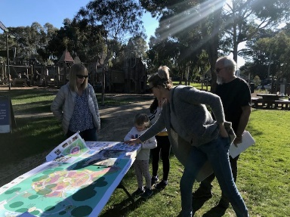

4.3 Feedback from Community Reference Group Member’s Networks
Bayside Special Development School
- Importance of a Communication Board that uses symbols and words for children who are non-verbal, and some advice on clarity
- Suggested a further slide be added to the Eyrie, possibly spiral
- Totems near the flying fox should not have a human form
- Both the kid play space and senior play space could be useful to the school community for social and recreational participation

4.4Support for actions
Overall feedback on the draft plan showed support for the playground plans, in particular in carrying forward the timber character and castle/fort theme. That only 6% of people who viewed the plans online left comments can be interpreted to mean that the majority of viewers were happy, or at least comfortable, with the proposals. In face to face consultations participants were positive about the importance of a place where everyone can play, in particular families with a child with a disability. Most people understood the need for renewal, though many expressed sadness at the loss of a playground that had been dear to them and to their children.
Strong support was expressed for picnic shelters, for additional trees for shade and character, and for a more open feel to the playground with better sightlines for supervision of children.
The concept of a seniors playground is still relatively new in Australia, but the draft plans received strong support from the Bayside Healthy Ageing Reference Group. The circuit walking path was seen as a good addition to the park by most respondents.

Item-specific feedback
- Toilet Facilities - The draft plan proposes replacing the existing, ageing toilets with new facilities appropriate to the inclusive playground, and the many people with a disability expected to use the park. The Community Reference Group has advocated strongly for incorporating an accessible adult change facility. This is considered contemporary best practice. In on-site consultations, the character of the artwork on the existing toilet received criticism.

- Walking path and exercise equipment. The circuit path around the reserve received interest and support and many saw the 500m circuit path as valuable in encouraging informal and incidental exercise. Residents of two properties adjacent to the park expressed concern about bringing more activity to the southern end of the park. Some residents who were in favour of the path were concerned about the introduction of more concrete. The proposal for additional planting, which will soften the park landscape, was well received, provided strong sightlines are retained.

- Picnic shelters – most people were in support of the picnic shelters and the opportunity for family gatherings that they facilitate. Concern was expressed by some respondents about the proposed picnic shelters being used for social gathering after daylight hours.

- Wheelchair swing – Incorporating a wheelchair swing in the inclusive playground was the subject of extensive discussion by the Community Reference Group, seeking a balance between opportunity, inclusion and safety concerns given the weight of a moving wheelchair swing. The swing could only be included in a public playground in Bayside if fitted with a lock, with a key available to families with a person with a disability.

- Dogs – Thomas Street Reserve is an on-lead park. Some respondents expressed concern about owners allowing their dogs to be off-lead, and what this means for the safety of the playground users and other park visitors.

- Other activities – respondents asked for a tennis wall, basketball half court , BMX track and skate park. The more sporting pursuits of tennis wall and half court are enjoyed by older children and young adults and some could potentially be accommodated in the Thomas Street Reserve (north) when netball moves to a new home in Sandringham.

Corrections
Community and stakeholder feedback identified a number of potential errors in the plan document which will be corrected.
Barbecues are not overtly labelled on the plan but are intended to be included.
Water taps are not overtly shown, but are intended to be included

Project evaluation

Learnings for future projects:
- Consider establishing a larger Community Reference Group, to allow for the fact that members are often busy with caring, work or other family or community commitments
- In on-site or telephone discussions, ensure that information is captured in similar format to the online survey, to be able to be included directly in quantitative analysis
- Renders illustrating the proposed playground were not developed until after consultation had commenced. Everyone’s skill level in reading plans differs, and had renders been developed earlier, participation in consultation may have been easier for some people.
- Develop a quick and simple method for people who view the plan on-line, are happy with the plans and have no concerns, to be able to tick a box indicating their general agreement with the plan as a way of capturing that information.
- The main playground was the focus of attention and the seniors exercise area proposal may have not received as high a profile, and therefore feedback, as it would have if it was a stand-alone project.

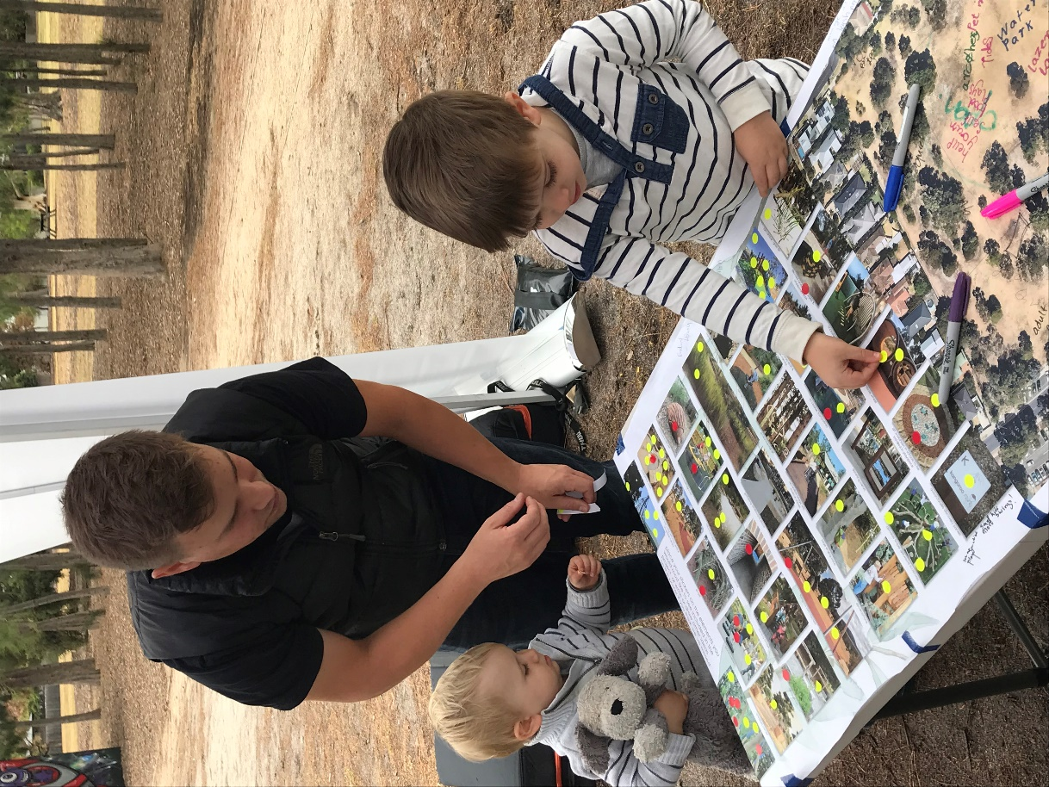
Drop in information day during the Gather Ideas phase

