Community Engagement Report Brighton Recreational and Wilson Reserve Masterplan

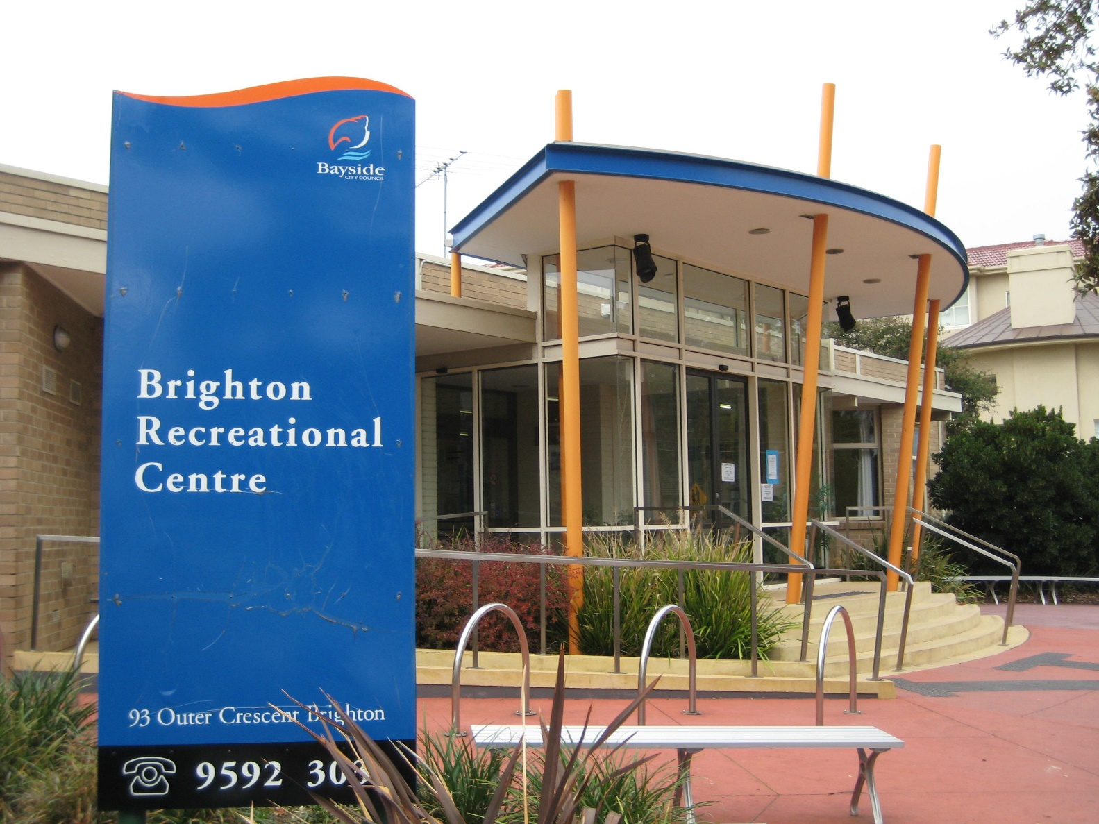

Xx insert image with one owned by Council.

Bayside City Council
Corporate Centre
76 Royal Avenue
SANDRINGHAM VIC 3191
T (03) 9899 4444
F (03) 9598 4474
www.bayside.vic.gov.au
.
Contents
1 Overview 3
1.1 What’s next? 3
2 Background 3
3 Definitions and scope 4
3.1 Glossary of Terms 5
3.2 Related Council documents and consultations 5
4 Consultation process 5
5 Consultation findings 9
5.1 Consultation Feedback: Community Workshops 10
5.2 Consultation Feedback: Ideas wall, drop-ins and surveys. 13
5.3 The Centre 13
5.4 Wilson Reserve 14
6 Project evaluation 15
7 Next Steps 16

1 Overview
This document provides a summary of stakeholder and community feedback on Stage 1 of the Brighton Recreational Centre (the Centre) and Wilson Reserve Masterplan (the Masterplan).
The purpose of the community engagement was to gather information and ideas from the community and key stakeholders to inform the design of the draft masterplan. During engagement Council:
- Consulted the community by seeking information and ideas on how they would like to use and interact with Wilson Reserve and the Centre in the future;
- Further involved, consulted and informed key stakeholders and partners; and
- Evaluated the success of community engagement.
The community engagement was guided by Council’s Community and Stakeholder Engagement Policy 2017 and followed the levels of engagement based on the International Association for Public Participation (IAP2) Spectrum.
During engagement Council received many excellent suggestions for how the Centre and Wilson Reserve can be improved. It also became clear that the Centre and Wilson Reserve are important to the community for a variety of reasons and there is a strong desire to improve the sites to meet the future needs of the community.
One of the most pleasing aspects of the engagement process was the recognition by respondents that the Centre and Wilson Reserve are community assets that can be shared and enjoyed by all. Stakeholders were also open to opportunities to share facilities to ensure the Masterplan benefited as many people as possible.
The other main findings from the engagement were:
- The Centre and Wilson Reserve are much loved community assets that greatly benefit the community. The main inclusions respondents want from an updated Centre and Reserve are:
- a larger and better designed Centre so more frequent and varied classes can be offered;
- more parking so it is easier to access the Centre and Wilson Reserve;
- improved oval surface for Wilson Reserve; and
- improved interface between Wilson Reserve, the Centre and Bayley House.

1.1 What’s next?
Over the following year Council will draw on the engagement findings and work with key stakeholders to design the Masterplan.
When the community engagement plan was endorsed by Council in 2018 it was originally anticipated that the draft Masterplan would be taken to the community for feedback in February 2020. Due to the complexity and size of the possible rebuild and the number of interested stakeholders this will now likely occur in late 2020.
Stakeholders can stay updated on the progress of the Masterplan through the project’s ‘Have Your Say’ page. We will use Have Your Say to communicate any major updates to those interested in the project and subscribed to the page and welcome questions anytime through the process.

2 Background
Brighton Recreational Centre (the Centre) is located on Outer Crescent, Brighton and is part of the bayside cluster of community centres. The Centre is operated by a not-for-profit community-based organisation, leasing the Council owned building. The Centre provides a range of services and spaces, catering to the needs of a range of different user groups of varying ages and abilities.
In 2018 Council conducted a social needs infrastructure assessment of the Centre that included broad community and stakeholder consultation. The main findings of the assessment were:
- The Centre is ageing and lacks contemporary design features (e.g. natural light, flexible meeting rooms, waiting areas and spaces for socialisation);
- The building lacks storage and spaces for group administration;
- The Centre has minimal interface and connection and access with the neighbouring Wilson Reserve; and
- Many of the existing spaces within the Centre are not fit-for-purpose and require significant set up and pack down between activities.
Based on these findings, the assessment recommended Council undertake a Masterplan process of the Centre and Wilson Reserve. On 21 August 2018 Council resolved to;
- Endorse the recommendations in the Social Infrastructure Needs Assessment for Brighton Recreational Centre;
- Notes the findings from the community engagement activities undertaken to support the recommendation;
- Commences preparation of a Masterplan for the Brighton Recreational Centre and Wilson Reserve area.
The Community Engagement Plan for the Masterplan was endorsed by Council on 18 December 2018 and outlined two stages of consultation.
Stage 1: Gather information and ideas from the community and key stakeholders to inform the design of the draft Masterplan.
Stage 2: To begin once concept designs are complete. The engagement during this stage will present the draft Masterplan to the community for public comment. The feedback from the community and key stakeholders will inform the design of the final Masterplan.
This document summarises Stage 1 of community engagement.

3 Definitions and scope
Stage 1 of community engagement was broad in scope and aimed to gather information and ideas from the community and key stakeholders to inform the design of the draft Masterplan.
The following stakeholders have identified that they have an interest in the project.
- The Centre’s Board.
- Sports groups (including squash, gymnastics, cricket and rugby)
- Sporting associations.
- Individual members of the community.
- Residents directly looking at Wilson Reserve.
- Schools.
- Non-users of the Centre and Wilson Reserve
- Community groups and organisations.
- Council staff.

Glossary of Terms
Item | Abbreviation
Brighton Recreational Centre | The Centre
Brighton Recreational Centre and Wilson Reserve Masterplan | The Masterplan
Stakeholders | See above for stakeholder list.

Related Council documents and consultations
- Community Engagement Plan Brighton Recreational Centre and Wilson Reserve Masterplan 2018.
- Council Community and Stakeholder Engagement Policy 2017.
- Bayside Community Plan 2015
- Council Plan 2017-2021
- Wellbeing for all Ages and Abilities Strategy 2017-2021

Consultation process
The consultation was designed to provide stakeholders and the broader community with opportunities to provide input into what they would like to see from a redeveloped Centre and Wilson Reserve. We asked for feedback and ideas on what people value most about the existing facilities and how they think they could be improved.
A number of engagement methods were used to collect information and ideas. These included;
Details | Activity
1 May – 30 June 2019  140 responses | An online and hardcopy survey was distributed at drop in sessions and made available on the project Have Your Say Page (see below). The survey provided insights into the community’s use of the Centre and Wilson Reserve to understand future needs and aspirations for the facility and site. It was also designed to understand why local residents were not attending programs at the Centre or using Wilson Reserve.
1 May – 30 June 2019  67 contributions | Have Your Say – a project page was established on Council’s website in June 2019. The initial phase outlined the project and invited participants to respond to an online survey. The “gathering ideas” phase ran from Wednesday 1 May to Friday 28 June and over 60 contributions were received.
1 May – 30 June 2019  120 responses | Ideas wall – a large piece of butcher’s paper was installed at the Centre so Centre users could suggest ideas for what they would like in an improved site. This tool was selected to encourage those who attend the Centre at times outside of the onsite engagement activity, the chance to participate. It also provided opportunities for young people to give feedback.
8, 9, 24 May  17, 24 June | Drop in sessions – held at:  Brighton Rec (2) Wed 8 May and 24 June (62 attendees)  Brighton Library (1) Friday 24 May (unknown no. of attendees)  Wilson Reserve (2) Thurs 9 May and Mon 17 June (15 attendees)  Council Officers reported that respondents represented a range of gender, age, cultural background, user type and abilities.
March 2019 | Workshops - Three community workshops were conducted which included various stakeholders. Workshop attendees were emailed a copy of what was discussed at the workshop and were provided the opportunity to amend or clarify any points that were made.  Brighton Rec Board (1) Tue 11 June (6 attendees)  Frequent Users of the Centre and Wilson Reserve (1) Wed 12 June (17 attendees)  Neighbours of Wilson Reserve (1) Thur 13 June (7 attendees)

Commentary on activities
Workshops
The workshops were well attended and involved representations from a wide range of interested parties including Bayley House, sports clubs, Brighton Grammar School, sport representatives (e.g., squash, gymnastics, personal training) staff from the Centre and the Board.
The conversations during the workshops centred around three main topics, including;
Why the Centre and Wilson Reserve is important to the community;
Ideas + Opportunities for the Centre,
Ideas + Opportunities for the Reserve and Interface.
The discussion allowed stakeholders to provide feedback which was summarised in the form of sticky notes (see picture). Stakeholders were then invited to speak to the group about their views and why they were important to them. This process allowed attendees to hear a variety of opinions and views about the project and to gain a better understanding of community needs.
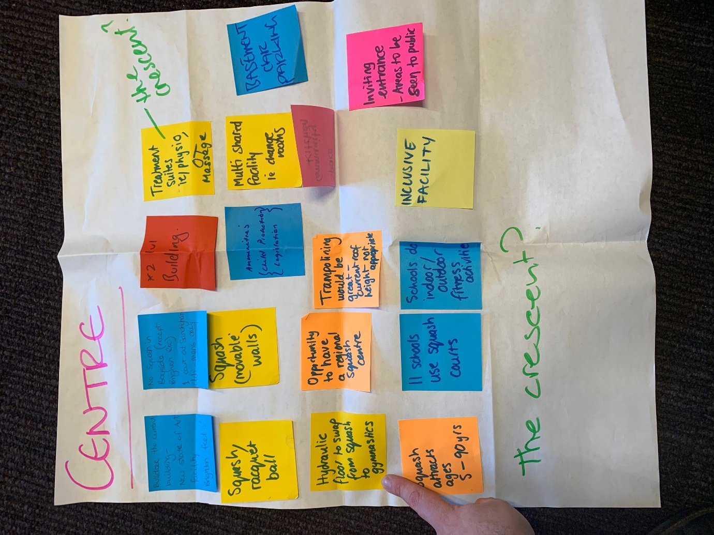
Photo: Feedback about the Centre received from frequent users workshop
Drop-ins
The drop-ins were conducted at the Centre, Wilson Reserve and Brighton Library. The most well attended sessions were at the Centre and the Brighton Library. At the drop-in at the library visitors were offered a free coffee from ‘The Coffee Cart Changing Lives’ if they completed a survey (hard and soft copies made available).
This method meant visitors had time to process their responses while drinking coffee and chatting to Council Officers about the project. The casual and ad-hoc nature of the drop-in allowed for longer conversations with the community about what they wanted from a new Centre and Reserve.
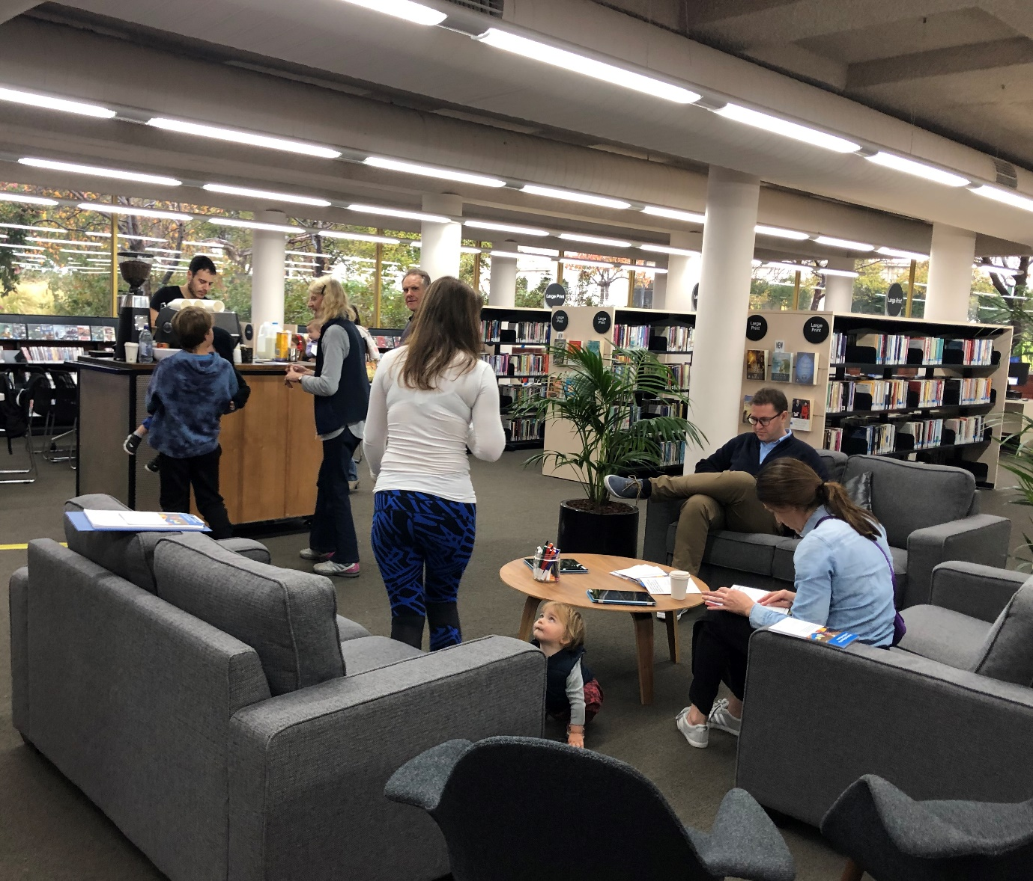
Photo: Drop in Session at Brighton Library
The proceeds from the coffee cart went towards barista training for young people experiencing homelessness. This approach allowed for conversations between Council staff and community members about Council’s role in the community and Council’s focus on improving the lives of all community members.
Finally, the drop-in that had the lowest attendance was at Wilson Reserve, possibly because of the very poor weather. Some neighbours and passers-by still provided feedback on the project and contributed ideas for improvements.
Ideas Wall
The Ideas Wall was installed at the Centre to provide opportunities for young people to contribute ideas. This method was very popular and many young people wrote suggestions for how the sites can be improved.
Survey
Hard and soft copies of the survey were made available for people to suggest ideas for the Masterplan. The soft copy was distributed via the project Have Your Say page and via an IPad at the drop-in sessions and hard copies were left at the Centre and Brighton Library. The two methods allowed for a variety of user types to make suggestions.
Communications
The opportunities to be involved have been widely promoted, through local traditional and social media. Signage on site at Wilson Reserve and Brighton Rec has been effective in raising awareness of the opportunity to have your say in person and online, in particular those who regularly use the facilities at Brighton Rec and Wilson Reserve and live outside Brighton.
The consultation was advertised through:
- Council’s website
- Advertisements in the Bayside Leader
- Paid social media posts via Council’s Facebook accounts
- Letterboxing: We delivered 2,500 flyers to households in Middle Brighton. The flyer contained the survey questions and offered residents the opportunity to drop off the completed survey to the survey box located at Brighton Rec.
- Posters and flyers promoting the consultation were also provided in the foyer of the Brighton Recreational Centre and Brighton Library. These provided information about the project and how to find out more.
- On site signage at each entrance to Wilson Reserve and The Centre

Consultation findings
Over 200 people participated in the consultation and 642 ideas for improving the sites were collected. The data collected from drop in sessions, ideas wall, online and hard copy surveys and workshops are synthesised in this section into key themes. In the interest of stakeholder and community privacy, individual quotes have not been included within this public document.
When asked what they loved about the Centre and Wilson Reserve respondents from across all engagement activities identified the following reasons.
The Centre
  - Children focused activities
  - Adult focused activities
  - Gymnastics
  - Sense of belonging
  - Health, fitness and wellbeing
  - Social interactions
  - Location
Wilson Reserve:
  - Relaxation / Passive recreation
  - Dog walking
  - Formal sport
  - Nature
  - Health and wellbeing
  - Nature, open space, location
  - Social interactions
The responses show that Wilson Reserve and the Centre are important recreational and social sites for the community. Many people spoke nostalgically about the friendships they had made at the Centre and the sense of belonging they experienced when attending classes. They also said that Wilson Reserve is an important open space where they can be in a natural environment, socialise and get fit.
Despite the positive responses almost all respondents acknowledged that Wilson Reserve and the Centre need upgrading and expressed that the sites will not meet the needs of the community in the future.

Consultation Feedback: Community Workshops
The community workshops were relaxed in nature and were designed to facilitate conversation between participants and Council Officers. The following feedback is a compilation of the conversations that were had during the workshops.
Community Workshop 13 June 2019: Neighbours (7 attendees)
Themes | Discussion Points
Why is the Centre important to you? | - Long term community importance.  - Good view.  - Keeps people active.
Ideas + Opportunities for Masterplan | - Exercise equipment  - Seats for the elderly  - Planting: Add more natural elements to the park.  - Keep Park as is.
What we don’t want from the Masterplan | - BBQ’s: They encourage anti-social behaviours.  - No basketball because of noise.  - Fencing.  - Lights.  - Pool at Centre.  - Cricket: Safety of balls hitting houses and young people. Sound is also concerning. School aged cricket would be ok.  - Toilets, not near residences, possibly connect them to the Centre so the cricket players can use it, but lock the bathrooms at night to avoid anti-social behaviour.
Concerns | - Playgrounds, kids are playing there are doing recreational drugs.  - Parking: Outer Crescent is difficult, Middle Crescent not so much. Programs require parents to stay. Schools/teachers take up street parking. People ‘stalk’ car spots.

Community Workshop 11 June 2019: Centre Board (6 attendees)
Themes | Discussion Points
Why is the Centre important to the community? | - Family connections  - Long term community importance  - Keeps people active  - Business growth  - Great relationship with Brighton Rotary.  - Governance is important to ensure continued value to Brighton  - Engages – Teens, Mums, and seniors.  - Caters towards 1-90 years old.
Ideas + Opportunities for Masterplan | - Programs that run into the Reserve  - Parking under oval  - Parking is a priority  - Parking is not just for Centre users  - Drop off spaces (the cricket club wants this too)  - More area for Youth  - A bigger sized Gymnasium  - More area for Childcare  - Flexible meeting spaces  - Café  - Pottery / Arts space  - Quiet space for programs like Yoga  - Squash – if replaced it would need to be for community benefit and multi-use (this is what the squash users suggested too)
Centre Business Growth Opportunities | - After hours programing + meeting rooms.  - Kitchen to support alternative use + childcare  - Consider liquor licence but not for major functions.  - Café
Reserve and Relationship to Centre | - Programs into the reserve.  - Gymnastics break outside (mix of indoor/outdoor activities).  - Childcare outdoor space (could connect with Birthday celebrations, industrial sized kitchen).  - Rooms with independent security access to outside (this is what Cricket users said).  - Fencing around play area.  - After hours function areas.  - BBQ near the Centre– to attract new people.  - Seating.  - Improvements to landscaping.  - Sensory interests for Bailey House (Bailey House said this too).  - Sensory guidance (and in Centre too) note: Bayside has the highest rates of people that adopt Guide Dog puppies before they go off to school.  - Basketball court  - Balances and shared use  - Cheerleading

Community Workshop 12 June 2019: Frequent users (17 attendees)
Themes | Discussion Points
Suggested improvements to the Centre | - Bulldoze the current building and replace with a new state of the art facility with a Brighton feel.  - 2 level building to fit more services  - Treatment suites (e.g., physiotherapy and massage)  - Basement car parking  - Inviting entrance  - Areas that can be seen from outside  - Multi shared facility (e.g., change rooms)  - Community kitchen  - Squash courts with moveable walls (squash appeals to 5-90 year olds, hydraulic floor to swap from squash to gymnastics)  - Opportunity to have a regional squash centre  - Schools indoor/outdoor fitness activities  - Trampolining would be great (the current roof height does not allow it.  - Inclusive facility  - Underground car park x 3
Suggested improvements to Wilson Reserve | - Lights for outdoor sports – so kids can play after 5:30pm in winter  - Make oval bigger for adult cricket  - Make oval bigger  - Dog activities to draw dogs away from main sports grounds  - Soccer (but it would need a big car park and may upset residents)  - Fitness track stations x 3  - Running track x 2  - Parameter fencing to assist in preserving the surface against damage.  - Fence.  - Benches, tables, BBQ, covered areas.  - Service for rugby, soccer, cricket.
Interface between the Centre and Wilson Reserve | - Café overlooking the reserve  - Pedestrian access (possibly through a tunnel)  - Partnership between Centre and local schools  - Café + access for outdoor sports to interact with venue  - Better traffic management

Consultation Feedback: Ideas wall, drop-ins and surveys.
The following sections synthesize the data collected from the ideas wall, drop-in sessions and hard and soft copy surveys.

The Centre
Users and non-users of the Centre provided feedback that they would like an expanded Centre with additional services, including a hydrotherapy pool, book club, Pilates and first aid classes. An expanded and upgraded Centre would also have a facility built that would enable it to offer full-day child care that would see clients able to have up to five full days of child care per week.
The three most common improvement to the Centre were an improved and larger Centre (99 mentions), improved Gym & Gym Facilities (75 mentions) and the inclusion of a café or some sort of food outlet (57 mentions).

The below table outlines the number of mentions that the main improvements for the Centre received.
Suggested improvements for the Centre | Main Themes
- Improved and larger Centre (e.g., painting, air con) (99 mentions)
- Improved Gym & Gym Facilities (75 mentions)
- Canteen, Café, Vending, Food (57 mentions)
- Improved childcare & kids spaces (31 mentions)
- Improved parking and access (31 mentions)
- Additional classes (sewing, yoga, tai chi, book club, Pilates , language, first aid,) (44 mentions)
- Foam pit (42 mentions)
- Tumble track (33 mentions)
- Pool, hydro therapy etc. (19 mentions)
- Improved opportunities to socialise (18 mentions)
- Other sport (12)
- Retain Squash (9 mentions)

Wilson Reserve
Compared to the Centre, there was less feedback about Wilson Reserve. This is possibly because on the days of the drop-ins it was very cold and there were not many people on-site. Despite this, the respondents who spoke about Wilson Reserve were passionate and had many great ideas for how it could be improved.
The three most common improvement to the Centre were amenities (drink fountain, tables, seating) (27 mentions), improved surface (21 mentions) and an undercover area (19 mentions).

The below table outlines the number of mentions that each improvement for Wilson Reserve received.
Suggested improvements for Wilson Reserve | Themes
- Amenities (drink fountain, tables, seating) (27 mentions)
- Improved surface (21 mentions)
- Undercover area (19 mentions)
- BBQ (16 mentions)
- Improved Parking and Access (13 mentions)
- Improved Playground (12 mentions)
- Toilets (12 mentions)
- Plants, Gardens etc. (11 mentions)

Project evaluation
In terms of stakeholder reach, the engagement activities attracted:
Measure | Outcome | Evaluation
At least 20 participants per drop-in session. | Approximately 30 people attended each of the drop in sessions at the Centre and Brighton Library. However, only 14 people attended the 2 drop-in sessions at Wilson Reserve. | Measure partially met, the low number of attendees at the Wilson Reserve drop-in sessions was ppossibly due to very poor weather.
At least 30 attendees for the community workshops. | A total of 36 people, representing the broad range of stakeholders attended the community workshops. | Measure met.
At least 100 survey responses. | A total of 187 survey responses (hard and soft copies) | Measure met.
At least 50 responses on the ideas well. | A total of 120 responses were communicated. | Measure met.
The response to the community engagement indicates strong interest in a redeveloped Centre and a moderate interest in redeveloping Wilson Reserve. The community workshops, drop-ins, ideas wall and surveys provided many ideas for improving the sites and provided the project team with a greater understanding of why the sites are important to the community and how they can be improved.
The results of the consultation will inform and assist Council’s decision making towards the design of the Masterplan and future direction.

Next Steps
The community engagement has been invaluable in providing Council Officers with a greater understanding of what is important to the community from a redeveloped Centre and Wilson Reserve. Guided by this information, Council staff will now work with key stakeholders on designing the draft Masterplan.
The draft Masterplan will be taken to the community for feedback once it is complete.
Stakeholder can stay up to date on the project by the project Have Your Say page - https://yoursay.bayside.vic.gov.au/Brighton-Recreational-Centre

