Climate Emergency Action Plan -
Stage 2 Community Engagement Summary

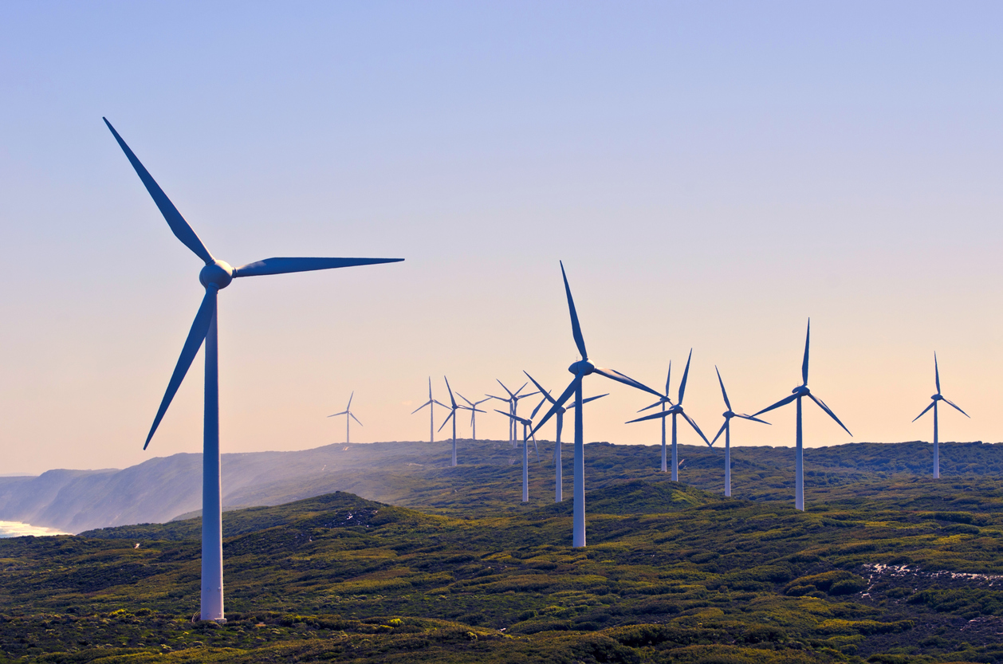

August 2020

Bayside City Council
Corporate Centre
76 Royal Avenue
SANDRINGHAM VIC 3191
T (03) 9899 4444
F (03) 9598 4474
www.bayside.vic.gov.au

Contents
Overview 3
1 Background 4
2 Consultation process 5
2.1 Consultation purpose 5
2.2 Consultation methodology 6
2.3 Communication tools and channels 6
3 Participant profile 7
4 Consultation findings 7
4.1 Summary of overall response to draft Action Plan Themes 7
4.2 Feedback on Theme 1 ‘Build the foundations’ 8
4.3 Feedback on Theme 2 ‘Mobilise with our community’ 9
4.4 Feedback on Theme 3 ‘Move to zero carbon transport’ 9
4.5 Feedback on Theme 4 ‘Transform to a climate responsive built environment’ 10
4.6 Feedback on Theme 5 ‘Protect and enhance our natural environment’ 10
4.7 Feedback on Theme 6 ‘Transition to a Circular Economy to avoid waste’ 11
4.8 Feedback on Theme 7 ‘Switch to zero carbon energy’ 11
4.9 Discussion on social media 11
5 Project Evaluation 12

Overview
Bayside City Council declared a Climate Emergency in December 2019 and resolved to develop a Climate Emergency Action Plan by October 2020. The first stage of community engagement was conducted over February-March 2020 and focused on gathering ideas from the community, and then prioritising those ideas into themes.

The second stage of community engagement involved the public release of the Draft Climate Emergency Action Plan for feedback. During June-July 2020, Council conducted a six-week community engagement process to collect feedback on the direction and content of the draft Action Plan. Overall, there were 52 individuals who provided feedback, either on-line or via email to Council. Three stakeholder organisations provided detailed comments to Council via email.

The Draft Plan was viewed 500 times, and with only 4 negative comments. The 48 respondents ‘support’ and ‘support with comments’ across the 7 themes of the Action Plan was between 32-58% and 30-59% respectively. Across the 7 themes no support was between 9-16%. These figures highlight the overall support there was for the draft Action Plan.

The individual emails and organisation submissions were also mostly supportive and provided further comments to improve the Action Plan by setting ambitious actions targets and driving faster change.
A report on the second stage of community engagement to refine the Action Plan, and the final draft Climate Emergency Action Plan, will be presented at a Council Meeting in September 2020 for Council approval.

Background
In December 2019, Bayside City Council declared a Climate Emergency. Council responded swiftly following a petition from the community requesting that Council declare a Climate Emergency and develop a Climate Emergency Action Plan, received in November 2019 with overwhelming support. Through its declaration and commitment, Council recognised that climate change is causing significant damage to our economy, society and environment, and that urgent action is required to reverse current trends and quickly adapt to the already changing climate.

The first stage of community engagement was conducted over February-March 2020 and focused on gathering ideas from the community, and then prioritising those ideas into themes. Over 2,900 people provided feedback through face-to face, on-line and written formats.

The seven themes listed below reflect the aspirations of the Bayside community and the multi-faceted response required to address the Climate Emergency:
- Build the foundations: Develop an educated, mindful culture ensuring the Climate Emergency response becomes business-as-usual across all Council departments.
- Mobilise with our community: Work with our community to take climate action and minimise the threats from climate related shocks and stressors, such as heatwaves and flooding.
- Move to zero carbon transport: Drive the transition away from internal combustion engine vehicles to sustainable transport such as walking, cycling, public transport and electric vehicles powered by renewable energy.
- Transform to a climate responsive built environment: Ensure the built environment provides comfortable, liveable spaces for people and will withstand climate related shocks and stressors, such as extreme heat, flooding and sea level rise.
- Protect and enhance our natural environment: Seamlessly integrate the natural environment into cityscape, strengthening land, water and ocean-based habitats.
- Transition to a Circular Economy to avoid waste: Drive the move away from the ‘take, make, dispose’ economy, towards one where all materials are treated as precious resources, with little thrown away.
- Switch to zero carbon energy: Support the decarbonisation of the energy system through switching to efficient, renewable energy solutions such as solar and wind power.

The draft Climate Emergency Action Plan was prepared for the second stage of community engagement. The draft plan included actions Council will take to respond to the Climate Emergency, as well as support for our local community to take action to reduce our impact on the environment. The actions were presented under the seven themes.

Each action had a nominated timeframe for delivery; an estimated cost; budget source; consideration of the delivery complexity; identified lead responsibility for implementation; and an outcome.

This document provides a summary of the second stage of community engagement, noting the stakeholder and community feedback on the draft Climate Emergency Action Plan.

Consultation process

Consultation purpose
The second engagement process was open to all residents, community groups and any other interested stakeholders in the Bayside area. The purpose of the second engagement process was to collect resident, visitor and other stakeholder feedback on:

- the thematic direction of the draft Action Plan;
- the focus of the actions under each of the seven themes; and
- any implementation issues or other comments on the proposed actions.

Stakeholders
A wide range of stakeholders was identified as part of the project planning process (refer to the engagement plan for full details). These stakeholders were:

- all Bayside residents and households (particular sub-groups identified in the engagement plan)
- aged care residents and facility managers
- small-medium businesses in Bayside
- Bayside Tourism Network
- community groups including flora and fauna groups, service clubs
- recreation clubs and foreshore users
- Climate Change ‘deniers’
- South East Councils Climate Change Alliance
- Bayside Emergency Climate Action Network (BECAN)
- Councillors and internal Council departments.

The community engagement plan identified the following negotiables:

Non-negotiables | Negotiables
Council is required to develop a Climate Emergency Action Plan | Possible actions under each theme
Council accepts the science of climate change | To stop or change existing actions and priorities
Timelines for publication of Plan | Involvement of community in implementation
Any action/suggestion outside Council jurisdiction may need to be an advocacy item | Prioritisation of actions/timing within each theme
Implementation timeframe of Action Plan | Partnerships with government and other organisations
Themes | Review outstanding actions from previous Climate Change Strategy and Carbon Neutrality Action Plan
Not just Council-created emissions | Big ideas
Environmental Upgrade Agreement (EUA) program for medium - large size Bayside businesses
Non-climate change related actions will not be included in the Plan

Consultation methodology
The following activities were undertaken for the second stage of community engagement:

- project information including the draft Action Plan, details of each theme and a theme-specific survey hosted on the on-line engagement platform Have Your Say;
- promotion of the project using Council communication channels, including social media.

Details | Activity
5 June – 26 July 2020  582 visitors  43 contributors  48 contributions  20 project followers | On-line engagement platform Have Your Say  Surveys seeking feedback on the themes and actions under each theme
5 June – 26 July 2020  0 comments  1 ‘Shares’  57 ‘Likes’ | Social media Bayside Council Facebook and Instagram page  4 separate Facebook and Instagram posts were made by Council alerting readers to the second stage of community engagement
5 June – 26 July 2020  3 emails were sent from organisations  5 emails and 1 REX were sent by individuals | Correspondence to Council  Emails with detailed comments were sent to Council by the following organisations:  - Bayside Emergency Climate Action Network (BECAN)  - The Wilderness Society Bayside (TWS)  - South East Councils Climate Change Alliance (SECCCA)

Communication tools and channels
The second stage of community engagement was promoted via the following communication channels:

On-line
- Council website and email subscription service – This Week in Bayside news items
- On-line engagement platform Have Your Say project page
- In The Loop news item for staff who are residents/visitors

Social media
- Facebook and Instagram posts

Direct Email
- External stakeholders/organisations and community groups (as listed)
- Have Your Say subscribers
- Bayside Sustainable Living email subscribers

Participant profile
Participant characteristics were assessed as being not relevant for the second phase of community engagement. Where registered Have Your Say members participated in the engagement, some limited demographic data was recorded.

Consultation findings
The following section summarises the community and stakeholder feedback on the seven themes of the draft Action Plan. In the interest of stakeholder and community privacy, individual quotes have not been included within this public document. Where there was more than one mention of a topic or item, the number of mentions has been specified in brackets and italics.

Summary of overall response to draft Action Plan Themes
Overall the majority of stakeholders supported the Action Plan themes and acknowledged the important step Council had taken in drafting an Action Plan to address the Climate Emergency.
The following table and chart summarises the survey responses received through the On-line engagement platform Have Your Say project page.

Theme of draft Action Plan | Support all of actions | Support some of actions but have comments | Do not support actions | Total
Build the foundations | 24 (55%) | 15 (34%) | 5 (11%) | 44
Mobilise with our community | 24 (55%) | 15 (34%) | 5 (11%) | 44
Move to zero carbon transport | 14 (32%) | 26 (59%) | 4 (9%) | 44
Transform to a climate responsive built environment | 17 (38%) | 21 (47%) | 7 (16%) | 45
Protect and enhance our natural environment | 20 (47%) | 17 (40%) | 6 (14%) | 43
Transition to a Circular Economy to avoid waste | 19 (45%) | 18 (43%) | 5 (12%) | 42
Switch to zero carbon energy | 25 (58%) | 13 (30%) | 5 (12%) | 43

In addition to the Have Your Say feedback, Council received email correspondence from three organisations and other individuals. Email correspondence from individuals was mostly supportive, however comments on Council’s overall approach to the Action Plan provided valuable feedback. The plan was seen as high level with further detail needed to understand the effectiveness of the actions. Targets for emission reductions for the community was suggested, with the acknowledgement that Council may not be able to control but influence this outcome. Across the themes some actions were identified as needing to be accelerated and the community’s role and actions relating to the community were not clearly defined.

BECAN provided extensive feedback as an organisation. They were supportive of Council’s work on this topic but felt that the Action Plan lacked a sense of urgency with long timeframes and ambiguous language; measurability and clear KPI’s; and targets to achieve the outcomes stated across each theme. They wanted to see more background information to add greater understanding of the situation and specific details of action delivery. They felt the Action Plan was missing Indigenous perspectives and expressed concern that pre-existing plans needed to be reviewed in the Climate Emergency context. Feedback on each theme was provided, which has been incorporated in the ‘Feedback’ sections.

TWS contributed to the BECAN submission and also provided a separate organisation submission to represent the youth in the community. Similar to BECAN, TWS was concerned the draft Action Plan required updates to ensure it dealt with the emergency in an urgent manner, with greater detail and concrete commitment on delivery of actions coupled with a more comprehensive reporting and monitoring approach. The group called on Council to be more ambitious in setting targets and needing to update existing plans referenced in the Action Plan in line with the Climate Emergency. Similar to BECAN, TWS saw no evidence of consultation with Indigenous members of the community and called on Council to maintain communication and reporting to the community to develop trust and strengthen accountability. Feedback on each theme was provided, which has been incorporated in the ‘Feedback’ sections.

SECCCA’s Executive Officer provided feedback to Council on behalf of the organisation. SECCCA stated the Action Plan was comprehensive, with positive feedback overall. The feedback that was provided promoted the regional approach to addressing the Climate Emergency and indicated support for collaborative actions and suggested further deliverables aligned with SECCCA projects. Targets aligned to the Paris Agreement were suggested and clarity on responsibility and accountability for staff for delivering the Action Plan was sort.

Feedback on Theme 1 ‘Build the foundations’
The theme covered a wide range of topics with 12 actions and the overall feedback for this theme was positive. There were comments provided on different actions to improve the approach.
Support some of actions but have comments
Need for measurability, reporting and accountability of actions and deliverables (13 including BECAN and TWS)
Lack of urgency with long timeframes (10 including BECAN and TWS)
Stronger language and more commitment in actions and deliverables (10 including BECAN and TWS)
Need to set targets and/or Key Performance Indicators (8 including BECAN and TWS)
Need for awareness building and conversion to action for staff (6 including TWS)
No direct or indirect investment in fossil fuel projects (4 including BECAN and TWS)
Procurement Policy needs to be utilised to influence contractors (4 including BECAN and TWS)
Indigenous community needs to be consulted (4 including BECAN and TWS)
Advocacy action is insufficient and needs to be expanded and accelerated (2 including BECAN and TWS)

4.3 Feedback on Theme 2 ‘Mobilise with our community’
Theme 2 outlined 9 actions covering a range of topics with overall positive feedback. There were comments provided on different actions to improve the approach.
Support some of actions but have comments
Need for awareness building and conversion to action for the community (12 including BECAN and TWS)
Need for measurability, reporting and accountability of actions and deliverables (9 including BECAN and TWS)
Lack of urgency with long timeframes (5)
Stronger language and more commitment in actions and deliverables for the adults, school students and businesses (5 including BECAN and TWS)
Funding is required, with support to implement innovative funding models to meet the long term funding requirements (4 including BECAN and TWS)
Existing programs need to be built upon and new programs rolled out efficiently (3 including BECAN and TWS)
Need to set targets (2 including BECAN and TWS)
Need to understand in-kind support offered to community groups (2 including BECAN and TWS)
Grants program should be provided to businesses (2 including BECAN and TWS)
Indigenous community needs to be consulted (2 including TWS)
Advocacy should assist with amplifying community voices (2 including BECAN)
How the COVID-19 pandemic can allow the community to change BAU (1 including BECAN)

4.4 Feedback on Theme 3 ‘Move to zero carbon transport’
The theme covered a wide range of transport topics with 5 actions and the feedback for this theme was mostly positive. There were comments provided on different actions to improve the approach and provide more detailed response in to addressing this theme.
Support some of actions but have comments
Need for dedicated bicycle lanes for safety and incentive to choose active transport (13 including TWS)
Stronger language and more commitment in actions and deliverables (9 including BECAN and TWS)
Lack of urgency with long timeframes (8 including BECAN)
Request for Council to install public Electric Vehicle and Electric Bicycle chargers (7 including BECAN and TWS)
Reviews needed of the major strategies identified as vital to deliver the Action Plan to align with Climate Emergency declaration (6 including BECAN and TWS)
Call for greater connectivity for active transport routes, within and beyond Council boundary (4 including BECAN)
Not relying on carbon offsets for the fleet (3 including TWS)
Need for measurability, reporting and accountability of actions and deliverables (3 including TWS)
Consideration of contractors’ fleet’s (2)
Funding is required to meet the long term funding requirements (1 including BECAN)
Advocacy action is insufficient and needs to be expanded and accelerated (1 including TWS)

4.5 Feedback on Theme 4 ‘Transform to a climate responsive built environment’
Theme 4 outlined 10 actions covering a range of topics with overall positive feedback. There were comments provided on the theme as a whole with some direct comments on different actions to improve the outcomes.
Support some of actions but have comments
Need for adherence to and improved building standards including retrofitting for existing buildings (17 including BECAN and TWS)
Need for awareness building and conversion to action for residents and within the building industry (11 including BECAN and TWS)
Working in collaboration with other stakeholders (9 including BECAN)
Need to understand impact of overdevelopment on environmental outcomes and the inherent link between the urban and natural environment (9)
Need for measurability, reporting and accountability of actions and deliverables (8 including BECAN and TWS)
Need to set targets (5 including BECAN and TWS)
Stronger language and more commitment in actions and deliverables (4 including TWS)
Lack of urgency with long timeframes (3 including BECAN)
Leasing Policy needs to be utilised to maximise building use i.e. no single use buildings (2 including BECAN)
Requirement to remove gas from buildings (2 including BECAN)
Need to understand the impact of foreshore erosion on buildings (1)
Need for overhead wiring to be diverted underground (1)

4.6 Feedback on Theme 5 ‘Protect and enhance our natural environment’
The theme covered the range of natural environment topics with 9 actions and the feedback for this theme was positive. There were comments provided on different actions to improve the timing and approach.
Support some of actions but have comments
Need to improve and maintain canopy cover, including ensuring new tree survival and private land tree management (8 including TWS)
Lack of urgency with long timeframes (6 including BECAN and TWS)
Indigenous community needs to be consulted and Indigenous plants promoted and prioritised (6 including BECAN and TWS)
Need for measurability, reporting and accountability of actions and deliverables (5 including BECAN and TWS)
Reviews needed of the major strategies identified as vital to deliver the Action Plan to align with Climate Emergency declaration (5 including BECAN and TWS)
Further action on local food production, including distance travelled (4 including BECAN and TWS)
Utilise open space to divert stormwater and improve water quality and create natural ecosystems (3)
Need to manage foreshore erosion and the inherent link between the urban and natural environment (3)
Stronger language and more commitment in actions and deliverables (2)
Working in collaboration with other stakeholders (2)
Need for education on current lifestyle impacts on the natural environment and climate change (1 including TWS)
Need to set targets (1 including TWS)

4.7 Feedback on Theme 6 ‘Transition to a Circular Economy to avoid waste’
Theme 6 outlined 4 actions using a holistic approach with overall positive feedback. There were comments provided on the theme as a whole with some direct comments on different actions to improve the approach and outcomes.
Support some of actions but have comments
Need for awareness building and conversion to action for the community (14 including BECAN and TWS)
Need to set targets, including waste to landfill and food/organics diversion from landfill (11 including TWS)
Need for measurability, reporting and accountability of actions and deliverables (7 including TWS)
Need to focus on repurpose and salvage initiatives (4 including BECAN)
Request for Council to maintain easy to use and efficient recycling approach (4)
Need to promote the circular economy, including purchase of recycled products (2 including TWS)
Lack of urgency with long timeframes (1)
Stronger language and more commitment in actions and deliverables (1)
Investigate waste to energy options (1)

Feedback on Theme 7 ‘Switch to zero carbon energy’
Theme 7 outlined 8 actions covering a wide range of topics with overall positive feedback. There were comments provided on the theme as a whole with some direct comments on different actions to improve the approach.
Support some of actions but have comments
Lack of urgency with long timeframes (6 including BECAN and TWS)
Working in collaboration with other stakeholders, including network providers (5 including BECAN)
Need to set targets, including those relating to the community (4 including BECAN and TWS)
Need for awareness building and conversion to action for the community, including incentives (4 including TWS)
Need to focus on energy efficiency, beyond street lighting (4 including BECAN and TWS)
Need for measurability, reporting and accountability of actions and deliverables (3 including BECAN and TWS)
Stronger language and more commitment in actions and deliverables (3 including TWS)
Existing programs need to be built upon and new programs rolled out efficiently (3 including TWS)
Requirement to remove gas from buildings (2 including BECAN and TWS)
Not relying on carbon offsets, with focus on reducing emissions (2 including TWS)
Advocacy action is insufficient and needs to be expanded and accelerated (2 including BECAN and TWS)
Need to understand economic benefits of implementing zero carbon energy actions (2 including BECAN)
Request for carbon neutrality to be certified under the Climate Active Carbon Neutral Standard (1 including BECAN)
Need to consider negative emissions profile/draw down options (1 including TWS)
Request for details on the Power Purchase Agreement (1 including TWS)

Discussion on social media
There were no comments and therefore discussion on the draft Action Plan on social media. 37 people liked the posts and 1 shared the post, which are both indicators of support for the Action Plan.

Project Evaluation
In terms of stakeholder reach, it was proposed that the second stage of engagement activities would attract a minimum 25% visitor return rate, which would equate to 694 visitors (based on the 2774 visitors from the first stage of community engagement). The second stage of engagement resulted in 582 visitors.

The conversion goals for visits to the Have Your Say project page were, that:
- 5% of visits would have at least one contribution made;
- 30% of visits would last at least one active minute (time spent actively looking at project information); and
- 20% of visits would have at least two actions were performed (moving around project page, clicking on links).

The results for this project are shown below, with all three conversion goals achieved:
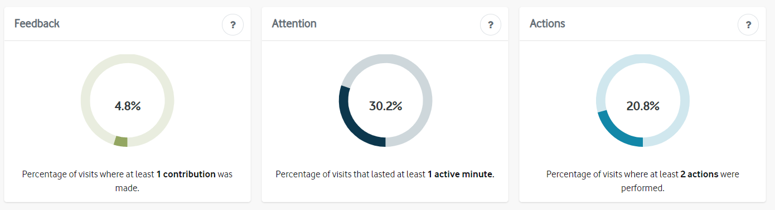

The major stakeholder groups attended Teams meetings, and subsequently emailed Council with their feedback.
In terms of stakeholder satisfaction, feedback was collected through follow up online video call meetings with stakeholders.

An important measure of the success of the communications regarding climate action is that stakeholders and community members understand the role and capability of Council, as reflected in their comments about the draft Plan. Overall the majority of the feedback received on the draft Climate Emergency Action Plan related to Council's role and capability.

Other key measures for the second phase of engagement were that the Council or the delegated decision maker was confident in the reliability of data - measured by the inclusion of the full Engagement Summary in the Council report, and that Council does not request further engagement be conducted. These measures of project success will be assessed following consideration of the Action Plan at the September 2020 Council Meeting.

