Council policy title: | (Draft) Community and Stakeholder Engagement Policy 2021
Council policy sponsor: | Director, Community and Customer Experience
Adopted by: | Bayside City Council
Date adopted: | February 2021
Scheduled review: | February 2025
Document Reference: | [insert TRIM Document reference]

(Council Policy is a high level public statement formally resolved by Council, which clearly states Council’s requirements, intent or position with regard to a particular matter or issue. It is not intended to be procedural in nature.)
Policy intent
The Community and Stakeholder Engagement Policy 2021 (the Policy) affirms Bayside City Council’s commitment to engaging its community, and relevant stakeholders, about matters that affect them. The Policy is designed to strengthen trust and confidence in Council to make evidence-based decisions that benefit the Bayside community through the consistent application of a transparent process.

- Policy purpose
Council undertakes community engagement to inform its decision making. The Policy sets Council’s commitments when delivering community engagement.
The Policy also expands on requirements defined in the Local Government Act 2020, for how Council will:
- Apply the community engagement principles
- Include deliberative engagement practices
- Describe type and form of community engagement proposed
- Specify a process for informing the municipal community of the outcome of engagement.
The Policy delivers outcomes related to two of the strategic objectives in the Council Plan 2017-2021 (2020 Review):
- “We want a Bayside where the community engages in advocacy, transparent decision making and is part of the solution” (Strategic Objective 7.2)
- “We want a Bayside where decision making is open, transparent and informed by representative community views” (Strategic Objective 8.3), with the associated actions to “Improve community engagement to inform Council decision making” and “Implement legislative changes as a result of the new Local Government Act”.

People have a basic human right to receive and share information and ideas (the right to freedom of expression). This right might be limited to respect the rights and reputation of other people, or for the protection of public safety and order. People have a basic human right to take part in public life. The human rights implications of this Policy have been properly considered and the Policy has been found to comply with Charter of Human Rights and Responsibilities Act 2006 (Victoria).

- Glossary - Definitions and Abbreviations
Term | Meaning
Community/ municipal community | ‘Community’ is used it to describe people of a municipality, or Council area, generally, including individuals or groups who live, work, play, study, visit, invest in or pass through the municipality.  The Local Government Act 2020 (Vic) defines the term “municipal community” as:  (a) people who live in the municipal district of the Council; and  (b) people and bodies who are ratepayers of the Council; and  (c) traditional owners of land in the municipal district of the Council; and  (d) people and bodies who conduct activities in the municipal district of the Council.
Stakeholder | An organisation or defined group of people who are interested, affected by or contribute to an outcome. Often these individuals or groups have a defined intent or ‘stake’ in the project or matter.  A stakeholder group may have a single or shared perspective on an issue or may have different views. A delegate may represent a shared view on behalf of a group.  Some examples are government departments and public services, traders/business operators, and community organisations such as sports clubs, environmental groups, and service clubs.
Engagement | Getting community and/or stakeholder input or feedback to inform a Council decision.  Can also be referred to as ‘consultation’, however engagement is the preferred term to avoid confusion with the Consult level of the IAP2 Spectrum.  When a project or matter will not extend beyond the ‘Inform’ level on the IAP2 spectrum, it will be considered ‘communication’ and not referred to as ‘engagement’. This is done to prevent confusion and manage expectations.
Public engagement | Refers specifically to engagement that will be open to participation for all members of Bayside City Council’s municipal community.

Representative participation | For some matters, especially those with deliberative characteristics, participation may be designed or selected to align with the demographic features of the impacted community using data published by the Australian Bureau of Statistics.  The measure, relevance and emphasis on representative participation may vary between projects.
Deliberative practices | A fair and transparent process by which we provide the relevant representative people/group with the practical information, forums and resources they need to reach a considered conclusion and provide recommendations on a defined issue.  This may occur in combination with other formats of research or engagement.
Research | The systematic collection, collation, analysis and interpretation of data relevant to policy or practice, or to understand future trends, local needs and good practice.
Communication | Communication is about providing information to build a shared understanding between Council and the community. It refers to the many ways Council keeps the community up to date with news, projects and opportunities.
Publication | For projects involving public engagement, information will be published on Council’s website and/or Bayside Have Your Say and available in print or other formats.
Subscription | During engagement individuals can subscribe to receive updates by providing email or postal addresses or ‘subscribing’ to pages on Have Your Say.
IAP2 and Public Participation Spectrum | The International Association of Public Participation (IAP2) provides sector leadership, resources and development. Many of its tools are central to Council’s Policy and process.  “The IAP2 Public Participation Spectrum is designed to assist with the selection of the level of participation that defines the public’s role in any community engagement program. The Spectrum shows that differing levels of participation are legitimate depending on the goals, time frames, resources and levels of concern in the decision to be made. However, and most importantly, the Spectrum sets out the promise being made to the public at each participation level.” The Spectrum is illustrated in Appendix 1, with the Bayside application explained in Appendix 2 and 3.
Hard to reach / marginalised stakeholders | There are groups or sections of our community who may find it more difficult to participate in community engagement activities. These groups can be considered ‘hard to reach’ because of the barriers to engagement that they experience. These groups include, but are not limited to:  - Aboriginal and Torres Strait Islander people  - Children, young and older people  - Culturally and Linguistically Diverse (CALD)  - Lesbian, gay, bi, trans, intersex and queer (LGBTIQA+) people  - New and established migrant communities  - New residents to the municipality  - People experiencing homelessness  - People with health issues  - People with limited literacy  - People with limited access to and/or skill in digital technologies  - People with lived experience of disability  - People with lower discretionary income  - People with non-standard work patterns/schedules  - Residents in public housing  We recognise the requirement to consider gender identity and its impact on participation and tool selection.  We will adapt engagement tools and processes to ensure fair and accessible representation for these sections of the community.

- Scope
Council will engage the Bayside community and/or stakeholders on matters that both interest and affect them, including but not limited to:
- Substantially changing or reviewing a Council service, program or facility;
- Significant review, change or proposing a new Council policy, plan or strategy;
- Capital works projects including public buildings, community centres or other infrastructure.
The Community and Stakeholder Engagement Policy 2020 will specifically apply to the following Bayside City Council documents and processes as nominated in the Local Government Act 2020:
- A local law (Section 73)
- The Community Vision (Section 88)
- The Council Plan (Section 90)
- The ten-year Financial Plan (Section 91)
- The development or review of the Asset Plan (Section 92)
- The budget or revised budget (Section 96)
- The purchase or compulsory acquisition of land (Section 112)
- The sale or exchange of land (Section 114)
- The lease of land (Section 115).
Community engagement undertaken for the Community Vision, Council Plan, Financial Plan and Asset Plan will be conducted using deliberative engagement practices.
The Policy applies to the Council, individual Councillors, Council delegated committees, and Council employees.
Research is included within the definition of engagement, noting it is primarily at the Consult level of the IAP2 Spectrum.
Out of scope
In the context of Bayside City Council, when a project or matter will not extend beyond the ‘Inform’ level on the IAP2 spectrum, it will be considered ‘communication’ and not referred to as ‘engagement’. This is done to prevent confusion and manage expectations.
Council may not engage when it has an adopted policy, strategy or decision that determines a clear direction for implementation which has already been the subject of appropriate community engagement.
The Policy does not apply where Section 223 of the 1989 Local Government Act still applies, including:
- Section 157(5) – council decision to change system of valuation
- Sections 163A and 166(4) – special rates
- Section 169(1C) – rebates and concessions
- Section 179 – Regional Library agreements
- Section 199 – concentration or diversion of drainage
- Section 200 – drainage of land
- Section 207A – a range of traffic and road related matters.
It also does not apply to routine statutory planning applications for residential developments on private land. We highlight that statutory planning processes cannot be used in lieu of community engagement where is it required by this policy.

- Policy statement
Principles for Engagement
Bayside City Council commits to the five principles noted in Section 56 of the Local Government Act 2020 and has created an additional principle on equity. The statements below define our commitment deliver each principle.
Principle 1: A community engagement process must have a clearly defined objective and scope
When engagement is launched, we will publish an Engagement Plan Overview including a description of the project or matter that is the subject of engagement. This will explain:
- Why the project is needed
- What the community can influence and what they can’t
- What information we need from the community
- Methods in which we will gather feedback / contribution from the community
- The timeline in which the community can provide feedback and when the matter is expected to be decided
- Community feedback on a matter will not be considered after closing date to enable reporting to be completed within this timeline.
If the project or matter will have multiple stages of engagement, we will define the objective and scope for each stage.
We will allocate resourcing for engagement that is relative to the scope and complexity of the project or matter.
Principle 2: Participants in community engagement must have access to objective, relevant and timely information to inform their participation
We will provide timely access to factual and transparent information on the project or matter, including:
- A summary of known impacts, risks and benefits including social, natural and built environment, and financial
- Relevant background information, technical and research reports, related policies, budget estimate and funding source.
This information will be provided through a combination of printed, verbal, digital, audio-visual formats.
We will provide information in accessible formats, plain language summaries and provide opportunities to ask questions and receive a response, either individually or via shared communications.
Translations and/or interpreters will be provided when required.
Principle 3: Participants in community engagement must be representative of the persons and groups affected by the matter that is the subject of the community engagement
We will identify members of the community that have a connection to the project or matter, and publish an assessment of the level of:
- Impact: what level of change will the community member experience as a result of the project/matter
- Interest: what level of interest has been expressed or is anticipated
- Influence: we use the International Association of Public Participation (IAP2) Spectrum to identify the level of influence they can expect over the end outcome or decision (refer to appendix 1).
This information is used to understand the types of tools and techniques that will be most effective for engagement and communication (refer to Appendix 3).
Community members who are identified as likely to experience a significant impact from a change or decision, may be offered a higher level of engagement and influence on the decision than others.
Individuals will be able to request additional community members or stakeholders to be considered in the engagement and/or a review of assessment ratings.
Principle 4: Participants in community engagement are entitled to reasonable support to enable meaningful and informed engagement
We will design engagement including the methods, activities and schedule to meet the needs and requirements of identified community members. This will consider:
- Multiple methods to participate, including written, visual, online and verbal
- The time participants will require to provide an informed response
- The resourcing available for engagement relative to the scope and scale of the project.
Methods and tools selected will relate to the type of project and level of influence relative to the IAP2 Spectrum and relative to the project budget. This is discussed in more detail in Appendix 1 to 3.
For community members who may experience barriers to participation, additional resources may be considered such as:
- Information and feedback processes in alternative formats
- Support to participate, including personal care and/or support, transport
- Incentives such as an expense allowance or prize draws.
Principle 5: Participants in community engagement are informed of the ways in which the community engagement process will influence Council decision making
We will explain how and when the decision will be made, including:
- The influence community feedback will have, referencing the IAP2 Spectrum of Participation
- Other information that will inform decision making, including technical information, research, policies, legislation, Council priorities, commitments and available budget.
Where there are multiple phases of engagement, we will describe the above for each phase.
Providing feedback to participants is crucial in respecting our relationship and partnership with our community. We will:
- Provide updates to subscribers at key progress points, including when the item will be discussed at a meeting of Council
- Publish a summary of the engagement process and results within two months of the close of engagement. This will include summary of participants and process
- If the outcome of engagement is referenced in a report to Council or will inform a Council decision before the above deadline, the engagement summary will be published at the same time as the Council agenda
- Provide updates to subscribers on the outcome of the project or matter within one week of key decisions and milestones.
Principle 6: A community engagement process must be designed to promote fairness and equality
Traditional engagement activities can be biased towards the participation of those who are easy to communicate with, have a pre-existing relationship with Council, and are vocal and reasonably comfortable in a public setting.
We will design engagement programs to encourage fairness, equality and the participation of marginalised or hard to reach groups through:
- Selection of methods and tools, including one to one and small group discussion
- The ability to participate in a private or closed forum and/or anonymously
- Monitor the participation of hard to reach groups and adapt activities to promote increased participation if required
- Moderation and management of public forums to enable respectful and equitable sharing of ideas.

- Monitoring, evaluation and review
Monitoring, evaluation and review of the Policy will be undertaken by the Manager Communication and Engagement. Implementation of the Policy and Principles will be published and available to the community, including an annual summary of achievement of targets for:
- Publication of Engagement Plan Overview
- Publication of engagement report and key project updates within stated timeframes.

The effectiveness of the Policy will be assessed by longer-term outcome measures including:
- Community trust and confidence in Council
- Community recognising Council as a respected information source
- Community understanding of Council’s role and the local government role.
The next Policy review is scheduled for February 2025.

- Roles and responsibilities
The Manager Communication and Engagement coordinates the development, implementation, compliance, monitoring, evaluation and review of this Policy.
Across Council, Departmental Managers are accountable for determining the need to undertake community engagement and responsible for the development, implementation, reporting and evaluation of engagement activities. It is their responsibility to confirm the scale of engagement activities based on the scope and complexity of the project or matter and the resources available.

The Communication and Engagement Department are responsible for providing advice in relation to this Policy and will support other Council staff in the planning and delivery of community engagement projects. The level of support provided will vary according to available resources, the complexity of the matter and impacts on the community.
Other departments of Council may be called upon to provide support or advice on subject matter expertise, including community and stakeholder identification and assessment. Where relationships exist between specific departments and individual community members and/or stakeholders, especially hard to reach populations, those departments may lead the communication and/or engagement with those individuals.

- Related documents
Legislation | Defamation Act 2005 (Victoria)  Freedom of Information Act 1982 (Victoria)  Information Privacy Act 2000 (Victoria)  Local Government Act 2020 (Victoria)  Planning and Environment Act 1987 (Vic)  Privacy Act 1988 (Commonwealth)  Privacy and Data Protection Act 2014 (Victoria)  Racial and Religious Tolerance Act 2001 (Victoria)  Roads Act (2004)  Wrongs Act 1958 (Victoria)  Public Health and Wellbeing Act 2008 (Vic)
Policies | Bayside City Council Customer Experience Policy 2018  Bayside City Council Disciplinary Policy 2018 (DOC/18/160713 organisational policy)  Bayside City Council Governance Rules 2020  Bayside City Council Privacy and Data Protection Policy 2017  Bayside City Council Records Management Policy 2011 (DOC/15/8767 organisational policy)  Bayside City Council Social Media Policy 2020  Bayside City Council Transparency Policy 2020
Strategies / Plans | Bayside City Council, Council Plan 2017 – 2021 (2020 Review) and 2020/2021 Annual Action Plan  Bayside City Council, Bayside Community Plan 2025  Bayside City Council Organisation Strategy 2019 (internal)
Procedures / Processes | Bayside City Council, Community and Stakeholder Engagement Guidelines (2017)  Bayside City Council, Community Engagement and Research process (Promapp)  Bayside City Council, Engagement and Research Tool Kit, 2018  Local Government Victoria guidelines 2020 (unpublished)
Other | Bayside City Council Councillor Code of Conduct 2017  Bayside City Council employment contracts  Bayside City Council Staff Code of Conduct 2020  Victorian Small Business Commission - Small Business Friendly Council Initiative 2020

Please note: This policy is current as at the date of approval. Refer to Council’s website (www.bayside.vic.gov.au) to ensure this is the latest version.

Appendix 1: IAP2 Spectrum of Public Participation
Bayside City Council’s engagement process is based on the International Association of Public Participation’s (IAP2) Spectrum of Engagement. The IAP2 is a recognised leader in community engagement and has developed tools that are widely used by governments, institutions and other entities that affect the public interest.
The IAP2 Spectrum identifies five levels of engagement. At each level the public can expect to have a different amount of influence over the end outcome or decision.
As shown in the table below, the level of engagement with the lowest opportunity to influence is ‘Inform’, while ‘Empower’ provides the greatest level of influence, putting the decision completely in the hands of the community.
Within the Bayside context, when a project or matter will not extend beyond the ‘Inform’ level on the IAP2 spectrum, it will be considered ‘communication’ and not referred to as ‘engagement’. Where a project may involve engagement at other levels on the spectrum, there may be some community members and/or stakeholders
The level of engagement may also vary for different stakeholders and/or stages of a project.
Table 1: IAP2 Spectrum of Public Participation
Level | Public participation goal | Promise to the public
Inform | To provide the public with balanced and objective information to assist them in understanding the problem, alternatives, opportunities and/or solutions. | We will keep you informed.
Consult | To obtain public feedback for analysis, alternatives, or decisions. | We will keep you informed, listen to and acknowledge concerns and aspirations, and provide feedback on how public input influenced the decision.
Involve | To work directly with the public throughout the process to ensure that public concerns and aspirations are consistently understood and considered. | We will work with you to ensure that your concerns and aspirations are directly reflected in the alternatives developed and provide feedback on how public input influenced the decision.
Collaborate* | To partner with the public in each aspect of the decision including the development of alternatives and the identification of the preferred solution. | We will work together with you to formulate solutions and incorporate your advice and recommendations into the decisions to the maximum extent possible.
Empower | To place final decision making in the hands of the public. | We will implement what you decide.

Appendix 2: Alignment of the IAP2 Spectrum with Bayside City Council project type
Figure 1 indicates where Council anticipates alignment of different projects or matters against the IAP2 spectrum based on the stage of planning. The selection of level of engagement is made for each project individually in response to scope and complexity.
Figure 1: Indicative alignment of project type with the IAP2 Spectrum
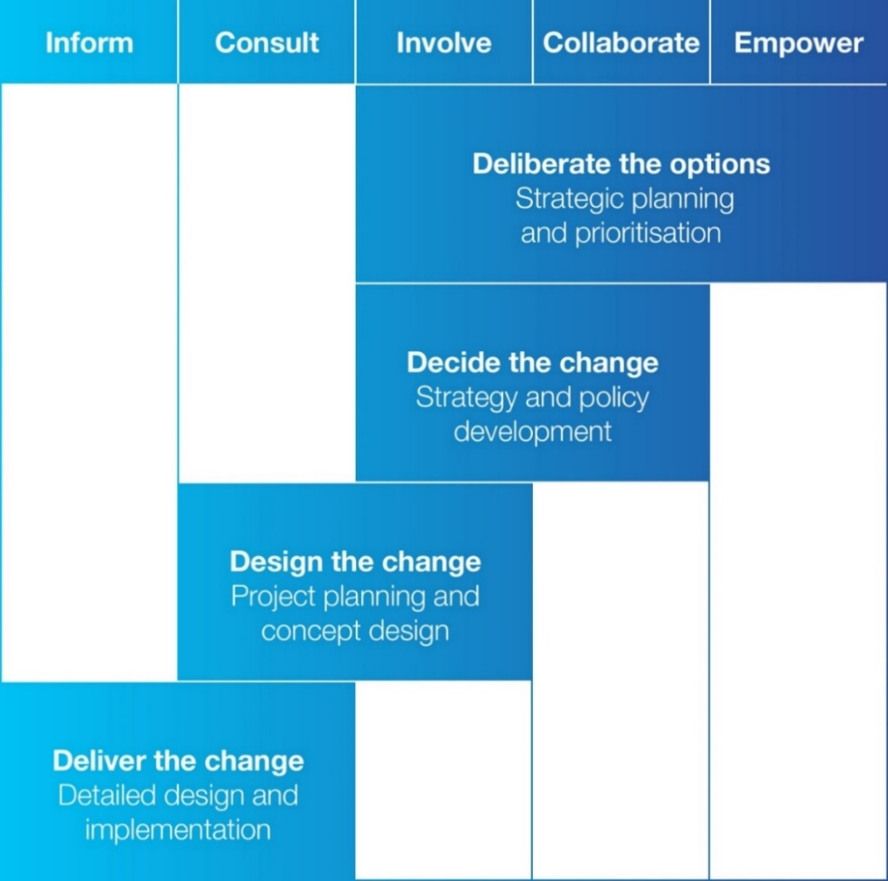
We deliberate the options for the development of long-term strategic plans, such as the Council Vision, Council Plan, Financial Plan and Asset Plan. We will use deliberative engagement practices to develop these plans, working with the community at moderate to high (involve, collaborate and empower) levels of influence and engagement.
Decide the change is the big picture; developing the strategies that focus and prioritise our resources. Here, we’ll work with (involve) or partner with the community (collaborate) to achieve consensus and create solutions. This is when the community can expect to have a moderate to high level of influence on ideas, initiatives and decisions.
Design the change is when we begin planning what an idea or project could look like. Here, we’ll seek feedback (consult) and work with people (involve) who are directly affected by the change. The community can expect to have a moderate level of influence.
When it comes time to deliver the change, there may not be much that the community can influence as many decisions have been made through earlier strategy, policy, or planning decisions. Engagement is mostly seeking feedback (consult) from those most affected or providing information (inform) to our community.
Appendix 3: Level of influence and selection of tools
The below table provides an overview of the standard tools and techniques used for community engagement activities. Tools are selected to ensure we can capture relevant feedback, meet the needs of participants, and are appropriate to the level of engagement and influence.
For example, if the level of engagement is ‘collaborate’ where participants have a high level of influence, we may run working groups and deliberative panels. These types of tools would not be appropriate at an ‘consult’ level where participants have limited ability to influence the decision.
Within a single project, different parts of the community or specific stakeholder groups may have different levels of influence and therefore be offered specific opportunities to participate.
Table 2: Level of influence and tool selection
IAP2 Spectrum | Level of influence | Example tools and techniques
Inform | No ability to influence the decision. | - Letter  - Newsletter  - Flyer, poster  - Signage  - Social media  - Website
Consult | Low level of influence.  Usually a requirement for feedback or more information by Council. | - Survey  - Submission  - Poll  - Drop in / pop up
Involve | Moderate level of influence.  Council and community benefit from an exchange in information. | - Interviews  - Workshops  - Focus groups  - Community forum  - Site visit
Collaborate | Moderate to high level of influence, decision making still lies with Council.  Greater opportunities to influence the project through a planned and longer consultation process. | - Advisory groups  - Working group  - Deliberative panel
Empower | High level of influence.  Decision making is placed in the hands of the public. | - Delegated Committees  - Citizens Juries  - Democratic voting

Bayside City Council, Council Plan 2017-2021 (2020 Review)
Adapted from Local Authorities Research Intelligence Association, Creating effective research in local government, United Kingdom, 2005.
International Association for Public Participation (IAP2) Australasia, https://www.iap2.org.au/resources/iap2-published-resources/ accessed 26 April 2020.
The ability to provide indicative budget estimates may be influenced by the stage of planning; known scope and scale; and future competitive tendering processes.
This could include diagrams, illustrations, images, videos, recordings or animations.
Through data gathered in the Annual Community Satisfaction Survey
Under Local Government Act 2020 engagement for these strategic plans must include deliberative practise.
When a project or matter will not extend beyond the ‘Inform’ level on the IAP2 spectrum, it will be considered ‘communication’ and not referred to as ‘engagement’.
When a project or matter will not extend beyond the ‘Inform’ level on the IAP2 spectrum, it will be considered ‘communication’ and not referred to as ‘engagement’.

