Peterson Street Reserve Public Art
Community Engagement Summary

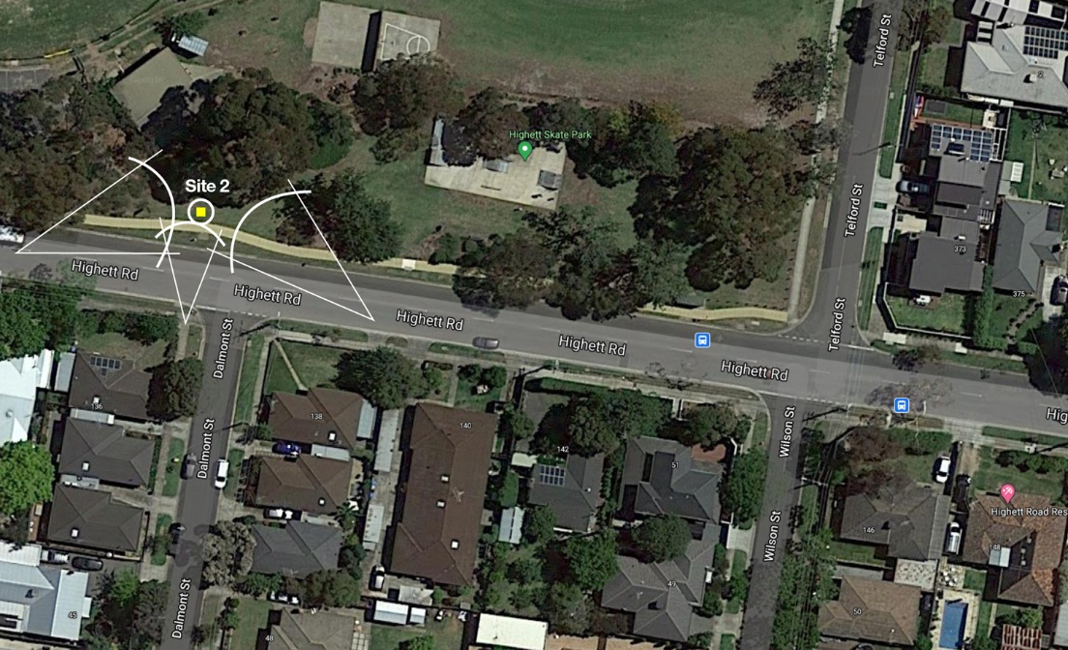

28 May 2021

Bayside City Council
Corporate Centre
76 Royal Avenue
SANDRINGHAM VIC 3191
T (03) 9899 4444
F (03) 9598 4474
www.bayside.vic.gov.au

Background
This document provides a summary of stakeholder and community feedback to inform the Artist’s Brief for a public artwork to be installed at Peterson Reserve in Highett. The Artist’s Brief will be part of the Expression of Interest tender process for securing an artist to create the artwork.
Public art plays an important role in the character and identity of the Bayside municipality, particularly along its coastline. While Bayside has a well-established regime of public art installations, primarily defined through Bayside’s ‘Coastal Art Trail’, more recent commissions highlight Council’s commitment to the development of a diverse, prosperous and sustainable municipality that values its rich natural, cultural and urban heritage. Public art serves a key role in delivering such an ambition. Recent commissions include David Wood, ‘Spirit of Place’ 2021 Elsternwick Park South; Carla Gottgens, ‘Bayside Ripple’ 2018 Dendy Street South Playground, Brighton East; Anne Ross ‘Summertime’ 2017, Sandown St, Brighton and James Voller, ‘Little Boxes’ 2017 Martin Street, Gardenvale.
In June 2021, Bayside City Council will call for Expressions of Interest from artists to submit preliminary ideas for a public artwork/s that will be located at Peterson Street Reserve, Highett. The reserve is positioned centrally within Bayside. It is a local park of around 4.4ha in area which comprises two sporting ovals, a playground, the Peterson Youth Centre and a skateboard park and several freestanding pavilions.
The park is bound by Peterson Street to the north and west, Highett Road to the south and Telford Street to the east. Residential properties surround the park and busy Highett Road to the south has a public bus transport stop located in the reserve. The park has a strong youth; sport and recreation focus and is an ideal location for a public art installation. The preferred location for an artwork is 100m towards the west along Highett Road, near the skate park.
As a form of creative expression, public art projects come in many forms. Public artworks can be permanent or temporary; site-specific or integrated or the responsibility of a sole author or many collaborators. The artwork selection process will be part of an integrated program which encompasses diverse media and scales that can either be permanent, temporary or ephemeral.
Art located in public spaces can engage people in their everyday lives and provides an opportunity for dialogue and social interaction in many ways. A range of options are applicable to the Peterson Street Reserve Expression of Interest process in both permanent and temporary installations.

Consultation process

Consultation purpose
The consultation purpose was to gather ideas generated by the community to incorporate into the Artist’s Brief that will be included in the Expressions of Interest document for tender. It was very apparent during the consultation process that vandalism and graffiti was something that needed to be addressed, as well as referencing the Indigenous heritage of the area.
A high priority was placed on consulting youth, and while mixed feedback was received from this demographic, some ideas included a boy and girl with a skateboard; art murals on the club room walls and skateboard ramp and a graffiti wall. As a result of the consultation, there will be the option for an artist to adopt a community cultural development approach to the commission if they choose, working directly with the youth in the area.

Consultation methodology
The engagement process was open to all residents of the Bayside municipality and any other interested members of the wider community.

Online feedback was sought via Council’s Have your say webpage and promoted to local schools, sporting clubs and the nearby Bluff Road Housing Estate. There were 23 contributions made through an online survey on Council’s Have Your Say website. All of these contributions are attached (See Attachment A).

At the drop-in session on site, people discussed their ideas with Council officers at who took notes, in addition to a whiteboard being made available for people to write comments.

Details | Activity
Onsite signage | - notification of the project, promotion of the drop-in session and a QR code linking to the online feedback tool on Council’s Have Your Say website
Stakeholder notifications | - email correspondence to Sandringham College and St Agnes Primary School, Hampton Football Club and Highett West Cricket Club promoting online consultation, drop-in session and requesting promotion to their networks via email or newsletter.
Council website news item | - information visible on Council website  - inclusion in two x weekly eNews ‘This Week in Bayside’ sent to over 8000 subscribers  - notification of a proposed new public artwork  - directed interested parties to complete online feedback via Council’s Have Your Say platform
Face-to-face meeting | - open discussion with Freeza Youth Committee around the type of emotion that young people wanted the artwork to elicit when they walked past and saw it.  - four attendees
Promotion in third party newsletter | - article in Bluff Road Housing Estate monthly newsletter promoting online feedback tool  - distributed to 190 units
Letterdrop | - promotion of online platform and drop-in session  - distributed to 100 neighbouring properties to the reserve.
Social media | - four posts on Council’s Facebook page and one shared to Bayside Gallery Facebook page  - organic reach 3,650 people  - three paid advertisements on Facebook targeted to local Highett community  - paid reach 15,562 people
Council ‘Have Your Say’ page | - online feedback tool for community members to post ideas and comments  - provided some frequently asked questions and answers  - provided a library of relevant documents included the Bayside Arts Strategy 2018 – 2021, Site Analysis and the Sportsground Improvement Plan  - provided some examples of inspirational public artworks in Bayside, greater Melbourne and international  - provided an opportunity for people to ‘subscribe’ to the page and receive updates  - two news updates were sent to subscribers.
Drop in session | - on-site at Peterson Street Reserve  - open discussion around the type of emotion that young people wanted the artwork to elicit when they walked past and saw it  - 15 people attended.

Participant profile
A range of age groups provided feedback to the consultation with a high proportion of younger people participating in the face-to-face drop-in session. Approximately 50% of those who provided feedback on-site were aged between 12 – 16 years of age.

 | Demographic | Bayside  2016 Census | Participants (%)
Gender | Male | 47.6% | 20%
 | Female | 52.4% | 80%
 | Unknown | -
 | Other identity | -
Age | 15-24 | 11.5% | 50%
 | 25-39 | 13.6% | 10%
 | 40-49 | 16%
 | 50-59 | 14.% | 30%
 | 60-69 | 11.5% | 10%
 | 70-84 | 9.9%
 | 85+ | 3.7%
 | Undisclosed | -
Suburb | Beaumaris | 13.5%
 | Black Rock | 6.5%
 | Brighton | 24.1%
 | Brighton East | 15.9%
 | Cheltenham | 3.7%
 | Hampton | 13.6%
 | Hampton East | 5.0%
 | Highett | 7.2% | 100%
 | Sandringham | 10.5%
 | Outside Bayside | -

Consultation findings
The following section summarises the key themes which arose through the Peterson Street Reserve Public Art community engagement process:

Theme | Community feedback
Indigenous heritage | “Would love something by a local Aboriginal artist that assists in providing education and knowledge of the traditional owners of this land.”  “Building on some of the proposals for work from an Aboriginal and Torres Strait Islander artist and connecting that with the promise of the next generation, I'd like to see something that represents harmony and progress.”
Materials and surfaces need to deter graffiti and vandalism | “High zone for vandalism, tags, broken lights, windows so it needs to be indestructible.”
Use of the site by sports groups, young people, children, families and pets | “Could be brass sculpture ( similar to one on the beach at Sandown st of the dog) of a combination of a skateboarder ( unisex) footballer and netballer possibly.”  “Given the location near the youth centre and the skate park, it would be nice to have an artwork created by bayside youth community group/schools - led by an artist skilled in leading these types of projects.”
Bright and colourful that interacts in some way with the activity of the area | “I’d love to see something colourful that makes people smile. It occurs to me that there were some lovely things that happened around this park during lockdown. Mostly at the hands of children.”  “Fantastic! I would love to see something bright, colourful with indigenous and local history captured. Interactive would be fun for any walkers and being seen at night would be awesome too!”
Positivity: something that will create a sense of well-being in the viewer and maybe make them smile. | “Like the Idea of something that makes people curious and created mindfulness so people can stop and forget about all their stresses and worried for a moment, park spaces should always be for escaping, rest, fun and being present.”  “Or if a sculpture, then something whimsical that could be enjoyed by all ages.”

Support for actions
Results of the community engagement consultation process showed most respondents were positive about a work of art being located at this site. While some community members responded negatively, this was directed more to the allocation of funds to a public art installation versus upgrading the current Council facilities and the need for public space for young people.

Item-specific feedback
One of the main concerns raised during the consultation was about the state of sporting facilities in the reserve but this but did not relate to the public art project directly, it was more a question about spending priorities of Council.
Topic | Community feedback
Sporting facilities | Four comments were made to Council staff about the state of the sporting facilities at the reserve

Project Evaluation
The project reached all of the target audiences outlined in the Engagement plan overview, evidenced by their participation in the consultation. The tools and techniques used were appropriate for this engagement and elicited more than expected numbers of responses for this type of project. There was no negative feedback received about the process, suggesting the information on how to provide feedback was clear and easy to understand.
The initial drop-in engagement session that was scheduled on a weekend had to be cancelled at the last minute due to a COVID scare. A testing site was established at the reserve and it was deemed inappropriate to conduct a community consultation session nearby.
The rescheduled session was postponed to a Thursday afternoon between 4-6pm during the school holidays. The fact that the drop-in session was postponed and held on a weekday in school holidays could have affected the turnout. It also rained mid-way through the drop-in session, requiring the staff to move to nearby Peterson Youth Centre which could have confused people and also the inclement weather might have deterred people. There was also an error on the onsite signage where the date of the drop-in session was updated but not the time. All other communications material was correct but the error did result in one person attending at the wrong time who fortunately contacted Council and returned at the correct time.

Attachment A
“There have been many musicians grown up in the Highett area An art work replicate music art and sports I feel would be appropriate.”
“I would like something with colour if it isn't a bronze. If possible, an animal would be nice - surely we all like animals? In fact, it would be nice to get one of the UooUoo's that are a part of the Royal Children’s Hospital's 150th anniversary art trail.”
“Please don't make it political, the last thing we need is angry people or making drivers angry after they go past. … So, I would like to say it again - please don't use it to make a political statement.”
“I can't think of any other pieces of artwork in Bayside Highett so it's pleasing to hear that the Council are planning some investment. I'd like to see something that makes me feel proud. Inspired by a local Highett hero. Someone like Alan who picks up rubbish and returns trolleys for the community. A returned veteran. Celebrating the achievements of the old CSIRO Highett. Maybe someone from the Advantage Road arts precinct would have some ideas.”
“Could be brass sculpture ( similar to one on the beach at Sandown st of the dog) of a combination of a skateboarder ( unisex) footballer and netballer possibly.”
“High zone for vandalism, tags, broken lights, windows so it needs to be indestructible.”
“Something in whimsical in metal. Like the Windhover in Sandringham or three businessmen in the city.”
“1) How about an artsy throne (think SkyHigh Mt Dandenong chair) or a decorative over the top “couch” like the Brunswick St Mosaic couches (but nicer). Get creative with surrounding paving Eg. in the shape of sunrays? Or Hopscotch paving? “Whatever it is should be interactive and be “instagram-able” and iconic. 2) Make a small mound and put an oversized skateboard on it 3) create a Giant optical illusion 4) Giant hands making sign language symbol? Or something interactive inspired by ScienceWorks.”
“Building on some of the proposals for work from an Aboriginal and Torres Strait Islander artist, and connecting that with the promise of the next generation, I'd like to see something that represents harmony and progress. This is a fantastic initiative and, as another suggestion puts it, has the ability to connect with other creative works in Highett and Sandringham”.
“The area selected for an art installation is in an area used by teens and close to affordable housing where unwanted activity often occurs. It will no doubt attract vandalism etc. I would have thought something more consistent with the recreational and open space use would be appropriate.”
“Given the location near the youth centre and the skate park, it would be nice to have an artwork created by bayside youth community group/schools - led by an artist skilled in leading these types of projects. Or if a sculpture, then something whimsical that could be enjoyed by all ages.”
“Fantastic! I would love to see something bright, colourful with indigenous and local history captured. Interactive would be fun for any walkers and being seen at night would be awesome too! I would love people to go WOW! Personally I love some of the street art around Bayside & Melbourne and can't wait for this project!”
“Would love to see an interactive structure or sculpture that educates and inspires the community about indigenous life and culture. I can visualise perhaps walking through it or underneath with some form of eye catching night illumination.”
“I suggest that there should be no abstracted symbolism, Australians have a great track record of renaming and belittling creativity.”
“Like the Idea of something that makes people curious and created mindfulness so people can stop and forget about all their stresses snd worried for a moment, park spaces should always be for escaping, rest, fun and being present - this could incorporate indigenous works, puzzles to interact with etc.”
“I’d love to see something colourful that makes people smile. It occurs to me that there were some lovely things that happened around this park during lockdown. Mostly at the hands of children. There were chalk drawings and well wishes on footpaths and fences, an art competition tied to a hedge, teddies and spoonvilles... perhaps a permanent representation of a spoonville would be an idea?! A colourful and happy reminder that we all helped each other through a very difficult time. In years to come our view of it will change from the emotional familiar to a curiosity about a long ago challenge that this community faced.”
“Would love something by a local Aboriginal artist that assists in providing education and knowledge of the traditional owners of this land.”

