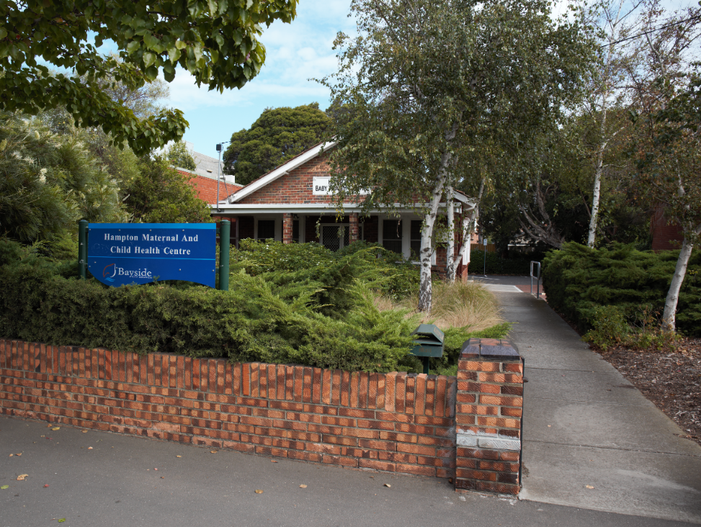
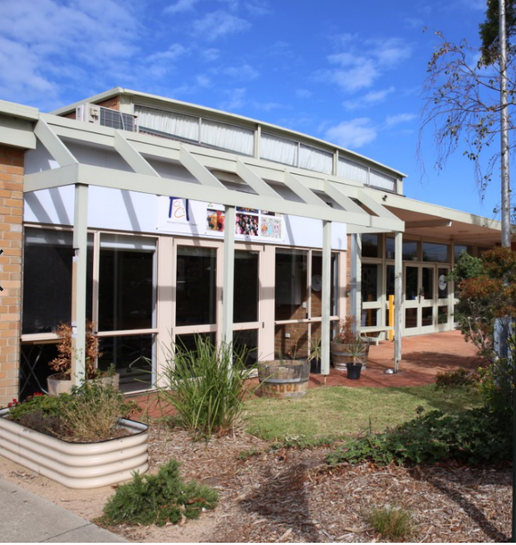

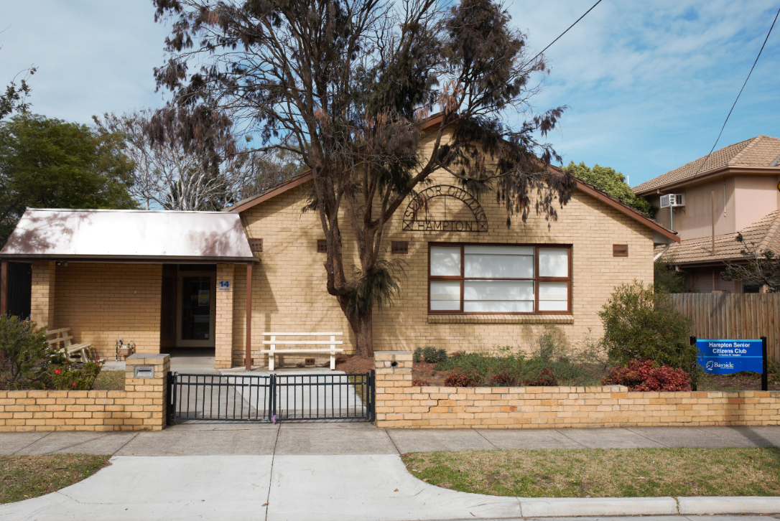
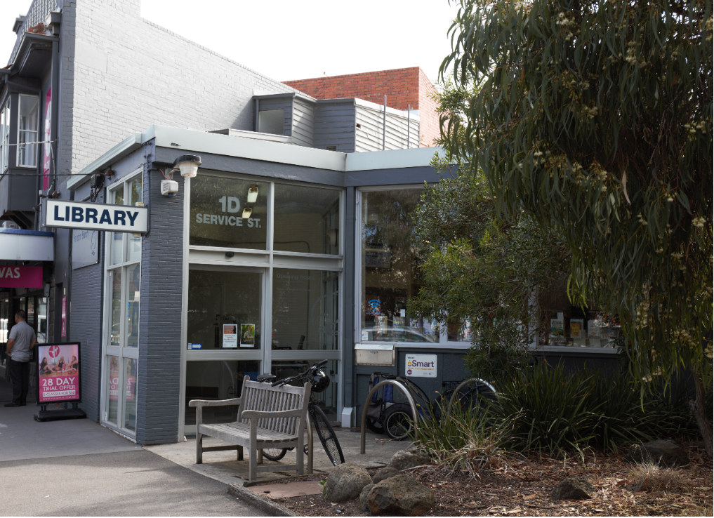

Hampton Community Infrastructure Masterplan

Planning for Council owned land in the Hampton Major Activity Centre

June 2021

Contents
- Executive Summary 3
Purpose 3
Intent and Scope 3
Key Issues 4
Strategic Direction of the Masterplan 4
Guiding Policy Framework 6
- Background 7
- Context: A changing and growing Hampton 8
Policy Context 8
People and Housing 8
Movement and Transport 10
Social and Community Infrastructure 11
Physical Context 11
- Existing conditions 13
How are the sites set up to meet future needs? 15
- Vision for the Hampton MAC 17
Community values 17
Consultation on draft Masterplan 19
- Strategic opportunities for Public Land 22
- Implementation 41

Executive Summary
The Hampton Community Infrastructure Masterplan has been prepared by Bayside City Council and provides the strategic direction for the future of community services and facilities in the Hampton Major Activity Centre.

Purpose
The purpose of the Hampton Community Infrastructure Masterplan is to underpin the strategic direction for all 13 Council-owned sites within the Hampton Major Activity Centre. The Masterplan informs the planning for the centralisation of community facilities into an Integrated Community Hub. The Masterplan also informs the implementation processes to deliver the outcomes in the short term, longer term and ongoing actions.
What is an ‘integrated community hub’?
An integrated community hub is a multi-purpose facility that provides spaces for Council, community service organisations and community groups to offer a range of services, activities and programs to service a variety of community needs.
Community hubs accommodate wide ranging uses, but can include elements such as multi-purpose spaces, meeting and consultation rooms, libraries, neighbourhood houses, youth groups, early childhood facilities and other community spaces. Hubs provide communities with access to a variety of social, cultural, educational and recreational opportunities in a centralised location.

Intent and Scope
Council has a robust planning framework in place to guide the built form and land use outcomes envisaged for the activity centre. The Masterplan does not intend to revisit the planning controls that guide general built form outcomes for the broader centre, but instead plans for how the existing public land can be best used and configured to ensure that community facilities are meeting future community needs. The outcome will then result in a Masterplan that provides the strategic direction for the management of public land and assets, as well as providing a framework for a number of longer-term infrastructure and place-making projects across the centre.
The Masterplan relates only to Council owned sites and is informed by:
- The opportunities and constraints of each of the 13 sites within the centre;
- A fit for purpose assessment to understand whether the facilities will meet future needs;
- Community engagement feedback in relation to the centre and a centralised community facility that supports future needs;
- Technical expertise to inform the long term planning.
There are a number of actions that have already been decided by Council, and the purpose of this document is to bring together the existing policy framework, Council’s decision making on certain matters and identified further opportunities to ensure that clarity exists as to the future centralisation of community services and infrastructure within the Hampton Activity Centre.

Key Issues
This Masterplan draws upon previous reports and data that reviews the current conditions and utilisation of Council’s existing community facilities and assets, and the anticipated community floor space demands to 2036.
Many of the existing community facilities within Hampton were built in the 1950s or earlier and are in need of renewal in order to meet the needs of future residents. Whilst this Masterplan does not provide for conceptual design for redevelopment, it provides direction on the uses and development of existing sites which supports the vision to incorporate services into an Integrated Community Hub. Council will continue to partner with user groups and stakeholders at each facility to advance a design brief for the Integrated Community Hub at the appropriate time, as the implementation of this plan progresses.
There are a range of access and mobility challenges throughout the centre that further impact accessibility. Whilst this plan does not include the final outcomes for matters such as the future bus interchange location, it provides the framework for the continued implementation of these actions and identifies opportunities for further improvements.
There is an identified shortage of public open space in the area that will only continue to grow, as the population in the activity centre increases. Whilst in some areas the solution is to create additional parks and green spaces, different options including opportunities for plazas and town squares, will need to be considered having regard to the site’s activity centre context.
In parallel with the completion of this Masterplan, an initial financial feasibility assessment has been undertaken and implementation of this Masterplan will depend on inclusion of the indicative costs within the long-term financial plan. It is highly likely that support from the State and/or Federal Government will be required to deliver on the major infrastructure works outlined in the Plan.

Strategic Direction of the Masterplan
The Masterplan provides for:
- Opportunities to redevelop sites to improve the public benefit in relation to open space, parking and community facilities, including:
  - The identification of a new Community Hub in the Willis Street Precinct;
  - Consideration of a multi-deck car park at the Service Street Car Park site;
  - Transitioning land within the Willis Street Precinct into open space;
- The potential to divest sites that are deemed surplus to requirements to contribute to the funding of other projects identified in the Masterplan;
- A number of public realm improvements that can ensure new facilities are well integrated into their surrounds; and
- The necessary vehicle and pedestrian network improvements required to support the connectedness and accessibility of the centre.
The full suite of actions arising from the Masterplan is identified on Page 41.

Guiding Policy Framework
The development of this Plan has been informed by Council’s considerable policy framework to guide the land use and development outcomes for Hampton. The relevant documents include:
- Bayside Housing Strategy 2019;
- Hampton Major Activity Centre Structure Plan 2006;
- Hampton Major Activity Centre Structure Plan Review 2016;
- Hampton Willis Street Precinct Urban Design Framework 2013;
- Bayside Retail, Commercial and Employment Strategy 2016;
- Bayside Open Space Strategy 2012;
- Bayside Integrated Transport Strategy 2018;
- Early Years Infrastructure Plan 2018-2028; and
- Library Services Strategy Plan 2018-2022.

A summary of each of these documents as they relate to the Hampton Major Activity Centre is included at Appendix 1.
The findings from this report have also been informed by other documents prepared on behalf of Council, including:
- Hampton Street Activity Centre Social Infrastructure Assessment, Ethos Urban, May 2018;
- Hampton, Our Centre: Planning for People – Background Report, Navire Advisory, May 2019;
- Hampton Activity Centre Social Needs Assessment, K2 Planning, May 2019;
- Hampton, Our Place: Options Consultation Summary, Collaborations, August 2019;
- Hampton: Our Centre: Planning for People – Land Use and Development Options Analysis, Navire Advisory, August 2019;
- Hampton Public Land Masterplan – Community Engagement Report, Bayside City Council, September 2020;
- Hampton Public Land Masterplan Urban Design Review, BladesStudio, October 2020;
- Traffic Impact Assessment, Cardno Victoria Pty Ltd, November 2020; and
- Public Space Concept Plan – Willis Street Precinct, Hampton, BladesStudio and Lat37, May 2021.

Background
Over the past 15 years, Council has secured a comprehensive strategic planning framework for its Major Activity Centres, providing clear direction as to how future housing, population and commercial floor space growth will be accommodated into the future.
Through past strategic planning work, there is an identified need for a plan that considers the increased demand for and growth of community facilities in the Hampton Major Activity Centre, as the population growth and changing community needs impact the need for services and the demand for community infrastructure increases.
In 2018, Council engaged Ethos Urban Pty Ltd to undertake a preliminary social needs assessment to better understand the opportunities and constraints to achieving an integrated community facility in Hampton, having regard to the six existing decentralised community facilities. The findings from that work recommended that Council establish a consolidated community hub incorporating various community facilities from across Hampton Major Activity Centre which provides for a range of local services.
Through 2019, Council engaged Navire Advisory Pty Ltd to prepare a more detailed investigation and analysis into the development feasibility assessment for an integrated community facility.
The analysis and research stage involved drawing upon previous reports and data that provided detail to the current condition and utilisation of Council’s existing assets. Demographic projection analysis was utilised to assess the anticipated community floor space demands to 2036. This first stage of the project informed the preparation of draft Place Values, which were then validated through targeted preliminary consultation with the community and key user stake holders.
Based on their findings, the consultant team generated the Land Use and Development Options for consideration. Two options for community floor space were identified – a centralised option, where all existing stakeholders are brought together in a single facility, and a ‘village scale’ option, where two smaller facilities bring together clusters of user groups. The options were tested with the community throughout a series of engagement activities in July 2019.
Through community engagement, the centralised option was identified as being the community’s preference with the benefits of co-location recognised by most participants. For many people, this option offered the greatest benefits including intergenerational interaction, facilities for multiple uses and activating the ‘triangle area’.
Council resolved to proceed with a centralised, neighbourhood scale facility in order to maximise the opportunities for the community. In moving forward to implement a centralised option, consideration must be given to the future of the individual sites that would be surplus under a centralised option as well as what other opportunities exist to maximise community value. This Masterplan seeks to set direction for each individual site, aligning with the objectives of the centralised option, and providing implementation options that will seek to maximise community value.

Context: A changing and growing Hampton
Over the next 20 years, like many of Melbourne’s suburbs, Hampton is expected to grow and change.
Whilst Council has plans and controls in place to guide development on private land, including residential development, commercial floor space, there is currently no strategic plan in place to guide the development of Council owned land in order to allow community infrastructure to meet the changing needs of the community.
With an aging population, an increase in lone person households and the continued growth of family households, it is important to ensure that social infrastructure that exists to support the community is able to be adapted so that facilities and services continue to meet need.
In 2019, Council commissioned a social needs assessment to better understand the future needs of Hampton residents in relation to community facilities and services. The assessment, which was prepared by consultants K2 Planning, provided key findings to the social trends and population forecasts for Hampton. The key changes that have influenced the background work and which provide the support for the future planning for the next 20 years are summarised below.

Policy Context
The commercial shopping strip at Hampton and adjoining residential area is designated in the State Governments metropolitan strategy Plan Melbourne as a Major Activity Centre; being an area close to public transport, shops, community facilities and other services where increased population growth is to be directed.
Council has prepared the Hampton Activity Centre Structure Plan to guide the planning controls and built form outcomes in the centre. These have been in operation for a number of years and have been effective in concentrating the growth expected in the area to within the Activity Centre boundary. Whilst there is still further work to be done to ensure that development in the residential parts of the centre reflects the preferred character for these areas, much of the land use and built form outcomes intended for the centre are embedded in policy to some degree.
Further policy guidance has been provided for land within the Willis Street Precinct through an urban design framework for the area which has informed the development of the State Government development beside the railway line.
The Structure Plan was reviewed in 2016 and it was recommended that Council undertake the strategic work to identify community infrastructure needs in the activity centre. Since then, Council has developed its understanding of the community infrastructure needs. Currently, there is no plan in place for how these facilities will be modified or expanded to ensure that they are meeting expected demand.

People and Housing
The City of Bayside population and household forecasts presents a forecasted growth of 118,590 by 2036. To accommodate this increase of 15,853 people, it is important that it be directed into Bayside’s activity centres. In the coming years, Hampton will too undergo population growth with a high portion being families with children, couple-only and lone person households, as well as retirees.
Of this growth, it is anticipated that Hampton will increase by 2,123, with a population of 16,077 by 2026, making it the third largest suburb in Bayside. The following data has been compiled from Council’s Profile.id and Forecast.id websites, presenting a summary of the expected changes.
Figure 1 | Forecast growth for Hampton
Forecast population, households and dwellings
HAMPTON | FORECAST YEAR
 | 2016 | 2021 | 2026 | 2031 | 2036
Population | 13,954 | 14,893 | 15,171 | 15,587 | 16,077
Change in population (5yrs) |  | 938 | 279 | 415 | 491
Average annual change |  | 1.31 | 0.37 | 0.54 | 0.62
Households | 5,163 | 5,754 | 5,986 | 6,219 | 6,450
Average household size | 2.69 | 2.57 | 2.52 | 2.49 | 2.48
Population in non-private dwellings | 88 | 88 | 88 | 88 | 88
Dwellings | 5,373 | 6,001 | 6,243 | 6,488 | 6,733
Dwelling occupancy rate | 96.09 | 95.88 | 95.88 | 95.85 | 95.80

Analysis of the types of dwellings in Hampton in 2016 shows that 62.7% of all dwellings were separate houses; 30.1% were medium density dwellings, and 6.5% were in high density dwellings. Whilst separate houses are still the highest portion of dwellings within Hampton, it was found that the largest changes in the types of dwellings found in Hampton between 2011 and 2016 were:
- High density (+171 dwellings);
- Medium density (+130 dwellings); and
- Separate housing (+62 dwellings).
Considering there is a forecast increase of over 1.056 households from 2016 to 2026, and a decrease in the average household size from 2.69 to 2.49, it is expected that high and medium density will continue to increase.
Ageing population
Hampton is experiencing a significantly ageing population with forecasts in the number of people aged 70-84 years. It is expected that there will be approximately a 70% increase of people within this age bracket from 2016-2036, with many of these people in this age group requiring assistance due to a disability/impaired mobility. There will be an increasing demand for programs and activities that respond to the needs of senior groups and the aging population. It is important that the community facilities provide for an increase in services, programs and facilities to support the ageing population.
Increase in family households
There is an increasing proportion of families in the area. Between the 2011 and 2016 census period, there was a 12% increase of families with children, a 12.5% increase of families with older children, and a 9.4% increase in single parent families with mixed age children. It is important that community services and facilities and open space is provided for these families to support health and wellbeing outcomes.

Lone households
It is forecasted that there will be a 10% increase in lone person households. This is expected to reflect the aging population as well as the increased percentage of medium and high-density housing constructed within the activity centre.

Movement and Transport
Another social trend impacting the planning of community services in facilities has been the increase in number of people who travel to work by public transport. There has been a 26% train increase, and 47% bus increase from 2011-2016.
In Hampton, 87.5% of the households owned at least one car, while 6.3% did not, compared with 83.9% and 8.5% respectively in Greater Melbourne.
Of those that owned at least one vehicle, there is a smaller proportion who owned just one car; a larger proportion who owned two cars; and a smaller proportion who owned three cars or more.
Overall, 32.1% of the households owned one car; 40.6% owned two cars; and 14.8% owned three cars or more, compared with 33.2%; 34.8% and 15.9% respectively for Greater Melbourne. The largest changes in household car ownership in Hampton between 2011 and 2016 were:
- 3 or more motor vehicles (+126 households)
- 2 motor vehicles (+109 households)
- 1 motor vehicle (+73 households)
According to census data from 2016, 40.5% of Bayside residents live and work in the area. 59.5% work in the area but live outside of the Bayside municipality.
In 2016, there were 1,123 people who caught public transport to work (train, bus, tram or ferry) in Hampton, compared with 3,661 who drove in private vehicles (car – as driver, car – as passenger, motorbike, or truck).
Analysis of the method of travel to work of the residents in Hampton in 2016, compared to Greater Melbourne, shows that 17.8% used public transport, while 58.1% used a private vehicle, compared with 15.4% and 65.0% respectively in Greater Melbourne.
The major differences in persons between the method of travel to work of Hampton and Greater Melbourne were:
- A larger percentage of persons who travelled by train (17.0% compared to 11.5%)
- A larger percentage of persons who worked at home (7.8% compared to 4.2%)
- A smaller percentage of persons who travelled by car (as driver) (55.5% compared to 60.2%)
- A smaller percentage of persons who travelled by tram or ferry (0.1% compared to 2.4%)
The number of employed people in Hampton increased by 394 between 2011 and 2016.
The largest changes in the method of travel to work by resident population in Hampton between 2011 and 2016 were for those nominated:
- Train (+220 persons)
- Car - as driver (+123 persons)
- Worked at home (+106 persons)
Whilst the long-term impacts of the Covid-19 pandemic are unknown, Council needs to ensure that it is planning for the expected increases. As a result, any plans made in relation to parking and traffic need to be flexible to cater to the possibilities of more people working from home, and the overall longer term forecasts of a lesser reliance on private vehicles as the primary mode of transport, particularly in local areas.

Social and Community Infrastructure
The social needs assessment identified service and facility gaps to respond to in Hampton. Having regard to many of the constraints and limitations of the existing community facilities, it was recommended that the increase in services and development of new spaces be facilitated through the following approximate increase in size of community facilities:
- Consider the potential for a community hub of 3,500 square metres which includes:
  - Early years services (approx. 20% of the floor space);
  - General community services space;
  - An expanded library service;
  - Flexible and adaptable meeting rooms;
- Develop new areas of passive open space, including:
  - Multi-generational playground opportunities;
  - Access to nature and places to linger and sit;
  - A civic space for community gatherings;
  - Display of public art;
- Advocate the private sector to increase the availability of long day care and residential aged care.
Other services including long day care and residential aged care were identified, however it is noted that these services are not provided by Council, and the Bayside Housing Strategy 2019 provides further direction in relation to these areas. Some feedback from the community sought a more aspirational community facility which incorporates a Performing Arts Centre or leisure centre, which were considered through the social needs assessment. The assessment found that Hampton Activity Centre is not a suitable area for the location of regional or municipal level community infrastructure, and that any facility should be of a more neighbourhood scale, to respect both the community aspirations for a village scale and the constraints of the road network.
It is anticipated that State Government will announce the introduction of three-year-old kindergarten (5 hours per week in 2021 and increasing to 15 hours by 2028). Through the detailed consideration of the uses to operate from any future community hub, consideration should be given to the extent of early years floorspace that is provided to respond to the demand for 3-year-old kindergarten places.
This Masterplan provides strategic direction to accommodate the increase in community facilities within a centralised, neighbourhood scale community ‘hub.’ Council will be seeking to partner with service providers to determine how the community facilities and services will come to fruition and what kind of model is going to work best to meet both community and service provider needs.

Physical Context
Hampton as a suburb bounded by South Road in the north, Bluff Road in the east, Highett Road and Bridge Street in the south, and the Port Phillip Bay foreshore and New Street to the west. The suburb is 424ha in size and has a population of 14,429 (profile id bayside).
The Hampton Major Activity Centre is the primary area that growth is to be directed, which generally addresses Hampton Street or other land within close proximity to the Hampton Railway Station. Hampton Street contains a mix of services including retail, commercial, health care, lifestyle and residential. A key opportunity for the Hampton Major Activity Centre identified within the Retail, Commercial and Employment Strategy 2016-2031 is for the centre to continue to grow and diversify its retail offering. Anecdotal feedback has been provided to Council about the increasing number of vacant shops appearing in Hampton Street and the length that these premises stay vacant. It will be important to ensure that retail uses and activity are as consolidated as possible in the core of the activity centre, ensuring that Hampton Street remains a vibrant and active streetscape.
The Sandringham Railway Line runs through Hampton with Hampton Station being easily accessible from Hampton Street. Access is also provided to the centre via bus routes 708 and 828, with the interchange located to the north of the station. Further bus routes service Hampton Street including the 600, 922 and 923. The railway station is to be reconfigured as part of the redevelopment of the State Government owned land, though some residents have expressed concerns about the proposed configuration.
Activity within the centre is relatively high throughout the day and on weekends. Hampton Street has welcomed several bars and restaurants that have also seen an increase in activity at night. It will be important to ensure that the night time economy continues to grow and the centre remains an attractive and safe place to be in the evenings.
There is minimal open space within the Hampton Major Activity Centre, though it is noted that for the southern part of the activity centre, the foreshore area is reasonably accessible from Small Street and Orlando Street. The lack of open space was an issue reiterated during community engagement, and a key driver for developing this Masterplan is to identify opportunities for additional public open space for investigation.

Existing conditions
In addition to the roads and streetscapes within the activity centre, Council currently owns 13 properties in the centre that are used and developed for a range of community infrastructure and public car parking. The location and existing use of these assets is identified in Table 1 below.
The opportunities and constraints of each site has been considered in determining the role that each site can play in continuing to meet community needs.
Table 1 | Description of Council owned sites
 | Facility Name
1 | Former Hampton Scout Hall at 6a Willis Street
2 | Hampton Children’s Playhouse at 12 Willis Street
3 | Hampton Community Centre at 14-18 Willis Street
4 | Car park at 1A Willis Lane
5 | Car park at 20-22 Willis Street
6 | Hampton Maternal and Child Health Centre at 483 Hampton Street
7 | Hampton Library at 1D Service Street
8 | Car park at 4 Thomas Street
9 | Car park at 36 Willis Street
10 | Car park at 1 Mills Street
11 | Car park at 1 Crisp Street
12 | Hampton Senior Citizens Centre at 14 Service Street
13 | Car park at 143 South Road

Figure 2 | Aerial image of activity centre
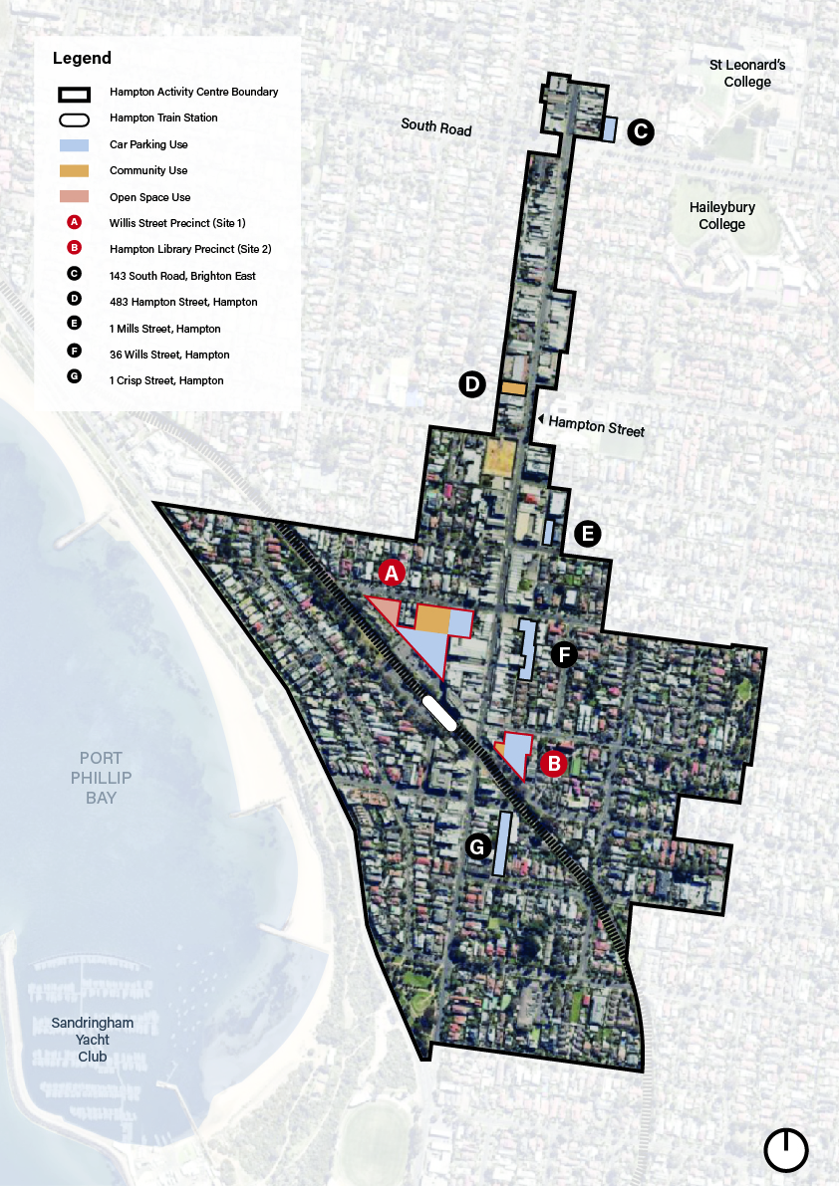
How are the sites set up to meet future needs?
In 2019, K2 Planning prepared an analysis of the existing building conditions for all 13 Council owned assets. The analysis acknowledged that the current size and layout of many facilities severely restricts the current service function. The grading of facility conditions, use, opportunities and constraints has been considered in the preparation of this Masterplan. Notably, many of the facilities currently rank highly in term of their building condition. Those that are in ‘fair’ to ‘poor’ condition include the Scout Hall and the Community Centre.
The Social Needs Analysis prepared by K2 Planning provided key issues that were raised through the consultation with current community facility user groups in Hampton. The issues included the need for:
- Access to large hall/meeting rooms for strength and gentle exercise programs. Factors impacting on this demand included: ‘seniors are not comfortable going to a gym’ and challenges with programming enough classes given that ‘older people want the same hours; everyone wants to come in the mornings’. Services stressed that ‘we cannot provide enough strength classes in Hampton’.
- Spaces to run U3A activities and provide space for U3A volunteer staff. U3A is currently using the Beaumaris and Brighton Community Centres and the Brighton Seniors Centre, often running 12 activities at the same time including exercise groups, history talks, language classes etc. it was stressed that ‘there is a desperate need for a U3A presence in Hampton’.
- Provision of spaces that respond to the particular needs of senior resident, such as, compatibility of sharing spaces with other groups, a desire for dedicated space for seniors, low facility costs allowing access for seniors.
- Ongoing use of a Department of Housing in Ludstone Street to provide outreach services to residents in that part of Hampton, particularly social housing tenants.
By 2036, it is anticipated that there will be a need to provide a minimum of 3,540m² community floor space in the Hampton Major Activity Centre. Compared to the 1,800m² currently provided. To ensure that this additional space is designed to support services into the future, Council is committed to working with community groups and users of these services to inform the concept design of the Integrated Community Hub and ensure that the floorspace provided meets community need.
As part of the Analysis and Research (Stage 1) of this project, the consultant team developed the following assumptions by using population projections in conjunction with industry benchmarks for community infrastructure floor space requirements. Table 2 outlines the minimum floor space requirements, whilst Table 3 provides for potential additional floor space.

Table 2 | Minimum Floor space Requirements
Hampton MAC | Minimum Floor space Requirement for 2036
Early Years
Maternal & Child Health Services | 120m²
Playgroups | 631m²
Occasional Child Care Centres | 51m²
Sub Total Early Years | 802m²
General Community Services
Centre Based Libraries | 616m²
Community Meeting Spaces – small through to large | 1499m²
Regional Meeting Spaces | 322m²
Multi-purpose Community Centres – Small | 844m²
U3A Requirements | 305m²
Sub Total General Community | 2,742m²
Total | 3,544m²

Table 3 | Potential options for additional inclusions for Hub Floorspace
Hampton MAC | Additional Floor space 2036
Neighbourhood House Programs | 800m²
Youth Facilities | 150m²
Toy Library | 75m²
Kindergarten (550m² for 3 & 4 y/o respectively) | 1,100m²
Other / Flexible Space | 1600m²
Total | 3,725m²

Council plans to develop the concept of an Integrated Community Hub that provides for spaces that can be flexible and will meet community need. Council will continue to work with community facility user groups to provide for the above services and spaces to co-locate into a new, purpose-built facility that allows for the expansion of services required to meet future demand. Through the Implementation of the Masterplan, Council will need to consider the services and full range of uses accommodated within any future community building to ensure that the floorspace requirements listed in Tables 2 and 3 can be further refined.

Vision for the Hampton MAC
Through the various community engagement pieces in recent years, the vision for the Hampton Major Activity Centre has been well cemented in policy.
The vision for the Hampton Major Activity Centre is as follows:
Noted for its friendliness, community spirit and ambience, the Hampton Street Centre will provide a variety of community, commercial and residential uses to attract a diverse range of people. It will encourage lively interaction, entertainment and provide a community focal point. It will continue to support a conveniently located and reliable public transport system, which connects the community with major transport infrastructure. The connectivity will be complemented by enhanced movement networks for pedestrians and cyclists and result in overall improved traffic flows for all road users.

Community values
There are often tensions that arise as areas change and communities are faced with the impact of redevelopment on the places they value. Through the previous community engagement processes, the following community values were identified and validated through the Hampton: Our Centre community engagement in 2019:
- Hampton is safe and accessible;
- Hampton has a ‘village’ scale and feel;
- Hampton is green and people focused;
- Hampton has high quality public space and community amenities;
- Hampton offers an active community life; and
- Hampton is sustainable and ready for the future.
The community engagement feedback identified the following key objectives were of high value:
- High amenity open space and access to nature;
- Integration of open space/public spaces and services for all ages/access;
- Pedestrian and cycling amenity, public and active transport options;
- Better management of parking and congestion;
- Sustainable building design;
- Minimising over shadowing and optimising access to natural light;
- Strong connectivity with the library, community centre and playhouse;
- Retain ‘village feel’ of Hampton; and
- Investigate the opportunity for a multi-campus approach to community facilities.

As part of the community consultation, respondents were also asked to priorities the Place Values. The results from online respondents is provided in Table 4.

Table 4 | Prioritised Place Values
High priority | Medium priority | Lowest priority
Hampton will have a village scale and feel. | Hampton will be safe and accessible. | Hampton will offer an active community life.
Hampton will have high quality public spaces and amenities. | Hampton will be welcoming, green and friendly. | Hampton facilities will be sustainable and ready for the future.

Following the development of the place values, a criteria was developed to undertake a preliminary multi-criteria assessment of the Land Use and Development Options, based on the Place Values set through community engagement. Each option was assessed against the multi-criteria and it was found that the centralised option best responded to each criteria. The criteria is outlined below in Table 5.
Table 5 | Place values and evaluation criteria
Place Values Multi-criteria
1 | Hampton is safe and accessible | - Lively public spaces (integration of uses)  - Increased number of public carparks  - Risk of congestion in Hampton Street
2 | Hampton has a ‘village’ scale and feel | - Scale and location of facilities retains the integrity of local groups  - Extent of mixed use development  - Encourage pedestrians to walk through the Activity Centre
3 | Hampton is green and people focused | - Extent/Net increase of civic/public gathering spaces  - Diversity of spaces and facilities available  - Retention of substantial trees
4 | Hampton has high quality public space and community amenities | - Amount of community floor space provided  - Co-location of community facilities and open/public space  - Co-location/integration of services supports improved outcomes for users
5 | Hampton offers an active community life | - Amount of open space provided  - Connectedness of the open spaces
6 | Hampton is sustainable and ready for the future | - Net capital position for Council  - Capacity of facilities and spaces to meet changing needs over time (based on scale, not detailed design)  - Catalytic Impact on further development

Aside from considering the place values, the community was also asked to make comment other elements in relation to community facilities and infrastructure. The following were frequently mentioned ideas throughout the community engagement:
- Upgrading the library and enhancing the functions and services available;
- Integrating open space with community facilities;
- Retaining the Playhouse as a use. The attachment to the building seemed to be less important than the continuation of the Playhouse as a community group/service;
- Enhancing the function and the sustainability of all facilities, particularly the community centre;
- Providing a diversity of public open space in the centre;
- Supporting local living through the provision of key services for all ages;
- Supporting a diversity of transport options; and
- Investigating the opportunity for a multi-campus approach to community facilities.
These findings from the community engagement have informed the directions for the Project and have informed the creation of this Masterplan. The future development of public land within the centre will have regard to the place values and criteria to ensure that development achieves the community vision for the centre.

Consultation on draft Masterplan
During July-August 2020, Council conducted a four week community engagement process to collect feedback on the direction and content of the draft Action Plan, specifically focusing on the three key areas, being:
- the inclusion of the Playhouse as part of the Hub;
- the sale of public land identified as surplus to requirements; and
- the multi-deck car park.
Nearly 1000 people visited the Have Your Say project page, with 154 people making contributions via the feedback survey or a question for the project team. Social media was used successfully to raise awareness of the project with 1,290 people engaged. There were 32 individuals who provided feedback via direct email to Council rather than through the on-line survey.
In summary community sentiment regarding the specific proposals and the draft Masterplan was as follows:
- polarised views regarding the construction of a multi deck car park next to the current Hampton Library (46% support/52% oppose);
- majority support for the inclusion of the Playhouse into the community hub (72% support);
- polarised views regarding the sale of the two surplus sites (44% support/54% oppose);
- majority support for Council to explore pedestrian connections between the Hub and Hampton Street (76% support);
- broad support for Council to explore increased open space adjacent to the multi-deck car park (63% support);
- mixed views about the location, and amount of open space in the Masterplan; and
- polarised views regarding the transition of the Scout Hall site to open space (39% support/34% no support).
Some of the comments provided that further elaborate on those matters were not able to be implemented. For example, there isn’t sufficient space for a multi-deck car park to be located in the Willis Street precinct as this site is required for a larger community facility. As such, Service Street is the only feasible site where a multi-deck car park can be accommodated.
Others raised concerns about traffic impacts on the area, however these can be managed with some relatively minor interventions. The appearance of the building can also be designed to minimise the negative visual impact.
Similarly, the sale of public land is generally not widely supported, however consideration must be given to the broader strategic vision. If sites are proposed to be sold, this is to offset the cost of construction of the community hub to meet future needs, as those smaller, isolated sites have no other identified suitable purpose.
In relation to the scout hall, while there was support for it becoming open space in the long term (39%), more detailed analysis indicates this would lead to poor outcomes and the site would be best transitioned to an alternative use rather than open space.
Following this, Council undertook further analysis of particular actions to understand their feasibility and ensure that any final actions recommended in the Masterplan could be delivered. This included detailed traffic advice, urban design advice and high level financial and cash flow advice to inform the actions to be included in the final Masterplan.
This resulted in several changes and additions to the Masterplan from the advertised draft, including:
Willis Street Precinct
- The scout hall site was originally shown as being a location for public open space once it is no longer required for parking purposes. The urban design advice indicated that this location is not ideally suited for this purpose and that there are other opportunities that better integrate with the Hub. As such, this site is recommended for disposal to help offset the construction costs of the Hub and associated infrastructure improvements.
- The car park on the eastern side of Willis Lane was to be retained as a car park. This has been revised following consideration of the opportunities to increase public open space in the activity centre, with the site now recommended as being transitioned to public open space. The loss of this space as car parking can be offset through the construction of basement parking in the hub development.
- Opportunities for concentrating density, public open space and transport improvements have been identified, with an indicative envelope for the future community hub and public open space better defined. In addition, the opportunity for positioning parts of Willis Lane and Koolkuna Lane as shared spaces.
Library Precinct
- In the draft Masterplan, an opportunity was identified to potentially purchase or acquire several shops along Hampton Street to create public open space. The Masterplan has removed reference to this as this will now be offset in the Willis Street Precinct. This was in part due to the considerable cost and complexity in purchasing and redeveloping those sites. A more realistic and beneficial open space outcome can be achieved in the Willis Street Precinct instead of in this location.
- As a result, the current library building can be sold as it would become a surplus site, should the library transition into the Hub.
General
- A Streetscape Masterplan should be developed to coordinate materials, finishes and treatments for new or upgraded public areas/linkages, and to ensure that development occurs in a way that is individual to Hampton as a distinct place.
- A number of traffic and road improvements have been identified to ensure the activity centre continues to be properly managed from a traffic and transport perspective.
- In considering the range of services to operate at the Hub, and with the introduction of funded three-year-old kindergarten in the coming years, consideration should be given to the ability for the Hampton Community Kindergarten to meet future need. It may be appropriate to relocate the kindergarten service entirely to the Hub, with the current site in Myrtle Road becoming surplus. This is similar to the Brighton South Playhouse, which will again become a vacant and surplus premise from late in the current decade.
Following this, a final draft Masterplan was presented to Council for adoption in December 2020. At this meeting, Council resolved to defer consideration of the Masterplan in order to undertake further strategic work and consultation. In February 2021, the work was clarified and a revised approach adopted by Council, which included:
- The development of guiding principals for, and maximisation of, the new public open space in the Willis Street Precinct;
- Explores opportunities for potential commercial uses as part of the community hub;
- Develops a community and stakeholder management plan to inform the planning for the community hub and public open space.
Since February, Council appointed consultants to better understand the commercial opportunities as part of the Community Hub and to set the guiding urban design principles for the new open space., which are set out throughout this report.

Strategic opportunities for Public Land
Each site has a role to play in delivering future infrastructure, whether it be through providing a building at which the community can gather, public open space or car parking. The two primary opportunities to achieve redevelopment outcomes that will result in improved facilities are within the Willis Street Precinct and the Hampton Library Precinct.
Whilst the Masterplan does not provide the detailed design of the potential changes at each site, it is intended to provide the overarching strategic direction so that the individual projects can be scoped and proceed at the appropriate time.
It is envisaged that for the most part, this Plan provides the long-term strategic direction. The changes outlined are to occur over a longer timeframe, with sufficient time provided to work through the implications of these potential changes with the affected user groups to ensure that an appropriate transition plan is prepared.

Land within the Willis Street Precinct
This land will be the primary area that community facilities will be located. Through a centralised ‘hub’ model, it is proposed to transition the existing community facility user groups into a purpose built facility that provides the benefits of a centralised, intergenerational hub model. It is envisaged that this will be located at the site of the existing Community Centre and will take in land that is currently used for car parking and the Playhouse site.
The vision is to develop an Integrated Community Hub that provides a long term facility for groups that currently use the Senior Citizens Centre, MCH, Playhouse, Child Care, Library, Arts and Culture Spaces, Meeting Rooms, U3A and Community Centre. Whilst there are longstanding associations with each of the buildings these users currently operate from, the development of an Integrated Community Hub presents an opportunity to provide greater access to the range of services within the centralised location, while also allowing for new programs and initiatives to take place in a facility that can accommodate the demands of the future. Council will consider opportunities to incorporate commercial uses into the space, to create additional activation and uplift opportunities as part of the hub and open space development.
The building footprint would be adjoined by a leafy green multi-generational open space area. Pocketed plazas and outdoor seating will surround the building footprint, to facilitate community connection and integration. Basement car parking will be provided to ensure that there is ample parking to meet the demand of such a facility.
Whilst there is further detail to be resolved with each group about how the facility would operate, whether there will be co-located but stand-alone facilities, or a more consolidated option will be worked through with stakeholders through the implementation of the Masterplan.
The design and scale of the building will have regard to the activity centre context but also the residential areas on the northern side of Willis Street, providing an appropriate interface at the edges of the development. Higher density development will be located at the south-western part of the site. The building will be a ‘neighbourhood scale’ facility with a floor area of approximately 3,500 square metres. Opportunities to provide affordable housing or other commercial uses at the Hub will also be considered as part of the subsequent design process.
It is important to ensure that the facility connects well with Hampton Street to ensure that the main street remains the primary commercial precinct, with a focus on community facilities and other uses that do not compete with the shop fronts along Hampton Street.
The car park on the eastern side of Willis Lane will remain as a car park before transitioning in the longer term to a new public open space area, creating visibility and linkages from Hampton Street to the new Community Hub. The configuration of the building footprint in this area may necessitate changes to the land plan, however the extent of building floorspace and open space will be worked through in the concept design stage, with open space being maximised.
The Scout Hall site will be transitioned to a car park in the short term, until the completion of the Hub when the site will become surplus and will be sold.
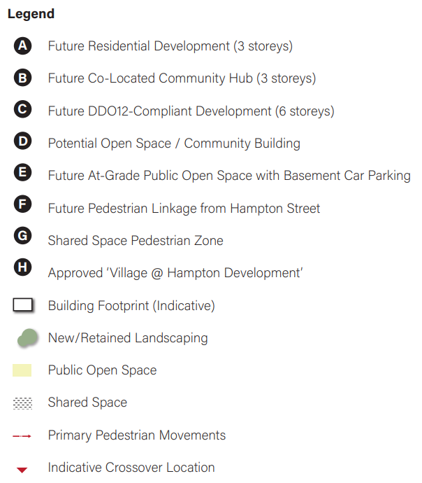
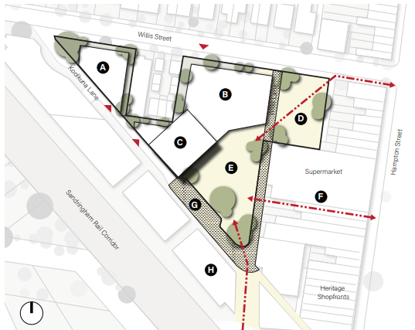
*Building footprint and open space configuration will be resolved through the concept design phase. This image is indicative only.
*Image is conceptual and not to scale
Figure 3 | Willis Street Precinct Plan

Public Open Space outcomes in the Willis Street Precinct
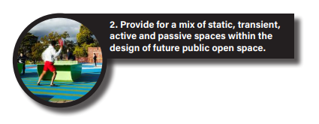
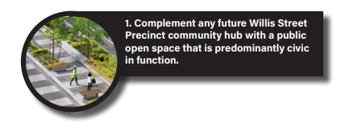
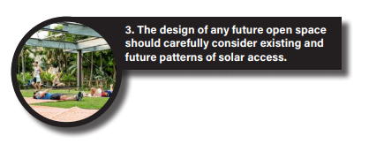
The following urban design principles have been identified through an analysis of the physical and policy context of the precinct itself, as well as the ‘lessons learnt’ from various precedent case studies and benchmarking. A total of 10 urban design principles have been identified, along with the rationale that underpins them and suggestions as to how they can be achieved within the Willis Street Precinct. These are listed below, with a more detailed analysis included at Appendix 2.

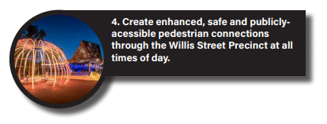
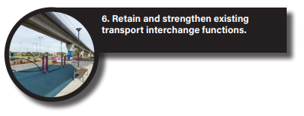
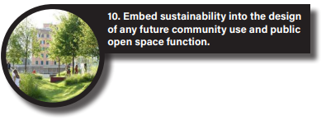
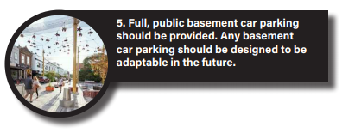
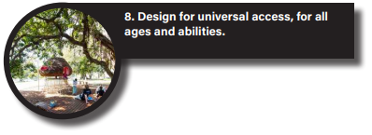
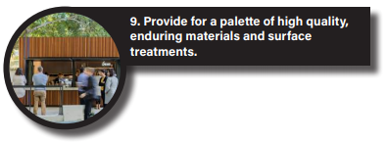
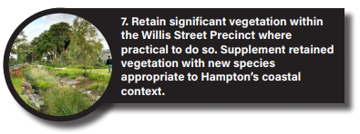

There are many ways to design a predominantly civic space, and there are therefore a number of potential design solutions for what this could potentially look like for the Willis Street Precinct. Fundamentally, however, a predominantly civic space is typically ‘sealed’ and paved and provides more of a ‘civic square’ type function than a recreational or ‘green park’ type offering. They are typically able to accommodate a range of activities (including ‘static’ or stationary activities), are largely functional in nature, provide the opportunity for formal events and functions (such as civic ceremonies and festivals), and provide for the capacity to be programmed for community events and functions (including markets or ‘moonlight cinema’ type events). They are destinations and ‘meeting points’ for local communities, and also typically feature formal and informal opportunities for seating, landscaping, and high-quality tactile surface treatments.
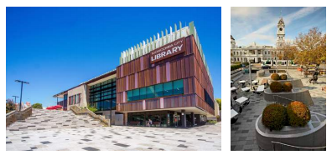
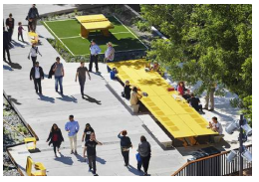
The Willis Street Precinct is a large precinct capable of accommodating a range of potential sub-uses that could stand in addition to it’s predominantly ‘civic square’ function, including (but not limited to) an outdoor children’s playspace/playground area, an active play area (including multi-function sports court or similar), a BBQ and picnic space, opportunities for community gardens and vegetable-growing spaces, sculptural installations, and/or fixed social infrastructure (such as fixed tables for a game of chess or ping-pong). These all stand in addition to informal uses of a potential civic public open space, including seating and edging to opportunities to simply ‘sit and observe’.
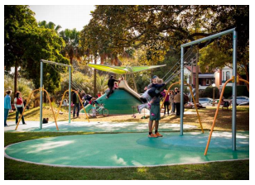
Designing for a range of multiple complementary uses and opportunities within the Willis Street Precinct will respond to the diversity of the Hampton community, and allow greater engagement, utilisation, participation and – ultimately –vibrancy within the precinct itself.

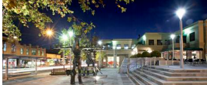
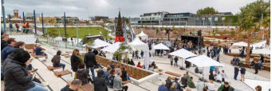

As a general urban design principle, solar access to public open spaces is best preserved to those times of day when they are most likely to be used. For inner-urban environments in Melbourne (including Hampton), this is typically between the hours of 10am – 2pm (as it is during this period when lunchtime pedestrian movements are typically at their highest), but also often in morning periods, too. It is also during the Winter months when solar access is of greatest importance from a microclimate perspective, as ambient temperatures are cooler and sunlight is scarcer compared to the warmer months due to the fact that the sun comparatively rises later and sets earlier.
As translated to the Willis Street Precinct, an analysis of year-round patterns of solar access suggests that the greatest levels of existing and future year-round solar access exist within the north-eastern portion of the precinct (at-grade car park at 20-22 Willis Street, Hampton), north-western portion of the Precinct (former Scout Hall at 6 Willis Street, Hampton) and the centre of the Precinct’s interface to Willis Lane (directly west of the existing Woolworths Supermarket).
These locations therefore present the best opportunities to site future public open space for excellent year round solar access. Other parts of the Willis Street Precinct – such as the Precinct’s interface to Willis Street (12-14 Willis Street, Hampton), or directly south of existing residential development at 8-10 Willis Street – are more likely to be shaded throughout the day (especially in the cooler months) and lend themselves to being locations that are more suitable for future built form, such as a future community hub building. Providing buildings in these types of locations will also help ‘encircle’ the central public open space and provide for a better wind protection from Hampton’s coastal winds, particularly compared a public open space located toward an extremity of the Willis Street Precinct.
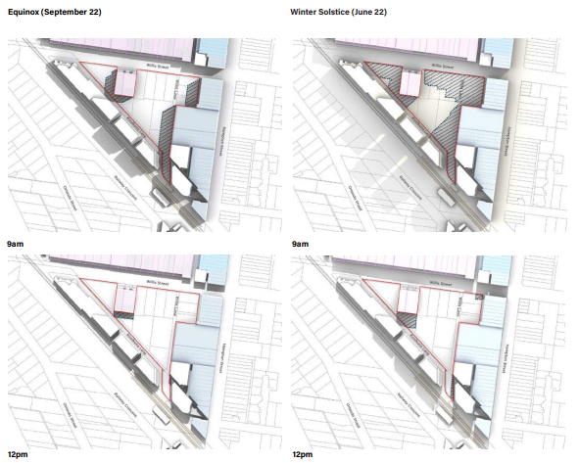

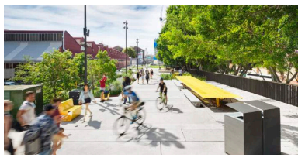

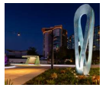

Safe, attractive environments are achieved through the conscientious application of CPTED design principles. As applied to future public open space in the Willis Street Precinct, this could be achieved through a range of specific design mechanisms, including:
- Designing for active edges to any future public open space (edges that are largely devoid of architectural elements such as solid walls without glazing, loading docks, high fencing and/or service cabinetry)
- Maximising the opportunity for passive surveillance at both Ground Floor (and potential levels above) through high levels of glazing, low levels of solidity and deliberate siting of ‘active’ uses behind (commercial floor space, apartment habitable rooms and/or balconies etc.)
- Ensuring that the design of future public open space and any building that interfaces onto it does not result in ‘places of entrapment’, such as building insets or alcoves in which people and activities can occur without being surveyed.
- Simple, fundamental design mechanisms, such as providing for clear, direct sightlines throughout the precinct and providing for adequate lighting throughout the night.
The mix of uses surrounding any future public open space within the Willis Street Precinct and their specific operating hours can also be critical to achieving ‘around the clock’ activation of the broader Willis Street Precinct itself. For example, uses such as offices and community centres tend to be most active during weekday working hours (9am to 5pm), and uses such as bakeries, cafes and restaurants tend to be most active during morning, midday and evening meal times. Residential uses (such as apartments) tend to be most active after work hours or on weekends, as are gymnasiums or outdoor workout equipment. Careful consideration of the potential for a mix of uses within and around the Willis Street Precinct (that could potentially complement a future community hub on site) can have a dramatic effect on the achievement of ‘around the clock’ activation and safety within any future on-site public open space within the Willis Street Precinct itself.
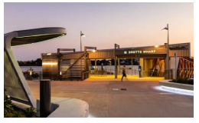
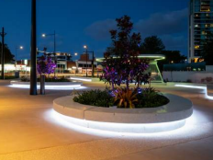
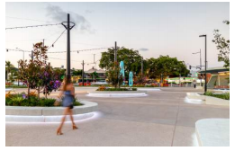

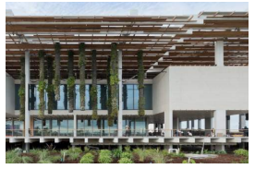
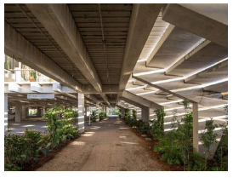

Basement car parking within the Willis Street Precinct will allow for the community to continue to use the precinct for its current, predominant purpose of car parking in a way that will allow for a range of other uses to occur on site – including a community hub with appurtenant integrated public open space.
There is a certain design logic to providing for the opportunity for basement car parking closer toward Willis Street, as it will be more accessible from the higher order roads surrounding the Willis Street Precinct (both Hampton Street and Willis Street) and avoid the need for private vehicles to travel deep into the precinct itself along either Koolkuna Lane and/or Willis Lane. Although it will likely mean that retention of existing vegetation within the existing community hub and playhouse at 12-14 Willis Street will not be possible (due to the need to excavate for basement car parking, including excavation of existing root systems of established trees on these properties), siting basement car parking toward Willis Street will likely allow for the retention of existing canopy trees at the interface of Willis Street Precinct to Koolkuna Lane.
The design of any basement car park should be adaptable and futureproof, and be readily able to be converted to potential other alternative uses in the event that car parking within public land is no longer required. This can be achieved by making use of slightly higher floor-to-floor heights for any basement car park level (ideally in the order of 4m in height) to enable future adaptation for alternative non-residential uses in the future, semi-basement car parking where appropriate, and/or deigning of at-grade public spaces to allow for potential light court conversion in the future. Future potential uses for basement carparking could include subterranean community uses (like the subterranean Council library explored in the Green Square precedent example), internally-illuminated sporting courts, office spaces or similar.
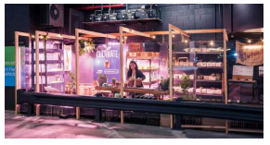
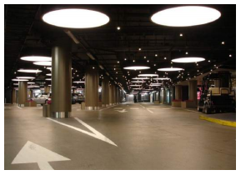
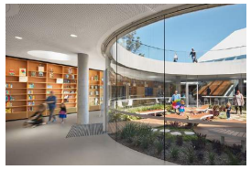
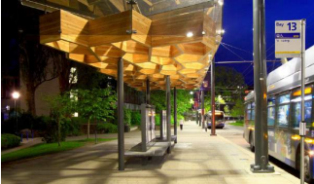
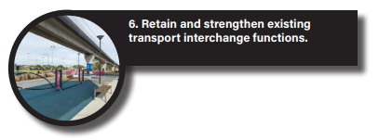

The current transport interchange function of the broader Willis Street Precinct occurs south of the precinct itself (VicTrack land), and stems from the manner in which patrons of the Hampton Train Station are able to conveniently transition between train services and other transport mode (particularly buses) in convenient proximity to the train station itself. As the approved multi-level residential development of this land begins to takes shape, the Willis Street Precinct represents an ideal opportunity to capture and retain this function as part of the design of any future public open space on site. The design benefit of doing so is the ability to capture activity within the south of the Precinct, and – in doing so - provide for an additional, specific activity-generating function within full diversity of potential uses and activities that could occur within the Willis Street Precinct. It can also combine with the Hampton Train Station more broadly to preserve a ‘southern anchor’ of activity within the Willis Street Precinct, in a way that integrates with any proposed community hub (within the balance of the precinct) and any pedestrian arrivals from Hampton Street (within the north of the precinct) to create the capacity for full activity and pedestrian movement throughout the majority of the Precinct.
With specific respect to bus transport, the design of any future specific bus interchange on site need not dominate or occupy a significant portion of any future public open space on site. Simple design mechanisms – such as a linear indented ‘bus bay’ along either Koolkuna Lane (northern edge of Koolkuna Lane or Willis Lane (western edge) with tactile ‘shared space’ surface treatments, clear sightlines and low vehicle speeds - are one way of providing for safe, low-disruption public transport vehicle movements through the Precinct in a manner that does not detract from pedestrian primacy.
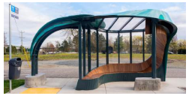
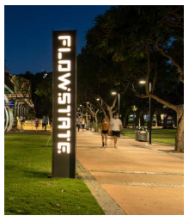
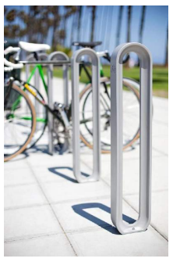
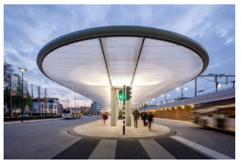
With specific respect to cycling and walking, the transport interchange function and potential for the Willis Street Precinct can be reinforced by simply providing relevant infrastructure throughout the precinct, including cycling hoops, cycling storage cages, wayfinding signage, seating and pedestrian water fountains.

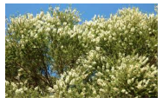
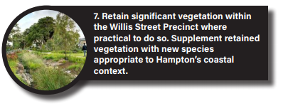
A key design asset of the Willis Street Precinct is the presence of a number of large, established canopy trees throughout, particularly within the rear of the existing community and playhouse buildings (12-20 Willis Street, Hampton) and at the southern interface of the Precinct to Koolkuna Lane. Whilst full retention of all existing canopy trees throughout the Precinct would certainly assist in providing for a landscaped and leafy public open space and community hub offering, the reality is that other design realities (such as basement car parking and the need to construct new community hub buildings) will make full retention of every existing significant tree difficult. Therefore, where possible and feasible to do so, as many canopy tree species within the Willis Street Precinct should be retained as possible, and will likely be best achieved through retention of many (if not all) of the existing canopy trees at the Precincts southern interface to Koolkuna Lane.
Retained trees can also be supplemented by new canopy tree species throughout the site, in in raised planter beds or similar. This is particularly so within the north of the Willis Street Precinct, where they could be potentially capable of growing to a height sufficient to provide for dappled shade and solar relief within any future public open space during the warmer months.
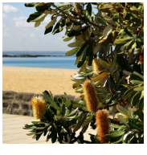
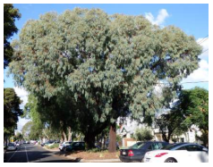
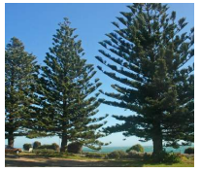
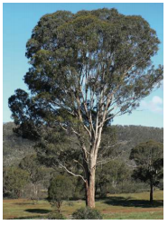
Council have also identified a range of coastal appropriate tree species that should ultimately be used in the landscape program of any future public open space, and a selection of these are shown right in a potential ‘landscape palette’. It is important to use context-appropriate planting such as these for a number of reasons, including biodiversity, local habitat, and the reinforcement of a ‘sense of place’ within Hampton and the Bayside region more broadly as a location distinct from others within both Melbourne and Victoria.
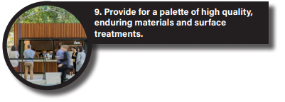
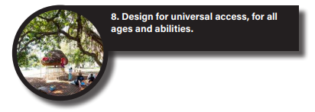

Universal access is about designing to ensure that spaces are accessible by all, including people of different abilities and ages. It seeks to limit stairs where possible, and provide for ramps, gentle gradients, lifts and other mechanisms to ensure that the full diversity of a community can utilise a public open space and community facility. As applied to the Willis Street Precinct, designing for universal access is enhanced by the fact that the precinct does not have a significant slope and does not have terrain that makes access throughout the Precinct potentially difficult, and means that large amounts of stairing or ramping are likely not required to provide access through the precinct and any future public open space. It allows any design to cater for a broad cross section of the community without the need for overt ramps, lifts and stairs.
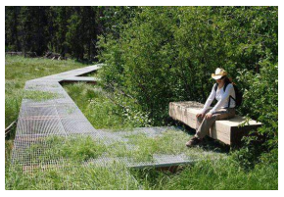
The design of any public open space within the Willis Street Precinct should ensure that that floor levels align with the Finished Floor Level of the future community hub use, and provide for a range of mechanisms – including stairs, lifts and potentially travelators – to facilitate access between any potential future basement car park and at-grade public open space and/or community hub.
There are many ways to achieve high quality materials and surface treatments within the Willis Street Precinct, including through the specific type of material used as well as it’s specific application within the ultimate design of any public open space. Stonework, cobblestones, paving and tactile surface treatments make for suitable ground surface treatments in civic public open spaces, with materials such as blockwork, bricks and sheet metal often being appropriate for seating, edging and feature elements. Timber decking, grasscrete and stepping stones often add interest and excitement to ‘softer’ areas of a public open space (such as landscaped pockets).
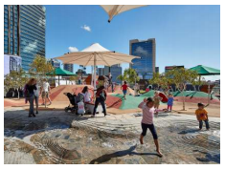
The ultimate design of any public open space could also contemplate the role of surface treatments in contributing to the achievement of positioning both Willis Lane and Koolkuna Lane as shared spaces, as simple design mechanisms – such as different shades of the same surface material to designate pedestrian areas with shared space areas – help provide legibility to a public space in a way that ‘blurs the distinction’ between pedestrian and vehicle and create the perception of a larger public environment.
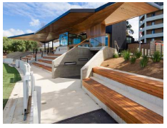
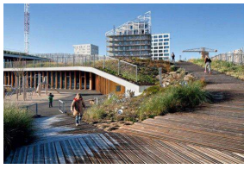
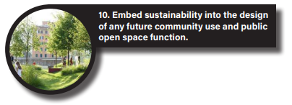
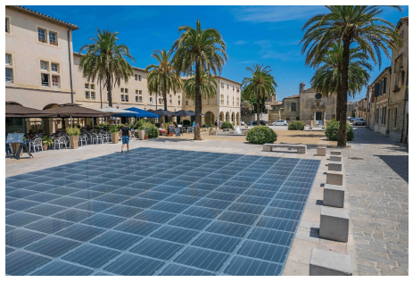
There are many potential solutions to achieve sustainable design within the Willis Street Precinct, both within any future community hub building and within the design of any future public open space itself. This includes (but is not limited to) water swales, stormwater capture, use of recycled materials, green roofs, solar panels, wind sockets and wind turbines, double-glazing, solar-powered lighting, electric vehicle charging stations, bicycle facilities and infrastructure, community ‘swap points’ and active sustainable community uses as part of the ultimate program of any future community hub building.
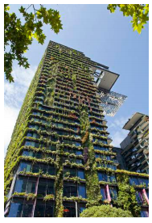
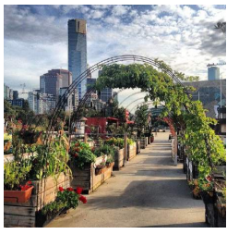
Hampton Library and car park site
This site presents an opportunity to access Federal Government funding announced for Hampton and provide a multi-deck car park, incorporating a mix of commuter parking and extra visitor parking for the centre.
There are opportunities to explore lightweight or prefabricated options to minimise on-site construction time and ensure there is minimal disruption for traders and residents. A prefabricated option may also allow the development to be dismantled and removed from the site in the event a different outcome is sought in the longer term, should the reliance on private vehicles change. This will also allow for the site to be considered for other potential uses if the site is no longer required for car parking.
There is opportunity to create a small amount of commercial or community floorspace at the ground floor to ensure that the building frontage is activated and that the building appears from the street as something more than just a car park.
Providing extra car parking at this location, whether it be a long term option or a more short term option, would also allow for additional car parking to be provided to offset the loss of any car parking whilst the community hub is being constructed in the Willis Street Precinct. The ground floor uses also provide the opportunity for temporary community spaces whilst the community hub is constructed, and the community centre may be temporarily displaced.
There is opportunity for landscaping to be provided at the site interfaces and the car park structure to be appropriately screened and designed. This will ensure the building is attractive and transitions appropriately.
A laneway will be created between the proposed car park and the library to allow for an attractive and vibrant node that creates activity beside the car park.
The former library building will be sold following the library being relocated into the new Hub.
This development will be prioritised over the Community Hub building so that the impacts of construction in relation to car parking can be managed, with this site providing some relief for motorists whilst the Hub is being constructed.

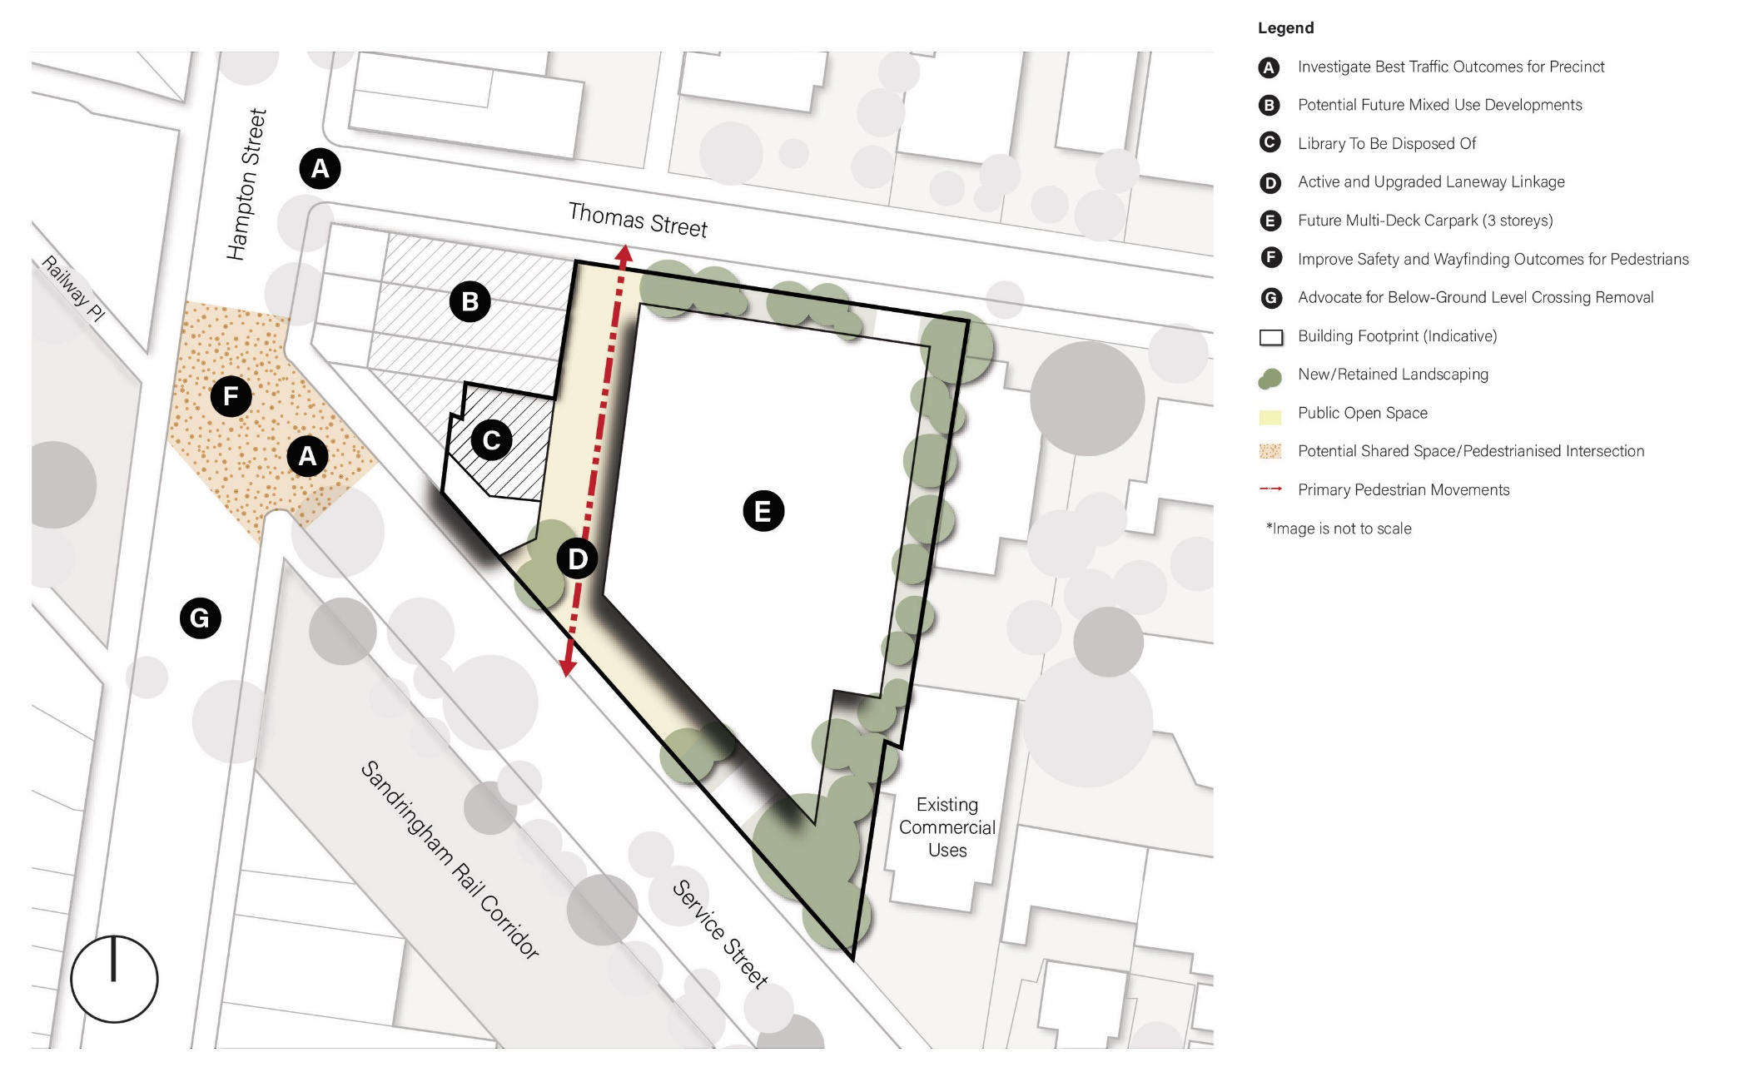
Figure 4 | Hampton Library Precinct Plan
Wayfinding and safety improvements to Hampton Street/Service Street intersection
Detailed consideration will need to be provided to ensure that the multi-deck car park connects well with the Hampton Railway Station, which may necessitate some changes to road conditions on Hampton Street. Key safety improvement opportunities include:
- Improvement to pram ramps on either side of crossing to ensure crossing is accessible for all users;
- Extend Keep Clear heading southbound on Hampton Street before Service Street, this is to stop cars queuing on the pedestrian crossing desire line when boom gates are down. Also gives the ability for pedestrians to make eye contact with stopped driver and avoid potential collisions;
- Introduce green pedestrian pavement marking to allow vehicles to enter Hampton Street safely and separate the bus stop and the car park either side; and
- Look to remove the last parallel car space north of the crossing on the west side of Hampton Street and provide kerb outstands to improve pedestrians sight lines when crossing.
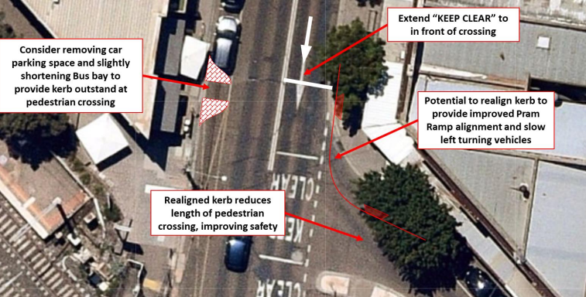
Action 4: Implement the road and pedestrian safety improvements required to ensure the road network functions appropriately and that the needs of pedestrians, cyclists, public transport and private vehicles are balanced.

Various car parks
In order to continue to service the business operating in Hampton Street, it is proposed that the following car parking sites remain as car parks.
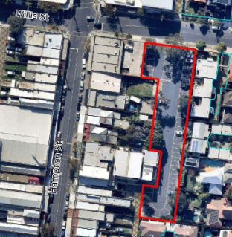  CAR PARK at 36 Willis Street (Site 9) | It is proposed that the site continue to be used as a car park. | 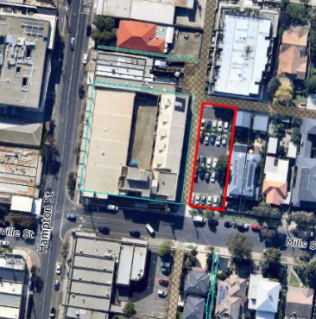  CAR PARK at 1 Mills Street (Site 10) | It is proposed that the site continue to be used as a car park. If in the longer-term increased car parking can be provided in the Willis Street Precinct through the hub development, Council will consider disposing of this site, however this will be subject to a separate process.
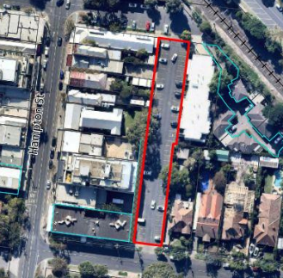  CAR PARK at 1 Crisp Street (Site 11) | It is proposed that the site continue to be used as a car park. | 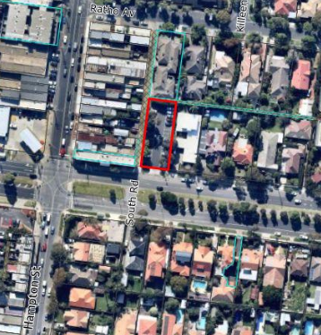  CAR PARK at 143 South Road (Site 13) | It is proposed that the site continue to be used as a car park. This car park will continue to serve the northernmost part of the activity centre.

Additional sites that will become surplus
The consolidation of Council assets questions the future of other sites within the Hampton activity centre. With the user groups relocated into a community hub, the following sites have been identified as surplus sites. Whilst the disposal of public land can be a controversial issue, there is little benefit in retaining these sites if the users (and indeed most other community groups operating in the area) are located in a new hub.
The two sites outside the Willis Street and Library precincts that would be surplus to requirements include:
Hampton Senior Citizens Centre at 14 Service Street (Site 12) | Hampton Maternal and Child Health Centre at 483 Hampton Street (Site 6)
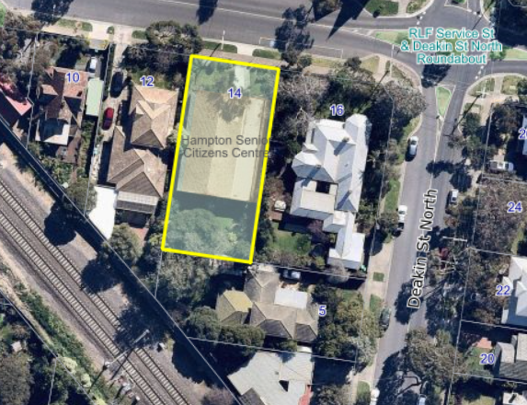 | 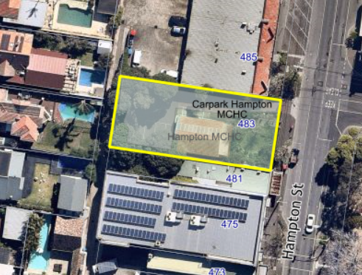

Were these sites to be sold, the funds would be reinvested to fund the construction of the community hub and the improvements to the public realm.
Each of these sites has planning controls in place that provide an indication of the likely development outcomes that could occur at the site. The planning controls and likely development outcomes for each site are summarised below.
Hampton Senior Citizens Centre
The site is currently within the General Residential Zone Schedule 2 and is affected by overlays including the Design and Development Overlay Schedule 12 and the Development Contributions Plan Overlay Schedule 1. These controls generally encourage infill development due to the sites location within an activity centre and restrict development to a maximum height of 3 storeys.
If the site is to be sold, it is most likely that the site highest development outcome would be for the site to be developed with six townhouses of up to three storeys. It is unlikely that the site would be developed with apartments due to the size of the lot.
Retaining the site does not provide significant community benefits – the site is too small to be useful as public open space, and the purpose of relocating the Senior Citizens Centre user groups into a combined facility will result in the site being surplus to requirements. It is anticipated that the revenue generated from the sale of the site would be directed towards the construction of the new hub building.
Hampton Maternal and Child Centre
The site is currently within the Commercial 1 Zone and is affected by overlays including the Design and Development Overlay Schedule 12, the Development Contributions Plan Overlay Schedule 1 and the Heritage Overlay Schedule 508. With the maternal and childcare centre being relocated into a new hub, this site becomes surplus to requirements and Council must consider alternate opportunities for the site.
Whilst the sale of the site has been considered, due to the constraints of the site it may be challenging to sell, and the Heritage Overlay that applies to the site may create some reputational risk to Council were it to sell a heritage asset to a developer.
Rather than proceeding with the sale of the site, it may be preferable for Council to undertake works to the site to make it a more fit-for-purpose medical centre, and aim to seek a long term tenant for the building. The revenue generated from leasing the premises could be directed towards offsetting the construction costs of the new hub building.
In addition to those sites, there are two further sites that are outside the Activity Centre boundary that Council will consider disposing of in order to contribute to the funding of the new Hub. These will need to be subject to further processes and Council decisions, however are outlined below.
Brighton South Playhouse, at 665 Hampton Street, Brighton | Hampton Community Kindergarten, at 1A Myrtle Road, Hampton
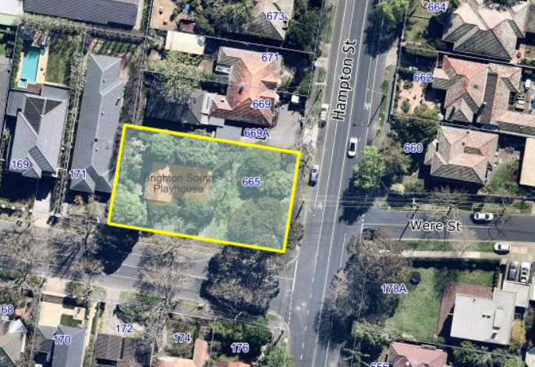 | 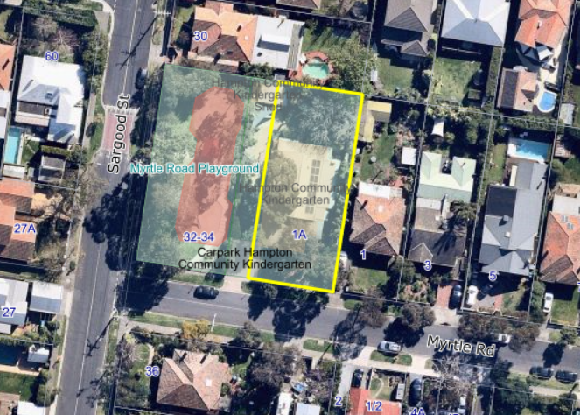
The Playhouse is expected to be used to temporarily accommodate early years services whilst capital projects outlined in the Early Years Infrastructure Plan 2018 are being delivered. Following the completion of several early years infrastructure projects that will result in several uses temporarily operating from the Playhouse, the Playhouse building will remain vacant. Disposing of the site to contribute to the increased and improved community facilities in the new Hub will ensure that the costs of construction are reduced, and that the early years facilities are grouped together in the area. If there is no capacity for the Hampton Community Kindergarten to grow or to be modified to accommodate both 3 and 4 year old funded kindergarten programs, and these services are instead to be offered as part of the future Community Hub, Council will consider disposing of the Myrtle Road site so as to assist to generate the funds required to build the new facility as part of the Hub. These disposals will be subject to separate statutory processes however are being identified now given the relevance of the Hub project from the Masterplan. Further consideration will need to be given to the sites to be disposed of once Council confirms the range of uses and the scale of the new Community Hub.
Implementation
There are a number of both statutory and non-statutory actions that will be required to implement the outcomes from this Plan that will be further refined and scoped as the implementation progresses.
Council will need to further consider the scope of the individual projects as well as giving greater consideration to the budget and funding of the various capital works projects.
The timing of the individual actions of the Masterplan is indicative and will be subject to inclusion in Council’s Long Term Financial Plan and annual budget process.
It is anticipated that the majority of actions listed below will be subject to their own community engagement processes as the plan is implemented. The individual opportunities for feedback and input will be considered and scoped as each project progresses.
The scope of each project will also require further consideration as a business case is made. At this point, Council will be able to better consider and understand the specific implications of each project and what might need to be considered in the design of new buildings and spaces.

Implementation Actions
Area | Project | Responsible
Statutory Actions | Amend the Bayside Planning Scheme to give effect to the outcomes from this Masterplan. | Urban Strategy
Multi-Deck Car Park | Investigate feasibility and concept design for the Service Street Multi-Deck Car Park. | Urban Strategy
 | Demolish Scout Hall and construct car parking at that location in advance of any loss of parking at the Service Street site. | Project Services
 | Following concept design and further consultation, undertake the detailed design and construction process to facilitate the creation of the multi-deck car park at Service Street. | Project Services
Community Hub and public open space | Develop a functional design brief for the future hub, considering in detail the range of uses, consideration of floorspace needs and governance and operational models. This will include engagement with key stakeholders to ensure this is robust. | Urban Strategy
 | Following the functional design brief, develop a concept design that responds to the needs of the brief and provides an informed understanding of delivery cost and stages. | Project Services
 | Undertake the design and construction process for the new Community Hub and adjoining public open space. | Project Services
Traffic and Public Realm | In partnership with VicRoads, implement the necessary improvements required to facilitate improved access across Hampton Street between Willis Street and Service Street. | Sustainability and Transport
 | Investigate the feasibility of relocating the bus interchange and consider whether there is a better location that exists within the Hampton Activity Centre. | Urban Strategy / Sustainability and Transport
 | Develop a Streetscape Masterplan for the Hampton Activity Centre to coordinate finishes, treatments and materials for new or upgraded public linkages in a way that is individual to Hampton as a distinct ‘place’. | Urban Strategy
 | Implement the streetscape works to Koolkuna Lane and Willis Lane to make these environments shared spaces. | Project Services
 | Investigate the appropriate tool to create a linkage between Willis Lane and Hampton Street to improve pedestrian connectivity to the Community Hub. | Urban Strategy
Surplus Land | Following construction of any new Community Hub, proceed with the sale or repurposing of surplus sites identified in this Masterplan. | Commercial Services
 | Repurpose the Maternal and Child Health building to become a fit for purpose medical centre and secure a tenant. | Project Services
 | Convert the car park at 22-26 Willis Street to public open space. | Project Services
Implementation Timeline
Traffic and pedestrian works to Hampton Street
Feasibility and Concept Design of multi-deck car park
Amend Planning Scheme to implement Plan
Convert Scout Hall site to car park
Design and construct multi-deck car park
Investigate options for bus interchange
Concept Design for Hub and Open Space
Design and Construct Hub and Open Space
Surplus Site disposal
Modify existing MCH building and lease
Convert 22-26 Willis Street to open space
Create linkage between Willis Ln & Hampton St

Appendix 1 – Summary of relevant Planning Policy

Plan Melbourne 2017-2050
Plan Melbourne 2017-2050 is the State Governments metropolitan strategy that guides the growth of Melbourne to 2050. It sets the strategy for supporting jobs, housing and transport, whilst building on Melbourne’s legacy of distinctiveness, liveability and sustainability. The vision is that Melbourne will continue to be a global city of opportunity and choice.
Plan Melbourne acknowledges that ‘Activity centres have been a part of Melbourne’s pattern of development for decades. They fill diverse roles – including housing, retail, commercial and civic services – and are a focus for services, employment and social interaction. In recent times some activity centres have become a focus for higher-density development. They often have significant public transport infrastructure and have benefited from other public and private investment.
The Plan acknowledges that ‘all activity centres have the capacity to continue to grow and diversify the range of activities they offer. Opportunities to partner with the private sector to enable future diversification, investment and employment growth should be explored and where appropriate, facilitated through planning provisions.
Plan Melbourne states that ‘to support increased housing supply in established areas, it will be necessary to define locations best able to support increased densities.’ The Plan outlines Metropolitan and Major Activity Centres as areas where growth is to be encouraged.
Hampton, along with three other centres in Bayside, is identified as a Major Activity Centre. Major Activity Centres are identified in Plan Melbourne as ‘suburban centres that provide access to a wide range of goods and services. They have different attributes and provide different functions, with some serving larger subregional catchments.’
Plan Melbourne goes on to describe that ‘activity centres are usually well served with public transport and offer access to a range of services and facilities. Many activity centres can support additional housing growth and will need flexibility, particularly where there is a significant population and household growth forecast… Once identified, appropriate policies, provisions and guidelines must be developed and put in place to encourage and support planned growth.’
Principle 5 within Plan Melbourne is to create a network of 20 minute neighbourhoods, being accessible safe and attractive local areas where people can access most of their daily needs within a 20 minute walk, cycle or local public transport trip, making Melbourne healthier and more inclusive.
Within the Plan Melbourne Implementation Plan, there are a range of actions that relate to Local Government, including:
- Action 9: Planning for activity centres:
Work with metropolitan regional groupings of Councils to review the opportunities and constraints of the activity centre network and individual activity centres in implementing Plan Melbourne. This may include identifying priority activity centres for future planning, developing a program to prepare or update Structure Plans, reviewing local planning policy and streamlining planning provisions.
- Action 24: Planning system reforms for social and affordable housing:
Reform the planning system to facilitate the supply of social and affordable housing. Reforms should:
  - Develop and implement definitions of social and affordable housing in the planning system;
  - Formally recognise and give statutory effect to the delivery of social and affordable housing as a legitimate planning outcome in Victoria. This will enable the development of new planning provisions or tools to deliver social and affordable housing including exploring inclusionary zoning and mechanisms to capture and share value created through planning controls;
  - Develop a streamlined planning approval process for social housing projects.

- Action 25: Surplus government land for social housing:
Identify underutilised and surplus government land that has potential to deliver additional social housing. Undertake pilot projects to demonstrate how planning mechanisms can deliver more social and affordable housing.
- Action 35: Improvements in the metropolitan bus and tram network:
Implement further improvements across the metropolitan bus and tram network, including (inter alia)
  - Investigating changes to the road-space allocations to prioritise bus and tram movements in priority locations;
  - Progressively update existing bus service plans to better link people to job-rich areas and community and service centre, following bus network consultation across Metropolitan Melbourne.
- Action 53: Place-making for public places
Work with local government to improve planning, design and management of public places across Melbourne, including public squares, parks, laneways and pedestrian malls. This includes identifying opportunities for new public places as part of planning for activity centres, urban renewal precincts and other strategic locations. A more focused place-making approach will be adopted to strengthen the design of quality public spaces, accessibility and the interfaces between private developments and the public domain.

Council Plan
The Council Plan 2017-2021 (the Plan) sets out our vision, goals, strategic objectives and strategies for the Council’s 4-year-term in office. The Council Plan was developed in response to the ideas and aspirations expressed by the community in the Community Plan 2025.
The Plan is structured around the seven domains of liveability and sets goals for each of these domains.
- Infrastructure
- Transport
- Housing and neighbourhoods
- Open space
- Environment
- Local economy and activity centres
- Community health and participation
In addition to setting goals for each of the domains of liveability, the Plan adds ‘Governance’ as an eighth goal to reflect the community and Council’s desire to improve community engagement to inform decision making and deliver financially responsible services and facilities that meet community needs.
The Plan acknowledges the need to plan for the future use and development of all community facilities. The following strategies and actions have been identified within the Infrastructure domain.
- ‘Provide modern library services that meet the needs of the community.’ The action of this strategy states;
Complete and commence implementation of an improvement plan for library infrastructure and services that addresses municipal and local area needs.
- ‘Provide fit for purpose, modern multi-use facilities that are effectively utilised for our children’s early years.’ The actions of this strategy includes;
Develop an Early Years Plan including Preschool and Maternal and Child Health services and incorporating service and supporting asset and infrastructure plans; and
Commence implementation of the Early Years Plan
- ‘Plan for the future of recreation centres, senior centres, U3A and similar community facilities to ensure the assets meet future service needs and deliver strategies for renewal.’ The action of this strategy states;
Develop a Community Facilities and Services Strategy that identifies suitability, including Brighton Recreation Centre and other community facilities.
The need to develop increased commuter parking and parking capacity within activity centres is identified within the Transport domain. The strategies and actions include:
- ‘Facilitate transport options to meet community needs.’ The action of this strategy includes;
Update and implement the Integrated Transport Strategy to reflect the new Council’s priorities, including:
- Opportunities for increased parking capacity in activity centres and ‘private car park sharing’ for residents.
- Influence state government planning through advocacy for:
- Enhanced bus routes through the Public Transport Victoria route review
- Increased commuter and bicycle parking, including drop zones and options for double deck parking.
The action of this strategy includes:
Develop and implement an advocacy action plan for bus routes, commuter parking (including bicycle parking) and the Pennydale and Cheltenham station redevelopments.
The strategic objectives in the Council Plan are reviewed annually to ensure Council is able to adapt to changing community needs and other internal and external factors.

Bayside Housing Strategy 2019
The Bayside Housing Strategy 2019 is an update from the previous 2012 Strategy which sets the direction to accommodate population and housing growth in Bayside. The Strategy implements State policy by directing housing growth into Bayside’s activity centres, with the primary focus being on Major Activity Centres and other Key Focus Residential Growth areas in order to ensure a more limited level of change for land within the Neighbourhood Residential Zoned areas.
The Housing Strategy outlines the future projections for housing and population growth and recognises the tensions between balancing the need for growth with the existing community’s desire to protect the village feel of activity centres and the green and leafy, low scale housing character. The Housing Strategy will lead to a concentration of development in defined locations which will result in a greater impact on the character of that area, however it enables the protection of neighbourhood character throughout the remainder of the municipality.
The previous Housing Strategy informed the application of the residential zones across Bayside, with the General Residential Zone being applied to residential precincts within the activity centre boundary.
The Housing Strategy acknowledges the need to ensure that appropriate physical and social infrastructure is provided to meet the changing needs of the community.
The 2019 updated Strategy also provides further guidance for Council to consider further strategic work, including:
- Better communicate to Bayside residents where housing change is being directed and what types of development they can expect;
- Develop a specific approach to facilitating and delivering more social and affordable housing in Bayside;
- Undertake a community infrastructure needs assessment to inform a strategic approach to asset management and the provision of services based on community need; and
- Continue to implement the Bayside Open Space Strategy 2012 and associated suburb analysis action plan, prioritising the provision of additional open space in Housing Growth Areas.

Hampton Major Activity Centre Structure Plan 2006
The Hampton Major Activity Centre Structure Plan 2006 (the Structure Plan) sets strategies, objectives and actions specific to the centre. The Structure Plan provides a vision for the activity centre which notably presents a core focus on mixed use development, and the development of community facilities. The vision states:
Noted for its friendliness, community spirit and ambience, the Hampton Street Centre will provide a variety of community, commercial and residential uses to attract a diverse range of people. It will encourage lively interaction, entertainment and provide a community focal point. It will continue to support a conveniently located and reliable public transport system, which connects the community with major transport infrastructure. The connectivity will be complemented by enhanced movement networks for pedestrians and cyclists and result in overall improved traffic flows for all road users.
Areas of growth and development are identified within the Future Role and Character Statement:
In the Hampton Street Centre, activity will be focused in between Willis Street and the railway line and extending behind to the revamped Willis Street precinct. The existing grade level car park will be replaced with a mixed use development incorporating community facilities, housing on upper levels, a new public space and basement car parking for commuters and residents.
Built form, and the redevelopment of the activity centre is too cemented within the Character Statement:
The modest scale of Hampton Street’s two storey shopfronts will be maintained with modern buildings of three storeys matching the height at the street frontage. The Willis Street precinct site will be promoted as a significant redevelopment site in the heart of the Centre.
…
Hampton Street will become an important space with new streetscaping providing places to site and meet. The revamped Willis Street precinct will provide improved waiting spaces and a public open space, which will be a focus for the centre and encourage people to use public transport.
The Centre will continue to provide a range of community services with further emphasis on creating and enhancing community hubs. These would incorporate functions such as library services and flexible meeting spaces for social, recreational and community educational opportunities for all ages and abilities.
The Structure Plan provides strategic direction for the activity centre by setting objectives, strategies and actions for ‘Activities’ ‘Building,’ ‘Spaces’ and ‘Access.’ The first relevant outcomes identified below are within the ‘Activities Plan’ and include:
Objectives
- Strengthen the role of the Hampton Street Centre as a multi-use centre offering retail, office, entertainment and community services to a large neighbourhood sized catchment.
- Maintain the retail strip and street life on Hampton Street between Ratho Avenue and Crisp Street.
- Consolidate retail and other service uses in a central core area between the railway line and Willis Street.
- Maintain and consolidate community service functions within the Centre.
Strategies
Precinct 1: Primary Activity Area
- Develop a high activity, retail and mixed use core between the railway line and Willis Street.
- Facilitate redevelopment of the Willis Street precinct and railway car park to a mixed use development with basement car parking, integrated community facilities, improved links to the station and between transport modes, improved station facilities and a public space.
- Ensure that building frontages have a high degree of visual connection to the street. Provide a pedestrian link to the Willis Street precinct.
Actions
- Prepare and implement an amendment to the Bayside Planning Scheme to introduce the Objectives and the applicable Strategies into the Local Planning Policy Framework.
This action was implemented through Amendment C103 which was gazetted on 4 July 2013. The Amendment gave effect to the structure plan and rezoned a number of properties within the activity centre. The amendment reintroduced DDO2 over 528 Hampton Street (Hampton Primary School) and removed DDO6 from all land and deleted the schedule from the planning scheme.
The second pillar ‘Building’ identifies proposed building heights and sets direction for the activity centre to ensure that the existing character is not impacted. The relevant outcomes of this section include:
Objectives
- Develop the Centre in a way that conserves and enhances its valued urban character and heritage places.
- Accommodate more intense development in suitable locations within the commercial core, immediately next to the commercial core, and on large sites, in ways that avoid materially altering the perceived scale of the Centre.
- Maintain and enhance an active and accessible street frontage in commercial areas to ensure vibrancy, interaction and safety.
- Encourage greater environmental sustainability in building design and siting.
Strategies
Built Form Character
- Generally encourage conservation and restoration of existing Victorian / Edwardian two-storey buildings and other two-storey buildings of architectural significance.
- Conserve and restore buildings having heritage significance as identified in the Bayside Planning Scheme.
- Encourage additions to, or replacement of, single storey buildings with new multi-storey buildings to provide additional housing opportunities in the commercial areas of the Centre.
- Ensure that alterations and additions to heritage buildings in the Centre are undertaken in a way that respects their design, appearance and significance in accordance with Council’s Heritage Policy.
Building Frontages
- Design new buildings with well-articulated facades, fenestration, parapet treatments, other detailing and materials to provide interest at street level and reinforce the human scale.
- Provide continuous weather protection along the Hampton Street footpaths between Crisp Street and Ratho Avenue.
- Ensure new buildings in the redeveloped Willis Street precinct area look onto future public open space and the railway station.
- Encourage the redevelopment of the station car park in Railway Crescent to provide housing that fronts to the street and also looks onto the station.
Commercial / Residential Interface
- Ensure that new buildings in commercial areas do not significantly overlook the private open space and habitable room windows of adjoining residential properties. This should be achieved by applying the Res Code overlooking standard to commercial properties that abut residential areas.
Sustainability Principles
- Design new buildings and building alterations for energy efficiency, considering solar access and utilising sustainable energy and construction techniques wherever possible. This should be done early in the design process (refer to the Building Code of Australia, Res Code and Council’s Environmental Sustainability Framework).
- Encourage the design of buildings to allow for adaptive re-use in the future, where possible.
- Encourage best use of development sites to maximise retention of existing vegetation and landscape design that assists in passive solar heating/cooling.
- Make use of building materials with minimal environmental impact such as recycled materials and re-use of existing buildings where possible.
- Encourage new development to incorporate water sensitive urban design techniques wherever possible.
- Encourage the use of environmental management plans and green travel plans for larger development proposals or where there are site constraints to encourage more innovative solutions for achieving ESD features (such as energy and water conservation, vegetation retention, waste minimisation, more public transport, walking and cycling).
The third pillar, ‘Spaces’ identifies areas and outcomes for future streetscape and open spaces improvements, weather protection and activity frontages. Outcomes include:
Objectives
- Improve the pedestrian amenity, connectivity, safety and appearance of the street space and other open spaces in the Centre.
- Promote active uses at street level to maintain the vibrancy, attractiveness and safety of the Centre.
- Implement streetscape works in order to improve pedestrian amenity and add to an overall cohesive image for the Centre.
Strategies
Open Space
- Identify opportunities for increasing the amount of accessible public open space.
- Improve the amenity of pocket parks adjacent to the railway line and pedestrian access to these parks so that they form a green treed corridor dissecting the Centre.
- Provide a new public open space within the Centre of the redeveloped Willis Street precinct site that incorporates the existing large eucalypts, where possible.
Street Spaces
- Maintain and improve street spaces in the Centre with high levels of amenity, especially for pedestrians.
- Provide appropriate street furniture, and manage street trading to support public activity, amenity and social interaction in the street.
- Investigate the possibility of undergrounding powerlines in Hampton Street between Crisp Street and Ratho Avenue with the high activity area of Hampton Street between Crisp Street and Ludstone Street being a higher priority.
- Encourage the use of artists in an integrated manner in the planning and design phases of streetscape projects and consider public art opportunities.
- Encourage signage that provides a consistent look to the Centre and promotes the special features of the Hampton Street.
- Provide weather protection and active frontages on properties facing Hampton Street between Crisp Street and Ratho Avenue.
Actions
- Ensure that any redevelopment of the Willis Street precinct site provides a new public open space which incorporates the existing large eucalypt trees where possible.
- Work with railway operators to improve the amenity of strip reserves adjacent to the rail line, improve access to the reserves and extend where possible to form a continuous green link along the rail corridor.
- Review opportunities for acquiring additional public open space.
The final pillar, ‘Access’ provides outcomes to improve access within the centre for vehicles, pedestrians, public transport users and cyclists. The following outcomes are relevant to this Masterplan:
Objectives
- Provide and manage car parking to meet the needs of residents, retailers and visitors.
- Improve the safety and appearance of laneway connections and off-street car parks.
- Improve public transport services, connections and amenity of the station, bus interchange and surrounds.
- Improve access for pedestrians with all levels of mobility.
- Establish a network of priority pedestrian routes integrating the main shopping strip on Hampton Street with surrounding car parking areas, public transport, residential areas and other attractions.
- Improve bicycle routes and facilities in and around the Centre.
Strategies
Local Access
- Create continuous service and car park access lanes at the rear of commercial properties to provide through access to the rear of shops and future housing.
Car Parking
- Maintain existing numbers of public parking spaces and ensure that any new development provides appropriate numbers of additional parking spaces, in accordance with the Hampton Parking Precinct Plan, to support added intensity of uses in the precinct.
- Improve the safety for pedestrians moving between off-street car parks and Hampton Street.
- Provide additional car parking in the redeveloped Willis Street precinct site to account for car parking lost to the redevelopment of the car park in Railway Crescent.
- Provide for safer and more convenient access to disabled parking in the Hampton Street retail strip.
Public Transport
- Improve integration between all forms of transport and the local area.
- Enhance the transport interchange facilities at Hampton Station and provide opportunities for increased pedestrian presence during the day and night.
- Improve the safety of pedestrians moving between the station, bus interchange, and surrounding streets.
Pedestrian Access
- Provide additional pedestrian links and improve existing links, to better integrate the commercial centre and Willis Street precinct site with surrounding residential areas.
Actions
- Develop a laneway maintenance strategy for safety, sanitation etc. The strategy should consider:
- Repaving to ensure even surfaces (asphalt typical.
- Lighting
- Work with Vic Track and adjoining landowners to facilitate the redevelopment of the Willis Street precinct area and adjoining car parks. The redevelopment would include additional car parking, integrated community facilities, public open space, housing and improved transport interchange facilities and links.

Hampton Major Activity Centre Structure Plan Review 2016
The Hampton Major Activity Centre Structure Plan Review 2016 (the Review) presents the findings of a review of the Structure Plan. Since the preparation of the Structure Plan in 2006, significant progress was made to complete those actions listed in the Structure Plan. The Review identifies those key actions that have now been completed.
The Review considered the relevance for the remaining actions, and considered new approaches to achieve the Structure Plan vision.
With regard to the scope of the review, it was structured into the following elements:
- An audit of the status of the actions from the Structure Plan
- A Literature and Policy Implementation review, which reviewed Panel reports, VCAT decisions, Council strategies, plans and State policy, and identified areas of potential conflict or issues which may require updating or clarifying
- A demographic and housing analysis, which considered updated population characteristics, projections and housing and development characteristics
- An economic analysis and forecasting study, which provided an understanding of current and future floor space requirements and expected commercial growth
- A Neighbourhood Character review, which focussed on character issues in the residential areas.
The Review identifies that 15 of the 38 actions contained in the Structure Plan are complete, 16 are underway/ongoing, and 7 have not commenced. There are a number of actions that are yet to be commenced, most notably the preparation of a car parking plan, laneway investigations and community infrastructure planning. Whilst some of the background work to inform the car parking plan has been completed, further work needs to be undertaking to understand the feasibility of some of the proposed actions for investigation to address future car parking needs.
The Review also considers local strategies and plans that have been developed by Council since 2006. It notes that the Bayside Housing Strategy (2012), and the Hampton Willis Street Precinct urban Design Framework (2013) provide particular importance as they provide direction to development within the area.
In considering the controls in place over the Hampton Street Centre and the purpose and application of the General Residential Zone, Residential Growth Zone and Commercial 1 Zone, it is recommended that:
- The General Residential Zone be retained for the residential precincts within the Centre, consistent with the use of this zone outlined within PN58: Applying the Residential Zones
- The Commercial 1 Zone be retained for the commercial precincts
- The Residential Growth Zone be retained in the Willis Street Precinct.
Recommendations specific to the planning controls include:
- Amend DDO12 to remove inconsistencies, and improve ease of use and discretionary decision making.
- Update building heights in the Hampton Street Centre Buildings Plan to ensure alignment with DDO12.
- Ensure consistency between the Clause 21.11 maps and the DDO maps.
- Prepare a Planning Scheme Amendment to correct the zoning at 31 Service Street, Hampton to General Residential Zone 2.
The Review also provides insight into the implications from Implications from demographic, housing and economic changes in Hampton. It notes that there will be an ageing of the adult population within Bayside, which is consistent with the data outlined in other Council Reports and Plans. The Review states:
While the residential population in the Hampton Street Centre is expected to have a relatively young age profile in 2031, the balance of the suburb is forecast to experience an ageing of the population. This overall demographic change indicates there will be a need for a greater provision of medical and aged care services.
The ‘Implementation’ section of the Review is put forward as a table outlining the issues, opportunities and recommendations for the Hampton Activity Centre. There is a total of 15 recommendations. Of the 15, the following relate to the development of the ‘Hampton Hub’ and centralising community facilities within the activity centre:
- Encourage health services to locate within the Hampton Street Activity Centre
- Continue to use the Commercial 1 Zone and create opportunities for mixed uses in the centre.
- Continue to apply the RGZ to the Willis Street Precinct and the General Residential Zone in the residential precinct of the Hampton Street Centre to provide for the housing outcomes anticipated in the Bayside Housing Strategy (2012).
- Continue to support residential development and intensification in the centre, including through shop top development.
- Undertake the further strategic work identified in the Bayside Housing Strategy (2012) regarding community infrastructure issues.
- Continue to support the recommendations of the Hampton Willis Street Precinct Urban Design Framework (2013) in relation to community facilities.
- Define what is meant by ‘village feel’ and ‘village character’ in the Planning Scheme in relation to the Hampton Street Activity Centre.
- Continue to support opportunities to provide additional public open space.
- Prepare a car parking plan for the Hampton Street Activity Centre.

Hampton Willis Street Precinct Urban Design Framework 2013
The purpose of the Hampton Willis Street Precinct Urban Design Framework 2013 (‘the UDF’) is to underpin appropriate planning for the Hampton Willis Street Precinct. In particular, the UDF’s key objectives are to:
- Inform Council’s response to the VicTrack planning and EOI process in the short term;
- Inform Council’s ongoing planning for and redevelopment of the precinct in the longer term; and
- Provide clear direction and certainty for current and future stakeholders.
The precinct comprises the land bounded by the Sandringham train line to the southwest, including the Hampton Train Station, Willis Street to the north and Hampton Street to the east. The UDF provides a review of the existing conditions at these sites within the Willis Street Precinct, and identifies the strategic and planning context relevant to each site. Methodology to the preparation of the UDF is also explained within the document.
The UDF sets the following ‘vision’ for the precinct:
The Hampton Willis Street Precinct will be a place for reflecting environmentally, socially and economically sustainable development, with a focus on community benefit and opportunities. It will make a positive contribution to the broader Hampton area and community.
The UDF seeks to encourage and support actions in accordance with key principles as follows:
Pedestrian networks
The Hampton Willis Street Precinct is a complimentary community destination with improved pedestrian connections and clear way finding between the precinct and the successful Hampton Street shopping strip.
Vehicular network
The Precinct delivers an accessible, mixed mode transportation hub that is welcoming, inclusive and safe for all and balances pedestrian, cyclist, public transport and private vehicle use
Built form
The Hampton Willis Street Precinct is an active mixed use urban village, acknowledging the existing fine grained residential interface to Willis Street, the existing vibrant retail activity to Hampton Street and new multi-storey developments on the larger central sites.
Use and Activity
New mixed use development including residential, parking, complementary retail and employment opportunities provide socio-economic opportunities within the precinct. Integrated community services co-located within the precinct improve opportunities for interaction, spatial efficiency and cross community relationship building.
Streetscape Character and Environment
The Precinct demonstrates an overall commitment to environmental sustainability, presenting ‘green’ gateways at each entrance, encouraging additional indigenous vegetation, soft landscaping and seating areas along new pedestrian routes and the central plaza.
Within the ‘Streetscape Character and Environment’ section of the UDF, green gateways are mapped, and presented at each entrance within the precinct. The UDF identifies a Green Gateway at Willis Lane and Koolkuna Lane. A new Central Plaza with high quality public open space is also presented. Landscaped buffers between residential areas should be provided on Willis Street, Koolkuna Lane (south) and upon Hampton Street.
Strategic Interfaces
The UDF provides further technical detail in relation to strategic interfaces – and several diagrams which incorporate further detail including recommended dimensions for pedestrian and vehicular networks, sectional information on the built form articulation, and landscape information that informs the streetscape character.
Implementation strategy
The UDF explores indicative time frames to implement the development of the precinct. This is sectioned into short, medium and long term outcomes. These outcomes are consistent with the outputs of this Masterplan.
The UDF concludes by providing outline to the next steps that are required to be undertaken by Council, including:
- Feasibility study on the preferred site of an Integrated Community Hub within Hampton, and detailed brief and concept design.
- Detailed parking studies of public parking requirements within the wider Hampton Activity Centre, including parking to the east of Hampton Street.
- Detailed studies of traffic flow and road design into the Precinct and for Willis Lane and Koolkuna Lane.
- Detailed design and development of the bus interchange in conjunction with VicTrack and PTV.
- Progress realignment of Koolkuna Lane and Scout Hall land.

Bayside Integrated Transport Strategy 2018
The Bayside Integrated Transport Strategy 2018 (‘the ITS’) was prepared to establish a strategic direction to guide transport planning decision making within Council over the next 10 years. It identifies a range of actions for implementation.
The ITS covers all forms of mobility, including public transport, walking, cycling, freight, private vehicles and the street network. It does this through a set of six complementary goals which reflect the aspirations of the community and will assist Council to achieve an integrated and sustainable transport system and improved liveability within the municipality. Each goal is supported by a number of strategic directions and actions and explored further within the main document. The goals, strategic directions and actions contribute to Council’s vision for transport:
The transport system will meet the needs of the community through the provision of a sustainable, well-connected, safe, accessible and convenient transport options that positively contribute to a strong economy, the health and wellbeing of the community and a low carbon future.
The following 6 Goals are identified within the ITS. Relevant strategic directions of these goals have been identified, and include:
- Enabling Sustainable Transport Choices
Council will raise awareness of sustainable transport options as more convenient alternatives to vehicle trips in the community and support initiatives that increase transport choice and reduce transport emissions
Strategic Direction 2
Promote and encourage sustainable transport choices to the community. The community needs to be aware of all available transport options, including the pros and cons associated with each mode in order for them to make an informed decision when planning their journey. Whilst building new infrastructure provides an opportunity to facilitate travel behaviour change, it is important that Council is able to increase community awareness and actively promote the benefits of sustainable travel to encourage an uptake in more sustainable modes.

- Improving Local Accessibility
Council will prioritise walking and cycling as the preferred modes of transport for short trips in Bayside
Strategic Direction 6
Prioritise walking in areas of high pedestrian activity. In areas of high pedestrian activity, including activity centres, the foreshore and other key trip generators, facilities that both assist and prioritise the safe movement of people need to be provided to create streetscapes that invite people to walk. This can require removing road space currently available to cars.
Strategic Direction 7
Maximise provisions for walking in new developments and streetscape upgrades. When planning for new developments or streetscape upgrades, high quality pedestrian environments that are accessible, safe and attractive need to be provided to create opportunities for walking trips to be encouraged. Existing pedestrian routes and access to public transport should not be removed or significantly lengthened by new developments or by improvements or maintenance to the street.
Strategic Direction 10
Improve the integration of cycling with land use development, public transport and other key amenities. The way we plan for land use and transport can increase the proportion of cycling trips. Establishing an environment conducive to cycling will assist in facilitating an increase in transport choice within the community. The provision of end of trip facilities for cyclists and how well cycling is integrated with other modes of transport will be a major factor in ensuring that cycling is considered as a transport option for local trips within Bayside.
- Better Public Transport
Council will advocate to the State government for improved public transport access to, within and from Bayside
Strategic Direction 12
The public transport system will be fully accessible and integrated. Ensuring universal access to the public transport system will provide people of all abilities with the opportunity to use the public transport system within the municipality. Similarly, providing improved integration between public transport and modes such as walking and cycling will ensure that the community has a choice of transport options when travelling to a train station or a bus stop as part of an onward journey.
- User Friendly Streets
Council will treat streets as places where people live, work and play and provide access for a range of users in order to deliver a safe, accessible and efficient transport system
- Integrated Transport and Land Use
Council will work to ensure that land use and development supports sustainable transport use
Strategic Direction 15
New land uses and development will be located in accessible locations that provide the greatest access to public transport and facilitate walking and cycling. The integration and coordination of land use and transport in Bayside can play a crucial role in creating connected communities and promoting sustainable travel behaviour. Effective land use and transport integration will promote sustainability through an urban environment that reduces the need for travel and distances travelled, enhances access to goods, employment and services, provides a variety of equitable and affordable travel alternatives and promotes the use of sustainable modes of transport.
Strategic Direction 16
Development will support and encourage walking, cycling and public transport use. In order to reduce parking demand and traffic in our streets new developments will need to support and encourage sustainable modes of transport. Requiring developers to provide adequate end of trip facilities for pedestrians and cyclists, and good connections to the public transport network will assist in making these sustainable travel modes more desirable.
Strategic Direction 17
Improvements to transport infrastructure and facilities will complement and support the local economy. Increased prosperity for businesses can be aided through increased street activity as more people walk and cycle and spend a longer time at local shops. In addition, improving access to employment and retail within Bayside for those in surrounding areas will result in a better connected local economy.
- Optimising Parking Opportunities
Council will maximise the utilisation of existing parking space and balance the needs of drivers to ensure sufficient parking opportunities are available for those who need it
Strategic Direction 18
Manage parking for the benefit of the whole community through the use of policy tools. Appropriate car parking is essential for encouraging access to residential, commercial, recreational and industrial activities, and promoting connections with public transport. To manage parking demands across the municipality, policy tools will be developed to assist Council to manage parking across the municipality in a strategic way for the benefit of the whole community.
The ITS identifies an ‘Action Plan’ which seeks to implement the strategic directions and actions over a ten year period to better integrate transport and land use and encourage a shift towards more environmentally sustainable travel modes. An action of the ITS includes:
- Ensure that parking in activity centres is managed so available spaces are used more efficiently to enable appropriate turnover

Bayside Open Space Strategy 2012
The Bayside Open Space Strategy is a 20 year planning document which provides policy and strategy to enable Council to make decisions about how open space is used, developed, managed and maintained across the municipality.
It is guided by and supports Council’s high level planning documents including the Bayside 2020 Community Plan, the Bayside Council Plan, the Municipal Strategic Statement and the Health and Wellbeing Plan. It provides the context for and links with a range of other current or proposed strategic documents including the Housing Strategy, Integrated Transport Strategy, the Recreation Strategy, the Asset Management Policy and individual park masterplans.
The Strategy acknowledges that open space plays an important role in contributing to community health and wellbeing. It notes that as the community becomes more diverse and needs change, there will be increased competing demands on open space. Open spaces need to be flexible to adapt to changing community needs and ensure equitable access to the open space network as a whole.
The purpose and role of the Bayside Open Space Strategy is to:
- Define and describe the role of open space across the City of Bayside City Council
- Establish Council’s policy direction to guide the planning, management and development of open space, including vision, principles, strategic priorities and strategies
- Build a sound planning framework from which Council can partner with and support the range of community and environmental interests in open space
- Directly inform the desired service standards relative to the resourcing and support of open space across the City
- Inform the Bayside Planning Scheme for the protection of existing open space and the provision for future needs through statutory planning processes and requirements
- Inform Council’s Long-Term Financial Plan to guide long-term decision making to sustain and enhance the Bayside open space system
- Provide a clear link between the strategic planning for open space to the practical, operational delivery and management of Council managed parks, trails and reserves.
The Bayside Open Space Strategy establishes a Vision and six Principles to guide decision making in relation to the open space network in Chapter Three.
Vision
From our foreshore, to our parks, our heathland and our trails, we cherish our open space. We will work together to build our open space network in ways that celebrate our strengths, support biodiversity, improve health and wellbeing and community connections, for future and current generations.
The vision is underpinned by six principles. The Hampton Hub Masterplan strategically aligns and is consistent with the following two principles:
Principle Five: Connections  Connectivity relates to the physical and visual links between different parts of the  open space network, and other key destinations in and outside the municipality. | - Better connect open spaces and key community destinations to encourage walking and cycling.  - Enhance the connectivity of the open space network to provide habitat corridors.  - Improve landscaping along streets to create an attractive, green and connected suburban environment.
Principle Six: Communication  Communication relates to the exchange of information and ideas between different  people and groups of people. Effective communication is an essential part of managing the open space network due  to the large number of stakeholders involved in the development, management  and use of the open space network, the changing demands on the open space  network over time and the competitive advantages that the open space network  provides to Bayside. | - Work with other stakeholders to find innovative ways to enhance the open space network and individual sites.  - Develop efficient and appropriate systems to manage and maintain the open space network.  - Encourage the use of the open space network through promoting the range of spaces, connections and attractions offered.  - Have respectful discussion with the community in relation to changes to open space.

The Bayside Open Space Strategy (2012) also identifies the need to mitigate the urban heat island
effect and the impact of more compact development in the MACs. The Strategy states that:
Provision of open space within these centres is highly important to offset the build-up of urban heat. Planting large canopy trees in open space and the street will also help mitigate this impact.
Chapter Five of the Open Space Strategy establishes a range of policies and actions that will be carried out in order to achieve the vision and principles of the Strategy. Key initiatives include:
- Guidance and standards relating to community access to, and provision of facilities within, open spaces
- a commitment to ‘no net loss of open space’, and policy to guide when and how land will be acquired and how changes of use will be managed
- a commitment to developing a Management Plan for each open space in Bayside
- guidance as to when primacy of use (that is the exclusion of other uses) will be considered in particular open spaces
- a review of commercial and community use of open space for advertising and promotion
- preparation of a dogs in open space policy that addresses how Council will support dog owners in using open space, and the expectations on dog owners when they use open space
- policy to guide capital expenditure on open space a review of operational funding allocated to open space
- Justification and policy to introduce a public open space contribution levy on developers of at least five per cent for strategic sites, and five per cent for all other land
- guidance for management of Conservation Reserves
- development of a trail strategy to link open spaces, Activity Centres, schools, employment nodes and other key destinations
- development of design standards for open space infrastructure
- standards for managing climate change impacts within open space
- a commitment to community consultation in decision making in open spaces.
The expected outcomes of the Bayside Open Space Strategy are to:
- integrate the development, management and use of the open space network
- introduce strategies for management of conflicting uses to optimise the benefit that can be gained from each open space and the network as a whole
- introduce an open space levy into the Bayside Planning Scheme to assist with the funding of improvements to the open space network
- ensure open space is appropriately zoned in the Bayside Planning Scheme
- improve community understanding of what they can expect to experience when they visit Bayside’s open spaces
- achieve no net loss of open space in Bayside
- improve or increase open spaces in areas defined as deficient in access
- enhance working relationships with owners, managers and tenants of open space within Bayside and immediately adjacent to Bayside
- properly fund open space infrastructure
- develop an expanded network of pleasant and safe trails for cyclists and pedestrians that link open spaces and key destinations.
The Open Space Strategy acknowledges Bayside’s projected population growth and the need to provide this growth within and around activity centres. This targeted population growth will place greater pressure on open space near these areas as the density of population increases around these locations.

Bayside Public Transport Advocacy Statement
The Public Transport Advocacy Statement (the PTAS) outlines how Council advocates for deliverable improvements to the public transport system in Bayside.
Council will use the advocacy actions identified within the PTAS to work constructively with the State government and public transport providers in order to improve public transport within and through the municipality.
The PTAS provides advocacy actions relating to rail, bus and X. The following action in relation to rail is of particular interest, and is a key action within this Masterplan.
Council will advocate to State government for a program to expand commuter parking at train stations within Bayside to meet the current and future demand for commuter parking.
The PTAS acknowledges that, ‘the provision of commuter car parking at train stations is a State government responsibility. Whilst some commuter car parking is provided at train stations, there is a deficiency in the level of parking available with most commuter car parks typically full before 8am on a weekday. Not only does this discourage many commuters from catching the train, it also forces them to seek alternative parking in and around residential streets impacting on residential amenity.’
Appendix 1 provides an advocacy action summary and identifies 16 action items. Whilst all actions are relevant to the Bayside Municipality, the following actions are considered important to the Hampton Activity Centre:
- Council will advocate to State government for a program to expand commuter parking at train stations within Bayside to meet the current and future demand for commuter parking;
- Council will advocate to State government for a 10 minute train frequency on the Sandringham line
- Council will advocate to State government for the introduction of Parkiteer bicycle cages at all train stations serving Bayside, with Gardenvale Station being the highest priority
- Council will advocate to State government for a bus service timetable review of all rail-bus interchange connections within the municipality in order to improve bus-rail connectivity
- Council will advocate to the State government for better resourced community engagement as part of designing and implementing any public transport service changes effecting Bayside, including timely engagement with the community and Council.

Early Years Infrastructure Plan 2018-2028
The Early Years Infrastructure Plan was developed to provide Council with a strategic framework for the future provision of Council-owned early years facilities across the municipality.
The key objectives of the Plan are to:
- Assess the suitability of the facilities for their current use in the light of current practices, community expectations and anticipated future need;
- Analyse the planning context in which early years facilities operate and identify the implications of this context for the future provision of facilities;
- Identify the anticipated need for repair, refurbishment and replacement of Council owned early years facilities over the next 10-15 years;
- Identify any opportunities for co-location of early years services and/or greater flexibility in the utilisation of early years facilities to best meet the needs of the local Bayside community;
- Propose a sustainable strategy for addressing the anticipated needs of early years services operating from Council owned buildings so that Council can effectively manage upgrading, refurbishment and replacement of these buildings over the next 10 years; and
- Identify the non-financial issues, challenges and site constraints and opportunities that will need to be considered in the implementation of the proposed strategy.
M&CH Service
- The M&CH service is essentially a suburban level service. Therefore, it is important the centres are located on or close to public transport routes. All the centres are situated within 300m of a train station or bus stop;
- As a universal service, the main driver of demand is the 0-4yo population. Between 2001 and 2016, the 0-4yo population of Bayside increased by 605. The largest increases occurred in Cheltenham, Hampton/Hampton East and Highett. The largest decline occurred in Beaumaris. A modest increase of 390 children (0-4yo) is projected across Bayside by 2031. Increases are projected in Beaumaris, Brighton and Sandringham. The existing M&CH centres can accommodate more sessions and will be able to satisfy this demand;
Generally, the centres are well located and in good condition. However, they have some functionality/maintenance issues. The Hampton centre…
- Hampton: second consulting room is comparatively small. There are parking and safety concerns at the centre. Shoppers are parking and driving through the centre’s carpark. Conflict is occurring with the cars that are attending the centre.
Playhouses/toy library
Hampton Children’s Playhouse operates from a converted house. It is a highly popular venue and is functional and in good condition;
Occasional care/playhouses
- Where occasional care is provided, the ability to license at least one playroom at the centre for 22 places;
- Secure entry to the building from the street. i.e. separate from the outdoor play area;
- A front entry area which enables the easy circulation of parents and children;
- Suitably sized office, kitchen and storage areas which connect directly to the indoor playroom/s;
- Staff/accessible toilet close to the indoor playroom/s;
- If multiple indoor play areas are provided, a direct connection between the two playrooms;
- Children’s toilets which are accessible from the playroom/s and outdoor play area;
- A suitable sized, shaped and enclosable rear veranda which can be directly accessed off the play room;
- External store/s serving play area which has covered access; and
- An attractive exciting play area which can be easily supervised and used for a range of diverse play experiences.
M&CH centre
- A covered front entry area which enables the easy circulation of parents, carers and toddlers;
- An attractive and suitably sized waiting room that has the capacity to be used for group sessions;
- Public and staff/accessible toilets;
- Suitable baby change facilities;
- Two good sized consulting rooms with adequate storage; and
- Suitable kitchen facilities.
The Early Years Infrastructure acknowledges the Hampton Hub feasibility study, and the strategic direction for the activity centre to create a core focus on integrated community facilities by providing capital cost estimates to the redevelopment of the Hampton M&CH Centre.
Table 3 – Infrastructure Plan; Cost estimates, recommended actions and individual centres acknowledges that the M&CH Centre in Hampton requires a $365,000 cost to be considered as part of the Hampton Hub feasibility study.
In section 7.6 of the Plan, it is acknowledged that redevelopment works are proposed for most of the early years facilities, and in some cases, the provision of temporary alternative locations is required. Options include:
- Maximising enrolments at existing facilities.
- Portable buildings on the current site.
- Portable buildings in the adjacent park.
- Relocation to another suitable existing site – e.g. Brighton South Playhouse, hall etc.
- Relocation to a new facility – e.g. the proposed Fern St Children Centre.
As the Plan exclaims, some actions will cause disruption to the services - services being disrupted by building works, staff being shifted to other locations etc. Council will need to develop and implement an effective, targeted communication plan. The plan should contain specific strategies and explain the relevant recommendations in the infrastructure plan.

Library Services Strategic Plan 2018-2022
The Library Services Strategic Plan 2018-2022 has been developed based on the recommendations brought forward in the Library Services Strategic Service Review Parts One and Two, which was conducted in 2016 and 2017 and endorsed by Council in 2016 and 2018. Key influencers in the strategic plan align with Wellness for All Ages and Abilities Strategy 2017-2021 and the Digital Transformation Strategy 2018-2021.
The strategic plan incorporates a program of improvements resulting from the Strategic Library Services Review Parts One and Two (which were noted by Council at the July 2016 and February 2018 Council meetings. Council resolved a number of the recommendations in relation to infrastructure). The remaining actions have been identified through alignment with cross organisational strategies such as the Wellness for All Ages and Abilities Strategy and the Digital Transformation Strategy. The recommended actions promote the ongoing provision and improvement to infrastructure, customer experience and community programs.
Strategic goal two for the Library Services Strategic Plan is ‘Providing access to information’ the objectives underpinning this goal include:
- We will provide modern library facilities and services that meet the needs of the community.
- Ensure Infrastructure supports service delivery.
- Provide systems that support access and service delivery.
- Ensure that programs and services are promoted to the community.
The third strategic goal, ‘Strengthening Community Connection’ aligns with the vision for the Hampton Activity Centre, and the creation of a central core for community facilities and services to build on social networks. Strategic goal three underpins the following key objectives;
- We will promote and support the health and wellbeing of our community through increasing opportunities for social connectivity.
- Support opportunities that build social networks and community connections.
- Improve access to affordable, appropriate and inclusive services.
- Develop approaches to encourage community volunteering, including opportunities to reward and recognise community leaders and volunteers.
The objectives for each Strategic Goal are put into action through the ‘Action Plan.’ Strategic Goal 2 is to be developed through the implementation of 5 Action Items. Action Item 3 specifically relates to the Hampton Library;
 | Action Item No | Actions | Time frame | Costs | Resourcing | Deliverable | Performance Indicator
Provide Infrastructure that supports service delivery | 3 | Hampton Library – Present options for a library service in Hampton to the community. | Year 3-4 | To be determined | External | Improved facilities that meet the needs of Hampton library patrons. | Maintain or improve current satisfaction with library services (Score 8.78)

Strategic Goal 3 provides a number of action that are not specific to the delivery of infrastructure, however, the roll out of the following actions would be assisted by the redevelopment of the Hampton Library and Hampton Activity Centre, and assist the accessibility of these services and opportunities.
 | Action Item No | Actions | Time frame | Costs | Resourcing | Deliverable | Performance Indicator
Improve access  to affordable,  appropriate and  inclusive  services | 1 | Review Library late fees and charges to  ensure fines do not impact adversely on  marginalised community members and run  a trial to assess the value of fines in the  return of materials | Year 1-2 |  | Internal  resources |  | Maintain or  improve current  satisfaction with  library services  (Score 8.78)
Ensure that  programs and  services are  promoted to the  community | 2 | Implement actions from the Bayside  Library Marketing Plan | Year 1-4 |  | Internal  resources | Increased  usage by  identified nonusers i.e. Men  age 55+ | Membership 45%  Visits 630,000  Attendance at  each program at  80% of capacity
Raise  awareness of  the work and  value of public  libraries in  Victoria | 3 | Participate in the State-wide Public  Libraries Advocacy Campaign “Libraries  Change Lives” by incorporating actions  from the campaign into Library Marketing  and Promotions | Year 1-2 |  | Internal  Resources | A set of  testimonials and  stories  developed  about the library  service that  capture the  “Libraries  Change Lives”  theme. | Twenty stories  shared on social  media
Develop  approaches to  encourage  community  volunteering,  including  opportunities to  reward and  recognise  community  leaders and  volunteers | 4 | Provide opportunities for volunteers to  attend technology training, dementia  training and other training relevant to their  role | Year 1-2 |  | Internal  resources | Volunteers feel  valued and  supported | Number of volunteers  maintained or  improved

The Library Services Strategic Plan has also acknowledged the key issues that were discovered through extensive consultation, including:
- Bayside libraries are not accessible across the municipality
The location of Bayside’s libraries does not provide easy access to all residents. In particular the eastern suburbs of Highett, Hampton East and Cheltenham are not well served. There are major new residential developments under construction and planned in Hampton East/Moorabbin and Highett and Council have identified the opportunities to locate a new library in association with the CSIRO site in Highett.
- Provision of spaces in branch libraries could be improved
Users of every branch identified there should be more space for ‘activities that encourage children to read and learn.’ The majority of users of the Brighton, Hampton and Sandringham branches wanted more areas to read, study and work quietly.

Bayside Retail, Commercial and Employment Strategy 2016
The Bayside Retail, Commercial and Employment Strategy (‘the RCE Strategy’) sets the vision for the vision and direction of commercial land in Bayside, including the economic roles of individual activity centres.
Building on SGS’s economic forecasts from the Issues and Opportunities Paper (‘the Issues Paper’) and a community consultation process, the RCE Strategy provides recommendations to Council as to how retail, commercial and employment activities can continue to be accommodated and encouraged to evolve within the Bayside context. There is a focus on actionable strategies for Council to pursue over the next 15 years to ensure Bayside’s commercial areas contribute to a liveable City.
The Strategy summarises key macro-economic and spatial trends relevant to Bayside, key drivers, influences and forecast population growth. Together these factors largely determine the employment future of Bayside which, via the RCE strategy, can be directed, enhanced or limited through a number of initiatives.
The vision for Bayside’s retail, commercial and employment lands as outlined in the Strategy is:
Bayside’s retail, commercial and employment lands will continue to provide a variety of employment opportunities and services for local residents in the 21st Century. Possessing some of the best local strip centres in Victoria, Bayside will seek to further enhance its local economy through incremental growth in its Activity Centres to address evolving services needs. An innovative reimagining of its ex-industrial lands will provide a focus for high quality jobs locally in a high amenity and well connected environment.
The strategic actions relating to the Hampton Street Major Activity Centre strive to ‘Accommodate the residential population within the Hampton activity centre and provide population serving uses.’
In order to achieve this, it is acknowledged that:
The primary role of the Hampton Street Activity Centre will be to accommodate a residential population which contributes to the vitality and activation of the retail environment. Supporting the residential intensification of the Hampton Street Activity Centre will achieve a greater level of street activation, pedestrian foot traffic and retail demand along the street in the long term.
The development of the Masterplan is consistent with this strategy as it will allow for the development of population serving uses to be accommodated on Council owned sites. The creation of a new community hub will ensure that community services are responding to the increased population growth and are fit for purpose. The outcomes to be delivered through the Masterplan, including new pedestrian linkages, new open space and community facilities, will directly respond to the RCE Strategy directions for Hampton and will deliver on the vision.

Bayside Climate Emergency Action Plan 2020-25
The Bayside Climate Emergency Action Plan 2020-25 has been developed to respond to future Climate Change challenges across the municipality, and to support our local community in reducing the impact on the environment.
The plan works to address the complex problem through an integrated and multi-faceted response that is delivered through seven themes, aimed to reflect the aspirations of the Bayside community and the multifaceted response required to address the Climate Emergency. Actions to the Climate Emergency are presented under the seven Bayside Climate Emergency Themes, which are:
- Build the foundations: develop an educated, mindful culture ensuring the Climate Emergency response becomes business-as-usual across all Council departments.
- Mobilise with our community: work with our community to take climate action and minimise the threats from climate related shocks and stressors, such as heatwaves and flooding.
- Move to zero carbon transport: drive the transition away from internal combustion engine vehicles to sustainable transport such as walking and cycling, public transport and electric vehicles powered by renewable energy.
- Transform to a climate responsive built environment: ensure the built environment provides comfortable. Liveable spaces for people and will withstand climate related shocks and stressors, such as extreme heat, flooding and sea level rise.
- Protect and enhance our natural environment: seamlessly integrate the natural environment into cityscape, strengthening the land, water and ocean-based habitats.
- Transition to a Circular Economy to avoid waste: drive the move away from the ‘take, make, dispose’ economy, towards one where all materials are treated as precious resources, with little thrown away.
- Switch to zero carbon energy: support the decarbonisation of the energy system through switching to efficient, renewable energy solutions such as solar and wind power.
The plan includes actions to minimise greenhouse gas emissions and to reduce vulnerability to the effects of climate change and draws upon the Council’s role as a facilitator. Council is engaging in its role as a leader and facilitator, working with the community to participate and collaborate to effectively implement the plan and to continue to work on climate change mitigation and adaptive responses.
The Hampton masterplan works to achieve common goals that align with the Bayside Climate Emergency Action Plan. The creation of a hub for community facilities and services within the Hampton activity centre will align with the aims of the strategy to implement climate resiliency within the built form. The outcomes to be delivered through the masterplan, including the inclusion of sustainable design in public use spaces and climate resilience building design, will accommodate accordingly with the Climate Emergency Action Plan.

Buildings Service Driven Asset Management Plan 2016
The Bayside Buildings Service Driven Asset Management Plan 2016 (B-AMP) outlines a business case for the continued investment into buildings and facilities across the municipality, and the services those buildings offer. The plan is used to inform Council on its buildings and facilities, areas of growth and change, and future investment opportunities.
The purpose of the plan is as follows:
- Identify the required asset management regime and forecast financial requirements for the current stock of building infrastructure for the next 10 years.
- Identify the likely growth or change in asset-based building services identified by strategic service planning and predict the financial impact on capital works and operations/maintenance budgets of these changes over the next 10 years.
- Identify improvement actions required to address limitations in the scope of this B-AMP and drive improvements in asset management process.
As the purpose of the plan is to identify and forecast financial requirements of current building infrastructure and to identify the likely growth or changes in asset services, the Hampton masterplan identifies an opportunity to consolidate and improve facilities and services, based on population growth and by effect, the usage of these facilities and services by local residents.
The Hampton masterplan is consistent with the plan in identifying opportunities for infrastructure and service improvements. The Hampton masterplan identifies opportunities to improve building and facilities, and the consolidation of multiple services and facilities into a centralised location. The outcomes delivered by the masterplan, including the consolidation of services and facilities, and the continued investment in services and facilities, align with plan and work to achieve shared goals.

Bayside City Council Policies relevant to the Hampton Masterplan
Whilst not directly relevant to the consideration of the Hampton Masterplan, the following policies will be relevant to the implementation of the actions from the Masterplan:
- Community and Stakeholder Engagement Policy 2021;
- Contaminated and Potentially Contaminated Land Policy 2018;
- Footpath Treatments within Road Reserve Policy 2019;
- Investment Policy 2016;
- Lease and Licence Policy 2018;
- Procurement Policy 2020;
- Public Transparency Policy 2020;
- Service Driven Asset Management Policy 2018;
- Street and Park Tree Management Policy 2020; and
- Sustainable Infrastructure Policy 2017.
A short summary of the relevance of the each of these policies is provided below. Council officers will need to ensure that future projects are conducted in accordance with these policies.
Community and Stakeholder Engagement Policy 2021
The Community and Stakeholder Engagement Policy 2021 (the Policy) affirms Bayside City Council’s commitment to engaging its community and relevant stakeholders, about matters that affect them. The Policy is designed to strengthen trust and confidence in Council to make evidence-based decisions that benefit the Bayside community through the consistent application of a transparent process. Future community engagement activities that occur as part of the implementation of the Masterplan will be required to have regard to the Policy and an Engagement Plan will be prepared for each stage of the project.
Contaminated and Potentially Contaminated Land Policy 2018
The purpose of this policy is to provide a framework for Council as land owner, land manager and as Responsible Authority to manage contaminated and potentially contaminated land in the Bayside municipality. Council will take a risk based approach that takes into account the potential for land to be contaminated, the hazard associated with potential contamination and the level of potential exposure to human health and the environment. The policy provides for Council to take a risk based approach to potential contamination, and this will be factored into any future capital projects outlined in the Masterplan.
Footpath Treatments within Road Reserve Policy 2019
This policy outlines Council’s position in relation to:
- Where new footpaths within the road reserve should be provided;
- The materials used to construct new footpaths; and
- The prioritisation process used to determine when new footpaths should be constructed.
Any future footpath works required as part of the projects outlined in the Masterplan will be constructed in accordance with the requirements of this policy.
Lease and Licence Policy 2018
The policy supports decision making in relation to occupancy arrangements on Council land in accordance with obligations under the Local Government Act 1989. It provides clarity on approach to leasing and licencing for the community and commercial use of Council land. Any future commercial opportunities arising from projects identified in the Masterplan will be implemented in accordance with the Policy.
Procurement Policy 2020
The intent of the Procurement Policy is to ensure high standards of probity and accountability in Council’s procurement activities while obtaining best value for money outcomes when purchasing goods, services and works and managing contracts and supplier relationships. When implementing the actions from the Masterplan, Council’s responsibilities in relation to procurement are clear and the policy and relevant processes will be followed in the purchase of goods or services.
Public Transparency Policy 2020
This policy supports Council in its ongoing drive for good governance and the importance of open and accountable conduct and how council information is to be made publicly available. Council must adopt and maintain a public transparency policy under section 57 of the Local Government Act 2020 (the Act). This policy gives effect to the Public Transparency Principles outlined in section 58 of the Act. Any future decisions of Council will be made in accordance with the policy, with transparency a key factor in decision making. Confidential reports may be required at times through the implementation of the Masterplan, were Council to consider potential commercial partnership opportunities.
Service Driven Asset Management Policy 2018
This Policy establishes the guiding principles for the management of Council infrastructure assets, in accordance with the Council Plan and Long Term Financial Plan. This Policy:
- demonstrates a commitment by Council to provide service-driven physical infrastructure assets, that are appropriately managed and relevant to meet community needs;
- establishes a framework to ensure that asset management is undertaken in a structured, coordinated, and financially sustainable manner, and adheres to legislative requirements;
- guides Council decision making with respect to the Capital Works program, Annual Budget, and Long Term Financial Plan.
This Policy is applicable to all Council owned or managed infrastructure assets that deliver a nominated service to the Bayside community. The Policy applies to all Council services involved in the creation, maintenance, renewal, upgrade, and rationalisation of physical infrastructure assets, and all contracts applicable to these services.
The community service needs assessment that has informed the development of the Masterplan is consistent with this policy. The investigations have confirmed that several of the Council owned facilities are not able to be expanded to facilitate future demand, and that a new approach is required in relation to the delivery of community infrastructure in the Hampton MAC. The consolidation of facilities recommended in the report will ensure that there is sufficient community floorspace to meet projected needs and that Council is best positioned to respond to those needs.
Street and Park Tree Management Policy 2020
Bayside City Council is committed to protecting and enhancing the benefits of urban trees and to managing tree-risk matters. Environmentally, tree benefits include removal of air pollutants, carbon dioxide removal, rainfall interception, shading, cooling, stormwater runoff reduction and habitat provision and connectivity for native fauna. Economically, healthy and aesthetically pleasing park and street trees have been demonstrated to increase property values. Urban trees also contribute to a sense of community, connect urban environments to natural areas and provide a visual connection between neighbourhoods. The Street and Park Tree Management Policy (The Policy) is intended to contribute to Bayside’s liveability by protecting and enhancing the Council (public) trees of the municipality’s urban forest. Bayside City Council manages approximately 66 000 Council trees. Council has established the service levels required for the management, protection, maintenance, removal, selection and replacement of Council-owned and managed trees.
Any future removal of trees arising from the Masterplan will need to comply with this policy and demonstrate that the outcomes envisaged align with Council’s policy intent. The impacts of new development on individual trees will need to be considered as each project progresses as the opportunities to avoid and minimise vegetation impacts will need to be considered as part of the detailed design stage of each project.
Sustainable Infrastructure Policy 2017
The intent of this Policy is to set out Council’s commitments and the approach to ecologically sustainable design (ESD) principles in the design, construction, operation and maintenance of Council owned and/or managed infrastructure that will allow Council to adapt to the impacts of climate change, to reduce greenhouse gas emissions and to use energy and water efficiently. This Policy aims to enhance liveability through improved services and higher levels of efficiency and aligns with the targets identified in Council’s Environmental Sustainability Framework (ESF) for implementing ESD. The financial sustainability requirements of Council’s infrastructure, which is determined through long term renewal forecasting, is not considered within the scope of this Policy.
Each action from the Masterplan that will result in the creation of new public infrastructure will need to be consistent with Council’s policy and the detailed design stage will need to ensure Council is delivering its ESD commitments through new buildings.

Appendix 2 – Public Open Space Concept Plan, Willis Street Precinct, Hampton

