Graffiti removal and street art project
Community Engagement Summary

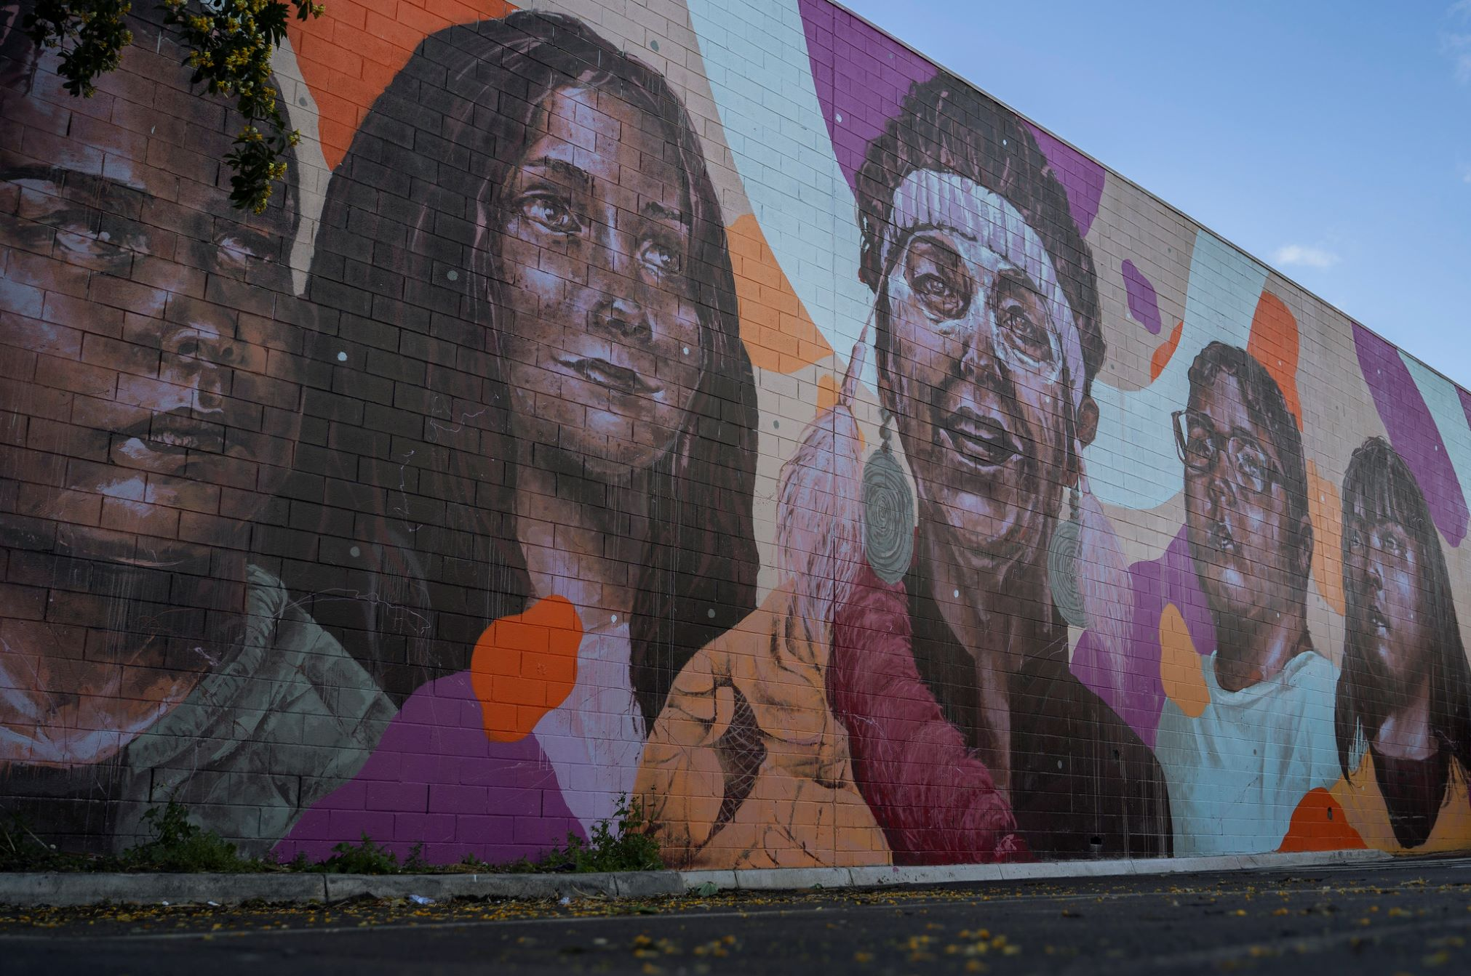

July 2021

Bayside City Council
Corporate Centre
76 Royal Avenue
SANDRINGHAM VIC 3191
T (03) 9899 4444
F (03) 9598 4474
www.bayside.vic.gov.au

Background
Bayside City Council is removing and preventing graffiti with the installation of street art murals across to Bayside, thanks to funding from the Victorian Government. Through the Working for Victoria grant, Council is pleased to support people getting back to work and improving their skills. The six-month project employs several people in cleaning, graffiti removal and street art mural installation.
The community engagement component of this project relates to the street art murals, aiming to create awareness of the project and involve the community in the type of art they would like to see in their suburb.

Consultation process

Consultation purpose
To seek community input in developing themes that characterise Bayside suburbs. These themes will be used to create briefs for street artists to design and install a number of street art murals in shopping strips, foreshore and public assets such as bridges, signal boxes, light poles, public toilets and walls.

Consultation methodology
The main tool for gathering ideas from the community for this project was Council’s online consultation website Have Your Say. The consultation was held for three weeks from 16 June – 6 July 2021
We invited the community to submit words, ideas, pictures, videos, significant buildings, famous people, historical and/or cultural references that come to mind when you think about their suburb.
Questions asked:
- How do you feel about the suburb where you live/work/shop/play/visit?
- What makes it special?
- Are there three words you could use to describe your suburb?
- What characterises your neighbourhood?
Participants were able to support other people’s ideas by liking or commenting on their posts. The feedback will be collated into a brief for the artists that they will use to inspire their design concepts. The panel will also use the community’s themes as selection criteria for approving the final designs.
The consultation was promoted via social media on the main Bayside City Council Facebook page, Bayside Arts Facebook page, Bayside Youth Services Facebook page and Council’s Instagram page. We used both organic and paid advertising. Although we encouraged people to visit the Have Your Say page to provide feedback and provided a convenient link, some social media users opted to provide their feedback on the page. This feedback has also been included in this summary for the Artist’s Brief.

Details | Activity
16 June – 6 July  Council’s Have your say page  3646 page views  2067 visitors  105 contributions  80 contributors  41 subscribers | Online consultation – Have Your Say  The online project pages included information about the project, funding and scope. The primary means of collecting information was through an open discussion tool where participants were asked to describe what makes their suburb special. There were individual sub-pages for each of the suburbs in Bayside:  - Beaumaris  - Black Rock  - Brighton  - Brighton East  - Cheltenham/Pennydale  - Hampton  - Hampton East  - Sandringham  A Frequently Asked Questions section was featured on the Have Your Say page. These questions were very comprehensive and could account for the reason no questions were submitted via the open–ended Question and Answer tool. There was just one suggestion for a theme for a mural that related to all Bayside rather an individual suburb.  The Engagement Plan Overview for this project was published in line with Bayside City Council’s Community and Stakeholder Engagement Policy 2021.  The online consultation was promoted via Council’s website (two news stories); Council’s enewsletter (This Week in Bayside) – for three consecutive weeks, two feature stories and three consultation ads; two posts on Council’s Facebook page; Council’s Instagram feed; Bayside Arts Facebook page; and Bayside Youth Services Facebook page.
Direct consultation
The artists contacted representatives of the Bayside Community Nursery and Friends’ Groups to research flora and fauna that is indigenous to the area. These volunteers were very helpful in supplying information, photographs and pictures that will assist the artists with their concept designs.
Social media reach 39,920 | Social media consultation  Paid advertisements were organised for the general Facebook post and targeted posts to individual suburbs which did not generate a lot of traction in the first two weeks. The suburbs that were chosen for individual suburb promotions were:  - Gardenvale  - Hampton East  - Cheltenham/Pennydale  - Brighton East  - Highett  Paid advertisements were also shared across Twitter and Instagram.

Communications activities
It is estimated that communications via Council channels reached nearly 40,000 community members. Communications shared via public social media groups further expanded this reach.
Sponsored social media advertising was particularly effective in raising awareness of the consultation, particularly among Bayside residents who may not subscribe to Council communications channels. A large proportion of visitors (1608 people 43.52%) were directed to the engagement webpages via social media. In contrast, (1076 people 29.12%) arrived at the engagement webpages via direct email from Council.
Engagement was promoted via the communication channels listed in the table below (results at 7 July 2021).
Communications tools and reach activities and participation
Details | Activity
Council website  274 views | News item: What makes your suburb special?  Page views 274, time on page 55 seconds
E-newsletter | This Week in Bayside e-newsletter  - 17 June 2021, 8378 recipients, 3.785 opens, 166 clicks  - 24 June 2021: 8,404 recipients, 3,928 opens, 49 clicks  - 1 July 2021: 8,416 recipients, 3,509 opens, 122 clicks
Social media (organic)  Main Council page  2,329 reach | Facebook post promoting consultation (organic)  Posted 18 June 2021: 9,908 reach, 137 comments, 11 shares  Posted 30 June 2021: 4,069 reach, 36 comments, 6 shares
Social media (organic)  Bayside Gallery  Bayside Youth Services | Facebook post promoting consultation (organic)  Reach 189  Reach 99
Social media (community groups) | Bayside Community Hub (22,000 members)  Posted 30 June 2021 by Bayside City Council
Social media  (paid advertising)  10,853 reach | Facebook ad targeting individual suburbs  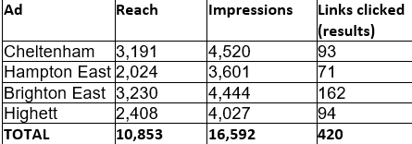
Social media  30 June | Instagram – 2,046 organic impressions  Twitter – 365 organic impressions

Participant profile
The consultation was open to all Bayside residents and the wider community, which includes those who they live, work, play, shop or visit in Bayside. No personal or demographic data was requested or collected to participate.
Have Your Say members who have indicated an interest in the topic area of location, received an alert to inform them of the opportunity to participate in this consultation.. For this project, 40 Have Your Say members (representing 36%) participated in the consultation. They were geographically spread across Bayside.
Member data
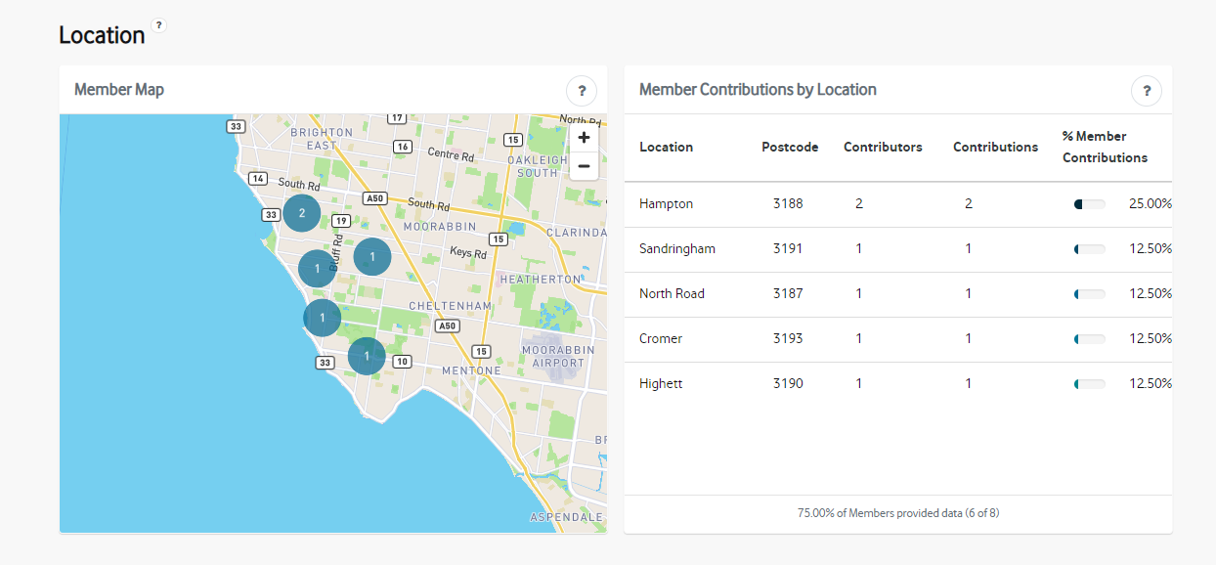

Consultation findings
The following section summarises the key themes which arose in community feedback for the Graffiti removal and street art project. as the comments were made in a public discussion forum, they are have been included verbatim.

Support for actions
The majority of people expressed support for the project as a whole:
- As a Hampton resident of more than 20 years and mother of 5 I believe so strongly in the many benefits of investing in beautification which also serves as an anti-graffiti strategy. I also love that it will provide scope for budding artists.
- Love this initiative. Well done
- Street art brightens my mood. Graffiti darkens my mood. Sandy Street Art Project has done amazing work in Sandy and I'd love to see them grow and contribute their work outside Sandy into my suburb Highett and other Bayside areas. If it's done right then it would create an income stream and employment for aspiring creative artists inc sculptures, pottery, places etc, not just paintings. In my opinion private/public funding should be researched to maximise opportunities. I've several ideas inc offering local cafe's/bars/shops 50/50 funding for engaging SSAP to paint murals inside or outside their premises. As part of the funding the council could insist on agreeing the artwork is appropriate and agree to a 2 week/1month decision. The council could also cap annual funds for such projects in line with budgets which would focus the private sector on submitting plans promptly. Happy to expand on this suggestion.
- Provide more opportunities and open space for our youth to offer their artistic talents. Legal walls to paint and create art on.

Others didn’t see the need for street art but expressed a desire for graffiti to be removed:
- Why do we need to put so called 'Art' up to replace graffiti? Why can't the council just keep the walls clean and tidy and have no spray cans art on any wall? Would look so much nicer.
One person felt that a comprehensive strategy is required to combat graffiti:
- Certain sites in Brighton are targets for the paint rats that deface our beautiful suburb There needs to be a combined effort to eliminate this disgusting menace from Bayside. A 3-pronged attack is required.
1. Prompt removal of ALL graffiti. There needs to be a council hotline so that graffiti is reported swiftly and removed within 24 hours of notification
2. More CCTV and police presence with a determination to prosecute offenders
3. Murals and artworks on target sites. In particular the electricity substation on the corner of New St and North Rd and the railway overpass in Martin St which is an eyesore. Aboriginal art seems to be a NO GO zone for paint rats.

Out of scope feedback
A few people (especially on social media) used the opportunity to vent their frustrations with issues that affect them but were out of the scope of this consultation. These responses were received in answer to the question posed – What do you love about your suburb? – and included referenced to high-density development, construction noise, and cycling safety issues.

Item-specific feedback
Although there were some common themes across all of the individual Have Your Say pages being nature, the beach and bird life, the purpose of the consultation was to draw out themes for each suburb so the feedback has been grouped under suburbs.

Beaumaris
The most popular themes for depicting Beaumaris were mid-century modern architecture and the beautiful foreshore, in particular Ricketts Point.
Topic | Community feedback
G Flip Mural - Australian singer, songwriter, producer, drummer, and music | G Flip (Georgina Flipo), super talented local girl raised in Beauey, Internationally recognised, ARIA nominated, MTV Europe Award for best Australian Act, growing and emerging talent with a huge future ahead!  Such an awesome personality that resonates with everything “Beaumaris”:  Humble, Beautiful, Hidden Treasure, Real, Talented, Artist, Home Grown, Creative, Amazing sounds (sounds of nature), untouched, born & bread…  Something unique & creative to the stereotypical visual representation of marine and bird life however a mural of G flip can also have subtle undertones to the beautification of the nature that epitomises Beaumaris and it’s diverse & natural surrounds
Mid-century architecture  1 support vote | I would like to see artwork depicting the Beaumaris mid-century architecture. Also art depicting the Australian impressionist artists that frequented the area.
COUNCIL EXAMPLE: Mid-century modern architecture (Beaumaris Modern)
Notable architects such as Arthur Boyd, Peter McIntyre, Neil Clerehan, Chancellor and Patrick, Yunken Freeman, John Baird, Mockridge Stahle Mitchell, McGlashan Everist, Anatol Kagan, David Godsell and Peter Carmichael designed and built their homes in Beaumaris
Ricketts Point, foreshore, nature and wildlife  1 support vote | Ricketts Point is the Beaumaris jewel which attracts residents and visitors alike to its natural beauty.  The Coastal Banksia canopies provided shelter for the Boon Wurrung people; the area was particularly important for women's business. Today the beach fringe area gardens are enjoyed by walkers and picnickers year-round and is home for many wildlife flora and fauna.  The sandy beaches and shallow inner bay waters facilitate safe swimming and are popular with young families.  Offshore, the Marine Sanctuary protected area is a haven for fishes, molluscs and seaweeds - a snorkeler's paradise.  Pelicans, silver gulls and cormorants regularly visit the exposed outer reefs to roost, drying their wings in the sunshine. Black swans also fly in to feed on the seagrass beds in the sheltered bays.  The ever-changing seasons and weather provide an always interesting kaleidoscope of natural wonders at Ricketts Point.
 | Red cliffs, coastal banksias, picnics, children playing on the beach, pelicans, black swans, dolphins, yachts, fish & chips, blue skies, cyclists, coffee, mussels, scallops, pasta, Sandringham railway line,
4 support votes | The juxtaposition between the Long Hollow heath, the Sandringham College, and the adjacent ovals (when seen from Balcombe Rd) says so much about how Beaumaris has evolved, keeping our reserves strong and vibrant whilst securing amenities in keeping with community expectations.  The reveal of the Beaumaris Life Saving Club, walking along the beach from Table Rock to Rickets Point and the same with the Rickets Point Tea House. Both these reveals offer significant opportunities to explore the natural surroundings of the sea, rocky platforms, flora and bird life whilst the buildings emerge with sympathetic architectural designs from this natural landscape.
1 support vote | COUNCIL EXAMPLE: The underwater interest at Ricketts Point Marine Sanctuary is considerable. Sandstone rock platforms extend from the shore, supporting a great diversity of flora and fauna. It is characterised by extensive sandstone intertidal platforms, subtidal reef, soft substrate, sand and seagrass habitats. There are secluded caverns and under-rock ledges hosting colourful sponge gardens. Fifty-one species of fish have been identified in the Sanctuary, the most common being southern hulafish, zebra fish, dusky morwongs, moonlighters and Australian sweep. The Sanctuary is also home to smaller and less mobile animals including abalone, winkles, sea urchins, brittle stars, sea stars and crabs. Crucial to this rich marine eco-system are the algae, seaweeds and seagrass meadows which provide a beautiful palette of verdant green, red and brown. The majority of the area is shallow water of less than five metres, providing an easily accessible recreational area for snorkelling and diving. Source: http://marinecare.org.au/about-ricketts-point-marine-sanctuary/
History  1 support vote | COUNCIL EXAMPLE: In the late 1800s a horse drawn tram connected Beaumaris with the train line in Sandringham
Shopping precincts  1 support vote | COUNCIL EXAMPLE: Beaumaris Seaview and Concourse shops

One person raised a suggestion regarding establishing a community book recycling facility to share books and connect with other readers.

Black Rock
Participants in the Black Rock consultation voiced the sense of community, the beaches, playgrounds and Black Rock House as being important themes for this area.
Topic | Community feedback
Beach, Half Moon Bay, playground, community | Black Rock is a lovely place to live, lovely village and great beaches. Half Moon Bay is beautiful. However, it is being spoilt during the summer with too many noisy jet skis. They weave through bathers to park up on the beach, can be up to ten jet skis at a time. it’s only a matter of time before a child is hit. There needs to be laws put in place that they at least stay the other side of the pier. PLEASE look into this matter.
 | Black rock - a beautiful suburb we feel so lucky to call home. Stunning beaches, lovely community, a great place for children. Beach is a playground of senses for little ones to explore and enjoy. Birds singing, fresh air, amazing views and peacefulness are my favourite things about my neighbourhood (and all the art!)
3 support votes | Black Rock is a celebration of community. By this I mean everything about Black Rock is focussed on community. A diverse shopping village which is conveniently located for both locals and visitors, a coastal area that caters for a range of recreational activities, a safe children’s playground near the beach, an excellent public transport system, medical facilities and best of all(!), friendly, welcoming Black Rockians.
 | Black Rock- Beautiful beaches, magnificent sunsets, friendly locals, endlessly inspiring, good for the soul
Black Rock House | I got married in the gardens of this magnificent old homestead. The Moreton bay fig at Black Rock House is spectacular.
Beautiful Black Rock is filled with charm, beauty and happiness
Historically Black Rock House is a treasure
Laneways and beach road filled with wonderful art

Brighton
The most support from this suburb’s consultation was to feature the iconic Icebergers that swim daily at Brighton Beach. There was also support for flora, fauna and the now well-known personality – Karen from Brighton.
Topic | Community feedback
Karen from Brighton  1 support vote | Please do a tribute to Karen from Brighton!
Fauna and beach | I love to see the black swans arrive when the sea grass appears. It’s fantastic that we still have the remains of indigenous maddens and lovely to see children enjoying themselves with such simple pleasures on the beach
Flora | As a great idea for graffiti removal and replace it with great art I like to see some Art with the native plants in it (like protea, gumtree leaves, bottle brush trees and so on)
Icebergers  3 support votes | Icebergers have been braving the elements at Brighton Beach since the 1880s These locals are inspiring and form a unique community

Brighton East
The people provided feedback relevant to the topic voiced support for the beautiful parks (Landcox, Hurlingham and Dendy); walking dogs in the friendly neighbourhood; and the great shopping strips. The most support was given to the tram on Hawthorn Road – the only tram route in Bayside with a unique history.

Topic | Community feedback
Parks and community | HYS: My family and I love living here. It has the right mix of family homes, apartments and townhouses. This leads to a great mix of families, singles and elderly people. This balance attracts lovely neighbours who are very thoughtful and respectful. We have beautiful Dendy park, Landcox park and the beach close by. Great selection of schools and lots of room to spread out.
Parks, community and dogs | FB: I love my kind and friendly neighbours, the fact I can walk to almost everything. I love walks at Dendy Park with my dog, and the beach so close by.
Parks and dogs | FB: Dendy Park a central point for many activities and dogs playground too .
Parks, community and tram | HYS: East Brighton has been my home for 25 years. It holds the precious family memories of my Grandparents and parents, along with our neighbours who we call friends.  The sound of the Hawthorn Rd Trams, Landcox and Hurlingham parks buzzing with children, their families and pets. The beautiful gardens, trees and homes add to its beauty.  It has heart and soul.  It is my home.
Tram/history  4 support votes | HYS: The terminus on Hawthorn Rd where it meets Nepean Hwy is apparently the southernmost tip of Melbourne’s public tram network. There is no regular tram stop closer to Antarctica anywhere in the world. I read this in a quaint book about Melbourne’s tram network in a shop in Brighton specialising in model trains. I’ve been testing the claim over the years as I have travelled and there is a tourist tram in Christchurch NZ but it doesn’t count as a standard PT network tram. Sit down for a coffee in Brighton East shops and there’s nothing that hints at this extraordinary but everyday fact. This might inspire a mural to the southernmost stop of the 64 tram.
FB: As the tram starts at Brighton East, what about a Mural of a tram with Beach boxes and city lights.

Make it relevant and let’s not do anymore people murals.
History | What about a mural to the founders of Brighton and its environs? Dendy, Were et al
Shops | FB: Friendly shopping strips, a smile a hello,
 | FB: it's a great shopping village.
FB: I think Melbourne's best fish and chips! And burgers.
Pier 33 Fish & Chips
Burger Time

Flora | Some tubs of geraniums please.
 | Trees and lots of them.

Brighton East was targeted with a Facebook ad to elicit more feedback. Relevant comments have been included in the table above. Out of scope comments (2) related to building, planning and development in the area.

Cheltenham/Pennydale
The feedback for Cheltenham/Pennydale did not really assist with identifying community themes for street art in this area but it did identify some sites that might be relevant for future street art projects.
Topic | Community feedback
Identifying sites for street art | HYS: Given the recent recognition of the Pennydale neighbourhood within Cheltenham, it would be great to incorporate a clever welcoming mural/street art near the entrance to the area from the Kingston side. A large scale graffiti mural with the name Pennydale incorporated on the south side of the underpass of the Bay Road Bridge and/or near the entrance to Pennydale on the Park Road entrance just past (Cheltenham Station) where there are long uninspiring fences running parallel to the train lines. There are some beautiful murals around Bayside and it would be great to have some local artists create visually appealing murals for us locals to enjoy that are walking distance from our homes. In particular, families with children enjoy local murals (there are a few great ones already in Black Rock) and it would be wonderful for the Pennydale community to also have some brilliant artwork cleverly integrated into our community to enjoy. The other benefit to creating artist murals/street art is that it tends to keep local unsightly graffiti away in those areas.
 | HYS: I love Pennydale but the entrance to the suburb (and Bayside) on Bay Road at the rail bridge near Southland leaves much to be desired. It's a dark, graffiti covered concrete rail bridge that does nothing to signify the transition from Kingston to Bayside, or the beautiful nature of our city. I would like to see the footpath under the bridge widened by 1-2 feet. I would like to see lighting added and some pleasant murals, perhaps by local artists.
HYS: I have lived in Heather Grove Pennydale for 42 years and love its friendly community, walkability and safety. Sadly, the LXRP removed many mature canopy trees and replaced them with acres of concrete, which has made parts of the railway line from Park Road to Heather Grove very bleak (as you can see from the before and after aerial photos attached).
Improved access for cyclists along the railway is great, but we now get more graffiti on fences especially along the SUP. There is also nothing to soften the view to Southland or screen the noise and dust from trains passing by.
Murals and plantings would make a big difference. A traffic island in the court at the bottom of Heather Grove hill would also be a great step forward, helping to regain some of our lost amenity as well as ensuring the safety of pedestrians crossing the railway line.
The Pennydale community has already stepped forward to help with plantings, but we need Council support to make more substantial progress.
FB: Under the rail bridge on Bay road is a perfect place to put in murals and keep the graffiti away. Even though this is a major road with vehicles at all hours, the graffiti here can fill the walls very quickly. Maybe a railway mural or 2 to go here.
Also, along the railway line from Park Road to Heather Grove where the Level Crossing Removal did their work there are brand new fences that have already begun being covered in graffiti. Again, maybe a very long mural on the railway or something showing the history of the area over time starting at Cheltenham where the station opened up Cheltenham along the line towards Southland where the Shopping Centre opened up that area and the new Southland Station.
There are also 2 laneways in Pennydale - 1 leading from Pennydale Park to Paul Street and the other leading from Seide court to Bay road. These lanes also get vandalised and graffitied from time to time. A lovely mural in each would brighten the laneways up and make them more inviting and less intimidating.
Lastly, the wall of the Olympic Avenue Kindergarten with Pennydale Park is a large wall that also lends itself to a lovely mural that could prevent graffiti. Something suitable could be children playing in the park or sandpits in the Kinder or similar.

HYS: Not sure what toilet block you're referring to but the public toilets at the undercover parking behind charman roadi think should be market themed.
In reference to the markets that take place there but also a nod to the Pennydale orchard history of the area.
 | FB: Mural on the side wall of The Fore apartments on Charman rd is full of Cheltenham inspiration

One out-of-scope comment requested rotundas to be installed in Cheltenham Park.

Gardenvale
Only one comment was received for the relatively small area in Bayside known as Gardenvale. It received one support vote for the suggestion of a theme relevant to the history, bay and/or marine life.

Topic | Community feedback
History, bay and marine life  1 support vote | This strip shopping centre should be preserved to keep its uniqueness as it a charming and eclectic part of Bayside. The fact that everything is bound within a 300 metre area makes it great to shop in. The strip has nearly everything you need from hospitality venues, health and medical businesses, food shopping, fashion and homewares. The growth of new apartment complexes has given the strip a lively buzzing atmosphere. The street art should reflect what the strip is and there are lots of walls crying out for a mural. It could be from the Martin Brothers after whom the street is named to a connection with the bay and the marine life found in it.

Hampton
The popular themes for Hampton were Rainbow Lorikeets, beaches and sporting clubs.
Topic | Community feedback
Flora and fauna | I appreciate the artwork already in existence and congratulate the committee/artists who have contributed, e.g. sculpture of deck chair at corner Hampton and Grenville Sts. and historical tiles set in footpath, I would like to see more of this and perhaps birds and bushes painted on walls.
4 support votes | - Flocks of Rainbow Lorikeets and Musk Lorikeets partying overhead and among the flowering gums along the railway line and in parks.  - The wide sweep of the bay on a clear day when the arms of the two peninsulas almost seemed to meet and yachts dash through the sparking water.  - Farmers markets full of wonderful produce, families, dogs, kids, the lot.
 | When I think of Hampton, I think of rainbow lorikeets flying around and perching in the trees.
 | My suggestion is to look at the back of shops facing the small carpark nr Woolworths Hampton. I would prefer money spent on planting trees and plants and beautifying public spaces around Hampton library for example. An ideal spot for street art Spring themed in Australian native plants.
Beach, parks, family, community clubs and facilities, pets, cafes | I love that our seaside community is so family focused, safe, pet friendly, environmentally conscious and active.  The beautiful beaches, parks, sporting clubs, farmer’s markets, cafes and restaurants create a very relaxed, outdoor, active culture.
 | Beach, weekend outings, cycling, family time, inter-generational connection, close knit community, Hampton village, kids, laughing.
 | When I think of Hampton, I think of the Life saving club, summer days at the beach, dogs having a ball at the dog beach, cafes, kids running around playgrounds and parks,
1 support vote | Community clubs and facilities where we interact with other locals for sport or leisure, eg Hampton Rovers Football club, the netball, cricket, soccer, Rotary, libraries, etc etc. For example, if artspace is near the library the theme could be books. All provide health, wellbeing and friendships within our suburbs for all. Thank you. 😀

Hampton East
Ducks was the most popular theme for Hampton East and the parks, playgrounds and trees.
Topic | Community feedback
Parks, playgrounds, cafes | Parks and playgrounds and trains.  Little elephant coffee and wides streets
Parks, flora, ducks, dog walking | Basterfield park & the ducks, dog walking, possums, native trees.
Parks, flora, ducks, dog walking, houses with yards and pools | Hampton East is a small bit beautiful superb boasting Parks and ponds, greenery everywhere and just a short trip to everywhere in Bayside.  Beautiful gum trees abound.  Great restaurants, shops and so close to the beach. Dog walking, bike riding and the city not too far away. Swimming pools in many backyards, large houses with actual backyards. Veggie gardens, fruit trees and chooks!
Parks, ducks | With little kids, everyone almost always thinks of Basterfield park and its ducks when I mention I live in Hampton East. Any mural should depict the ducks
Parks | Hampton East is a small bit beautiful superb boasting Parks and ponds, greenery everywhere and just a short trip to everywhere in Bayside.  Beautiful gum trees abound.  Great restaurants, shops and so close to the beach. Dog walking, bike riding and the city not too far away. Swimming pools in many backyards, large houses with actual backyards. Veggie gardens, fruit trees and chooks!

A range of specific concerns were raised during the consultation that were out-of-scope including perceived lack of investment in the Hampton East area and condition of local affordable and social housing developments.

Highett
Children and the sense of community in Highett, particularly during lockdown, received the most support for any suggestion across all of the suburbs in this consultation. A total of 18 people supported this theme.
Topic | Community feedback
Community feel, children and acceptance | I’m a Taiwanese.I has been Australia over 7 years and live in Highett over 7 years.  Highett is my turning point, my husband and I have 3 children all grow up in Highett,  They also get a lot of help from MCH Highett, even my girl went to Livingston kindergarten, sometimes we can see Greek group have lovely meeting in community center,let me feel whatever you went,love always around you whoever you are.  In Highett In bayside,many peoples you don’t know but they always give you a smile and ask how are you?  It encourages me and make me feel better if I’m lost in my position.  For my opinion, I would like to see different articles about love Life and cultural heritage.  Because I want everyone feel love and remember it, whoever you are wherever you go, you are not alone, we are here doesn’t matter culture or skin colour.  Love is no limit.
16 support votes | I would love to give back to the amazing Highett community who welcomed us in 2020 when we brought our home during the first lockdown. I absolutely love the village mentality and community support I feel whether it be going for a walk or shopping in the local stores, there’s such a warmth that to be quite frank, I wasn’t expecting! I’m an artist and mum of 3 little ones and I’d be honoured to offer my time for free to paint a wall mural on Peterson reserve to celebrate our children and Their resilience over the last 18 months, they coped tremendously well whilst enduring huge changes, unsettled parents, home-schooling and losing their freedom. They took it in their stride putting teddys in Windows, drawing rainbows everywhere and often using their pets as a therapy So my design is a celebration of our children and our community and it will hopefully brighten up a dark spot near the car park on Peterson reserve and stop graffiti. (see scribbled design in pic, actual mural will be perfect) white background rainbow colours.
History | I love the photos of Highett that are in Woolworths car park entry. Highett has gone through many changes over time and it would be great have an artistic photo display showing some of the beautiful structures that used to be in Highett e.g. the old post office and bank on the corner of Highett Rd and Henry St, Highett P.S or older photos of the area. I love the new character of Highett that is developing with bars and restaurants so a fitting mural and great landscaping will catch the eye of commuters in Highett.
Music, bohemian atmosphere  2 support votes | Highett was/is the Bohemian part of our Bayside Community. It’s changing face is wonderful .. kicking off a music street fest a few years back.. I’d love to see some music based street art with one of those outdoor pianos painted in multi colours in the heart of the Highett shopping strip close to the bubbling restaurants near the station..🎶🎹🪕🎷
Collage of young people’s art | Let's give our young people a voice. I saw some amazing artwork in councils offices the other day all created by young people in bayside. Could there be a vote for the best one to be used as street art in Highett? Or a collage of the entrants? I have no idea if any artists were from Highett.
Indigenous art | I’d love to see art that represents the boon wurrung people. Get an indigenous artist to design a mural or sculpture that represents their culture and this land.

Sandringham
The common theme for Sandringham was a beachy/marine focussed theme or the beautiful views along the foreshore. There was a specific suggestion for the Beaumont Street underpass to celebrate the historical creek that used to be in the area which received support.

Topic | Community feedback
Foreshore, community, cafes and restaurants | I love the Community  Feel of Sandringham. Everyone knows many people in their local neighbourhood. It’s kinda old fashioned how suburbs used to be where everybody looks out for one another. Apart from the sheer beauty of Bayside’s foreshore this is the single most thing I value as a resident.
3 support votes | Have an abstract mural that reflects colours of the ocean. The mural could even incorporate the colours of the red cliffs as well, rolling into the ocean.
 | Living in Sandringham is like being on holiday everyday! With its beautiful beaches, fabulous cafes and restaurants and friendly locals who look out for each other it's a great place to live and bring up a family.
1 support vote | I love the walking track along the esplanade in Sandringham (and beyond). It would be nice to see a mural of a leafy walking track with some trees, looking out to the red rocky cliffs and the ocean. A different take on the classic ocean pic to include the nature walk.
3 support votes | The Sandringham Foreshore Association love the work of the Sandringham Street Art Group who have transformed many boring unsightly boxes and walls, into dynamic, interesting, colourful and inspirational artwork that tell stories that reflect the history and life of Bayside. We love the beachy themes, stories of the First Nations People and images of wildlife and life in Bayside. Please continue your great work, where-ever possible. The illustrations are bringing life, happiness, joy, fun and playfulness to our neighbourhood and that of our character. Also, can we suggest more Bayside environmental themes to help appreciate our marine life, local beaches and cliffs, and raise awareness of our local archaeological, geological, cultural, and heritage sites such as the Bayside fossil sites. The Bayside cliffs and fossils are unique to Sandringham all the way to Beaumaris. Eg a "fossil" mural - bright & stylized
1 support vote | Love the village atmosphere and beautiful coastal walks. Would like to see nature and seascape murals.
1 support vote | ALL the portaloos in Bayside look horrible and can do with a good beachy make up. Especially the portaloos in front of the Sandringham Lifesaving club and in the playground area opposite Sims St on Beach Rd, next to Sims St car parking area.  Beachy themes on Portaloos would be great and fun!
Historical creek  2 support votes | On the north side of Bamfield Street from Sandy Primary to the Beaumont Street underpass used to run a creek. This underpass is used by many residents and children. Why not re-create an artistic impression of this creek with creatures peeking out (for kids to spot such as sleeping owls, possums etc) and local flora. The underpass could be part of a walking tour/theme extending from the Sandy School caterpillar thru the underpass to Rosie's parrots in Post Office Lane, the Coles dogs and beyond. Could consider a solar powered light to illuminate at night.

A range of specific concerns about Sandringham that were out-of-scope to this consultation included planning, building and development issues, using vegetation to deter graffiti, relocation of street lights and underground powerlines, appreciating the natural beauty of the local environment rather than artist’s impressions, recognising Bayside’s Traditional Owners and protecting the foreshore.

General
One general comment was received on Instagram that was not specific to any suburb which was to feature local vegetation and bird life.
A further suggestion was submitted under the Question and Answer section, which is general for Bayside to create a street art mural showing PWD's (people with disabilities) and all the different sports they play.

Project Evaluation
Engagement Plan Overview
An Engagement Plan Overview (Appendix 2) was published as a subpage on the Have Your Say website as part the consultation on the Graffiti removal and street art project. The Engagement Overview page was viewed 27 times (24 visitors) during the consultation period with no comments or questions received.
Q&A tool
The Q&A forum received no questions just one suggestion for a theme that didn’t fit neatly under any suburb was more of a Bayside wide suggestion about representing people with additional needs. This is outlined in section 4.2.11.
The reason no questions were received which could be attributed to the comprehensive Frequently Asked Questions section. The Frequently Asked Questions on this page were viewed 16 times by 15 individuals.
Participant reach and participation
Targets set for the reach and participation, based on similar projects, were all exceeded.
It was proposed that the engagement activities would attract at least:
- 500 visitors to the online engagement platform Have Your Say (exceeded, 2,067)
- 50 contributions (exceeded, 105 contributions)
- 20 project subscribers (exceeded, 41)

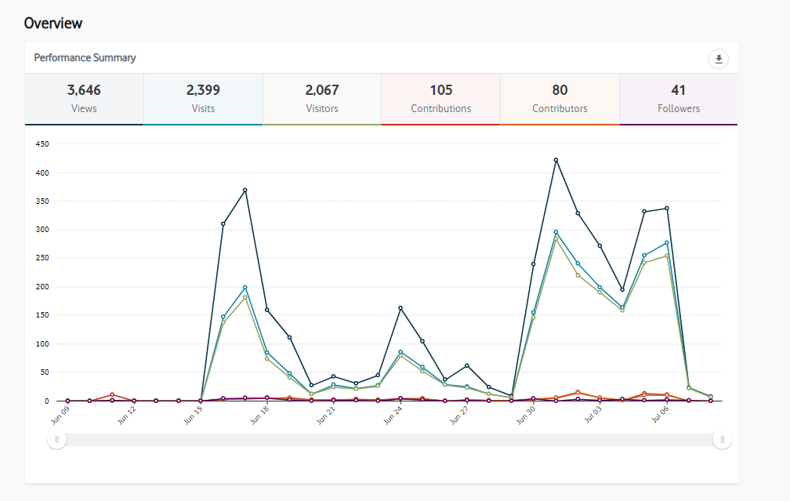
It was proposed that the communication activities would achieve at least:
- engagement with news articles 100 views (exceeded, 274 views)
- social media engagement 3% (exceeded, 6%)
- reach 15,000 (exceeded 61,756)
All project deadlines were met, and the engagement process was delivered within budget.

Next steps
Consultation on the Graffiti removal and street art project has been completed with community feedback being included in the Artists’ Brief to design concepts for the project. The concepts will be considered by a Panel consisting of:
- Joanna Bosse is the Curator of Bayside Gallery, owned by Bayside City Council, and is leading the Panel process for selecting designs created by the artists.
- Ian Cochrane is Secretary of the Sandy Street Art Project and is a Sandringham resident and a writer, with a background including Visual Arts, Engineering Design, Local Government, Project Management, Web Design and Social Media.
- Geoff Bransbury is a long-time resident of Beaumaris and the founder and leader of Neighbourhood Watch 3193 Graffiti Busters program which was a finalist in the 2020 Keep Australia Beautiful Awards. Geoff has also been involved with NHW 3193’s mural projects in Black Rock and Beaumaris. Geoff is passionate about keeping Bayside beautiful and works tirelessly as a community volunteer.
- Daniel Vaughan is a local restaurateur who has owned and run The Pantry Group since 1993. Daniel lives in Bayside; his children attend school in Brighton and he thoroughly enjoys being involved with the community wherever he can.
- Leanne Johnson is the Cleaning and Graffiti Management Officer at Bayside City Council and is coordinating the Working for Victoria Graffiti and street art project in partnership with CityWide.
On assets such as signal boxes, power poles and bridges which are owned by other organisations such as VicRoads, United Energy or MTM, the designs will also be submitted to them for approval.
The designs will be featured on the Have Your Say project page and promoted via news updates to subscribers; website news stories; and on social media.

Appendices

Appendix 1: Have Your Say questions
The consultation on Have Your Say was not set up as a formal survey but as a discussion forum where participants were asked to make comments or upload pictures or videos.
The below paragraph was posted on the top of each suburb page to generate ideas and discussion:
Have your say
How do you feel about the suburb where you live/work/play/visit/shop? What characterises your neighbourhood? What images would you like to see across Bayside that will add colour and life to our municipality? We invite you submit words, ideas, pictures, significant buildings, famous people, historical and/or cultural references that come to mind when you think about your suburb. You can support other people’s ideas by liking or commenting on their posts. Your feedback will be collated into a brief for the artists that they will use to inspire their design concepts. The panel will also use the community’s themes as selection criteria for approving the final designs.

6.2 Appendix 2: Community Engagement Plan Overview

Project objective
We are removing and preventing graffiti with the installation of street art murals across to Bayside, thanks to funding from the Victorian Government. Through the Working for Victoria grant, we are pleased to support people getting back to work and improving their skills. The six-month project employs several people in cleaning, graffiti removal and street art mural installation.
We are seeking community input to develop themes that characterise Bayside suburbs. These themes will be used to create briefs for street artists to design and install a number of street art murals in shopping strips, foreshore and public assets such as bridges, signal boxes, light poles, public toilets and walls.

Project impacts
We want local communities to be involved with developing street art to deter graffiti. Street art can deter graffiti as graffitists are reluctant to ‘tag’ over other artists’ work. Other impacts include:

- Street art adds colour and interest to local areas and deters graffiti.
- Community involvement will ensure briefs are reflective of the neighbourhood.
- Community can submit ideas about things that make a local area special, etc. what they love about the location area.
- Involving the community in developing suburb themes will ensure a sense of ownership of the artwork designs.

What information do we need from the community?
We would like the community to have a say in the type of street art that will be installed across Bayside.

What can the community influence?
- themes that will inform the artists’ briefs to develop the artworks
- traders will have some influence over the timing of installation in shopping precincts

What can’t the community influence?
- choice of artist
- materials used
locations
- Working for Victoria graffiti removal and mitigation program

Stakeholders and community
This stakeholder assessment is a generalised understanding of sections of the community that have a connection to the project or matter. This information is used to understand the types of tools and techniques that will achieve the strongest and most effective outcomes for engagement and communication.
Impact: What level of change the stakeholder / community segment may experience as a result of the project / matter
Interest: What level of interest has been expressed or is anticipated
Influence: Reference to the IAP2 Spectrum
Stakeholder  Be specific | Interest  L-M-H | Impact  L-M-H | IAP2 Level
VicRoads | M | M | Consult
United Energy | M | M | Consult
PTV | M | M | Consult
Metro Trains | M | M | Consult
Directly affected traders (own the assets) | H | H | Consult
General traders | M | M | Consult
Sandringham Street Art Project | H | M | Consult
Church Street Traders | H | M | Involve
Neighbourhood Watch Beaumaris | H | M | Involve
Sandringham Life Saving Club | H | H | Consult
Residents living close by (within sight lines of the artwork) | H | M | Consult
Residents living close by (but not within sightlines of artwork) | M | L | Consult
Visitors to the area | L | L | Consult
Local artists | M | L | Consult
Residents who own properties where fences are being cleaned | H | H | Involve
General Bayside community | M | L | Consult
Local schools | L | L | Consult
Department of Environment, Water, Land and Planning | L | L | Consult
Foreshore/Environment Groups | L | L | Consult

Selected tools and techniques
The tools and techniques selected for this project are informed by the project content, stakeholders and type of feedback sought. The impact of COVID-19 restricts our ability for face-to-face communication, as well as slower distribution of printed mail.

Key tools for communicating the project
- email notification to Have Your Say members
- website news stories and This Week in Bayside e-newsletter
- social media posts – organic and paid
- direct emails to key stakeholder groups, including trader groups and local schools
- Face-to-face/email/phone communication with impacted stakeholders
- Letter drop to affected residents/traders where required

Key methods for gathering feedback
- online engagement through Have Your Say, including opportunity to ask questions, as well as provide feedback
- phone, post and correspondence to Cleaning and Graffiti Management Officer

Project timelines
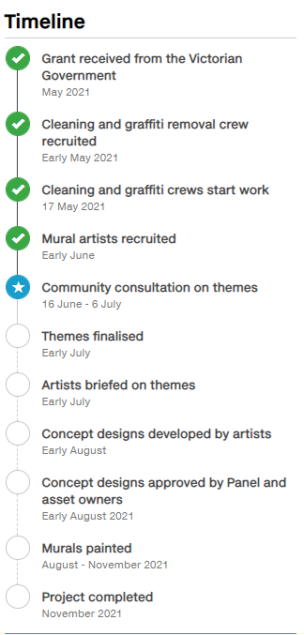

Stage title | Stage Status:  Incomplete / Active / Complete | Timing
Grant received from Victorian Government | Complete | May 2021
Cleaning and graffiti crew recruited | Complete | May 2021
Cleaning and graffiti crew start work | Active | 17 May 2021
Mural artists recruited | Complete | May/June
Community consultation on themes | Complete | 15 June – 6 July
Themes finalised | Complete | Mid July
Artists briefed on themes | Incomplete | Mid July
Concept designs developed and approved by Panel | Incomplete | Late July
Murals painted | Incomplete | Aug - Nov
Project completed | Incomplete | November

Decision-making process
The artists will prepare concept designs to be evaluated against the community developed themes and approved by the asset owners (VicRoads, United Energy, PTV and Council). The final designs will be selected by a volunteer panel consisting of:
- Joanna Bosse, Curator of Bayside Gallery
- Ian Cochrane, Secretary of the Sandringham Street Art Project
- Geoff Bransbury, Neighbourhood Watch 3193, Graffiti Busters program
- Daniel Vaughan, Church Street Traders Association
- Leanne Johnson, Cleaning and Graffiti Management Officer, Bayside City Council
The successful designs will be shared with the community and the murals will be painted across Bayside from July – November 2021.

More information
Leanne Johnson, Cleaning and Graffiti Management Officer, ljohnson@bayside.vic.gov.au or call 9599 4613

buildings, famous people, historical and/or cultural references that come to mind when you think about your suburb. You can support other people’s ideas by liking or commenting on their posts. Your feedback will be collated into a brief for the artists that they will use to inspire their design concepts. The panel will also use the community’s themes as selection criteria for approving the final designs.

