Bayside Urban Forest Strategy
Background Report

Contents
- Traditional Owners acknowledgement 5
- Executive Summary 6
- Introduction 7
Methodology & Stakeholders 7
Guiding Principles 9
Regional Targets: Living Melbourne Strategy 9
Bayside Tree Canopy Cover in Broader Context 10
- What is “Global Warming” and “Climate Change”? 13
- Bayside’s Climate Emergency Action Plan 16
- What is an Urban Forest? 18
- The Role and Benefits of the Urban Forest 18
- Policy Context 21
- Bayside Local Context 21
Bayside’s Population and Age 24
- Vulnerable populations in Bayside 27
Women’s safety 29
- Community Views 31
- Bayside’s Urban Forest 40
- The Council managed tree population 42
Tree Health and Age (Maturity) of Bayside’s Tree Population 42
Species Diversity: Bayside’s Tree Population 44
Analysis of Bayside’s Existing Urban Forest and Tree Canopy Coverage 52
- Key Challenges to Bayside’s Urban Forest 54
Socio-Economic vulnerability 54
Older people, children and people with disabilities and carers 54
Bayside Tree Management: Maintenance, Removal and Replacement
Planting 58
- Key Challenges: Private land 66
Bayside Landscape Guidelines 2016 73
- Key Challenges: Public use and Council-owned land 85
Trees removed from public land due to Vandalism 87
Identified Vacant Street Tree Sites 87
- Summary 90
- Appendix 1 – Policy Context 91
- Appendix 2 – Glossary 103

LIST OF FIGURES
Figure 1: Photo of Banksia integrifolia
Figure 2: Tree canopy cover across metropolitan Councils (2018)
Figure 3: Tree Health in Bayside’s tree population on public land as at June 2020
Figure 4: Tree Age (Maturity) in Bayside’s tree population on public land as at June 2020
Figure 5: Tree Canopy Cover in 2014 and 2018
Figure 6: Park Tree Diversity
Figure 7: Popular Tree Families in Bayside
Figure 8: Useful Life Expectancy of trees in Bayside
Figure 9: Street Tree Diversity
Figure 10: Bayside Estimated Tree and Vegetation Canopy Cover adapted from State Government canopy cover from 2018
Figure 11: Tree Protection and Tree Removal Permit Processes
Figure 12: Minimum size requirements for Local Law Tree Removal Permit
Figure 13: Tree Removals and Plantings by suburb 2009-2019
Figure 14: Clause 22.04 Bayside Business District Policy within local section of the Bayside Planning Scheme
LIST OF MAPS
Map 1: Inner South East Region Vegetation Cover and Tree Canopy
Map 2: Australian Rainfall for 2018-2019
Map 3: Average Surface Temperature – Australia Source
Map 4: Australian Average Rainfall (1999-2018) Source: Bureau of Meteorology
Map 5: Municipality of Bayside
Map 6: Strategic Residential Framework Plan
Map 7: City of Bayside, Index of Relative Socio-economic Advantage and Disadvantage
Map 8: Public Open Space and Conservation Reserves Across Bayside
Map 9: Street and park trees that are below ‘fair’ health
Map 10: Useful Life Expectancy (ULE) of Trees in Bayside
Map 11: Vacant sites in Bayside
Map 12: Vegetation Cover in Bayside
Map 13: Tree Canopy Cover in Bayside
Map 14: Location of Significant Land Overlay in Beaumaris
LIST OF TABLES
Table 1: Targets for tree canopy and for canopy and shrubs, by region to 2050 (Living Melbourne
Table 2 Estimated Tree Canopy Coverage n Melbourne’s Metropolitan Regions (2019)
Table 3: Percentage of Tree Canopy Cover for Inner-South Eastern Councils (2018)
Table 4: City of Bayside Forecast Dwellings and Development by suburb between 2016 and 2036
Table 5: Previous Feedback received from Community Consultation
Table 6: Useful Life Expectancy
Table 7: Planting Attrition from 2007-2019
Table 8: Use of Myrtaceae Family per Suburb
Table 9: Local Law Tree Removal Permits (Approved, Refused & Total Number of Applications) 2020-2015
Table 10: Assessment criteria for local law tree pruning or removal permits from different Councils
Table 11: No. of Requests per Suburb (2016-2020) for trees to be identified on the Significant Tree Register.
Table 12: VPO3 Permits 2019-2017

Traditional Owners acknowledgement
Bayside City Council acknowledges the Traditional Owners and custodians of this land, the Bunurong people, and we pay our respects to their Elders past, present and emerging.
Indigenous culture and heritage is respected and appreciated by the Bayside community who will work together to create a better future for all Australians.
Bayside City Council recognises the distinctive relationship that Indigenous people have with local land and waters, including trees, hills and valleys, creeks and foreshore of Bayside.

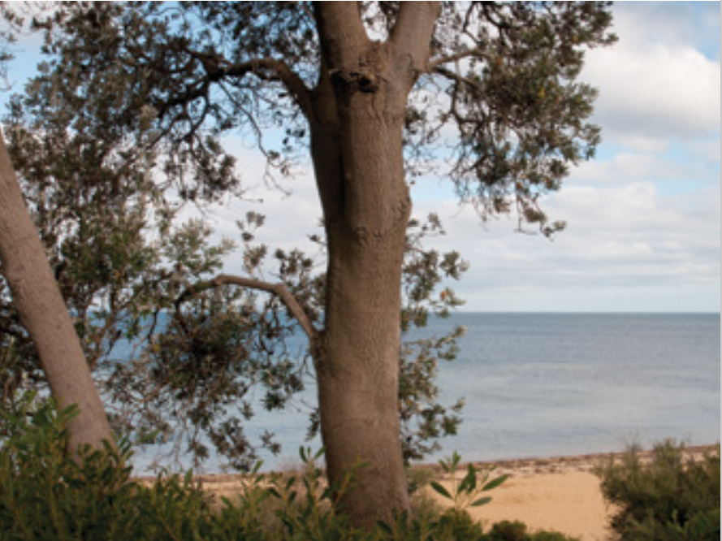
Figure 1: Photo of Banksia integrifolia – Coastal Banksia (near Ricketts Point)

Executive Summary
Across Bayside, tree retention and protection has become an increasingly urgent issue to address. This Draft Strategy has been developed to enable the protection and expansion of the Bayside Urban forest. There are many challenges that are impacting the Bayside Urban Forest, and this document identifies actions for Council and the community to undertake to ensure we can increase and diversify new trees in our urban forest, while also protect and monitor our existing urban forest.
In December 2019, Bayside City Council declared a climate emergency and has since prepared a Climate Emergency Action Plan 2020-2025. The impacts of climate change will continue to be an emerging and evolving issue for the Bayside community to address, and expanding the Bayside Urban Forest is one way that we can help cool the urban environment in which our residents live within. In addition, Bayside City Council has endorsed Living Melbourne: Our Metropolitan Urban Forest in 2019, which sets out regional targets for tree and vegetation canopy cover to be reached by 2030, 2040 and 2050.
The removal of trees on private property is a significant and challenging issue to address as trees on private property also make up a significant proportion of Bayside’s urban forest. The management of “private” trees, to some extent, falls into the hands of individual property owners. There is, however, a regulatory framework that governs tree removal, which is primarily the Bayside Planning Scheme and Local Law No.2. In administering these frameworks, Council has encountered several challenges in how they operate and how data is recorded in relation to protecting trees and vegetation on private property.
The frameworks often overlap, particularly when a planning process involves the removal of a Local Law protected tree. Further to this, there are limitations to regulating vegetation removal where tree protection becomes a challenge in the face of ongoing development pressure and individual (community) attitudes towards trees on private property.
By undertaking a number of process improvements and streamlining Council’s biodiversity, tree and related strategies, it will result in a more clarified set of outcomes that will increase the growth of Bayside’s urban forest.
Undertaking a precinct-based approach to the protection, retention and enhancement of the urban forest will allow Council to consider the local opportunities for vegetation and tree plantings, process improvements and other locally specific issues.
It is recommended that Council develop its Urban Forest Strategy having regard to the findings from this Background Report, and that the Strategy develop the overarching strategic objectives with precinct-based approaches to assist with the delivery of the recommended objectives and actions. It is noted that many of the objectives likely to result from the Urban Forest Strategy will already exist in some capacity in other strategic planning documents, however the opportunity to centralise and consolidate these with localised action plans will ensure that there is a holistic approach to managing Bayside’s urban forest.

Introduction
The purpose of this Background Report is to provide the context, technical information and current data which seeks to inform the key recommendations and actions of the draft Urban Forest Strategy.
This Background Report seeks to study and measure the state of the urban forest in Bayside, primarily through the analysis of tree canopy cover across Bayside, and to identify the key issues affecting the tree population (which makes up the urban forest) on public and private land. From this information, the Background Report aims to investigate and recommend actions to ensure Bayside can meet the target set in the Living Melbourne Strategy, and expand the tree and vegetation canopy cover into the future.
The Urban Forest Strategy will seek to address issues relating to tree canopy change as identified across both private and public land, and to implement actions that address those issues, whilst monitoring the urban forest more closely in the short to medium term. It is recommended that the action plan in the Urban Forest Strategy is reviewed in 2025 to ensure the successful implementation and provide an update on changes in tree canopy across the municipality. This is essential to inform the ongoing monitoring, analysis, and tree planting regime in Bayside towards achieving the canopy cover expansion by the 2030, 2040 and 2050 targets.

Methodology & Stakeholders
This Urban Forest Strategy Background Report has been created with the assistance and input from the following units within Council:
Urban Strategy
The Urban Strategy team prepares and implements strategies and plans to guide Bayside’s urban landscape. The team has developed this strategy, with the assistance of the key internal stakeholders listed below.
Development Services
Development Services have been responsible for implementing Council’s decision making in relation to development and tree removal through planning permits. There are several planning ordinances and overlays within the Bayside Planning Scheme related to vegetation protection including the Heritage Overlay, Significant Landscape Overlay and Vegetation Protection Overlay. The Development Services Team assisted in the preparation of this strategy by providing Planning Permit data on tree and vegetation removal. This was broken down into the number of applications that were refused and approved over recent years.
Amenity Protection (Local Laws)
The Amenity Protection team assist in the regulation of Local Law policy, specifically neighbourhood amenity. The team has assisted in the preparation of this strategy by providing data on Local Law tree removal applications and the number of applications that have refused and approved over recent years.

Open Space, Recreation and Wellbeing
The Open Space team is responsible for the development and implementation of the Biodiversity Action Plan and works alongside Council’s contractor CityWide who undertakes tree planting, maintenance and removal. The team also undertakes masterplan works at parks and reserves and identifies opportunities for tree planting and habitat connectivity.
Sustainability and Transport
The Sustainability and Transport team has developed the Climate Emergency Action Plan 2020. This Plan identifies the actions Council will take to respond to the Climate Emergency, and support our local community to take action to reduce their impact on the environment. A key action identified in the Action Plan is the implementation of Bayside’s Urban Forest Strategy by 2025.
Community Services
The Community Services Team provides a comprehensive and integrated range of assistance to support Bayside residents who are experiencing vulnerability to connect them with the specialist services that they require. The Community Services team regularly responds to issues regarding tree maintenance and removal on or near private property where the owner has limited mobility and/or has been impacted upon by a tree. The team’s input and ability to share the experience of vulnerable residents has identified the need to expand our assistance and support in relation to this issue.
IT (GIS Specialist)
The GIS team has assisted the development of this strategy by preparing and providing maps which display the tree and vegetation canopy cover for Bayside. The GIS team has also implemented data from council’s contractor, CityWide which has allowed Council to identify tree health, age, species diversity, useful life expectancy and vacant tree sites in Bayside.
This Background Report assesses the level of tree canopy cover across the Bayside municipality to determine whether there are varying levels of change across different locations and land types, and to address the issues that are affecting Bayside’s urban forest, and changes in canopy cover that have been observed through analysis. This was undertaken by preparing and utilising the following data and research:
- Tree canopy data has been utilised from the State Government’s aerial imagery and has been analysed by Council’s GIS (Geographical Information System) to determine an approximate level of tree and vegetation canopy cover per suburb.
- Council’s tree planting and removal data reveals a number of different data sets that have helped inform key topics such as tree selection and species diversity, tree health and age, and planting attrition rates.
- Planning permit analysis which has assisted in understanding the key trends in terms of tree removal in the Vegetation Protection Overlay Schedule 3.
- Local Law tree removal application process which has provided insights into the number of permits approved each year, and tree replanting that subsequently occurs.
- There has been internal consultation with various stakeholders within Council on the key issues that have emerged during the creation of this report.

Guiding Principles
As aforementioned in this Background Report, Bayside City Council has declared a Climate Emergency. As a key action of the Climate Emergency Action Plan 2020, Council is to finalise and implement the Urban Forest Strategy by 2025.
The implementation of the Urban Forest Strategy is a key priority and responds to the Climate Emergency by reducing Urban Heat Island impact, increasing tree canopy cover and strengthening biodiversity and habitat.
The preparation of this Background Report and the Draft Urban Forest Strategy has also been guided by several State and Local Government Policies, Plans and Laws which have been identified in Appendix 1 of this Report.

Regional Targets: Living Melbourne Strategy
Bayside City Council has endorsed Living Melbourne – Our Metropolitan Urban Forest. Table 1 below provides a guide for the regions identified in Living Melbourne and their respective canopy cover targets for 2030 and 2050. For the Inner South-East Region, which includes Bayside, Boroondara, Glen Eira and Stonnington municipalities, the tree canopy coverage combined target set is 24% by 2030, and 30% by 2050. In addition, there is also a total tree canopy and shrubs target for 2030 of 44% for the Inner South-East region, meaning that an additional 20% of the coverage will be from the understory canopy and shrubs.
It should be noted that this target for the region has been set by Living Melbourne and is not the target each individual Council should be aiming for in terms of its own municipality. These targets should be specific to each region and should consider local conditions such as development density, land use, and climate. Coordination and collaboration is required in order to understand how the region, comprising of four municipalities is going to work towards this shared target.
Importantly, the strategy recommends that at least 30% of the additional canopy and shrub cover planted to achieve targets should be on private land. This has significant implications for local councils and the broader community as there needs to be greater involvement and understanding around the importance and benefits of nature for people’s lives and health.

Bayside Tree Canopy Cover in Broader Context
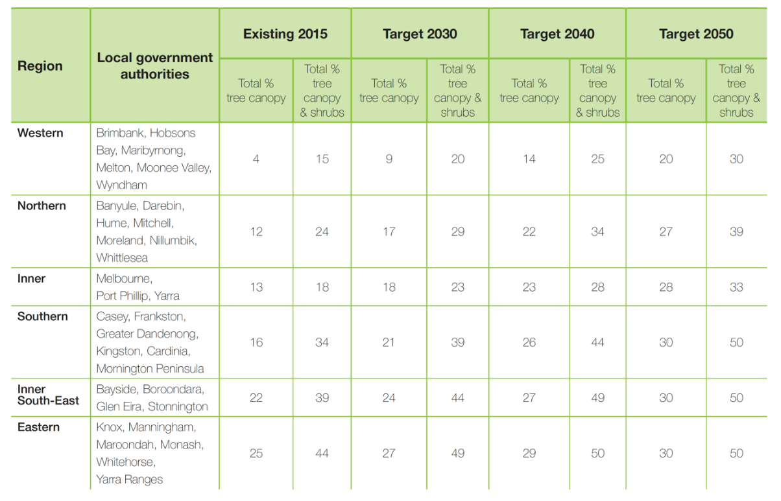
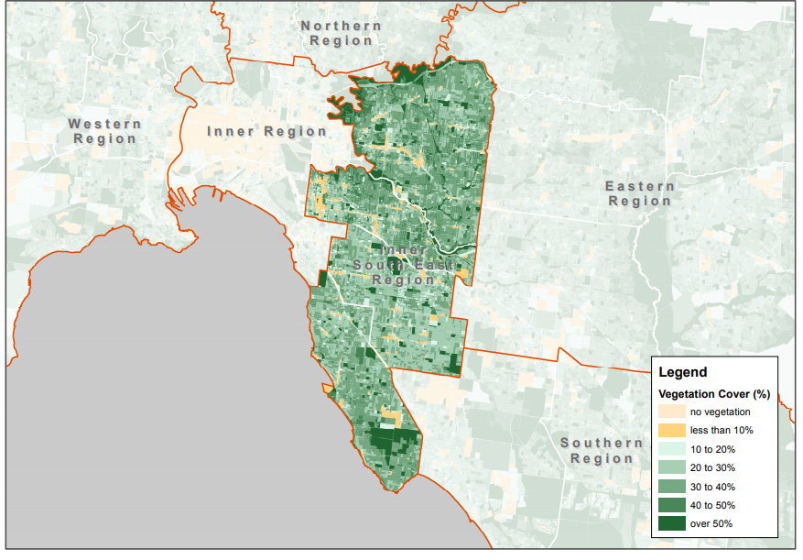
Table 1: Targets for tree canopy and for canopy and shrubs, by region to 2050 (Living Melbourne)
Map 1: Inner South East Region Vegetation Cover and Tree Canopy. Source DELWP Modified Mesh Block
According to tree canopy coverage data from 2018, Bayside is considered to have a reasonable level of tree canopy coverage (estimated at 16.07%) when compared to other areas of metropolitan Melbourne as indicated in Figure 2 below and Table 2. Many municipalities (including Bayside) have experienced a gradual decline in tree canopy cover due to the process of ongoing urban consolidation and tree removal, over the past 10 years.
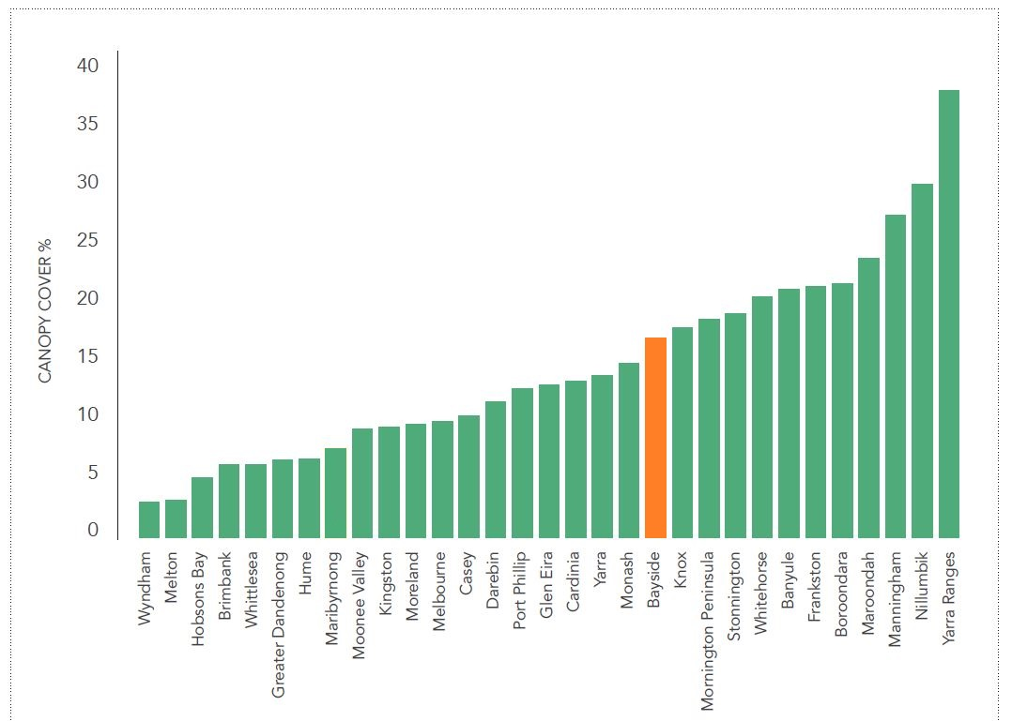
Figure 2: Tree canopy cover across metropolitan Councils (2018)

Table 2: Estimated Tree Canopy Coverage in Melbourne’s Metropolitan Regions (2019)
Metropolitan Regions in Melbourne | Percentage of land with canopy cover (tree heights between 3 metres to 15 metres)
Eastern  (Knox, Manningham. Maroondah, Monash, Whitehorse & Yarra Ranges) | 25 %
Inner South East  (Bayside, Boroondara, Glen Eira & Stonnington) | 22 %
Southern  (Casey, Frankston, Greater Dandenong, Kingston, Cardinia & Mornington Peninsula) | 16 %
Inner  (Melbourne, Port Phillip & Yarra) | 13 %
Northern  (Banyule, Darebin, Hume, Mitchell, Moreland, Nillumbik & Whittlesea) | 12 %
Western  (Brimbank, Hobsons Bay, Maribyrnong, Melton, Moonee Valley & Wyndham) | 4 %
Total metropolitan tree canopy cover | 15 %

For the purpose of this Background Report and for comparability with the Living Melbourne Strategy and target set for the Inner South East Region, Bayside City Council has utilised the Living Melbourne tree canopy cover datasets from 2014 and 2018.
Living Melbourne: Our Metropolitan Urban Forest Strategy.
While the target set for the Inner South East Region for 2030 is 24%, it is considered appropriate that Bayside also set its own benchmark to ensure its accountability and responsibility as a municipality.
A target of 25% canopy cover across Bayside by the year 2030 would require a moderate increase in canopy cover of approximately 9% across the municipality. This Background Report observes the key challenges that will need to be overcome to reach this target, and the actions Council can undertake to do so.
Table 3: Percentage of Tree Canopy Cover for Inner-South Eastern Councils (2018)
Municipality | Percentage Tree Canopy Cover %
Bayside | 16.07 %
Boroondara | 20.6 %
Glen Eira | 12.5 %
Stonnington | 19.0 %
Average | 17.1 %

What is “Global Warming” and “Climate Change”?
According to NASA (National Aeronautics and Space Administration), global warming is ‘the long-term heating of Earth’s climate system observed since the pre-industrial period (between 1850 and 1900) due to human activities, primarily fossil fuel burning, which increases heat-trapping greenhouse gas levels in Earth’s atmosphere.’ The term is frequently used interchangeably with the term climate change, though the latter refers to both human- and naturally produced warming and the effects it has on our planet. It is most commonly measured as the average increase in Earth’s global surface temperature.
The State of the Climate report from the CSIRO and Bureau of Meteorology for 2020 provides the latest climate data for Australia, providing an alarming picture of where we are (as a country) and what potentially lies ahead. The trend in global warming and its impacts in Australia are clear:
Australia’s weather and climate are changing in response to a warming global climate. Australia has warmed on average by 1.44 ± 0.24 °C since national records began in 1910, with most warming occurring since 1950 and every decade since then being warmer than the ones before. Australia’s warmest year on record was 2019, and the seven years from 2013 to 2019 all rank in the nine warmest years. This long-term warming trend means that most years are now warmer than almost any observed during the 20th century. When relatively cooler years do occur, it is because natural drivers that typically cool Australia’s climate, such as La Niña, act to partially offset the background warming trend.
In addition to the warming trend, the La Niña and El Nino weather systems also greatly influence climatic patterns in Australia. The 2010 to 2011 and 2011 to 2012 La Niña events were two of the most significant in Australia’s recorded meteorological history. The successive La Niña events spanning 2010 to 2012 were associated with record rainfall over much of Australia and some of the biggest floods in living memory. This followed years of severe drought in many parts of the country.
Maps 2, 3 and 4 show Australia’s average surface temperature and rainfall, respectively, with 2010 and 2011 demonstrating the effects of a La Niña weather system on rainfall in Australia, which resulted in severe flooding across parts of Australia. Drought conditions were experienced in the years that followed.
The impacts of climate change on the tree population are difficult to assess based on available current data. However, reduced annual rainfall and hotter, drier summers are causing heat stress to many species of trees and vegetation. Survival rates that have been analysed in Council’s data records have indicated that Council’s current management of street and park trees needs to be greatly modified to enable the urban forest to provide increased canopy cover in future years, as the climate gets warmer and drier.

Map 2: Australian Rainfall for 2018-2019 (Source: Bureau of Meteorology)
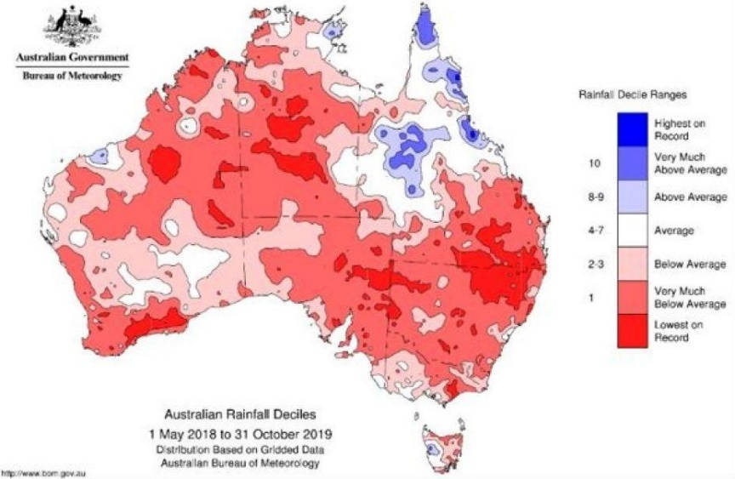

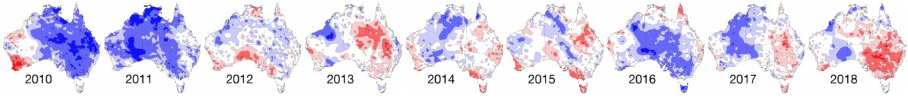
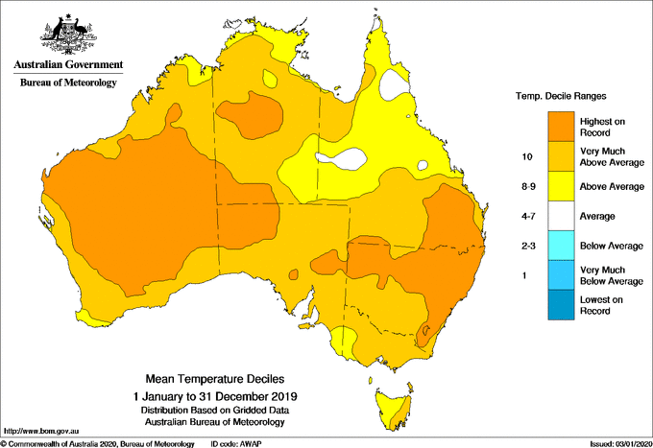
Map 1: Average Surface Temperature – Australia Source: Bureau of Meteorology

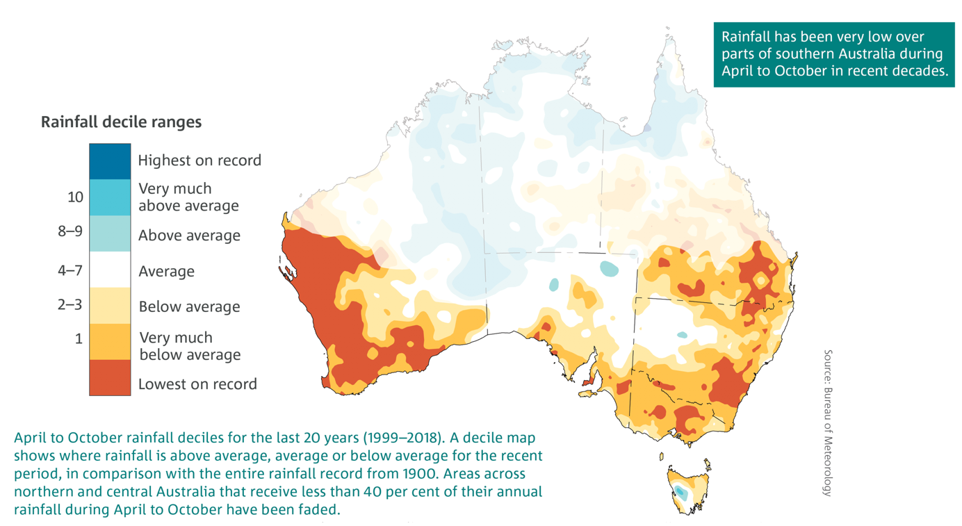
Map 2: Australian Average Rainfall (1999-2018) Source: Bureau of Meteorology

Impacts of the Urban Heat Island Effect
The “urban heat island” effect is a well-known phenomenon where urban centres are hotter than their surrounding rural areas. An urban heat island is the accumulation of increased surface temperatures across urban areas that have an abundance of hard surfaces that trap heat when there is insufficient vegetation and ground water (or natural features) that naturally cool the air through the process of “evapotranspiration”. This is the result of increasing hard surfaces and the ability for these buildings to retain heat during severe heat waves, similar situations occur when buildings are not properly shaded.
The presence of trees around properties and buildings assists in mitigating the impacts of extreme temperatures during summer. Healthy urban forests with a high level of canopy cover assist in mitigating and reducing the impacts of urban heat in summer, by providing shade and cooling the air, when the risks of urban heat to the Bayside community are greatest.
In Bayside, areas at risk of creating urban heat islands are those areas with an abundance of hard surfaces compared with trees and vegetation, such as the Bayside Business District and the Major Activity Centres. It is important to increase tree canopy and vegetation in these locations to ensure that urban heat islands are not created as yearly summer temperatures continue to rise.
As the impacts of climate change inevitably increase year by year, it is important to plan for mitigation measures and in particular to increase tree canopy across Bayside, particularly in areas where canopy cover is low, such as Activity Centres and the Bayside Business District.

Bayside’s Climate Emergency Action Plan
In response to the changing climate, Bayside City Council has prepared and adopted the Climate Emergency Action Plan 2020-2025. The overarching vision of the Action Plan is:
Bayside’s urgent response to the Climate Emergency will protect current and future generations, and the places we all love.
The Action Plan has been broken into 7 key themes:
- Build the foundations,
- Mobilise with our community,
- Move to zero carbon transport,
- Transform to a climate responsive built environment,
- Protect and enhance our natural environment,
- Transition to a circular economy to avoid waste, and
- Switch to zero carbon energy.
Theme 5 is of relevance, providing a main objective to; Seamlessly integrate the natural environment into cityscape, strengthening land, water, and ocean-based habitats. Outcomes to be reached by 2025 under Theme 5 include:
- Reduced Urban Heat Island impact,
- Increased tree canopy cover,
- Strengthened biodiversity and habitat,
- Healthier waterways and reduced pollutants in the bay,
- Water resources are managed more efficiently,
- Water is used in the landscape to improve climate resilience, and
- Open space in Bayside is more resilient to the impacts of climate change.
As also outlined in the Action Plan; Urban greening delivers a huge number of benefits. It helps to cool our City, creates habitat for the biodiversity essential for natural systems maintenance, reduces water runoff that contributes to flooding, purifies the air we breathe, supports food supply systems, delivers aesthetic benefits, provides space for recreation, and supports the physical and mental health of our community.
Through the Climate Emergency Action Plan, the preparation and implementation of an Urban Forest Strategy has been identified as a key action to respond to the changing climate by helping reduce urban heat island impacts, increasing tree canopy cover, and strengthening biodiversity and habitat. To ensure these outcomes can be reached, the delivery of the Urban Forest Strategy is to be finalised and implemented by June 2025.

What is an Urban Forest?
The urban forest encompasses all the trees and other vegetation – and the soil and water that support them. The urban forest incorporates vegetation in streets, parks, gardens, plazas, campuses, river and creek embankments, wetlands, railway corridors, community gardens, green walls, balconies and roofs. Fauna is an important component too, with complex interrelations between animals and plants helping to maintain the urban forest.
For metropolitan Melbourne, the urban forest plays a significant role in making our city a place where we can all thrive. But Melbourne’s urban forest is also under pressure. A denser urban form will increasingly crowd out opportunities for trees, while a changing climate and higher urban temperatures put physical stress on the forest.
Urban forest strategies have become increasingly recognised as important in addressing the issues associated with urbanisation and tree loss, combined with the emerging impacts of climate change, including urban heat islands created by a prevalence of hard surfaces.

The Role and Benefits of the Urban Forest
Trees have an intrinsic value, from an environmental perspective, but also from an economic, amenity and character perspective. Trees and vegetation are an integral part Bayside’s neighbourhood and urban character, contributing to the liveability of our suburbs, encouraging active participation in the form of walking, running, cycling and social gatherings and interaction.
In Bayside, the urban forest plays a critical role in providing for a high amenity urban environment, fostering habitat and biodiversity, contributing to neighbourhood character, and providing a range of environmental benefits, which include:
- providing shade and cooling the urban environment,
- providing relief from (reducing) the urban heat island effect,
- filtering air pollutants,
- providing wind protection,
- locking up carbon and releasing oxygen into the air,
- reducing storm water run-off,
- providing habitat for wildlife,
- acting as a screen for privacy, dampening noise, reducing air temperature,
- preventing erosion and stabilizing the soil, particularly for coastal environments,
- lowering water tables, which reduces the risk of salinity,
- improving urban amenity and therefore community pride of place,
- providing cool green space for active and passive recreation,
- supporting our mental health and feeling of well-being, and
- protection/conservation of remnant indigenous vegetation.
Urban forests provide critical ecosystem services such as air and water filtration, shade, habitat, oxygen, carbon sequestration and nutrient cycling. The urban forest also provides a connection to nature that is often perceived to be missing in urban areas.

There are also many broader benefits, such as improving social connection and cohesion, reducing energy costs, encouraging outdoor activity, providing shade, and cooling our city, helping to build a stronger individual and collective identity, and improving habitats for native species. Protecting and enhancing natural areas and habitat for flora and fauna in cities is essential for strengthening our resilience to acute shocks and chronic stresses, many of which will be exacerbated by climate change and rapid urbanisation.
The Socio-Economic benefits
Trees provide often immeasurable benefits, including socio-economic and health benefits by cooling buildings and their surroundings, as well as increasing the life span of road infrastructure. Health benefits are both physical and psychological as green spaces in cities encourage social participation and exercise.
Green spaces provide important socio-economic benefits, such as lowering energy costs by shading and reducing heat, reducing maintenance costs, and boosting business activity. By shading buildings in summer, trees reduce the need for air-conditioning, and can reduce annual cooling costs by between $30 and $400 per year, depending on the height of the tree. Trees can also protect asphalt pavements from heat, reducing the need for regular maintenance.12
Physical and mental health benefits
As outlined in the Living Melbourne Strategy:
Urban forests improve people’s physical and mental health by reducing heat stress, encouraging physical activity, and offering recreational opportunities. The urban forest provides space that encourages the types of physical activity that reduce people’s risk of developing chronic heart disease, diabetes, dementia and some cancers. Easily accessible green spaces and trees have positive effects on people’s wellbeing, improving their mental health.
Environmental benefits
Urban trees provide a range of environmental and health benefits and provide a connection with nature, improving mental health and wellbeing. Trees provide shade and cool the air, increasing the energy efficiency and comfort of buildings during summer.

Environmentally Sustainable Development (ESD) benefits
Environmentally Sustainable development is an approach to development that seeks to meet the needs of the present without compromising the ability of future generations to meet their own needs. It has economic, social and environmental dimensions.
Incorporating elements of environmentally sustainable development has several benefits:
- Improves energy, water and waste performance of buildings,
- Delivers cost-effective environmental outcomes and major emissions reductions, improve health and comfort, and support a lower cost of living,
- Reduce the need for active heating and cooling.
Council provides fact sheets for the community and developers on the various aspects of ESD which form part of a series of fact sheets on the Sustainable Design Assessment in Planning Process (SDAPP). Urban Ecology and Permeability are two components of ESD that can be assessed as part of a development (planning) application.
Human health and wellbeing benefits
Studies show that green spaces (plants, trees, parks etc.) are good for human health and wellbeing. What’s more, green spaces in cities have been closely linked with improved physical, social, and mental wellbeing. Studies have found that hospital patients with a view of green space from their window, compared with a wall, needed less pain medication and recovered faster from surgery.
Economic benefits
The economic benefits of having trees in proximity to buildings can be both direct and indirect:
- Air-conditioning costs for cooling can be up to 50 percent lower in a tree-shaded home as the home is provided with effective shading of windows and walls.

- Trees increase in value from the time they are planted until they mature. The housing market acknowledges that landscaped homes are more valuable than non-landscaped homes. The savings in energy costs and the increase in property value directly benefit each home buyer.

Permeability benefits
Permeable sites minimise stormwater run-off by permitting rainwater to be absorbed into the soil. A lack of permeability increases flooding in urban areas during storm events affecting not only infrastructure, but our homes as well. Many simple measures can be taken to counteract this, and good building design should always consider ways in which site permeability can be enhanced or maintained.16

Policy Context
This Draft Urban Forest Strategy Background Report has been informed and guided by a range of existing policies and strategies. Appendix 1 identifies the State and Local Government plans, policies, and strategies in place that the preparation of the Draft Urban Forest Strategy is guided by.

Bayside Local Context
The City of Bayside is located in Melbourne’s middle-southern suburbs, between eight and 20 kilometres south of the Melbourne CBD and is 36 square kilometres in size. Having a large coastline, the key defining feature of Bayside is its foreshore, which covers a total of 98.9 hectares and represents 23.76% of Bayside’s publicly accessible open space network.
Bayside is renowned for its natural assets in the environment and has a total of 416.21 hectares of open space spanning 138 publicly owned open spaces including four publicly owned golf courses. When excluding the publicly owned golf courses, there is still a considerable total of 297.23 hectares of open space.
Bayside has a large amount of land dedicated to golf courses due to its location on an ancient coastal dune system. Collectively the publicly owned golf courses cover 118.98 hectares. This amount excludes the privately owned golf courses which take up about the same amount of land again.
The Bayside community has a long and passionate history in protecting and actively caring for areas of natural habitat on public land. Bayside’s foreshore is highly valued for its combination of the beach and the associated bushland and retaining that bushland has come about through the work of many people over many years, in conjunction with Council and the Department of Environment Land Water and Planning. Bayside currently has 18 Friends of Bayside Reserves and Parks groups, whose members are hands-on helpers in caring for the local natural environment.
In 1978 year, the then Sandringham Council was one of the first municipalities in Australia to establish a nursery growing local native plants. The nursery is still in operation and supplies around 10,000 tubes per year for use in managing and restoring local bushland, as well as retailing local plants for local private gardens.
There are many volunteers that work at the Bayside Community Nursery, and/or are part of Friends of Parks groups in Bayside, which support activities, projects and programs to enhance and protect biodiversity in Bayside. Council supports the community’s role in development and acknowledges the mammoth effort and work that volunteers have provided over the years. Community planting, propagation, weeding and conservation work helps to develop an understanding and skill for planting and tree retention on both public and private property, and this Background Report recognizes this work as a major strength to assist the expansion of the Bayside urban forest.
With the support of Council, community involvement should continue to be strengthened to bring more people together and build our community’s awareness and education on the importance of a healthy and resilient urban forest. Building community resilience will allow the Bayside community to grow together and strengthen the connection to local land.
Engaging the community in activities such as tree plantings and maintenance can have a great impact on Bayside’s tree population. It provides residents with a platform to become involved with Bayside’s urban forest while also educating them on the best ways to care for their own trees at home. This will provide Council with a pathway to influence the tree population that exists on private land and help residents maintain their health.

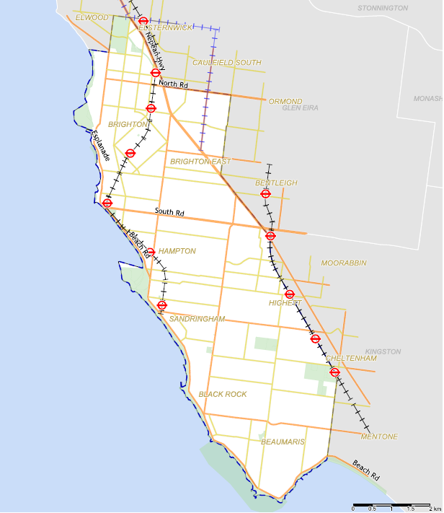
Map 5: Municipality of Bayside

Bayside’s Population and Age
The City of Bayside Estimated Resident Population for 2020 is 107,541, with a population density of 28.92 persons per hectare. It is forecasted to grow to 128,169 by 2041.
The largest increase in persons between 2016 and 2026 is forecast to be in ages 75 to 79, which is expected to increase by 1,537. As of 2016, there were 3624 residents over 85 years of age, making up for 3.7% of the Bayside population, which exceeds Greater Melbourne average of 2%. Already, Bayside’s ageing population has influenced local employment, with Health Care and Social Assistance being the largest employer in the City of Bayside, making up 17.3% of total employment.
Housing size and supply
The City of Bayside Estimated Resident Population for 2021 is 109,376, with a population density of 28.92 persons per hectare. It is forecasted to grow to 128,169 by 2041.
With population growth comes housing growth. The residential development forecasts assumes the number of dwellings in Bayside will increase by an average of 480 dwellings per annum to 53,273 in 2041 with the average household size falling from 2.57 to 2.49 by 2041. This decrease in household size reflects the type of development that has started to occur in Bayside with dual occupancy, townhouse and apartment developments all becoming increasingly popular within and around Bayside’s activity centres. Ensuring there is a diverse mix of household sizes in new developments will be important as group households, single-person households and couple households (without dependents) are all forecasted to increase within Bayside.
The increase in housing stock, especially of high and medium density developments, has significant implications for Bayside’s urban forest and neighbourhood character as various types of developments change the physical and aesthetic landscape of Bayside’s suburbs. Recognising suburbs and activity centres that will be most prone to housing growth is important as these locations will likely require more specific mechanisms to ensure the Urban Forest is not impacted.

Where will housing growth occur?
The Bayside Housing Strategy 2019 recognises that housing growth will occur at varying levels of density across the municipality, setting the direction of growth to Bayside’s Activity centres, Housing Growth Areas and Strategic Redevelopment Sites.
Residential dwelling growth is expected to continue across all parts of Bayside. The suburbs that are expected to experience the highest levels of growth until 2036 are Cheltenham (52.3%), Highett (34.1%), Hampton East (33%) and Sandringham (31.6%), with Hampton also at 25.3%. This is identified in Table 4 below.
It should be noted that these figures reflect known strategic redevelopment sites (such as the former CSIRO site in Highett and the uptake of sites in the Activity Centre Zone in Hampton East. The Major Activity Centres in Sandringham and Hampton also provide opportunities for future high-density development, including the approved development on VicTrack land at Hampton Station.
Table 4: City of Bayside Forecast Dwellings and Development by suburb between 2016 and 2036
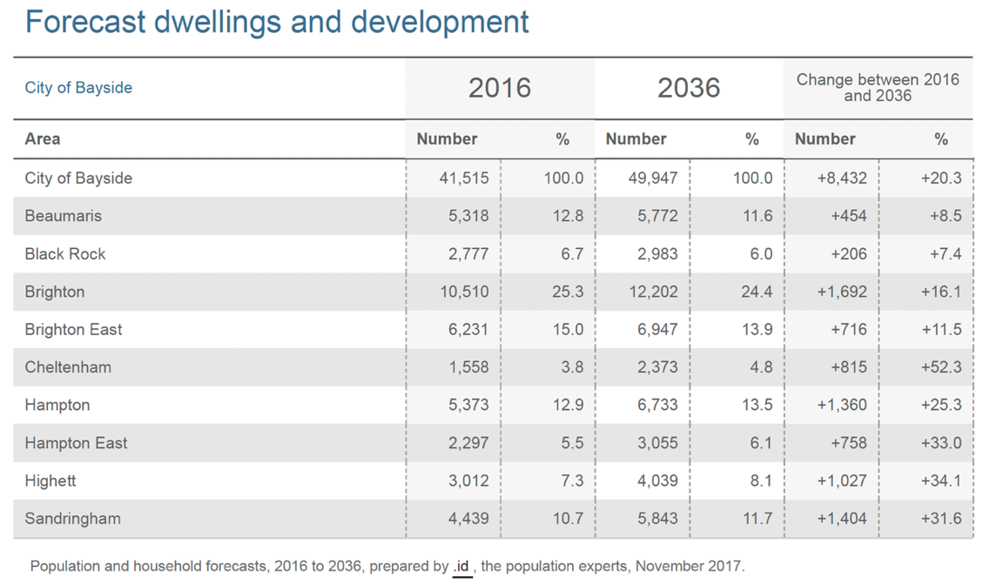
As part of the Bayside Planning Scheme, Clause 21.02 identifies the key issues and strategic vision for Bayside. In Clause 21.02-4, the Strategic vision is set:
“Bayside will be a city which protects and enhances the quality and character of the natural and built environment through environmentally sustainable development and management of land.
Bayside’s Activity Centres and the BBD will continue to provide a variety of employment opportunities and services for local residents. Possessing some of the best local strip centres in Victoria, Bayside will seek to further enhance its local economy through incremental growth in its Activity Centres to address evolving service needs. The BBD will provide a focus for high quality jobs locally in a high amenity and well-connected environment.
Bayside will be an environmentally focussed city in which its natural resources are valued by all the community, present needs are met, and development is responsibly managed for the benefit of this and future generations.”
The following map has been taken from Clause 21.02-5 as it illustrates Strategic Residential Framework Plan set for Bayside, identifying areas to accommodate housing growth.
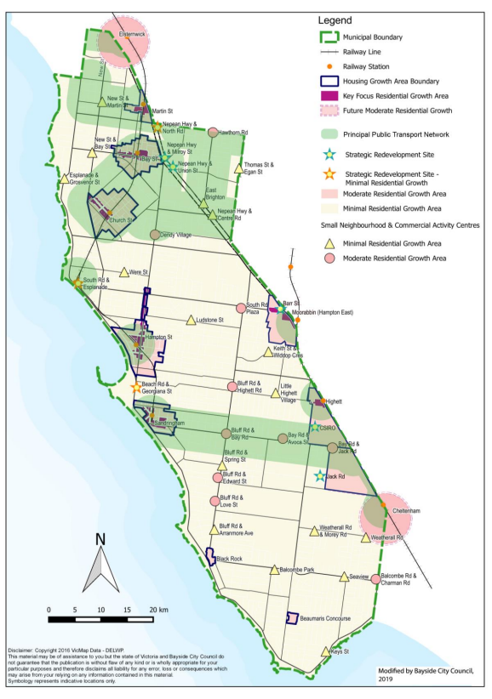
Map 6: Strategic Residential Framework Plan

What are the implications on housing growth with enhancing and protecting tree canopy cover?
Urban development and consolidation in Bayside will have an impact on the ability to maintain, enhance and expand tree canopy cover and vegetation. It may also affect the levels of air pollution, reduce permeability and the size of land available for planting trees on private property.
In areas that are projected to have more intensive residential development such as activity centres in Cheltenham, Highett, and Hampton East, it will be challenging to ensure that the existing urban forest is protected whilst seeking to expand tree canopy cover. Responding to challenges that are specific to these areas would be best undertaken through precinct based urban forest plans. These plans would determine and specify actions to increase and diversify tree canopy cover in response to the makeup of private and public land, land uses and zoning designations for each suburb. Actions should be inclusive of and encourage the increased utilisation of green walls and green roofs in specific areas where high density housing growth is occurring as it is recognised that the provision of canopy trees can be challenging.
This Draft Background Report explores the many options for growing an urban forest in these challenging environments such as green roofs, walls and facades, which are typically known as Environmentally Sustainable Development (ESD) features, and how this can be facilitated in Bayside. When these features are incorporated in new developments, they have the capacity to enhance the environment, creating sustainable and lush social and leisure settings.

Vulnerable populations in Bayside
The term “vulnerability” in our community is widely used yet it remains a difficult concept to define. The concept of vulnerability, regarding population groups and individuals in Bayside, encompasses aspects of risk and resiliency which include both personal and societal factors. According to the Australian Bureau of Statistics’ (ABS) framework of social statistics it is “those who are physically or psychologically disadvantaged.” So in its broadest sense, the notion of vulnerability refers to the situation of individuals, households or communities who are exposed to potential adversity from one or more risks. Individuals may pass through stages of vulnerability in their lives and it may not always be a fixed state. These risks/underlying causes of vulnerability can include:
- disadvantage
- social exclusion
- barriers to participation
- poor governance
- discrimination
- inequality
- inadequate access to resources and livelihoods
When planning for the expansion of Bayside’s Urban Forest, it is important to understand the challenges faced in both geographical areas as well as the population groups experiencing higher levels of vulnerability. Understanding how tree coverage can have both a positive and negative impact on our community is important and is recognised as a challenge within this Draft Background Report.
Map 7 (page 30) identifies the highest areas of socio-economic disadvantage for Bayside in 2016. The Index of Relative Socio-Economic Advantage/Disadvantage is derived from attributes such as income, educational attainment, levels of unemployment, jobs in relatively skilled or unskilled occupations and variables that broadly reflect disadvantage rather than measure specific aspects of disadvantage (e.g. Indigenous and Separated/Divorced). According to the 2016 Census data, the areas with the highest level of disadvantage in Bayside are Hampton East, Highett Activity Centre, Highett, and Hampton East (Moorabbin) Activity Centre.
Increase in tree canopy cover is proven to mitigate urban heat island impacts, as well as improve mental health and wellbeing, cool the air and reducing the need for active household heating and cooling. This is of particular importance for vulnerable communities, especially for households that need to keep household costs to a minimum, and their ability to save money on energy consumption can be attributed to an increase in tree canopy cover. It is also likely that these residents are living in a household that has limited private open space, and relies heavily on the surrounding locality for tree canopy cover and all its benefits.
More vulnerable members of the community also include older people, young children and people with disabilities and their carers who are at greater risk of harm from the extreme temperatures that can be experienced during heat waves. Increasing tree canopy cover has been found to increase energy efficiency and comfort of buildings during summer.
However, while trees do bring many benefits, they also create challenges for some population groups. The following section highlights challenges faced by more vulnerable groups within the Bayside community regarding the management of trees.
Information access
- Digital isolation due to information and forms online; trees are managed by multiple departments in Council and it can become a challenge for the resident to receive consistent information depending on where tree is located.
Advocacy
- Understanding and navigating council processes to have the tree reviewed;
- Inability to advocate for themselves
- Inability to advocate for self in Council processes – completing online forms, collecting evidence required
- Limited external sources to support through advocacy.
The maintenance of trees can be challenging to undertake especially for vulnerable residents that are of an older age and/or living with a disability and have limited mobility. Trees that are overhanging private property or within the private property can become hazardous and the process to have the tree pruned or removed can too become a burden.
Currently, there are limited subsidised services through aged care services that provide for tree maintenance. It can be difficult for residents to navigate and purchase these private services and can become too expensive if the resident has a limited or low income. It is recommended that Council investigate the possibility of providing financial assistance or create a panel of private providers that we could refer residents to.
Alongside this, there is a need to remove obstacles and create a clearer and easier process to obtaining information and services to assist vulnerable residents. Council should investigate the implementation of a concierge system where there is one contact point who is responsible for meeting with other relevant Council officers to provide a resolution. Accessibility and information sharing through this process must also be considered.

Women’s safety
As aforementioned in this Draft Background Report, understanding how tree coverage can have both a positive and negative impact on our community is important and is recognised as a challenge that must responded to and considered appropriately.
The OECD Better Life Index found that only 61% of Australian women reported feeling safe when walking alone at night in the area where they live, compared to 77% of men. There are a number of elements that contribute to women feeling unsafe including low visibility, lighting and lack of passive surveillance from nearby residents and/or other groups. Trees can contribute to this problem if not managed correctly as they have the potential to block visibility from the street if planted too close together. Tree locations may also provide areas that attackers can use to hide as well as block light on the space. It is vital that these factors are considered when planting trees so that the Bayside community and visitors can feel safe.

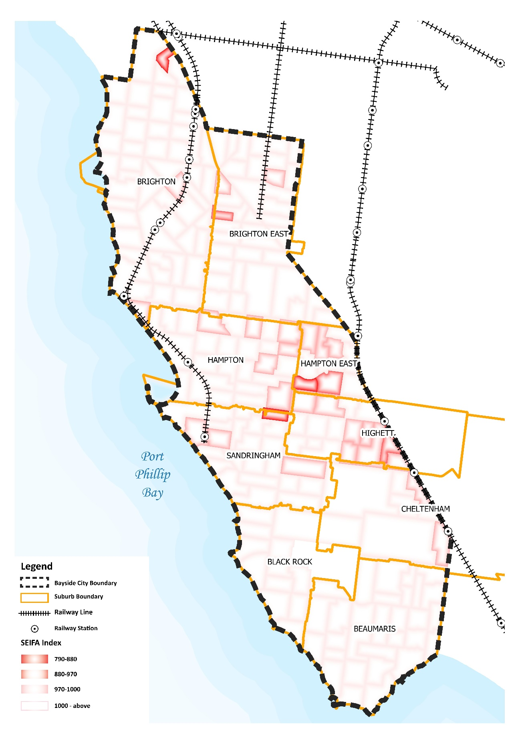
Map 7: City of Bayside, Index of Relative Socio-economic Advantage and Disadvantage

Community Views
The garden character of much of Bayside’s residential areas is highly valued by the community, with trees and vegetation being essential components of urban infrastructure. The community considers the most important benefit of enhancing vegetation and tree canopy cover in Bayside is with the contribution it makes to the neighbourhood character and biodiversity. The community has raised concern that developments are removing mature vegetation, particularly canopy trees, which contributes significantly to the character of Bayside. Community engagement on issues relating to climate change, the environment and the role of the urban forest are fundamental in the future success of increasing tree canopy.
Community Attitudes towards Trees and the Environment
Council has undertaken comprehensive community engagement exercises in recent years of which trees and vegetation have been a consistent theme within. While the community value trees for their character and environmental values, there are mixed views and concerns regarding Council regulation and processes to allow for tree removal, and future consultation processes will need to canvas these issues as potential items for further discussion. Previous feedback received from community consultation has been outlined in Table 5 below.
Community awareness, education and engagement will be an essential element to the success of the Bayside Urban Forest Strategy. To support the preparation of the Draft Urban Forest Strategy, a Communications and Engagement Plan has been developed to ensure that the community engagement outcomes are maximised and adding value to the development of the document.
As part of the preparation of the Draft Urban Forest Strategy, Council undertook Focus Group sessions as part of its first phase of engagement to better understand the varying community views. Through these sessions, Council sought participants for two focus group sessions: one for individual members of the Bayside community and another for local community organisations.
Council was able to capture a diverse range of perspective on trees from participants and this feedback was utilised to help inform the finalisation of the Draft Urban Forest Strategy.
Outcomes of Focus Group Sessions:
To inform the finalisation of this Draft Urban Forest Strategy, Council requested Expressions of Interest from residents and community organisations to bring local expertise and lived experience into the Strategy. The self-nominated residents were independently selected by Activate Consulting through a stratified process to broadly represent the Bayside population in terms of suburb, age and gender. The community organisation focus group comprises up to two representatives from environmental/conservation focussed community groups and organisations in Bayside.
Participants from Focus Group 1 (individual residents) identified a range of potential actions to support the achievement of the following four objectives:

Increase | Diversify | Monitor | Maintain
- Focus efforts on public space for significant canopy gains  - Community education and support for private land owners  - Incentivising tree planting and retention on private land  - Stronger regulation and enforcement of development  - More flexibility in council guidelines  - Focussing on all types of planting (trees and vegetation) | - Council to lead by example, set and monitor targets  - Ensure a pragmatic approach and carefully consider appropriate species  - Provide resources, support and incentives for the community  - Diversify the available local tree supply  - Greater regulation and enforcement for developers | - Suggestions around different methods of monitoring  - Recommendations about the type of data to collect and how it should be used  - Considerations for an effective Urban Tree Monitoring Program | - More flexible approach to tree removal and replacement that is site specific  - Education and support for the community  - Greater enforcement capability coupled with incentives  - Foster tree stewardship and pride
The participants were asked to consider a series of key challenges and opportunities that were identified in the Urban Forest Strategy Background Report and identify actions or approaches to address them. The responses received have been summaries as themes:
Question 1: Participants from both groups were asked ‘How can we support older people and vulnerable residents to manage trees on private property?’
Theme 1: Proactive communication and a flexible approach. Ideas included:
  - Proactive communication to make older/vulnerable residents feel special and supported by Council to encourage retention of trees as much as possible and seek help from Council.
  - Start by reaching out to these community members and asking them what their challenges, barriers or concerns are so that tailored support plan can be developed.
  - Where challenges arise, Council’s response should be innovative and adaptable to seek to achieve the residents’ objective while retaining the tree (not just focus on tree removal).
Theme 2: Financial incentives and support to offset the costs of tree maintenance. Ideas included:
- Financial support including a rate reduction, or council-subsidised arborist services
- A municipal tree-levy for all residents that vulnerable people can draw down on that fund to pay for the services
Theme 3: Provision of free tree maintenance services, but mixed views on who should provide theme.
There were mixed views evident about who should provide the free service (Council or volunteers) and ensuring appropriate qualifications, safe practices and protecting the safety of vulnerable people in their homes. Ideas included:
- Extending Council’s existing maintenance service provided through aged care to any vulnerable resident that requires it.
- Council being responsible for maintaining any tree on the Significant Tree Register
- Community groups, schools and neighbourhood volunteers providing advice and assistance with tree and garden maintenance, for example ‘Gardeners on Wheels’.
- Council creating a register by suburb of properties requiring assistance and coordinating that assistance either by their own maintenance team or community groups based on the requirement.
Theme 4: Improving processes and information. Ideas included:
- Ensuring information is easy to find and understand and processes are simple, accessible, and streamlined.
- Providing human assistance to navigate process and complete and submit forms.

Question 2: Participants from both groups were asked ‘What is the acceptable level of Council regulation of trees and vegetation on private land?’
The feedback received by individual residents in comparison to the community organisation feedback varied.
Individual resident feedback
A small number in this group cited issues with developers removing trees and the need for better regulations and follow up about new planting requirements, such as ‘enforcing larger minimum surface permeability and minimum of at least one tree per title (of appropriate size)’.
Yet, overall, this group did not want any further Council regulation on private land than currently exists: ‘Council has not paid for my property so why do they get so much say in how I use my property?’ and ‘The general pop(ulation) does not appreciate Council involvement on private land.’

A number of participants felt that some regulation is acceptable ‘as long as the property owner has some control and there is transparency’ around decision making. They wanted more flexibility to ‘allow for practical solutions’.

In addition some commented that regulations should be consistent with Council practice, for example ‘Council assesses a tree to stay but on the other hand, the nature strip hardly has any tree’, and what developers are permitted to do, ‘We should not be penalising those that have bigger back yards by making them keep (and keep planting) inappropriate trees while others that subdivide blocks can easily get rid of their trees.’
The majority of participants agreed that Council should focus canopy growth on public land, ‘Council would get more bang for its buck throwing resources at planting trees on public land’ and ‘Concentrate planting of canopy trees on public spaces, state schools, cemeteries, public housing vacant lands, car parks’. It was suggested on private land ‘the focus shouldn't be solely on tree canopy, but also the garden density or the undergrowth.’
Community organisation feedback
There was strong support and discussion for greater Council regulation and enforcement around development to protect, retain and replace trees, ‘Council need to push harder to ensure design of development retains more trees’ and ‘ensure that appropriate space is provided to plant canopy trees and not just minimum landscaping/shrubs.’ Suggestions proposed included:

- ‘Need to get the balance right – developers need to be prepared to consider a lesser yield in favour of the greening outcome’. ‘Tree canopy cover is a key element that needs to be integrated with development outcomes’.
- ‘Decks and pools should be considered part of the building footprint and not the open space component for planning permits’
- ‘Advocate for the removal of the VicSmart provisions’
- ‘Increase enforcement and issue appropriate fines for trees being lost in protected areas’ (vegetation Protection Overlay)

A popular suggestion was for Council to put a financial value on trees, ‘put a $ value on a tree to ensure that the financial element is considered.’
The group commented about the need for Council’s planning and local laws to be strong and aligned, ‘ensure that Planning Scheme and local laws are working together and are more robust, and consistent’, and appropriate for different areas: ‘not a one size fits all, different contexts require different approaches’, for example parks, golf courses and schools.
It was also suggested that incentivising tree retention was important to complement regulation, ‘how can we look at ways to ensure developers are getting what they need, while the environmental and landscape outcomes are being delivered.’
Community education and communication about the need for trees was also a strong suggestion, ‘Aim to educate from the young upwards about the ‘why’’. This included ‘emphasising appropriate trees in appropriate places’, ‘celebrating what is happening to encourage others to have an opinion, and ‘raising awareness that developers have a responsibility’.
Question 3: Participants from both focus groups were asked ‘How can we better incentivise tree protection and retention on private property?’ or ‘How can we better encourage/achieve compliance with tree plantings on private property?’
Theme 1: Education and awareness activities around the benefits of trees. Ideas include:
- Education to developers and the community about the benefits of trees, with messages tailored to the motivations of the target audience (for example, lifestyle, energy/cost savings, property values, biodiversity).
- Education focussed on schools to reach the adults of the future.
- A broader Melbourne-wide campaign, with State Government support for councils and community to reach its set targets.

Theme 2: Financial incentives, short and long term. Ideas include:
- Discounted rates based on the proportion of tree cover on a property, which could also be promoted by developers to potential purchasers
- Incentives through the planning process itself, such as compromise on other elements (for example parking or height) or fee discounts
- A mix of immediate and longer term incentives to encourage tree maintenance (for example, council provide a free tree, then rate discounts once established)
- Using the iTree system or similar to put a dollar value on trees and coupling with a bond system (to the value of the tree) to create more of a financial incentive for developers to retain/protect trees

Theme 3: Ensuring regulation and incentives work together. Ideas include:
- Making people aware through the property purchase process about relevant tree and vegetation restrictions, especially trees listed on a public ledger/register.
- Using incentives to encourage developers to design developments around/incorporating existing trees.
- Neither incentives nor regulation alone will work, needs a complementary approach.

Theme 4: Promote and align the community around a strong blue and green identity for Bayside. Ideas include:
- Promote Bayside as a blue and green city and encourage community pride
- Develop an awards program to celebrate trees, such as: tree of the year, planting of the year, housing design of the year (incorporating existing trees), habitat of the year, and promote widely which will also boost community awareness and pride
- Significant Tree Register process is too difficult, should be streamlined and incentives provided for people to add to it.

Theme 5: Council advice and support around planting and maintenance. Ideas include:
- Council taking responsibility for management of trees on the Significant Tree Register, and providing discounted arborist services for large, established trees on private land.
- Information and advice around appropriate trees for the area and supply of trees, and expertise, through the Bayside Community Nursery.

Theme 6: Offer more flexible, tailored policies around tree planting and retention. Ideas include:
- Different policies for different types of areas in Bayside rather than a one size fits all approach (for example, for developers, established areas, golf courses)
- For larger areas (such as golf courses), develop longer term management plans, suited to the circumstances and objectives, that are approved by council once, rather than having to apply for permits every time.
- Greater flexibility and broader range of trees in policies may increase compliance and support from residents.

Theme 7: Increasing and encouraging planting on nature strips. Ideas include:
- Review nature strip planting guidelines to allow for trees/ a wider range of trees as well as shrubs and grasses.
- Council proactively planting nature strips with understorey in between trees.
Question 4: Participants from the Community Organisation focus group were asked ‘What are the strengths of our many community organisations and how can these be leveraged to increase Bayside’s urban forest?
Theme 1: Education programs with schools and young people. Ideas included: 20
- Education around the benefits of native trees and shrubs and understorey planting to connect young people with their local area
- Greater connections with youth groups, student groups and environmental groups in Bayside
- Education around biodiversity and gardening for wildlife
- Grant schemes to support local schools to partner with Bayside Council and Community Groups
- Bayside Community Nursery working with schools

Theme 2: Greater Council funding and strategic approach to planting and management. Ideas included:
- Council investment in the natural environment should be more proportional (as much of a priority) to the amount of funding provided for the built environment
- Quadruple our tree planting - increase nature strip planting throughout Bayside
- Council’s contractor CityWide need more resourcing and aren’t able to keep up
- Planting locations need to be staggered and strategically selected and prioritised
- Planting must focus on appropriate trees in appropriate locations (some indigenous trees don’t offer significant shade cover) and vegetation planting is just as important as trees
- Opportunity to work better with golf clubs on the management of trees rather than just treating them the same as private property and connecting them in with the Bayside Community Nursery.

Theme 3: Council playing a coordination role between contractors, the Bayside Community Nursery and community organisations. Ideas include:
- Community organisations have strong connections and can work well with Citywide and Council when given the opportunity
- Council needs to support and assist existing and new community groups such as blanket coverage for insurance where necessary.
- Having one contact person in Council that can better coordinate activities between Council, Citywide, Bayside Community Nursery and community organisations
- Developing a streamlined process for accessing planting locations and hosting planting days.
- Supporting community organisations on local initiatives, such as an initiative by the Beaumaris Conservation Society to get nesting boxes (made by Beaumaris College) up in residents’ trees.

Theme 4: Council facilitating community planting days. Ideas include:
- People want to plant trees, so Council should fund tree planting projects (such as the Trees for a Safe Climate initiative)
- Community activation to enable ownership over local areas, not just relying on community organisations alone.

Participants from Focus Group 2 (community organisations) were also asked ‘What is the change you would like to see through this Strategy?’. The responses related to:
- An increased diversity of trees and vegetation
- Greater regulation, accountability, and transparency, particularly for developers
- A focus on more appropriate, native planting
- Greater community awareness, appreciation and commitment with the urban
- Habitat connectivity
- Appropriate rules for private property
- Prioritising protection of existing canopy and mature trees

Other feedback and comments
During the focus group participants offered additional feedback and discussion not specifically related to a question, but important to capture to inform the draft Strategy. Key themes included:
- Tree canopy target – some participants commented that the proposed target of 25% tree canopy by 2030 should be more ambitious, citing Melbourne City Council’s target of 40% tree cover by 2040
- Tailored approach to planting by area – some participants commented that tailored plans should be developed broken down beyond suburb level to ensure each local neighbourhood is considered.
- Safety – where dense planting is undertaken it also needs to consider lighting and other related issues to ensure the community feel safe, especially women using the space
- Powerlines – a long-term consideration would be to move powerlines underground.
Summary
The feedback received from focus group participants indicated an overall support for the increase in tree canopy cover, however the enforcement of this increase and how Council meets this goal was of varying opinions.
Council recognises that regulating tree removal on private property will continue to be a balancing acting into the future and throughout the implementation of this Strategy and its actions. The feedback received, especially those in relation to support and incentives, and tailoring private property regulation for different areas and circumstances has been considered by Council and has informed the actions set in this Strategy.
The discussions had with both focus groups highlighted the need for a larger focus on community engagement, education, information, and resources. Council has taken this on board and identified ‘educate’ as a fifth key theme of this Draft Strategy. Through this key theme, Council will focus on how best to educate the community on the benefits of trees and vegetation, what is appropriate to plant and where, and how best to plant, care and maintain trees and vegetation.

Table 5: Previous Feedback received from Community Consultation
Engagement on Council Plans and Strategies | Community Engagement Outcomes
Council Local Law No.2 (Neighbourhood Amenity) Community Engagement Summary – November 2020 | Council undertook community consultation in relation to Local Law No. 2/ There has been a range of feedback, and the following views have been expressed:  Tree protection (104 comments)  Mixed views:  - General support for tree protection, some support for increasing penalties  - Allow ratepayers to remove or prune own unsafe or unwanted tree without Council consent  - Support for more trees, particularly those species that are suited to planting locations.  Trees or plants not to obstruct or obscure (46 comments)  - Support for trees not obstructing or obscuring generally or overhanging footpaths  - Support for trees not damaging footpaths  Other (158 comments)  - Allow tree removal if dead, dangerous or unsafe.  - Tree protection laws are overly restrictive and onerous  - Plant more trees, specific and appropriate types of trees  - Concerns about nature strip trees (tree selection, over-hanging, inappropriate and pruning)  - Concerns about trees being removed for development  - Concerns about tree disputes with neighbouring properties  - More resident consultation about trees.
Bayside Community Plan 2025 | Surveys conducted for the Bayside Community Plan (2025) also revealed that the community has the following concerns and/or values in relation to trees:  - Support for protecting and maintaining the tree lined streets  - Provision of open space is a key factor and the amount of greenery in the streets  - Some of the key challenges are - climate change, retaining trees, environmentally sustainable design, managing waste, and protecting the natural coastline.
Community Satisfaction Surveys | Community satisfaction surveys focus mainly on areas of Council responsibility in terms of street and park tree planting and maintenance. The surveys have indicated that the community has the following satisfaction in relation to trees  - The community indicated a very high importance for the provision and maintenance of trees, placing a high value on street trees.  - Although the community indicated the importance on the provision and maintenance of trees, residents indicated that recurring issues surrounding planning and development, car parking and traffic, held a higher importance, as street trees was the fourth mentioned topic from residents.
Community Vision 2050 | The Community Vision undertook feedback on several recognised issues and challenges for the long-term future of Bayside, with residents responding with their opinions and feedback on the issues and challenges. Feedback received by the community indicated the challenge of ‘combating heat and drought with more vegetation and tree cover’ as the second most important priority.
Climate Emergency Action Plan 2020-2025 | Recent engagement on the Climate Emergency Action Plan identified that the community has a clear understanding of the connection between climate change and trees and its importance. The following views were expressed:  - Tree canopy was included under the overall theme of Biodiversity, which was indicated to as the third highest priority for council to focus on.  - Of the results, 58% of respondents said they would definitely take own action in future to support biodiversity, 19% probably would take action, 17% were unsure on what to do themselves.
Bayside Housing Strategy 2019 | The Bayside Housing Strategy feedback was sought in relation trees and vegetation. Residents indicated the following views:  - Residents indicated that the enhancement of vegetation and trees benefited neighbourhood character and biodiversity the most. This was followed by the intrinsic value of trees, combating the heat island effect, and the role vegetation and trees play in adapting to climate change. Privacy was considered by residents but was their least important benefit.  - The community indicated that Council should have more control over the removal of trees and vegetation on private property  - Residents felt that the enforcement of tree protection should be stronger, and that Council needs to engage in more monitoring of both existing vegetation stock and monitoring of landscape plans following development.

Bayside’s Urban Forest
As identified in this Background Report, the Bayside population is changing; residents are getting older, and the number of households in Bayside is continuing to increase. To ensure Bayside continues to be an environmentally focussed city in which its natural resources are valued by all the community, there is a need to expand the Bayside urban forest.
The urban forest in Bayside provides environmental benefits that enhance the character, amenity and liveability of the municipality through building resilience into the urban environment by mitigating some of the impacts of climate change, and generally provides a connection to nature that people enjoy.
Bayside’s urban forest is made up of native, indigenous, and exotic trees, shrubs, grasslands, and other vegetation, growing on public and private land, and the soil and groundwater that support them. This includes vegetation in parks, reserves, and private gardens, along railways, waterways, main roads and local streets, and on other green infrastructure such as green walls and roofs. The urban forest provides habitat to a wide range of fauna.
While the Bayside urban forest is spread over the entire municipality, large pockets of tree canopy cover, and opportunity to expand tree canopy cover can usually be found within Bayside’s public open spaces. In Bayside, there are 138 publicly owned open spaces which covers 416.2 ha (11%) of the total area of the municipality, including three publicly owned golf courses (119 ha). Of this 416.2 hectares, approximately 77.09 hectares of open space is specifically managed for conservation (See Map 8), including 56.72 hectares along the foreshore and 20.37 hectares in eight inland reserves.
Foreshore Reserves | Inland Reserves
Beaumaris Foreshore (North) | Balcombe Park
Black Rock (South) | Bay Road Heathland Sanctuary
Brighton Dunes | Cheltenham Park Flora and Fauna Reserve
Picnic Point | Donald MacDonald Reserve
Ricketts Point Hinterland (landside) and Foreshore | George Street Reserve
Sandringham Foreshore (South) | Gramatan Avenue Heathland Sanctuary
 | Long Hollow Heathland
 | Highett Grassy Woodland Reserve (scheduled for expansion
 | Elsternwick Park Nature Reserve (Masterplan project underway)

Map 8: Public Open Space and Conservation Reserves Across Bayside
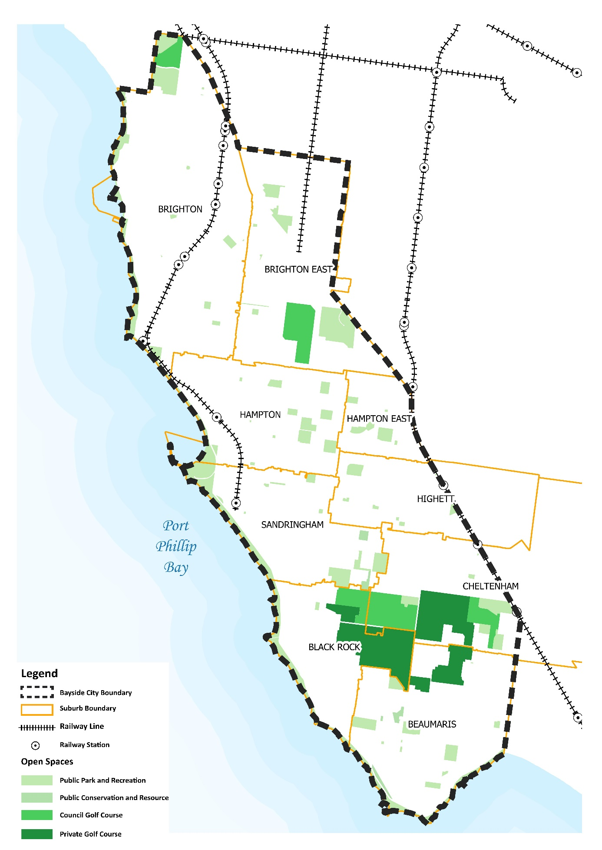

The Council managed tree population
There are over 60,000 trees in parks and streets in the City of Bayside. Each year, Council plants over 1,400 trees in streets and parks in Bayside. Depending on the number of street upgrades, proposed park planting and other opportunities that arise to plant trees, this can sometimes increase to over 2,000 trees per year.
Council has a tree inventory to help Council officers manage and monitor the Council managed tree population in Bayside. The tree inventory is regularly updated as monitoring, pruning, removal and planting works on individual trees are undertaken. The species, age, health and estimated useful life expectancy of each tree is recorded in the inventory and this data has been used to develop a profile of the Council managed street and park trees in Bayside.
Factors such as tree species, health, maturity, and useful life expectancy play key roles in ensuring the longevity and resilience of the Council managed tree population, and have been informed the key challenges identified in this Draft Background Report.

Tree Health and Age (Maturity) of Bayside’s Tree Population
Urban environments can be very impactful on the health and condition of trees and ensuring these challenges can be appropriately addressed is key to a healthy and resilient urban forest.
The climate and soil conditions in Bayside can be challenging, and this affects a trees ability to grow and mature healthily. Bayside soils are Sand and Clay Plains from the Cainozoic period which drain well but are low in nutrients. For tree planting, this may require frequent establishment watering, to ensure the tree responds well to the site and its health is optimized.
Data on tree age/maturity demonstrates a reasonable level of diversity in the age of trees with the highest proportion being “semi mature” at 42.5%. Data from June 2020 also reveals that nearly 80% of the population classified as in good health and 5% as excellent.
Figure 3: Tree Health in Bayside’s tree population on public land as at June 2020

Figure 4: Tree Age (Maturity) in Bayside’s tree population on public land as at June 2020

Species Diversity: Bayside’s Tree Population
A resilient urban forest has a diverse range of species from different families. As seen in Figure 5 and 6, Bayside’s street and park tree population is largely dominated by the Myrtaceae family, making up 60% of all street trees and 56% of all park trees, with no other family making up more than 10%.
Figure 5: Street Tree Diversity

Figure 6: Park Tree Diversity

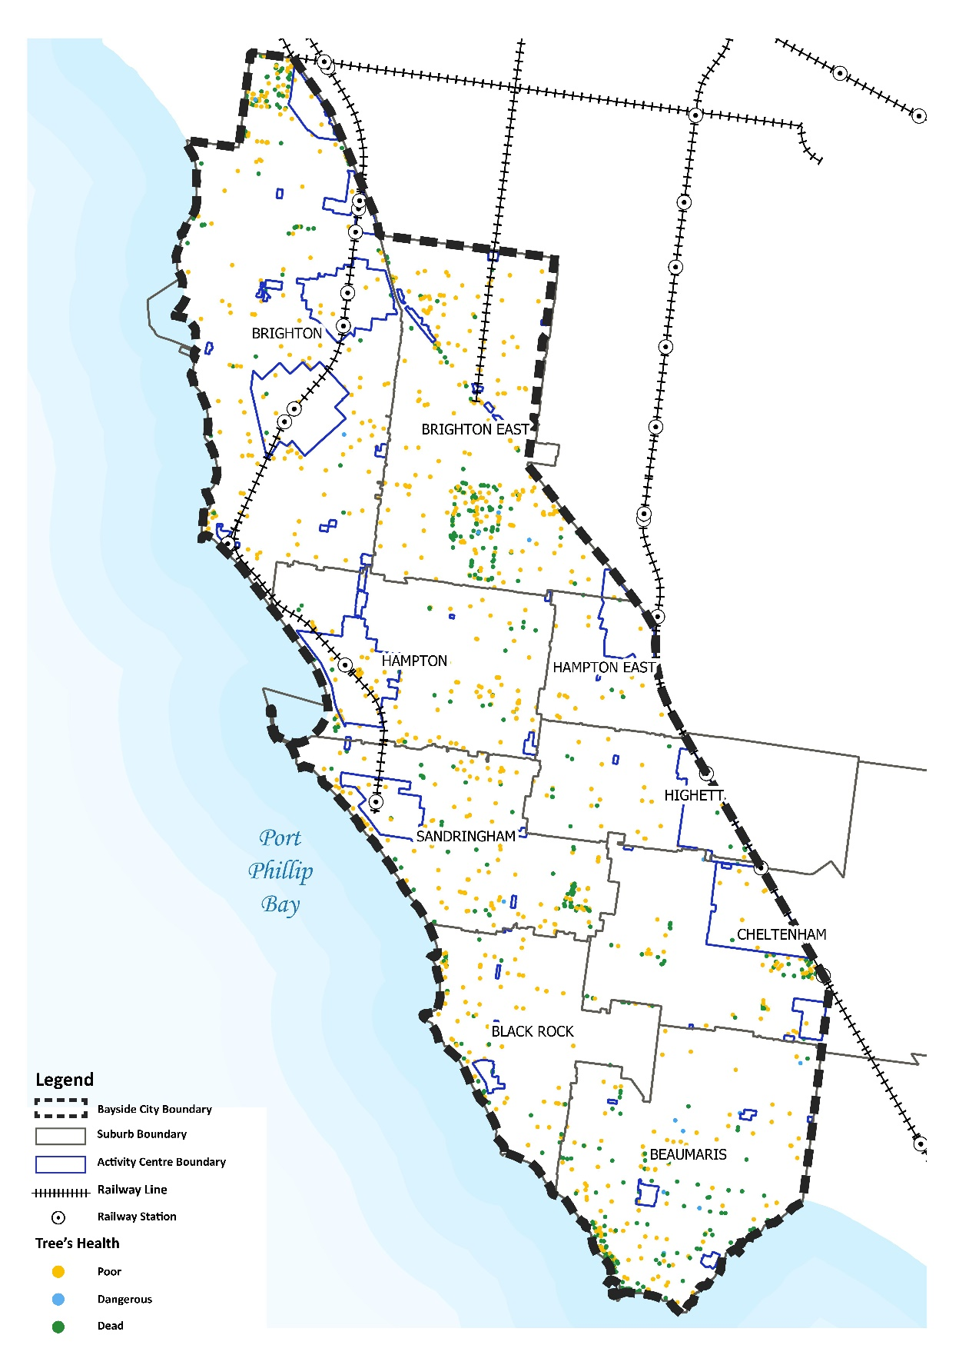
The following map identifies where trees that are below ‘fair’ health are located within Bayside which makes up for 1.59% of street trees and trees in parks. While most of these trees are scattered throughout the municipality, there are several locations where the number of trees in bad health are notably heightened.
Map 9: Street and park trees that are below ‘fair’ health
Estimating the useful life expectancy of the Council managed tree population is regularly undertaken and can inform the future management options for trees that have limited useful life left. The assessment of a trees useful life expectancy provides an indication of health and tree appropriateness and involves an estimate of how long a tree is likely to remain in the landscape based on species, stage of life (cycle), health, amenity, environmental services contribution, conflicts with adjacent infrastructure and risk to the community. It is not a measure of the biological life of the tree within the natural range of the species, and more a measure of the health status and the tree’s positive contribution to the urban landscape.
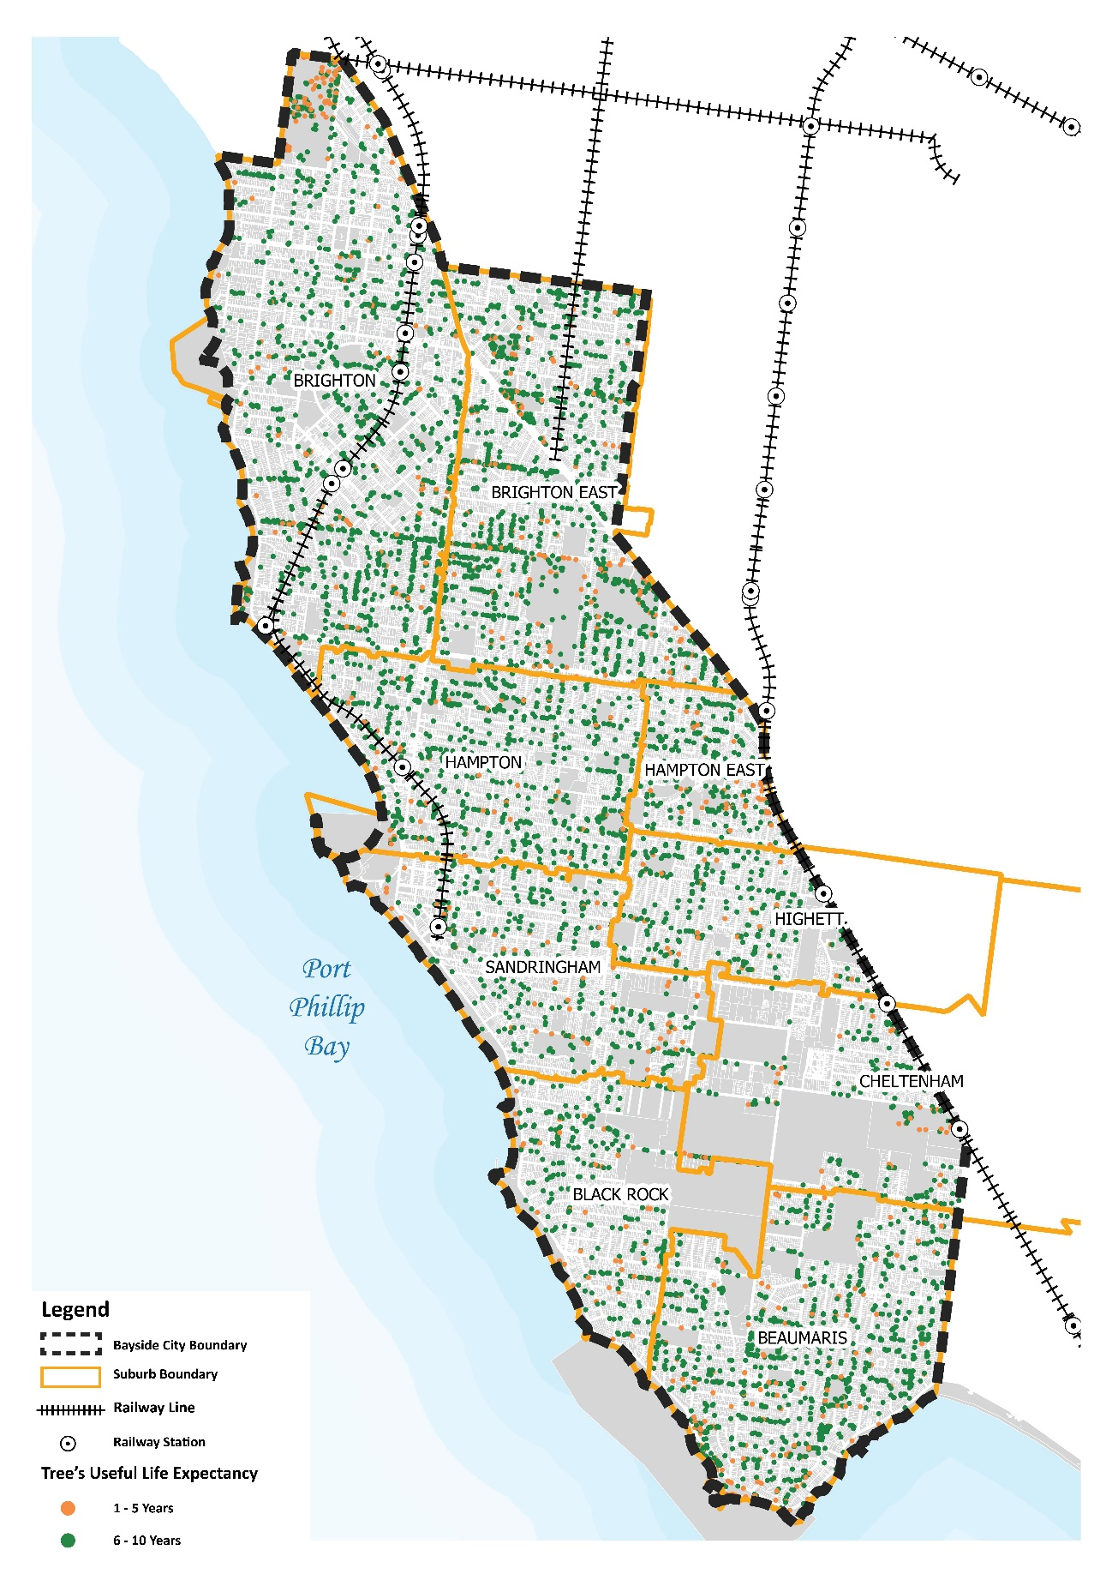
There are approximately 7,799 trees managed by Council that will not survive or remain in the Bayside landscape after the next 10 years. By 2040, a total of 51,400 Council managed trees will have reached the end of their useful life expectancy and will need to be replaced. It is vital that the replacement trees are diverse in species and planted intermittently to enable. The following map identifies the location of trees that have 1-5 years and 6-10 years of useful life left.
Map 10: Useful Life Expectancy (ULE) of Trees in Bayside

Table 6: Useful Life Expectancy
Suburb | NULL | 1-5 Years | 6-10 Years | 11-20 Years | 20+ Years | Grand Total
BEAUMARIS | 1 | 157 | 815 | 4522 | 3088 | 8583
BLACK ROCK | 72 | 52 | 279 | 3197 | 499 | 4099
BRIGHTON | 806 | 196 | 1152 | 10313 | 1725 | 14192
BRIGHTON EAST | 789 | 196 | 1052 | 8758 | 1426 | 12221
CHELTENHAM | 10 | 52 | 165 | 2972 | 509 | 3708
HAMPTON | 148 | 76 | 670 | 5168 | 1058 | 7120
HAMPTON EAST | 66 | 64 | 218 | 2240 | 353 | 2941
HIGHETT |  | 29 | 230 | 2131 | 901 | 3291
SANDRINGHAM | 137 | 56 | 311 | 4300 | 1862 | 6666
Grand Total | 2029 | 878 | 4892 | 43601 | 11421 | 62821

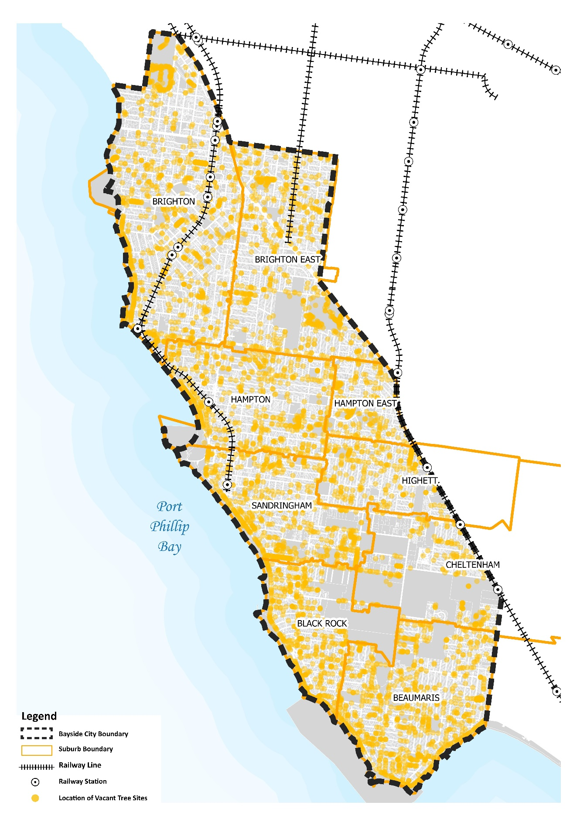
The following map identifies the 4,023 vacant tree sites in Bayside where a tree has been removed and a new tree can be planted. These sites have been mapped by Council’s Contractor (Citywide) and are within streets and parks.
Map 11: Vacant sites in Bayside
The following map identifies the vegetation cover across Bayside. Map 12 shows land areas that have 55% and above vegetation cover are parks, reserves and golf courses.
Map 12: Vegetation Cover in Bayside
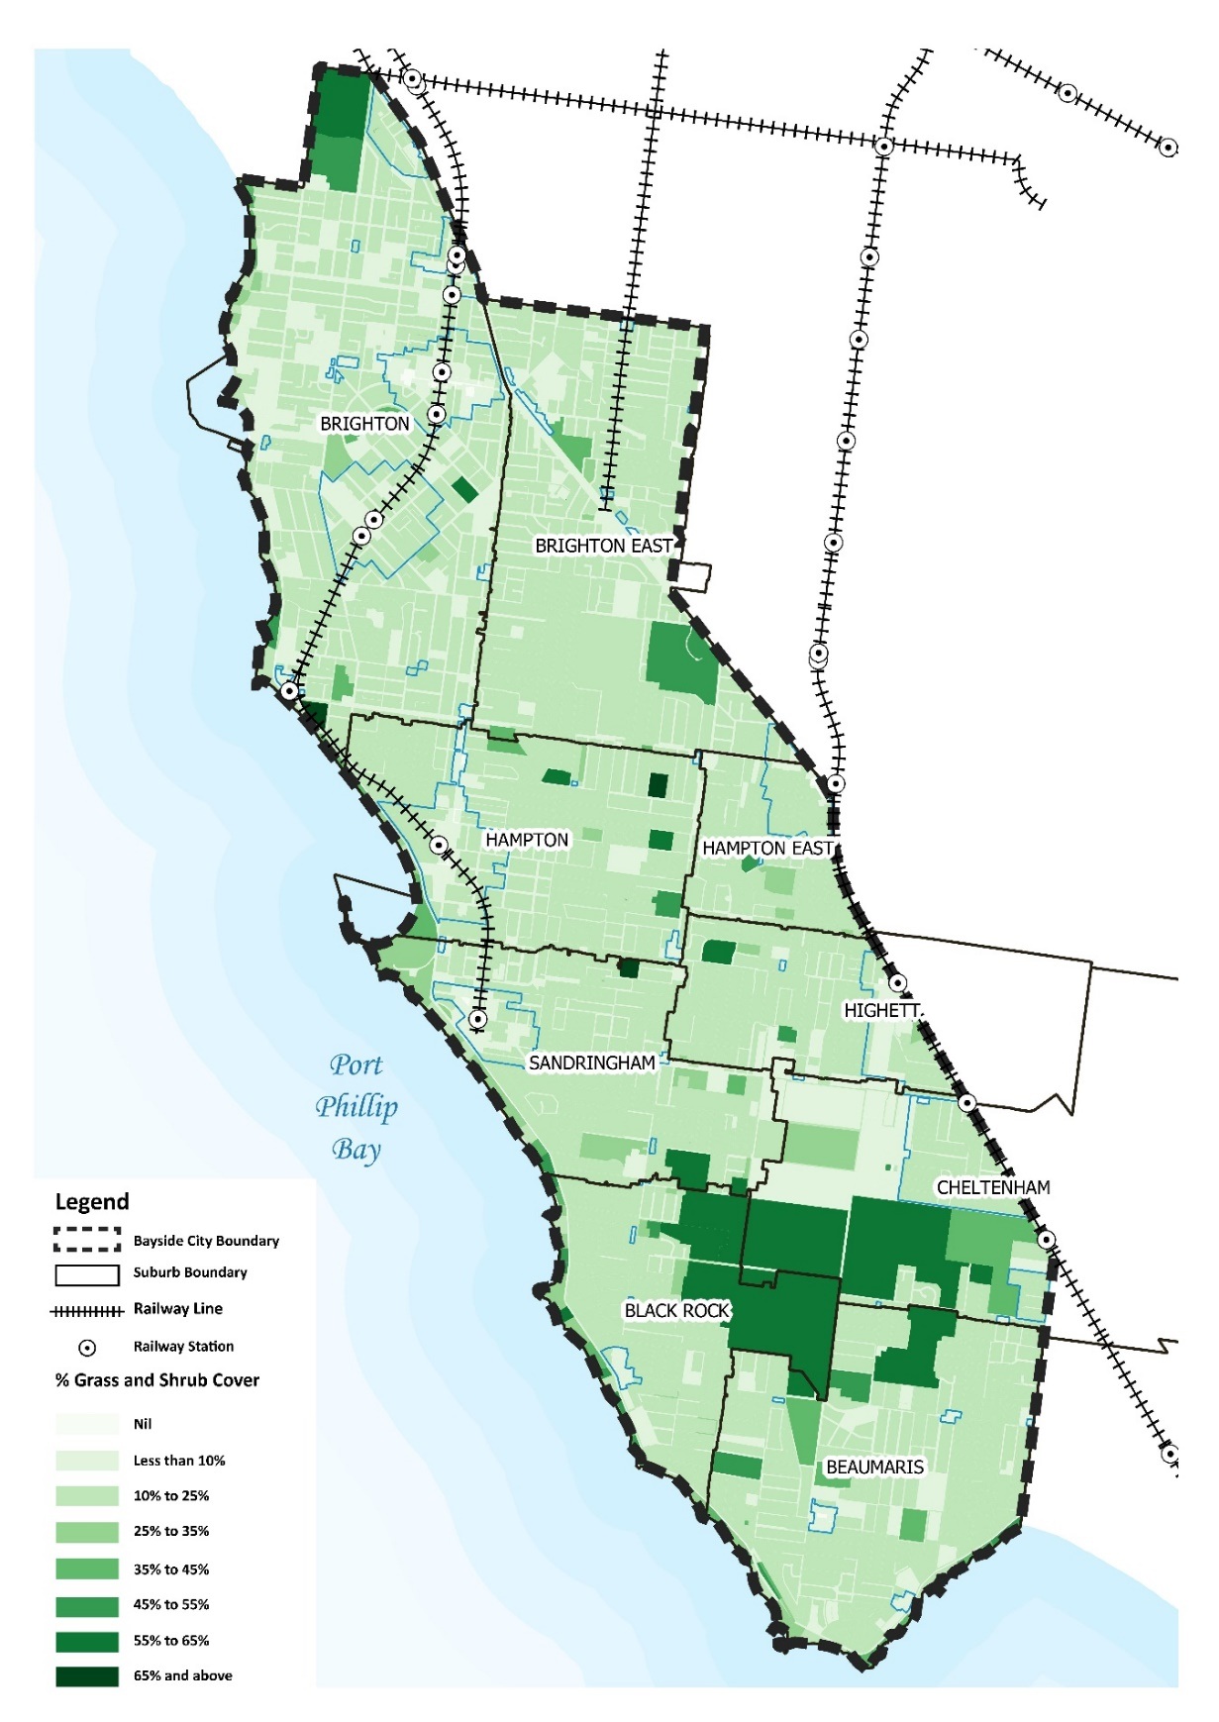

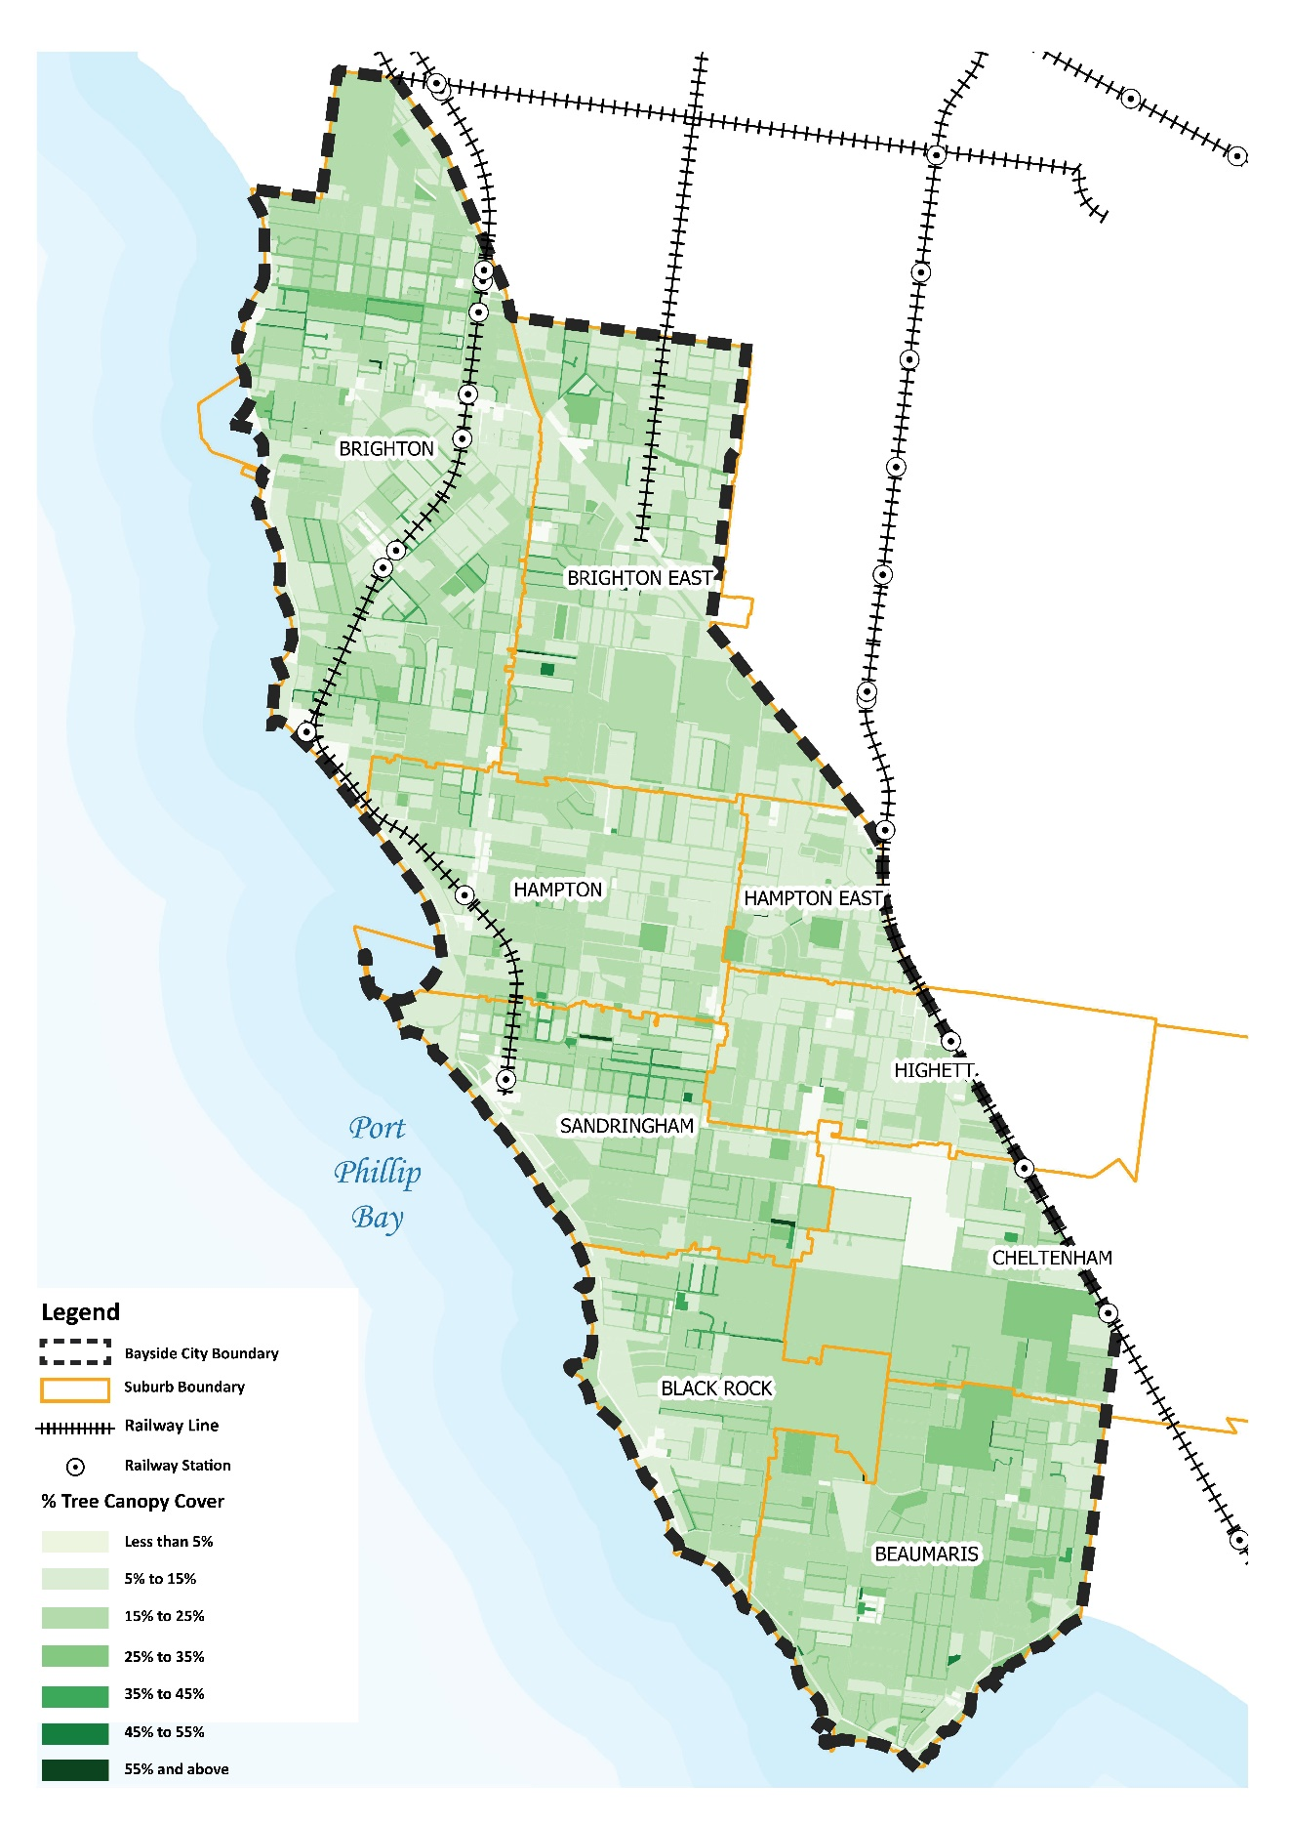
The map below shows the total tree canopy cover for Bayside (measured at three metres). There is approximately 16.07% of tree canopy cover in Bayside.
Map 13: Tree Canopy Cover in Bayside

Analysis of Bayside’s Existing Urban Forest and Tree Canopy Coverage
To ensure we reach 25% of tree canopy cover in Bayside, Council should aim to increase tree canopy cover by 1% each year over the course of the next 9 years.
Utilising the State Governments tree and vegetation canopy cover data from 2018, Council’s GIS team has analysed this to approximate the tree canopy cover per suburb. Figure 5 below identifies Beaumaris having the highest amount of tree canopy cover, which is followed by Black Rock and Brighton.
Council is currently implementing an Urban Tree Monitoring Project to assist with the monitoring of canopy cover changes in Bayside in the future. Tree canopy figures are derived from a particular methodology that involves computer assisted analysis (“machine learning”) of high-resolution aerial imagery (LiDAR). Monitoring canopy cover by utilising LiDAR imagery will assist Council’s review of the Urban Forest Strategy in the future and monitor Council’s ability to expand the tree canopy cover.
Prior to 2018, Bayside’s tree canopy cover was estimated at approximately 16.89% in 2014. Figure 7 below compares the tree canopy cover for each suburb between 2014 and 2018. The data observes a slight decline in tree canopy cover, with the biggest changes being felt in Highett, Hampton, Beaumaris, and Brighton East. These suburbs are geographically the largest in Bayside, and it is assumed that this is one of the main reasons why a decrease in canopy cover has hit the hardest in these suburbs.
To ensure Council does not continue this downward trend, an important aspect of preparing the Urban Forest Strategy will be to provide quantifiable targets for each suburb to increase tree canopy cover, and meet the tree canopy and vegetation cover targets set by Living Melbourne for 2030, 2040 and 2050. In order the reach this goal, Bayside must set actions and investigate its abilities to overcome the key challenges set out in this Draft Background Report.

Figure 7: Tree Canopy Cover in 2014 and 2018

Key Challenges to Bayside’s Urban Forest
As this Background Report has identified, the Bayside urban forest is made up of approximately 16.07% of tree canopy cover. To ensure Council can increase the tree and vegetation canopy cover for Bayside and reach the targets set by Living Melbourne, it is important to understand and identify the different types of challenges that Bayside’s urban forest face so that they can be addressed appropriately.
Increasing tree canopy cover on public land alone cannot solve this issue, and instead Council must also look at ways to overcome challenges by looking at its existing measures on monitoring and retaining trees on private land and whether these measures can be strengthened. It is also important that this Background Report observes the different types of environmental impacts that the Urban Forest will face in years to come due to climate change and educate the Bayside community on these impacts and how they can be overcome.
Vulnerable populations in Bayside
When planning for the expansion of Bayside’s Urban Forest, it is important to understand the challenges faced in both geographical areas as well as the population groups experiencing higher levels of vulnerability. Understanding how tree coverage can have both a positive and negative impact on our community is important and is recognised as a challenge within this Draft Strategy.

Socio-Economic vulnerability
Increase in tree canopy cover is proven to mitigate urban heat island impacts, as well as improve mental health and wellbeing, cool the air and reducing the need for active household heating and cooling.
This is of particular importance for financially vulnerable communities who need to keep household costs to a minimum as ability to save money on energy consumption can be attributed to an increase in tree canopy cover, and may be living in a household that has limited private open space, and relies heavily on the surrounding locality for tree canopy cover and all its benefits.
The SEIFA index identifies that Highett and Hampton East have the highest level of disadvantage in Bayside. These two suburbs also rank last and second-last in Bayside for tree canopy cover with Highett having approximately 13.9% and Hampton East having approximately 14.5% coverage in 2018 (Figure 1). It is expected that these suburbs, alongside Bayside’s activity centres, schools, hospitals, public housing estates, medical centres and aged care facilities are areas that could benefit from increased tree canopy coverage.

Older people, children and people with disabilities and carers
The largest increase in persons between 2016 and 2026 is forecast to be in ages 75 to 79, which is expected to increase by 1,537. Already, Bayside’s ageing population has influenced local employment, with Health Care and Social Assistance being the largest employer in the City of Bayside, making up 17.3% of total employment.
More vulnerable members of the community include older people, young children and people with disabilities and their carers. While trees do bring many benefits, they do however also create challenges for these population groups. Maintenance of trees can be challenging for older people or people living with disabilities to undertake. Trees that are overhanging private property or within the private property can become hazardous and the process to have the tree pruned or removed can too become a burden. Access to information and forms online as well as understanding and navigating council processes to have a tree reviewed can also become challenging.
Currently, there are limited subsidised services through aged care services that provide for tree maintenance. It can be difficult for residents to navigate and purchase these private services and can become too expensive if the resident has a limited or low income. It is recommended that Council investigate the possibility of providing financial assistance or create a panel of private providers that we could refer residents to. The process of obtaining these services from Council should be as easy as possible. Information should be made readily available and accessible on Council’s website and in person at Bayside’s Corporate Centre.
Women’s safety
The OECD Better Life Index found that only 61% of Australian women reported feeling safe when walking alone at night in the area where they live, compared to 77% of men. There are a number of elements that contribute to women feeling unsafe including low visibility and lack of passive surveillance from nearby residents and/or other groups. Trees can contribute to this problem if not managed correctly as they have the potential to block visibility from the street if planted too close together. Tree locations may also provide areas that attackers can use to hide as well as block light on the space. It is vital that these factors are considered when planting trees so that the Bayside community and visitors can feel safe.
Climate Change Impacts
As aforementioned, the health and prevalence of the tree population and canopy cover will be impacted as the likelihood of extreme weather events (including heat waves, drought, floods, sea-level rise, and coastal erosion) occurring are forecasted to increase. Trees that are not prone to these extreme weather events will become increasingly sparse. Therefore, planning for the decline of the tree population is important and factoring in the effects of climate change, with heat stress and drought conditions predicted to be significant factors, will create significant issues to be addressed.
The slight increase of trees recorded in 2014 aligns with a significant climate (weather) event known as the La Niña which saw significantly higher than average rainfall from 2011-12. The approximate 2018 tree canopy cover has identified a decline in tree canopy cover, and while there are many factors that have impacted this, the decrease in tree canopy does correspond to the lower incidence of annual rainfall which has produced drought conditions across parts of the country in more recent years. Of course, climate change is only one of the factors (although highly significant) that has contributed to this decline in rainfall.
To ensure the Bayside urban forest is ‘climate resilient’ and prepared for future impacts, Council must consider using a wider range of species and utilise more diverse and resilient species selection of trees and shrubs that provide for increased tree and overall vegetation cover as well as habitat and biodiversity. This will ultimately influence the overall ability for the urban forest to thrive and expand whilst improving the forest’s resilience to withstand the impacts of climate change. This will also improve the community’s capacity to adapt and be able to response to the impacts of climate change.
Currently, Council has two guidelines in place to provide criteria of tree species for planting in Bayside.
- Tree Selection Guide, which applies to Council owned land; and
- Bayside Landscape Guidelines, which applies to private land.
While the current framework for both guidelines is already strong, it is recommended that both documents are reviewed to reflect the introduction and increase of more climate resilient plant and tree selection alongside native indigenous plantings.
The Bayside landscape guidelines already sets a requirement that plantings within the Vegetation Protection Overlay Schedule 3 (VPO3) need to be 80% indigenous by species type and count. Council should investigate setting other targets (outside of the VPO3) for diverse and resilient species of trees to ensure these species are being planted as Bayside expands its urban forest in Council’s parks and streetscapes. Outside of any set target(s), Council should also continue to encourage residents to plant climate resilient trees and vegetation on their property and front nature strips.
Useful Life Expectancy of Trees in Bayside
As aforementioned in this Background Report, approximately 7,799 trees will not survive or remain in the Bayside landscape after 10 years. By 2040, a total of 51,400 trees will have reached the end of their useful life expectancy.
Not only does Council need to plant more trees that are diverse, trees that are at the end of their useful life will also need to be replaced. Figure 8 below identifies what suburbs will be hit the hardest, with Brighton and Brighton East both having the highest volume of trees reaching the end of their useful life expectancy in 11-20 years from now.
Council should undertake a more extensive tree planting program that is geographically spread and evenly paced in process to allow for a diversity of age and species. There will be little benefit from mass planting in one suburb over a one year period, of the same species, as this will result in a mass senescence in this area once these trees have all reached the end of their useful life expectancy.
Expanding Council’s knowledge and ability to undertake a successful tree planting program will also be beneficial for Council’s yearly budget on tree planting, rather than paying a large upfront cost for mass tree planting over a smaller period of time.

Figure 8: Useful Life Expectancy of trees in Bayside
Soil Types and Salt Tolerance
Bayside soils are Sand and Clay Plains from the Cainozoic period. Most of Bayside consists of deep sandy soils that drain well but are low in nutrients. For tree planting, this may require frequent establishment watering.
At the eastern and southern extremities of the municipality, a dark grey sand is more likely to be found. Drainage may sometimes be impeded by a clay subsoil or perched water table. These soil types have been considered when recommending species for each nature strip type. However, urban soils are generally highly disturbed, often highly compacted and the soil profile at any particular site may differ significantly from an adjacent site. Trees planted in streets close to Port Phillip Bay must be tolerant, to some extent, of salt spray and salinity.
Identifying the different types of soils and soil conditions in Bayside has been challenging. Council commissioned a study in 2019 to test variations on watering intervals and soil conditions on different species of trees and the results showed that the use of bark chips and reduced watering intervals during hotter or drier weather periods will increase the level of moisture and chances of survival for young street trees. While Council can now learn from this study and apply these results to Council owned trees, it is not as easy to apply this learning to private properties. Retaining trees to ensure they live to a mature age is one of the major challenges faced on private land, and ultimately a major challenge to expanding the Bayside urban forest.
Council should continue its investigation into different soil types and conditions by undertaking further investigations into the type of soils within each suburb and identify different tree species that are best suited to these soils. This can help inform specific planting and locations through precinct based urban forest plans for each suburb based on the soil conditions.

Bayside Tree Management: Maintenance, Removal and Replacement Planting
Council’s ongoing management and maintenance of the tree population involves continuous monitoring and evaluation of tree health and age, tree risk and community requests for tree removals based on risk to property or personal wellbeing, or to facilitate new development.
The maintenance of the tree population in Council managed streets and parks is an ongoing process, undertaken by Council’s contractor and trees are generally removed for the following reasons:
- Utility works,
- Private Development (crossovers),
- Streetscape upgrade,
- Vandalism; or
- Tree structurally compromised or dead (unsafe/hazard).

The process to remove a tree, and whether a permit is required or not, depends on the type of tree and location (whether it is on private or Council-owned land). The challenges associated with the regulation of tree removal on private land is discussed in the following section of this Background Report – Key Challenges: Private land.
On Council-owned land, tree removal is generally due to utility works, streetscape upgrades or because it has become a hazard and is unsafe to the community. The challenges associated with the regulation of tree removal on public land is discussed in the following section of this Background Report – Key Challenges: Public land.
Removal of trees on both private and public or Council-owned land may also be because the tree has come to the end of its useful life.
Council’s policy and current contract with citywide is focussed on the maintenance, removal, and subsequent replacement of trees, located on Council owned land, based on the identification of “vacant sites” as trees are removed. Whilst the importance of tree canopy is stated, the policy does not seek to actively expand tree canopy by identifying new locations for planting.
There is further scope for Council to investigate to understand if “vacant opportunity sites” can provide for additional future tree planting to increase the tree canopy even further in these areas. This would assist Council’s planning for a more extensive tree planting program.
Planting Attrition (Survival Rates)
Planting attrition is defined as trees planted but have not survived to a useful life expectancy and have instead died at a young age. Tree loss (and survival) is influenced by a number of factors, which have been identified in this Background Report, in addition to the urban context within which trees exist:
- Climate change (more severe weather conditions)
- Rainfall and water retention
- Soil conditions (including soil type and compaction)
- Tree maintenance and watering schedules

The following Table 7 identifies the number of trees that survived the first year they were planted, and those that did not from 2007-2019. Notably, tree attrition rates were extremely high from 2008-2015. In 2019, the survival of trees being planted was more successful, with only 76 trees having not survived, while 1095 trees did survive.

Table 7: Planting Attrition from 2007-2019
Year the tree was planted | Active  (tree survived the year) | Deactivated  (tree did not survive the year)
2007 | 3 | 57
2008 | 14 | 1,523
2009 | 126 | 845
2010 | 1,233 | 792
2011 | 766 | 502
2012 | 1,125 | 588
2013 | 912 | 431
2014 | 839 | 429
2015 | 1,200 | 534
2016 | 777 | 348
2017 | 868 | 265
2018 | 1,285 | 336
2019 | 1,095 | 76

When trees are planted, they are maintained for a two-year period. During the two-year maintenance period, trees are watered, mulched, and pruned. The current tree planting program generally commences in April, weather conditions permitting, and continues through to October. This allows the trees to have a better chance of establishing through the following summer and overall, a greater chance of survival over the longer term.
While a two-year maintenance period is considered an average amount in comparison to other Council’s maintenance periods, challenges continue to occur following this, as some trees can take a lot longer than 2 years to establish. Council’s cyclic maintenance program looks at each tree every two years, but also has no mechanisms to assist a struggling young tree within these 2 years (other than the watering, mulching and the pruning that occurs).
High tree attrition rates are likely due to a number of reasons; dry spells, soil quality in the nature strips that replacement trees are planted within, the sandy soil conditions that make up much of Black Rock and Beaumaris, buying and planting poor tree stock and planting native trees that are not fast growing and require a longer maintenance period.
To reduce the rate of tree attrition, Council should consider maintaining trees for a longer period and ensuring trees are well watered during dry spells. Whether this is for all trees, or for trees considered in need of more “help” following the two-year period. The size and maturity of a tree matters, and if Bayside’s urban forest is unable to mature with time due to high levels of tree attrition, many impacts will be felt.
Larger mature trees generally provide greater benefits in comparison to small trees, so ensuring trees can grow and reach a mature age is vital to the success of the urban forest. Large trees provide habitat for other animals and plants to facilitate important ecological cycles. Further, there is also a greater cultural value placed on large and mature trees. To ensure trees can survive to a mature age, research has found that one way to invest is to garner community support with tree plantings. This can reduce vandalism and create a sense of ownership. It has also been found that trees that have been planted with community participation, had significantly higher rates of survival, ranging from 60-70% higher, as compared to trees planted without community participation. Involving the community in tree planting may also increase neighbourhood ties, sense of community, and lead to a positive social effect.
Species Diversity
A resilient urban forest has a diverse range of species from different families. A limited list of successful species may provide good results in the short term but may result in a vulnerable tree population in the future. In the long term, pests or diseases that attack one or more of those species have the potential to significantly reduce the street tree population. As previously mentioned in this Draft Background Report, climate change will also impact less resilient trees and vegetation which too will result in a decrease of canopy cover if there is not a diverse range of species in Bayside.
As outlined in Bayside’s Street and Park Tree Selection Guide, a single pathogen has the potential to not only affect a species or genus, but an entire family of plants. Therefore, diversity is required at the species level, the genus level and the family level.
In order to promote more resilience for the whole ecosystem and ensure that future threats to the tree populations are minimized, there needs to be a transition away from the use of this single family of tree species in favour of other, less represented indigenous species under a different family.
The Tree Selection Guide was introduced in 2016 and highlighted the issue of diversity in Council’s tree planting program. However, the planting of this family has remained constant in recent years, remaining at 54.7% (2,766) from 2016-2019. Even when an analysis is undertaken by suburb, the Myrtaceae is currently the family of tree predominantly used for all suburbs of Bayside, with a particular reliance on this family in Sandringham, Hampton and Highett.

Table 8: Use of Myrtaceae Family per Suburb
Year/Suburb | 2007-2010 | Use of Myrtaceae | % | 2016-2019 | Use of Myrtaceae | %
Beaumaris | 2,775 | 1,353 | 48.75 | 890 | 364 | 40.9
Black Rock | 1,265 | 817 | 64.6 | 416 | 232 | 55.8
Brighton East | 2,616 | 1,041 | 39.8 | 597 | 282 | 47.2
Brighton | 3,072 | 1,017 | 33.1 | 921 | 390 | 42.3
Cheltenham | 9,24 | 590 | 63.85 | 300 | 175 | 58.3
Hampton | 2,391 | 1,809 | 75.66 | 673 | 498 | 74.0
Hampton East | 842 | 529 | 62.8 | 282 | 152 | 53.9
Highett | 1,212 | 746 | 61.5 | 353 | 231 | 65.4
Sandringham | 1,901 | 1,353 | 71.2 | 627 | 450 | 71.8
ALL BAYSIDE | 16,990 | 9,247 | 54.4 | 5,051 | 2,766 | 54.7

Aside from the Myrtaceae Family, other popular tree families that are planted in Bayside have been identified below.
Figure 9: Popular Tree Families in Bayside

Notably, the Myrtaceae Family is known to have a number of native and indigenous species that are resilient and well suited to the conditions in Bayside, which is why it has been so well utilised over the years. It is also a family that is extensively planted in other municipalities. When considering new species for tree planting, the Council’s Tree Selection Guide has set out the following tree selection criteria:
- Relationship with local landscape character
  - Surrounding streetscapes
  - Vegetation Protection Overlays (VPO2, VPO3)
  - Heritage values
- Ability to tolerate and thrive in a site’s environmental conditions
  - Species that have or can adapt to local conditions
    - Climate
    - Soil
    - Tolerances (e.g. coastal and salt)
    - Pests and diseases.
- Possible future damage to infrastructure
  - Playgrounds,
  - Pathways,
  - Private infrastructure,
  - Public infrastructure,
- Specific considerations
  - Development of significant landscapes,
  - Existing park landscape character,
  - Relevant masterplan,
There is currently a disconnect in terms of the identification of diversity issues and the implementation of a more diverse tree planting program through the Tree Selection Guide. The Tree Selection Guide is the principal document that informs street and park tree planting in terms of species selection. It sets out a number of criteria and objectives in relation to tree selection, however it states that diversity targets are a consideration in tree selection but has not provided targets within the document.
Diversity targets will assist in setting future benchmarks for a more diverse tree population. Therefore, updating the Tree Selection Guide with a list of native and indigenous species that are suitable as alternatives to species within the Myrtaceae family is a logical course of action in addressing this issue. The following families currently form part of the overall tree population in Bayside’s Streets and Parks, at a significantly lower percentage than the Myrtaceae family, and therefore an increase of their inclusion would be beneficial:
- Oleaceae (6%)
  - 3.3% of all trees planted since 2007; 1.5% from 2016-19
- Proteaceae (4%)
  - 10.5% of all trees planted since 2007; 13.1% from 2016-19
- Rosaceae (4%)
  - 3.5% of all trees planted since 2007; 2.4 % from 2016-19
- Platanaceae (4%)
  - 3% of all trees planted since 2007; 3.9% from 2016-19

In accordance with the Tree Selection Guide, it is also important that the neighbourhood character of a street is considered when planting new trees in that street. Plant selection should continue to ensure character is considered and this can be managed at a Precinct level for each suburb. Similarly, suitability of soil type will also need to be considered and this too can be managed through the preparation of Precinct based urban forest plans for each suburb.
Finding equally resilient trees that are able to mature and also align with the character of the street is continuously strived for by Council and it will be important to recognise this through the review of the Tree Selection Guide.
Distribution of Tree Canopy Coverage Across Bayside’s Suburbs
Tree Canopy Coverage across Bayside can be observed in many ways, the distribution of canopy on private vs public, residential land vs non-residential land, and at a broader context, coverage comparison for each suburb in Bayside. Tree Canopy Coverage per suburb is considered the most valuable way to measure coverage and any key challenges or actions specific to each suburb can be addressed through the development of Precinct based urban forest plans. This Draft Background Report recommends that Council prepare Precinct plans as a next step to discuss the makeup of private and public land, as well as land use and zoning designations for each suburb and how this influences the current level of canopy cover, and methods to increase this cover into the future.
This section of the Background Report observes the distribution of tree canopy coverage to provide a broader lens on the types of challenges and actions that affect Bayside on both a municipality level and at suburb level. Utilising the State Governments tree and vegetation canopy cover data from 2018, data was analysed to approximate the tree and vegetation canopy cover per suburb. Figure 10 below identifies Beaumaris having the highest amount of tree canopy cover (20%), which is followed by Brighton (17%) and Sandringham (17%).
Figure 10: Bayside Estimated Tree and Vegetation Canopy Cover adapted from State Government canopy cover from 2018
Beaumaris and Sandringham are rich in native and indigenous vegetation and covered (all or in part) by the Vegetation Protection Overlay (VPO3) which likely contributes to its increased percentage in tree canopy cover.
Cheltenham, Hampton, and Hampton East all have approximately 15% tree canopy cover. Highett has the lowest overall tree canopy cover figure at approximately 14%.
As previously identified in this Background Report, population and dwelling forecasts show that Cheltenham, Highett, and Hampton will experience the highest levels of growth. Implications that can occur subject to housing growth include:

- More demand for public open space and increased pressure on existing parks,
- Higher levels of tree removals for development than other suburbs; and
- More higher density housing, reducing the capacity of sites to accommodate trees.
It is assumed that the housing growth being experienced in these areas is a factor in relation to the minimal tree canopy coverage in Cheltenham, Hampton, Hampton East, and Highett.
The challenge to increase tree canopy cover while also retaining, monitoring, and diversifying tree canopy cover will be felt differently for each suburb. Which is why it will be important to separate specific actions and identify opportunities on a suburb basis through set Precinct plans.

Actions to consider…
- Investigate Council’s ability to expand its support of vulnerable residents in the Bayside community
There is opportunity to support the pruning and maintenance of these trees and Council should investigate the creation of a volunteer network to be able to support clean-up of debris and leaf litter.
Providing an advisory service to support residents that are considering whether to cut down trees with options around pruning and maintenance that may avoid the removal of the tree.
- Expand the Urban Forest: Future Planting Sites
Council’s current approach is to maintain the tree population. Scope to increase the tree canopy cover is currently limited, and in order to meet the Living Melbourne tree canopy cover target by 2030, 2040 and 2050, this needs to change. A more purposeful and targeted approach of identifying new sites/areas, or expanding existing areas, is required to grow and enhance the urban forest whilst ensuring resilience to the future impacts of climate change. Identifying opportunities to plant more trees should be undertaken to increase habitat connectivity, advance neighbourhood character, and ensure the safety of the Bayside community and visitors is not lessened by low visibility, limited lighting, or lack of passive surveillance.

Increasing tree planting on public land should be undertaken through a project dedicated to identifying the opportunities across the open space network to increase canopy and vegetation, as well as a dedicated program of new site identification along Councils streetscapes. Engagement with the community in identifying and nominating sites will be a key feature of ensuring the community is involved.

Actions to consider…

- Prioritise tree planting locations through Precinct Plans
A key action of the Urban Forest Strategy should be the preparation and implementation of Precinct Plans for each suburb in Bayside by:
  - Increase street trees in areas deficient (Beach Road).
  - Where possible, allocating more than one tree per property frontage.
  - Addressing hotspots in each suburb
  - Address vulnerable areas (social and heat)
  - Age/Health/ULE of particular trees
  - Identification of corridors/linkages
  - Increase understorey plantings in nature strips (not just trees)
Further research in relation to species selection, soil types, weather conditions and rainfall (climate change) will also be required before selecting the appropriate species to diversify our tree population and to ensure when the trees are planted, they have a greater chance of survival under these challenging conditions.
- Diversify the Urban Forest
Currently, the most dominant tree family is the Myrtaceae family as it has a large variety of native and indigenous species which have been the preferred planting types for Council’s tree planting program and have contributed to the strong character of Bayside’s streetscapes
Increasing diversity across the street tree population will make the urban forest more resilient. This can be achieved by:
  - Updating the Tree Selection Guide 2016 to include different tree species
  - The Bayside Open Space Strategy 2012 provides the direction on the use of open space and the competing demands that influence how spaces are used, and to cater for the needs of a growing population. This strategy is to be reviewed in 2022. It is recommended that areas for increasing vegetation and habitat are identified and planned for to align with the Biodiversity Action Plan.

Key Challenges: Private land
This section of the Background Report observes the current regulations, processes and challenges for tree planting and removal on private land. While it is important to understand the key challenges that affect the Bayside municipality as a whole, it is also recognised that challenges on private and public land are different, and ways to address these challenges are likely to differ too. Tree planting as well as the ability to monitor and retain existing trees on private land is largely a responsibility of the respective property owner. Tree removal on private property comes with challenges and while Bayside City Council has implemented processes to regulate this, it does not mean illegal activity is voided.
Regulating tree removal on Private Property
To ensure Council is able to protect and expand the tree canopy of the entire municipality, regulation of tree removal on private property is applied utilising various mechanisms. The Bayside Planning Scheme and Local Law No.2 ‘Neighbourhood Amenity’ are the two main ways to enforce this protection, alongside the Bayside Significant Tree Register.
An overview of the local law and planning permit processes has been provided in Figure 11 below. The processes compliment Council’s strategic planning framework to protect tree and vegetation. However, there is room for improvement throughout these processes and the actions of this Draft Strategy seek to respond to this.

Figure 11: Tree Protection and Tree Removal Permit Processes
Statutory Planners and Arborists provide advice either through enquiries or pre application discussions on tree removal, replanting and landscaping requirements.
Statutory Planners undertake assessment of the proposed development and implications on tree and vegetation are assessed against the relevant planning requirements. The Bayside landscaping guidelines inform the assessment of the proposed landscaping plans, however these guidelines are not currently incorporated in the Bayside Planning Scheme.
Once a planning permit is issued:
A Tree Management Report must be provided. This Report should outline how construction will be undertaken to limit the impacts of neighbouring trees through construction activity. A hired arborist must oversee the construction and management of trees in the tree protection zone; and
A condition of the planning permit is that the approved landscape plan is implemented and complied with.
Tree protection zone is set to align with the Tree Management Report. Hired Arborist oversees the implementation of tree management and protection measures.
Council is also investigating and implementing the application of tree bonds to Council owned street trees within the tree protection zone.
Inspection at completion to ensure compliance with requirements.
At completion of development, Council undertakes a landscaping audit to ensure the approved landscaping plan has been complied with.
Pro-active auditing at various intervals following development, including 2 and years later.

PLANNING PERMIT PROCESS
Private building surveyor ensures the compliance of the planning and building permit.
Arborist provides advice and/or on-site inspection to discuss the probable removal of the tree
Assessment of the tree is undertaken utilising supporting evidence and reason for tree removal provided by applicant.
Once a Local Law permit is issued, it is generally a condition that a replacement tree is planted. The replacement planting should be suitable to the local vegetation character and site constraints
Inspection to ensure required plantings have been delivered.
Pro-active auditing at various intervals following development, including 2 and years later.

LOCAL LAW PERMIT PROCESS

Bayside Local Law No. 2 ‘Neighbourhood Amenity’
Clause 36 in the Local Law No. 2 ‘Neighbourhood Amenity’ protects trees, by regulating tree removal and pruning of trees on private property. Under the Local Law, the following requires a permit for removal:
- Significant Trees included on the Significant Tree Register; and
- Canopy trees on private land that have a single or combined trunk greater than 155 centimetres measured at 1m above ground level. If the tree has several trunks, the 4 largest trunks circumferences should be added together. See Figure 9 below for reference.
For tree removals, the property owner will need to provide a reason and supporting evidence:
- Tree risk - a report from a qualified arborist including a risk assessment utilising a recognised method, or completion of Council’s quantified tree risk assessment data sheet.
- Quantified tree risk assessment datasheet
- Damage to property or infrastructure - a report from a licensed and/or qualified person in their field, e.g. plumber, engineer, architect, builder
- Building - a copy of building permit
- Medical condition - a copy of medical certificate
- Social criteria - applicable evidence
- Plus, any other supporting evidence

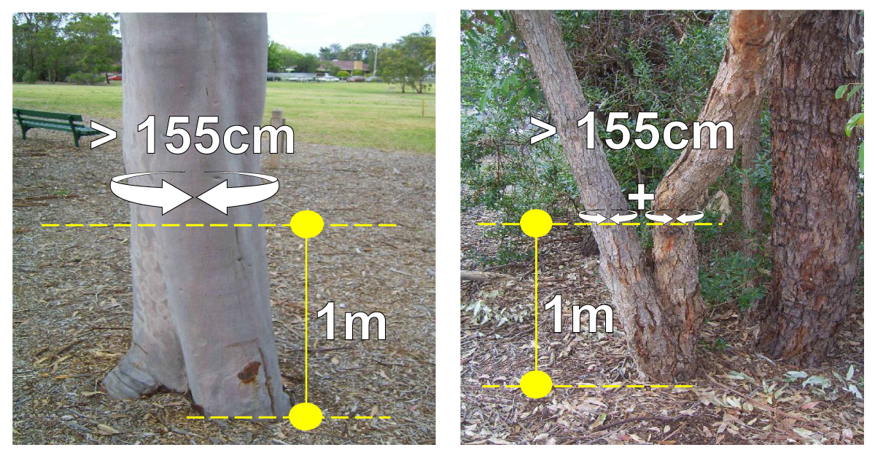
Figure 12: Minimum size requirements for Local Law Tree Removal Permit

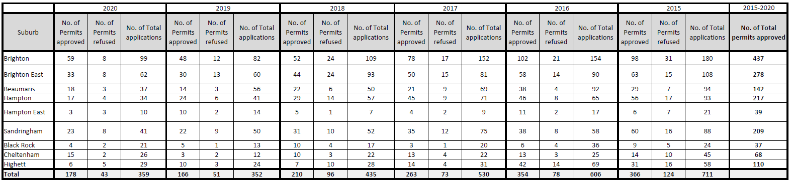
Table 9: Local Law Tree Removal Permits (Approved, Refused & Total Number of Applications) 2020-2015
Over the course of five years, the highest volume of tree removal permits approved have been in Brighton (437 approved permits). Following this is Brighton East (278), Hampton (217) and Sandringham (209).
Over the five-year period, it appears that the total number of tree removal applications are slowly steadying. In 2015, Council received a total of 711 applications, whereas in comparison to that received in 2020, it was 359. It is assumed that this is a positive result; that less residents are wanting to undertake tree removal. However, it could also be assumed that more residents are undergoing tree removal without seeking a permit approval.

Tree Removals and Plantings
Where a Local Law permit is required and is approved by Council, a condition of permit is that a replacement tree is planted. The replacement planting is intended to be achieved using species that are suitable to the local vegetation character of the area and site constraints.
Figure 13 depicts the number of tree removals and plantings by suburb between 2009 and 2019 in Bayside. It demonstrates Council’s ongoing activity intended to ensure the tree population remains relatively stable. The recorded numbers show that in any given year, more trees are planted than are removed.
Figure 13: Tree Removals and Plantings by suburb 2009-2019

A high proportion of the removals are based on trees being either dead or structurally compromised, as identified by Council’s contractor. The attrition data presented previously in this Background Report provides an insight into the difficulty of young trees surviving, an issue that Council is actively monitoring and addressing through varied watering schedules and other measures to increase survival, including species diversity.
It is likely that survival rates of young, establishing trees are relatively low because trees planted on private property have not been suitably managed to ensure the tree is then able to grow to a mature age.
The local law removal and planting data also suggests the suburbs of Brighton, Brighton East, Beaumaris and Hampton have seen the highest levels of removal and replacement planting, which aligns with the local law tree removal permit data in Table 9. However, it can be assumed this is because these are also the four largest suburbs in terms of land area in Bayside.
Where tree removal is required due to trees being either dead or structurally compromised, Council should investigate the current mechanisms in place to support the appropriate replanting of trees on private property; being the Bayside Landscape Guidelines. There is a need to minimise tree removals through the local law and planning processes and consideration as to how Council can actively do so needs to be further investigated.
A review of the assessment process for tree removals in other municipalities was investigated as part of this Background Report and it was found that the assessment criteria utilised by other Councils varied between municipalities. Councils can set their own minimum assessment criteria as there is currently no set standard in Victoria. Bayside’s assessment criteria only apply to trees with significantly sized larger trunks. Conversely, the review found that other Councils have introduced assessment criteria required for smaller trunks. This meant that more tree removals and/or pruning would require permit application and approval.
Table 10: Assessment criteria for local law tree pruning or removal permits from different Councils
Council | Bayside | Stonnington | Boroondara |  | Moonee Valley |  | Kingston
Trunk Circumference (cm) | 155cm | 150cm | Canopy trees are measured and protected utilising both measurement requirements below. |  | If multi-stemmed, 110cm | 150cm | 110cm
 |  |  | 110cm | 150cm
Height Above Ground | 1m | 1.4m | 1.5m | 0m | 1.5m | 0m | 0m
One of the most evident and challenging issues that the Urban Forest Strategy will need to respond to is the high volume of applications that Council receives in request for a Local Law Tree Removal Permit. There is a need to educate the community on the importance of trees and instead of undertaking reactive measures, alike replanting trees following a tree removal, upfront conversations with property owners on the importance of trees need to be had. A large piece of the Urban Forest Strategy will be the promotion of the Bayside Urban Forest and looking at how Council can create a behavioural change. As previously identified in this Background Report, there is also a need to review the Bayside Landscape Guidelines and investigate the current mechanisms in place to support the appropriate planting of trees on private property.
Council may wish to consider reviewing the assessment criteria in the Local Laws No.2 to reduce the measurement height of the tree being assessed, which would result in more trees requiring a permit for removal, allowing Council greater control of trees on private land and ensuring that tree removal is regulated to a greater extent.
Bayside Significant Tree Register
Bayside currently has 99 trees listed on its Significant Tree Register that have been identified and assessed using the criteria by the National Trust of Australia (Victorian Branch) for their Significant Tree Register. This criteria assesses trees based on their social, historic and/or aesthetic significance.
Due to their status and importance, Significant Trees require higher levels of protection than Local Law protected (canopy) trees and other vegetation, but both are regulated through Bayside’s Local Law No. 2 – Amenity Protection. Some Significant Trees are protected by the VPO (Vegetation Protection Overlay) and some by the HO (Heritage Overlay) and applications for their removal are undertaken in accordance with the Bayside Planning Scheme.
Planning applications requiring a planning permit that include a proposal to remove a Significant Tree are assessed under the provisions of the Planning Scheme (not through the Local Law), but also require a resolution by Council via a Council meeting to approve their removal. The Significant Tree Register is not currently part of the Bayside Planning Scheme; however the requirement of the register is identified in Clause 36(4) of Local Law No.2:
(4) The Council must maintain a significant tree register recording all Significant Trees within the Municipal District and ensure that such register can be inspected at the Council’s principal office during normal business hours.
There have been 41 requests between 2016-2020 from residents to have trees identified as significant, with some requests for individual trees being made multiple times.
Table 11: No. of Requests per Suburb (2016-2020) for trees to be identified on the Significant Tree Register.
Suburb | No. of Significant Tree Requests
Brighton | 12
Brighton East | 4
Beaumaris | 4
Hampton | 4
Hampton East | 3
Sandringham | 8
Black Rock | 1
Cheltenham | 4
Highett | 1
Total | 41

To promote the importance of Significant Trees in Bayside further, Council has provided a nomination form on the Bayside City Council website which allows anyone to nominate a tree, be it located on private land or Bayside City Council land, to be added to the Significant Tree Register. This has only recently been implemented.
Outside of seeking nominations, Council could consider undertaking an investigation of trees on private and public land in Bayside that are potentially significant. Actively investigating the significance of trees will allow for a higher level of protection for these trees. This would act as both a deterrent from those considering any potentially unlawful removal, as well as allowing Council to prosecute any unlawful removal through the Planning and Environment Act rather than the Local Law processes.
Bayside Planning Scheme
The Bayside Planning Scheme provides for protection of trees and vegetation by triggering a planning permit approval process. The following sections of this Background Report identify the relevant provisions of the Bayside Planning Scheme in relation to tree removal and replanting, and conditions of permit that are generally required when tree removal has been approved.
Tree Management Report: Tree Protection
As development continues to increase, so does the impacts on trees due to construction activity. Impacts on the health of Council owned street trees due to construction activity upon nearby or adjacent property development sites attributes to tree loss in Bayside.
As part of the conditions of a planning permit, a Tree Management Report is to be provided to outline how construction will be undertaken to limit the impacts of neighbouring trees through construction activity. A hired arborist must oversee the construction and management of trees in the tree protection zone and implement these measures during the construction phase.
While these measures are put in place, it has not always prevented trees from being impacted and a more proactive approach to minimising these impacts needs to be undertaken. Council is currently investigating and implementing the application of tree bonds on Council owned street trees that are within tree protection zones at the time of construction.
Endorsed Compliance: Landscape Plans
A Landscape Plan is a requirement for selected planning permit applications, allowing Council’s Statutory Planners to assess the vegetation proposed for removal as well as replacement planting. It is requested that a Landscape Plan be prepared in accordance with the Bayside Landscape Guidelines 2016. Council arborists also provide advice on whether the removal of trees is appropriate, and whether the replacement tree planting scheme is appropriate.
To ensure landscaping has been provided in accordance with the approved landscape plan, Council officers undertake a landscape audit assessment. If determined to be compliant, the applicant is provided with a Statement of Compliance.

Bayside Landscape Guidelines 2016
The Bayside Landscape Guidelines document was created to assist applicants’ understanding of the replanting requirements associated with VPO3, SLO1 and for all planning applications involving the removal of trees and requiring a Landscape Plan as part of the application process.
The Bayside Landscape Guidelines were endorsed by Council in 2016 however, do not currently form (and are not referenced) as part of the Bayside Planning Scheme. The guidelines provide advice on where to locate replacement trees and vegetation on a development site, to assist landscape architects on the preparation of their landscape plan.
While the landscape guidelines provide guidance for how replanting should be planned for in a landscape plan, the utilisation of guidelines by applicants and landscapers when undertaking landscaping, is not always compliant. To exemplify this, the following excerpt has been taken from the guidelines:
When designing your replacement planting scheme please consider that:
- proposed canopy trees need to be appropriately planted in order to optimise tree growth and vitality and to reduce the likelihood of long-term conflict with buildings,
- vegetation should be centred within their tree replacement planting area in order to encourage even growth,
- trees should be planted outside of easements and in accordance with service authority guidelines (e.g. away from sewer and water mains and power-lines),
- overlapping of tree canopies should be minimized,
- trees should be clear of buildings, hard surfaces and clothes lines,
- where buildings, basements or hard surfaces do encroach, you must demonstrate that there is sufficient soil volume for the optimal growth of the tree,
- vegetation must be planted in a location where it will have access to sunlight and water; and
- you normally need to install automatic drip irrigation to all planted areas of the site.
Council has previously identified challenges during the landscaping audit process, with the replacement planting scheme being undertaken differently from the approved landscape plan. This is a challenge that needs to be addressed and should be undertaken through the review of the Landscape Guidelines.
Soil volume and water supply/retention are two essential components for the survival and enhancement of the trees being newly planted on private property. Measures taken to incorporate these essential elements into new development can help to support a growing urban forest, however this is at times overlooked. The Bayside Landscape Guidelines recommends soil volumes required based on the fully grown tree canopy size, however this needs to be considered more carefully by both applicants and planning officers, when preparing and assessing landscape plans.
There is the possibility to heighten the enforcement of the guidelines to ensure trees are being planted appropriately to optimise tree growth. When trees are planted inappropriately, they are more likely to be removed earlier and this impacts tree attrition and minimises the ability to expand the Bayside urban forest. It is recommended that a review of the Landscape Guidelines is undertaken to understand if its application can be expanded and strengthened. As landscape plans are generally required for all planning applications involving new residential development and/or the removal of trees, the use of the document could be expanded to apply to Local Law permit applications to provide further guidance to applicants, and all landscape plans submitted to Council of the standard that is required for planning applications.
There is also a need to shift the conversation from how landscaping should be undertaken around the design of a building, to how can the design of a building ensure landscaping can be optimally achieved. In doing so, Council should investigate amending the planning scheme, particularly schedules to the Neighbourhood and General Residential Zones. There is the possibility to set more sufficient front and/or rear setbacks through these schedules to ensure canopy trees can be provided. Site coverage, permeability and soil volume could also be introduced and discussed in further detail.
A review of the landscape guidelines should also investigate the possibility of setting species diversity targets, as a way of enhancing species diversification in the Bayside urban forest.
Heritage Overlay
The objective of the Heritage Overlay (HO) is to ensure heritage landscapes and trees are adequately conserved, maintained, and managed and are not adversely affected by development of these places or their settings. When a property is identified under the schedule to the Heritage Overlay as one where tree controls apply, a permit is required to:
- Remove, destroy, or lop a tree if the schedule to this overlay specifies the heritage place as one where tree controls apply. This does not apply:
  - To any action which is necessary to keep the whole or any part of a tree clear of an electric line provided the action is carried out in accordance with a code of practice prepared under Section 86 of the Electricity Safety Act 1998.
  - If the tree presents an immediate risk of personal injury or damage to property.
Currently, the Schedule to the HO identifies that tree controls apply to 48 heritage places in Bayside. Of these 48 trees, 27 of which are also identified in the Significant Tree Register.
Significant Landscape Overlay
The Significant Landscape Overlay (SLO) is used to identify significant landscapes, and conserve and enhance their character. The SLO applies to a limited area in Bayside including parts of Coral Avenue and Point Avenue, Beaumaris (identified below in Map 14). The SLO protects all trees (native and exotic) greater than 2 metres high and with a trunk circumference greater than 50 cm (at 1 metre above ground level). A permit is required to remove, destroy, or lop a tree. This does not apply to:
- Vegetation that is less than 2 metres high or has a single trunk circumference of less than 0.5 metre at a height of 1 metre above ground level.
- The pruning of vegetation to remove that part of any branch which overhangs an existing dwelling or is within 2 metres of an existing dwelling.
- A tree which is dead or dying to the satisfaction of the responsible authority.
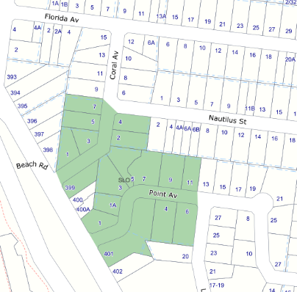
Map 14: Location of Significant Land Overlay in Beaumaris

Vegetation Protection Overlay
The Vegetation Protection Overlay (VPO) specifically seeks to prevent the loss of native and particularly indigenous vegetation incurred by development and tree removal, as well as retaining the amenity, aesthetic character and habitat value of vegetation within the area and promoting the regeneration and replanting of indigenous species.
Bayside currently has three schedules to the Vegetation Protection Overlay in the Planning Scheme. They are outlined below:
Under VPO1 ‘Coastal Areas’, a planning permit is required to remove, destroy or lop native vegetation. An application must include the following information:
- The extent of native vegetation to be removed, destroyed, or lopped.
- Details of the impact of the proposed removal, destruction or lopping on soil stability.
- Details of proposed revegetation, including proposals for ground stabilisation, species to be planted and source of plants.
Under VPO2 ‘Bushland Areas’, a planning permit is required to remove, destroy or lop native vegetation. An application must include the following information:
- The extent of native vegetation to be removed, destroyed, or lopped.
- Details of the impact of the proposed removal, destruction or lopping on soil stability.
- Details of proposed revegetation, including proposals for ground stabilisation, species to be planted and source of plants.
Under VPO3 ‘Beaumaris and Black Rock Native Vegetation Areas’, a planning permit is required to remove, destroy or lop any vegetation native to Australia. This does not apply to:
- The removal, destruction or lopping of vegetation which is less than 2 metres high or has a single trunk circumference of less than 0.5 metre at a height of 1 metre above ground level.
- The pruning of vegetation to remove that part of any branch which overhangs an existing dwelling or is within 2 metres of an existing dwelling.
In 2020, 77 applications were submitted in request for a tree to be removed within VPO3. Of these 77 applications, 45 were approved. In previous years, there have been less VPO3 permits granted, as identified below in Table 12.
Table 12: VPO3 Permits 2019-2017
 | 2019 |  |  | 2018 |  |  | 2017
Suburb | VPO3 Removal - Granted | VPO3 Removal - Refused | VPO3 Removal - Other | VPO3 Removal - Granted | VPO3 Removal - Refused | VPO3 Removal - Other | VPO3 Removal - Granted | VPO3 Removal - Refused | VPO3 Removal - Other
Beaumaris | 41 | 13 | 3 | 40 | 20 | 8 | 48 | 14 | 5
Black Rock | 11 | 3 | 7 | 12 | 7 | 1 | 20 | 4 | 3
Brighton
Brighton East |  |  |  |  |  | 1
Cheltenham |  |  |  | 2 | 3 |  | 1
Hampton
Sandringham |  |  | 1 | 1 |  |  |  |  | 1
Hampton East
Highett
Total | 52 | 16 | 11 | 55 | 30 | 10 | 69 | 18 | 9
Council has also identified the number of trees removed that have been approved through planning permit applications, that aren’t proposing the removal of a tree in VPO3. However, this data is likely not to be completely accurate, due to human error when entering details related to each planning permit application in Council’s system.
More recently, Council has updated the level of information to be recorded in the Delegations Report which will allow for greater accuracy when monitoring tree planting and removal through planning permits. Within the Delegations Report, the Council planning officer assessing the application provides their assessment and justification for approval or refusal. The Delegations Report now requests the following information to be provided by the Council planning officer:
- No. of trees proposed for removal
- No. of trees approved for removal
- No. of trees to be replanted
- Is a street tree being removed?
This information can be utilised as data to assist Council’s understanding of how many tree removals are approved through planning permits in the future. Collection of this planning data should form part of Council’s internal processes and will be a key action of the implementation of an Urban Tree Monitoring Program at Bayside.
Erosion Management Overlay
The Erosion Management Overlay (EMO) specifically seeks to protect areas prone to erosion, landslip, or other land degradation processes, by minimising land disturbance and inappropriate development.
Under the EMO, a planning permit is required to remove, destroy, or lop any vegetation. This does not apply:
- If a schedule to this overlay specifically states that a permit is not required.
- If the table to Clause 44.01-4 specifically states that a permit is not required.
- To the removal, destruction or lopping of native vegetation in accordance with a native vegetation precinct plan specified in the schedule to Clause 52.16.
Planning Practice Note 7 – Vegetation Protection in Urban Areas
As outlined in this section of the Background Report, Council has a number of Overlays in place to assist with the protection of significant vegetation. Identifying, assessing and protecting significant vegetation through the planning scheme should continue to be a priority of Council’s and this should be undertaken consistently with Planning Practice Note 7 – Vegetation Protection in Urban Areas.
The purpose of the Planning Practice Note is to provide guidance on how to assess the significance of vegetation in urban areas and how to protect significant vegetation through the planning scheme. The practice note:
- identifies issues associated with protection of vegetation in urban areas
- outlines techniques for the assessment of the significance of vegetation
- provides guidance on developing local objectives and strategies for protecting vegetation through a local vegetation protection strategy and the planning scheme
- provides suggestions for using tools in the Victoria Planning Provisions (VPP) and other measures to implement local vegetation protection strategies
- provides guidance on enforcement and monitoring of policy performance.
A local strategy for vegetation protection should identify vegetation issues at the local level and formulate objectives and strategies for vegetation protection and enhancement. Suggested steps for preparing and implementing a local vegetation protection strategy are:
- Undertake a vegetation survey
- Determine vegetation significance
- Prepare a local policy (MSS and local policy)
- Apply overlay provisions, where appropriate
- Enforce the planning scheme where necessary
- Monitor outcomes.
Other mechanisms
When deciding applications for multi-residential development, there are provisions that require applicants to provide or allow Council to request additional relevant information. The following clauses and provisions are identified as they relate to the protection and retention of existing vegetation:
- The native vegetation provisions listed at Clause 52.17 provide for a range of matters relating to the removal of native vegetation, generally a lesser issue in Bayside given the developed and heavily planted nature of the municipality.
- A neighbourhood and site description (clause 54.01-1, clause 55.01-1), including (inter alia):
  - Any notable features or characteristics of the neighbourhood.
  - Location of significant trees existing on the site and any significant trees removed from the site in the 12 months prior to the application being made -where known,
  - Any contaminated soils and filled areas- where known.
- An urban context report (clause 58.01-1) that includes:
  - The location of private open space of surrounding properties and the location of trees, fences and other landscape elements.
  - Solar access to the site and to surrounding properties.
  - Views to and from the site.
  - Any environmental features such as vegetation, topography and significant views.
  - Street design and landscape.
  - Any other notable or cultural characteristics of the area.
- Provision for Council to consider before the approval of an application or plan (clause 65.01):
  - The effect on the amenity of the area.
  - Factors likely to cause or contribute to land degradation, salinity or reduce water quality.
  - Whether the proposed development is designed to maintain or improve the quality of stormwater within and exiting the site.
  - The extent and character of native vegetation and the likelihood of its destruction.
  - Whether native vegetation is to be or can be protected, planted or allowed to regenerate.
  - The degree of flood, erosion or fire hazard associated with the location of the land and the use, development or management of the land to minimise any such hazard.
- Provision for Council to consider before the approval of an application to subdivide land (clause 65.02):
  - The subdivision pattern having regard to the physical characteristics of the land including existing vegetation.
  - The provision and location of reserves for public open space and other community facilities.
  - Whether, in relation to subdivision plans, native vegetation can be protected through subdivision and siting of open space areas.
As identified in this section of the Background Report, there are several mechanisms currently in place within the Bayside Planning Scheme that require the submission of a planning permit for tree removal. This has assisted Council’s ability to protect significant vegetation. To ensure Council can retain more tree and vegetation cover in Bayside, and possibly increase tree canopy cover on private property, there is possibility to investigate amendments of the current planning scheme mechanisms.
Nature Strip Tree Removals for Approved Crossover Permits
From 2014 - 2019, the number of Council trees removed for the provision of a new vehicle crossover due to private development was 328. This is an average of 65.6 tree removals per year. While this is a relatively low number, there is capacity to increase the number of trees on nature strips, and opportunities to replace trees, where removal has been approved, should consider more than the “like for like” approach, and rather, identify more than one site for replacement planting.
There are opportunities for the Bayside residents to enhance habitat corridors by planting drought-tolerant indigenous ground covers, shrubs and grasses vegetation on their nature strips. A Nature Strip Planting Permit is issued by Council to residents who wish to plant on the Nature Strip directly outside their residence. There are many benefits to providing wildlife habitat on private property including:
- help manage erosion
- assist with salinity control
- control pests naturally
- nurture biodiversity for sustainable agriculture
- provide links between nature reserves, allowing for wildlife movement and genetic interchange
Wildlife habitat can contribute to the survival of plants and animals that are dependent on the habitats that once occupied the fertile areas now largely used for agriculture. Remnant native vegetation is especially important.
Investigating Tree bonds on private and public property
An asset protection bond is sometimes required by Council to ensure that developers take the appropriate measures to protect all Council assets, including trees, and that any damage is the financial responsibility of the developer. In the case of footpaths or other built environment components, it is relatively straightforward to either repair or pay for the cost of re-construction. Trees, however, are a more sensitive asset and sometimes more valuable asset and if damaged may take more than a year to show signs of decline.

A number of Councils require a ‘tree bond’ to ensure that tree damage or loss as a result of buildings and works is compensated to Council. This is more practical as the cost and scale of development increases, is in proportion to the value of the tree that is sought to be protected. The Cities of Melbourne and Moonee Valley use tree bonds as a way of protecting Council owned trees during and after development. Moonee Valley also uses its policy to require a bond to protect ‘significant’ and ‘canopy’ trees on private land.
As aforementioned in this Background Report, Council has commenced the application of tree bonds on Council owned street trees to lessen the impact on these trees from construction activity. In relation to tree bonds on private property, through the Urban Forest Case Study for Beaumaris, Council previously investigated the use of landscaping bonds as a potential measure to ensure that trees and vegetation proposed within an endorsed landscape plan are complied with. Rather than pursuing the implementation of landscape bonds on private properties, the Case Study recommended that Council continue its enforcement auditing of planning permits (landscape plans) prior to issuing the Certificate of Occupancy.
If it was considered appropriate to implement such a bond arrangement on private landscaping requirements, the mechanism required to facilitate such a process would be limited to that of a Section 173 agreement. The use of a Section 173 agreement would place a legal obligation on the land owner to undertake replanting in exchange for the bond being returned or providing the Responsible Authority the ability to execute the works. Further, implementing a bond process to ensure replanting could cost the applicant approximately $3,200 (non-refundable) in order to receive a refundable bond of a maximum of 200%. For a single tree which may cost $100 it would be considered an excessive cost imposed on an applicant.
It is considered that more simple approaches could be investigated, through the development of the Urban Forest Strategy, where tree bonds are only required for different situations on private property (where the tree is within a Planning Overlay or is identified as a Significant Tree).

Housing Growth
The Bayside Housing Strategy 2019 sets out that housing growth will occur at varying levels of density across the municipality, setting the direction of growth to Bayside’s Activity centres, Housing Growth Areas and Strategic Redevelopment Sites.
Bayside’s Activity Centres and the Bayside Business District are key locations that provide opportunities for increase tree and vegetation canopy cover. As land uses within these locations are generally more built up and developed in comparison to residential areas, this contributes to the lack of tree canopy cover. For activity centres and other areas designated for higher density, localised controls are still supporting the provision of canopy trees and vegetation that align with the areas preferred character. There is scope for this to be expanded through the increased utilisation of green walls and green roofs in these areas as it is recognised that the provision of canopy trees can be challenging.
Encouraging Environmentally Sustainable Development (ESD) in commercial and multi-dwelling developments
New mixed use buildings with upper levels of apartments and lower levels of commercial (including retail) are usually developed with higher levels of site coverage than lower scale buildings in residential areas and therefore do not provide the space on sites to accommodate trees or other vegetation. There are many opportunities to integrate living (green) walls and green roofs into these developments and the roadmap to introduce a State-wide ESD provision is one way to ensure greater policy action is implemented in the planning scheme.
The Bayside Planning Scheme does not refer to an ESD policy that can include elements such as green roofs and walls that contribute to an overall ESD score for apartment buildings. Given the State Governments Roadmap is set to introduce changes to Victorian planning schemes in 2021, there is little benefit in commencing the development of a Bayside specific ESD planning policy at this time.
The ESD provisions introduced by the State Government will be undertaken in a two-stage approach. Stage 1 will provide update to the Planning Policy Framework, and Stage 2 will update particular provisions within all Victorian planning schemes.
Council currently promotes the use of the Built Environment Sustainability Scorecard tool (‘BESS’) to applicants and encourages ESD Measures to be included in new development through Council’s website and at pre-application meetings. Council is also proposing to include a condition of permit on applications for development where no ESD Plan or assessment has been provided having regard to Clause 21.06-2 of the Bayside Planning Scheme. The objective of this clause is to ‘enhance the sustainability of the built environment’ and the strategy to ‘require development to demonstrate best practice Environmentally Sustainable Design.’ This clause further states that ‘development as a minimum should:
- Be energy and water efficient: including considering solar access and utilising sustainable energy and construction techniques,
- Allow for adaptive re-use in the future,
- Maximise retention of existing vegetation,
- Utilise landscape design to assist in passive solar heating and cooling,
- Make use of buildings and materials with minimal environmental impact, such as recycled materials and re-use of existing buildings,
- Incorporate water sensitive urban design techniques; and
- Include communal open space areas in larger residential developments. Encourage the use of environmental management plans and green travel plans for larger development proposals to encourage more innovative solutions for achieving Environmentally Sustainable Design.’
Encouraging ESD in Bayside will be benefitted by the ESD Policy introduced by the State Government. While it is expected to be broad, it will provide a strong foundation for requiring applications to deliver quality outcomes through new development. Alongside this, Council’s implementation of the ESD planning permit condition will further strengthen this foundation.
Bayside Business District (Commercial 2 Zone)
Whilst this is not a residential area and expectations for higher levels of amenity are limited for commercial areas, it is important to recognise the potential for this area to become a future “hot spot” in terms of the urban heat island effect.
The Bayside Business District (BBD) is an area of particularly low canopy and low volume of identified vacant street tree sites. Whilst the BBD currently serves as a commercial and partially industrial area, Council’s Retail, Commercial and Employment Strategy envisages a shift towards high end professional services in an area that attracts those types of businesses. The area has the potential to transition towards a higher amenity (office park) character area and has a Local Planning Policy in the Bayside Planning Scheme to support and encourage the provision of setbacks to accommodate landscaping including canopy trees (as identified in Figure 14 below). Council’s existing Landscape Guidelines provides for the inclusion of landscaping buffers within street setbacks however further clarity could be provided in relation to achieving Council’s preferred built form and public realm character for the area, which can inform future street tree planting and landscaping. Through the preparation of precinct based urban forest plans, direction for species diversity and increased tree planting within the BBD can be explored.
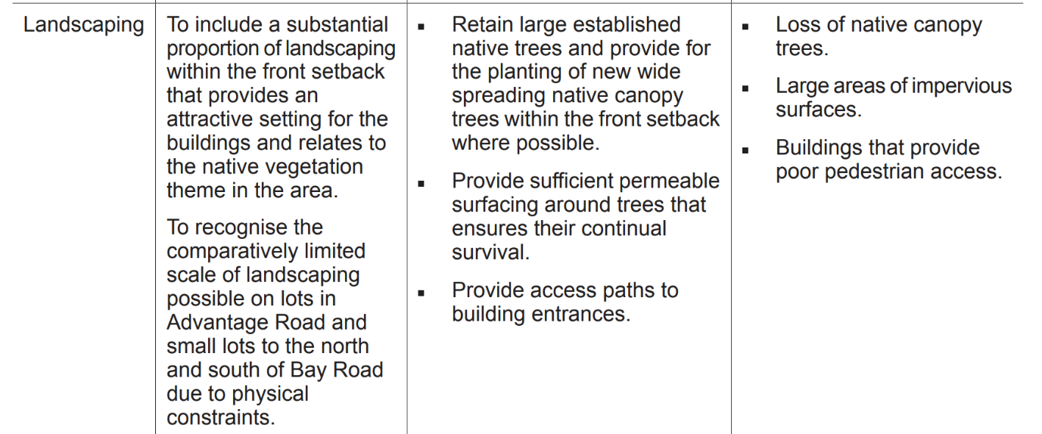
Figure 14: Clause 22.04 Bayside Business District Policy within local section of the Bayside Planning Scheme
While Council has had success in applying this, the only applications that will trigger these controls relate to applications for new development. It is considered that Council may need a more robust approach to greening the space as waiting for redevelopment sites to present themselves is not the most effective way of avoiding urban heat issues and ensuring a cool climate.

Actions to consider…
- Provide an advisory service to support residents when considering whether to cut down trees with their options around pruning and maintenance that may avoid removal of the tree.
Council must act proactively and provide upfront support to property owners that have a large tree on their property.

- Investigate amendments to current policy requirements to allow for the expansion of tree canopy cover on private property
Council should investigate the current local law criteria and planning scheme ordinances for tree removal, protection and landscaping and whether there is a need to strengthen these controls.
  - Review the Bayside Landscape Guidelines and incorporate into the Bayside Planning Scheme
  - Review the Street Tree Selection Guide
  - Consider increasing Local Law minimum tree size requirements to ensure that more trees are requiring permits for removal.
  - Amending the Bayside Planning Scheme, specifically the Neighbourhood Residential Zone, to strengthen tree protection and landscaping requirements as part of new development.
  - Undertake strategic justification to amend the current Vegetation Protection Overlay in Beaumaris and Black Rock to strengthen protection of native vegetation and non-native species of existing canopy trees.

- Monitor the Urban Forest
Implement an Urban Tree Monitoring Project as an ongoing program which seeks to:
  - Track canopy cover and tree numbers per year,
  - Improve Council’s Data collection and reporting of Local Law and Planning Permit tree removals per year,
  - Provide yearly updates on the:
    - Useful Life Expectancy of trees,
    - Tree canopy cover percentage (%),
    - Tree count in Bayside,
    - Vacant sites in Bayside,
    - Thermal Mapping; to monitor impact of tree planting efforts, and
    - Tree health - to monitor percentage of trees that are less than fair in condition.

- Enforcement and Compliance
Continue Council's enforcement and compliance program for Local Law Tree Removal Permits to ensure that replacement plantings are provided and retained, at the point of completion for new development, and at 2 and 10 years after, with an aim for a minimum of 75% target compliance.

Actions to consider…
- Increase green roofs and walls in more urban contexts where possible
There are many opportunities to integrate living (green) walls and green roofs in high to medium density developments and the introduction of the State-wide ESD (Environmentally Sustainable Development) provision will assist the integration of ESD in Bayside.

- Prepare and implement a Communications and Engagement Strategy targeted to private property and business owners
Council will encourage landowner participation in greening, particularly for businesses within activity centres and the Bayside Business District. This will be undertaken through a coordinated urban forest communications and engagement strategy that has a focus on education, awareness of the benefits of trees, and participation in increased tree planting through nominated planting days, giveaways, and information seminars.

- Prepare and incorporate Precinct based Urban Forest Plans to respond to site specific challenges and identify opportunities for increased planting.
In order to increase tree canopy cover across the entire municipality, it is important that Council understands and recognises the key challenges, especially those that are site specific and contributing to low canopy cover within that suburb. A key action of this Strategy will be to prepare precinct based urban forest plans to identify:
  - priority areas for increased planting, including hotspots, areas of declining canopy or aging trees, highly trafficked pedestrian routes and gaps/vacancies in public planting;
  - areas of significant landscape character,
  - potential hotspots and potential habitat/biodiversity corridors across both public and private land.
  - Opportunities for boulevard plantings and the creation of improved streetscape outcomes;
Once precinct based urban forest plans have been adopted by Council, a planning scheme amendment will be undertaken to implement these plans and to ensure the appropriate vegetation related controls are in place across Bayside.

- Develop a program to support vulnerable residents to assist the maintenance of canopy trees on their property
There is opportunity to support the pruning and maintenance of these trees and Council should investigate the creation of a volunteer network to be able to support clean-up of debris and leaf litter.
Providing an advisory service to support residents that are considering whether to cut down trees with options around pruning and maintenance that may avoid the removal of the tree.

Key Challenges: Public use and Council-owned land
This section of the Background Report observes the current processes and challenges for tree planting and removal on public use and Council-owned land. There are several State government owned land parcels within Bayside which are of varying land uses, including:
- State Schools,
- Cemeteries,
- Public Housing Estates,
- Vacant land nearby train stations (Level Crossing Removal Projects),
- VicTrack land (including train stations and surrounding railway land).

It is necessary for Council to identify approaches and actions to increase tree canopy cover, particularly on State government owned and Council owned land where the opportunities are more readily identifiable and potentially more achievable to increase tree canopy cover.

Existing management of Reserves and important areas of habitat
Bayside City Council currently manages a combined total of nearly 60,000 trees including more than 45,000 street trees and over 12,700 park trees, excluding bushland reserves and the foreshore.
The Bayside Tree Strategy 2011 sets the current direction for Council’s approach to tree management and protection across Council managed and private residential land. The strategy is further reinforced by the following policies and plans that inform the management of trees on Council-owned land:
- Street and Park Tree Management Policy 2016
- Street and Park Tree Selection Guide 2016
There are also four key documents that inform Bayside’s management of Council-owned conservation reserves:
- Bayside Fauna Survey (2012)
- Ecological Data Review (2017)
- Biodiversity Action Plan (2018-27)
- Bayside Native Vegetation Works Program (2013)
All Council tree maintenance services are delivered through the contract for Management and Maintenance of Open Space Services. This contract complies with Electric Line Clearance Regulations and defines the service levels and standards to be met including those determined by National and State legislation and industry best practice.
Consistent with Bayside’s Biodiversity Action Plan 2018–2027 and where assessed as suitable under Bayside’s Method for Assessing Tree Habitat, Council will preserve hollow-bearing trees as habitat, as well as install suitable nesting boxes or nest logs for bats, possums and birds. To protect habitat trees, these boxes and trees will be regularly monitored and appropriately maintained.

Citywide is currently contracted by Bayside City Council to manage the vegetation within foreshore and bushland reserves throughout the Bayside municipality and coordinates pest animal management and undertakes controlled burns as appropriate at these reserves.
Public Use Zoned Land
The public use category are areas designated and zoned as “Public Use”. Purposes of public land use include service & utility, education, health & community, transport, cemetery/crematorium, local government use or other public use.
There are several sites in Bayside that are zoned “Public Use” including the cemetery in Cheltenham, State Government owned Schools, Public Housing Estates and land along the train line and stations (generally owned by VicTrack).
As the types of land uses that are owned by State Government departments are of varying kinds, any actions to increase canopy cover on Public use land will require Council to liaise with relevant agencies and landowners to advocate and promote tree planting and greening initiatives. As such, advocacy and partnerships would be the primary opportunity to increase canopy cover on PUZ land. Council has been involved in many conversations with the State Government in relation to Level Crossing Removals, Affordable Housing in the South East, the Bayside Community Development Steering Committee as well as various other working groups where the proposal of increased tree canopy cover can be discussed.
Open Space, Streetscapes and Reserves
As previously discussed in this Background Report, Council is the owner of 138 “open spaces” which expands over 416.23 hectares. Council is also the owner of many car parks in Bayside, as well as roads, which includes road reserves and nature strips.
Council-owned open space, streetscapes and reserves provide the best opportunities to increase tree canopy cover and these sites should be individually analysed for tree planting locations. Parks and reserves in particular are diverse areas of habitat for a range of fauna and can be enhanced to benefit the habitat role of these areas whilst increasing tree canopy cover.
Bayside’s reserves have been assessed as provide a high level of quality habitat as identified in the Bayside Fauna Survey. Habitat connectivity has been identified as a key issue to address in the Biodiversity Action Plan and this involves identifying the suitable locations in which to prioritise tree and understorey planting to facilitate the movement of various species including bird and reptile species. This needs to be implemented through the Bayside Native Vegetation Works Program which should be updated to respond to these opportunities.
This requires detailed planning and management and should be integrated with Council’s Street and Park Tree management program, including the Tree Selection Guide, and the Bayside Native Vegetation Works Program. Current policy documents (Street and Park Tree Management Policy) should be updated with a clear objective that fundamentally increases tree canopy coverage, rather than simply maintaining the current tree population, is a priority for Council.
This prioritisation of increased tree planting on Council-owned open spaces, reserves and nature strips should form part of the review of Bayside’s Open Space Strategy and the review of the Native Vegetation Works Program that are scheduled to occur in 2022. Site specific opportunities to scope tree planting in Council parks, reserves and streetscapes should also form part of Precinct Plans for each suburb that they fall within. Further, these Precinct Plans should investigate opportunities at Council-owned community buildings and sport clubs and the ability to plant more trees surrounding these buildings.
Outside of a precinct level plan, a large opportunity to increase tree planting on Council-owned land is presented on the foreshore. The identified vacant sites map for Bayside identified a high volume of vacant sites along the foreshore and within Elsternwick Park.
Council is currently undertaking the redevelopment of Elsternwick Park by transforming the former golf course into an environmentally focussed nature reserve. It is estimated that approximately 1 million plants will be planted in the reserve over the next 12 years. The redevelopment of the site will be an exemplary case study which Council can learn from and apply to other locations where transformation is being proposed.
The foreshore has been prone to vandalism in the past and has been earmarked as a location for replanting due to the illegal tree removals that have occurred in recent years. To ensure that Council can increase, monitor and retain trees on public land, there is a need to further investigate the existing penalties for tree vandalism on public land and the reasons why illegal tree removal is occurring along the foreshore and in other locations within the municipality in hope that this will fuel a behavioural change in Bayside.

Trees removed from public land due to Vandalism
Between 2014 and 2019, the percentage of tree removals due to vandalism was recorded as 0.4%. While this is a relatively low figure, the loss it brings comes to a total of 40 trees across Bayside. This is not only an additional resource and management issue that Council has to address through its tree planting program, it is also a loss of habitat, a loss to the Bayside urban forest, and a loss of 40 mature trees that bring positive impacts that cannot be replaced simply by replanting 40 new trees. In an effort to deterrent vandals, Council has adopted a strong stance on vandalism and has installed signs and advertised on social media platforms an offering of rewards for information when an act of vandalism has occurred.

Identified Vacant Street Tree Sites
When undertaking scheduled tree maintenance and removals, Council’s contractor (Citywide) maintains a database of identified “vacant sites” that have become available or alternate sites to replace the trees that have been removed, and this database is used for future tree planting. There are currently 4,023 vacant sites identified in Council’s database
Beaumaris and Brighton appear to have the highest number of current vacant street tree sites, which correlates with the removal and replacement data which identifies Brighton as the most active area for Council in terms of removal and replacement planting. Inland areas of Highett, Cheltenham and Hampton East have the lowest number of vacant street tree sites despite Cheltenham also having the lowest level of tree canopy cover.
The vacant sites identified currently only represent sites that Council’s contractor has recorded during scheduled tree removal works and sites identified by residents requesting a street tree. There are many more unidentified planting sites across Bayside which could be proactively identified and verified as a suitable planting site in Council’s database. This would require the current contract with Citywide to be reviewed to provide for this further service.
Council has recently established a public platform for residents to assist Council by nominating their nature strips as a suitable location for a street tree planting. This approach has provided an opportunity to engage with the Bayside community and can be further promoted through the Community Engagement period for the Draft Urban Forest Strategy.
Further Council-owned and Public site-specific opportunities can be identified through Precinct Plans for each suburb. As aforementioned in this Background Report, the most obvious corridor for identified planting opportunities is shown along Beach Road. However, this has impacts on views, which can be a controversial issue to discuss with the community and will require further input.

Actions to consider…
- Expanding the Urban Forest across Council and public land
Large opportunities exist to increase tree planting on Council-owned open spaces, reserves, streetscapes, and as part of car parks, sport clubs and community buildings upgrade projects and this should be further investigated through an expansive tree planting program.
Further, Council should liaise with State Government departments to advocate and promote tree planting and greening initiatives. Opportunities to increase tree planting at public housing estates, State government owned schools and cemeteries should be prioritised.
- Increase habitat corridors on Nature Strips, Council Parks and Reserves and Backyards
Habitat connectivity has been identified as a key issue to address in the Biodiversity Action Plan. and this involves identifying the suitable locations in which to prioritise tree and understorey planting to facilitate the movement of various species including bird and reptile species. Council should continue to progress its implementation of the ‘Park Improvement Habitat Planting Program’ while also reviewing the Bayside Native Vegetation Works Program to understand if further opportunities to increase habitat corridors can be identified.

- Monitoring the health of trees impacted by construction activity
As development continues to increase, so does the impacts on trees due to construction activity. The number of Council owned street trees that have been indirectly impacted due to construction activity upon nearby or adjacent property development sites is unknown.
Council’s ability to retain mature Council managed trees can be strengthened by undertaking a pilot project to observe the health of trees nearby development sites and whether any impacts are attained during the construction phase. The findings of this project would justify any strengthening of Council’s asset protection and the application of tree bonds on street trees.

Actions to consider…
- Increase Council’s ability to protect Significant Trees
Council should undertake further assessment and identification of Significant Trees in Bayside.
Following this identification, Council should investigate options to strengthen the protection of Significant Trees through the Bayside Planning Scheme.

- Reducing public tree removal
A high proportion of street and park trees planted and have struggled to survive, either during or after their initial period of high maintenance (first 2 years).
Council should continue to review the current maintenance program for new public trees to ensure Council is able to increase the survival rates of trees. Already, Council has amended the watering schedules for these trees. A review of the program should consider lengthening the current two-year maintenance period from when a tree is planted. It should also consider a lengthened management of trees that are inspected following the end of the maintenance period which appear to be in bad health.
- Identify opportunities for increased tree planting
Council’s contractor (Citywide) maintains a database of identified vacant sites that have become available or alternate sites to replace the trees that have been removed, and this database is used for future tree planting. There are currently 4,023 vacant sites identified in Council’s database. This database will continue to be utilised as an ‘easy wins’ to identifying locations for increased tree planting in Bayside.

Summary
While this Background Report has separated key challenges by ownership of land (public and private), it is important to understand and recognise the Urban Forest as a whole, and that it is greater than the sum of its parts.
Managing tree removals on private and public land will be an ongoing responsibility and one that can at times receive strong opposition from the community. As residential land is the main land type on which the urban forest in Bayside exists, managing tree removals and replacement planting is a key factor to ensuring that tree canopy coverage increases rather than decreases over time.
This Background Report has sought to identify the key challenges that will need to be addressed to ensure Council is able to increase, diversify, monitor and retain the Bayside Urban Forest, and educate the community on the importance and benefits that a healthy and resilient urban forest brings. Throughout this Background Report, possible solutions to address these challenges have also been considered and have helped inform the Draft Urban Forest Strategy.

INCREASE | DIVERSIFY | MONITOR | RETAIN | EDUCATE
Increase the level of tree canopy cover on private and public land in Bayside. | Grow a diverse and healthy urban forest | Improve our ability to monitor the urban forest and identify trends, challenges, and changes, and implement approaches to learn and overcome obstacles. | Retain Bayside’s tree and vegetation cover by improving our regulation of tree removal on private property and educating on the benefits of the Bayside Urban Forest. | Educate and encourage greater care and protection of the Bayside Urban Forest through information sharing, partnering with community groups and through community participation in tree planting on private and public land.

Appendix 1 – Policy Context
Victorian Government
Living Melbourne: Our Metropolitan Urban Forest Strategy
Living Melbourne: Our Metropolitan Urban Forest is a bold new strategy for a greener, more liveable Melbourne.
The strategy brings together 32 metropolitan councils, State government agencies, non-government and community organisations, and other partners to unite around a common vision for an urban forest. The strategy establishes six steps for action to bring this vision into reality. These Actions are listed below:
- Protect and restore species habitat, and improve connectivity
- Set targets and track progress
- Scale up greening in the private realm
- Collaborate across sectors and regions
- Build a toolkit of resources to underpin implementation
- Fund the protection and enhancement of the urban forest
As one of the metropolitan Councils that have endorsed this Strategy, Bayside has committed towards implementing these actions. This strategy was a key reference for the formation of Bayside’s own Urban Forest Strategy.
Plan Melbourne
Plan Melbourne is the metropolitan planning strategy, implemented through the Victoria Planning Provisions (VPP), providing the overarching State planning policies for all municipalities. Plan Melbourne is a comprehensive long-term plan for the cities growth and establishes seven key outcomes to strive for in creating a competitive, liveable and sustainable city.
“Outcome 6: Melbourne is a Sustainable and Resilient City” focuses on improving Melbourne’s environmental sustainability and protecting Melbourne’s biodiversity and natural assets. The Strategy acknowledges the urgent need for Melbourne to adapt to climate change and make the transition to a low-carbon city. The sections of this outcome that are relevant to this Background Report are listed below:
Direction 6.4 Make Melbourne cooler and greener
This Direction states thatto “mitigate the impacts of increased average temperatures, Melbourne needs to maintain and enhance its urban forest of trees and vegetation on properties, lining transport corridors, on public lands, and on roofs, facades and walls”. This statement is supported by the following policies:
Policy 6.4.1
Support a cooler Melbourne by greening urban areas, buildings, transport corridors and open spaces to create an urban forest
Policy 6.4.2
Strengthen the integrated metropolitan open space network
Direction 6.5 Protect and restore natural habitats
This Direction focuses on the need to maintain and improve the overall extent and condition of natural habitats and is supported by the following policies:
Policy 6.5.1
Create a network of green spaces that support biodiversity conservation and opportunities to connect with nature
Policy 6.5.3
Protect the coastlines and waters of Port Phillip Bay and Western Port
State Planning Policy Framework
The following Clauses are those which relate to the implementation of the Urban Forest Strategy.
Clause 12.05-1s – Environmentally sensitive areas
The Objective of this Clause is to “protect and conserve environmentally sensitive areas”. This includes Port Phillip Bay and its foreshores, placing extra emphasis on the importance of the trees in this area of bayside.
Clause 12.05-2s – Landscapes
The Objective of this Clause is to “protect and enhance significant landscapes and open spaces that contribute to character, identity and sustainable environments”.
Clause 13.01s – Natural hazards and climate change
An Objective of this Clause is to “consider the risks associated with climate change in planning and management decision making processes”.
Clause 13.04-2s – Erosion and Landslip
A Strategy of this Clause is to “promote vegetation retention, planting and rehabilitation in areas prone to erosion and land instability”. This is especially relevant to the coastal areas within Bayside.
Clause 15.02-1s – Energy and Resource Efficiency
This Clause has two strategies focusing on urban greening and vegetation retention which are listed below:
- Reduce the urban heat island effect by greening urban areas, buildings, transport corridors and open spaces with vegetation.
- Encourage retention of existing vegetation and planting of new vegetation as part of development and subdivision proposals.
Clause 15.01.2S – Building Design
- This clause is underpinned by several strategies. One of which is to encourage development to retain existing vegetation.
Local Government
The Draft Urban Forest Strategy is informed by Council’s current strategic framework. It will i inform and influence the direction of current strategies as well as the development of future strategies, particularly in relation to Council’s tree management across parks and streetscapes.
Community Vision 2050
The Bayside Community Plan 2025 has identified that improvements to open and green spaces and the importance of protecting and supporting the natural ecosystem are key aspirations of the Bayside community for the future. Residents also indicated their aspiration to protect both mature and established trees, along with a stronger enhancement in garden landscapes to protect tree canopies and vegetation.
The Urban Forest Strategy aligns with the Community Vision 2050, particularly Theme 1: Living Environment/Natural Environment. Within this Theme, Priority 1.2 aligns with the strategic objectives of the Urban Forest Strategy:
Priority 1.2: Protect the coast, land and sea through measures such as increased tree planting, sensitive landscaping and enhanced pedestrian connections with nature, planning for the effects of extreme weather.
Council Plan 2017-2021
The Council Plan 2017-2021 sets out Bayside’s vision and priorities for the current Council term. It provides an overview of the strategies, services and programs that will be implemented as part of Council’s commitment to making Bayside a Better Place.
Goal 5 of the Council Plan focuses on the environment, stating that “Council and the Bayside community will be environmental stewards, taking action to protect and enhance the natural environment, while balancing appreciation and use with the need to protect natural assets for future generations”.
Strategic Objective 5.4: “protect and enhance Bayside’s tree canopy and vegetation on public and private land” also aligns perfectly with the goals of the Urban Forest Strategy.
Municipal Planning Strategy
The following Clauses are those which relate to the implementation of the Urban Forest Strategy.
Clause 02.02 – Vision
“Bayside will be a city which protects and enhances the quality and character of the natural and built environment through environmentally sustainable development and management of land. Bayside will be an environmentally focussed city in which its natural resources are valued, present needs are met and development is responsibly managed for the benefit of current and future generations.”
Clause 02.03 – Strategic Directions
Environmental and landscape values
Biodiversity
Bayside has a wide range of significant habitats including eight inland bushland/heathland reserves ranging from state to local significance, these include Long Hollow Reserve, Donald MacDonald Reserve, Bay Road Heathland Sanctuary, Gramatan Avenue Heathland Sanctuary, George Street Reserve, Cheltenham Park Flora and Fauna Reserve, Balcombe Park Reserve and Highett Grassy Woodland (located on the CSIRO site), golf courses which cover 175 hectares and the foreshore. In addition to their environmental values as an important flora and fauna habitat and wildlife corridor, these areas contribute to the character of Bayside and are important recreational and educational resources.
Given Bayside’s significant vegetation within the existing urban setting, as well as its high levels of coastal vegetation in areas such as Beaumaris.
Council seeks to:
- Assist the conservation of biodiversity through retention of native vegetation, protection of habitat.
- Protect the natural biodiversity of Conservation Reserves by ensuring that the primary purpose of the reserve is maintained.
- Protect habitat provided by established trees and gardens on private property that may be reduced and fragmented by increased medium density housing.
Coastal areas - foreshore
Bayside’s coastal foreshore contains unique topography, ranging from low coastal scrubland and dunes in the north and rising to high cliff faces south of Sandringham. The vegetation on the foreshore similarly transitions north to south from managed parkland to important areas of remnant coastal bushland. Areas of regional environmental significance are located at Ricketts Point Marine Sanctuary and the Beaumaris cliffs, which contain a fossil site listed on the register of the national estate.
Council seeks to:
- Protect and enhance the foreshore as a natural, environmental and cultural resource as this is key to the ecological and economic viability of the Bayside municipality.
- Maintain and protect the ecology and natural qualities of the coast having regard to its wide range of ecosystems, recreation opportunities and the increasing public demand for access to it.
- Develop sustainable approaches to managing a dynamic environment and infrastructure that is vulnerable to the impact of climate change.
Environmental risks and amenity
Climate change
A changing global climate will magnify some of the natural processes that shape and impact on the coast. Sea level rise, more frequent storm events, temperature and rainfall changes are expected to increase the risk of erosion, inundation, infrastructure damage, drought conditions and ecological change. These changes will need to be accommodated while maintaining environmental quality.
Council seeks to manage the impact of climate change on the coastal environment by:
- Prioritising the maintenance of recreation areas, protection of assets and reduction of offshore cliff erosion based on the degree of vulnerability to coastal processes and sea level rise.
Planning Policy Framework
Clause 12.01.1L – Protection of Biodiversity
This Clause is underpinned by the following Strategies:
- Retain significant tree and vegetation cover particularly in areas where trees and plants contribute to habitat, erosion control and absorption of run-off.
- Design subdivision to retain links between habitat areas and open space.
- Maintain indigenous vegetation forming part of the corridor along the sandbelt (golf club region).
- Protect the biodiversity values of the Bay Road Heathland Sanctuary.
- Provide landscaping treatments and flora species on properties adjoining the Bay Road Heathland Sanctuary that are compatible with its biodiversity values.
- Implement measures to help control pest plants and animals wherever possible.
Clause 15.01-1L – Urban Design
This Clause is underpinned by several general strategies. One of which is to:
- Retail significant trees including designing and locating buildings and works to protect them.
Clause 15.02-1L – Energy and Resource Efficiency
This clause is underpinned by the following strategy:
Design development to:
- Promote sustainable design measures such as water efficient design and solar access using site layout, design and construction techniques.
- Allow for adaptive re-use in the future.
- Use landscape design to assist with passive solar heating and cooling.
- Make use of buildings and materials with minimal environmental impact, such as recycled materials and re-use of existing buildings.
- Include communal open space areas in larger residential developments.
Clause 15.03-1L – Heritage Conservation
This policy applies to all properties affected by a Heritage Overlay. Several strategies based on the type of work proposed is outlined within this Clause by which trees are considered as relevant. The following have been identified:
Subdivision strategies
- Maintain the historic settings and contexts for significant and contributory heritage buildings, trees and gardens.
- Retain gardens and established trees, that contribute to the setting of a significant or contributory heritage building or precinct in the same allotment as the building.
Restoration strategies
- Encourage the restoration and reconstruction of the original or early appearance of contributory fabric, particularly when seen from the street.
Clause 15.01-5L Bayside preferred neighbourhood character
This policy applies to development in the Neighbourhood Residential Zone, General Residential Zone and Mixed Use Zone. The general objectives of this Clause is:
- To retain and enhance the identified elements that contribute to the character of the area.
- To ensure that development is responsive to both the site and the preferred future character of the area.
- To encourage development that accommodates the need for change around activity centres while respecting the desired future character of the area.
- To encourage the retention of dwellings that contribute to the valued character of the Precinct.
- To maintain and enhance the garden settings of the dwellings.
- To maintain and enhance the bayside vegetation character of the area.
- To provide space for front gardens.
- To maintain the rhythm of spacing between buildings.
- To minimise loss of front garden space and the dominance of car parking facilities, driveways and crossovers.
- To respect the dominant building forms and scale of buildings in a precinct.
- To ensure that development does not visually dominate the streetscape or adjacent identified heritage buildings.
- To ensure that new buildings provide an articulated and interesting façade to the street.
- To respect the identified heritage qualities of adjoining buildings.
- To use building materials and finishes that complement the dominant pattern within the streetscape or reflect the building materials in locations where there is particular consistency.
- To use a variety of building materials and finishes that provide visual interest in the streetscape.
- To use building materials and finishes that complement the natural setting in coastal locations.
- To maintain and improve the openness of streetscapes and the visual connection between buildings and the street.
- To encourage views of front gardens.
Preferred character strategies are set for each precinct identified within Clause 15.01-5L. Notably, all precincts (except for one) mention design guidelines around trees and their importance to neighbourhood character.
Bayside Community Plan 2025
The Bayside Community Plan takes the varying views and aspirations of the Bayside community through the feedback from more than 1200 people across a broad range of ages and backgrounds. This feedback was compiled into “Community Aspirations”. Below are the aspirations which relate to the Urban Forest Strategy:
Tree canopy continues to increase in public open space.
Bayside will be a better place when:
- The right trees are planted in public spaces, so they don’t need to be removed because of property damage.
- The use of chemicals to control weeds is minimised.
- Mature trees and garden landscapes are protected and enhanced.
Bayside’s bushland and heathland reserves are protected and enhanced.
Bayside will be a better place when:
- Indigenous planting is increased along the foreshore and public areas.
- New developments retain established trees and plant new trees.
Mature trees and garden landscapes are protected and enhancedThe community also notably identified that “protection against the loss of trees and vegetation is a growing concern, especially for communities that live closer to developing areas. With an understanding of climate change, the community is aware of the importance natural vegetation and the tree canopy play in preventing soil erosion, providing habitats for animals and decreasing the temperatures in the suburbs and urban areas”.
Wellbeing for All Ages and Abilities Strategy
The Wellbeing for All Ages and Abilities Strategy 2017-2021 meets the requirements of the Public Health and Wellbeing Act 2008 and streamlines community services planning for health and wellbeing from early childhood, through to youth, adult lives and older years. The Strategy has 3 goals: an engaged and supportive community, a healthy and active community and safe sustainable environments.
Objective 3.4 of this Strategy is to “improve environmental sustainability”, while the Strategy also states that “with increasing temperatures predicted, trees play an important role in the provision of shade and respite in Council’s parks and streetscapes”.
Environmental Sustainability Framework 2016
The Environmental Sustainability Framework 2016-2025 sets direction and guidance for Bayside’s environmental planning and decision-making. The framework is split into four goals, with Goal 4: Sustainable Places addressing urban forestry related issues.
Goal 4 Sustainable places
Advocating and influencing for healthier ecosystems and more livable Bayside urban areas and infrastructure.
Targets and Objectives:
- Net gain of indigenous flora and fauna species
- Increased landscape scale connectivity of indigenous and other vegetation
- Increased tree canopy cover
Development of a Bayside Urban Forest Strategy is one of the Actions of Implementation for these Objectives. Other Actions include the creation of a Bayside Biodiversity Action Plan and encouraging the establishment of wildlife corridors and steppingstones to increase connectivity between remnant vegetation.
Bayside Biodiversity Action Plan 2018-2027
This plan provides specific actions to implement the strategic objectives of the Environmental Sustainability Framework 2016-2025 and other issues raised through consultation with the Bayside community, along with the recommendations presented in Ecology Australia’s (2017a) Ecological data review for the Bayside City Council Municipality. The Plan addresses the following issues:

- Measurement of municipal wide vegetation cover (net loss/gain)
- Maximising conservation of habitat diversity and connectivity
- Promotion of indigenous plants and increasing biodiversity and ecosystem health on public and private land
- Raising awareness of biodiversity with Council and the community through education
- Measuring the quality and extent of existing flora and fauna and changes to these over time
- Increasing tree canopy cover to reduce heat island effects, provide shade and improve overall amenity
- Addressing weeds, controlling introduced species and pest animal issues; and
- Developing a monitoring and data collection system.

Bayside Open Space Strategy
The Bayside Open Space Strategy is a 20-year plan to provide policy and strategy to enable Council to make decisions about how open space is used, developed, managed and maintained across the municipality.
The expected outcomes of the Bayside Open Space Strategy are to:
- integrate the development, management and use of the open space network
- introduce strategies for management of conflicting uses to optimise the benefit
- that can be gained from each open space and the network as a whole
- introduce an open space levy into the Bayside Planning Scheme to assist with
- the funding of improvements to the open space network
- ensure open space is appropriately zoned in the Bayside Planning Scheme
- improve community understanding of what they can expect to experience when they visit Bayside’s open spaces
- achieve no net loss of open space in Bayside
- improve or increase open spaces in areas defined as deficient in access
- enhance working relationships with owners, managers and tenants of open
- space within Bayside and immediately adjacent to Bayside
- properly fund open space infrastructure
- develop an expanded network of pleasant and safe trails for cyclists and
- pedestrians that link open spaces and key destinations.
Tree coverage is identified in Principle 4.2 – “Managing Climate Change Impacts” of the Strategy where it is stated that Council will “ensure adequate and appropriate tree planting within the open space network that can add to carbon sinks, habitat corridors for fauna and protection from the sun”.
A review of the Bayside Open Space Strategy is scheduled for 2022.
Bayside Coastal Management Plan 2014
The Bayside Coastal Management Plan (CMP) provides strategic direction and policy on coastal use, management and development for the municipalities foreshore. It provides a framework for detailed local action plans as well as funding priorities.
One of the Plan’s Strategic Directions is to “Ensure the protection and rehabilitation of all high value areas of natural vegetation with priority given to high use locations”. The supporting Actions of this Direction are listed below:
- Carry out vegetation management across the foreshore on the basis of the Vegetation Management Strategy*.
- Define high value natural vegetation areas and give funding priority to measures to protect and improve these areas.
*The Vegetation Management Strategy splits foreshore vegetation into three categories and then provides specific Aims and Management Actions to protect and enhance each categories vegetation.
Bayside Housing Strategy 2019
The Housing Strategy guides how residential development in Bayside will be planned and managed over the next twenty years. The Strategy looks at the location and type of residential development required in order to meet the changing needs of the Bayside community; whilst ensuring development is consistent with and enhances Bayside’s valued urban character, manages any associated environmental risk and is equitable and appropriately serviced. The following objectives are those that relate to the Urban Forest Strategy:
Objective 7 – “To protect and enhance vegetation for the role it plays in contributing to biodiversity and in defining the character of Bayside”.
Implementation Actions:
- Retain the existing Schedule 2 and 3 to the VPO to protect and enhance the unique habitat value and character of bushland areas and Beaumaris and Black Rock native vegetation areas.
- Retain the existing Schedule to the SLO to conserve and enhance the landscape character of Coral Avenue and Point Avenue, Beaumaris.
- Investigate whether a VPO or SLO is justifiable and appropriate for some or all of the residential areas of Pennydale and Highett Activity Centre.
- Undertake an ‘Urban Forest Strategy’ to identify issues and opportunities to enhance Bayside’s tree canopy and vegetation cover and to achieve a number of environmental benefits for the community.
- Review existing local laws and the criteria used to identify trees that require a permit for removal.
- Investigate the option of introducing a bond scheme that seeks the retention of trees in the public (and potentially private) realm.
- Investigate options to incentivise tree retention and educate the community about the environmental benefits of retaining and protecting trees on private land, including through publications and information on Council’s website.
Objective 8 – “To protect and enhance the foreshore, an area that contributes to the character, identity and sustainable environment of Bayside”.
Implementation Actions:
- Retain the existing Schedule to the VPO 1 recognising the habitat and vegetation value of the foreshore.
- Retain the existing Design and Development Overly – Schedule 1 to protect and enhance the foreshore environment and views of Bayside from Port Phillip Bay.

Bayside Tree Strategy 2011
The Bayside Tree Strategy was developed to provide a framework of actions to ensure that the future public and private spaces within Bayside are well treed. The Vision of this Strategy is that “Bayside will have a sustainable landscape that integrates and enhances the City and provides places for trees to grow”.
This Vision is supported by three Objectives listed below:
Influence PEOPLE through:
- Effective communications and community education
- Encouragement or facilitation of initiatives
- Appropriate regulation and enforcement
Protect and enhance TREESCAPES to:
- Promote tree health
- Enhance neighbourhood “character”
- Contribute to biodiversity and habitat
- Enhance the amenity of private property
- Enhance public landscapes
MONITOR our tree population to:
- Establish and measure the “Landscaping Rating” of the City
- Collate and manage data on the Bayside tree population
- Provide evidence to influence future decision
Bayside Climate Emergency Action Plan 2020
This Plan identifies the actions Council will take to respond to the Climate Emergency and support our local community to take actions to reduce their impact on the environment.
Theme 5 of this Plan addresses the protection and enhancement of our natural environment. The following Actions relate to the Urban Forest Strategy:
- Finalise and implement the Urban Forest Strategy.
- Implement the Biodiversity Action Plan.
- Review and update the Street and Park Tree Management Policy to ensure mature trees managed by Council are regularly checked for health and potential safety hazards (e.g. shedding of limbs due to dry or stormy conditions) by qualified specialists.
- All planting and landscape renewal plans in Council open space consider hardiness and adaptability of species in the context of climate change risks.
Retail, Commercial and Employment Strategy 2016-2031
This strategy explores and provides policy directions on the future evolution of Activity Centres and employment lands within Bayside. The Vision of this Strategy states that “an innovative reimagining of [Bayside’s] ex-industrial lands will provide a focus for high quality jobs locally in a high amenity and well-connected environment.”
Action 4E of the Strategy looks to implement this vision by “ensur[ing] that building design delivers high quality social and environmental outcomes”.
Economic Development Strategy 2014
The Economic Development Strategy is a framework that supports the sustainable development of the local economy. It references the needs and trends within the existing community and opportunities to promote investment and employment growth within the changing local, domestic and international economic and environmental landscapes.
It is stated in a section about the Bayside Business Employment Area (BBEA) that “improved presentation of the area and more trees were the two improvements that would assist the most in attracting investment to the BBEA by local businesses”.
Bayside Walking Strategy 2015
The Walking Strategy aims to address the barriers to walking and build on these opportunities to establish a more walkable municipality.
Community and external stakeholder feedback raised a concern that “too many trees have been removed where new developments have been constructed, so that footpaths don’t have enough shelter from sun and rain and also become less inviting to walk along”.
Action 3.2 - “Use landscaping to mitigate the impact of motor traffic”. states that lining walking routes and rest areas with trees will provide beauty and shade.
Bayside Tourism Strategy 2013
The purpose of the Bayside Tourism Strategy is to consolidate Bayside’s existing tourism strengths and successes, find new opportunities for leadership in the sector and to identify suitable partnerships with industry and the community.
The Strategy states that “the preservation of Bayside’s environment and character preserves the competitive advantages of Bayside’s tourism assets (particularly natural attractions such as the foreshore and parks)”.
Ecological Data Review 2017
The purpose of this data review was to identify areas where further survey work or potential habitat augmentation work would be beneficial. This work fed into the drafting of the 10-year Biodiversity Action Plan that Council prepared. The recommendations of the Ecological Data Review include:
Undertake supplementary plantings and habitat protection works for threatened plant species known to occur in the municipality.
To increase habitat of wildlife (particularly for birds and bats) in residential areas, and to mitigate the gradual removal of trees. The following Actions support this recommendation:
- Update policies to limit the removal of healthy native and exotic trees (excluding invasive species) on public and private land (e.g. see City of Darebin’s Tree Retention Policy, City of Whitehorse’s Clause 22.4 Tree Conservation)
- Require plantings to replace trees removed and ensure plantings are implemented through monitoring/enforcement
- Increase street tree and shrub plantings, preferably with indigenous species; and
- Encourage residents to plant indigenous species into their gardens through initiatives such as “Gardens to Wildlife”.
Neighbourhood Character Review 2011
The Neighbourhood Character Review identified areas across Bayside that are considered to have a high or moderate degree of neighbourhood character significance. The review recommended the introduction of the Significant Landscape Overlay at Point Avenue and Coral Avenue in Beaumaris as this area is significant for its vegetation quality. It was considered that the SLO offered the most suitable form of planning control and recommended the introduction of the following controls:
- require buildings to be sited a minimum of 4 metres from those trees listed in the VPO3 schedule that are over 2 metres in height.
- reduce the maximum site coverage to 40%, to retain adequate space for planting and retention of the tree canopy.
- introduce a building height objective to ensure that roof forms do not extend above the height of the tree canopy, so that the vegetation remains the dominant visual element of this area.
The Significant Landscape Overlay was implemented in the Point Avenue and Coral Avenue area through Amendment C80 in 2012.
Sustainable Infrastructure Policy 2017
The purpose of the Sustainable Infrastructure Policy is to set out Council’s commitments and the approach to environmentally sustainable development (ESD) principles in the design, construction, operation and maintenance of Council owned/managed infrastructure. This allows Council to better adapt to the impacts of climate change, reduce greenhouse gas emissions and use energy and water more efficiently.
One of the ESD Objectives is Urban Ecology. Under this Objective it states to:
- Retain and protect existing canopy trees, biodiversity and biodiversity corridors wherever possible.
- Ensure landscaping and plant selection enhances local biodiversity and natural habitats, minimises the urban heat island effect and encourages the provision of space for productive gardens.
- Prevent light pollution into the night sky and light spill beyond the site boundaries.
The policy identifies vegetation removal as one of the “significant environmental impacts caused by the construction and ongoing operations of Council’s infrastructure”. The following Actions focus on vegetation:
- Maximising Infiltration of stormwater within the landscape to improve passive irrigation of vegetation using IWM principles
- Revegetation projects to select indigenous vegetation species tolerant of drought and heat wave conditions

Appendix 2 – Glossary

Biodiversity: ‘all components of the living world: the number and variety of plants, animals and other living things (including fungi and micro-organisms) across our land, rivers, coast, and ocean. It includes the diversity of their genetic information, the habitats and ecosystems within which they live, and their connections with other life forms and the natural world’.
Canopy cover is the layer formed by the branches and crowns of plants or trees. The cover can be continuous, as in primary forests, or discontinuous - with gaps as in an urban area. Canopy is defined in Living Melbourne as vegetation above three metres in height
Canopy tree - A tree which has, or at maturity is likely to have, sufficient height and canopy characteristics to make a positive contribution to local amenity, sense of place, microclimate and/or biodiversity. Minimum 8 x 4 metres.
Climate change refers to a change in the state of the climate that can be identified (e.g., by using statistical tests) by changes in the mean and/or the variability of its properties and that persists for an extended period, typically decades or longer.
Climate change adaptation is the process of adjustment to actual or expected climate and its effects.43
Climate change mitigation is the human intervention to reduce the sources or enhance the sinks of greenhouse gases. 43
Climate Emergency refers to the catastrophic changes to the climate brought about by human activity that poses a dangerous threat to all life on the planet.43
Environmentally Sustainable Development: Development that is designed, constructed and managed to optimise indoor environment quality, energy efficiency, water efficiency, stormwater management, low carbon transport, waste management, urban ecology and use of sustainable building materials.
General Residential Zone (GRZ) is applied to land in areas where growth and housing diversity is anticipated. It is expected that the type of housing provided will evolve over time to provide more diverse forms of housing, but not at the expense of existing open garden character.
Habitat - All the physical and biological things that collectively make up the place where a plant or animal lives.
Habitat Corridor - A habitat corridor is a linear two-dimensional landscape element that differs from the surrounding vegetation, in both vegetation structure and form, and connects two or more patches, of otherwise isolated, habitat that have been connected in historical time, this is meant to function as a conduit for both plants and animals.
Heat Vulnerability Index – The heat vulnerability index (HVI) is represented by a scale of 1 to 5 based on quintiles, with 1 representing low exposure, low sensitivity or high adaptive capacity and 5 representing high exposure, high sensitivity or low adaptive capacity. We integrated indicators of heat vulnerability to calculate a Heat Vulnerability Index (HVI) at SA1 level. The index consists of three component layers: heat exposure, sensitivity to heat, and adaptive capability. Integration was accomplished by summing the scores from the three vulnerability components, dividing the SA1s into quintiles, and attributing SA1s with a Heat Vulnerability Rating scaled from 1 to 5.
Neighbourhood Residential Zone (NRZ) is applied to land that has been identified as having specific neighbourhood, heritage, environmental or landscape character values that distinguish the land from other parts of the municipality or surrounding area.
Permeability - The readiness with which a surface, whether man-made (such as a paved road) or natural (such as soil or rock) allows water, air or plant roots to penetrate or pass through.46
Residential Growth Zone (RGZ) is considered a substantial change area where medium density housing growth and diversity of housing types is encouraged for example townhouses and apartments around activity centres and close to train stations.
Resilience: the capacity of individuals, institutions, businesses and systems within a city to adapt, survive and thrive no matter what kind of chronic stresses and acute shocks they experience. 43SEIFA: Socio-Economic Indexes for Areas (SEIFA) measures the relative level of socio-economic disadvantage and/or advantage based on a range of Census characteristics.
Senescence is the process by which cells irreversibly stop dividing and enter a state of permanent growth arrest without undergoing cell death.
Significant Landscape Overlay (SLO) - The Significant Landscape Overlay (SLO) is the most appropriate planning scheme tool for protecting and managing significant landscapes. Its purpose is to identify significant landscapes, and conserve and enhance their character. The SLO can require a permit to construct a building or construct or carry out works, construct a fence, and remove, destroy or lop any vegetation.
Significant Tree - Some trees, through age, size, and rarity of planting or association with historical events achieve a higher level of importance on private or public land. The National Trust Australia (Victoria) identifies the following the categories used to define significant trees as scientific, social, historic, and aesthetic.

Tree Canopy - The uppermost trees or branches of trees in a forest, forming an almost continuous layer of foliage. The topmost layer of bioactivity in a forest setting. 46
Urban Forest - All of the trees and other vegetation – and the soil and water that support them. Urban forest incorporates vegetation in streets, parks, gardens, plazas, campuses, river and creek embankments, wetlands, railway corridors, community gardens, green walls, balconies and roofs. 46
Urban Heat Island Effect - The phenomenon of dense urban areas having significantly warmer air and land surface temperatures than surrounding rural areas.46
Useful Life Expectancy (ULE) - Assessment of useful life expectancy provides an indication of health and tree appropriateness and involves an estimate of how long a tree is likely to remain in the landscape based on species, stage of life (cycle), health, amenity, environmental services contribution, conflicts with adjacent infrastructure and risk to the community. It is not a measure of the biological life of the tree within the natural range of the species. It is more a measure of the health status and the tree’s positive contribution to the urban landscape.
Vegetation Protection Overlay (VPO) - The VPO focuses on the protection of significant vegetation, including native and introduced vegetation in urban environments. The overlay can be applied to individual trees, groups of trees or areas of significant vegetation. It requires a landowner to obtain a permit to remove, destroy or lop any vegetation specified in a schedule to the overlay subject to a list of exemptions. Some of those exemptions apply to particular types of vegetation and others apply to specific situations, for example, to clear vegetation from electricity lines and to ensure emergency access.
Vulnerability – Exposure to contingencies and stress, and the difficulty in coping with them. This can apply to ecosystems, trees, people and places.
Water Sensitive Urban Design (WSUD) is a more sustainable approach to urban planning and design to make use of stormwater and reduce the harm it causes to our natural waterways.

Photo taken at the Bayside Coastal Trail Network
Resilient Melbourne, Living Melbourne Strategy, 2018, available at: https://resilientmelbourne.com.au/wp-content/uploads/2019/09/LivingMelbourne_Strategy_online3.pdf
Environment, Land, Water and Planning, ‘Urban Vegetation Cover Analysis’,2018, available at: https://www.planning.vic.gov.au/__data/assets/pdf_file/0018/440172/CompiledReport_MelbourneMetro_v2.1.pdf
Resilient Melbourne, ‘Living Melbourne Strategy’, 2018, available at: https://resilientmelbourne.com.au/wp-content/uploads/2019/09/LivingMelbourne_Strategy_online3.pdf
DELWP, ‘Melbourne Urban Vegetation Cover: 2018 Inner South East Region’, 2019, Available at: https://www.planning.vic.gov.au/__data/assets/pdf_file/0021/440175/CompiledReportInnerSouthEast2018_v2.1.pdf
NASA, Global Climate Change Vital Signs of the Planet Weather, ‘Global Warming and Climate Change’, available at https://climate.nasa.gov/resources/global-warming-vs-climate-change/
CSIRO and Bureau of Meteorology, ‘The State of Climate Report’,2020, available at: https://www.csiro.au/en/research/environmental-impacts/climate-change/state-of-the-climate
Department of Environment, Dr. Martin Ely and Sharyn Pitman, Water and Natural Resources, ‘Green Infrastructure - Life support for human habitats’, 2012, available at: www.aph.gov.au/DocumentStore
Resilient Melbourne, Living Melbourne Strategy, 2018, available at: https://resilientmelbourne.com.au/wp-content/uploads/2019/09/LivingMelbourne_Strategy_online3.pdf
City of Melbourne, ‘Urban Forest Strategy – Making a great city greener 2012-2032’, 2012, available at: https://www.melbourne.vic.gov.au/sitecollectiondocuments/urban-forest-strategy.pdf
Bayside City Council, ‘Urban Forest Strategy – Case Study of Beaumaris’, 2019, available at: https://www.bayside.vic.gov.au/sites/default/files/council/urban_forest_case_study_and_attachments_-_december_2019.pdf
Resilient Melbourne, Living Melbourne Strategy, 2018, available at: https://resilientmelbourne.com.au/wp-content/uploads/2019/09/LivingMelbourne_Strategy_online3.pdf
Plan Melbourne, Outcome 6: Melbourne is a Sustainable and Resilient City, available at: https://www.planmelbourne.vic.gov.au/
Victoria State Government, ‘Plan Melbourne’, 2017, available at: https://planmelbourne.vic.gov.au/__data/assets/pdf_file/0007/377206/Plan_Melbourne_2017-2050_Strategy_.pdf
Thomas Astell-Burt, Xiaoqi Feng, Gregory S Kolt, ‘Mental Health Benefits of Neighborhood Green Space are Stronger Among Physically Active Adults in Middle to Older Age: evidence from 260,061, available here: https://pubmed.ncbi.nlm.nih.gov/23994648/
City of Melbourne, ‘Inner Melbourne Action Plan (IMAP) - Sustainable Design Assessment in the Planning Process: 8.0 - Urban Ecology - SDAPP Fact Sheet, 2006, available at :https://imap.vic.gov.au/
School of Economics - University of Queensland, ‘Property Value Returns on Investment in Street Trees: A Business Case for Collaborative Investment in Brisbane, Australi’, 2016. Available here: https://www.uq.edu.au/economics/abstract/563.pdf
Bayside City Council, ‘Bayside Open Space Strategy’,2012, Available here: https://www.bayside.vic.gov.au/sites/default/files/bayside_open_space_strategy_april_2012_combined_final.pdf
i.d. Consultants, ‘City of Bayside Population Forecast’, 2016, available here: https://forecast.id.com.au/bayside/population-summary
i.d. Consultants, ‘City of Bayside Population Forecast’,2016, available here: https://forecast.id.com.au/bayside/population-summary
i.d. Consultants, ‘City of Bayside Five Year Age Groups’, 2016, available here: https://profile.id.com.au/bayside/five-year-age-groups
i.d. Consultants, ‘City of Bayside Economic Profile’, 2016, available here: http://economy.id.com.au/bayside/employment-census
i.d. Consultants, ‘City of Bayside Population Forecast’,2016, available here: https://forecast.id.com.au/bayside/population-summary
i.d community, ‘Residential Development’, 2016, Available at: https://forecast.id.com.au/bayside/residential-development
ABS, ‘Population Groups’, available at: https://www.abs.gov.au/ausstats/abs@.nsf/Lookup/4160.0.55.001main+features10019Jun+2015
i.d. Consultants, ‘City of Bayside – SEIFA by profile area’,2016, available here: https://profile.id.com.au/bayside/seifa-disadvantage-small-area
University of Queensland, ‘Property Value Returns on Investment in Street Trees: A Business Case for Collaborative Investment in Brisbane, Australia’, 2016, Available here: https://www.uq.edu.au/economics/abstract/563.pdf
Plan Melbourne, ‘Outcome 6: Melbourne is a Sustainable and Resilient City.’
OECD, ’OECD Better Life Index 2020‘, 2020, available at: http://www.oecdbetterlifeindex.org/topics/safety/
Womens Health East, ’Creating Safe and Inclusive Public Spaces for Women’, 2020, available at: https://whe.org.au/wp-content/uploads/sites/3/2020/05/WHE-Creating-Safe-and-Inclusive-Public-Spaces-for-Women-Report_Digital.pdf
i.d. Consultants. City of Bayside, Index of Relative Socio-economic Advantage and Disadvantage. Available here: https://atlas.id.com.au/bayside/maps/seifa-index
Department of Health and Human Services, ‘Arboricultural Assessment Holland Court, Flemington– 3.7 Useful Life Expectancy(ULE)’, 2017, Available at https://www.planning.vic.gov.au/__data/assets/pdf_file/0011/105500/SHRP-SH1-15.a.-Tree-Logic-Rpt_Holland-Court,-Flemington.pdf
i.d. Consultants. City of Bayside, Index of Relative Socio-economic Advantage and Disadvantage. Available here: https://atlas.id.com.au/bayside/maps/seifa-index
i.d. Consultants, ‘City of Bayside Population Forecast’,2016, available here: https://forecast.id.com.au/bayside/population-summary
i.d. Consultants, ‘City of Bayside Economic Profile’, 2016, available here: http://economy.id.com.au/bayside/employment-census
OECD, ’OECD Better Life Index 2020‘, 2020, available at: http://www.oecdbetterlifeindex.org/topics/safety/
Womens Health East, ’Creating Safe and Inclusive Public Spaces for Women’, 2020, available at: https://whe.org.au/wp-content/uploads/sites/3/2020/05/WHE-Creating-Safe-and-Inclusive-Public-Spaces-for-Women-Report_Digital.pdf
Plants People Planet, ‘The Benefits of Trees for Liveable and Sustainable Communities’, 2019, available here: https://nph.onlinelibrary.wiley.com/doi/full/10.1002/ppp3.39
DELWP, ‘Land for Wildlife’ available at: https://www.wildlife.vic.gov.au/protecting-wildlife/land-for-wildlife
The State of Victoria Department of Environment, Land, Water and Planning, ‘Protecting Victoria's Environment – Biodiversity 2037’, 2017, Available at https://www.environment.vic.gov.au/biodiversity/biodiversity-plan
CID Bio-Science, ‘Forest and Plant Canopy Analysis – Tools and Methods’, 2019, Available at https://cid-inc.com/blog/forest-plant-canopy-analysis-tools-methods/
Definition has been sourced from ‘Bayside’s Climate Emergency Action Plan 2020-2025 – Glossary’, 2019, Available at https://www.bayside.vic.gov.au/sites/default/files/sustainability_and_environment/climate_emergency_action_plan_v1.2_140920_for_web.pdf
SDAPP Fact Sheet by IMAP, available at: https://www.bayside.vic.gov.au/sustainable-design
Victorian Planning Authority, ‘Reformed Residential Zones – General Residential Zone’, 2017, Available at https://www.planning.vic.gov.au/__data/assets/pdf_file/0023/103865/General-Residential-Zone.pdf
Resilient Melbourne and The Nature Conservancy, ‘Living Melbourne – Our metropolitan Urban Forest’,2019, Available at https://resilientmelbourne.com.au/wp-content/uploads/2019/05/LivingMelbourne_Strategy_online.pdf
Definition as used in ‘Corridors for Habitat and Biodiversity Conservation in the Act with Links to the Region’ from ‘The theory of wildlife corridor capability – in Nature Conservation 2: The role of corridors’, 1991 by Soulé, M. E. and M. E. Gilpin, Available at https://www.parliament.act.gov.au/__data/assets/pdf_file/0008/381077/PE_06_Environment_attach.pdf
Department of Environment, Land, Water and Planning, Victorian Government ‘Urban Vegetation, Urban Heat Islands and Heat Vulnerability Assessment in Melbourne, 2018’, Available at https://www.planning.vic.gov.au/__data/assets/pdf_file/0018/440181/UHI-and-HVI2018_Report_v1.pdf
Victorian Planning Authority, ‘Using the residential zones – Planning Practice Note 91, Clause 32.09’, 2019, Available at https://www.planning.vic.gov.au/__data/assets/pdf_file/0033/445389/PPN91-Using-the-residential-zones.pdf
Victorian Planning Authority website, ‘Frequently Asked Questions – What is a Residential Growth Zone (RGZ)’, 2017, Available at https://vpa.vic.gov.au/faq/berwick-residential-growth-zone-rgz/
Id community, ‘Demographic Resources’, Available at https://profile.id.com.au/bayside/seifa-disadvantage-small-area?WebID=10
CSIRO Linked Data Registry, ‘Definition of Senescence’, Available at http://registry.it.csiro.au/def/keyword/nature/subjects/senescence
Victorian Planning Authority, ‘DPCD South West Victoria Landscape Assessment Study – Regional Overview Report’, 2013, Available at https://www.planning.vic.gov.au/__data/assets/pdf_file/0023/94820/ROR-Chapter-5-Implementation-Part-2.pdf
Bayside City Council, ‘Significant Tree Management Policy 2020’, 2020, Available at https://www.bayside.vic.gov.au/sites/default/files/trees_parks_and_beaches/significant_tree_management_policy_2020.pdf
Department of Health and Human Services, ‘Arboricultural Assessment Holland Court, Flemington– 3.7 Useful Life Expectancy(ULE)’, 2017, Available at https://www.planning.vic.gov.au/__data/assets/pdf_file/0011/105500/SHRP-SH1-15.a.-Tree-Logic-Rpt_Holland-Court,-Flemington.pdf
Victorian Law Reform Commission, ‘4. Planning law and regulation affecting trees on private land - Vegetation Protection Overlay, Available at https://lawreform.vic.gov.au/content/introduction-34
GreenFacts, ‘Vulnerability (in ecosystems), available at: https://www.greenfacts.org/glossary/tuv/vulnerability-ecosystems.htm
Melbourne Water, ‘Introduction to WSUD’, available at: https://www.melbournewater.com.au/building-and-works/stormwater-management/introduction-wsud

