Community engagement summary

FG Tricks Reserve playground

Two onsite drop in sessions were held on 5 September 2019 from 3.30 – 5pm and September 7 from 10 – 12pm.
Feedback was framed around three key questions:
- What is the best thing about this playground?
- What do you like least about this playground?
- How could this playground be made better?
A ‘dotmocracy’ was also used to gather feedback from playground users about their favourite style/s of play.
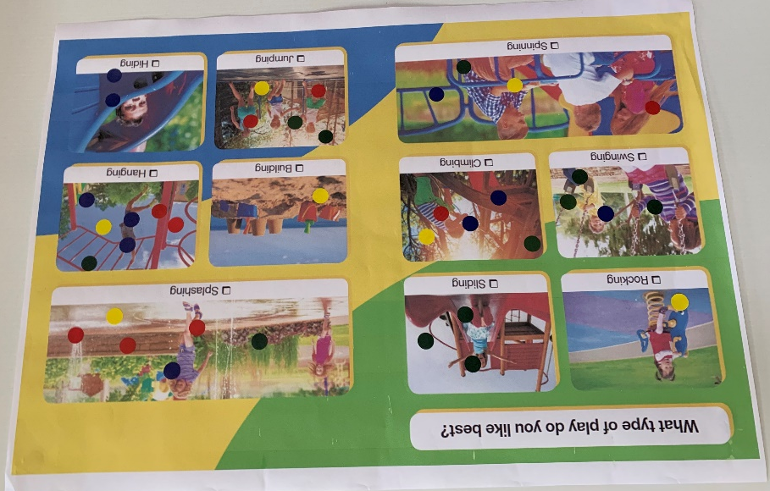
Hanging (7), Splashing (6), Climbing (5), Jumping (5), Spinning (4), Swinging (4), Sliding (3), Hiding (2), Rocking (1) and Building (1).
A total of 14 adults and 12 children provided their feedback.

Summary
There is an opportunity to build on existing natural play elements within the reserve by including rocks, logs or materials that invite children to explore areas outside the playground. Existing users highly value the open space surrounding the play equipment, which is used by older children for ball games or unstructured play. The rebound wall/basketball hoop is also very well used and could be improved upon with the inclusion of a netball hoop.
Users expressed their desire for more play opportunities and equipment catering to older children, hanging and climbing were the activities most commonly proposed. Splashing and waterplay were also popular suggestions.
The new design will need to explore retaining elements of the existing playground that are in good condition.
The inclusion of a public toilet will be referred to the City Assets and Projects Department for consideration.

What is the best thing about this playground?

It’s local
Monkey bars and things you can hang on (2)
Tennis/rebound wall (3)
The trees, to climb, ball games and the grass area
Monkey bars
Locality
Open space for free play and equipment for smaller kids
Water tap
Fun, slides and swings
It’s fenced (the reserve)
Slides
Interacting things
All the open space next to the playground
The playground works for lots of ages (2)
The path through the reserve – kids learn to ride their bikes on it
The greenspace and trees
Preserving the reserve for future

What do you least like about this playground?

Slides
Half court could be better utilised (include basketball/netball hoop) (3)
Not enough for your age (older kid)
No shade for sitting – no wet weather/hot weather options
The rebound wall – only used for tennis and basketball
I like everything
The circle things
Not many things for kids under 18 months
Needs more interesting things
No toilets (4)
No BBQs

How could this playground be made better?

It could be bigger and taller
Water play (3)
Flying fox (3)
Climbing
Include elements for all ages – things for older kids (2)
Basket swing
More swings
Soft undersurfacing so people/kids can practice gymnastics
More things for hanging/monkey bars (3)
More room to play
More rubberock surfacing
Bigger
Higher monkey bars
BBQ, gazebo
More options for climbing, playing hide and seek
Rope pyramid for climbing
Improve sightlines between playground and rebound wall
Scooter and bike stands
Correct fencing (unsure what this means)
Install toilets (3)

Other comments
More exploring areas
Swings – I like the ones at Spring St
The spinning bowl at Cheltenham Road playground
I like the Beach Road wooden playground
Likes Sandringham playground and risk taking
Retain trees for climbing
Could use unused space (tree’d area close to Bluff Road) for a nature play/walk area (2)
Improve connection between Bowls Club and playground/reserve (2)
I don’t like sand from mixing with grassed areas in playground
Likes the playground at Black Rock
Favourite playground is Thomas Street
Cab we reuse existing equipment?
The rebound wall and open space is used for alot of ‘firsts’ – basketball, tennis, soccer

