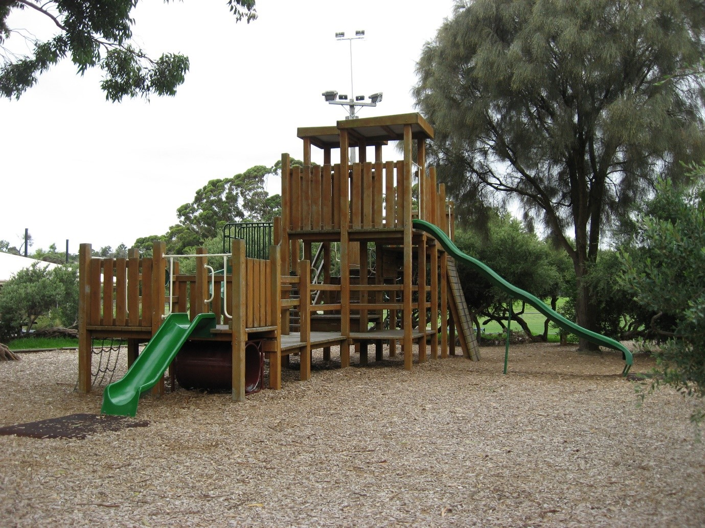
Playground Testers Program 20/21
Community Engagement Summary

June 2021

Bayside City Council
Corporate Centre
76 Royal Avenue
SANDRINGHAM VIC 3191
T (03) 9899 4444
F (03) 9598 4474
www.bayside.vic.gov.au

Contents
1 Engagement overview 3
1.1 Next Steps 4
2 Background 4
3 Consultation process 5
3.1 Consultation purpose 5
3.2 Consultation methodology 5
4 Participant profile 8
5 Consultation findings 9
5.1 Playground specific feedback 9
5.1.1 Donald MacDonald Reserve 9
5.1.2 Hampton Node 11
5.1.3 RG Chisholm 12
5.1.4 Hanby Street Reserve 14
5.1.5 Whyte Street Reserve 15
5.1.6 Train Street Reserve 17
6 Project Evaluation 19

Engagement overview
The purpose of this engagement was to ensure that the community, specifically playground users (our young people) of Bayside had opportunity to provide input into the development of the concept designs for six playgrounds listed for renewal/upgrade as part of Bayside’s Playground Improvement Plan (PIP) 20/21 program.
State Government restrictions imposed in response to the pandemic prevented onsite engagement to assist with idea generation, however the adaption of the existing playground testers program to collect feedback via QR codes saw the highest level of participation recorded in the six years that playground testers has operated.
The Bayside ‘Buccaneers’ was celebrated in the media with coverage on ABC Radio, Southern FM and LinkedIn. This innovative, pirate-themed program was designed to involve our younger community members in playground design by encouraging their feedback on playgrounds due for upgrade.
Harvest - Have Your Say digital engagement platform, also promoted the playground testing program as its ‘Project of the Month’, citing its inspiring digital engagement of children in local decision making.
This promotion generated a high level of interest with valuable feedback obtained however it is apparent that participants were not aware of the scope of works and budget allocated to each of the playground renewals, with disparity between community expectations and capacity. The Playground Improvement Plan available via the Have Your Say page, provides details of Councils plan for play including precinct planning, the category of playground, age group the playground targets, the proposed scope for renewal, and the allocated budget.
This has been valuable insight for officers who will ensure that subsequent round of engagement clearly articulates critical details to ensure community aspirations and budgets align. Increased visibility of the PIP on the Have Your Say page will also assist to impart this message.
The current PIP excludes several elements including:
- installation of shade (sail or planting unless the playground is classified as a district or regional playground)
- expanding footprint of the playground in most circumstances
- increasing the budget allocated for each playground upgrade or replacement
- timeframe for delivering the individual playground improvement
- location of the playground (utilisation of current site)
- landscaping or other open space features outside of the playground area
- provision or upgrade of public toilet or other facilities in the vicinity that is not included within the Public Toilet Improvement Strategy
- provision of outdoor fitness equipment or older adult equipment.
Hampton Node was removed from the PIP following feedback that the playground was not well used with the foreshore masterplan identifying this area as appropriate for additional seating to better utilise this space. It is proposed that the existing climbing wall will be retained.
While shade cloth is outside of the scope for all playgrounds excluding Donald MacDonald and W.L Simpson Reserve, strong feedback seeking shade was received. 96 respondents requested shade to protect children playing and supervising adults. While this feedback can not be addressed as part of the existing renewal program it will be used to support a broader Council response to climate change and Bayside’s declaration of a climate emergency, with specific focus on skin protection.
Age range suitability also received high volumes of feedback with 69 respondents commenting that playgrounds were either focused on very young age groups or older children providing gaps in the provision of play. The PIP responds to this view through a precinct planning approach where a precinct is defined as a residential catchment within an area defined by busy roads or railway lines which children cannot be expected to cross independently.
Precinct assessments are based on the principle that within most residential catchments or precincts, children and families could reasonably expect to find a range of play opportunities that suit their needs. It is not assumed that every park or playground will meet the needs of every user, but that as a package, between the playgrounds available, most residents will find a choice of suitable opportunities within walking distance of home. Due to development pressures and a lack of open space sometimes this is not possible. Feedback has requested that consideration to some elements that broaden play opportunities for a more diverse age range would be appreciated.
Play elements such as flying foxes and climbing structures were popular, however equipment such as these require significant space and would be limited to playgrounds classified as district or regional.
Respondents provided feedback on out-of-scope items such as:
- Picnic tables
- Provision of rubbish bins
- Cleanliness of areas
- Water fountains
- Fencing and
- Toilets

Next Steps
Feedback has been consolidated and provided to the relevant design team to generate concept designs for the five playgrounds (Hampton Node removed).
Designs will be displayed on Council’s Have Your Say page with Council seeking feedback on the proposed elements for each playground.
Following the four-week engagement period the final designs will be prepared and will be displayed at each playground. No further feedback will be sought.

Background
Council, through its capital works program, is replacing or upgrading all 61 playgrounds throughout the municipality, in line with the Playground Improvement Plan 2015-2025. This plan is in its seventh year of implementation.
The upgrades will cater for children of all ages and abilities, promote intergenerational use and ensure adherence with all Australian Safety Standards. Playground upgrades will adopt principles of universal design ensuring that they are not only able to be accessed but enjoyed by community members of varying abilities. The playground improvement plan aims to provide a range of play opportunities that suit the needs of residents within walking distance to their home and destination playgrounds within the municipality. The project will deliver six renewed pocket park/local play spaces.
The 2020/21 Playground Tester Program invited young people across Bayside to provide feedback on existing playgrounds via online surveys. This feedback was then collated and passed on to the playground designers to be used to inform the design process.
The introduction of a theme added some colour and life to the program and captured the interest of young people. Brightly coloured, pirate themed graphics were carried through the online consultation page (Have Your Say), signage and promotional material.
Playground Testers that registered for the program were sent a Treasure Map providing clues to discover the X marks the spot to provide feedback on each of the playgrounds. Playground Testers were incentivised by the chance to win movie tickets for each survey completed.
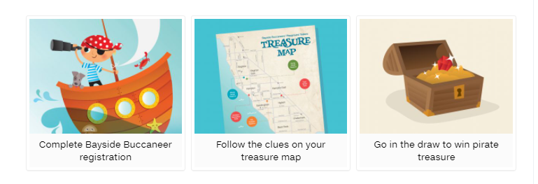

Consultation process

Consultation purpose
Each year Council consults the community on several playgrounds, develops designs and prepares for con. In the same year, Council constructs the group of playgrounds that were developed the previous year, so that Council has a continuous cycle of upgrades, working towards Council’s target of upgrading all 61 playgrounds by 2025.
The Playground Testers phase of engagement is designed to ensure that the actual users of the play spaces have an opportunity to contribute to and guide the design process for each playground.
Playgrounds tested during this round of engagement included:
- Hanby Street Reserve
- Train Street Reserve
- RG Chisholm Reserve
- Hampton Recreation Node
- Donald MacDonald Reserve
- Whyte Street Reserve
Following the initial round of consultation feedback, where possible will be incorporated into the draft designs, where a second round of community engagement will occur to test the suitability of the design.

Consultation methodology
The Bayside Buccaneers Playground Testers program was held from 16 March – 31 May 2021 with 271 children joining the pirate fleet.
The engagement plan considered the project’s complexity, the level of change/impact, and reputational risks. This project was assessed as ‘Consult’ level of engagement on Bayside’s application of the IAP2 Public Participation Spectrum.
The tools and techniques selected for this project were informed by the project content, stakeholders and type of feedback sought. Consultation was open for a four-week period.
The following engagement activities were undertaken:
- project information and feedback surveys through Have Your Say, including opportunity to ask questions.
The following table provides detail of each activity undertaken within the community engagement period:
Engagement activities and participation
Details | Activity
16 March – 31 May  338 surveys received | Six individual Have Your Say surveys  Individual surveys were set up for each of the six playgrounds. For each survey, respondents were asked what they liked and didn’t like about each playground and their ideas for making the playground better.  The opportunity to contribute was promoted via all Council communication channels (website, E-newsletter, social media and Have Your Say platform). Paid advertisements we used to boost the reach of the Facebook posts.  The results below detail how many surveys were received for each playground;
16 March – 31 May  55 respondents | Have Your Say survey  Donald MacDonald Reserve
16 March – 31 May  43 respondents | Have Your Say survey  Hampton Recreation Node
16 March – 31 May  59 respondents | Have Your Say survey  Hanby Street
16 March – 31 May  58 respondents | Have Your Say survey  RG Chisholm Reserve
16 March – 31 May  55 respondents | Have Your Say survey  Train Street
16 March – 31 May  68 respondents | Have Your Say survey  Whyte Street
16 March – 31 May  6 questions | Have Your Say platform – question and answer forum  A question and answer forum was promoted on Council’s Have Your Say platform, giving people the opportunity to ask questions about the Playground upgrades. These questions were answered by Council’s Recreation Planner.  The questions were general in nature and not specifically about this community engagement on the six playgrounds ready for upgrade.  The opportunity to contribute was promoted via all Council communication channels (website, E-newsletter, social media and Have Your Say platform). Paid advertisements were used to boost the reach of the Facebook posts.
16 March – 31 May  73 new followers | Have Your Say platform – subscribe to the project  A feature on the Have Your Say platform allows interested people to ‘subscribe’ to the page and be kept updated on the project. Subscribing to a project indicates a high level of interest in the Playground upgrades project.  The opportunity to subscribe was promoted via all Council communication channels (website, E-newsletter, social media and Have Your Say platform). Paid advertisements were used to boost the reach of the Facebook posts.

Communications tools and reach
The community engagement process for the Bayside Buccaneer Playground Tester project aimed to raise awareness of the Playground Improvement Program and to encourage playground users to provide valuable feedback to inform upgrades.
It is estimated that communications reached more than 23,911 individuals through channels, including:
- social media (organic and paid posts)
- two editions of Council's e-newsletter This Week in Bayside
- a promotional video inviting children to become Playground Testers

Reach | Tool
16 March  37 link clicks  8.69% engagement | Social media (organic and paid Facebook post)  A post was featured on Council’s Facebook page promoting the consultation.
28 March  452 link clicks  8.85% engagement | Social media (organic and paid Facebook post)  A post was featured on Council’s Facebook page promoting the consultation.
18 March  3694 people opened the newsletter  144 people clicked on the article | E-newsletter – This Week in Bayside  Council sends an e-newsletter each Thursday afternoon to over 8000 subscribers. This is an effective way to promote our consultations.
22 March  34 views | Promotional video  A video that was created for a previous consultation was updated and used to promote registrations for Playground testers.
1 April  3300 people opened the newsletter  160 people clicked on the article | E-newsletter – This Week in Bayside  Council sends an e-newsletter each Thursday afternoon to over 8000 subscribers. This is an effective way to promote our consultations.

Have your Say
Between 16 March – 31 May 2021, the page generated the following traffic:
Views – the cumulative number of times a visitor visits the page
Visits – the number of end-user sessions associated with a single visitor
Visitors – the number of unique public or end-user in a site. A visitor is only counted once
Contributions – the total number of responses of feedback collected
Contributors – the unique number of visitors who have left feedback, and
Followers – the number of visits who have subscribed to the page using the follow button.
The consultation collected basic participant data including age range and gender. The traffic through this site indicates that community were aware of the proposal and had opportunity to provide feedback.

Participant profile
The Bayside Buccaneers Playground Testers Program was promoted to all 2-12-year-old residents of the Bayside municipality as the primary users of playgrounds. Children outside of the municipality were also accepted into the program. Children were encouraged to register to go into the draw to win prizes, but children were also free to provide feedback without formally registering for the program.
 | Demographic | Bayside  2016 Census | Participants (%)
Gender | Male | 47.6%
 | Female | 52.4%
 | Unknown | -
 | Other identity | -
Age | 2 – 12 years | N/A | 100%
Suburb | Beaumaris | 13.5% | 7.6%
 | Black Rock | 6.5% | 5.6%
 | Brighton | 24.1% | 15.1%
 | Brighton East | 15.9% | 4.0%
 | Cheltenham | 3.7% | 11.2%
 | Hampton | 13.6% | 8.8%
 | Hampton East | 5.0% | 6.0%
 | Highett | 7.2% | 9.2%
 | Sandringham | 10.5% | 8.8%
 | Outside Bayside | - | 23.9%

Consultation findings
The following section summarises the key themes which arose in community feedback for playground upgrades/renewal within the municipality. In the interest of stakeholder and community privacy, individuals have not been identified within this public document. Where there was more than one mention of a topic or item, the number of mentions has been specified in brackets and italics.

Playground specific feedback

Donald MacDonald Reserve
55 respondents provided feedback to the Donald MacDonald Reserve playground.

5.1.1.1 Things we love
Respondents were asked to answer, ‘What do you like about this playground?’
Comments submitted by 54 respondents
Topic | Community feedback
Slides and swings  (30 comments) | - Comments regarding the size and fun of the existing slides  - Comments that young people loved the variety of slides  - Comments that the spiral slide was a lot of fun  - Great swings
Cubby house  (10 comments) | - Comments regarding the joy the cubby brings
Shelter  (5 comments) | - Comments seeking that the large shelter is retained
Monkey bars  (15 comments) | - Comments the monkey bars are great
Flying fox  (6 comments) | - Comments regarding the zip line is cool  - Comments regarding how fast and smooth the flying fox is
Sand play  (4 comments) | - Comments that the sand pit is lots of fun
Natural play elements  (16 comments) | - Comments regarding ability to climb on trees  - Comments regarding the trees and nature play  - Comments regarding ability to play hide and seek within the natural environment
General Comments  (18 comments) | - I love it all  - The slide is really fast  - Fun equipment  - Lots of fun hiding spots  - Everything is great  - I like the wilderness

5.1.1.2 Things we don’t like
Respondents were asked to answer, ‘What don’t you like about this playground?’
Comments submitted by 50 respondents
Topic | Community feedback
Slides  (4 comments) | - Comments that the slides are too small
Shelter  (2 comments) | - Comments that additional shade is required
Natural play elements  (6 comments) | - Comments to add additional stumps to climb on
General comments  (10 comments) | - The sand pit is too big  - Noisy Road next to the playground  - Too many open gaps up high  - Oval is too noisy  - Mostly a ton of wood that is dirty  - Rusty poles

5.1.1.3 Requests for new/additional elements
Respondents were asked to answer, ‘My ideas to improve this playground?’
Comments submitted by 55 respondents
Topic | Community feedback
More equipment for young children/toddlers  (5 comments) | - Comments seeking additional equipment for toddlers
More challenging equipment for older children  (8 comments) | - Comments to include additional tunnels, slides and climbing staircases  - Comments suggesting bouncing equipment.  - Comments seeking swings for older children
Flying fox  (2 comments) | - Comments to increase the size of the flying fox
Sand and water play  (10 comments) | - Comments seeking water play with stepping stones  - Comments requesting play equipment within the sandpit
Climbing elements  (10 comments) | - Comments to include rock climbing frame for older kids  - Comments seeking trees of different sizes to hide and climb  - Comments seeking more natural climbing items like rocks and logs - learn about wildlife, indigenous culture
Shade  (2 comments) | - More shade
General comments  (18 comments) | - Add more colour  - Water station to fill up bottles  - A few more chairs/benches would be great too  - Fence around the perimeter  - Toilet upgrade required  - Make a bigger skate park.  - Ninja warrior equipment  - Provide rubber soft fall  - More safety around bigger equipment

5.1.2 Hampton Node
43 respondents provided feedback to the Hampton Node playground.

5.1.2.1 Things we love
Respondents were asked to answer, ‘What do you like about this playground?’
Comments submitted by 40 respondents
Topic | Community feedback
Climbing Wall  (9 comments) | - Comments that the wall is fun to climb
Hopscotch  (5 comments) | - Comments that the hopscotch is fun
Proximity to the Beach  (21 comments) | - Comments regarding the beautiful location, proximity to beach and view
General Comments  (18 comments) | - I love the view  - The cubby  - The beach  - The floor is lava  - I love lying on the mermaid’s tail  - I love the bumps on the ground  - Good for obstacle course

5.1.2.2 Things we don’t like
Respondents were asked to answer, ‘What don’t you like about this playground?’
Comments submitted by 42 respondents
Topic | Community feedback
Lack of play opportunities  (34 comments) | - Comments that there is nothing to play on  - Comments that they don’t like it at all
Difficult to access  (4 comments) | - Comments that it was hard to access when driving
No shade  (2 comments) | - Comments regarding lack of shade

5.1.2.3 Requests for new/additional elements
Respondents were asked to answer, ‘My ideas to improve this playground?’
Comments submitted by 42 respondents
Topic | Community feedback
Equipment  (19 comments) | - Comments that the wall is fun to climb  Comments regarding beach theme – pirate ship  - Comments that slides and swings would be great
Shade  (2 comments) | - Comments that shade to enjoy the gorgeous view would be appreciated.
General Comments  (18 comments) | - I love the view  - The cubby  - The beach  - The floor is lava  - I love lying on the mermaid’s tail  - I love the bumps on the ground  - Good for obstacle course  - Drinking tap please

5.1.3 RG Chisholm
58 respondents provided feedback to the RG Chisholm Reserve playground.

5.1.3.1 Things we love
Respondents were asked to answer, ‘What I like about this playground?’
Comments submitted by 56 respondents
Topic | Community feedback
Swings/Slide  (39 comments) | - Comments that the swings/slides are great
Location  (8 comments) | - Comments that it being close to a sportsground is great.  - Comments that young people can play on the equipment and then run on the oval  - Comments that it is easy to park
Size  (4 comments) | - Comments that the playground is a good size  - Comments that the playground is too small
Spinners  (4 comments) | - Comments regarding spinner
General  (22 comments) | - Good playground for younger children  - Cute little playground  - Comments that the playground is safe  - I love the cubby, the steering wheel  - There is a dinosaur!  - Triceratops  - Picnic table is great  - I like the binoculars

5.1.3.2 Things we don’t like
Respondents were asked to answer, ‘What I don’t like about this playground?’
Comments submitted by 56 respondents
Topic | Community feedback
Lack of play opportunities  (15 comments) | - Comments that the playground is limited to under 7 years  - Comments that there isn’t much to play on and the equipment is dated  - Comments that equipment for older children is required
Dogs off leash  (6 comments) | - Comments that dogs off leash run through the playground  - Comments regarding dog poo found in the playground

5.1.3.3 Requests for new/additional elements
Respondents were asked to answer, ‘My ideas to improve this playground?’
Comments submitted by 58 respondents
Topic | Community feedb9ack
Size  (10 comments) | - Comments seeking a larger playground
Equipment  (31 comments) | - Comments that additional equipment is required  - Comments that sand pit and play elements would be great  - Comments seeking more climbing and balance items  - Comments seeking specific elements such as rocket ships, monkey bars, trampolines and rope tunnels would be great  - Comments suggesting play equipment for older age groups would be appreciated including larger swings and slides
Shade  (12 comments) | - Comments that shade is required
General  (14 comments) | - Additional seating would be great  - Fence the playground to keep dogs out  - A BBQ would be great  - Sand and water play  - Natural climbing and imaginative play required  - Skate park

5.1.4 Hanby Street Reserve
59 respondents provided feedback to the Hanby Street playground.

5.1.4.1 Things we love
Respondents were asked to answer, ‘What I like about this playground?’
Comments submitted by 50 respondents
Topic | Community feedback
Mirrors  (9 comments) | - Comments that the mirrors are fun and made us laugh a lot
Swings and Monkey bars  (17 comments) | - Comments that swing and monkey bars are fun  - Comments that with the equipment connected it is fund for continuous play
Blue Pelican  (8 comments) | - Comments that the blue pelican is the highlight of the playground
The Maze  (10 comments) | - Comments that the maze is so much fun
General Comments  (26 comments) | - Beautiful park  - I love the trees  - I love the colourful plastic  - Close to a café  - Big with lots of places to run  - Telescope is fun  - Good for picnics  - The round about to play traffic  - Great for climbing

5.1.4.2 Things we don’t like
Respondents were asked to answer, ‘What I don’t like about this playground?’
Comments submitted by 55 respondents
Topic | Community feedback
Size  (26 comments) | - Comments that the playground is too small  - Comments that there isn’t enough to do
Shade  (13 comments) | - Comments that there isn’t enough shade
Not enough equipment for older children  (17 comments) | - Comments that there isn’t enough equipment for children over 7 years  - Comments that the playground is only for young children
General Comments  (31 comments) | - Telescope is too high for toddlers  - Nothing I love it all  - The space isn’t used well  - Add elements inside the maze  - Monkey bars are unstable  - I just don’t like the playground

5.1.4.3 Requests for new/additional elements
Respondents were asked to answer, ‘My ideas to improve the playground?’
Comments submitted by 59 respondents
Topic | Community feedback
Climbing, flying and swinging  (26 comments) | - Comments that equipment for older children is required – larger slides and swings  - Comments suggesting installation of a flying fox  - Comments regarding the need for sand play  - Comments that climbing elements would be appreciated  - Comments that a tree house would be fun  - Comments that platforms for climbing are required
More colour  (6 comments) | - Comments that additional colour would be appealing to children
Shade Required  (4 comments) | - Comments that shade is required
General Comments  (18 comments) | - Sensory surfaces would be great  - A skatepark  - Mini sports equipment  - A seesaw would be cool  - More plants  - Fencing required  - A toilet please  - Things to balance on  - Seating and BBQ  - Drink fountain  - A lookout tower  - Ninja course

5.1.5 Whyte Street Reserve
68 respondents provided feedback to the Whyte Street playground.

5.1.5.1 Things we love
Respondents were asked to answer, ‘What I like about this playground?’
Comments submitted by 60 respondents
Topic | Community feedback
Climbing  (21 comments) | - Comments that there are lots of things to climb on  - Comments that monkey bars are great
Swings and Slide  (18 comments) | - Comments that swings are great  - Comments that the slide is fast and lots of fun
Location  (12 respondents) | - Comments that the playground and sportsground together is great  - Comments that it is safely located away from the road  - Comments that it is a beautiful setting
Amenities  (9 respondents) | - Comments that the BBQ is great  - Comments that public toilets are available
General comments  (7 respondents) | - Steering wheel and clock is fun  - Lots of wobbly things to climb  - I like the bit under the slide that I can pretend is a shop  - Balancing walkways and hanging things  - Slippery pole is fun

5.1.5.2 Things we don’t like
Respondents were asked to answer, ‘What I don’t like about this playground?’
Comments submitted by 56 respondents
Topic | Community feedback
Equipment  (12 respondents) | - Comments that there isn’t enough equipment  - Comments that the play equipment is old  - Comments that an extra swing is required  - Comments that monkey bars are too low  - Comments that the play space is for toddlers only
Dog off leash  (6 respondents) | - Comments that dogs off leash came close and frightened me  - Comments that dog owners weren’t stopping them from entering the playground.
Size of playground  (5 respondents) | - Comments that the playground needs to be larger
General comments  (10 respondent) | - Water fountain has no pressure  - Fireman pole is too short  - The voice tubes should be covered up (Covid)  - Its old and tired  - Not enough fun stuff to do  - It doesn’t look inviting

5.1.5.3 Requests for new/additional elements
Respondents were asked to answer, ‘My ideas to improve the playground?’
Comments submitted by 68 respondents

Topic | Community feedback
Equipment for older children  (32 comments) | - Comments to add a large climbing frame  - Comments that swings for older children are required  - Comments that ninja warrior equipment is required  - Comments that monkey bars would be great  - Comments suggesting inclusion of a flying fox
Size of playground  (6 respondents) | - Comments that the playground needs to be larger
Shade  (27 respondents) | - Comments that shade is required
General Comments  (17 respondents) | - Ban the consumption of alcohol in the park  - Scooter path  - Remove the dog poo  - More tables and chairs  - Add water play elements  - Add a paw patrol tower  - Paint existing equipment  - A vege garden  - A gymnastic bar  - A fort  - A bridge to play games like not being caught be a shark

5.1.6 Train Street Reserve
55 respondents provided feedback to the Train Street playground.

5.1.6.1 What we love
Respondents were asked to answer, ‘What I like about this playground?’
Comments submitted by 51 respondents
Topic | Community feedback
The Train and Trains  (41 comments) | - Comments that the train is the best part of the playground  - Comments that I love watching the trains go past and waving  - Comments that train spotting is the best part
Slide, fire pole and tunnel  (1 respondents) | - Comments that the fireman pole is fun  - Comments that the slide is fun  - Comments that the tunnel is fun and the bouncy see saw
Setting  (15 respondents) | - Comments that parents love the playground fully fenced  - Comments that collecting gum nuts is fun  - Comments that the trees are nice

5.1.6.2 Things we don’t like
Respondents were asked to answer, ‘What I don’t like about this playground?’
Comments submitted by 50 respondents
Topic | Community feedback
Equipment  (21 comments) | - Comments that the equipment s aimed at younger children  - Comments that swings don’t go high enough  - Comments that the steering wheel is too high  - Comments that equipment is old and rusty  - Comments that the fireman pole wasn’t fun
Safety  (3 comments) | - Comments that the playground is isolated  - Comments that individuals didn’t feel safe in the playground  - Comments that there is no passive surveillance
Size of playground  (22 comments) | - Comments that the playground is too small
General Comments  (16 comments) | - Aimed at pre-school children  - No bins of drink fountain  - The park is old and tired  - No basketball ring  - Often litter including needle caps and graffiti

5.1.6.3 Requests for new/additional elements
Respondents were asked to answer, ‘My ideas to improve the playground?’
Comments submitted by 55 respondents
Topic | Community feedback
Equipment for older children  (32 comments) | - Comments to add climbing elements  - Comments that swings and slide for older children are required  - Comments that monkey bars would be great  - Comments requesting equipment that spins  - Comments requesting a flying fox
Shade  (8 respondents) | - Comments that shade is required
General Comments  (17 respondents) | - Sandpit with diggers  - Trampoline  - Acquire additional property to extend playground  - Basketball hoop  - Elements for imaginative play  - Add a ticket window for the train  - It needs a good clean  - Add tables and chairs for picnics and snacks  - Add cobwebs  - Giant snakes and ladders  - Drink fountain  - Add a spinning see saw

Project Evaluation
The community engagement exceeded expectations with 4244 views on the Have Your Say page with 1978 visitors. 271 children registered for the project, which was increase of 50 participants from previous programs. In terms of reach 338 surveys were returned across the six playgrounds, and increase of 62 on last year’s program.
No specific targets were set for how visitors interacted with the Have Your Say however conversions were high in relation to projects of a similar size and interest.

