Proposed Sale of 126 Carpenter Street, Brighton
Community Engagement Summary

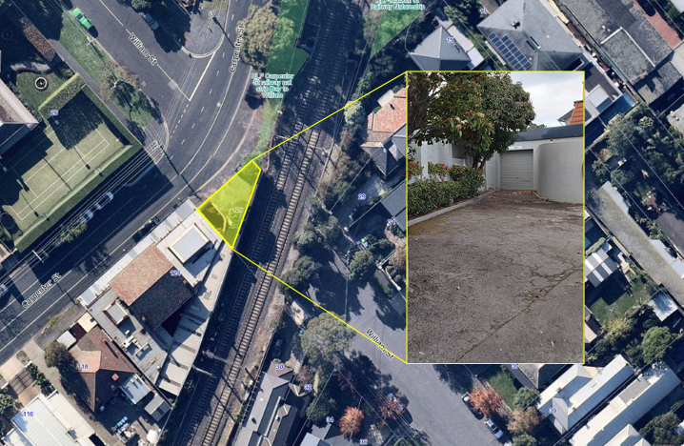

August 2021

Bayside City Council
Corporate Centre
76 Royal Avenue
SANDRINGHAM VIC 3191
T (03) 9899 4444
F (03) 9598 4474
www.bayside.vic.gov.

Background
This document provides a summary of stakeholder and community feedback on the proposed sale of 126 Carpenter Street in Brighton.
Bayside City Council is proposing to sell a small piece of land (102m2) located at 126 Carpenter Street in Brighton to the adjoining owner of 124 Carpenter Street, Brighton for $300,000 plus GST.
The subject land previously formed part of William Street and since 1971 has been utilised as a car park/loading bay by Monkhouse and Son for the adjoining premises at 124 Carpenter Street, Brighton. The business requires the subject land to maintain the ongoing operation of its activities. The car park was operating under a Licence Agreement with Bayside City Council and this licence expired in March 2021. The licence fee for the subject land is currently $8,717 per annum.
The land contains an underground sewerage easement that will continue to be accessed by South East Water following the sale.
Council has asked the community what they think about the proposed sale.
The consultation was promoted to the whole Bayside community but with a particular emphasis on Brighton residents and businesses, as the proposed sale is likely to be of most interest to those living close by.

Next steps
It is expected that Council will consider the results of the community engagement program and the proposed sale of 126 Carpenter Street, Brighton at the scheduled Council meeting on 26 October 2021.

Consultation process

Consultation purpose
The consultation was designed to:
- present the community with the proposed sale of the subject land, the reasons for the proposed sale and to receive submission from any individual or organisation concerning that proposed sale;
- to ensure that neighbouring owners are aware of the proposed sale and to ensure they have an opportunity to provide comment;
- to comply with Section 114 of Local Government Act 2020 (2) (a) (i); and
- to enable members of the public to register comments concerning the proposed sale for Council’s consideration, prior to a decision on whether to sell the land to the proposed purchaser.

Timeline and phases for the consultation on the proposed sale of 126 Carpenter Street, Brighton:
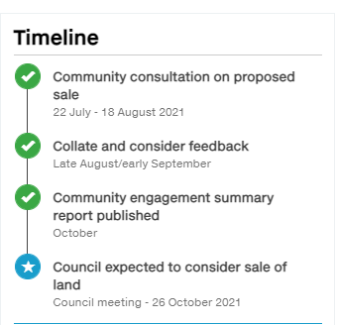

Consultation methodology
The engagement process was open to all members of the Bayside community, including individuals or groups who live, work, play, study, visit, invest in or pass through the municipality. Particular promotion was directed to residents living close by and other residents and businesses in Brighton.
The engagement plan considered the project’s complexity, the level of change/impact, and reputational risks. This project was assessed as ‘Consult’ level of engagement on Bayside’s application of the IAP2 Public Participation Spectrum.
The tools and techniques selected for this project were informed by the project content, stakeholders and type of feedback sought. Consultation was open for a four-week period.
The following engagement activities were undertaken:
- project information and feedback survey through Have Your Say, including opportunity to ask questions
- public submissions invited to be delivered in person, in writing or via phone or email.

The following table provides detail of each activity undertaken within the community engagement period:
Engagement activities and participation
Details | Activity
22 July – 18 August  Post, phone, in person and email  3 phone calls were received and no submissions, email or letters | Public submissions  Submissions were invited from the Bayside community and any other interested parties. The submission process was advertised in The Age and via all Council communication channels (website, E-newsletter, social media and Have Your Say platform).
22 July – 18 August  2544 page views  1781 visitors | Have Your Say platform – main page  The project was outlined on the Have Your Say page providing background to the proposal, images and relevant documents. There was a link to a survey and a facility to ask questions.
22 July – 18 August  Link from Council’s website  105 responses from 97 respondents | Have Your Say platform – survey  A survey was promoted on Council’s Have Your Say platform, asking people to comment on the proposed sale of 126 Carpenter Street. Respondents were also asked how easy or difficult they found the information to find and understand.  The opportunity to contribute was promoted via all Council communication channels (website, E-newsletter, social media Have Your Say platform and an email to Bay and Church Street traders). Paid advertisements we used to boost the reach of the Facebook posts in the Brighton area.
22 July – 18 August  Link from Council’s website  12 questions were received from 9 people | Have Your Say platform – question and answer forum  A question and answer forum was promoted on Council’s Have Your Say platform, giving people the opportunity to ask questions on the proposed sale of 126 Carpenter Street. These questions were answered promptly by Council’s Property Officer. Respondents could also vote via a thumbs up or down emoji providing a simple way for others to interact and support others’ questions.  The opportunity to contribute was promoted via all Council communication channels (website, E-newsletter, social media and Have Your Say platform). Paid advertisements we used to boost the reach of the Facebook posts.
22 July – 18 August  Link from Council’s website  16 subscribers | Have Your Say platform – subscribe to the project  A feature on the Have Your Say platform allows interested people to ‘subscribe’ to the page and be kept updated on the project. Subscribing to a project indicates a high level of interest in the proposed sale of 126 Carpenter Street.  The opportunity to subscribe was promoted via all Council communication channels (website, E-newsletter, social media, Have Your Say platform and an email to local traders). Paid advertisements were used to boost the reach of the Facebook posts.

The diagram below provides a summary of engagement with Council’s online consultation tool, Have Your Say:
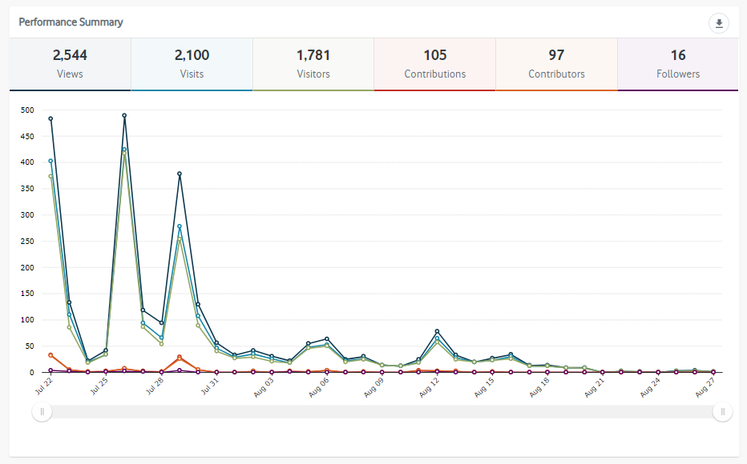

Communications tools and reach
The community and stakeholder engagement process aimed to raise awareness of the proposed sale of 126 Carpenter Street.
It is estimated that communications reached more than 13,221 individuals through channels, including:
- social media (organic posts and paid targeted advertisements)
- Council's e-newsletter This Week in Bayside
- letterdrop of addressed mail to five residents, referring them to the ‘Have Your Say’ page
- public notice in The Age brought three people to the ‘Have Your Say’ page.
- signage on site with QR code directing people to the Have Your Say page. Fourteen of the survey respondents came to the page from this tool.

Reach | Tool
22 July  3 people came to the Have Your Say page via the public notice | Public notice (The Age newspaper)  The consultation was advertised in The Age newspaper and also on the public notice section of Council’s website.
23 July  287 page views | Website news story  The consultation was promoted on Council’s website.
26 July  507 link clicks  17% engagement | Social media (organic Facebook post)  A post was featured on Council’s Facebook page promoting the consultation.
28 July  350 link clicks page views  17 % engagement | Social media (targeted Facebook advertisement)  A Facebook advertisement was geographically targeted to the Brighton area.
28 July  426 subscribers  190 opens  45 link clicks | Email  An email was sent to the traders in Church and Bay Streets Brighton via Council’s Economic Development team’s database
29 July  3652 people opened the newsletter  426 people clicked on the article | E-newsletter – This Week in Bayside  Council sends an e-newsletter each Thursday afternoon to over 8000 subscribers. This is an effective way to promote our consultations.

Participant profile
A total of 98 people took part in the online engagement: 90 via the online survey and a further eight people submitted questions.
Survey respondents were asked what their relationship to the site was:
- 25 lived in Brighton
- 17 lived in wider Bayside
- 5 were involved with funerals at the site
- 9 had other connections to the site
- 23 had no connections to the site.
Further representative participation was not considered to be relevant for this consultation and there was no requirement to provide personal information other than relationship to the site or to provide a user profile name when asking a question.

Consultation findings
The following section summarises the key themes which arose in community feedback on the proposed sale of 126 Carpenter Street Brighton. In the interest of stakeholder and community privacy, individual quotes have not been included within this public document.
There were 103 submissions in total expressing an opinion regarding the proposal, as follows:
- 71 submissions (68.9% of the total received) in favour of proceeding to sell the land at 126 Carpenter Street Brighton;
- 22 submissions (21.4% of the total received) objected to the proposed sale of land; and
- 10 submissions (9.7% of the total received) were discounted as the comment either did not leave sufficient information to be objectively interpreted or referred to unrelated projects or topics outside the scope of this consultation.

Excluding those submissions which were discounted, the responses can be summarised as follows:
Topic | Community feedback
Sell the land | 71 mentions
Do not sell the land | 22 mentions

Based on the above, the result of the consultation was overwhelmingly positive.

The graph below displays the percentage of positive and negative responses from the Have Your Say page and does not include the feedback received from other channels:
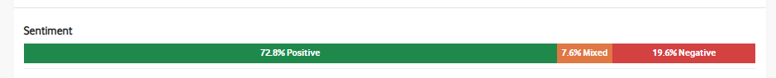

Support for actions
The feedback received regarding the proposal was overwhelmingly positive with 68.9% (71 of the 103 submissions) in support. Key feedback from the submissions included:
- that the proposal was a common-sense sale;
- that the land is of little use for another party other than the adjacent business who have been licensing the land for an extensive period of time; and
- that the sale will remove Council’s responsibility to maintain the land which was viewed as a positive outcome.
From the 22 non-supportive submissions Council received during the community engagement period, only eight of the objectors expressed a clear statement that Council should not sell this land.

Item-specific feedback
Further detail on the specific responses received is contained in the following table:
Topic | Community feedback
Sell the land (as proposed) | 69 mentions
Do not sell the land | 8 mentions
Should be sold at public auction | 2 mentions
Create a pocket park | 7 mentions
Continue to license the land | 6 mentions
Create an outdoor gym | 1 mention

From the 71 supportive submissions, there were two that were supportive of sale of the land but had the opinion that the land should be sold at public auction.
This subject was also raised in the Questions and Answers section of the Have Your Say page by the same submitters. In accordance with the Discontinuance and Sale of Roads, Rights of Ways and Drainage Reserves Policy 2018, Council will only sell such land holdings to abutting property owners.
From the 22 non supportive submissions Council received during the community engagement 14 submissions had a view of alternatives as opposed to selling. The alternatives were for Council to create a pocket park at the subject land (7 mentions), for Council to continue the license agreement with the adjoining business (6 mentions) and for Council to create an outdoor gym at the subject land (1 mentions).

Project Evaluation
The consultation was very successful and reached a far greater number of people than the Section 223 process that was formerly used to promote sales of Council land, prior to the introduction of the Local Government Act 2020. We expected 100 visitors to the Have Your Say page and received 1791 visitors. We anticipated five respondents to the survey and received 97 survey responses.
The conversions on the Have Your Say site were also higher than expected. The targets that were set were: Feedback 1%, Attention 10% and Action 5%. All were exceeded as illustrated in the diagram below:

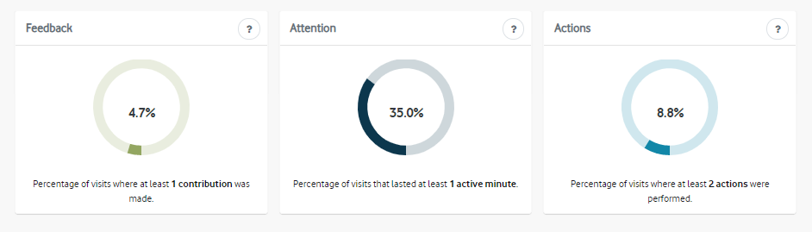
The responses and questions were considered, showing that respondents had taken the time to read the information and understand the proposal. Data collected with the survey reflected this assertion with over 89% of survey respondents that answered the question “Did you have the information you needed to provide your feedback?” found the information easy to find and understand or mostly easy to find and understand. Seventy-five people answered the question and 18 people skipped the question.
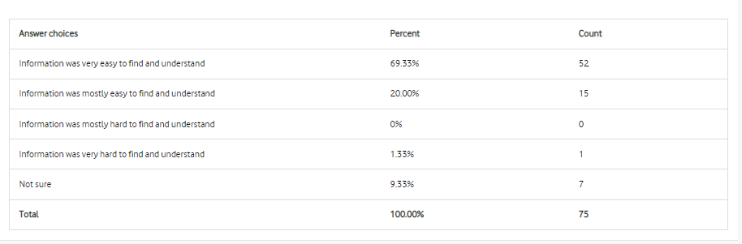
An area of improvement is the response time to questions on the Have Your Say page. To maintain trust and confidence with our community and compliance with Council’s Community and Stakeholder Policy, a response within three days is required. This was not achieved with all questions. Supplying a more comprehensive Frequently Asked Question section and/or preparing responses to anticipated questions may improve the response time in the future. This might also eliminate the need for the public to raise certain queries and will give more comprehensive information regarding the proposal.
The cost effectiveness of placing public notices in The Age newspaper could be evaluated. Only three people of 1781 visitors to the Have Your Say platform came from the public notice. Other communication tools such as the on-site signage, e-newsletters and social media were far more effective in reaching target audiences.

