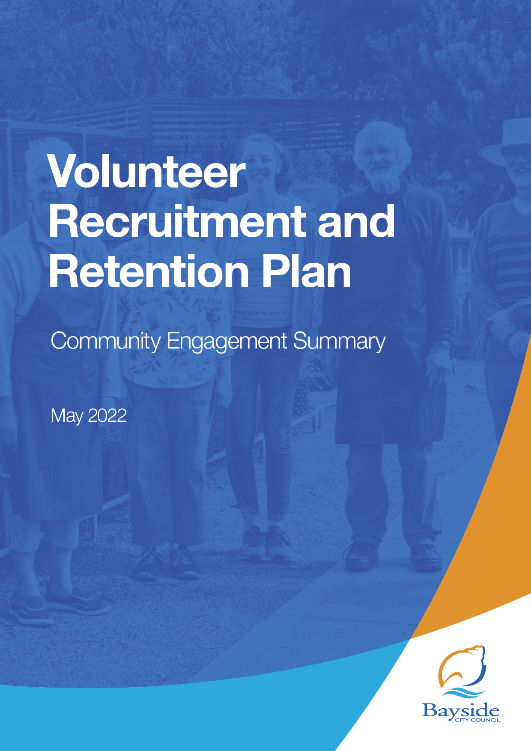
Table of Contents
1. Overview 3
1.1 Next steps 4
2 Background 4
3 Consultation process 4
3.1 Consultation purpose 4
3.2 Consultation methodology 4
4 Participant profile 6
5 Consultation findings 6
5.1 Support for actions 6
5.2 Item-specific feedback 8
5.2.1 Would you like anything else to be included in the Volunteer Recruitment and Retention Plan? 8
5.2.2 What do you think are the biggest barriers for volunteering? 9
5.2.3 How do you think Bayside can engage and support younger volunteers? 9
5.2.4 Have Your Say Vision Board 10
5.3 Project Evaluation 10
6 Appendix 11
6.1 Have Your Say general survey 11
6.2 Have your Say youth survey 12

Overview
Bayside City Council is developing a Volunteer Recruitment and Retention Plan to guide the volunteering priorities for Council over the next four years (2022-2025).
Volunteering plays a crucial role within Bayside, contributing to the overall health and wellbeing of the community. The Volunteer Recruitment and Retention Plan is an opportunity for Council to demonstrate its commitment to ensuring the growth and sustainability of volunteerism in Bayside and is a key deliverable of Council’s Municipal Public Health and Wellbeing Plan.
Over the past 12 months, many people have already shared their perspectives, passion and creativity for the future of volunteering in Bayside through the development of the Municipal Public Health and Wellbeing Plan.
Council is committed to creating a vibrant and engaged volunteer community for all ages and abilities. Volunteering is a valued and integral part of Bayside’s community. Across the municipality, the Bayside municipality hosts many clubs, community groups and organisations. The 2016 Census identified over 18,801 (24%) residents volunteer their time on a regular basis.
The nature of volunteering is changing and in Bayside there is an ageing volunteer workforce. Volunteers of all ages and abilities are increasingly looking for diverse and flexible ways to contribute their time. Currently, not everyone who would like to volunteer is able to access opportunities. There is a need to find new ways to attract a diverse range of people to volunteering and support them to stay involved.
We commenced the planning in June 2021 when we sent an online survey to registered Council volunteers and volunteer involving organisations.
In March to April 2022, we completed the community engagement process with the wider community.
In October we met with key internal and external stakeholders involving Friends of Bayside convenors or group representatives.
As part of this process, members of the community were invited to submit their ideas on what Council can do to build and strengthen volunteering for all ages and abilities in Bayside. We also asked community members to provide feedback on the following four focus areas that have been identified over the last 12 months:
- Increase and support volunteerism in Bayside to grow numbers and awareness of local volunteer opportunities.
- Create a coordinated “One Bayside” approach across Council run volunteer programs.
- Drive opportunities that increase youth volunteering.
- Strengthen the connection between Council and Volunteer Involving Organisations.
In summary, the community has asked us to prioritise the following priority areas in the Volunteer Recruitment and Retention Plan:
- Increasing promotion of volunteering opportunities
- Developing a recognition program
- Provide networking and training opportunities for volunteers such as involving volunteer organisations.
The biggest barriers for volunteering in Bayside included:
- Lack of time
- Unsure of volunteering opportunities
- Program flexibility.

Community feedback highlighted the importance of promoting volunteering and the variety of opportunities available was crucial for recruitment. A dedicated webpage that offered up-to-date information for the community will be a great way to draw awareness to current roles and also demonstrate the broad range of opportunities available.

Next steps

Consultation on the Volunteer Recruitment and Retention Plan has been completed, with feedback from the two phases of engagement incorporated in the Plan.
The Volunteer Recruitment, Retention and Recognition Plan will now be considered for adoption by Council in its July 5, 2022 meeting.

Background
This document provides a summary of stakeholder and community feedback on the Volunteer Recruitment and Retention Plan.
Bayside City Council’s (Council) Volunteer Recruitment and Retention Plan (Plan) outlines the volunteering priorities for Council over the next four years. The Plan is based on the Bayside City Council Plan 2021-2025 which acknowledges the value of volunteering to the Bayside community and its commitment to increasing opportunities for volunteering. Additionally, Council’s Municipal Public Health and Wellbeing Plan 2021-2025 outlines the strengthening of volunteerism as a key objective.
The Volunteer Recruitment and Retention Plan aims to support the above Plans and add value to the existing volunteer programs operating within the municipality.

Consultation process

Consultation purpose
The consultation was designed to provide stakeholders and the broader community with the opportunity to help Council set the priorities, themes and actions of the Volunteer Recruitment and Retention Plan.

Consultation methodology
Details | Activity
June 2021  Online  400 volunteers targeted | Online survey for volunteers  Online survey targeting Bayside City Council volunteers.  114 responses received
June 2021  Online  150 stakeholders targeted | Online survey for volunteer coordinators, convenors and stakeholders  Online survey targeting Bayside City Council volunteer coordinators, convenors, managers, and stakeholders  24 responses received
October 2021 – February 2022  Online  10 attendees | Volunteer Management and Convenors Monthly Meeting  Meeting involving Friends of Bayside convenors or group representatives.
9 March 2022 – 10 April 2022  541 visitors  125 contributions  1 email | Online Engagement - Have Your Say  The page included information on the draft Action Plan.  The primary means of collecting feedback was through two surveys. One aimed at the general volunteer feedback (Appendix 1) and the second focusing on feedback from youth (Appendix 2). Recruitment for the youth survey included an incentive of an Uber Eats voucher prize for participating.  101 contributions received via Supporting Volunteering in the Community survey.  18 contributions received via Youth Volunteering in Bayside survey.  6 contributions received via the Visioner board.  A phone number and email were made available for enquiries with one email received.
5 April 2022  1 session  0 attendees | Nursery drop-in session  One drop-in session was provided at the Community Nursery.  The drop-in session was advertised on the Have Your Say page and on social media.
6 April 2022 – 7 April 2022  2 sessions  0 attendees | Library drop-in sessions: Brighton and Sandringham  Two drop-in sessions were provided at Brighton and Sandringham libraries.  The drop-in sessions were advertised on the Have Your Say page and on social media.
9 March 2022 – 10 April 2022 | Print surveys  Hard copy print surveys were available on request.  No print surveys were received.
April 4 2022  Online  15 attendees | Bayside’s Disability Access and Inclusion Advisory Committee  Online forum discussion with committee members.  A phone number and email were made available for enquiries with one email received.
April 11 2022  Online  12 attendees | Bayside Healthy Ageing Reference Group  Face-to-face meeting with reference group members.  A phone number and email were made available for enquiries with no emails or phone calls received.

Participant profile
Table 1 provides a breakdown of participant demographics for the online survey completed during March and April 2022. A total of 124 community members participated in this survey.
Table 1: Participant profile online survey 9 March – 10 April 2022
 | Demographic | Participants (#) | Participants (%)
Gender | Male | 31 | 26.05%
 | Female | 86 | 72.27%
 | Prefer not to say | 1 | 0.84%
 | Other identity | 1 | 0.84
Age | 10-17 | 5 | 4.2%
 | 18-24 | 14 | 11.77%
 | 25-34 | 2 | 1.68%
 | 35-49 | 10 | 8.40%
 | 50-59 | 16 | 13.45%
 | 60-69 | 29 | 24.37%
 | 70-84 | 41 | 34.45%
 | 85+ | 1 | 0.84%
 | Prefer not to say | 1 | 0.84%

Consultation findings

Support for actions
Community members were asked their agreement level with the four proposed priority areas for the Volunteer Plan. Majority of respondents either agreed or strongly agreed with the four priority areas.

Item-specific feedback

Would you like anything else to be included in the Volunteer Recruitment and Retention Plan?
40% of survey respondents provided feedback with the main areas of concern focusing on increasing promotion of volunteering opportunities, developing a recognition program, and providing networking and training opportunities for volunteers involving volunteer organisations.

Topic | Community feedback
Improve promotion via Council’s website and social media pages  9 mentions | - Dedicated page on Council’s website for prospective volunteers to view roles and register interest  - Support and promote volunteers involving organisations equally  - Create a website for both Council-run and local organisations to list volunteer roles
Recognition  8 mentions | - Greater recognition for volunteers  - Recognise irregular volunteering
Provide networking and training opportunities  8 mentions | - Increase training opportunities and provide networking events for volunteers and volunteer involving organisations  - Upskill volunteers and involve volunteering organisations in volunteer management and software programs

What do you think are the biggest barriers for volunteering?
75% of survey respondents provided feedback with the main areas of concern focusing on lack of time, unsure of volunteering opportunities, program flexibility.
Topic | Community feedback
Time  41 mentions | - Unsure of the time commitment required  - Overcommitment  - Unable to commit to regular volunteering
Unsure of opportunities  31 mentions | - Unsure what volunteering roles are available  - Uncertainty of the required skills and abilities for volunteer programs and roles
Flexibility  10 mentions | - Lack of flexibility in volunteer programs  - Increase days and times of volunteer programs  - Develop taster sessions or casual volunteering opportunities

How do you think Bayside can engage and support younger volunteers?
59% of survey respondents provided feedback with the main areas to consider include connecting with local schools and sporting clubs and include skills-based volunteer programs.
Topic | Community feedback
Connect with schools and sporting clubs  22 mentions | - Build relationships with local schools and TAFEs  - Develop and advertise programs within schools  - Align with Duke of Edinburgh
Pathway to paid employment  13 mentions | - Create programs that can contribute to resume  - Provide volunteer programs that link to employment opportunities
Skills-based volunteering  13 mentions | - Incorporate volunteering with skills-based learning  - Provide training and education

Have Your Say Vision Board
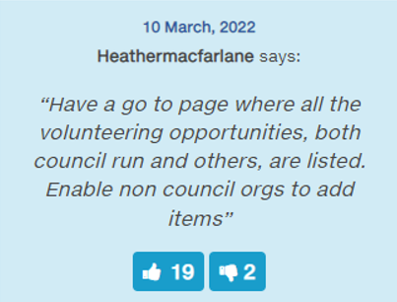
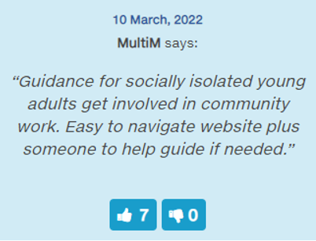

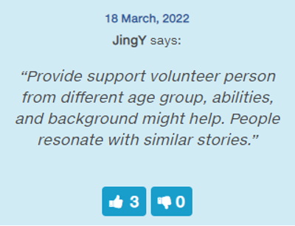
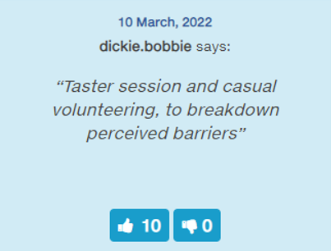

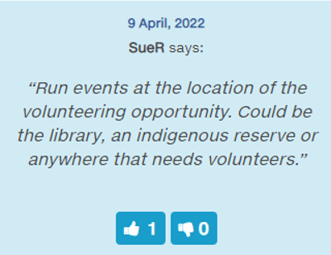

Project Evaluation

The most popular engagement activity was the online survey via Have Your Say. There was a broad age range of participants who provided their feedback however, a high proportion were female. The feedback highlighted the importance of promoting volunteering and the variety of opportunities available was crucial for recruitment. A dedicated webpage that offered up-to-date information for the community will be a great way to draw awareness to roles and also demonstrate the range of opportunities available.
Including a prize incentive for the youth survey was a successful exercise in gaining a different perspective on the barriers and interests of volunteering.
The engagement activities at the libraries and Community Nursery weren’t well attended.

Appendix

Have Your Say general survey
Participants 25 years of age and older were directed to the general volunteering survey.
- Do you currently volunteer? Y/N

- If yes, what type of volunteering to you do? Select all that apply
  - Council-run volunteer program (Arts & Gallery, Library Services, Friends of Bayside etc)
  - Bayside charity/not for profit organisation including sporting clubs, educational facilities, kindergartens etc. Please specify:
  - Charity/not for profit outside of Bayside
  - Informal volunteer (assisting family or friends)
  - Other – please specify:

- If you don’t currently volunteer, why not? Select all that apply.
  - Time constraints
  - Concerns about COVID-19
  - Not sure what opportunities are available
  - Don’t like any volunteering opportunities currently available
  - Not interested in volunteering at the moment
  - Other

- Would you be interested in volunteering in the future? Y/N

- Do you agree with the following four areas of focus that have been identified to inform Council’s Volunteer Recruitment and Retention Plan?
  - Increase and support volunteerism in Bayside to grow numbers and awareness of local volunteer opportunities.
<Strongly Agree, Agree, Disagree, Strongly Disagree>
  - Create a coordinated “One Bayside” approach across Council run volunteer programs.
<Strongly Agree, Agree, Disagree, Strongly Disagree>
  - Drive opportunities that increase youth volunteering.
<Strongly Agree, Agree, Disagree, Strongly Disagree>
  - Strengthen the connection between Council and Volunteer Involving Organisations.
<Strongly Agree, Agree, Disagree, Strongly Disagree>

- Would you like anything else to be included in the Volunteer Recruitment and Retention Plan?

- How do you think Bayside can engage and support younger volunteers?

- What is your age group:
  - 10 – 17
  - 18 - 24
  - 25 – 34
  - 35 – 49
  - 50 – 59
  - 60 – 69
  - 70 – 84
  - 85+
  - Prefer not to say
Did you have the information you needed to provide your feedback?

Have your Say youth survey
Participants aged between 10 – 25 were directed to a specific survey or could answer the same key questions via the general volunteer survey.
- Do you currently volunteer? Y/N

- What type of volunteering to you do? Select all that apply
  - Bayside charity/not for profit organisation including sporting clubs, educational facilities, kindergartens etc. Please specify:
  - Council-run volunteer program (Arts & Gallery, Library Services, Friends of Bayside etc)
  - Charity/not for profit outside of Bayside
  - Informal volunteer (assisting family or friends)
  - Other – please specify:

- Is there any reason you don’t currently volunteer? Select all that apply.
  - Don’t have the time
  - COVID-19 concerns
  - Not sure what opportunities are available
  - Don’t like any volunteering opportunities currently available
  - Not interested in volunteering at the moment
  - Other – please specify?

- Would you be interested in volunteering with Bayside Council in the future? Y/N

- What type of volunteering would interest you?

- What do you think are the biggest barriers for youth volunteering?
- How could Bayside Council better engage and support younger volunteers?

- Are you currently a student? Y/N
- What is your age group?
  - 10 – 14
  - 15 - 17
  - 18 – 24
  - Prefer not to say

- Would you also like to receive updates about this project? Yes / No

