Bayside Road Management Plan 2021
Community Engagement Summary

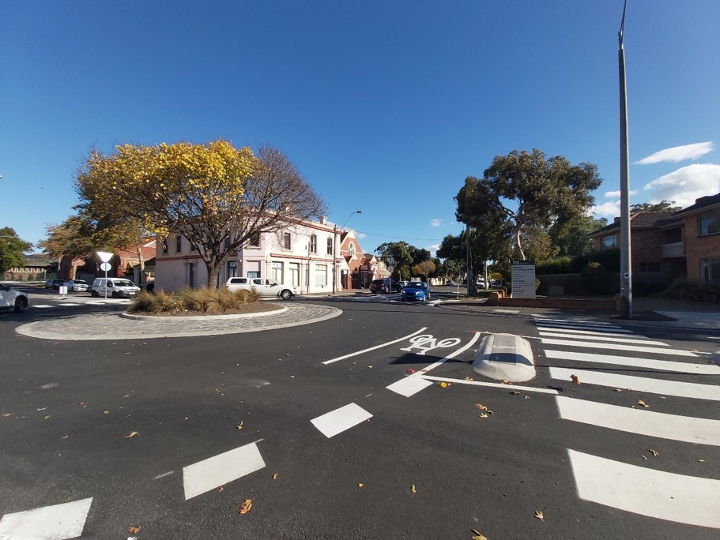

4 June 2021

Bayside City Council
Corporate Centre
76 Royal Avenue
SANDRINGHAM VIC 3191
T (03) 9899 4444
F (03) 9598 4474
www.bayside.vic.gov.au

Background
This document provides a summary of stakeholder and community feedback on the draft Bayside Road Management Plan.
Under Section 54 of the Road Management Act 2004, Council is required to prepare a Road Management Plan and periodically review that plan. The Plan sets standards as to how public roads are maintained including how defects are identified, how it shall be repaired, and how much time Council has to repair it once identified. The plan focuses primarily on roads but also includes kerbs, footpaths, laneways, bridges, and carparks. The Road Management Plan is reviewed every four years and applies to all road assets in Bayside.
As part of this review, the Bayside community was invited to provide comment, suggestion, or criticism of the document and how effective the service standards are. Council’s engagement portal Have Your Say (including a copy of the draft Plan) was made available to all interested parties of Bayside between 6 May and 2 June 2021.

Next steps
It is expected that Council will consider the results of the community engagement program and draft Road Management Plan with a view to adopting the final plan at the Council Meeting on 15 June, 2021.

Consultation process

Consultation purpose
Significant changes were made to the structure of the previous Road Management Plan, triggering a requirement for community engagement, as specified under s54 of the Road Management Act 2004.
The purpose of the consultation was to provide an opportunity for the community to comment and provide feedback on the draft Road Management Plan, including how effective the previous version was. This feedback will be collated in this report and be presented to Council as part of their consideration and deliberation before adopting the final Road Management Plan.

Timeline and phases for the Road Management Plan review:
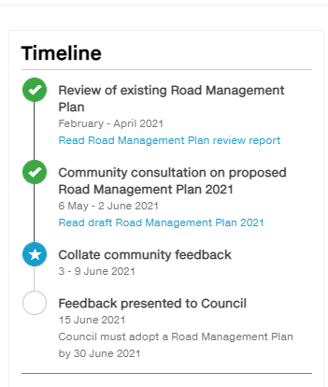

Consultation methodology
The engagement process was open to all members of the Bayside community, including individuals or groups who live, work, play, study, visit, invest in or pass through the municipality.
The engagement plan considered the project’s complexity, the level of change/impact, and reputational risks. This project was assessed as ‘Consult’ level of engagement on Bayside’s application of the IAP2 Public Participation Spectrum.
The tools and techniques selected for this project were informed by the project content, stakeholders and type of feedback sought. Consultation was open for a four-week period.
The following engagement activities were undertaken:
- project information and feedback survey through Have Your Say, including opportunity to ask questions
- public submissions were invited to be delivered in person, in writing or via email.

The following table provides detail of each activity undertaken within the community engagement period:
Engagement activities and participation
Details | Activity
5 May – 2 June 2021  Post, in person and email  No submissions received | Public submissions  Submissions were invited from the Bayside community and any other interested parties. The submission process was advertised in the Government Gazette, The Age and via all Council communication channels (website, E-newsletter, social media and Have Your Say platform).
5 May – 2 June  Link from Council’s website  13 responses from 12 respondents | Have Your Say platform – survey  A survey was promoted on Council’s Have Your Say platform, asking people to comment on the draft Road Management Plan. Respondents were also asked how easy or difficult they found the information to find and understand.  The opportunity to contribute was promoted via all Council communication channels (website, E-newsletter, social media and Have Your Say platform). Paid advertisements we used to boost the reach of the Facebook posts.
5 May – 2 June  Link from Council’s website  Six questions were received | Have Your Say platform – question and answer forum  A question and answer forum was promoted on Council’s Have Your Say platform, giving people the opportunity to ask questions on the draft Road Management Plan. These questions were answered promptly by Council’s Senior Asset Engineer. As expected, a lot of questions were related to maintenance, traffic and transport and were referred to the relevant department. Respondents could also vote via a thumbs up or down emoji providing a simple way for others to interact and support others’ questions.  The opportunity to contribute was promoted via all Council communication channels (website, E-newsletter, social media and Have Your Say platform). Paid advertisements we used to boost the reach of the Facebook posts.
5 May – 2 June  Link from Council’s website  7 subscribers | Have Your Say platform – subscribe to the project  A feature on the Have Your Say platform allows interested people to ‘subscribe’ to the page and be kept updated on the project. Subscribing to a project indicates a high level of interest in the draft Road Management Plan.  The opportunity to subscribe was promoted via all Council communication channels (website, E-newsletter, social media and Have Your Say platform). Paid advertisements we used to boost the reach of the Facebook posts.

The Have Your Say platform is Council’s main avenue for consulting with the community and was the most effective tool on this project. Here is a summary of the performance of the Have Your Say page:
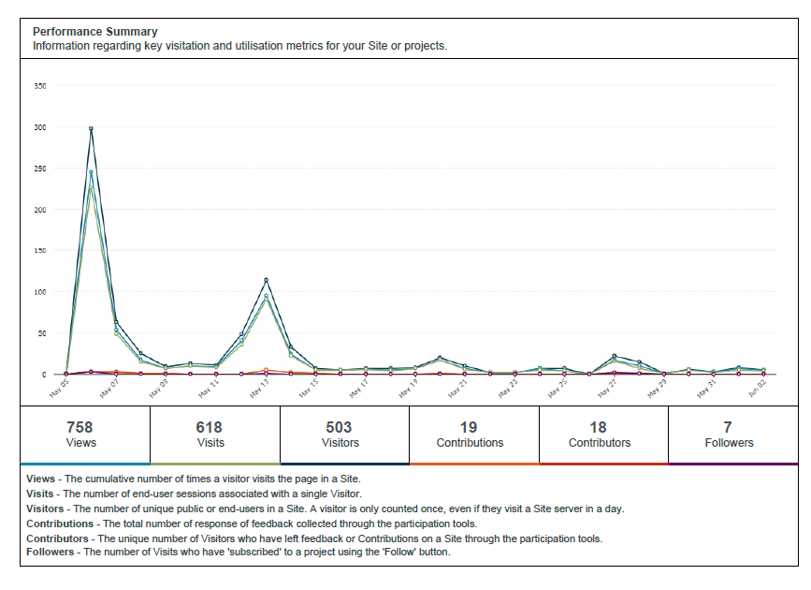
Communications tools and reach
The community and stakeholder engagement process aimed to raise awareness of the draft Road Management Plan and the proposed changes.
It is estimated that communications reached more than 3705 individuals through channels, including:
- social media (organic posts only)
- Council's e-newsletter This Week in Bayside
- a single interested party was emailed individually, referring them to the ‘Have Your Say’ page

Reach | Tool
10 May  322 page views  4% engagement | Social media (organic Facebook post)  A post was featured on Council’s Facebook page promoting the consultation.
13 May  3297 people opened the newsletter  199 people clicked on the article | E-newsletter – This Week in Bayside  Council sends an e-newsletter each Thursday afternoon to over 8000 subscribers. This is an effective way to promote our consultations.

Participant profile
A total of 18 people took part in the online engagement: 12 via the online survey and a further six people submitted questions. This included one respondent who made two submissions for a total of 19 submissions.
The only participant profile data that was recorded in survey responses and shown in the table below was suburb.

Further representative participation was not considered to be relevant or achievable for this consultation due to the historic low level of participation in Road Management Plan consultations and no requirement to provide personal information other than suburb or to register to provide feedback.

 | Demographic | Bayside  2016 Census | Participants (%)
Suburb | Beaumaris | 13.5% | 0
 | Black Rock | 6.5% | 0
 | Brighton | 24.1% | 25.0%
 | Brighton East | 15.9% | 8.3%
 | Cheltenham | 3.7% | 8.3%
 | Hampton/Hampton East | 18.6% | 33.3%
 | Highett | 7.2% | 8.3%
 | Sandringham | 10.5% | 16.7%
 | Outside Bayside | - | 0

Consultation findings

Support for actions
There was relatively little overall interest in the Plan itself, with only 13 submissions and 6 questions received. Most submissions and questions received referred to local maintenance or traffic management issues, which were not within scope of the document.
Some responses considered Council’s overall delivery of road maintenance which were considered more relevant.

Item-specific feedback
The responses received generally referred to one of two broad issues: local maintenance, local traffic management.
The balance of responses generally concerned other issues such as enforcement of local laws, issues for other authorities such as the Department of Transport, and adherence to standards for work carried out by Council and its contractors. Some responses considered the content of the Plan, the success of the previous plan, and other inter-related documents such as the Register of Public Roads.

Local Maintenance Issues
Local maintenance issues were those submissions which referred to individual defects in a particular location, or an overall opinion upon delivery of a particular maintenance task.
A link was provided on the ‘Have Your Say’ page so that most maintenance issues could be directed immedicably to Council’s customer request management system. This likely decreased the total number of submissions but ensured that these requests were actioned more quickly.
A range of specific concerns were raised during the consultation regarding this item:
Topic | Community feedback
Work standard | Two respondents complained that Council contractors did not attend defects quickly enough, or finish works to an appropriate standard.
Maintenance management | One respondent complained that maintenance issues sometimes take extended periods of time to rectify, and that Council and other authorities often could not agree whose responsibility it was
Repetitive maintenance | One respondent relayed that Council will repeatedly fix the same pothole, and that consideration should be given to a more permanent fix
Nuisance drainage | Two local drainage issues were reported. These were noted by the Assets team for future monitoring
Maintenance issues were generally referred to Council’s Maintenance Services team, or to the customer request management system.

Local Traffic Management Issues
Local traffic management issues included requests for new/modified traffic management assets such as traffic signals, a new pedestrian crossing, and queries about parking.
A range of specific concerns were raised during the consultation regarding this item:
Topic | Community feedback
Local laws | One respondent sought better controls for parking towed vehicles on public roads
Parking | One respondent sought additional parking in activity centres, including trader parking and new multi-deck parking structures
Traffic management standards | Several respondents voiced dissatisfaction with traffic standards, such as excessive provision of signs, request for additional line-marking, and traffic light cycle times
Traffic issues were generally referred to Council’s Traffic Management team.

Other
Council also received a range of other issues related to the content of the Plan, how Council carries out replacement and maintenance of its assets, and issues for other authorities:
Topic | Community feedback
Road register | One respondent noted Council’s road register was out of date
Council renewal programs | Two respondents considered the appropriateness of Council’s renewal program; why some roads were resealed while others were not. This was noted as a waste of rates
Issues for other authorities | Two respondents reported specific issues which are the responsibility of other authorities, specifically the Department of Transport
Improvements to Draft Plan | One respondent noted a limitation on the methods people could use to report defects. Another suggested adding details around responsibility for vehicle crossovers. Both were considered relevant and the draft plan was amended
Other issues were generally referred to Council’s Assets and Investigation team.

Project Evaluation
The draft Bayside Road Management Plan did not attract significant comment from the community. Most respondents had very specific concerns often relating to specific maintenance, local laws, traffic management, and issues for other authorities. Historically, this has been the case with this particular topic.
Under the Road Management Act 2004, community engagement is only required when specific changes are made to the Road Management Plan. While Council is required to review this document every four years, it is considered that community engagement may not be critical to that review, provided that no further changes are made.
The engagement techniques seem to correspond well to increases in the number of responses received from the local community. It was considered that engagement processes were effective but the interest in the subject was low.
The target participation on the Have Your Say platform for each of the objectives set in the Community and stakeholder engagement plan were exceeded:

Stakeholder reach | Target | Achieved
Visitors to Have Your Say page | 250 | 503
Expected conversions  - Attention  - Action  - Feedback | 10%  5%  1% | 33.5%  12.5%  2.8%
Expected activity participants | 10 | 19

An additional question was asked in the survey to gauge stakeholder satisfaction with the process and the information provided. The question asked was:
“How easy was the information to find/understand?”
The success measure for this objective was that 75% of respondents found the information easy to understand.
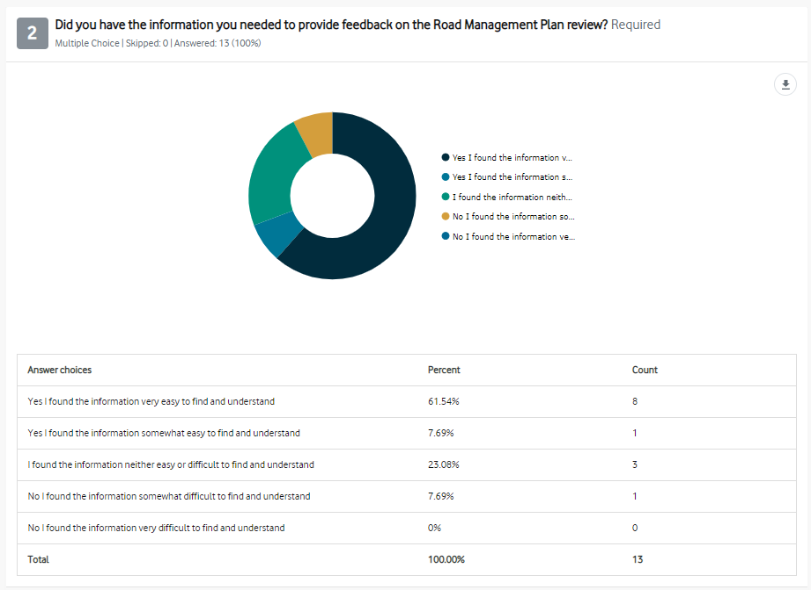
This was not achieved. The result was 69.23% found the information either very easy or easy to understand. Although this is quite a good result for the quite difficult subject matter of the Road Management Plan, we will take this on board as a learning for the next consultation on this topic. It is also understood that this was a relatively small sample size.

Appendix 1: Questions
No heading
When will crossings be provided at the New Street Bent Street roundabout. High pedestrian traffic, to school, to park many young people. many near mi
Scooter accessibility Dendy /New street railway crossing?
I live in Huntingfield Road Brighton. I bought a new scooter with the plan of being able to get to the beach from my street. To do this safely (as possible) I have to cross Dendy Street, at the St Joan of Arc school crossing then negotiate the most dangerous roundabout and cross the railway line. The passage over the railway line is very narrow and I feel quite intimidated by the traffic, cars come around the corner - New Street and Dendy Streets quite quickly.
Ensuring that contractors and subcontactors leave roads how they found them.
What is councils process to ensure that when works requiring local roads to be dug up, that the rectification works are safe and of the same quality of the original road. It is becoming a cycling and driving hazard with shoddy or shortcut rectification works multiplying rapidly.
Pedestrian crossing consideration
A pedestrian crossing is desperately required in Bay Road, Cheltenham near the Aldi’s store. It is dangerous for any elderly or other pedestrians as traffic is constant. There is nothing between Sandy Hill Medical and Reserve Road lights.
Traffic light vehicle priority
Council controlled traffic and pedestrian lights in Bayside favour motorists with pedestrians coming last in the thinking. When will Bayside adopt the more intelligent approach of other councils of providing pedestrians reasonable crossing priority to help encourage non-vehicle movement in shopping strips and near infrastructure sites like libraries. We hear council declaring dedication to pedestrians and other movement options. Now we need to see it in practice.
Kerbside parking
What decisions have been made for removing caravans and trailers being stored on roads outside properties? Too often these obstruct traffic flow and impede a clear view of oncoming cars where the road has a slight curve

Appendix 2: Submissions

There should be a link in the summary to amendments made (such as an updated list of Council’s roads, footpaths, bridges and laneways and how they are maintained. I did not see a section pertaining to safety measures within the road safety plan specific to traffic islands and pedestrian crossings. I have recently experienced the "blame game"between Vic roads and council regarding a suggestion of a traffic island at Small Street Hampton. Council say not their problem, Vic Roads say it is not a "black zone"....... it concerns me greatly the number of near misses here and the death of an elderly lady a couple of years ago........ shifting responsibility does not fix the problem and this needs to be addressed asap.
I also question the interpretation/ inference that the community feedback shows there are no problems with maintenance management and customer reporting- for example a raised dangerous section of of footpath in our street, that has caused elderly persons to fall, has been reported via phone and website OVER 6 MONTHS AGO- still not repaired.
Have you considered having a clause that allows for open communication regarding progress of repairs where the ownership is questionable- eg the paths along some of the railway are in a shocking state of disrepair. Any requests to fix fall on deaf ears from metro trains or council- the problems are never rectified and continue to represent discrimination against those less mobile/ wheelchair bound and a danger to all who brave them, particularly in the dark.
The bicycle path along the Nepean Highway from Dendy Park to Martin Street is badly in need of major work. It is downright DANGEROUS.
The tree roots and cracks in the bitumen make the path unsafe for it’s designed use.
The only safe alternative is to use the concrete footpath.
Furthermore the use of the bicycle path by Joggers and parents with perambulators further adds to the problem.
Heaven help a cyclist who collides with such a person; let alone someone on the footpath.
More attention needs to be payed to the needs of cyclists in Bayside.
Page 22 Drainage
I am still waiting to see a permanent solution to the drainage problem on Beach Rd at the junction with Grosvenor St. a 13 mm rainfall last Monday gave rise to substantial pooling of water next to the traffic lights outside the RBYC. It is hazardous, both for pedestrians wanting to cross, as well as for traffic on the inside lane going north. I have previously pointed out this problem to the council, but nothing appears to be done to provide a permanent solution. We have had 10mm or more rainfall at least 10 times so far this year.
Road management should also include clearly marked lines on both the curbs, drive ways and roads showing how close to T intersection and driveway cars can park so driver view of traffic while turning into streets or exiting driveways is clearer as this becomes dangerous if vehicles are parked to close to street and driveway exits.
1.Design consideration has to be given to the new Telstra hard plastic covers being installed, which are about 3cm higher than the surrounding footpath. They are potentially a trip hazard for elderly residents. An example is on the path adjacent to the RSL in Hardie St.
2. Street furniture by shop owners in busy shopping strips like Hampton St is being allowed to narrow the foot path too much and this is made worse by persons having a coffee moving chairs and having dogs on leads. The primary purpose of the footpath is surely for pedestrian use. This commercialisation of the footpath is not being policed sufficiently.
I am glad that BCC has upgraded their road management plan. One item that really needs addressing is the number of times a repaired pothole becomes a pothole again. I am really tired of having to notify council numerous times to report that the same pothole has not been repaired properly. What is wrong with this area of the repair team? I also note that developers often need to dig up roads to get services into their property and guess what!! Yes you guessed! It becomes a permanent fix repair, fix repair, until road users get tired of reporting. Should this be the responsibility of the developer or our rates going toward council responsibility of repairing the hole. Sorry to sound like a winger but it's very tedious filling out the complaint page. And you cannot do more things than1. Very very tedious.
3.7. page 14- Appreciate if you can add this point. If there is water pooling in the private section of the vehicle crossing, Council will not reconstruct it for the property owner.
I have a question thAt has baffled me for years. Why do councils re-seal roads that really don’t need it while leaving and do nothing to roads that desperately require works. Small st in hampton is a classic example.
Para 2.6 Car Parks : Look to creation of additional car parking for public in Sandringham by:
1) Provision of alternate car parking for traders by a) trader parking permits allowing parking in Abbott Street Beach Parking b) reducing allowed parking time in Melrose Street Car Park from 4 hrs to 2hrs c) look at changing to angle parking instead of parallel parking eg) North Side Melrose Street d) leasing of private car parks for trader use eg) All Souls Church Car Park.e) construction of multi level carpark on railway parking site.
2) Roads :a) Reduce speed on Beach Road in area of Village to 40km/h b) Make Melrose Street one way from Beach Rd and widen footpaths or alternatively close Melrose Street to traffic to create public space 3.6 Street Lighting Increasd lighting on beach tracks from carparks to Village 2.8 Signage Enhanced signage in Beach Rd to identify Sandringham Village Shopping Precinct
Section 4 - page 15 - Register of Public Roads
The Council register of Public roads is out of date (last updated on the webpage is version 1.4 December 2009) and requires an urgent update and upload.
The Register of public Roads does not have a section for ROW's of which there are 3 or 4 in Bayside and these trafficable roads for the general public also need to be added to the register as well as laneways.
Re Section 7.3 - Page 17 - Service Requests.
I am concerned that in this day and age you have specifically listed and locked in a set number of specific ways for people to advise Council of issues pertaining to defects. This list has left out lodging apps such as Snap Send Solve that Bayside Council have already began to use and which should be included in this list of ways to lodge an issue, but also other methods such as the Neat Streets app that also sends reports to Council which are being used. In my mind, the important issue is to actually GET the information to Council, and locking out other methods not listed will actually minimise the number of people who will in fact report an issue, especially if they consider it minor which it may well not be. Can I suggest that you include the use of reporting Apps such as described (especially if Council is already currently using and accepting reports from those apps), but maybe better to simply add a line similar to "{or any other method that can supply Council with the necessary information to locate and evaluate the issue being reported."
if road management means 20 signs at each round about. No i dont agree waste of Council and our rate Money.
Fixing foot paths then ripping up and doing again. No i dont agree waste of Council and our rate money
some footpath do need attention, but do it properly once, your contractor should not be slap stick Your contractor MUST do a good job once and council inspector should come and inspect.
highett grove has poor drainage and pooling of water at the bottom where it turns into graham rd.
also needs better signage for the no stand on the LHS of the rd. the signs are in poor location and are not seen by most driver as the pull up a large sign at the entry of the street my help with the issue

