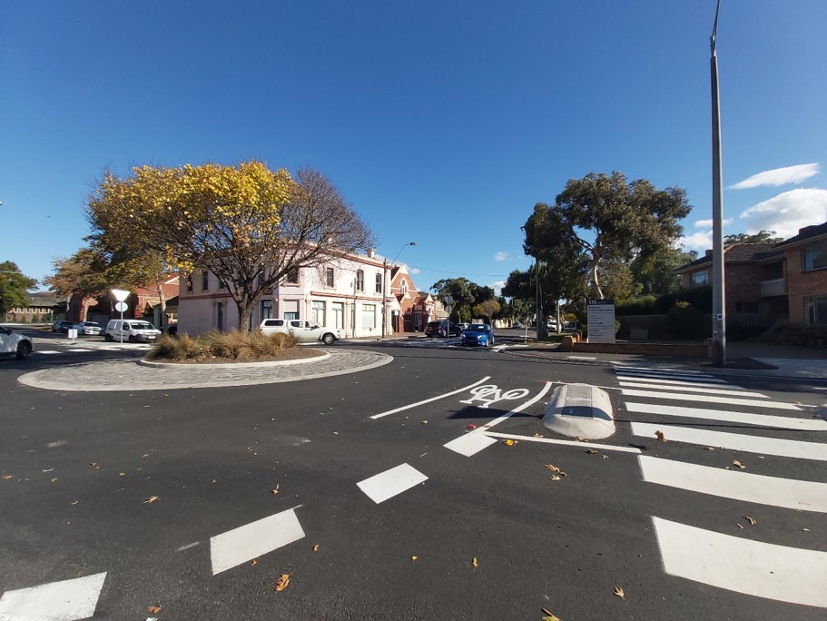

Bayside City Council
Road Management Plan
Adopted by Council on 15 June 2021

Contents
Glossary 6
1 Introduction 8
1.1 Scope and purpose 8
1.2 Road Management Act 2004 8
1.3 Availability of the plan 8
1.4 About Bayside City Council 9
1.5 Strategic context 10
1.6 Stakeholder engagement 10
1.7 Duty of care of road users 10
2 Council Road Assets 11
2.1 Inventory 11
2.2 Roads 11
2.2.1 Unsealed/Unconstructed Roads 12
2.3 Laneways 12
2.3.1 Unsealed/Unconstructed Laneways 13
2.4 Pathways 13
2.4.1 Unsealed/Unconstructed Pathways 14
2.5 Kerb and channel 14
2.5.1 Roads without kerb and channel 14
2.6 Car parks 14
2.6.1 Unsealed/Unconstructed car parks 14
2.7 Bridges 14
2.8 Signage 14
3 Non-Council road assets 15
3.1 Declared arterial roads 15
3.1.1 Car parking bays on arterial roads 15
3.2 Shared roads 15
3.3 Bridges and major culverts 16
3.4 Public transport 16
3.5 Utility infrastructure 16
3.6 Street furniture 16
3.7 Vehicle crossings 16
3.8 Street lighting 16
4 Register of Public Roads 17
5 Levels of service 17
6 Funding 17
6.1 Budget process 18
7 Road management system 18
7.1 Responsibility 18
7.2 Maintenance management system 19
7.3 Service requests 19
7.3.1 Response times 19
7.3.2 Emergency response 20
7.4 Asset management systems 20
7.5 Condition rating 20
7.6 Community survey 20
7.7 Exceptional circumstances 21
8 References 21
9 Appendices 21
Appendix 1 – Asset intervention level and response times 22
Appendix 2 – Asset inspection frequency 23
Appendix 3 – Road condition rating frequency 23

Glossary
The following terms may have particular meaning in this Road Management Plan and may accompany or clarify those definitions in the Road Management Act 2004.
Bridge | A road or pedestrian bridge, including all structural components
Condition Assessment | An assessment carried out on an asset to determine its overall physical condition.
Coordinating Road Authority | Road authority which coordinates road management functions for a specific road, as defined in s36 of the RMA
Council | means Bayside City Council
Day | means 8:30am to 5:00pm Monday to Friday, excluding public holidays
Defect | A defect is a localised imperfection within an asset that could potentially lead to the premature failure of the asset if not repaired
Intervention Level | The level at which a defect requires remedial action as set out in the Road Management Plan
Major Culvert | Culvert or culverts with a total span of greater than 6m
Pathway | A pathway is a footpath, bike path, or shared path developed by a road authority and located in the road reserve
Proactive Inspection | A proactive inspection is an inspection carried out by Council’s contractors at the frequency defined in Appendix B of this RMP
Public Road | A road that the Council decides is ‘reasonably required for general public use’ and is then registered on the Register of Public Roads.
Reactive Inspection | A reactive inspection is an inspection carried out in response to a report by a member of the public, Council officer, or other external notification.
Remedial Action | An action to reinstate a road or footpath to a below intervention level standard.
Responsible Road Authority | Road authority which has responsibility for some road management functions for a specific road, as defined in s37 of the RMA
Road | Any land declared a road under Section 11 of RMA or forming part of public highway or ancillary area.
Road Reserve | The land located between property boundaries, including all roads (as described above) and the adjacent roadside area.
Roadside | Any land that is within the boundaries of a road (other than the shoulders of the road) which is not a roadway or a pathway and includes the land on which any vehicle crossing or pathway which connects from a roadway or pathway on a road to other land has been constructed.
Service Request | A service request is a defect or issue report by a member of the community for Council to reactively inspect
Shared path | A pathway that is primarily used by both pedestrians and riders of bicycles.
Temporary response | An interim measure to isolate a defect that exceeds intervention level whilst awaiting Remedial action.
Vehicle Crossing | Part of private driveway which is located within the road reserve on public land.

Introduction

Scope and purpose
The purpose of this Road Management Plan (RMP) as defined by Section 50 of the Road Management Act 2004 is to:
- establish a management system for the road management functions of a road authority which is based on policy and operational objectives and available resources; and
- set the relevant standard in relation to the discharge of duties in the performance of those road management functions.
In simple terms, this means that certain aspects should be incorporated in any plan:
- clarification of those roads for which Bayside City Council, as a road authority, is responsible
- specification of appropriate levels of service to be delivered for those roads
- an outline of the management system for council’s road management functions, based on policy and operational objectives as well as available resources
- schedules of maintenance standards and processes used by Council in the management of its public roads network.
Under regulation eight of the Road Management (General) Regulations 2016, each incoming municipal council must review its Road Management Plan (RMP) within six months of a general election or 30 June of the following year, whichever is later. This Plan was formally adopted at the Council meeting on 15 June 2021.

Road Management Act 2004
The Road Management Act 2004 (RMA) is the principle road management legislation in Victoria. The purpose of the Act is to establish principles relating to the management of roads by authorities. The Act identifies Council as a ‘road authority’, and requires Council to establish appropriate road management practices which includes:
- establishing appropriate and affordable condition standards
- identifying and assess needs and set priorities; and
- allocating public money to meet those needs and priorities.
These standards and targets are to be included in a ‘Road Management Plan’ and the plan may be used as evidence of the reasonableness of the road authority’s position.

Availability of the plan
In accordance with Reg 13(2) of the Road Management (General) Regulations 2016, the Bayside Road Management Plan 2021 can be accessed at www.bayside.vic.gov.au/haveyoursay or may be provided by contacting Bayside City Council at enquiries@bayside.vic.gov.au or by calling 9599 4444.

About Bayside City Council
Bayside City Council was created on 15 December 1994. It comprises the former Cities of Brighton and Sandringham and parts of the former Cities of Mordialloc and Moorabbin and covers an area of approximately 37km². The coastline of Port Phillip Bay forms the western boundary of Bayside, while the Nepean Highway and the Melbourne to Frankston railway line form most of the eastern boundary.
Bayside is a primarily residential area, with several light commercial activity centres a small light industrial area. In 2021, the estimated resident population of Bayside was 107,566.
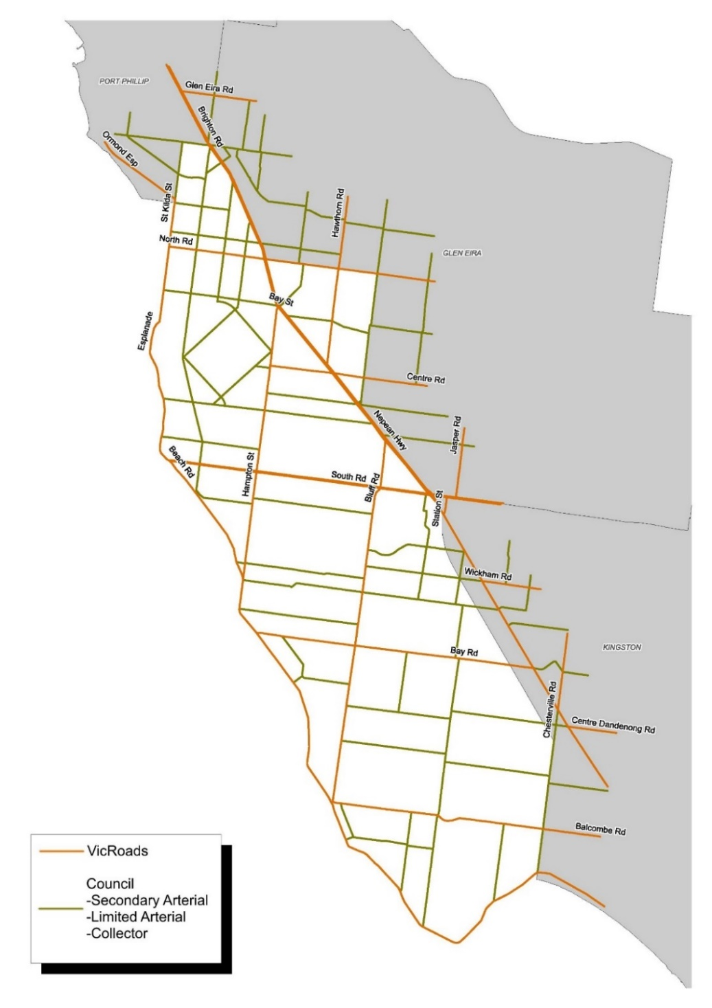
Figure 1. Bayside City Council road network (local and minor roads not shown)

Strategic context
The Road Management Plan sits in the context of a range of strategic council documents.
Strategic Resource Plan

Feedback
Council Budget

Council Plan

Road Management Act 2004

Asset Management Policy
Road Management Plan

Defect & Safety Inspections
Resident reports, requests & complaints
Road Asset Management Plan

Guidance
Figure 2. RMP in the context Strategic Council Documents

The Council adopts a Council Plan and Strategic Resource Plan for its four-year term, and a more detailed 10-year Long Term Financial Plan and Annual Budget each financial year. The Road Asset Management Plan informs the LTFP and forecasted budget required to manage the road network based upon asset quantity.
The Road Management Plan is interrelated with each of these documents. It provides information on Council’s Asset Management Policy Framework and the linkages to key corporate strategies, plans and system.

Stakeholder engagement
The review process involves aligning the plan with industry best practice and has been made available for review by a range of stakeholders. The following broad stakeholder groups have been identified:
- all residents and businesses adjacent to the road network
- motor vehicle users, cyclists, and pedestrians
- utility and non-Council service providers
- internal Council service-delivery teams .
This plan was made available for community consultation for prior to adoption to ensure that the needs and expectations of the Bayside community are taken into consideration.

Duty of care of road users
All road users have a duty of care as mentioned under Section 106 of the Road Management Act 2004 and Section 17A of the Road Safety Act 1986. This duty of care covers various aspects, including the appropriate condition and certification of vehicle and driver, observation of signage and other instruction, and the safe operation of the vehicle with respect to traffic, visibility, weather, and other road conditions.

Council Road Assets

Inventory
Infrastructure managed by Bayside which supports execution of its road management functions includes the road, footpaths, kerb and channel, traffic management devices (roundabouts, speed humps etc), bridges, street furniture, street signage, and carparks.
The road assets and their quantities which managed by Bayside City Council are summarised in Table 1 below.
Asset Group | Asset Types | Qty | Unit
Road | Asphalt | 356 | km
Road | Unsealed/unconstructed | 1 | km
Laneway | Concrete | 10 | km
Laneway | Asphalt | 3 | km
Laneway | Bluestone | 0.3 | km
Laneway | Unsealed/unconstructed | 6 | km
Pathway | Concrete | 566 | km
Pathway | Asphalt | 172 | km
Kerb and Channel | Concrete | 560 | km
Kerb and Channel | Bluestone | 113 | km
Bridge | Road | 3 | No.
Bridge | Pedestrian | 2 | No.
Traffic Mgmt. | Roundabout, speed hump, splitter/median etc | 434 | No.
Traffic Signals | Intersection, flashing lights, pedestrian crossing | 22 | No.
Signage | Identification, directional, informational, regulatory | 22,158 | No.
Sign Supports | Poles etc | 17,522 | No.
Carparks | Off-street | 118 | No.
Table 1. Road asset summary

Roads
A hierarchy of road classifications has been adopted by Bayside to help define the typical levels of service that can be expected to apply to each category of road. The Hierarchy can be considered as a balance between a roads ‘traffic’ and ‘access’ functions. For example, the Nepean Highway services significant traffic volumes but provides very little direct property access, whereas a small residential cul-de-sac is exclusively used for property access.
Bayside is responsible for all non-arterial road pavements and surfaces, including line marking associated with road management functions (including bus stop bays).

The function of each road hierarchy category and its ‘coordinating road authority’ is described in Table 2 below.
Type | Length (km) | Coordinating Road Authority | Function
Arterial Road | 54 | Department of Transport/VicRoads | Major metropolitan highways
Sub-Arterial | 33 | Bayside City Council | Sub-arterial roads supplement the Arterial Road network, and link key arterial roads. Higher traffic volumes, but which have largely stabilised
Collector | 45 | Bayside City Council | Major access roads. Typically link sub-arterial roads with key
Local Road | 276 | Bayside City Council | Property access roads which provide direct access to abutting land but may also service light through-traffic. Most roads in Bayside are local roads.
Laneway | 19 | Bayside City Council | Property access roads, which are characterised being narrowness, low speeds, and are often used by pedestrians and vehicles simultaneously. Laneways are often one-way, or share a traffic lane for bi-directional traffic
Table 2 Road Hierarchy function and summary

Unsealed/Unconstructed Roads
Most roads in Bayside have historically been sealed by Council several decades ago, and roadworks carried out by Council today are generally only renewal. There remains a small number of gravel local roads, located south of Bay Road which total 1km in length.
Council considers traffic volumes to have stabilised in these roads and is aware that the informal state of these roads is preferred by a majority of residents abutting these streets, and by the general community. Therefore, Council has no plans to upgrade these roads to asphalt.

Laneways
Laneways are a lower-order hierarchy of road, characterised by narrow width, low speed limits, low traffic volumes, and serve a primarily ‘access’ function. Laneways have varying construction methodologies and are not maintained as actively as other roads. Not all laneways are open to vehicular traffic, and often do not have dedicated roadside footpaths.
As part of this Road Management Plan review process, Council has adopted several laneways which had no previously confirmed owner, but which are considered to be ‘reasonably required for general public use’. A determination of whether a road is required for public use was conducted on a case-by-case basis including a consideration of the following:
- whether the laneway services more than three properties
- whether it forms a critical link between two local roads or other laneways
- whether it forms a critical link to a council managed facility, such as a reserve
- whether it has historically been used as a thoroughfare (i.e. public highway)
- whether it is on land owned by Council
- whether Council has historically managed or maintained the laneway.
In some cases, laneways not managed by Council may be managed by private landowners.

Unsealed/Unconstructed Laneways
There is approximately 19km of Council-maintained laneways in Bayside, 13km of which is sealed. The remaining 6km is natural surface such as grass, earth, or sand, and has in some places has been fortified with gravel.
Council has no plans to formalise these laneways, however upgrade shall be considered on a case-by-case basis where:
- traffic volumes are predicted to increase significantly as a result of new development (such as a new multi-storey apartment building)
  - This assessment is made by Council’s Traffic Management team (as per Bayside Planning Scheme clause 52.06-11) and shall generally require a developer to upgrade the laneway and contribute the asset to Council.
- traffic volumes have already increase to a point where maintenance frequency has increased and a gravel laneway is no longer cost effective
- there is significant community pressure from adjacent residents for an upgrade.

Pathways
Roadside pathways are located adjacent to roads managed by both Council and the Department of Transport, but generally managed by Council as the responsible road authority. Pathways in Bayside are generally constructed of concrete and asphalt, however higher standards of construction or different materials are often used in high profile areas.
Pathways through Council facilities or open spaces are not considered as part of this Plan, although are subject to similar treatments and maintenance regimes.
The hierarchy of pathways which support road management functions are as follows:
Category | Use
Major | Major pathways are generally located in high traffic areas adjoining Bayside’s shopping precincts, public and private high-use facilities, and shared paths.
Minor | Formalised pathways located in the road reserve in all areas not described above.
Track | Informal and non-constructed pathways located in the road reserve. Typically grass, earth, or sand, and not maintained to RMP standards
Table 3 Pathway Hierarchy

Unsealed/Unconstructed Pathways
Over the past several decades, Council has formalised most pathways in Bayside although many foot-trodden ‘tracks’ remain. Most footpath works carried out today are concern the capital renewal of existing asphalt and concrete pathways, and general maintenance of gravel paths.
New constructed pathways in the road reserve are subject to Council’s ‘Footpath Treatments within the Road Reserve’ policy, with particular emphasis on new footpaths south of Bay Road.

Kerb and channel
Bayside’s kerb and channel assets are a critical component of the drainage network, capturing and directing stormwater runoff from the road surface and property outlets into drainage pits.
The default construction material is concrete; however existing bluestone kerbs may be retained and reconstructed in areas where it has been historically dominant (as per Council’s Road Reserve Bluestone Replacement Policy).

Roads without kerb and channel
There are a small number of sealed and unsealed roads, which do not have a formal kerb and channel. Based upon historical observations, these roads can drain via infiltration or runoff being directed into existing pits or swales. Council has no plans to construct new kerb and channel assets where no specific drainage need has been identified.

Car parks
Car parks are ancillary areas, and support road management functions although are not located within the road reserve. Car park surfaces are generally asphalt and maintained to the same maintenance standards as local roads.

Unsealed/Unconstructed car parks
While most Council carparks have been sealed in the past, there are several gravel carparks largely located in Council’s parks and foreshore reserves. Council has no general strategy to upgrade these carparks, however upgrade is often considered as part of some Open Space master planning process where significant community consultation is involved.

Bridges
Council is responsible for three road bridges and two pedestrian bridges, not taking into consideration structures in reserves. They are all located over the Elster Canal in Brighton.

Signage
Bayside City Council is responsible for the provision of signage located in the road reserve which supports a traffic function.

Non-Council road assets
The principal objective of road management is to ensure that a safe and efficient network of roads is provided primarily for travel and transport. However, road reserves are commonly made available for other appropriate uses for which Council is not responsible. Roads and assets for which Council does not accept responsibility are described below.

Declared arterial roads
Whilst this Road Management Plan is primarily concerned with the roads where Council is the responsible authority, it also makes reference to roads which are the responsibility of others. These include Declared Arterial Roads and State Highways where the Department of Transport (formerly VicRoads) is the coordinating road authority. These roads cater for major traffic movements across the municipality and as such are of crucial importance to the community.
Guidance on the physical limits of operational responsibility between VicRoads and municipal councils for different parts or elements of the road reserve of a Freeway or Arterial Road is provided in the Code of Practice: Operational Responsibility for Public Roads 2017.
While DoT is the coordinating road authority for these roads, Bayside frequently takes the place of the responsible road authority where roadsides are concerned. In addition to the management of all footpaths adjacent to DoT roads, Bayside also has a formal Operational Works Maintenance Agreement with DoT where Council is reimbursed for the transfer of some maintenance responsibilities.
The Declared Arterial Roads within or abutting Bayside are listed in the Appendices of the Bayside Register of Public Roads.

Car parking bays on arterial roads
The Department of Transport is responsible for any part of the arterial roadway that could be used by through traffic. However, under the Code of Practice, Council is responsible for maintaining indented parking bays of lengths less than 200m between kerb outstands.

Shared roads
Shared roads are those that define boundaries with the City of Port Philip, City of Glen Eira and Kingston City Council. In most cases the adjoining municipalities are responsible for managing their half of the road and cooperating when major roadworks are required.
Roads which cross municipal boundaries are as follows:
- Head Street, foreshore to St Kilda Street, (City of Port Philip)
- Thomas Street, North Road to Nepean Highway, (City of Glen Eira); and
- Charman Road, foreshore to railway line, (Kingston City Council).

Bridges and major culverts
There are 20 roads, culverts, and footbridges in Bayside that are the responsibility of other authorities. These authorities include Melbourne Water, DoT, and VicTrack/MTM. Responsibility for these structures is dictated by the Road Management Act 2004 and Safety Interface Agreement.

Public transport
Infrastructure which supports public transport in Bayside is provided by the Department of Transport (including VicTrack and PTV), and their contractors. This includes all infrastructure associated with trains, trams, and buses as determined by agreement or standard with the Department.
Infrastructure includes railway tracks, tram tracks, bus shelters, signals and signage. A formal Safety Interface Agreement has been signed between Bayside, VicTrack, and DoT/VicRoads as to management of assets related to rail infrastructure at its interface points.

Utility infrastructure
Utility infrastructure within a road reserve commonly includes water supply infrastructure, sewer infrastructure, telecommunications, public lighting, electrical distribution, and gas infrastructure. The care and maintenance of these utility assets is the responsibility of the relevant utility authority whose rights and obligation are contained in specific legislation relating to each utility.

Street furniture
Infrastructure owned by non-Council entities in the road reserve include:
- Signage and signals managed by the Department of Transport;
- Private direction and advertising signs;

Vehicle crossings
Property owners are responsible for the construction, ongoing maintenance, and eventual replacement of any vehicle crossing servicing their property. The responsibility extends from the boundary line of the property to the edge of the road pavement, excluding the footpath section of the vehicle crossing.
Vehicle crossings must comply with Council’s Vehicle Crossing Policy and standard drawings.

Street lighting
Street lighting plays a primary role in road safety and amenity. Although Council funds the street lighting on its roads and shares the cost on the declared main roads, the public lighting assets are owned, inspected, and maintained by United Energy.
Council is responsible for the maintenance of non-standard lighting in some specific cases.

Register of Public Roads
Pursuant to Section 19 of the Road Management Act 2004, Council must maintain a register of roads for which it is the coordinating road authority. Details on the roads listed in the register are also stored in Council’s Asset Management System including its hierarchy, description, and the date it was added to the register.
Roads not included in the Register are generally the responsibility of the Department of Transport or are maintained by private landowners. Arrangements for transfer of road management functions between Council and another road authority are detailed in the Register of Public Roads.
A copy of this register can be accessed via the Council website.

Levels of service
The Level of Service is a measurable standard of service which Council has chosen to provide. Generally, a greater Level of Service will come at a higher cost.
The reasonableness of the adopted Service Levels is informed by:
- community satisfaction
- financial resources available
- technical levels of service based upon engineering advice
- competing demands upon Council resources.
As part of its Local Government Act 2020 commitments, Bayside City Council is intending to conduct a deliberative engagement process with the community to provide greater feedback as to appropriate service levels which better meet community expectations.
Appendix 1 of this Road Management Plan identifies the maintenance standards, intervention levels, and response times for the management of Council’s road assets.

Funding
The functions required to be exercised by Council, as a road authority, are limited by the financial and other resources that are reasonably available to Council. Funding for roads comes primarily from rates revenue and must compete against a wide range of Council services. Service Levels are critical to ensure that Council does not over-service roads and that it is capable of meeting its ongoing resource requirements.
Apart from rates, road expenditure is also regularly allocated through State and Federal grants processes. Other road funding options not currently used by Bayside City Council include Special Rates and Charges Schemes and Developer Contribution Schemes.

Budget process
Council’s annual capital and operating budgets are both developed as part of the annual budget process and based upon its 10-year Financial Plan. The 10-year Financial Plan is updated annually to reflect capital investment and asset deterioration.
Maintenance of Council’s road assets is undertaken by external maintenance contractors. Provision for monthly payments (primarily a lump sum with a small amount payable under Schedule of Rates arrangements for any minor discretionary works outside lump sum maintenance works) is made in the annual budget. Included in the annual operational budget is an allowance for growth to reflect additional assets being added to the contracts through subdivision and capital projects, and an allowance for rise and fall of costs for key materials and labour.
Annual defect inspections and periodic condition assessments are performed regularly to ensure that road assets are being adequately maintained and to avoid. Defect inspection and condition assessment frequencies are as specified in Appendix 2 and 3.

Road management system
Bayside has established a road management system to enable it to perform its road management functions. This system is managed by the Assets and Investigation team and overseen by the Maintenance Services team.

Responsibility
The primary organisational responsibilities for the management of road assets lie within the Environment, Recreation & Infrastructure Division of Council, including:
- management of periodic inspections and proactive maintenance programs
- management of service requests and reactive maintenance programs
- management of capital works delivery of road related assets
- management of maintenance contractors
- maintenance of the central Asset Register, Pavement Management System, and spatial asset datasets
- asset planning, predictive modelling, financial renewal planning etc.
Council’s maintenance contractor is Citywide, who handle most aspects of civil maintenance with Council’s Maintenance Services team providing contract management and oversight. Duties carried out by Citywide include maintenance of road assets (including drains, roads, pathways, and kerbs), inspection of road assets, street sweeping and cleaning, customer service, and end-to-end management of service requests.

Maintenance management system
Council has developed an integrated management approach for inspection, maintenance and repair of road infrastructure as shown diagrammatically below.
Identification by inspection or report by public/users
Intervention level as per the RMP Appendices

Intervention action as per the RMP Appendices

Target times for intervention action as per the RMP Appendices

Figure 4. Integrated maintenance management
Most defects or issues are identified during inspections by Citywide and organised into proactive maintenance programs. Inspections are carried out periodically so new defects are identified as quickly as possible, and inspectors are familiar with maintenance standards to determine whether intervention is required. The inspection frequency is as stated in Appendix A.
Issues which have developed between inspections may be reported by members of the community as ‘service requests’ and organised into reactive works programs. Reactive jobs must be confirmed by Council officers or maintenance contractors and rectified within the response times specified in this Road Management Plan.

Service requests
A service request occurs when a defect or issue is reported by a member of the community, and not as a result of a programmed inspection. There are several ways in which requests for reactive service requests are made to Council:
- directly reporting to Council staff at the Corporate Centre at 76 Royal Avenue, Sandringham
- phone call to Council call centre at 9599 4444.
- mail addressed to Bayside City Council, 76 Royal Avenue, SANDRINGHAM 3191
- using Council’s ‘Report an Issue’ webpage or by email to enquiries@bayside.vic.gov.au
- third-party online reporting tools (i.e. apps)
All initial customer requests are stored in Council’s Customer Request Management System (CRMS). Using the CRMS, reactive customer requests may be audited to ensure that requests have been closed in time and ensure compliance with Council’s Road Management Plan.

Response times
The protocols for response to service requests, specifically response times are clearly set out for the maintenance contractor. They are provided in Appendix 1.
The Contract details five intervention levels as follows:
- Level 1: Emergency response (including call outs)
- Level 2: Urgent response, Public Liability inspection, and Potential Hazard Response
- Level 3: Public Liability Incident
- Level 4: Traffic control device requests, written response to correspondence or complaint, road opening reinstatement.
- Level 5: All other requests
The response times stated in this Plan are measured from the date at which a service request is made to Council (via the means listed above) and are measured in working days.

Emergency response
The Civil and Open Space Maintenance Service Contractor maintains staff able to respond to emergency situations, regarding road and drainage infrastructure, 24 hours a day, 52 weeks per year. The Contractor must immediately on notification provide the staff, plant, signage and other materials to contain an identified emergency, undertake emergency repairs and minimise further risk. After the event the contractor records the details of the emergency on Council’s Customer Request and Management System.
An emergency response may include provision for installation of warning signs and barriers, traffic control, and a temporary reinstatement. After the site has been made safe, equipment may remain on site until such time as a permanent reinstatement may be carried out.

Asset management systems
Council has a partially integrated asset management system where all data in relation to road infrastructure is recorded. This information includes identifiers for all road infrastructure, all defects identified during proactive inspections, details of rectification works as well as asset condition captured during condition rating.
Citywide have also developed their own maintenance management system, which is intended to be integrated with Council’s own customer management and asset management systems.

Condition rating
While a maintenance inspection is carried out to identify localised defects or distresses, a road condition assessment is used to determine each asset’s current overall condition. The data collected for road surface, pathways and kerb and channel is collected and stored in Council’s Asset Management System and Pavement Management System and is used to estimate expected remaining useful life, prepare forward works programs, and develop financial reports. Road asset condition rating frequencies are stated in Appendix 3.

Community survey
The annual community surveys undertaken by the Victorian Government indicate that the community is generally satisfied with road asset maintenance, above the Metropolitan average. This indicates that the maintenance standards, intervention levels, and response times adopted by Council are considered appropriate by the community.

Exceptional circumstances
Council shall make every effort to comply with its road management functions, as identified through the Road Management Act 2004 and in this Road Management Plan.
However, there may be exceptional circumstances or situations in which the limited resources of Council are insufficient to meet its obligations, such as a natural disaster. In the case of such a scenario, the CEO of Bayside City Council may determine that the intervention levels or response times included in the RMP may be suspended under Section 83 of the Wrongs Act 1958.

References
References that may assist in the interpretation of this Plan include:
- Bayside Register of Public Roads
- Bayside Council Plan
- Bayside Asset Management Policy
- Bayside Asset Management Strategy
- Bayside Road Asset Management Plan
- Road Management Act 2004
- Road Management (General) Regulations 2016
- VicTrack Rail maintenance guidelines (2011)

Appendices
Appendix 1 – Asset Defect Intervention Level & Response Times
Appendix 2 – Asset Inspection Frequency
Appendix 3 – Road Asset Condition Assessment Frequency

Appendix 1 – Asset intervention level and response times
Intervention Level | Rectification action | Response time (working days)
 |  | Urgent / Initial response* | Standard
Roads – Constructed roads identified in the Bayside Register of Public Roads
Potholes exceeding 300mm diameter and 25 mm in depth. | Patch pothole to restore smooth riding surface. | 7 | 45
Ruts and depressions of road surface exceeding 50mm below the surrounding surface level. | Apply levelling course to restore smooth riding surface | 7 | 30
Edge break exceeding 25mm in depth and extending 150mm laterally over more than 1000mm in length. | Repair to line and level surrounding road surface. | 7 | 30
Emergency response: removal of material from traffic accidents or other debris, oil spills etc. which is a danger to pedestrian or vehicular traffic | Remove material or cover spills with suitable material. | 1 | N/A
Laneways – Constructed laneways identified in the Bayside Register of Public Roads
Potholes, Ruts, Depressions as well as other defects: Abrupt distortions of road surface exceeding 100mm below the surrounding surface level. | Patching of localised laneway surface distortions to restore a satisfactory ride condition surface in that laneway section for slow moving vehicles. | 7 | 45
Pathways – Along roads for which Bayside or DoT is the coordinating road authority (including shared / bike paths)
Potholes in footpath surface exceeding 25mm in depth. | Patch area to restore the line and level of the pathway surface. | 7 | 60
Pathway section Displacement of Depressions: Displaced pathway sections exceeding 25mm. | Restore alignment and level of pathway surface by replacement of pathway sections. | 7 | 60
Kerb & Channel – Along municipal roads
Horizontal or vertical displacement exceeding 50mm | Restore the alignment and level of the kerb or channel with replacement of defective sections | 7 | 45
Displacement which causes water to pond in the kerb for at least 3 days |  | 7 | 45
Street Signs
Signs - Damaged, illegible, or otherwise non-functional regulatory or warning signage | Make safe. Scheduled replacement of signage and or pole. | 2 | 45
Service authority assets
Service authority assets or works: For Service Authority Works Assets or works which result in defects above the intervention level on a road or pathway. | The responsible Service Authority to be notified | 2 | 60
Drains
Blocked Drains: Causing water to pond on trafficable sections of the road. | Clear blockage | 1 | 90
Drainage Pit: Missing or severely damaged pit lid or surround | Replace lid or barricade area | 1 | 45

* Urgent response primary focus shall be to make the area safe, after which the standard response time (less urgent response time elapsed) shall apply.

Appendix 2 – Asset inspection frequency

Item | Asset Type | Inspection Frequency
1 | Shopping Centre Areas – Pathways, car parks and pedestrian walkways within the designated Shopping Centre Area as identified in Appendix 4 | Once every 26 weeks
2 | Pathways – Abutting high use facilities as identified in Appendix 4 | Once every 26 weeks
3 | Pathways – Shared path along Beach Road and the Esplanade | Once every 26 weeks
4 | Roadside pathways other than those identified in item 2 and 3 | Once every 52 weeks
5 | Municipal Roads  All municipal road surfaces and kerb and channel | Once every 52 weeks
6 | Laneways | Once every 156 weeks
7 | Road related signs, bollards, , traffic signs and other street furniture | Once every 52 weeks
8 | Bridges  Structure and abutments | Once every 52 weeks

Appendix 3 – Road condition rating frequency

Item | Asset Type | Inspection Frequency
1 | Road Surface | Once every 4 years
2 | Pathway | Once every 4 years
3 | Kerb and Channel | Once every 4 years
4 | Laneways | Once every 4 years
5 | Bridges and Culverts | Once every 4 years

Road Management Act Code of Practice: Operational Responsibility for Public Roads (2017), p22.

