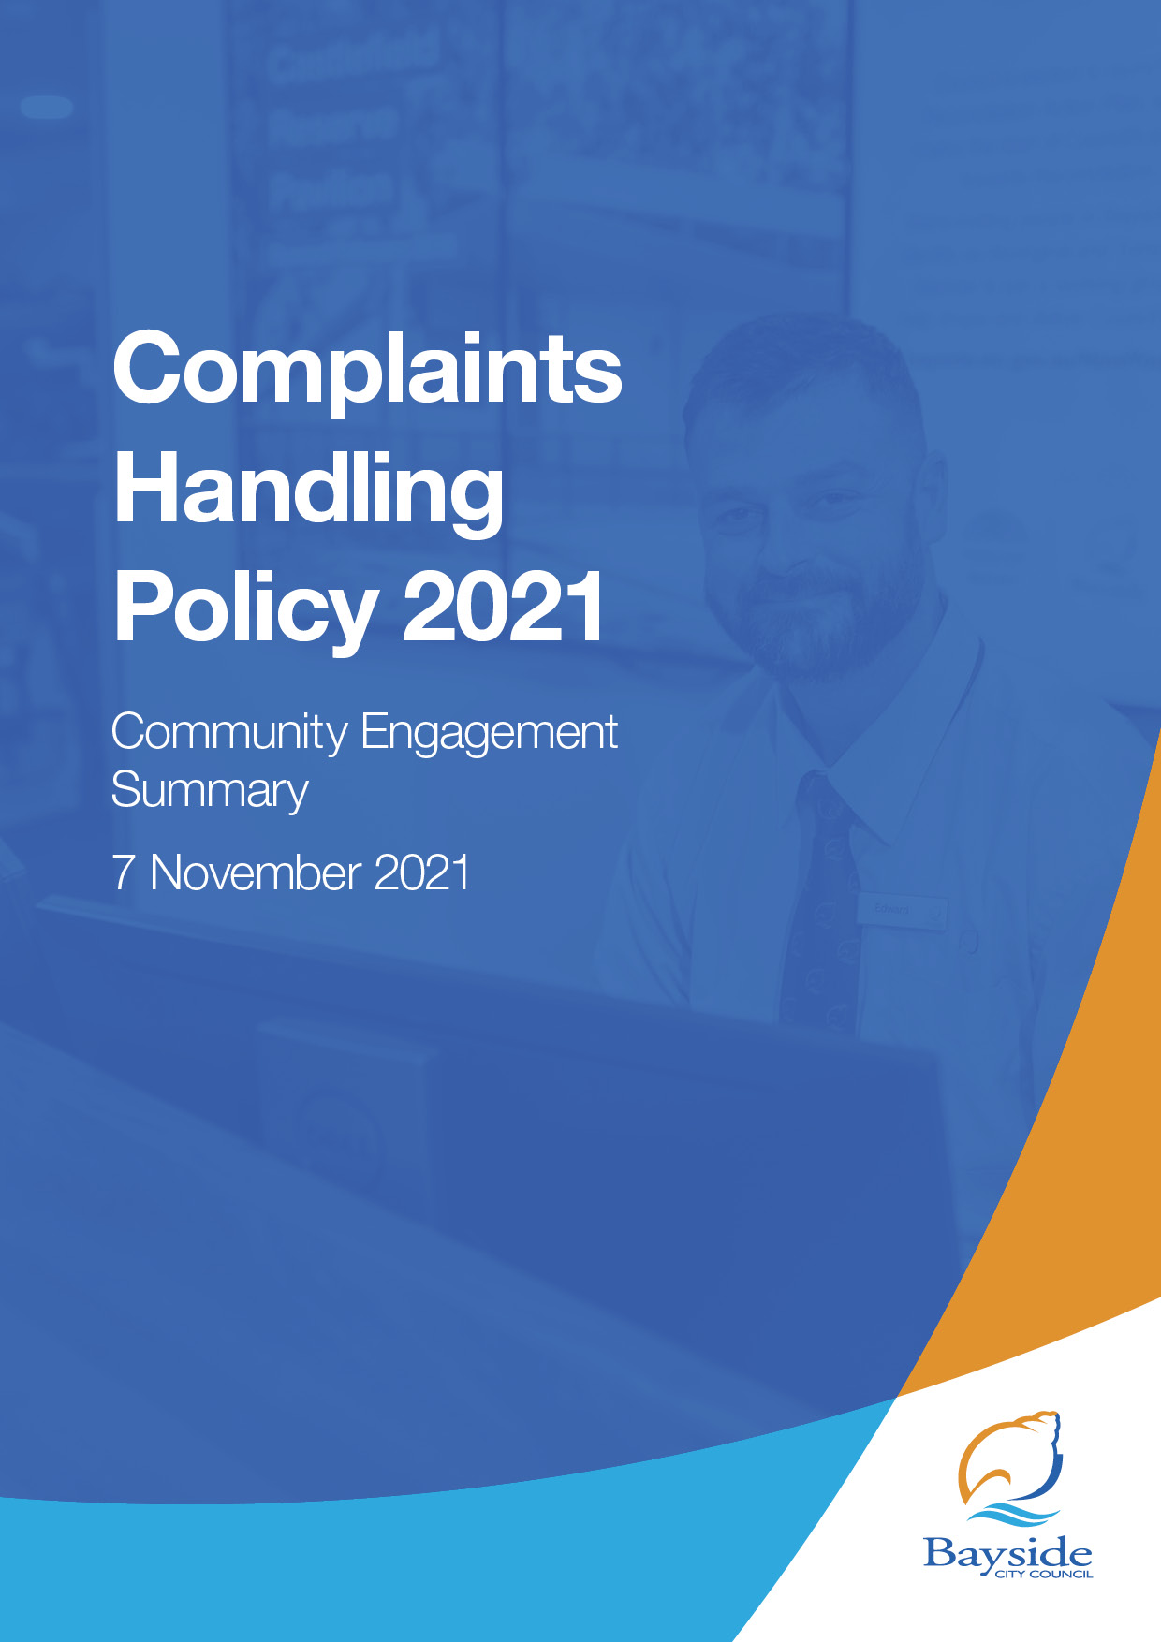

- Background
This document provides a summary of stakeholder and community feedback on the draft Complaints Handling Policy.
Bayside City Council has developed a new draft Complaints Handling Policy in accordance with the Local Government Act 2020. All Councils are required under sections 106 and 107 of the Local Government Act 2020 (the Act) to prepare, adopt and comply with their Complaint Handling policy.
The Policy outlines how Council will manage complaints and provides a framework for the escalation process. The policy demonstrates our commitment to providing a fair and consistent process for customers to make a complaint to Council. We are committed to open, transparent conversations with our community about Council policies and are seeking feedback on the draft policy for the consideration of Council.
The draft Complaints Handling Policy defines what is considered a complaint and applies a consistent, Council-wide approach to complaint handling. The Policy aligns with the Victorian Ombudsman’s Good Practice Guide and additional requirements set by the new Local Government Act 2020 (the Act). The policy aims to:
- provide an open and transparent complaint handling system
- ensure staff handle complaints fairly and objectively
- establish our timeframes for resolving complaints
- clarify the roles and responsibilities of Council staff
- set out how Council will record, respond to, and report on complaints to improve our service.
A new Complaint Handling Policy will strengthen Council’s commitment to exceptional customer experience. Learning from complaints data will enable Council to identify trends and improve the services offered to the community.
The new Complaints Handling Policy will result in amendments to our current Customer Complaint Escalation Procedure. This will be reviewed to align with the updated Complaints Handling Policy, the requirements of the Local Government Act 2020 and with consideration given to the Victoria Ombudsman Good Practice Guide.
The policy relates to the management of complaints made to Council, by any person who has been affected by an action, inaction, or decision of Council. The policy applies to all employees and extends to volunteers and contractors carrying out work on behalf of Council to the extent provided for in their contract / agreement with Council.

Overview of feedback
Participants were generally satisfied with the definition of a complaint in the draft Complaints Handling Policy with an average rating of 4 stars out of five. There was a high level of agreement (78%) that the draft Complaints Handling Policy sets out a fair and objective process and is easy to understand.
Next steps
Council will consider the results of the community engagement program and the proposed Complaints Handling Policy at its meeting on 23 November 2021.

- Consultation process

Consultation purpose
The consultation was designed to provide stakeholders and the broader community with the opportunity to provide input into the draft Complaints Handling Policy. The purpose of the engagement was to seek feedback on:
- Channels available to a customer to make a complaint
- Definition of a complaint and a service request
- Process and actions Council will take to manage and respond to Complaints
- Timeframes to respond and resolve to a complaint
- Fair methods to deal with unreasonable conduct by a complainant
The elements that the community were not able to change:
- The legislative requirement for Council to have a Complaints Policy, in accordance with Sections 106 and 107 of the Local Government Act 2020
- An outline of the types of complaints that are outside Council's responsibility and need to be managed by a separate statutory or legislative appeals process
- Procedures for complaints about specific matters that are governed by specific statutory and regulatory processes e.g., Complaints about a Councillor or Public Interest Disclosure Act complaints and the process for dealing with these matters.
- Roles and responsibilities of Council employees, managers and directors as well as the CEO and Office of the Mayor and Councillors
- Legislative requirements for Occupational Health and Safety Act 2004
- How Council will record complaints and adhere to the Privacy Act
- The requirement for and provision of accessible channels to make a complaint
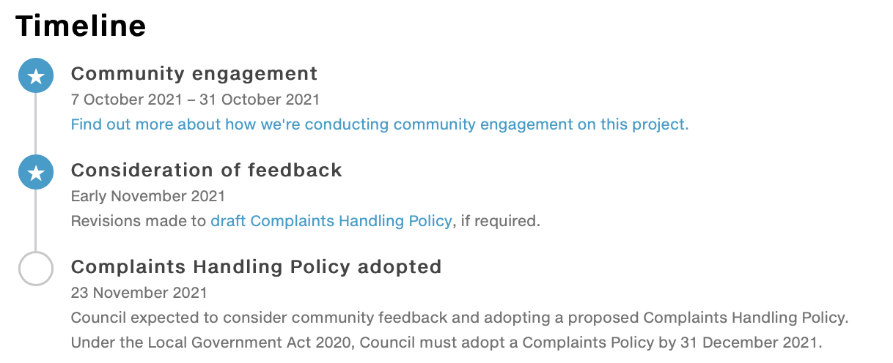

Consultation methodology
The following activities were undertaken from 7 October to 31 October 2021:
Table 1: Engagement activities, timeframes and outcomes
Timeframe | Activity and Outcomes
7– 31 October 2021  231 visitors  10 contributions | Have Your Say website  Project information and online survey hosted on the engagement platform Have Your Say, including opportunities to ask questions and provide feedback

Table 2: Communications activities
Timeframe | Activity and Outcomes
7 Oct – 31 July 2021 | Communications for this project directly reached more than 11,000 community members:  - Email notification to Have Your Say members (2,548 recipients)  - Council website news item (2) and e-newsletter, This Week in Bayside (4) (8,590 recipients)  - Council social media channels (1 post, 6 likes, 15 comments)  - Let’s Talk Bayside magazine (41,000 households)

Figure 1: A summary of engagement via the Have Your Say platform
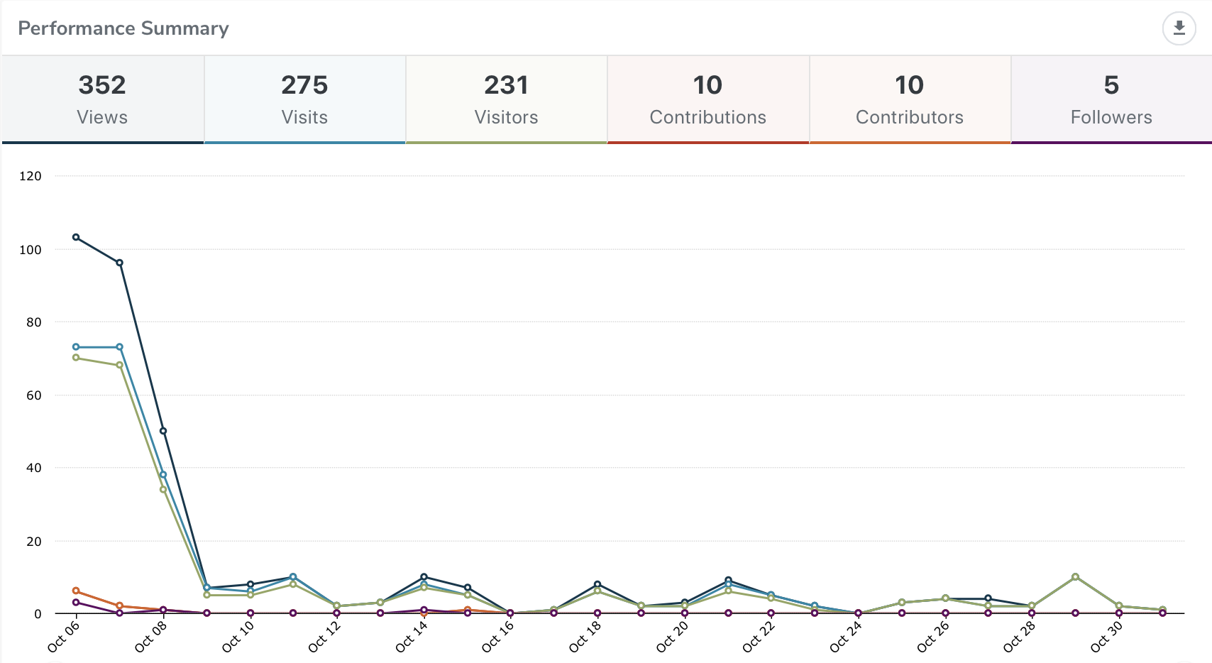

- Participant profile
A total of 10 participants provided feedback that directly addressed the project questions via the online survey on the Have Your Say project page. See Table 3 for demographic profile.
All respondents identified themselves as residents of Bayside City Council. Representative participation was not considered relevant to this engagement process.
Table 3: Selected participant personal characteristics, comparison with 2016 ABS Census
 | Demographic | Bayside  2016 Census | Participants (%)
Gender | Male | 47.6% | 70%
 | Female | 52.4% | 30%
 | Unknown | - | -
 | Other identity | - | -
Age | 15-24 | 11.5% | -
 | 25-39 | 13.6% | -
 | 40-49 | 16% | 14.3%
 | 50-59 | 14.% | 14.3%
 | 60-69 | 11.5% | 14.3%
 | 70-84 | 9.9% | 57.2%
 | 85+ | 3.7% | -
 | Undisclosed | - | -
Suburb | Beaumaris | 13.5% | 40%
 | Black Rock | 6.5% | 10%
 | Brighton | 24.1% | 20%
 | Brighton East | 15.9% | -
 | Cheltenham | 3.7% | -
 | Hampton | 13.6% | 30%
 | Hampton East | 5.0% | -
 | Highett | 7.2% | -
 | Sandringham | 10.5% | -
 | Outside Bayside | - | -

Participants were asked if they have a lived experience of disability or care for someone who does: most selected ‘no’ and one participant preferred not to say.
- Consultation findings
The following section summarises the key themes which arose in community feedback on the draft Complaints Handling Policy. In the interest of stakeholder and community privacy, individual quotes have not been included within this public document.

Support for actions
The level of dissatisfaction with the current complaints process and experience identified by respondents highlights the importance of a Complaints Handling Policy and detailed procedure.
High levels of dissatisfaction were reported for the length of time for resolution as well as communication and accountability issues. The new policy will ensure greater transparency and accountability of issues as well as improved communication and timeframes to respond to complainants.
The survey results indicated that the draft Complaints Policy delivers on its aim to deliver a fair and objective process and is easily understood by residents.

Item specific feedback

Definition of complaint in the Complaints Handling Policy
Of the 6 people who answered this question, 5 were satisfied with the definition of a complaint in the draft Complaints Handling Policy with only one person expressing dissatisfaction.

Complaints handling policy aims
There was a high level of agreement (77.7%) that the draft Complaints Handling Policy sets out a fair and objective process and is easy to understand.

Awareness of current complaint channels
The majority of respondents were aware that Council has a number of channels available to make a complaint:
- Mail and Telephone to Customer Service had the highest levels of awareness (90%) followed by Email (80%) and lastly Council website or In Person at the Corporate Centre (both at 70%)

Current complaint experience
- The majority of respondents (80%) of respondents who responded to the Have Your Say survey had contacted Council in the last 12 months about an issue.
- The length of time for resolution varied amongst respondents with only 1 person stating that their complaint was full resolved within 2 days. Two complaints were resolved within 1-2 weeks and a further 2 resolved after a month. There were three respondents who still had not had their issue resolved at the time of the survey.
- Email and Customer Service were the channels most likely to be used to report their issue (62.5% and 37.5% respectively).

Satisfaction with current complaint experience
Of the 10 respondents, 8 of them answered the satisfaction questions regarding their complaint experience.
- A total of 4 respondents were dissatisfied/very dissatisfied with how quickly they were able to speak to someone who could help you with their issue, with 1 person being very satisfied and a further 3 neither satisfied or dissatisfied.
- Ratings for how easy Council was to deal with were polarised with equal proportions being satisfied and dissatisfied.
- Four respondents were dissatisfied/very dissatisfied with the communication they received from Council throughout the process of their complaint, with 1 respondent being satisfied and a further 3 neither satisfied or dissatisfied.
- Resolution of the issue was rated poorly with 6 respondents dissatisfied/very dissatisfied, 1 being satisfied and 1 neither satisfied or dissatisfied.
- Ratings for the overall experience with the way the issue was handled was also rated on the lower end with 5 respondents rating dissatisfied/very dissatisfied and 3 rating neither satisfied or dissatisfied.
- Open-ended questions highlighted themes around accountability and ownership of the complaint as well as lack of communication and no follow up.

Project Evaluation
This report presents the findings from the analysis of the community feedback gathered from 7 October to 30 October 2021 for the draft Complaints Handling Policy.
Engagement activities attracted 10 participants via an online survey. Three of these respondents requested a follow up due to unresolved issues. Phone calls and email correspondence enabled residents to provide direct feedback on their complaint experience. Any unresolved issues were followed up on to seek resolution. There were no questions asked in the online Q&A forum.
The communications activities to promote participation reached more than 11,000 community members.
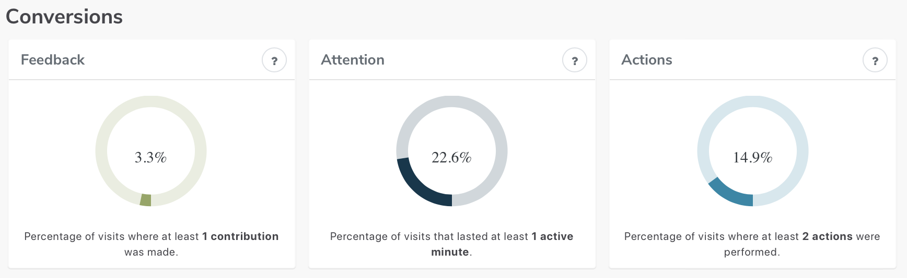
The low number of contributions via the Have Your Say website indicates a low level of interest from community members regarding the Policy.
The majority of participants (80%) reported that they had the right information to provide their feedback and it was easy to find and understand; 20% were not sure.
An engagement plan overview was published on the Have Your Say website and viewed two times.

Appendix 1
Online survey
Have your say on how we handle complaints
Were you aware before today that you can make a complaint to Council through the following channels?
 | Yes - I was aware | I'm not sure | No - I was not aware
Email to Council
Bayside Council website
Mail
Telephone to Customer Service
In person at our Corporate Centre

How we define a complaint
Our draft Policy defines a complaint to Council as:
any communication which involves an expression of dissatisfaction about an action, decision, policy or service that relates to Council staff, a Council contractor, or Council as a decision-making body.
How satisfied are you with this definition of a compliant? One star being very dissatisfied; three stars somewhat satisfied; and five stars very satisfied.

Your feedback on the draft Policy
To what extent do you agree or disagree with the below statements about the draft Complaints Handling Policy?
 | Strongly agree | Agree | Neither agree nor disagree | Disagree | Strongly disagree | I'm not sure
It sets out a fair and objective process
It is easy to understand

Please provide any other feedback or comments about the draft Complaints Handling Policy.

Your experience
Have you contacted Council regarding an issue in the past 12 months?
- Yes
- No
- I'm not sure

What was your issue(s) about? Please select all that apply.
- Bin collection
- Customer Service staff
- Lack of communication from Council
- Time to respond to issue/service request
- Noise
- Decision made by council
- Prefer not to say
Please tell us a little more about the type of issue(s)... [open comment]
How long was it from the time you first contact Council about the issue until the time it was resolved?
- 1-2 days
- Less than 1 week
- Less than 2 weeks
- Between 2 and 4 weeks
- More than 1 month
- Still not resolved
- I’m not sure
How did you report this issue? Please select all that apply.
- Email
- Bayside Council website
- Mail
- Telephone to Customer Service
- In person at Corporate Centre

About you
This section contains questions to help us understand the sections of our community that have provided feedback. The information you provide is confidential and non-identifiable.
- Age Group
- Connection to Bayside
- Gender
- Suburb

Do you have a lived experience of disability or care for someone who does?
- No
- Yes
- Prefer not to say

Did you have the right information to provide your feedback on the draft Policy?
- Information was very easy to find/understand
- Information was mostly easy to find/understand
- Information was mostly hard to find/understand
- Information was very hard to find/understand
- I'm not sure

