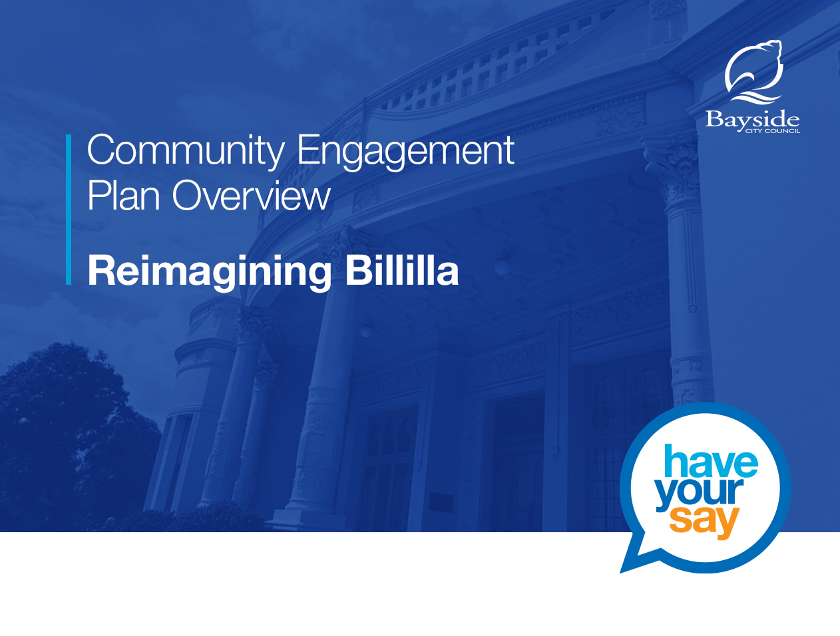

Project objective

In early 2022, the unique historic property of Billilla Homestead will become available for our community to explore and enjoy for the first time in over
15 years.
This presents an exciting opportunity to engage with the Bayside community on how to maximise social benefit from this landmark building and grounds in the heart of Brighton.
The engagement process will gather feedback from community members and stakeholders on ideas and possible uses for both the building and gardens. This feedback, along with technical, research, and feasibility reports, will assist Council in bringing new life to the historic homestead and creating positive outcomes for our local community.

Strategic alignment

The project will deliver on the goals and strategic objectives in Bayside’s Council Plan 2021 – 2025:
Goal 2: Our People
2.2 Engage with our diverse communities to improve access and inclusion in Bayside
2.3 Foster economic vitality, facilitation innovation and investment in our local economy.
Goal 3: Our Place
3.2 Infrastructure and assets are sustainable, accessible and fit-for-purpose now and for the future.
The project also aligns with the themes and key priorities in the Bayside Community Vision 2050:
Theme 5: Nurturing Creativity
5.1 Bayside will nurture a connected community by promoting creativity in the arts in all its forms.
5.2 Making use of public areas and infrastructure to encourage all people to be involved.
Theme 6: Promoting Innovation
6.1 Innovative methods, ideas and products to drive Council’s future planning.
Theme 8: Access and Inclusion
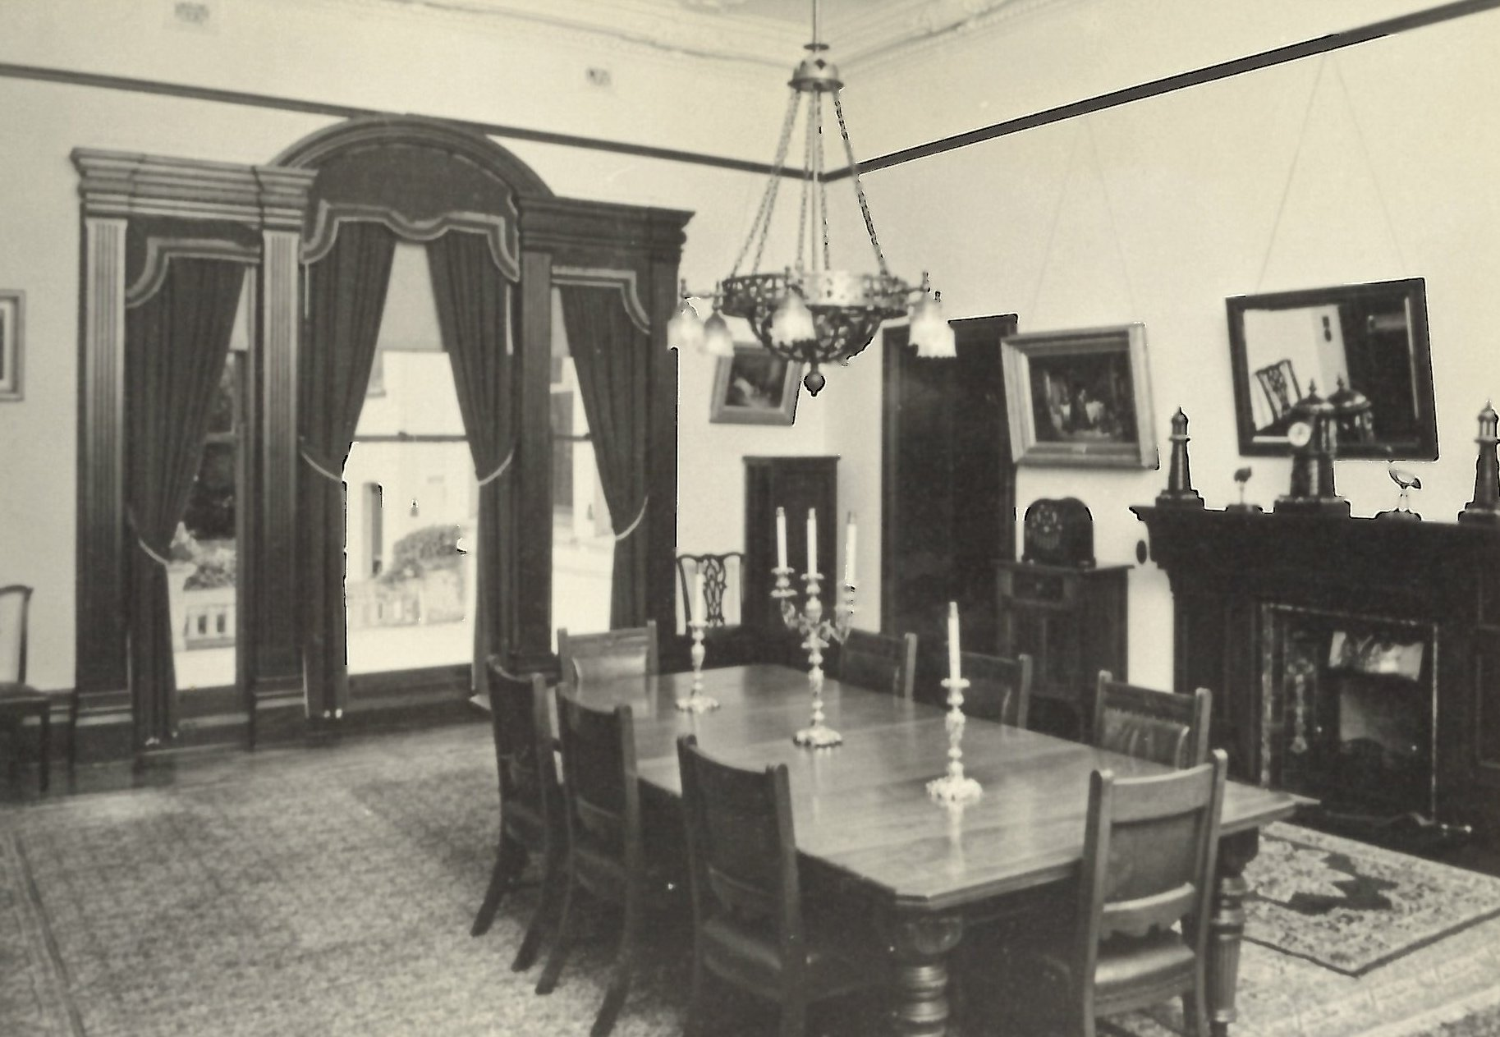
8.2 Bayside will improve accessibility to public infrastructure.

Project impacts
The Bayside community greatly values its heritage and a growing and aging local population will place more demand for accessible spaces and buildings.
Community engagement for this project is designed to foster creative participation through generating ideas about how we can return this significant Council-owned building and gardens to benefit our broader community.
The future vision of Billilla could be an intergenerational and inclusive space, creating opportunities for residents to express their ideas and abilities, share common interests, and feel a greater sense of connection and inclusion. There is also potential for commercial and/or social enterprise opportunities to be located at the site.
However, residents living close to Billilla may be concerned about any changes to the use of the Brighton landmark, which could increase noise, parking or traffic. Feedback from the community engagement program will inform a future management model, which would govern any tenants or events with strict conditions of use.
Council has undertaken research through a social needs assessment to inform the scope of this project and, in turn, the conversations with our community throughout the engagement process. The social needs assessment has considered nearby Council-owned buildings and services to identify any gaps that could be filled by the many spaces offered within Billilla, and will be used alongside the findings of community engagement to identify future opportunities.
Council has also commissioned a Conservation Management Plan (CMP) to gain a detailed understanding of the how to bring the broader community into Billilla now and protect it for future generations. The CMP is designed to be a highly practical document that will ensure the heritage values of the place are retained during maintenance, operation and any works at the site. The potential for alternative uses or development at the site will also be addressed through the CMP.
The heritage fabric of the building may present limitations on how Billilla can be used and will be a key consideration for Council when determining Billilla’s future. Further investment may be required to restore heritage features once the conservation management plan is completed and future uses are determined.
Some spaces within Billilla are currently leased at no cost to artists to support their creative pursuits. We’re continuing this popular program until at least the end of 2022 and are open to community feedback as to whether this should continue in its current form.

What information do we need from the community?

How would you like to experience and enjoy Billilla? We want to hear your stories, ideas and suggestions on how Billilla might be used in the future to maximise community benefit and support accessible, intergenerational use of the heritage building and grounds.

What can the community influence?
- ways to maximise community use of Billilla for social benefit
- ways to ensure Billilla offers appropriate and inclusive services that provide value and address local community needs
- ways to ensure intergenerational and broad use of the site
- ways to improve accessibility and inclusion
- ways to improve and increase community involvement and enjoyment of the gardens
- management model for the site, including how tenants and/or events should be managed
- whether to have commercial/social enterprise/community/Council service provision occupants and the mix of occupants
- allocation of restored/preserved spaces of the historic Homestead for tourism/education
- whether to add additional, purpose built, architecturally designed space to allow for larger, accessible gatherings
- ways to foster partnerships to support community connections and social engagement
- volunteering opportunities.

What can’t the community influence?
- changes to the layout of the building and any structural work
- Billillla gardens to remain open to the public under any future use of the site
- no sole/private occupation of the site that would prevent broad community access
- selling the building.

Stakeholders and community
This stakeholder assessment is a generalised understanding of sections of the community that have a connection to the project. This information is used to understand the types of tools and techniques that will achieve the strongest and most effective outcomes for engagement and communication.
Interest: What level of interest has been expressed or is anticipated
Impact: What level of change the stakeholder / community segment may experience as a result of the project / matter
Influence: Reference to the IAP2 Spectrum

Stakeholder / community | Interest | Impact | Influence
Residents close to Billilla | H | H | Involve
Brighton residents within walking distance | H | M | Involve
Wider Bayside community | M | M | Involve
Potential tenants/user groups | H | H | Involve
Artists in the Billilla Artists’ Studios | H | H | Involve
Community centres and Neighbourhood houses | H | H | Involve
U3A | H | H | Involve
Historical groups such as Brighton Historical Society, Bayside Historical Network and Friends of Black Rock House | H | H | Involve
Environmental groups | M | M | Involve
Older adult population | M | M | Involve
Young families | L | M | Involve
People living with disability | M | M | Involve
Heritage groups | H | M | Involve
Local schools | M | L | Involve
Young residents (< 25) | L | H | Involve
Indigenous residents / Traditional Land Owners | L | L | Involve
Council committees and reference groups (Arts, Disability Access and Inclusion Advisory Committee, Bayside Healthy Aging Reference Group) | H | M | Involve

Community engagement program design
The unpredictable impacts of COVID-19 means that while this engagement program is envisioned to be delivered predominantly through events that draw community members into Billilla, it can be adapted and delivered in stages and/or through interactive digital engagement tools.

It is proposed to begin the community engagement program with immersive and interactive digital experiences – allowing participants to wander the building and gardens through video and photographs, utilising 3D and virtual reality technology, where possible. An interactive building floorplan will enable users to select spaces to visually explore and understand more about the opportunities and challenges of each space.

Our Have Your Say engagement platform will feature a timeline with excerpts, photos and video, detailing the history of the Billilla Homestead and gardens. The community will be encouraged to add to the page by sharing their own stories, experiences and photos of Billilla.
Bayside is home to an innovative, imaginative and artistic community. A Visioner engagement tool on Have Your Say will encourage participants to share their ideas for the future use of Billilla and collaborate by commenting on or supporting other people’s suggestions.
From October 2021, we plan to expand the community engagement program to welcome people back into the building and gardens through small group tours, family events and cultural or artistic performances (COVID restrictions permitting).

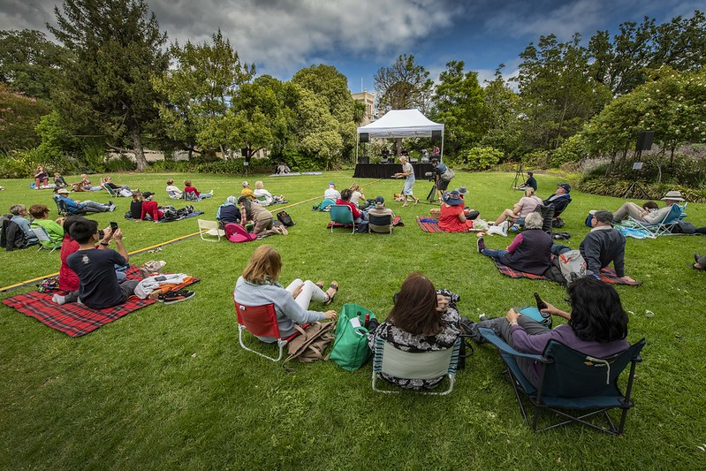
Selected tools and techniques
The tools and techniques selected for this project are informed by the project content; stakeholders; type of feedback sought; and current COVID restrictions.

Key tools for communicating the project
- community events and tours at Billilla (COVID restrictions permitting), including:
  - Halloween at Billilla 30/10/21: youth focused event, presented in collaboration with Youth Services and Freeza Committee. 6pm – 8pm younger audience, 8pm – 10pm older audience
  - Bayside Chamber Orchestra in the Billilla Gardens 5/12/21
- virtual interactive tours on Have Your Say engagement platform
- information sessions and meetings
- video and infographics
- interactive hotspot map with information on different aspects of the property (see example below)
- direct email to Have Your Say subscribers and key stakeholder groups
- letters/flyers to nearby residents
- website news stories and This Week in Bayside e-newsletter
- advertising, including prominent signage and social media
- Let’s Talk Bayside magazine.

Key methods for gathering feedback
- online engagement through Have Your Say, including opportunity to ask questions and submit ideas and stories
- stakeholder tours early Feb 2022: targeted tours for key community groups interested in tenancies and regular activities at Billilla (COVID restrictions permitting)
- Family Fun Day at Billilla 29/1/22: an event designed to bring people to Billilla in order to provide informed feedback: event could incorporate live music, performances, roving entertainers, tours and food trucks
- surveys and conversations at scheduled community event(s) at Billilla such as the Halloween and Chamber Orchestra events mentioned above (COVID restrictions permitting)
- meetings with key community groups
- printed information and surveys available from Billilla, Council’s Corporate Centre and libraries
- Information available in accessible formats available on request.

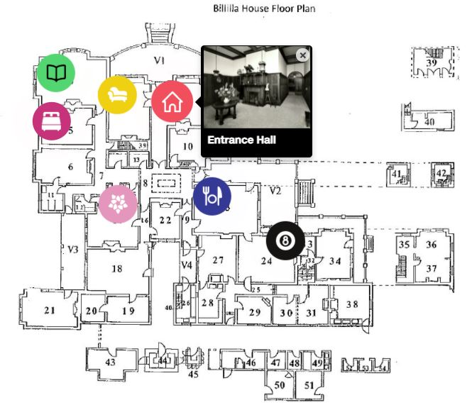
Project timelines

Phase 1: Research
- preliminary conversations with stakeholders, including Bayside community groups
- social needs assessment to understand demographic trends and social infrastructure needs
- update Conservation Management Plan and assess works required to maintain the integrity of the Billilla Homestead buildings (ongoing).
Phase 2: Discovery
- commence community engagement in late 2021 for up to 12 weeks
- gather community feedback on the type of uses, events and activities to maximise social benefit and inclusivity at Billilla
- foster conversations and connection through sharing personal stories, photos and experiences of Billilla
- online exploration of the building and gardens through a historical timeline, interactive floorplan, video, 3D imagery, and virtual reality tools, supported by site tours and events from late 2021, when access to the building and COVID restrictions permit
- feasibility study, including options for future use and purpose, schematic diagrams and financial modelling
- Council to consider community feedback and feasibility study report to consider future use (expected April 2022).

Phase 3: Delivery
- vision and purpose for Billilla Homestead endorsed by Council
- development of management model and conditions for use
- invite applications for lease/events (process managed by Council Property team).

Decision-making process

We will engage with the community over an approximate 12-week period beginning late in 2021 to gather feedback on the type of uses, events and activities the public would like to see at Billilla. Following this, a feasibility study will be commissioned to assess the options for future use, schematic diagrams and financial modelling and prepare a report on the findings.

Council will consider community feedback and the feasibility study to decide on a purpose and management model for the site. Applications for lease/events will be invited and assessed according to the purpose and criteria in the agreed management model by Council’s Property team. The community and all interested parties will be advised of the outcome and future plans for Billilla and invited to, once again, enjoy this historic home.

More information
Giacomina Pradolin
Arts and Culture Program Coordinator
Tel: 9599 4371
gpradolin@bayside.vic.gov.au

Newton Gatoff
Property Coordinator
Tel: 9599 4740
ngatoff@bayside.vic.gov.au
