Footpath Trading Review 2021
Community Engagement Summary

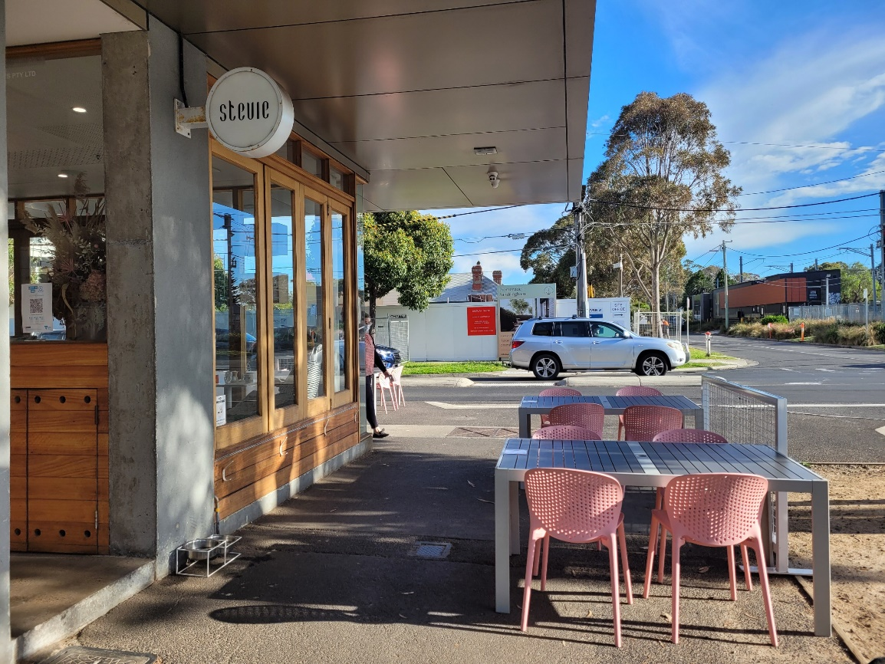

December 2021

Bayside City Council
Corporate Centre
76 Royal Avenue
SANDRINGHAM VIC 3191
T (03) 9899 4444
F (03) 9598 4474
www.bayside.vic.gov.au

Background
Footpath trading in the City of Bayside provides trade opportunities for businesses, enhanced public spaces, and sustained, inclusive access. Footpath trading aids the commercial viability of small businesses by increasing the area available for commercial activities. It allows traders to use the area adjoining the kerb, which increases the visibility of their commercial offerings to customers. Footpath trading plays a key role in promoting retail resilience and the ability of local businesses to employ staff.
Effective regulation of footpath trading ensures that universal access to activity centres for all residents is maintained. This universal access allows all residents to equally enjoy Bayside’s village feel. This footpath trading policy seeks to balance accessibility requirements and ensures that footpath trading aids the commercial viability and resilience of businesses, while also activating and enhancing the public realm for all residents.
Council will be considering whether to update the Footpath Trading policy with the below changes:
- heights and widths of allowable objects on the footpath
- kerb zone to be widened in certain circumstances to protect diners
- public liability insurance requirements
- permanent planter boxes will no longer be allowed, moveable planter boxes may be allowed
- installation of blinds from verandas is not advised and must be discussed with Council and meet strict criteria before installation
- installation of railings and glass screens is not advised and must be discussed with Council and meet strict criteria before installation.
As part of this review, the Bayside community was invited to provide feedback on the program through the online Have Your Say platform on the Council’s website from 18 November – 16 December 2021.
65 participants submitted a response on the Have Your Say platform.

Consultation process

Consultation purpose
The purpose of the engagement process was to seek feedback on the proposed update to the Footpath Trading Policy and measure the level of support for its key actions. Feedback would inform the proposed policy to be considered by Council in February 2022.

Figure 2: Timeline and phases for the Footpath Trading Policy
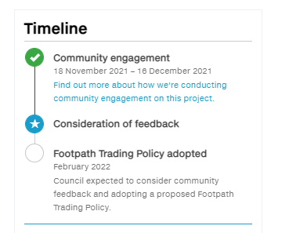

Consultation methodology
The engagement process was open to all members of the Bayside community, including individuals or groups who live, work, play, study, visit, or pass through the municipality..
The program was primarily delivered digitally. Consultation was open for a four-week period from 18 November - 16 December 2021.
The following engagement activities were undertaken:
- project information and feedback survey through Have Your Say
- printed survey and consultation materials available on request.
The following table provides detail of each activity undertaken within the community engagement period.

Table 1: Engagement activities and participation
Details | Activity
18 November to 16 December 2021  618 visitors  65 contributions  64 contributors  19 project followers | Online Engagement – Have Your Say  The online project pages included information on the footpath trading policy an open question and answer forum. The primary means of collecting feedback on the page was through a closed survey (Appendix 1).  65 contributions received via an online survey.  A phone number and email were made available for enquiries with no requests received.
Written submissions  No responses received | Stakeholders providing written submissions to Council  Council received no written submissions via email or mail in relation to the Footpath Trading Review.
E-mail / Phone call enquiries | Correspondence to Urban Strategy department  Council received no email enquiries or phone calls in relation to the Footpath Trading Review.

Table 2: Communication tools and reach
Channel | Distribution
18 November  228 views | Website news story  https://www.bayside.vic.gov.au/news/do-you-love-dining-and-shopping-outdoors
18 November  4197 opens (reach)  130 clicks | This Week in Bayside  E-newsletter send to 8797 subscribers
6 December 2021  4003 (reach)  8628 (reach)  12% engagement | Social media  Facebook post (organic) on Council’s main page  Facebook post (paid) boosted to broad Bayside audience
24 November 2021  644 opens (reach)  57 clicks | Direct email  Corporate branded email sent to 1600 traders, including Footpath Trading permit holders
13 December 2021  720 opens (reach)  59 clicks | Direct email  Reminder email sent to 1629 traders, including Footpath Trading permit holders

Participant profile
Council launched a seven-question survey (Appendix 1) on the Have Your Say platform to garner feedback on the draft Footpath Trading policy. The survey received 65 responses.
Table 1: Participant Demographics
 | Connection to Bayside | Participants | Rates (%)
Identity | Residents | 55 | 87.3%
 | Traders have current Footpath trading permits | 4 | 6.3%
 | Traders don’t have current Footpath trading permits | 7 | 11.1%
 | Visitors/shoppers | 23 | 36.5%
 | Other identity | 1 | 1.6%
Disability/Carer | Person with disability or a carer | 19 | 30.2%
 | Person doesn’t have a lived experience of disability or carer | 39 | 61.9%
 | Prefer not to say | 5 | 7.9%
Suburb | Beaumaris | 5 | 15.6%
 | Black Rock | - | -
 | Brighton | 8 | 25.0%
 | Brighton East | 2 | 6.3%
 | Cheltenham or Pennydale | 1 | 3.1%
 | Hampton | 4 | 12.5%
 | Hampton East | - | -
 | Highett | - | -
 | North Brighton | - | -
 | Sandringham | 12 | 37.5%
 | Outside Bayside | - | -
(Note: Participants can fall under multiple identities, i.e. I’m a Bayside resident and I’m also a trader)

Consultation findings
The following section summarises the key themes which arose in community feedback on the draft Footpath Trading Policy. Where there was more than one mention of a topic or item, the number of mentions has been specified in brackets and italics.

Data limitations
Due to the configuration of the questions around participants’ relation to Bayside, the survey did not capture the geographic data of all participants.
For example, residents and visitors could only provide their residential suburb when they ticked the option, ‘I am a Bayside resident.’ However, most participants ticked more than one box which meant that the survey did not capture where they lived.
The total amount of participants who indicated they lived in Bayside suburbs were 32. Therefore, the demographic percentage for suburbs was based on the total figure of 32 and not total participants (65).
The visitors/shoppers were all Bayside residents. Therefore, this report analyses the insights from residents and not specifically visitors/shoppers.
Like the above, traders were only able to provide their store location when they ticked ‘I am a trader/business with a current footpath trading permit’ and ‘I am a trader/business operator in Bayside but do not currently have a footpath trading permit.’ Due this oversight, no geographic data was captured for participants who were traders.

Results
The survey results showed that 19.0% of participants (12) believed that there is the right amount of footpath trading in Bayside. Additionally, 54.0% of participants (34) wanted more footpath trading in Bayside. However, 21% of participants (13) were worried about the amount of footpath trading and preferred to have less footpath trading.
The survey also generated opinions on the draft Footpath Trading Policy.

Topic 1: Footpath Trading amount in Bayside

Most participants (34, 54%) supported more footpath trading in Bayside. However, a small group (13,21%) opposed this proposal. Some survey participants believed that there is the right amount of footpath trading (12, 19%). Whilst a few participants preferred not to say or held other opinions (4, 7%).

Figure 1: Do you think there is the right amount of Footpath Trading in Bayside?

Some survey participants (32, 51%) also provided comments on which areas of Bayside they would like to see more footpath trading. These responses are summarised by sentiment and theme in the table below:
Sentiment | Community feedback
Support for more footpath trading | - All shopping centres  - All retail shopping for small businesses  - All areas, particularly while we get business going after all of us, including those who remained employed were smashed by lockdowns.  - All areas that have space to enable this.  - Everywhere  - I would like to see allowance for footpath trading anywhere - if the business complies with the guidelines in the draft policy. I cannot see why trading should only be allowed in specific locations within Bayside  - Wherever there is room and wherever it supports current and future outdoor bars and dining businesses  - Beaumaris (3 mentioned)  - Black Rock (4 mentioned)  - Brighton (8 mentioned)  - Hampton (4 mentioned)  - Sandringham (15 mentioned)
Oppose on more Footpath Trading | - Why is it needed - is there not sufficient inside shops ...which we have barely been in for 20 months
General feedback | - Too much in some areas nothing in others  - Leave business alone. Let them do it where it works for them. Stop trying to control everything

Topic 2: Opinions on the draft Footpath Trading Policy

Statement 1: Footpath trading provides trade opportunities and increases the visibility of business offerings to customers.
Participants were asked if they agree the draft Footpath Trading Policy provides trade opportunities and increases the visibility of business offerings to customer.
Most survey participants (51, 81%) agreed. However, 10 (16%) participants disagreed. Few participants had no opinion or were neutral (2, 3%).

Figure 2: Level of agreement on the increasing trade opportunities and the visibility to customers

Statement 2: Footpath trading will enable enhanced public spaces and add to the vibrancy of our shopping precincts.
Participants were asked if they agree that the draft Footpath Trading Policy enhances public spaces and adds vibrancy to shopping precincts.
Most survey participants (44, 70%) agreed with this statement. However, 13 (24%) participants disagreed. Few participants had no opinion or were neutral (4, 6%).
Figure 3: Level of agreement on the enhanced public spaces and the vibrancy of shopping precincts

Statement 3: The draft Footpath Trading Policy has clear guidelines to allow safe movement of people with mobility issues, prams or wheelchairs around footpath trading areas.

Most participants (41, 65%) expressed support for this statement. However, 10 participants (16%) disagreed. Some participants had no opinion or were unsure (12, 19%).

Figure 4: Level of agreement on the accessibility of footpath trading areas

Statement 4: The Footpath Trading Policy has clear guidelines to ensure that where and what is placed on the footpath is safe, insured and poses little or no risk to pedestrians, patrons, or Council.

Most survey participants (40, 64%) agreed with this statement. However, 11 participants (17%) disagreed. Some survey participants had no opinion or were unsure (12, 19%).
Figure 5: Level of agreement on the clear guidelines of safety and risk assessment on footpath trading areas

Suggestions and feedback
Participants (38, 59%) provided suggestions on the draft Footpath Trading Policy. There were 30 comments received. Some comments addressed more than one topic, so have been split accordingly.

Topic | Community feedback
Positive feedback | - Footpath trading has been great initiative during COVID with the changing health restrictions.  - I applaud the council on drafting the policy and sharing for consultation.  - It’s a good investment to create a community and build and economy.
Permit cost reduction | - There should be a permanent reduction in costs, the pandemic has already significantly affected trade (3 mentions).
Pedestrian safety | - Some paths experience high foot traffic and get quite crowded, it can be unpleasant to move through and poses a safety risk (6 mentions).  - There should be more done to clear the beggars from Church Street.  - The footpaths in Black Rock are uneven.
Accessibility issues created by footpath trading | - Footpath trading makes it difficult for those with a disability to navigate the area (2 mentions).
Stronger policy enforcement | - The policy needs stronger enforcement provisions, other than self-inspection (3 mentions).
Parking limitations | - Cars can no longer park close to gutters as footpath is blocked by trading.
More policy flexibility | - Ensure the policy contains enough flexibility to suit the wide range of footpath environments so each business can be assessed on a site-by-site basis. Some of the rules are too restrictive (2 mentions).
Design ideas | - Flower, green grocery, or planter boxes on footpaths can bring a sense of liveability (2 mentions).  - Encourage more bespoke architectural petitions.  - Blinds should be allowed to encourage outdoor dining.  - Incorporate spacelets as part of widened footpaths.

Participants (30, 48%) also provided suggestions on the Footpath Trading Policy, with 38 comments received. These comments are summarised by sentiment and theme in the table below:
Topic | Community suggestions
Safety | - The footpath policy is now a free for all that has been allowed to be abused. The restaurants and bars have used COVID to takeover footpaths, create unprecedented hazards, put people's safety at risk and disrupt other business. (4 mentions)  - We own Sustainable Soul in Black Rock; we're situated on the corner of Bluff and Balcombe and the speed I have seen children and their parents ride around this corner is really dangerous. In Black Rock there is a high number of elderly and we need to protect them.
Extension of footpath trading | - Increased outside dining is essential during COVID and beyond. (3 mentions)
Cost | - Make it easier and cheaper for business (4 mentions)
Pet concern | - I would like the topic of dogs on footpath eating areas to be addressed. Are they allowed or not? Also, something about dogs tied to tables etc, with leads that let them then lie right across the footpath. Often, I am forced on to the road as I am too scared to step over or near to dogs. (3 mentions)
Theft/crime | - I believe retailers who offer goods on the footpath attract shoplifters and thieves to the area. Council should install a CCTV system ASAP for the deterring factors of criminals. (1 mention)
Enforcement | - Stronger statement on the enforcement of the rules - some traders flout the rules (2 mentions)
Accessibility | - There must be space for people to park wheelchairs/ prams each when dining at tables. This might mean reducing number of tables, for example, to 6 from eight. (2 mentions)
Removal of footpath trading | - Get rid of footpath trading altogether it is too dangerous. Cars are trying to get from one end of shopping strip to the other with so many people there will be an accident. (4 mentions)
Bike use | - I feel there should be visible signs to ask bike and scooter riders to not ride on the footpaths in the shopping areas. (1 mention)
Permit application process | - I think that neighbouring businesses or residents should be given a copy of any applications with an opportunity to comment. (1 mention)  - Provide fewer broad rules and more site/specific assessments to suit the application (1 mention)
Footpath trading boundaries | - Please ensure the three zones are marked with tape/paint or some other means to clearly denote the required spacing (1 mention)  - It will be necessary for cafes to denote space for those waiting to collect take away orders, especially coffees as customers currently just stand in the footpath area as there is nowhere else for them to stand (1 mention)
Design ideas | - I would like to see more of and retain existing permanent planter boxes. I am in favour of café blinds where practical and safe. (3 mentions)  - Ensure Trading does not occur around Pedestrian Crossings and Public seating. (1 mention)
Community education | - It's possible that staff and customers will forget that the footpath forms part of the roadway and that in inadvertently blocking it during a sale may encourage people to step into the street. It's an issue that could be dealt with by an awareness campaign and letter drops, using ads in Neighbourhood Watch. (1 mention)

Project Evaluation
The draft Footpath Trading Policy did not attract significant comment from the community. The primary concern for most respondents was the overcrowding of footpaths and pedestrian safety. Overall, most participants (34, 54%) supported more footpath trading in Bayside and agreed that it allows for more trade opportunities (51, 81%).
Sandringham had the highest percentage of participants (12, 37.5%). However, there were no participants from Black Rock, Hampton East, Highett, North Brighton or outside of Bayside. This may be attributed to the configuration of the survey questions. The logic of the questions meant that some participants were not asked about their location.
The engagement techniques were effective in capturing participants’ opinions. Most participants gave detailed feedback or suggestions which will be valuable in refining the policy. It was considered that engagement processes were effective but the interest in the subject was low.
To improve upon the engagement process, more testing to ensure the survey questions are logical will allow for richer data collection.
All communication tools used to promote the campaign were effective with contributors coming to the survey from all sources, including the trader emails, Facebook and Council’s enewsletter evidenced by tracking url links placed in each piece of communication.

Appendix

Appendix 1: Footpath Trading Policy survey questions

1. Do you think there is the right amount of Footpath Trading in Bayside?
Yes just the right amount
No there should be more
No there is too much
Prefer not to say
Other (please specify)
2. To what extent do you agree or disagree with the below statements about the draft Footpath Trading Policy?

It provides trade opportunities and increases the visibility of business offerings to customers.

Strongly agree
Agree
Neither agree nor disagree
Disagree
Strongly disagree
Not sure

It will enable enhanced public spaces and add to the vibrancy of our shopping precincts.
Strongly agree
Agree
Neither agree nor disagree
Disagree
Strongly disagree
Not sure

It has clear guidelines to allow safe movement of people with mobility issues, prams or wheelchairs around footpath trading areas.

Strongly agree
Agree
Neither agree nor disagree
Disagree
Strongly disagree
Not sure

3. Would you like to suggest any changes to the draft Footpath Trading Policy?

4. Is there any other feedback you would like to provide on the draft Footpath Trading Policy?

About you
5. What is your connection to the draft Footpath Trading Policy and Bayside? (tick all that apply) Required

I am a trader/business with a current Footpath Trading permit
I am a trader/business operator in Bayside but do not currently have a Footpath Trading permit
I am a Bayside resident
I visit/shop in Bayside
Prefer not to say
Other (please specify)

6. Do you have a lived experience of disability or care for someone who does? Required
Yes
No
Prefer not to say

7. Did you have the information you needed to provide your feedback? Required
Information was very easy to find and understand
Information was mostly easy to find and understand
Information was mostly hard to find and understand
Information was very hard to find and understand
Not sure

