Review of Bayside City Council’s Parklet Program Residential and business community engagement results

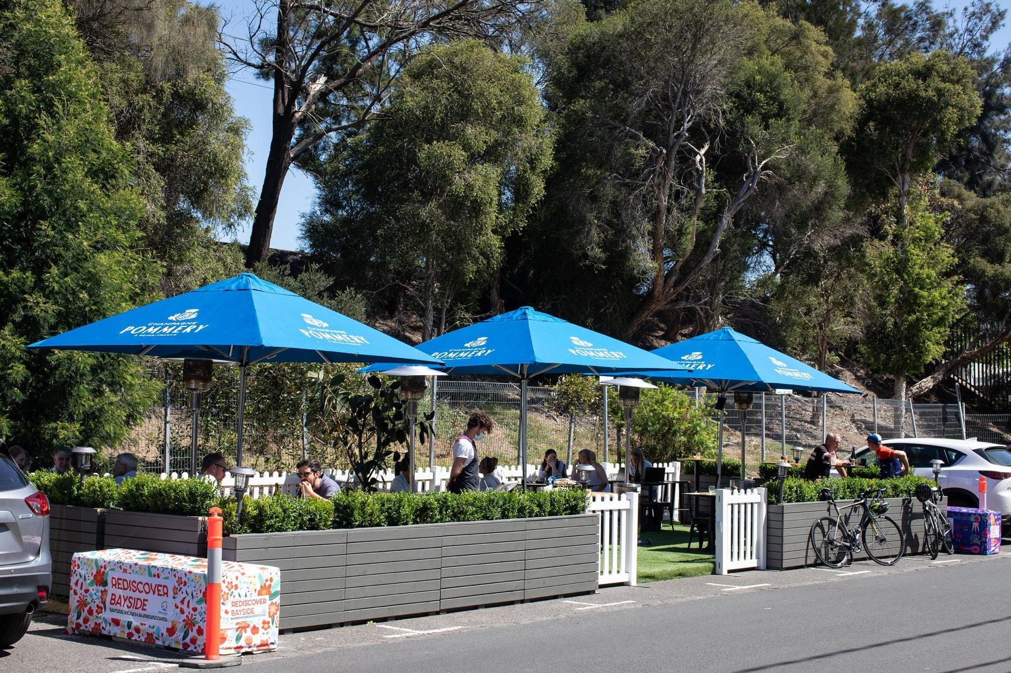
January 2021

7 January 2021

Bayside City Council
Corporate Centre
76 Royal Avenue
SANDRINGHAM VIC 3191
T (03) 9899 4444
F (03) 9598 4474
www.bayside.vic.gov.au
Contents
Background 3
Consultation process 4
Consultation purpose 4
Consultation methodology 5
Participant profile 5
Business Profile 5
Connection to Parklet Program 5
Type of business 6
Location of business 6
Age 7
Gender 8
Community Profile 9
Connection to Bayside 10
Suburb and proximity to a parklet 10
Experience with parklets 11
Consultation findings 13
Level of support by businesses 13
Level of support for the concourse 14
Impact on business 14
Impact on carparking 15
Impact on revenue 16
Future involvement in parklet program 16
Level of support by community 17
Appeal of outdoor dining 17
Impact on business 19
Impact on carparking 22
Introducing parklets permanently 23
Moving forward with the Parklet Program 24
Project evaluation 29
Evaluation of engagement program 29
Evaluation of engagement communication 29

Background
In September 2020, the Victorian Government announced its Outdoor Eating and Entertainment Package for local councils and businesses to make widespread outdoor dining safe and practical as the community and economy recovers from COVID-19.

Bayside City Council received $575,000 from the State Government to assist with the reactivation of the local economy through two components:
- Part A $300,000 Immediate Outdoor Activation (Rapid Implementation Fund): To immediately extend the life of existing outdoor eating and entertainment facilities, facilitate reactivation initiatives and provide new facilities for other businesses to also operate outdoors.
- Part B $275K Semi-permanent and Permanent Outdoor Precinct Establishment: To establish semi-permanent and permanent outdoor precincts that support a broad range of industries and will be of lasting benefit to local communities.

The outdoor dining and footpath trading expansion program was well received by traders and community, with the uptake and set up of 16 parklets (seating, shade) throughout Bayside, an outdoor dining marquee at Beaumaris and outdoor picnic tables at the foreshore in Black Rock. Table 1 shows the parklets across the municipality.

Table 1. Parkelet Locations
Suburb | Parklet # | Location | Traders
Brighton | 1 | 20-22 Church Street | Omri  Fish Tank
Brighton | 2 | 299 - 305 Bay Street | Hecho en Mexico  Too Many Chiefs
Brighton | 3 | 286 Bay Street | Hotel Brighton
Brighton | 4 | 350-360 Bay Street | Little Sister Brighton  Rocksalt Café
Brighton | 5 | 7 Spink Street | Sons of Mary
Brighton | 6 | 212 Bay Street | The Deck Brighton
Brighton | 7 | 118 Church Street | White Rabbit Brighton
Brighton | 8 | 368 Bay Street | Zeppelin Kitchen
Brighton | 9 | 106 Bay Street | Bossy Boots
Cheltenham | 10 | 386 Reserve Road | Bad Shepherd Brewing Co.
Hampton | 11 | 370 Hampton Street | The Paperboy Café
Sandringham | 12 | 66 Station Street | Ammos Greek Tavern
Sandringham | 13 | 19-21 Melrose Street | The Hobson Stores
Sandringham | 14 | 39 Melrose Street | Sidebar
Sandringham | 15 | 5 Melrose Street | Le Phan Vietnamese
Beaumaris | 16 | Concourse Green | -

Throughout the program several traders expressed the desire to see the 16 parklets continue, with some seeking to have the parklets on an ongoing permanent basis. Whilst considered highly successful, the parklets were constructed as temporary structures and were due to be removed in mid-May 2021. The assumption was that with restrictions continuing to be eased and outdoor dining less prominent during the cooler months, there would be an opportunity to return carparking spaces to the centres to support their transition towards a new COVID-19 normal.

Given their temporary nature, many require routine maintenance and upkeep. Likewise, the community in Beaumaris has been very complimentary of the outdoor dining space provided under the marquee in the Concourse Green with numerous requests from the local traders and community for its retention. A permanent structure was originally proposed under the Beaumaris Concourse Streetscape Masterplan, however, at the time the proposal was not wholly supported.

This report provides a summary of the community engagement conducted with Bayside traders, residents and shoppers regarding their views and experiences of the temporary outdoor dining parklets (table, chairs, shade) installed in the municipality. Results of this engagement program will be used by Council at the February 2022 Council Meeting to determine the feasibility of parklets as a short term, long term or permanent approach to street trading solutions.

To analyse open ended questions and submission, responses have been coded into broad themes to categorise community engagement feedback. When reading this report you will notice that numbers appear in brackets and italics (x) this is to show the number of people or responses related to the area of discussion.

Consultation process

Consultation purpose
The purpose of the engagement program was to understand:
- community and businesses attitudes towards parklets in the activity centres
- use and economic impacts of parklets
- safety and compliance requirements for the ongoing delivery of the program
- community preference for the use of the parking spaces (parklets, parking or other purposes).

The consultation program was open from 18 November to 16 December 2021.

Consultation methodology
The project stakeholders were defined as traders (trading from parklets), other surrounding businesses, broader community (visitors, parklet users and residents living in the immediate areas). To assist with decision-making, the engagement findings in Section 4 of this report have been organised by stakeholder type, residents, business owners/operators and visitors.
Table 2 lists the community engagement activities conducted by Bayside City Council.
Table 2. Community Engagement Activities
Details | Activity
18 November to 16 December 2021  57 respondents | Trader/business survey  Via Have Your Say, Council’s online engagement platform.  16 traders and 41 surrounding businesses (without a parklet).
18 November to 16 December 2021  784 respondents | Community survey  Via Have Your Say, Council’s online engagement platform.  612 participants had used a parklet, 149 participants had not used a parklet and 23 participants were unsure if they had/hadn’t used a parklet

The consultation program was promoted through a variety of channels. Traders were directly notified of the program through email, eNewsletter and letter. The project was promoted to the wider community through the Council’s social media channels, corporate website, eNewsletter and street signage at parklet locations. For traders the most effective channel used was emailing traders with 54 click throughs to the survey; for the wider community social media was most effective with 430 click throughs to the Have Your Say project page. Refer to Section 5 to view the complete evaluation of the engagement communication.

Participant profile
Participation in this project was voluntary, as was the collection of personal demographics. Therefore this information is not known for every person that participated. The participant profile for each survey is presented separately below.

Business Profile
Businesses connected to a parklet, along with those nearby a parklet or businesses in surrounding areas were encouraged to participate in this business specific survey. This survey was hosted on Have Your Say and was also completed by seven people without a business (resident, visitor). For the purpose of this section only the demographics of the 50 participants connected to a business are detailed.

Connection to Parklet Program
Of the 50 business participants that completed the survey, 16 had a parklet and 34 did not have a parklet. At minimum it appears that at least one business from each parklet participated. A total of 16 traders operate a business that have a parklet, while 41 do not have a parklet.

Type of business
Traders were asked to select a category that best describes the business that they operate in. Diagram 1 shows these results, where the most common types of business were Retail (16 responses) and Professional service (12 comments). Dining/Hospitality received 7 responses, while Beauty/Hairdressing and Takeaway food received 1 response each. ‘Other’ included businesses such as sports clubs and telecommunications, and had 3 responses in total.
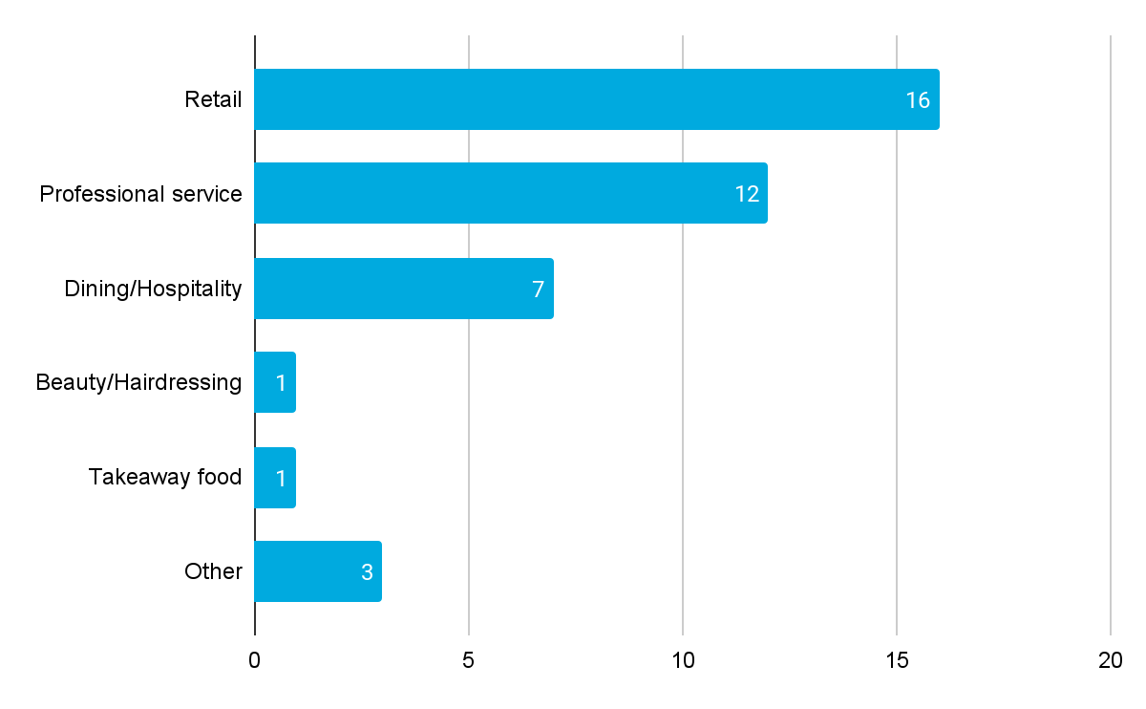
Diagram 1. Type of business

Location of business
Traders were also asked to indicate the location of their business. These locations are represented in the map below.
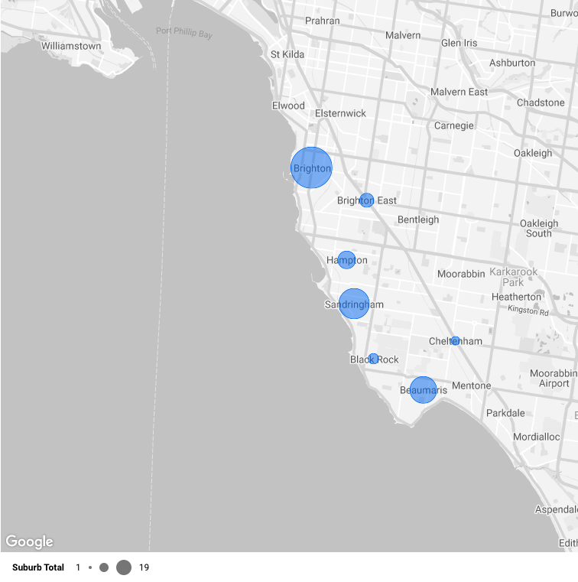
Diagram 2. Location of business
The size of each dot represents the number of responses per suburb. Brighton was the most populated suburb (19 responses), followed by Sandringham (13 responses) and Beaumaris (11 responses). Hampton (6 responses) and Brighton East (4 responses) both had a few participants, while Black Rock (2 responses) and Cheltenham (1 response) were the least populated suburbs in the survey. There were 0 responses for Hampton East, Highett, and Outside Bayside. Table 3 shows the representation.
Table 3. Representation of businesses to parklet
Suburb | Number of traders (survey) | Number of parklets | Representation
Beaumaris | 11 | 2 | overrepresented
Black Rock | 2 | 0 | overrepresented
Brighton | 19 | 10 | adequate
Brighton East | 4 | 0 | overrepresented
Cheltenham | 1 | 1 | adequate
Hampton | 6 | 1 | overrepresented
Sandringham | 13 | 4 | adequate
Over/under-representation decided by the number of traders/number of parklets. If > 5 - overrepresented, if < 0.5 - underrepresented.

Age
Traders were asked to specify their age in one of the various ranges offered, shown in Diagram 3.
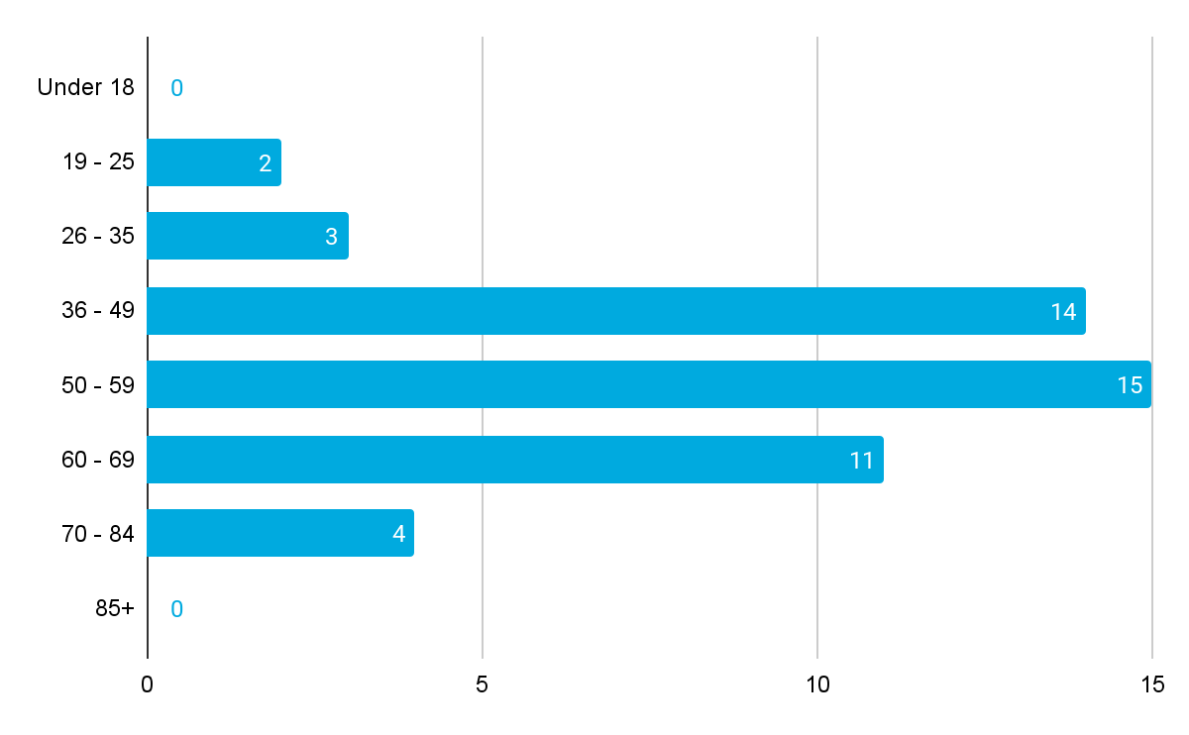
Diagram 3. Age of traders
None of the traders who participated in the survey fell in the ‘Under 18’ or ‘85+’ age bracket. The most popular range was ‘50-59’ (15 responses), followed by ‘36-49’ (14 responses) and ‘60-69’ (11 responses). Some of the less common ranges included ‘70-84’ (4 responses), ‘26-35’ (3 responses) and ‘19-25’ (2 responses). Two participants preferred not to disclose their age range.

Gender
Traders were asked to disclose their gender, with the option to provide an answer of ‘Non-binary’ or ‘Prefer to self-describe’. Results are shown in Diagram 4 below.
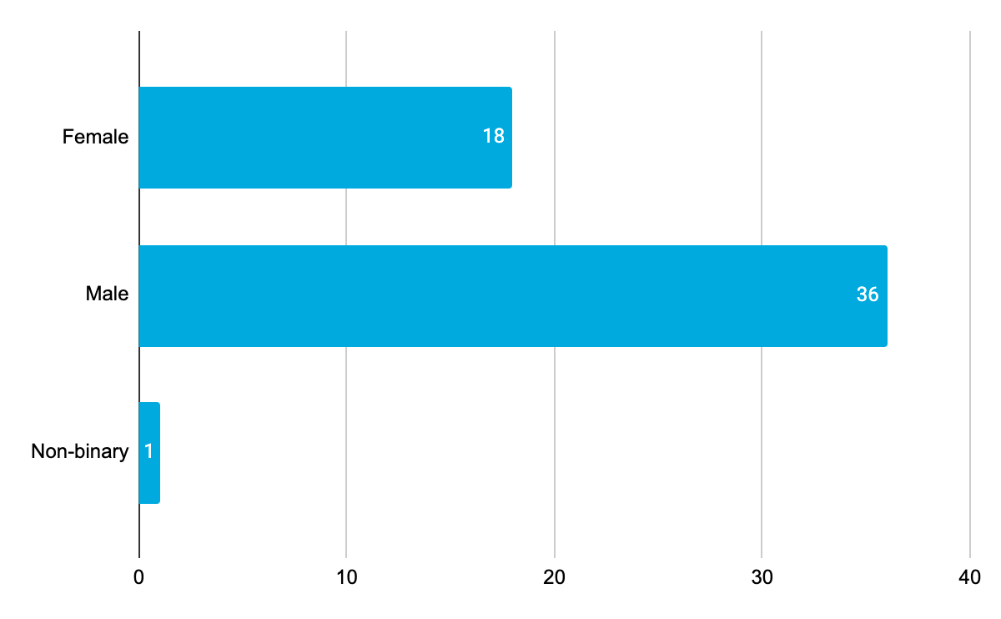
Diagram 4. Gender of traders
There were double the number of Male participants (36 responses) compared to Female participants (18 responses). One participant identified as Non-binary, while 0 preferred to self-describe. There were two participants who preferred not to answer.

Community Profile
Residents, visitors and parklet users were invited to provide feedback on their experience of the parklets within their community and/or across Bayside. This survey was hosted on Have Your Say and was open for completion by all. This survey attracted responses from 784 participants. Table 4 shows a comparison of participation against the 2016 Census data for the whole of Bayside. It is important to note that higher levels of participation in suburbs where there are more or larger parklets was expected. There were also higher levels of participation from people aged 40 – 69 in comparison to other age brackets. One reason for this might be the customer type that are dining more frequently across Bayside and using parklets. Other personal demographic information is detailed below.
Table 4. Comparison of Participation
 | Demographic | Bayside  2016 Census | Participants (%)
Gender | Male | 47.6% | 36%
 | Female | 52.4% | 62%
 | Unknown | -
 | Other identity | - | 2%
Age | 15-24 | 11.5% | 2%
 | 25-39 | 13.6% | 9%
 | 40-49 | 16% | 30%
 | 50-59 | 14.% | 25%
 | 60-69 | 11.5% | 20%
 | 70-84 | 9.9% | 12%
 | 85+ | 3.7% | 1%
 | Undisclosed | - | 1%
Suburb | Beaumaris | 13.5% | 18%
 | Black Rock | 6.5% | 7%
 | Brighton | 24.1% | 20%
 | Brighton East | 15.9% | 8%
 | Cheltenham | 3.7% | 3%
 | Hampton | 13.6% | 14%
 | Hampton East | 5.0% | 2%
 | Highett | 7.2% | 5%
 | Sandringham | 10.5% | 18%
 | Outside Bayside | - | -

Connection to Bayside
Participants were asked to describe their connection to the area of Bayside, shown below.
Diagram 5. Participant connection to Bayside
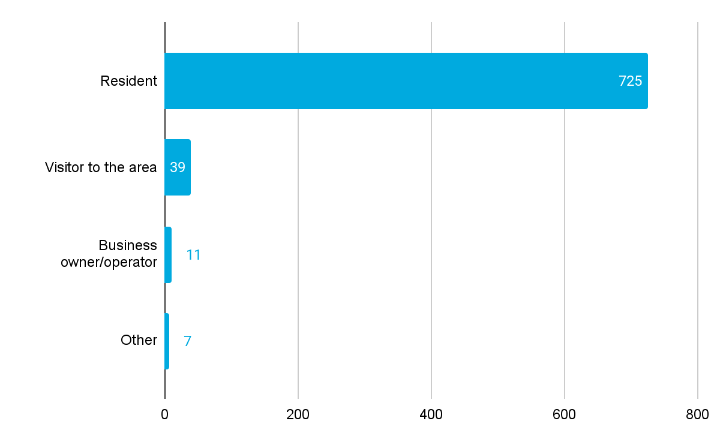
The majority of participants identified themselves as ‘Resident’ (725 responses), followed by ‘Visitor to the area’ (39 responses) and ‘Business owner/operator’ (11 responses). There were 7 other responses. Two participants preferred not to disclose their connection to Bayside.

Suburb and proximity to a parklet
Participants were asked to indicate their suburb of living. These locations are shown below in Diagram 6. The size of each dot represents the number of responses per suburb. The most common suburbs were Brighton (157 responses), Beaumaris (145 responses), Sandringham (143 responses) and Hampton (111 responses). Brighton East (66 responses), Black Rock (55 responses) and Highett (37 responses) were all responsible for a good number of participants, while Cheltenham (21 responses) and Hampton East (13 responses) had the least participation. 36 participants indicated that they live outside Bayside. The location pin shows where there is a parklet nearby.

Diagram 6. Location of participants and proximity to a parklet

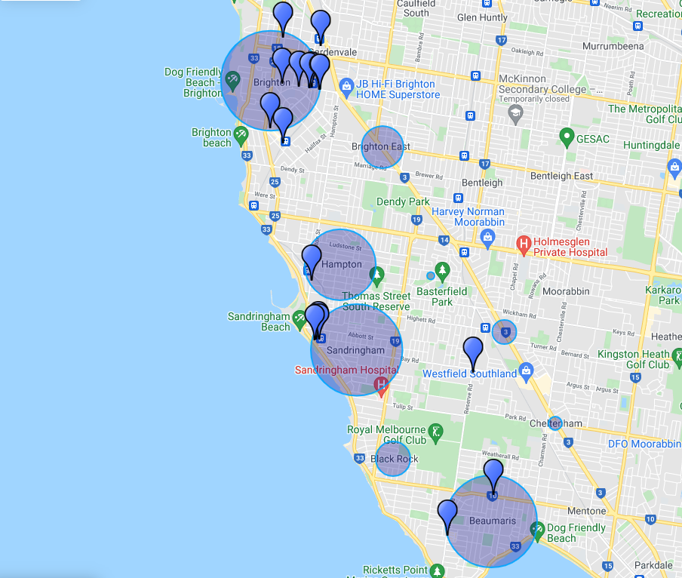
Experience with parklets
Participants were asked about their experience previously with parklets, if they attended, which ones they had frequented and how often. Overall participants had good prior knowledge of parklets. Diagrams 7 to 9 provide an insight into the community dining profile and their tendencies.
Diagram 7. Community diner profile
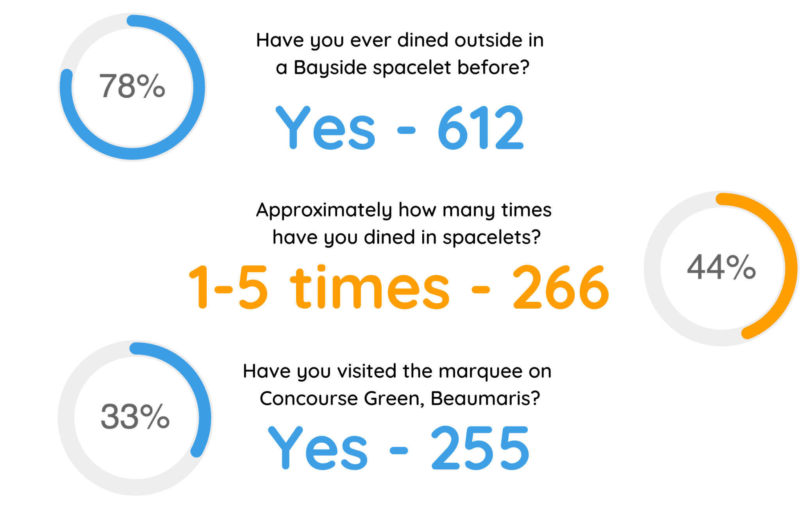

Diagram 8. Preferred aspects of outdoor dining in parklets
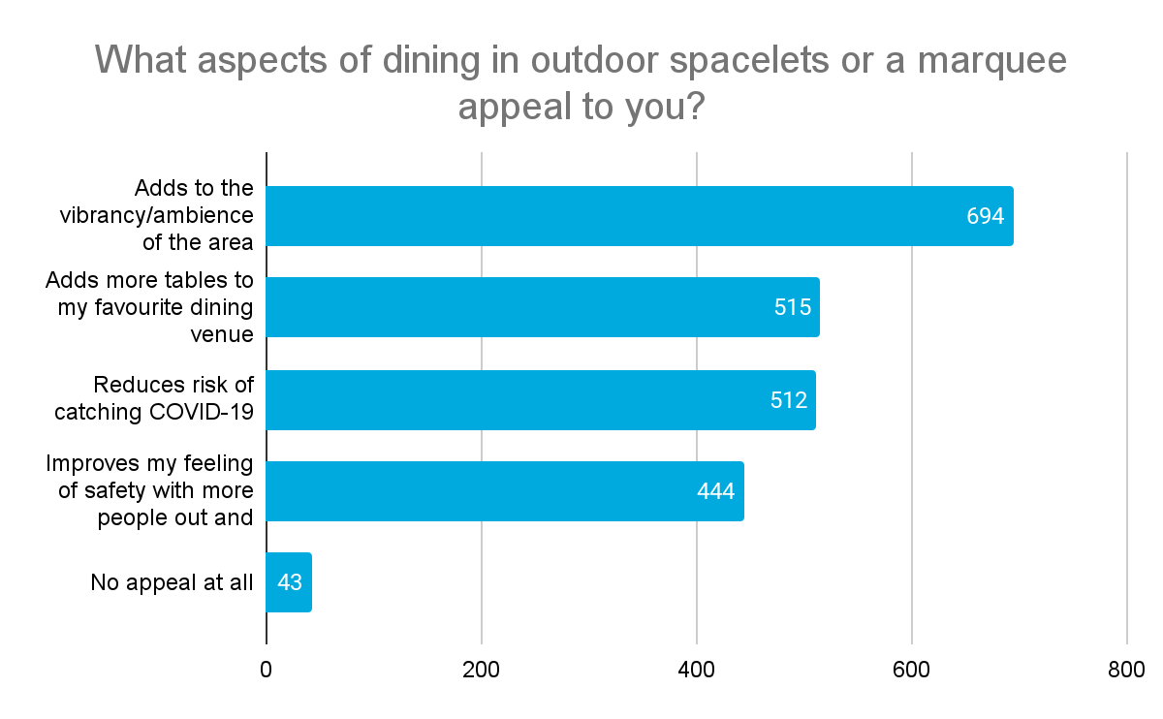
Diagram 9. Most visited parklets
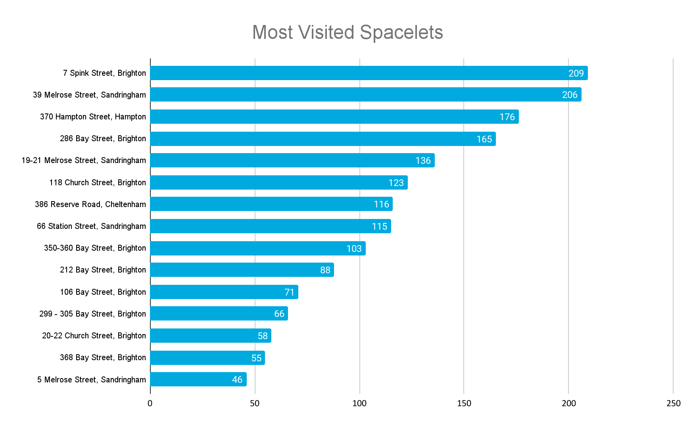

Consultation findings
The following section summarises the key themes which arose in community feedback on parklet program review. Throughout the document, quotes have been used to demonstrate the sentiment expressed by participants. Where there was more than one mention of a topic or item, the number of mentions has been specified in brackets and italics.
Findings are organised by stakeholder type (business owner/operator, resident and visitor), and in particular level of support for the continuation of the parklet program.
Overall there was a high level of support for the continuation of the parklet program with the majority of business participants, residents and visitors wanting to see the program continue in some form. The most cited benefit of the parklet program was improving the vibrancy of the area, helping business during a time of need and provided a layer of protection against COVID-19, which many commented (and were right) is not going away. Introducing parklets permanently was supported by participants in Brighton, Brighton East and Sandringham; whereas there was desire to see the seasonal use of parklets and marquees in other areas.

Level of support by businesses
Findings by business participants are broken into: businesses with a parklet and businesses without a parklet.
Diagram 10. shows the willingness of non-parklet owners and parklet owners to make parklets permanent. As shown, parklet owners were very much in support of parklets, with 13 wanting to make them permanent and the remaining three wanting parklets to be implemented on a seasonal basis. On the other hand, non-parklet owners were more mixed with their opinions, with an equal number (15 responses each) wanting to remove parklets and keep them on a permanent basis. Eight more people wanted to keep parklets on a seasonal basis, while special events and temporary for COVID both received one response each.
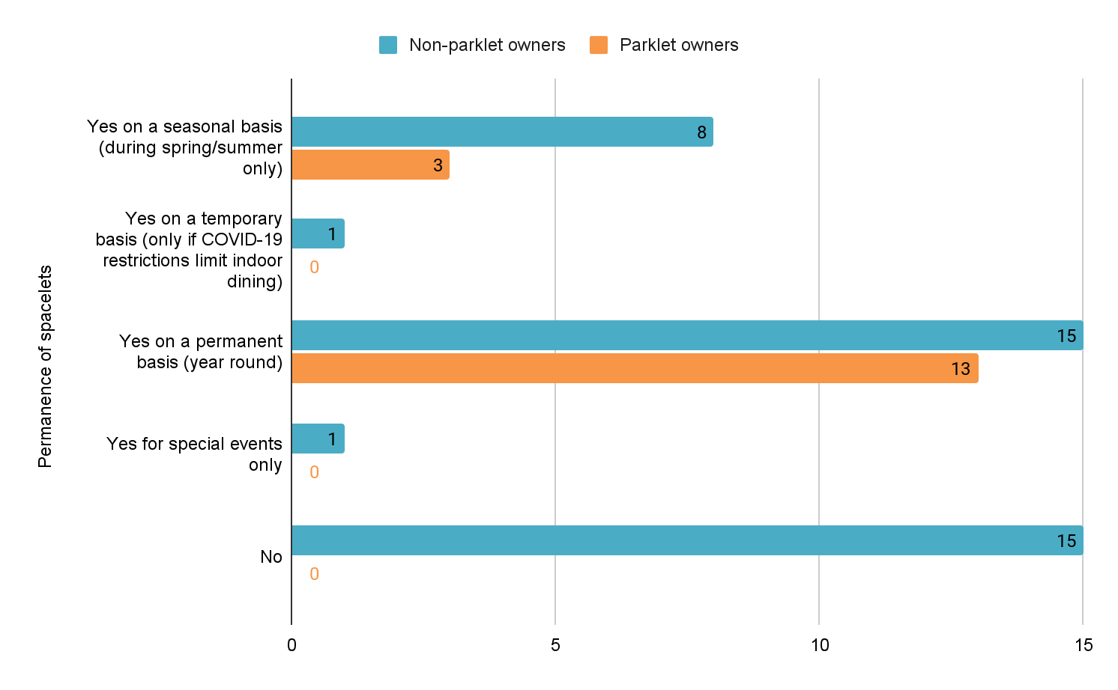
Diagram 10. Level of business support for parklets

Diagram 11. Level of support for parklets by suburb
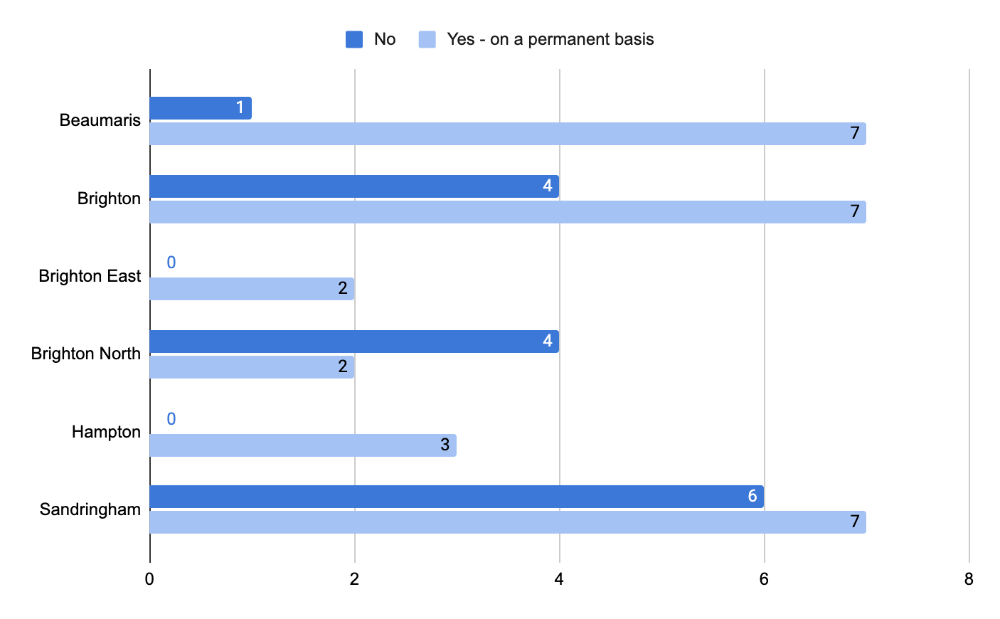
Diagram 11 above shows the support for parklets by suburb, where the support is measured on the extreme levels - i.e ‘No’ and ‘Yes on a permanent basis’ in response to “Would you like to see the parklet program introduced permanently?”. Most suburbs were more willing to keep the program on a permanent basis - except for Brighton North, where there were more responses of ‘No’ (4) than ‘Yes on a permanent basis’ (2). The suburbs where there were no responses of ‘No’ or ‘Yes on a permanent basis’ were excluded from the graph.

Level of support for the concourse
All of the 11 business participants from Beaumaris wanted to see the concourse marquee continued in some form. By far the majority (7) was for it to be there on a permanent basis, with the next best being during summer/spring (2) or during COVID-19 restrictions (2). Even though only two businesses had felt the business had a direct benefit.

Impact on business
Business participants were invited to consider the impacts, positive and negative the parklets have had on their business, community and within their activity centres. The majority of participants 30 (54%) felt the parklets had a positive impact. With only 14 (25%) participants feeling it had a negative impact. Despite this, even businesses that felt parklets had a negative impact on their business, felt that the parklets improved vibrancy of the streetscape with 75% of participants noting this (see Table 5). Likwewise 73% of participants felt that more people had visited the shopping strips as a result of the parklets.
Table 5. Impact on business
Adds to the vibrancy/ambience of the area | Makes the area more of a destination for the community | Improves safety with more people out and about | Reduces risk of catching COVID-19 | Allows more diners to enjoy the area | Does not contribute | Other
41 | 36 | 28 | 30 | 37 | 10 | 2 comments  Staff feel safer  Detracts from area

Reasons cited for this positive impact
- “The parklets have allowed my business to remain viable with the density limits that restrict the total number of patrons we are allowed to serve at any one time.”
- “Attracts people, visitors and community.”
- “It is ridiculous getting rid of the parklets. The pandemic is not going to be over by March 31st!”
- “Very evident the amount of foot traffic in Melrose St has increased substantially which is beneficial to many other traders & this an economic benefit to the village which has mostly been concentrated in the centre only.”
- “Less impact on the environment with less car traffic and the benefits of green footprint.” “We constantly hear the patrons feel like they’re somewhere in the Mediterranean. More room to sit outdoors and include their pets.”
- “It allows us to run our business smoothly, because Covid customers still refuse to sit in close contact with other customers. Parklet provides us that option, it brings a positive vibe for the locals to dine in at our cafe.”
- “...made it a destination and all the concourse businesses benefited out of it."

Reasons cited for negative impact
- "Loss of car parking.”
- “Detracts from the area."
- “My A-Frame sign has been displaced by the cafe tables on the footpath.”
- "Parklets are never used during the day.”
- “Parklets are only used when the weather is fine and the wind is not blowing, which is not often.”
- “Not near our store.”
- “...noise, smoking, drinking out the front of my shop.”
- “A small retail strip cannot afford to turn away customers because of lack of access for its customers, most of whom rely on vehicle access. The centre is for all traders, not just food outlets!”
- “It brings something different to Bay St. It gives it some life and atmosphere which it has been lacking. Very minimal car spaces are lost as we have big car parks in the side street.”

Impact on carparking
A common concern of traders is the amount of carparking available. Council is aware of this balance and wanted to understand the real and perceived impact parklets may have had on carparking. Business participants were asked to consider the impact parklets had had on carparking. Only 8 participants had felt reduced carparking had a significant impact on their business (reduced trade), with 7 receiving customer complaints about the lack of parking availability. The majority of business participants had felt no impact. Table 6 presents these findings.
Table 6. Impact on carparking availability
No  impact | Some impact | Considerable impact | Not sure | Customer feedback
28 | 10 | 8 | 1 | Increased customer complaints about carparking 7 mentions  Increased customers arriving by active or public transport 2 mentions

Impact on revenue
Business participants were invited to consider the financial impacts of the parklet program. Including turnover, staffing and trade. These questions were further along in the survey and answering these questions was skipped by business participants. Out of the 55 responses the number of responses received for each question is shown in brackets (nX).
- Turnover (n16), 10 turnover had increased as a result of the parklet program, four were unsure, one had no impact and one preferred not to say.
- Turnover increase (n8), five had an increase between 0 and 25%; one each for 26 - 50%, 51-75% and 76 - 100%.
- Staffing (n16), 11 felt they would need to employ additional staff to service the parklets, two were unsure, two did not think this was needed.
- Staff increase (n7), four businesses would need one additional employee, one needed two additional staff and two would need an additional three staff.

Future involvement in parklet program
Business participants were invited to consider their future involvement in the parklet program if it was to continue and their willingness to contirbture financially towards the set up and upkeep. These questions were further along in the survey and answering these questions was skipped by business participants. Out of the 55 responses the number of responses received for each question is shown in brackets (nX).
- Parklets outside of business (n24), if the parklet continues six would like one out the front of their businesses, while the majority (n13) would not, four needed to know more about it before committing.
- Contribution towards construction of parklet (n29), the majority of participants (n10) would be prepared to contribute financially towards the set up, eight would like a parklet however are not in a position to contribute, five were not prepared to contribute and six opted not to say. For 11 others this was not applicable as they did not have a food outlet or were a professional service provider “Our store is a fashion retail store so this does not apply to our trading situation”, “would not be used by us.”
- Contribution towards parklet on public land (n30), the majority of participants (n11) were not prepared to contribute to a parklet on public land; eight participants were, seven needed more information and seven provided additional information for most it was not applicable to however there were some comments about making the fee fair: “We don't disagree with the principal of contributing to the cost of building permanent parklets. Is it realistic to charge full price to 'new' access to road spaces when existing operators have been 'gifted' the same type of space via Council decisions of the past to remove parking and widen footpaths? I.e Dendy Deli, Pantry Brighton etc?”

Level of support by community
Findings by community participant is broken into two categories:
- residential community
- visitors, live outside of Bayside.
Both stakeholders were asked about:
- what aspects of outdoor dining appealed to them
- if outdoor dining had an impact on business and why that was
- if outdoor dining had negatively impacted on carparking access
- if they would ultimately like parklets introduced more permanently.

Appeal of outdoor dining
Participants were asked which parts of outdoor dining appealed to them most. They were able to select from a pre populated list which included ‘no appeal’ as well as provide open ended response to ‘other’. Table 7 shows the responses to the prepopulated responses.
Table 7. Tally of responses
Adds to the vibrancy/ambience of the area | Improves my feeling of safety with more people out and about | Reduces risk of catching COVID-19 | Adds more tables to my favourite dining venue | No appeal at all | Other
694 | 444 | 512 | 515 | 43 | 48 comments

There were 48 responses to ‘other’, comments varied in length from a short sentence to longer paragraph. A coding frame was developed to categorise the response into key areas. Some comments have been tagged more than once, depending on the level of detail provided. Table 8 shows the themes and lists the type of topics covered by each theme and the count of comments for each theme.
Table 8. Themed appeal detail
Topic | Community feedback
Vibrancy  (19 mentions) | Atmosphere  Cafe culture  European vibe  People outdoors (sounds, visual)
Welcoming  (16 mentions) | Come along in groups  Bringing pets  Flexibility to bring in food, or personalise food from different cafes
Safety  (12 mentions) | Reducing risk of catching COVID-19  Slowing down traffic and taking cars out of centres  Freeing up pathways as outdoor dining off paths
Comfort  (6 mentions) | Enjoying outdoor environments with shade  Comfortable tables and chairs
Supporting business  (3 mentions) | Knowing that it is having a positive impact on businesses  Feeling positive about Council
Negative (no appeal at all)  (3 mentions) | Increased crowds  Loss of carparking  Underutilisation

Community quotes
- "Provides much needed shade to comfortably sit outside safely to catch up with others nearby the shops."
- "Love the idea of converting car space into people space. I would love for our towns to be more people-friendly and less car-dominated. Even better if these outdoor dining areas incorporate urban greening, even if it's just pot plants."
- "Provides a safe environment for people to meet socially, be part of the community, connect with others which is so important for people’s emotional and mental health."
- "Stops vehicles from parking next to where I’m dining - hence I’m breathing less vehicle emissions. Reduces vehicle related emissions and air pollution for all diners , so has positive mental as well as physical health benefits."
- "It opens up the pathways to make it safer to move and to keep good distance apart"
- "I love being part of a cafe culture that has outdoor seating as an option. I also really like that cars are not parking beside me where I sit in a parklet. With so much new development coming in Hampton, we need this."
- "Able to enjoy fresh air and less noise from cafes and just enjoy being outside. Good cover for all weathers."
- "It allows people to be outdoors and enjoy the fresh air. We believe this encourages people to support our local hospitality venues."
- "Place making engaging with broader community - social connection very much needed"
- "Relaxed, in the concourse people can bring food from different venues- gives kids an area to meet friends, the number of elderly gathering has been super- these people may otherwise have been isolated."
- "Brings people together, beautiful atmosphere, stronger sense of community engagement"
- "Parklets have some appeal when utilised in conjunction with appropriate dining venues, but zero appeal when used by a bar that is only open late afternoon/evening and the car spaces sit vacant and unable to be used for parking all day long."

Impact on business
Participants were invited to comment on the impact they believed parklets were having on businesses. They were invited to select from a pre-populated list, results are shown in table 9. The majority of participants felt the parklets were having a positive impact on trade for businesses. Responses are split by connection to Bayside to show that visitors had an overwhelmingly positive response to parklets, although most residents also held the same sentiment.
Table 9. Perceived impact on business
Impact | Residents | Visitors
Negative | 27 | 1
Somewhat negative | 16 | 0
Neutral/no change | 12 | 0
Somewhat positive | 40 | 0
Positive | 619 | 38
I’m not sure | 6 | 0

Participants were then asked a follow up question, why do you think it has or will have this impact? There were 612 responses to this question, responses varied in length from a short sentence to longer paragraph. A coding frame was developed to categorise the response into key areas. Some comments have been tagged more than once, depending on the level of detail provided. Table 10 shows the themes and lists the type of topics covered by each theme and the count of comments for each theme.
Table 10. Reason for perceived impact
Topic | Community feedback
Vibrancy  (311 mentions) | Atmosphere  Cafe culture  European vibe  People outdoors (sounds, visual)
Welcoming  (181 mentions) | Come along in groups  Bringing pets  Flexibility to bring in food, or personalise food from different cafes
Supporting business  (121 mentions) | Knowing that it is having a positive impact on businesses  Feeling positive about Council
Safety  (115 mentions) | Reducing risk of catching COVID-19  Slowing down traffic and taking cars out of centres  Freeing up pathways as outdoor dining off paths
Negative (no appeal at all)  (68 mentions) | Increased crowds  Loss of carparking  Underutilisation
Comfort  (53 mentions) | Enjoying outdoor environments with shade  Comfortable tables and chairs
Environmental improvement  (25 mentions) | Reducing vehicle use in the centre  Taking cars out of the centre  Cooling streets by reducing asphalt  Cleaner air

More detail about each of these areas is provided below.
Vibrancy
Many participants felt that the addition of parklets helped to increase the feel and atmosphere of the area, especially in streets with multiple parklets. This increase in atmosphere subsequently helped to create a higher sense of community feel, as reported by a large number of participants.
Community quotes
- “The outdoor dining creates a great street culture.”
- “Creating an ambiance means more people are likely to hang around and check out more local shops rather than just get their coffee and go.”
- “Adds some atmosphere to our local shopping strips and it is nice to see people out and about, making the most of what Bayside has to offer.”
Welcoming
Another sentiment shared amongst participants was that parklets are more welcoming for patrons as it allows more options when out with pets or larger groups, while also offering a large variety of selections to choose from.
Community quotes
- “People can grab take-away food and coffee etc. and meet in small or large groups out in the fresh air.”
- “You are not restricted to one food outlet when with a group… everyone gets what they like and can enjoy each other’s company.”
- “Creates community, brings the town to life, can dine with pets…”

Supporting businesses
A very common opinion expressed by participants was that parklets support local business and allow hospitality to excel in the area. Those against the idea of parklets may argue that the parklets detract from other industries, although the majority of participants felt that the positives heavily outweigh the negatives.
Community quotes
- “Small businesses really need to continue to operate in our area given pressures of larger retail centres. Promote our dining/cafe experience as unique.”
- “Helps businesses with limited dining space to offer socially distanced dining options.”
- “Help support the traders that have done it tough for the last two years.”

Safety
Many of those in favour of parklets mentioned how outdoor dining allowed patrons to be COVID-safe, and how these settings removed risks associated with indoor dining. Some of those opposed to parklets argued that it was less safe on pathways and in the parklets themselves due to the increased vehicle and foot traffic in the area.
Community quotes
- “It allows more safe space for diners…”
- “...Increases sense of safety, reduces risk of infection with more space to dine outdoors, adds more space for people to enjoy.”
- “Dangerous”
- “I do not wish to eat and drink in close proximity to vehicles”

Negative (no appeal at all)
Many of the participants opposed to parklets had gripes with the perceived loss of car parking in the area, with others mentioning the loss of visual amenity in the streets and increased crowds.
Community quotes
- “Parklets are not being removed when the restaurants are closed. Often they only need to be there in the evenings and at night but currently take up parking spaces during the day while the restaurants are closed.”
- “Too many people, too little space on footpaths and a reduction in car space will encourage shoppers to shop in larger/non local precincts.”
- “They deter pedestrian shoppers and limit access to footpaths. Infringe on scarce parking spaces for other traders. Unattractive and look tatty.”
- “Taking more parking spaces is unfair to other traders and to ratepayers.”

Comfort
One of the perceived benefits of parklets is the addition of a level of comfort to outdoor dining with the inclusion of shade and spacious seated areas.
Community quotes
- “Good to have space around you.”
- “I love the outdoor spaces to sit. I feel like we need even more of them!”
- “Allows people to enjoy eating out while still not 100% comfortable being indoors eating with strangers.”

Environmental improvement
With the reduction of parking, less cars are used on roads containing parklets which may lead to more members of the community considering a different, more environmentally friendly form of transportation. This can also reduce the amount of fumes and ensure cleaner air in areas where there might be outdoor dining.
Community quotes
- “...Promotes being outside and active and less cars on the road.”
- “Improves air quality around local shops with less vehicle traffic.”
- “These spaces must stay. It not only keeps businesses operating safely but it encourages active transport use. For instance, we often cycle to Sons of Mary and feel more comfortable to be in the outside area in our cycle gear.”

Impact on carparking
Participants were asked to indicate how they felt about outdoor dining parklets occupying car spots, with the results shown in table 11. The majority of participants felt that parklets occupying carspaces did not cause an inconvenience. With only 7% (57) feeling significantly inconvenienced by parklets, without seeing the benefit of this program.

Table 11. Impact on carparking
How do you feel about outdoor dining parklets occupying car spaces? | Total
It does not inconvenience me at all | 448
It can be inconvenient, but I support outdoor dining and value this over a reduction in parking spaces | 177
It is a little inconvenient to me | 72
It is very inconvenient to me | 57
Initially, I did not support the occupation of parking spaces by parklets, but I became accustomed to the change | 12
I’m not sure | 11

The majority of community participants indicated that the parklets occupying car spaces does not inconvenience them at all (448 responses), while the second most popular response was that people value outdoor dining over the reduction in parking (177 responses). A smaller amount found the parklets and loss of parking a little inconvenient (72 responses), while less found it very inconvenient (57 responses). A few participants stated that they were now accustomed to the change (12 responses), and an additional 11 said that they were unsure how they felt. There were six other comments, with approximately half of the responses indicating that they felt that roads should be left for cars and they don’t want to dine in close proximity to them, while the other half felt that people need to get used to the changes.

Introducing parklets permanently
In Diagram 12 the level of support for parklets is shown by suburb. The size of the bubble corresponds to the number of participants from each suburb, while the colour of the bubble represents the average willingness of a participant from each suburb to make parklets permanent.
Yellow represents ‘Yes on a temporary basis during Summer/Spring only’, while green represents ‘Yes on a permanent basis (year round)’. None of the suburbs had an average below the seasonal level, showing that the feedback was extremely positive. On average, participants from Brighton, Black Rock and Beaumaris want to see parklets introduced on at least a seasonal basis. The average participants from Sandringham, Hampton, Hampton East, Cheltenham and Brighton East want to see parklets introduced on a permanent basis.
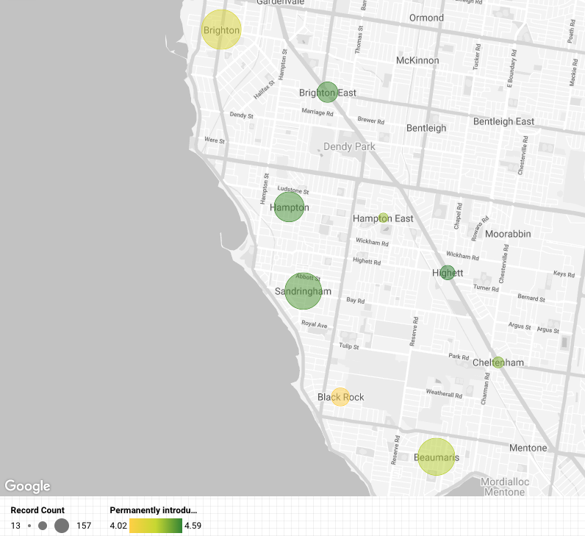
Diagram 12. Support for parklets by suburb

Moving forward with the Parklet Program
While the majority of participants were supportive of the parklet program continuing in some format. Many have offered feedback that can be used to strengthen the effectiveness of the project, reduce negative impacts and create a larger positive impact on the community. Summarised below is feedback collected from the community survey in response to Do you have any other comments you would like Council to consider about parklets?
There were 349 responses to this question (n349), all comments were open ended and varied in length from a short sentence to longer paragraph. A coding frame was developed to categorise the response into key action areas. Some comments have been tagged more than once, depending on the level of detail provided. Table 12 shows the themes and lists the type of topics covered by each theme and the count of comments for each theme.
Of these comments 136 offered their support for the parklets, reiterating the improvements seen as a result or their support of Council’s initiative. Another 19 comments felt that parklets also helped to further Council’s agenda around climate change, sustainability and reduced vehicle use. In this section we will focus on those comments coded Future Considerations.

Table 12. Community Suggestions/Feedback
Topic | Community feedback
Expand program  (101 mentions) | Increase the reach of parklets into other areas  Continue on with the program  Continue on with specific parklets (including Concourse Marquee)  Continue permanently  Continue seasonally  Expand onto the foreshore temporarily
Businesses need more support  (34 mentions) | Parklets increase the footprint traders can trade from  Traders needed to be supported to upgrade businesses to be COVID safe  Council needs to better promote businesses to encourage trade
Future considerations | Improve look/ feel/ function (37 mentions)  Look for locations where carparking or access is not greatly affected (33 mentions)  Seasonal parklets (24 mentions)  Create a larger barrier between road/selection of location/traffic calming (21 mentions)  Provision of additional carparking/signage (18 mentions)  Charge businesses appropriately, consider allocation (15 mentions)  Provision of rubbish removal, cleaning (10 mentions)  Monitoring and engagement continual (5 mentions)  Who can use the parklet (3 mentions)
Negative impacts | Negative impact on vehicle movement and amenity (22 mentions)  Perceived negative use of public funds (5 mentions)

Improve look/ feel/ function
If the parklets are to continue some participants would like to see the look, feel and function of the parklets improve. Community suggestions included:
- Heating and protection from elements
- Comfortable furniture (anti picnic table sentiment, and picket fences)
- Planting and greenery
- Music and performances (where the size is large enough)
- Iconic feel matched to the suburb and location
- Play equipment.
Community quotes

“These parklets can be improved to look more appealing by having floral/plant or decorations rather than concrete blocks and plastic fencing.”
- “… even in colder months … there can be heating and wind protection and deliver an ambiance that is good for Bayside areas and brings people to the area.”
- “Christmas decorations would be very appealing to get us all in the festive spirit.”

Parklet location selection (carparking and access)
For the introduction of future parklets, some participants felt that consideration to carparking availability and ease of pedestrian access should be central to Council’s decision. Community suggestions around this included:
- Set up parklets within carparks where Council knows there is higher availability of carparking or decreased use.
- Set up parklets further away from disabled carparking to ensure access.
- Set up parklets where footpaths are wider and there is reduced conflict between pedestrians and wait staff.
- Set up parklets in parks and outdoor areas, over carparks.
Community quotes
- “​​Only where parking is not compromised …. I use disability parking spaces and they are often unavailable and I have to walk a significant (for me) distance from the car ...”
- “Only consider parklets which do not eliminate parking.”
- “... restricted to areas that do not block the footpaths and thoroughfares. Restaurants like Bossyboots in Bay St Brighton and Mr & Mrs P in Bay St, Brighton, continually have tables and chairs spill out onto the footpaths as well as drinks trolleys against shop windows which block the footpath.”
- “Parklets are good if there is sufficient free parking behind the street. Mornington has done an amazing job with their walking street.”
- “Make areas for dining separate from footpaths to reduce current encroachment on footpaths and difficulty for pedestrian traffic.”
Seasonal parklets
Those in support of parklets and those opposed felt that adding parklets seasonally into Bayside’s dining mix might be a nice compromise. This would have the added benefit of reducing the conflict between those driving and those dining and making the most of Melbourne’s climate.
Community quotes
- “Given Melbourne’s climate, seasonal outdoor dining feels like a good compromise. It indicates the changing of the seasons and would most likely be used in Spring/Summer”.
- “Whilst it makes sense to set up parklets for spring and summer when the weather is better, the chances are that covid numbers will increase again in winter and dining outside will either be a safer option or will increase capacity for venues if restrictions are re-introduced.”
- “Given our weather there’s no point over winter but in warmer months it’s nice to have the outdoor dining…”
- “I think they are fabulous - happy to see them year round or else removed for the winter months - I can see how some additional street parking might be helpful for quick access to the shops in the winter.”
- Maybe reduced capacity in autumn/winter months instead of an all/nothing approach. These are great and we need more of them!”
Reducing risk from vehicle
Going forward some participants felt that Council needed to pay more attention to separating vehicles and people more to both increase the enjoyment of parklets and reduce risk. Community suggestions included:
- Consider installing larger barriers between parklets and the road.
- Locating parklets on minor roads rather than major roadways.
- Positioning parklets within open spaces rather than roads.
- Locating parklets away from bus stops or taxi stops to reduce emissions breathed by diners.
Community quotes
- “Accessibility that is free of trip hazards. Hard barriers to keep people safe so close to the road and fast moving vehicles. Speed limit reduction adjacent to parklets.”
- “I think it is a dangerous concept with traffic and cars so close to people. I would not like to sit so close to traffic and car fumes.”
- “Main concern is the risk of accidents involving vehicles colliding with the area, and exhaust from vehicles parked nearby especially those left running while the driver pops in to have their hair done, or it’s just too hot to turn off their air conditioning.”
- “Think it would be great if on certain days or even permanently certain streets (i.e. Hampton St, Sandringham etc) would be blocked completely for cars and become a pedestrian precinct. Of course this would require traffic management and larger parking houses around but would create beautiful centres.”

Supporting vehicle use
Parklets needed to be planned knowing the people are still going to drive to the centre. Some participants were also concerned that the future growth and development of the area was going to squeeze carparking spaces further. Community suggestions included:
- Better signage to existing carparking.
- Continue to lobby developers to include carparking in developments.
- Build a multistory carpark in transit areas.

Community quotes
- “The construction of multiple apartment buildings in Bayside and the proposed construction of many more on the former CSIRO site have added and will continue to add many more residents. Notwithstanding this increase in population there have been no additional car parks added…”
- “... the parklet program, which I congratulate the Council for investigating, should be given large prominence, and alternative rear secure park spaces constructed for visitors to the centre.”
- “We are losing so many car spaces through developments being approved without sufficient parking. Would like to see parklets but lack of parking through Bayside is already a significant issue and this will make it even harder...”
- “I realise that car parking spaces can be at a premium at times, certainly with the huge increase in new accommodation, I hope that Bayside Council has also planned appropriate carparking?”

Charge businesses/allocate appropriately
Allocation of use and costs was raised by a few participants. Some participants were eager to see other traders and businesses using the parklets (takeaway food, homewares, art work); while others wanted to make sure that this was not be funded by Council (and therefore community).
Community quotes
- “...parklets should therefore be regarded as a temporary stop-gap measure AT BEST - and only whilst being funded by taxpayers generally through the State Government. Beyond that, council should have no ongoing role and the practice should be abandoned on, say, 1 May 2022 as business conditions will hopefully have returned to normality and the winter lull approaches.”
- “Only benefits cafes & restaurants & makes things harder for other retailers.”
- “...the impact of parklets must be considered in the light of their effect on other traders, not just those whose premises they immediately serve. A parklet outside a cafe may benefit that cafe but could result in a loss of trade for another business whose customers are unable to access the vicinity due to fewer parking spaces overall.”
Provision of rubbish removal, cleaning
Some noted that rubbish within and around parklets had increased, particularly in Beaumaris where more people were bringing in food from outside to enjoy in the marquee. Some also noted that tables were not being cleared or wiped down and could therefore increase the risk of COVID-19 and attraction of pests.
Community quotes
- “Rubbish is of concern. Often bins are full, so rubbish is left behind.”
- “More bins required - unfortunately some people don't act responsibly towards the space and the comfort of others.”
- “Would like to see the council clean the concourse tables. When Covid first started people were wandering around Bayside cleaning random things. Now the tables are dirty and never seem to be cleaned…”
- “Retail providers are poor at hygiene, too much pollution on streets anyway. Council needs to do many more health audits of cafes and bars.”
Monitoring and engagement continual
With any future program some wanted the project to be continually monitored to understand if the program was having an impact on the community or traders. Others wanted traders to be engaged during the parklet selection process.
Community quotes
- “Regarding parklets year round, I would say it should be at the discretion of the business owner, based on demand.”
- “...More targeted consultation is needed on whether the shelter is needed, what it would look like, where it would be built and how many people would it accommodate before a decision is made regarding the provision of a permanent shelter…”
Who can use the parklet
A few participants spoke about those that were, or weren’t allowed to use parklets. There were two comments that suggested unvaccinated patrons should be allowed to dine in outdoor parklets. Likewise there were comments related to if dogs should be allowed to enter outdoor parklets with their owners. Both for and against.

Project evaluation

Evaluation of engagement program
While providing feedback on the project some participants provided feedback on this engagement program. Some business participants felt that the questions within the business survey were leading, meaning that they were phrased to elicit a positive response rather than being neutral to elicit a range of feedback. No examples were provided just a sentiment expressed in the ‘Other’ comments.

In the Community Survey a few felt that the Beaumaris Marquee should have had its on survey as it is very different to the other parklets and there was not room to provide a detailed response. Example of feedback provided:

The Beaumaris Marquee is not close to a busy road. I do not like sitting at tables on busy roads because of the pollution and constant noise. Therefore, the Beaumaris Marquee is completely different from the parking space parklets. This is not a very helpful survey for providing feedback on the BEAUMARIS CONCOURSE MARQUEE. I do not like the look of the present marquee, it is tacky and has unsightly seating. During lockdown, people were not allowed to congregate or sit down but they did under the marquee. The marquee encouraged the people to break the COVID regulations. The 2016 Beaumaris Concourse Streetscape Draft Masterplan Report included a shelter, rocks and gravel pathways. After community consultation none of these features were included and the green space was left largely as it was before the report was written. The respondents to the masterplan did not want these changes. More targeted consultation is needed on whether the shelter is needed, what it would look like, where it would be built and how many people would it accommodate before a decision is made regarding the provision of a permanent shelter. COVID may have changed the opinion of the majority of the residents.

Evaluation of engagement communication
The communications approach used to promote this project was successful in notifying people about the project. The objectives of the approach were to:
- Raise awareness among the residential and business community of the project
- Encourage stakeholders to act (visit the website, complete the survey, promote it).
Table 13 evaluates the approach against these desired objectives.
Table 13. Impact of the engagement communication
Impact Evaluation: | Commentary
Raise awareness among the residential and business community of the project. | Newsletter was sent to 8,797 subscribers  Trader email sent to 1629 traders (twice)  Social media posts reached 21,251 (paid, organic) with 13,000 Bayside community members
Encourage stakeholders to act (visit the website, complete the survey, promote it). | Engagement with social media post was 9.5%, which is considered high good is 5%. Action taken from social media posts:  - 430 link clicks  - 4 shares (user promotion)  - 120 action (reactions/comments)  Action taken from newsletter was 1% for the residential newsletter which is considered low (3.99%) and 4% for traders which is considered average. Action taken from newsletter:  - Trader email opens 644 (email 1) and 720 (email 2). Clicks 44 (email 1) and 57 (email 2).  - Residential email opens 4179 and clicks 44.  Click throughs to the Have Your Say website across channels:  - Emails to traders 62  - Onsite signage 56  - Facebook 38  - Email to residents 9.

