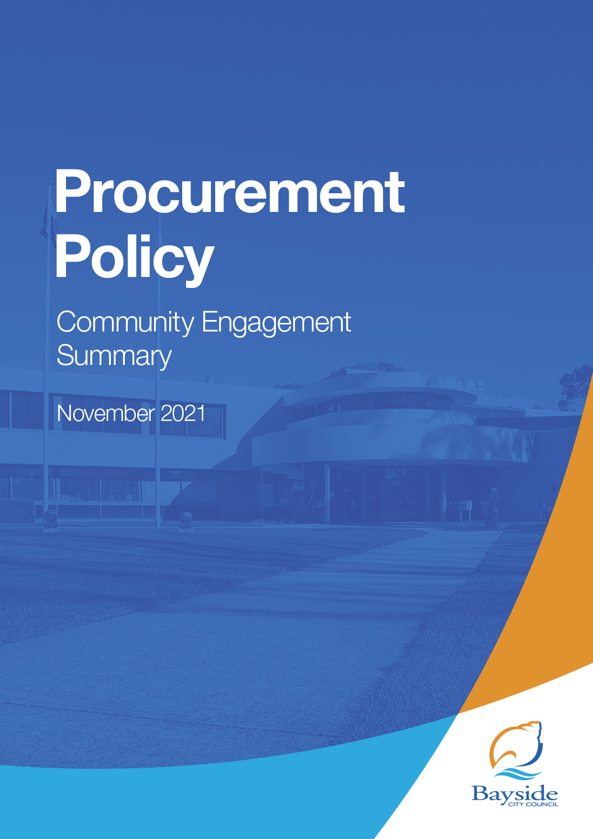

Background
A procurement policy sets out the key principles, processes and procedures applied to all purchases of goods, services and works by Council. All Councils are required under sections 108 and 109 of the Local Government Act 2020 (the Act) to prepare, adopt and comply with their procurement policy.

Bayside’s draft Procurement Policy is based on local government best practice and additional requirements set by the new Local Government Act 2020 (the Act), including:
- open and fair competition
- collaboration and shared services with neighbouring Councils
- method of advertising procurement opportunities
- Council’s tendering thresholds.
The new policy also includes information specified in the Procurement Best Practice Guidelines including:
- sustainable procurement
- emergency and disaster provisions
- environmental sustainability/circular economy
- social procurement.

Consultation process

Consultation purpose
Bayside City Council developed a new draft Procurement Policy in accordance with the Act and sought feedback on the draft policy from 28 October – 12 November 2021 for the consideration of Council.
The consultation was designed to provide stakeholders, including current suppliers, and the broader community with the opportunity to provide feedback on proposed Policy changes.

Consultation methodology
The tools and techniques selected for this project were informed by the project content, stakeholders and type of feedback sought.

Key methods for gathering feedback
- online engagement through Have Your Say, including opportunity to ask questions
- surveys in accessible formats available on request.

Table 1: Engagement activities, timeframes and outcomes

Details | Activity
28 October – 12 November  67 visitors  3 contributions | Have Your Say website  Project information and online survey hosted on the engagement platform Have Your Say, including opportunities to ask questions and provide feedback. No questions were received

Figure 1: A summary of engagement via the Have your say platform
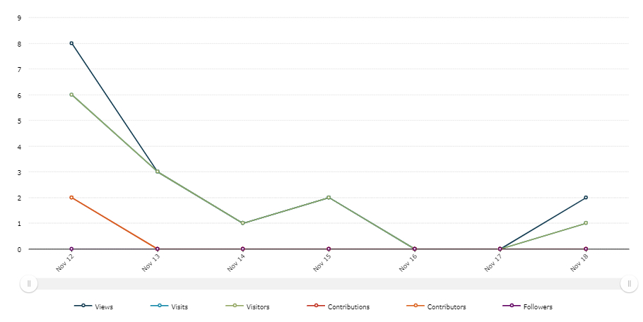

The spikes in visitation (mid-blue and green lines) correspond with the distribution of communications, in particular direct email.

Key tools for communicating the project

- direct email to Have Your Say subscribers and key stakeholder groups such as suppliers
- website news story and This Week in Bayside e-newsletter
- social media.

Table 2: Communications activities
Timeframe | Activity and Outcomes
28 Oct – 12 November 2021 | Communications for this project directly reached approximately 10,000 community members:  - email sent to 200 suppliers and contractors  - email notification to Have Your Say members (1,061 recipients)  - Council website news item and e-newsletter, This Week in Bayside (4) (8,590 recipients)  - Council social media channels (1 post, 10 likes, 0 comments)

Participant profile
The consultation was open to all Bayside residents and the wider community, which includes those who they live, work, play, shop or visit in Bayside. No specific demographic data was requested or collected, as it was not considered relevant to this engagement.
Two key identified stakeholders included Bayside City Council suppliers and contractors who were identified as likely to have an impact from and interest in changes to our Procurement Policy.
Of the 200 emails sent to suppliers and contractors, none chose to provide feedback vis our online consultation. Two respondents reported they may be interested in supplying goods or contracting to Council in the future, and two identified as Bayside residents (one respondent was both a resident and interested in supplying goods).
Figure 2: Participant connection to Bayside
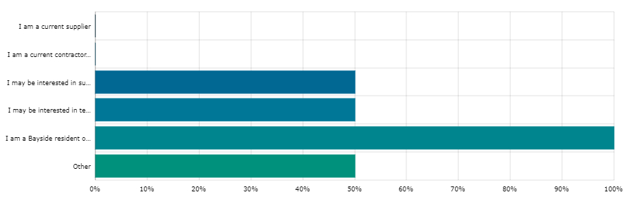

Consultation findings
The following section summarises the key themes which arose in community feedback on the draft Procurement Policy. In the interest of stakeholder and community privacy, individual quotes have not been included within this public document. Where there was more than one mention of a topic or item, the number of mentions has been specified in brackets and italics.

Support for actions
There was limited but specific feedback received from the 3 respondents. These comments predominantly related to the sustainability section of the policy.

Item-specific feedback

What is your overall level of comfort with the draft Procurement Policy
Of the three responses, one person was ‘ok with it’, and two had some reservations.
One respondent did not agree with the declaration of a climate emergency.
The other two responses related to social procurement factors. One expressed a desire to further strengthen the policy in this area. The other wanted to see more in the policy related to modern slavery and forced labour.

Would you suggest any changes to the draft Procurement Policy
A range of specific concerns were raised during the consultation regarding this item:
Topic | Community feedback
Social and sustainable procurement | Change the title to Social and Sustainable procurement Policy  Proposed wording changes to several sections related to sustainable procurement elements  Consider changing the at its discretion criteria of 10% for social procurement to a discretionary minimum 5% weighting in evaluation of all proposals for environmental, social and economic factors
Modern slavery | Ensure checking of labour policy and practices of suppliers

Project Evaluation
This report presents the findings from the analysis of the community feedback gathered from 28 October to 12 November 2021 for the draft Procurement Policy.
The low number of contributions via the Have Your Say website indicates a low level of interest from community members, including current suppliers, regarding the Policy.
Communications activities to promote participation reached approximately 10,000 community members.
The main communication tool to the key target audiences (suppliers and contractors) was direct email, ensuring that they were aware of the proposed changes to the Policy and the opportunity to participate.
There were 67 visitors to the Have Your Say website project page, resulting in three contributions and two people subscribed to the project page for updates.
Figure 3: Interaction with the project on the Have your say platform
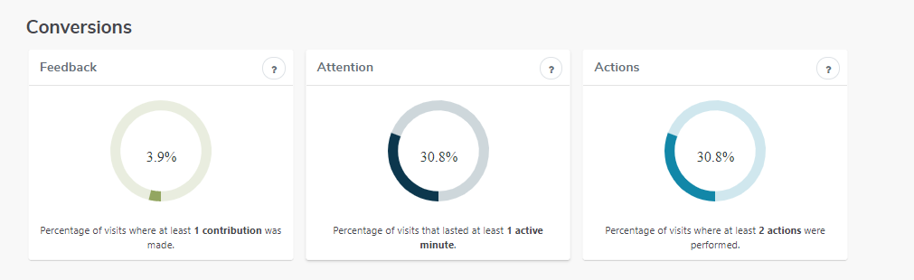

Of the three people who contributed, 66.7% found the information mostly easy to understand and 33.33% (1 person) said the information was very hard to find and understand.
An Engagement Plan Overview was published on the Have Your Say website outlining the process for engaging on this project.

Next steps
It is expected that Council will consider community feedback at its meeting on 21 December and decide whether to adopt the draft Procurement Policy.

The agenda for this meeting, including the community engagement report, will be published on 15 December 2021 via Council's website. Project subscribers will be notified of the results of the engagement and the Council report at this time.

