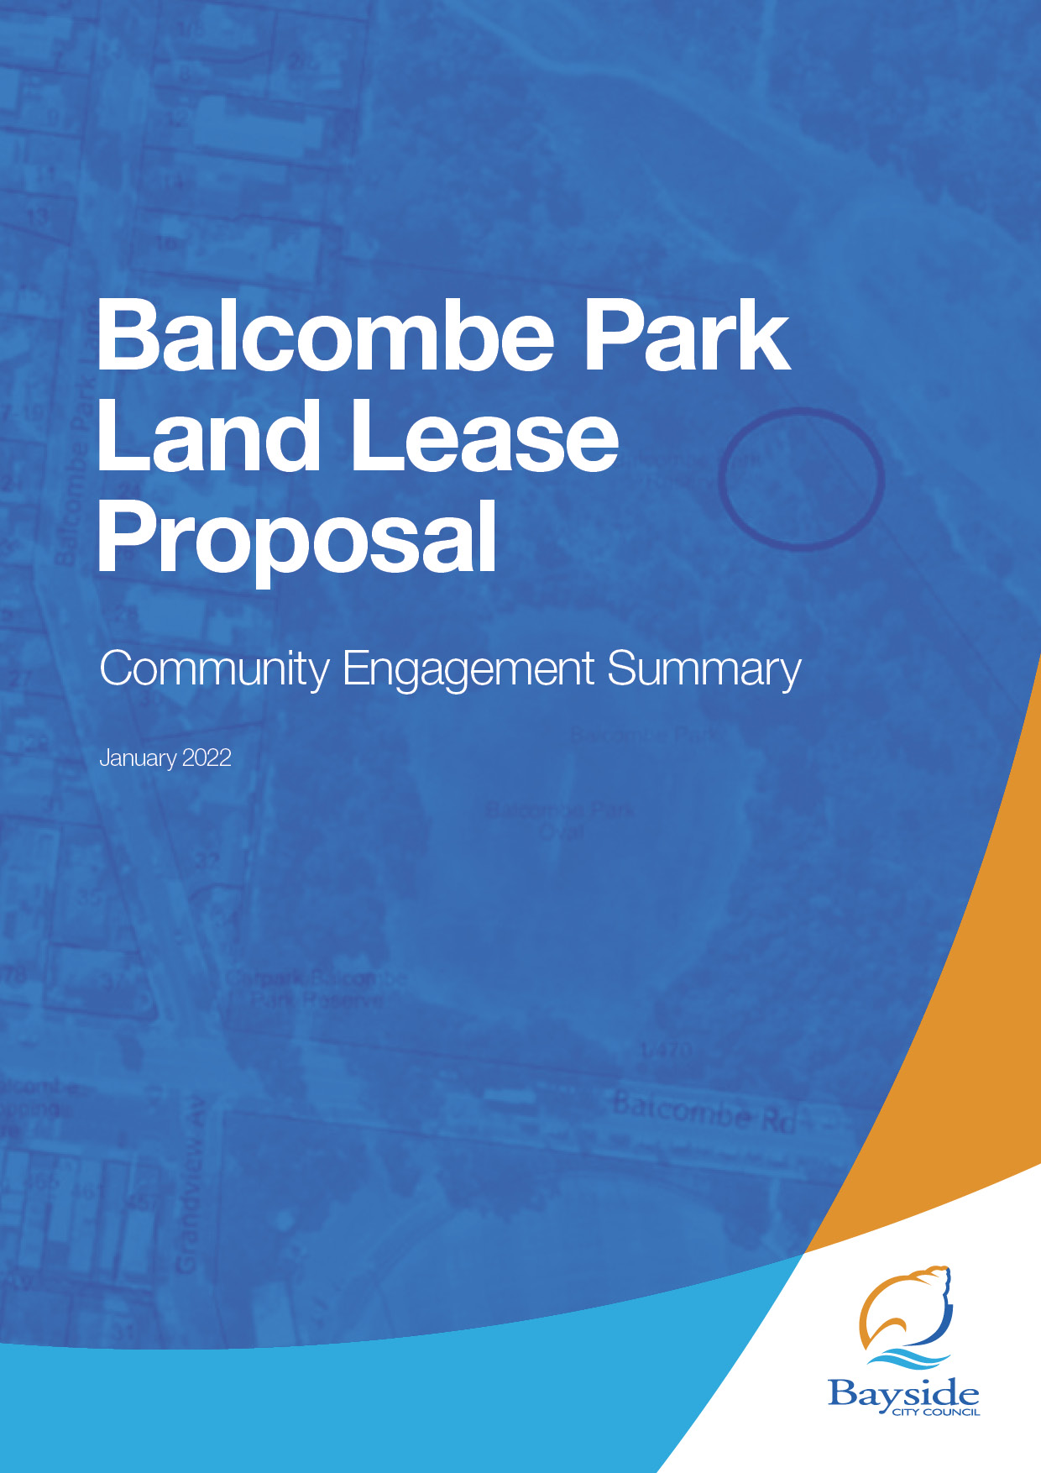

Background
This document provides a summary of stakeholder and community feedback Council’s intention to renew the lease for a small piece of land in Balcombe Park, Beaumaris. The land measures 4.5m x 6m (27m2) and is hidden deep into the trees of the park, on the boundary of the neighbouring golf course.
The land has a brick structure on it which houses telecommunications equipment and cabling that services a telecommunications tower in an adjacent building. This structure has been there for the past 10 years pursuant to a previous lease. The proposed sum of the lease is $20,000 per annum for 10 years with options to renew for two further terms of five years each.
The lease is not for the tower building or tower as that is a sub-lease arrangement between Telstra and Optus that Council is not a party to.

Consultation process

Consultation purpose
In accordance with Council’s Community and Stakeholder Engagement Policy 2021 and Section 115 of the Local Government Act 2020, Council invited public feedback between 22 December 2021 – 9 January 2022 about a proposed decision to renew the lease with Optus for the use of Council land in Balcombe Park for a period of 20 years.

Consultation methodology
The tools and techniques selected for this project were informed by the project content, stakeholders and type of feedback sought.

Key methods for gathering feedback
- online engagement through Have Your Say, including details of a contact person to email or call for further information
- opportunity to make an anonymous submission, either to be dropped off at the Corporate Centre or posted
- survey in accessible formats available on request.

Figure 1: Engagement activities, timeframes and outcomes
Details | Activity
22 December 2021 – 9 January 2022  81 visitors  18 contributions | Have your say website  Project information and online survey hosted on the engagement platform Have Your Say, including opportunities to provide feedback or contact the Project Officer for further information or to provide feedback over the phone or via email.  One email and no phone calls were received

Key tools for communicating the project

- direct email to Have Your Say subscribers and key stakeholder groups such as schools, sporting clubs that use Balcombe Park and the neighbouring golf course
- letterdrop to neighbouring residents.

Timeframe | Activity and Outcomes
22 December 2021 – 9 January 2022 | Communications for this project directly reached approximately 2718 community members:  - public notice posted on Council’s website  - letterdrop to 15 neighbouring residents  - email notification to Have Your Say members (2697 recipients which was opened by 1335 people)  - 6 emails sent to local schools; sport clubs that use the grounds at Balcombe Park; and the neighbouring golf club.

Participant profile
This consultation was targeted to residents and organisations that live close to the site of the proposed lease.
The only specific demographic data that was requested was the respondent’s connection to the site as displayed in the graph below.

Figure 2: Respondent connection to the site
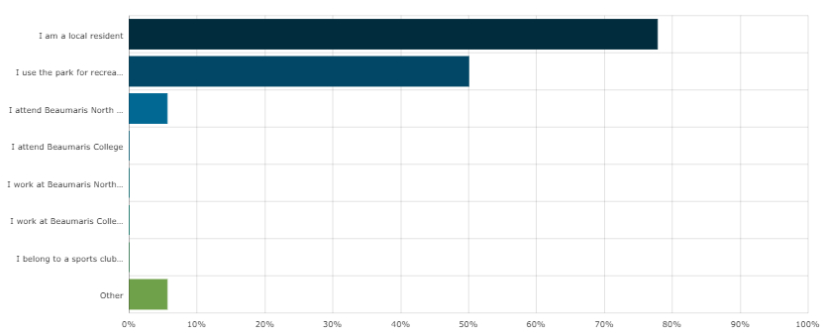

Consultation findings
The following section summarises the key themes which arose in community feedback on the Balcombe Park Land Lease Proposal. In the interest of stakeholder and community privacy, individual quotes have not been included within this public document. Where there was more than one mention of a topic or item, the number of mentions has been specified in brackets and italics.
On the Have Your Say page regarding the proposal the page visitors where asked the following question: Are you comfortable with Council’s intention to renew the lease with Optus for the piece of land in Balcombe Park? The options to respond to the query was yes, no and I’m not sure. There was a total of 18 contributions which can be summarised as follows:
Topic | Community feedback
Renew the Lease | 12 mentions
Do not renew the Lease | 4 mentions
I’m not sure | 2 mentions

Support for actions
The overall feedback received on the Have Your Say page was positive to the proposal with 66.6% (12 of the 18 submissions) in support. Only 22.2% (4 of the 18 submissions) opposed to the proposal. One submitter called the proposal a sensible pragmatic decision and another submitter in support expressed that the Lease should be renewed since it has a low visible impact and provides residents with required mobile and internet services.

Item-specific feedback
Via the Have Your Say page submitters had the opportunity to provide Council with their concerns and comments regarding the proposal. The feedback provided by the 18 submitters is summarised below:
Topic | Community feedback
Site | Monitor for graffiti (2 mentions).  Concerns about noise levels.  Investigate other site options not encroaching on green space for access/utilisation.  The infrastructure is necessary for the community and has a low visible impact.
Lease | Leasing fee too low.  Safety inspections conducted by the tenant as a condition to the Lease.  Require Optus to upgrade the reception in the area.  Should not allow for private entities utilising Council assets and land.
Community engagement | Community engagement not required for the proposal.

Majority of the concerns and comments were made from the submitters not supportive of the Lease renewal. There were some suggestions of conditions to add to the Lease such as safety inspections requirement to ensure that the surroundings of the site are safe and monitor for graffiti on the structure so that it can be promptly removed and require the telecommunications company to upgrade the signal strength in the area which in the opinion of the submitter is poor.
One submitter who were not sure if the Lease should be renewed stated an understanding that the telecommunication equipment is required but consider it to be noisy and was hoping that there is some course of action to be taken to reduce the noise levels.
From the supporting submitters there were one comment stating that the infrastructure is required by the community as it provides both internet and telephone service for the residents and the structure is not easily visible. Another supporting submitter understands Council’s commitment to engage the community in decision making and increase the transparency however did not see the need to involve the community in this particular decision.

Project Evaluation
The response to this consultation was reasonable considering the level of interest in a project of this kind.
49.5% of people opened the email that was sent to Have your say subscribers. With 30% being the industry average for email opens, this communication tool was effective in reaching audiences interested in this location and projects of this kind.
The letterdrop, email and public notice all directed recipients to go to the Have your say website to provide feedback or call/email the Project Officer for more information. The Project Officer received 0 calls and 1 email.
Usually a sign on site is an effective communication tool but as the site is quite hidden, it would not have received the traction of a more visible location so this tool was not used for this project.
The timing of the consultation was not ideal for engagement as it was over the Christmas/New Year period when a lot of people are away or busy with family events.
Promotion via Council’s e-newsletter and social media would have increased the promotion of this engagement.

