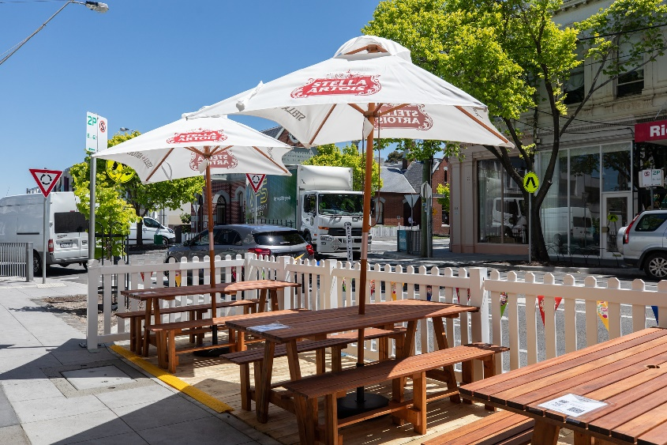
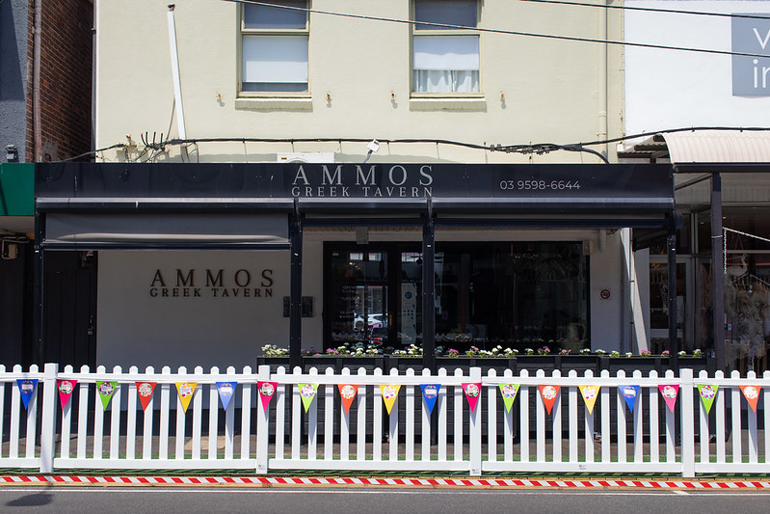
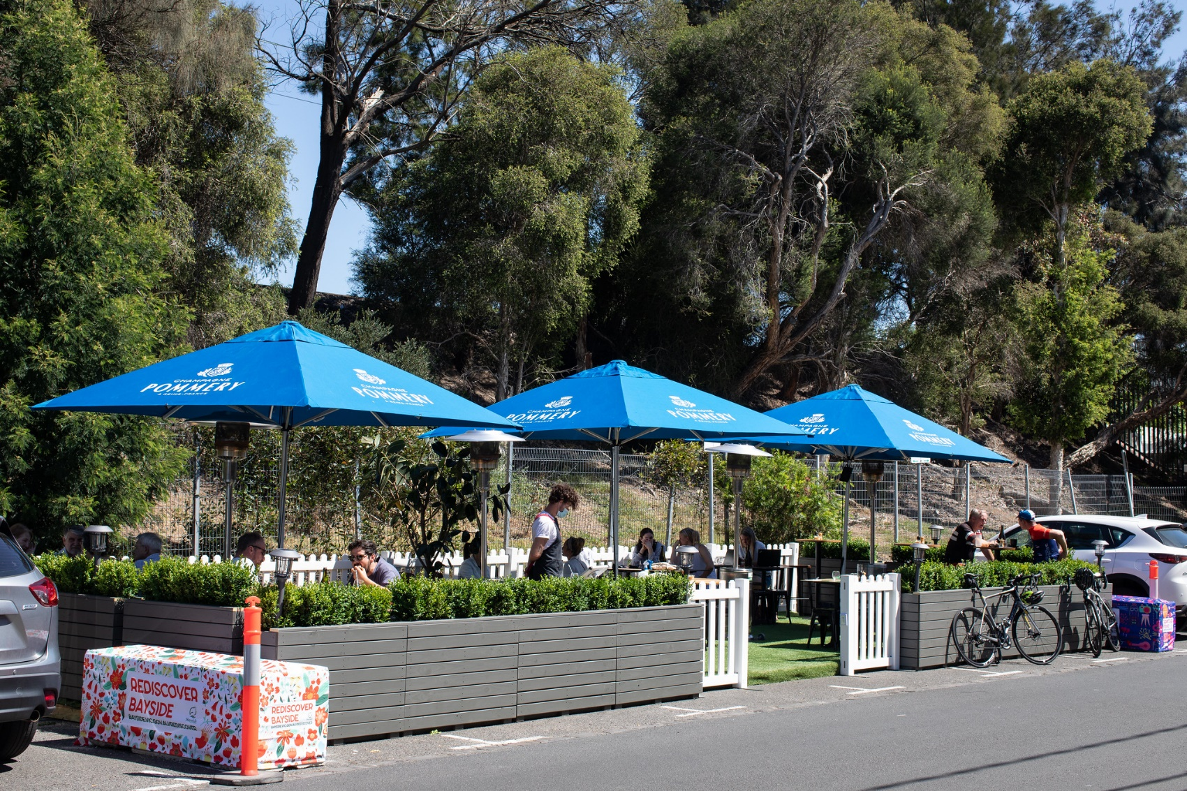

Design Guidelines

These guidelines provide a series of requirements and recommendations to inform the design of a business parklet. Use of the guidelines is required to ensure the parklet design is safe for users and the greater community.

These design guidelines cover a number of elements to be considered including:

- Parklet dimensions and buffer zones;
- Physical barriers and edge treatments;
- Platforms and drainage;
- Accessibility;
- Materials;
- Planting;
- Furniture;
- Lighting; and
- Overhead structures.

These guidelines should be read in conjunction with the Bayside Parklet Policy.

General Design Requirements

Prior to undertaking any parklet design works, the business owner must gain support from Council in regard to their proposed parklet location. The business owner must have a valid Footpath Trading Permit and is to follow the application process as outlined in the Parklet Policy, including provision of a Road Safety Audit.

The parklets are to be designed by a qualified professional, with structures designed by a registered Engineer or Architect.

- The Engineer must certify the structural design by submitting a Certificate of Compliance (Reg 126) – Design.
- Upon completion of construction, the Engineer must inspect and issue a Certificate of Compliance (Reg 126) – Inspection.
- The parklet must be installed by a registered builder.

The parklets must be designed such that they:

- Continue to appear as a parklet even when/if furniture is packed away, to prevent vehicle access at all times;
- Can be easily packed up and moved if required, to allow for any utility, maintenance or capital works; and
- Maintain the function and amenity of the footpath, leaving adequate unobstructed footpath width as set out in the Footpath Trading Policy.

Buffer Space

The buffer space refers to the setbacks required between the parklet edge and the adjacent parking spaces and traffic or cycling lanes. This space is to be kept clear of physical barriers and planting.

There must be a minimum 1 metre buffer on either end of the parklet and a minimum 30cm buffer against the traffic lane.

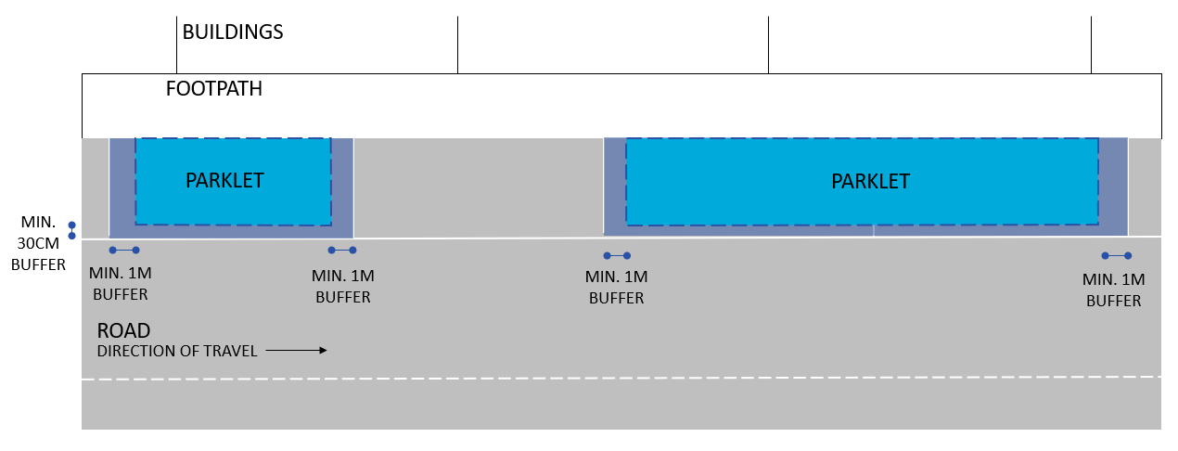
figure 1 – Edge buffer for parallel parking spaces

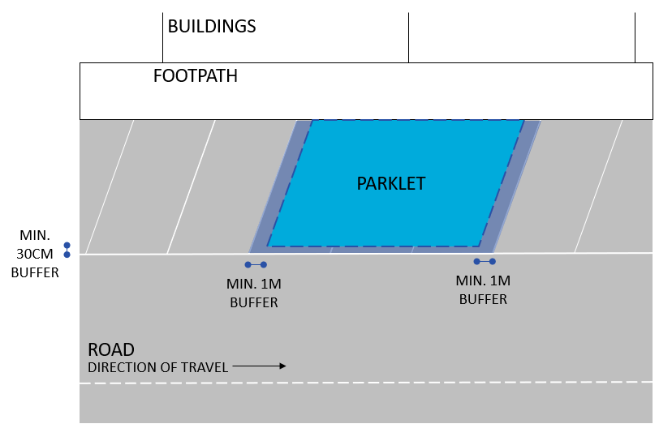
figure 2 – Edge buffer for angled parking spaces

Parklets that are located adjacent to kerb outstands will generally not require a buffer.

Physical Barriers

Parklets must provide a physical barrier around the outside edge to protect the space from vehicles and to keep patrons within the parklet space. This may consist of fencing and planter boxes which cannot exceed a height of 1.2m to maintain visibility.

Concrete blocks (which can double as planter boxes) must be provided at both ends of the parklet to reduce the risk of injury to parklet occupants by an errant vehicle, and to minimise risk of damage to the parklet from cars entering and exiting adjacent parking spaces.

A chevron sign is to be fixed to the concrete block on the approach side of the parklet to alert driver to the presence of a parklet.

Reflective tape is to be provided around the outside edge of the parklet to maintain visibility at all times. This must be fixed in place with galvanised staples or similar. Red reflectors may be used as an alternative.

An example diagram and real-life applications are shown below.

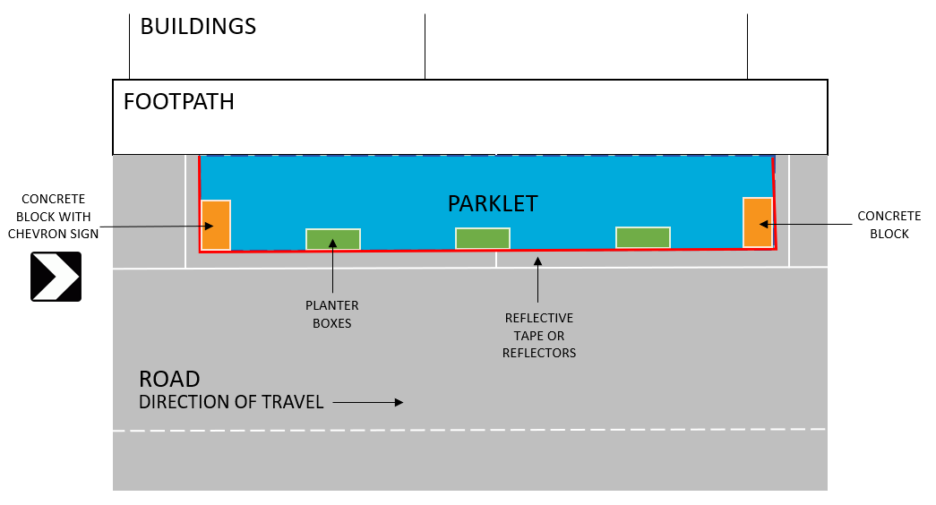
figure 3 – physical barriers example 1
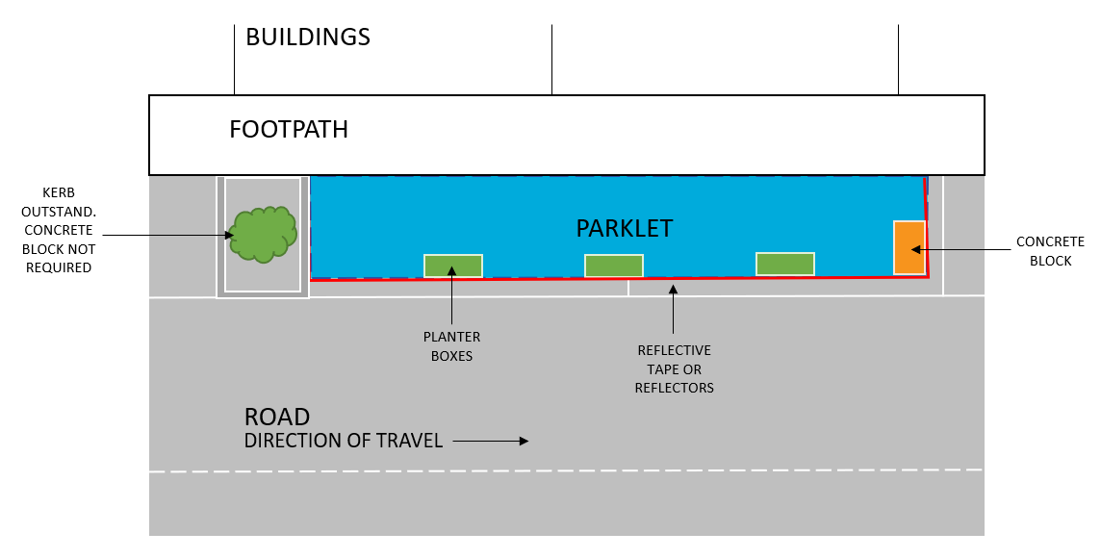
figure 4 – physical barriers example 2

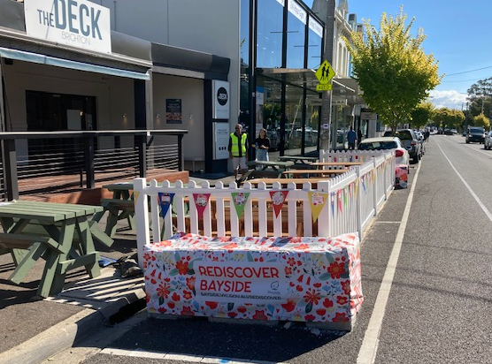
figure 4 – Concrete blocks provided at each end
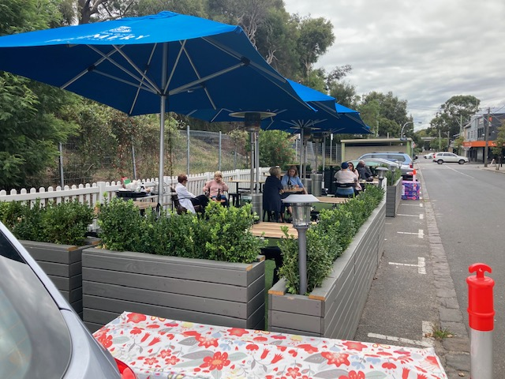
figure 5 – planters provided around the edge
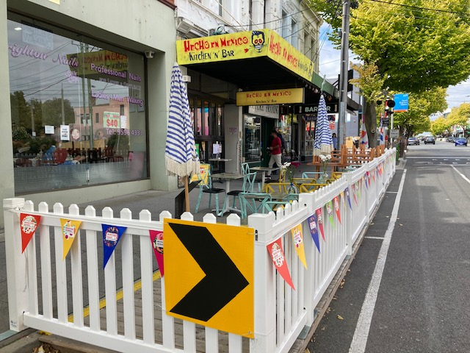
figure 6 – Chevron sigh provided on approach side
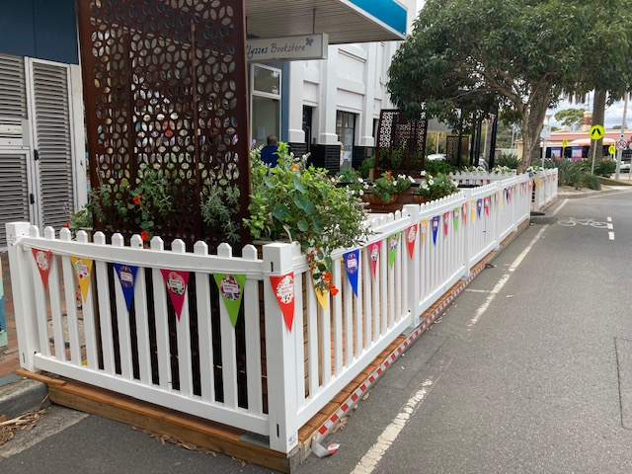
figure 7 – reflective tape provided around edge
Platform

All parklets must be provided with raised platforms unless special circumstances require otherwise. The platform of the parklet must appear as an extension of the footpath to ensure safety and accessibility and cannot be fixed to the road surface or kerb.

The platform needs to be relatively flat to allow tables and chairs to be placed comfortably. The design must ensure that water drains effectively and does not pool in the space or on the adjacent footpath. The surface of the platform is to be non-slip, heel safe and meet relevant Australian Standards.

The gap between the platform and the kerb cannot exceed 1cm. If the gap is greater than 1cm, or the height of the platform does not match the kerb height, a platform threshold treatment is required. This threshold treatment is to be robust and fixed down and must be compliant to DDA requirements.

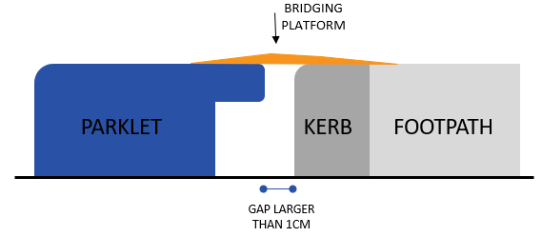
figure 8 – platform treatment if gap is greater than 1cm
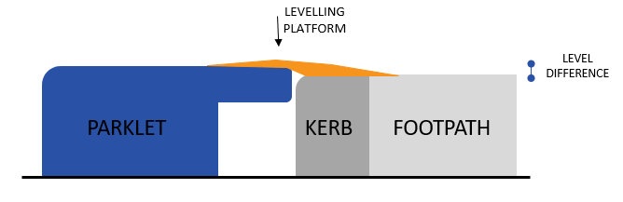

figure 9 – platform treatment there is a level difference

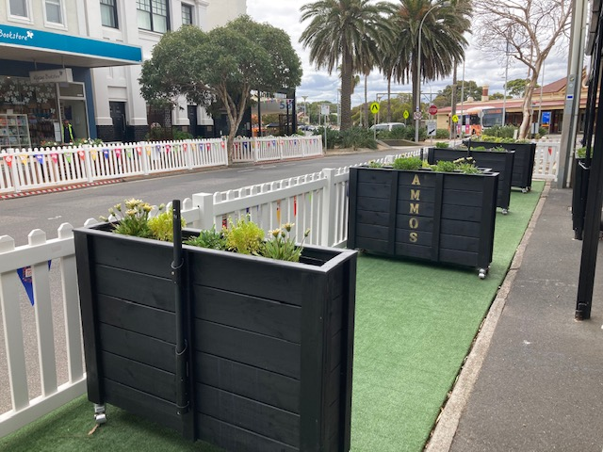
figure 10 – parklet platform sits flush against kerb
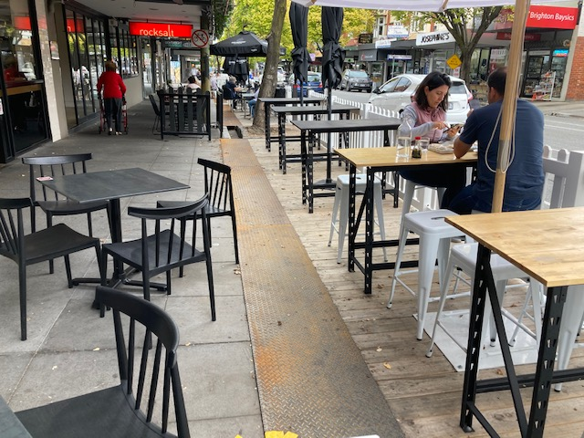
figure 11 – platform treatment provided to connect parklet to kerb

Drainage

Parklets should not be placed over drainage grates or pits, otherwise an inspection lid must be placed where a stormwater pit is located underneath a platform.

A 20cm gap underneath the platform and next to the kerb is required, to allow water to drain freely along the channel as usual. A rubbish grate is to be placed at either end to prevent rubbish and debris from collecting under the platform. The business owner shall be responsible for collecting rubbish that builds up against the grate.
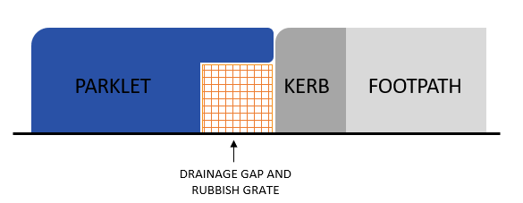
figure 12 – drainage and rubbish grate

Parklets are not permitted in areas subject to significant flooding. This should be checked with Council before you apply.

Accessibility

Parklets are to be accessible for all and unobstructed paths of travel must be provided for patrons using mobility devices such as wheelchairs, prams and walkers.

At least one point of access from the footpath to the parklet must have a width of at least 1.5m. the parklet is to include a wheelchair turning area with a minimum diameter of 1.5m.

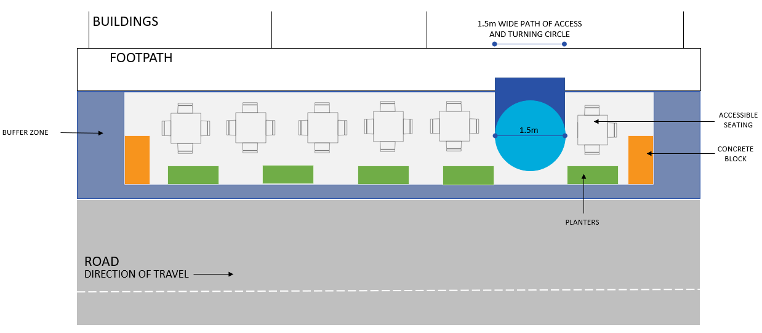
figure 12 – accessibility requirements

Materials

The materials used for the parklet are to be fit for purpose and suitable for public use. The materials and design should minimise visual clutter and be complimentary to the surrounding neighbourhood.

The materials selected should not deteriorate quickly, should be structurally sound, weather resistant and easy to clean. The following materials are encouraged:

- Concrete for the planter boxes. A lighter colour should be considered to contrast with the road surface.
- Metal for the planter boxes and fencing. A thicker type should be considered to avoid denting. If the parklet is to be located in close proximity to the foreshore, a marine-grade metal should be used.
- Some timber materials which must be treated and finished to ensure longevity. Hardwood timber is preferred, and plywood is not appropriate for outdoor use due to warping and buckling over time.
- Recycled plastic with UV stabilisation.

Non-recyclable materials such as composite materials and astroturf are discouraged.

Any damage or graffiti must be dealt with as soon as practicable by the Permit Holder. Materials that discourage graffiti and allow it to be cleaned off easily are encouraged.

Planting

Planting is strongly encouraged within the parklet to enable greenery and improve the aesthetic of the parklet. The plants cannot exceed a height of 1.2m from the road surface to maintain visibility.

The maintenance and watering of the plants is the responsibility of the business owner.

Plant selection should consider the local weather conditions and sunlight exposure, maintenance requirements and soil volume of the planters. It is recommended to seek advice from the Bayside Community Plant Nursery regarding appropriate plant species.

The incorporation of artificial plants is allowed but not encouraged.

figure 13 – low level planting adds to the aesthetic of the parklet.
figure 14 – low level planting adds to the aesthetic of the parklet.

Furniture

Furniture must be suitable for outdoor use, easy to clean, constructed from materials that do not deteriorate quickly and do not impose tripping hazards.

Furniture can be either fixed or removable. Fixed furniture must be integrated into the design and removable furniture must be sturdy and wind resistant, yet portable to be stored inside the premises out of operation hours. All movable furniture must be removed from the parklet when the Bureau of Meteorology forecasts wind speeds in excess of 30 knots.

Umbrellas may be placed in the parklet but must not be closer than 750mm to adjacent traffic lanes when fully opened. They must be suitable for commercial outdoor settings and must not obstruct traffic signals. Umbrellas must be 2.2m high at the lowest point other than the centre pole. When raining, water run-off from large umbrellas must not fall onto the pedestrian footpath.

Heaters are not permitted within parklets.

Lighting

Lighting can be provided within the parklet to contribute to the aesthetic and ambiance of the parklet. Lighting must be stable (not flashing) and pointing downwards so as to not distract drivers or pedestrians. Any lighting fixture or fitting must have a minimum clearance of 2.4m above the parklet.

Lighting must be resistant to water, dust and dirt to a rating of IP65 and illuminance must not exceed 5 lux.

Electrical cables must not extend across the footpath and lighting must not be attached to any trees or public infrastructure. The lighting cable can run from the existing building veranda and is to be installed by a qualified electrician.

Solar lighting should be considered to minimise the need to connect to another power source.

Overhead Structures

Structures such as canopies and marquees can be considered to provide further weather protection to the parklet, subject to a structural engineering assessment.

These must have a minimum height of 2.4m and must not protrude into the 300mm buffer zone, so as to not cause hazard to passing people or vehicles. They must allow rainwater to discharge to the kerb and channel and not cause runoff onto the footpath.

The overhead structures must be open above the planter/fencing height and lightweight in appearance to avoid obstructing visibility for vehicles and traffic signals.

Please note: This policy is current as at the date of approval. Refer to Council’s website (www.bayside.vic.gov.au) to ensure this is the latest version.

