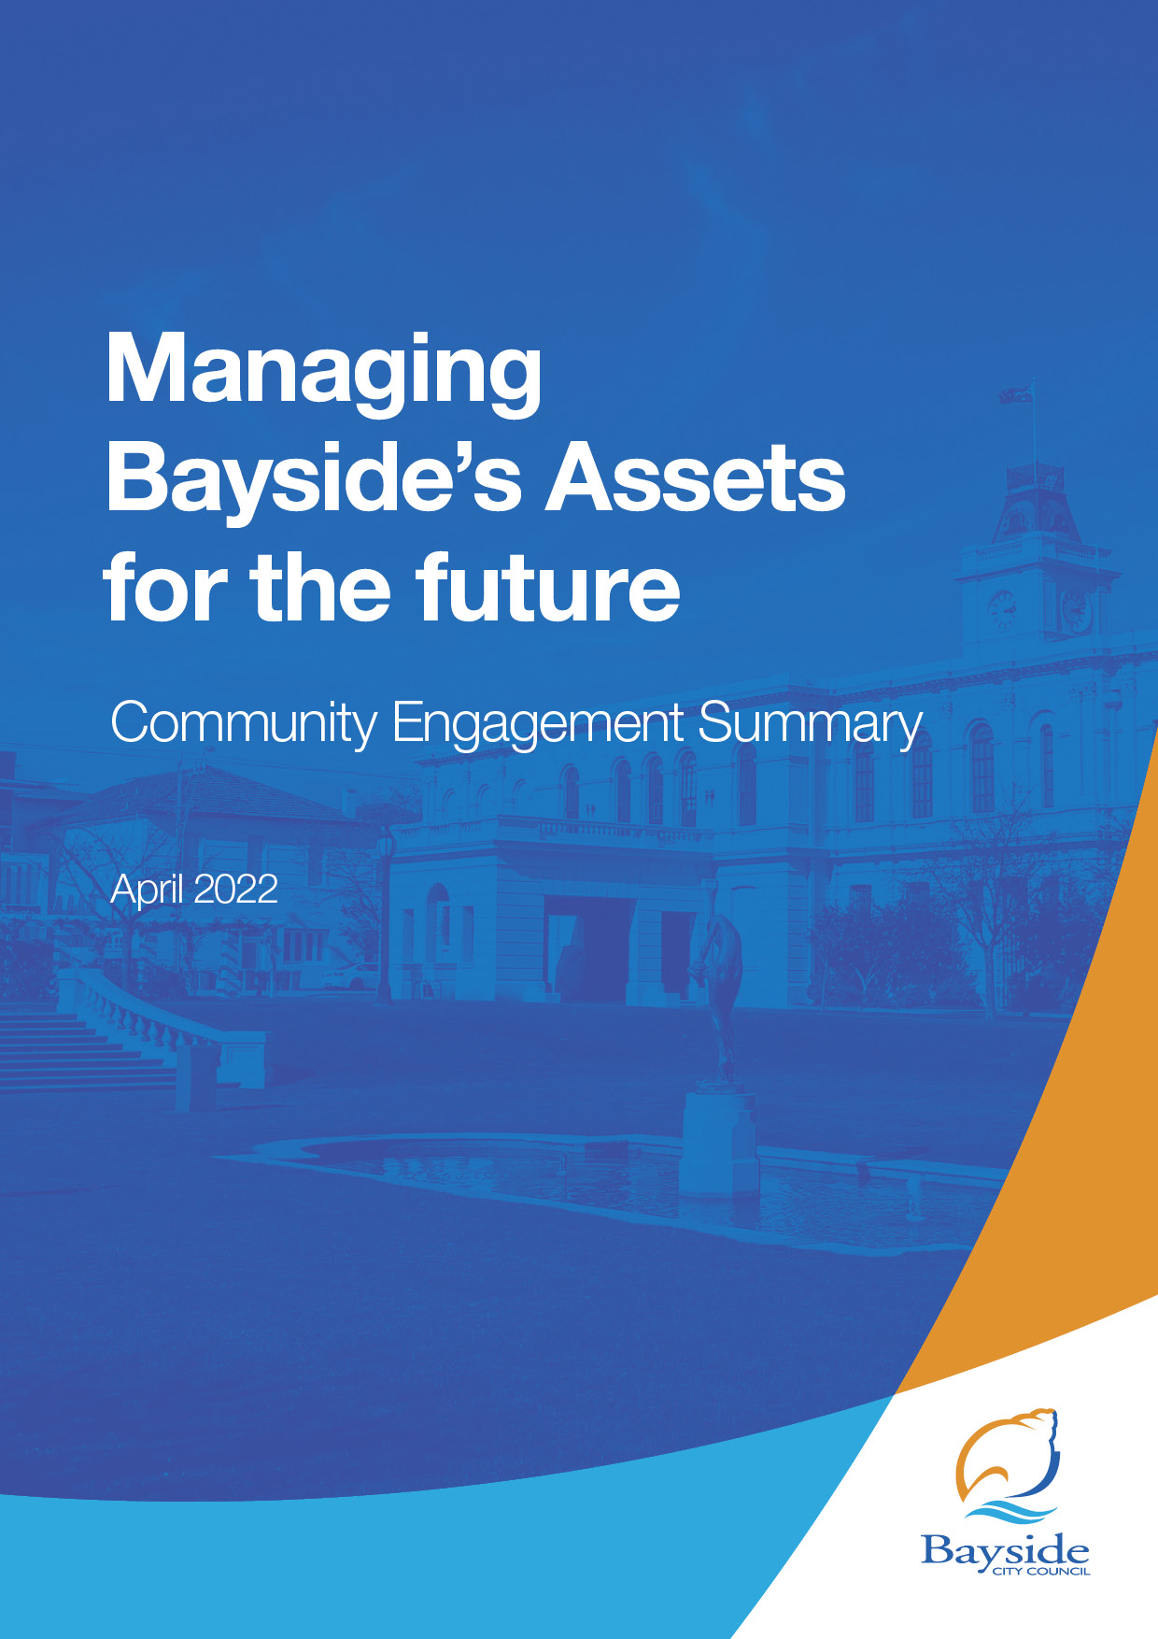

Background
This document provides a summary of stakeholder and community feedback on Bayside’s first Asset Plan. The community was invited to comment on the draft Asset Plan to inform Council’s decision making when considering the final Plan for adoption.
The Asset Plan is intended as a community facing document that shows how the Council’s Assets will be managed and maintained over the next 10 years, while meeting the community’s needs and interests. It informs the community on how the Council-controlled infrastructure and other assets are to be managed to achieve the Council Plan objectives and Community Vision statement.
The Asset Plan has been developed to comply with the Victorian Local Government Act 2020 (The Act) and summarise modelling of the funding required to meet the future service needs of the community.
The Act states that an Asset Plan must:
- Include information about maintenance, renewal, acquisition, expansion, upgrade, disposal, and decommissioning in relation to each class of infrastructure asset under the control of the Council and any other matters prescribed by the regulations, and

- be developed, adopted, and kept in force in accordance with the Council's deliberative engagement practices.

- Councils are expected to complete their Asset Plans by 30 June 2022 although deliberative engagement is not required for the first iteration of the Asset Plan.
This Asset Plan is a separate document to Council’s Road Management Plan 2021, the latter being a requirement for Council to comply with its specific responsibilities and obligations under the Road Management Act 2004.

Next steps
It is proposed that Council consider the results of the community engagement program and adopt the final plan at the Council Meeting on 26 April 2022.

Consultation process

Consultation purpose
We sought community feedback on the draft Asset Plan. It was an opportunity for Council to communicate and gain input into their long-term decision-making considerations in an accessible manner.

We also asked the community to identify risks and opportunities that affect the Asset Plan.

Consultation methodology
The engagement process was open to all members of the Bayside community, including individuals or groups who live, work, play, study, visit, invest in or pass through the municipality.
The engagement plan considered the project’s complexity, the level of change/impact likely to arise from the engagement, and reputational risks. This project was assessed as ‘Consult’ level of engagement on Bayside’s application of the IAP2 Public Participation Spectrum.
The tools and techniques selected for this project were informed by the project content, stakeholders and type of feedback sought. Consultation was open for a three-week period.
The following engagement activities were undertaken:
- project information and feedback survey through Have Your Say, including opportunity to ask questions and book a conversation with the Assets Coordinator
- public submissions were invited to be delivered in person, in writing or via email.

The following table provides detail of each activity undertaken within the community engagement period:
Details | Activity
15 March – 5 April  Draft Asset plan was downloaded 185 times  41 contributions were received from 39 respondents | Have Your Say platform - survey  A survey was set up on Council’s Have Your Say platform, asking people to comment on the draft Asset Plan. Respondents were also asked how easy or difficult they found the information to find and understand.  The opportunity to contribute was promoted via all Council communication channels (website, E-newsletter, social media and Have Your Say platform).
15 March – 5 April  8 visits to this page  2 questions were received from same respondent | Have Your Say platform - question and answer forum  A question and answer forum was promoted on Council’s Have Your Say platform, giving people the opportunity to ask questions on the draft Asset Plan. These questions were answered within Council’s advertised timeframe by Council’s Asset Coordinator.
15 March – 5 April  Link from Council’s website  12 subscribers | Have Your Say platform - subscribe to the project  A feature on the Have Your Say platform allows interested people to ‘subscribe’ to the page and be kept updated on the project. Subscribing to a project indicates a high level of interest in the draft Asset Plan.
15 March – 5 April  No bookings were requested | Have Your Say platform - book a meeting  The community was given the opportunity to book a meeting with the Asset Coordinator either in-person, via video conference or telephone.  Survey to seek opinions on various issues, and identify people interested in upcoming engagement and feedback sessions on Asset Service and Maintenance Levels.
15 March – 5 April  14 people indicated they would like to attend future sessions | Have your Say platform – sign up to future sessions  Respondents were given the opportunity to provide their contact details to receive invitations to upcoming engagement and feedback sessions on Asset Service and Maintenance Levels.

The Have Your Say platform is Council’s main avenue for consulting with the community and was the most effective tool on this project. Here is a summary of the performance of the Have Your Say page:
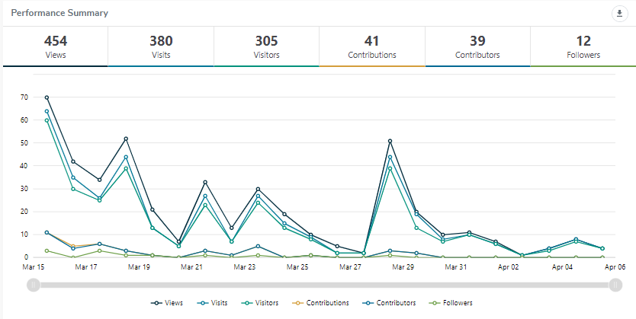

Communications tools and reach
The community and stakeholder engagement process aimed to raise awareness of the draft Asset Plan and the proposed changes.
It is estimated that communications reached more than 7550 individuals through channels, including:
- social media (organic post only)
- Council's e-newsletter This Week in Bayside
- a single interested party was emailed individually, referring them to the ‘Have Your Say’ page

Reach | Tool
15 March 2022  150 page views | Website news story  A story promoting and linking to the Have Your Say engagement was posted on Council’s website.
17 March 2022  5043 people opened the newsletter  9 people clicked on the article | E-newsletter – This Week in Bayside  Council sends an e-newsletter each Thursday afternoon to over 8000 subscribers. This is an effective way to promote our consultations.  Reached 9335 people
18 March | Direct stakeholder emails  Emails were sent to 202 contacts at community groups and lease holders on 18 March.
25 March | Direct stakeholder emails  89 emails were sent to sporting club contacts on 25 March.
28 March  3.1% engagement | Social media (organic Facebook post)  A post was featured on Council’s Facebook page promoting the consultation.  Reached 2357 people

Participant profile
A total of 41 people took part in the online engagement: 39 via the online survey and a further two people submitted questions.
The only participant profile data that was recorded in survey responses and shown in the table below was suburb.

 | Demographic | Bayside  2016 Census | Participants (%)
Gender | Male | 47.6% | 82%
 | Female | 52.4% | 18%
 | Unknown | -
 | Other identity | -
Age | 15-24 | 11.5% | 0%
 | 25-39 | 13.6% | 14%
 | 40-49 | 16% | 14%
 | 50-59 | 14.% | 42%
 | 60-69 | 11.5% | 14%
 | 70-84 | 9.9% | 14%
 | 85+ | 3.7% | 0%
 | Undisclosed | -
Suburb | Beaumaris | 13.5% | 13%
 | Black Rock | 6.5% | 7%
 | Brighton | 24.1% | 7%
 | Brighton East | 15.9% | 13%
 | Cheltenham | 3.7% | 13%
 | Hampton | 13.6% | 13%
 | Hampton East | 5.0%
 | Highett | 7.2% | 13%
 | Sandringham | 10.5% | 7%
 | Outside Bayside | - | 13%
Yrs in Bayside | Less than 1 Year |  | 4%
 | 1 – 5 Years |  | 12%
 | 5-10 Years |  | 4%
 | 11-20 Years |  | 36%
 | More than 20 Years |  | 44%
Have
What is your connection to Bayside?
Bayside resident or ratepayer | 78%
commercial lessee of a community facility | 3%
community group lessee | 21%
member of a community group | 24%
visitor to Bayside | 6%
39 respondents to this question. The majority bracket 80% bracket identified as Bayside residents and ratepayers, which included community group users of assets. only a small portion identified as commercial lessees of a council asset.

Have you lived experience of disability, or cared for someone who does?
Yes | 24%
No | 76%

Would you be interested in receiving an invitation to a short, dedicated workshop(s) about Asset Service Levels and/or Maintenance Service Levels to be held in the next 12 months?
Yes | 36%
No | 64%

What classes of Asset are you most interested in?
Drainage | 9%
Footpaths | 11%
Roads | 11%
Recreation, leisure, and open spaces | 37%
Buildings | 22%
All of the above | 9%

Consultation findings
The following section summarises the key themes which arose in community feedback on the Draft Asset Plan. In the interest of stakeholder and community privacy, individual quotes have not been included within this public document. Where there was more than one mention of a topic or item, the number of mentions has been specified in brackets and italics.

Support for actions
The key message from respondents was that existing assets should be sustainably upgraded and maintained in order to remain fit for purpose. In comparison the acquisition of new assets only received minor support. This is consistent with Council’s Asset management Policy which prioritises renewal, maintenance and upgrade over acquisition.
14 of the respondents provided contact details and expressed a desire to be invited to future workshops on asset service levels.

Item-specific feedback

What is important to you about the way council manage is infrastructure and assets?
Thirty-seven respondents showed a preference for assets being sustainable and fit for purpose over other options.
Service levels or ‘fit-for-purpose’ (whose purpose? primarily the community) of assets was the strongest response among any of the questions and showed that many respondents are sensitive to this critical aspect of the asset plan.
Sustainability, in itself is a critical aspect of service levels and fitness for purpose, so this was an encouraging set of responses and supports Council’s Asset Management Policy.

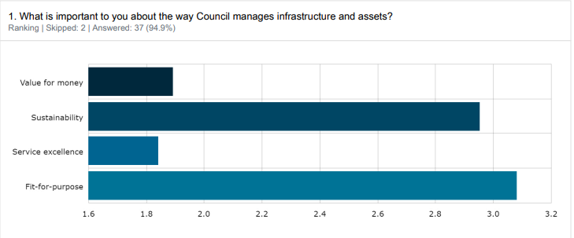

A range of specific concerns were raised during the consultation regarding this item:
Topic | Community feedback
Fit for purpose | We care for 2 year old twin grandsons. We live in Beaumaris, and there are few parks where we feel 2-year-olds would be safe  Consideration of critical service provision, and future-proofing (forward thinking)
Sustainability | Energy supply could be enhanced using new bladeless wind towers. And Solar cells and batteries for all  appropriate surfaces. Greening suitable buildings is an option.

What should Council's focus be regarding assets
38 respondents prioritised upgrade and maintenance of existing assets over acquisition of new assets. These responses are consistent with Council’s Asset Management Policy.
Upgrade is driven by an understanding of the service level demands of the asset users, so the planned engagement on asset service levels over the coming year and codification of is supported and defensible.
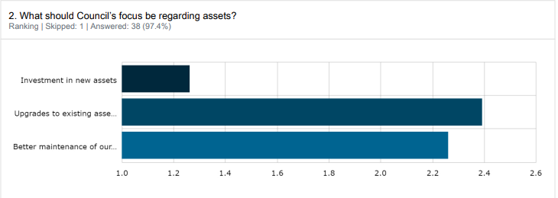
A range of specific concerns were raised during the consultation regarding this item:
Topic | Community feedback
Focus on upgrades and maintenance. | I am a president of a community kinder. We request the highest priority for kinder building maintenance and upgrades. Our kinders are our children’s first education service and the preschool years are crucial. These are essential asset  A focus on upgrading existing infrastructure is key as high density developments progress and increase without adequate upgrading of services, in particular storm water drains which are already struggling with "normal" rain levels

over the next 10 years, do you see the following issues as a challenge or an opportunity for council assets?
39 people responded to this question. There were no clear messages from this question, which shows that the respondents recognised the balance between Challenge and Opportunity. This gives some support to the recognised challenge of Asset Management; finding better ways to engage the community on informed discussion on trade-offs between meeting opportunities, and the costs that arise.
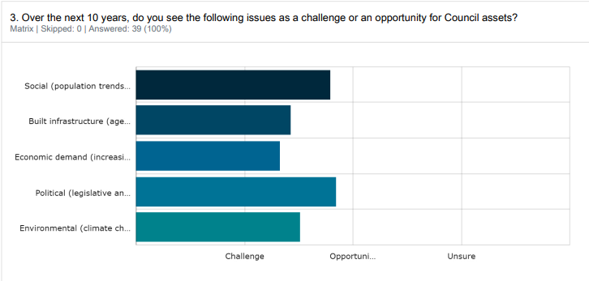
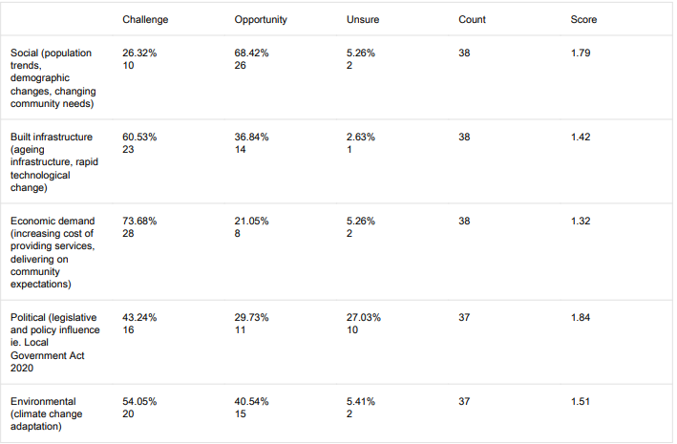
A range of specific concerns were raised during the consultation regarding this item:
Topic | Community feedback
Economic Challenge | Ensure the costs of implementing the ESD objectives of the endorsed Sustainable Building and Infrastructure Policy  (SBIP) are fully integrated into the costings - so that both the SBIP and the Asset Plan will succeed.
Social (population trends) | Please leave our wonderful parks for all the people to enjoy. Don’t take this space for organised sport or other uses. Live with and encourage nature in all forms

Project Evaluation
The consultation purpose to receive feedback on the draft Asset Plan was achieved. Sixteen comments were provided, in addition to the feedback submitted in the surveys. Most comments showed a high level of understanding of the concepts presented in the draft Asset Plan. This feedback will improve the draft plan and inform Council’s decision making.
Interest in Council Asset Plans is traditionally low, therefore the level of engagement on this consultation was pleasing.
Stakeholder reach
Visitors to Have Your Say page | 305
- Attention (% of visit that last at least 1 active minute)  - Action (% of visits where at least 2 actions were performed)  - Feedback % of visits where at least 1 contribution was made) | 31.84 %  23.95 %  10 %

Targeting key stakeholders with a direct email ensured that those most interest in the draft Asset Plan were connected to the consultation.
Collecting 14 interested peoples’ contact details for future workshops on Asset Service and Maintenance Levels was an excellent outcome. Many of the comments below allude to particular service level themes in specific asset groups and can be used to prime the workshops with real examples of community concerns.
An additional question was asked in the survey to gauge stakeholder satisfaction with the process and the information provided. The question asked was:
“How easy was the information to find/understand?”
The success measure for this objective as set by the Communications and Engagement team for all projects is that 75% of respondents find the information easy or relatively easy to understand.
This was not achieved as only approximately 59% found the information easy or relatively easy to understand. It is noted that was a relatively small sample size and that nearly 30% of respondents nominated “I’m not sure”. Approximately 11% said they found the information mostly hard to understand. No one said that they found the information very difficult to understand.
It is also noted that the subject matter of the Asset Plan is quite specialised and involves fairly difficult concepts to understand and interpret.

Appendix - comments

This is the full list of comments provided by respondents in the free text box to the question:
“Please share any other feedback you think is important for Council to consider when considering this draft of the Asset Plan”.

Understanding the true cost of service levels.
Ensure the costs of implementing the ESD objectives of the endorsed Sustainable Building and Infrastructure Policy (SBIP) are fully integrated into the costings - so that both the SBIP and the Asset Plan will succeed.
Recognising the requirements of all asset users
Ensuring that existing users of Bayside assets are not undermined by the laudable aspirations to broaden the services and facilities available in the area. Sporting facilities ...ovals, courts, bike tracks etc are so so important to the community and keeping youth occupied and healthy
Knowing and meeting the demand
Providing enough sporting opportunities and facilities
Multipurpose facilities
There does not seem to be any consideration for consolidation of assets such as multi-purpose facilities. p.21) There is no mention of council assets that are leased by associations such as sporting clubs. Our current lease agreement is that the cost for maintaining the clubhouse and surrounds is for the club to bare (sic) the cost and not the Council. I would expect to see a strategy of Council leased facilities as clubs cannot continue to afford repairing structural items as the assets continue to get older.
Think positive!
Everything is an opportunity - you've just got to think about it in the right way :)
Prioritising upgrade and maintenance to existing
I am a president of a community kinder. We request the highest priority for kinder building maintenance and upgrades. Our kinders are our childrens first education service and the preschool years are crucial. These are essential assets.
Understanding our service provision better.
Consideration of critical service provision, and future-proofing (forward thinking)
Distribution/targeting
I think Council should start looking at all of the Bayside area and not just pockets that seem to house the wealthy. Places like Hampton East, Highett & Cheltenham should be given the same equal attention as the other Suburbs, yet they are not even thought about in the big picture of things.
Planning
Please stop the removal of large trees from new house blocks and nature strips. Beaumaris is becoming 'nude'. Everything that is wonderful about bayside is slowly eroding from lack of trees in backyards.
Better upgrading of drainage
A focus on upgrading existing infrastructure is key as high density developments progress and increase without adequate upgrading of services, in particular storm water drains which are already struggling with "normal" rain levels
Communicating asset information
Need to know where these assets are. What equipment is available in the playgrounds. What accessibility is there?
Knowing our agreed Service Levels
In keeping with the stated asset management objectives of being (1) fit-for-purpose, (2) sustainability, (3) value for money, and (4) service excellence - and in seeking better maintenance of our existing assets (as a priority), the City of Bayside should ensure immediate steps are taken to remove and replace harmful assets to personal health (for example: the Norfolk Island Hibiscus trees on nature strips) - and steps taken to ensure such action is expeditiously and efficiently processed, and any procedural obstacles identified and removed.
Sustainability
Energy supply could be enhanced using new bladeless wind towers. And Solar cells and batteries for all appropriate surfaces. Greening suitable buildings is an option.
Communicating asset information
I'd like to see all rate payers given read access to your Asset Management System so that we can view the metrics/values applied to assets though self service reporting
Ensuring we communicate playground service levels
We care for 2 year old twin grandsons. We live in Beaumaris, and there are few parks where we feel 2-year-olds would be safe.
Competing views on value of space
Please leave our wonderful parks for all the people to enjoy. Don’t take this space for organised sport or other uses. Live with and encourage nature in all forms.

