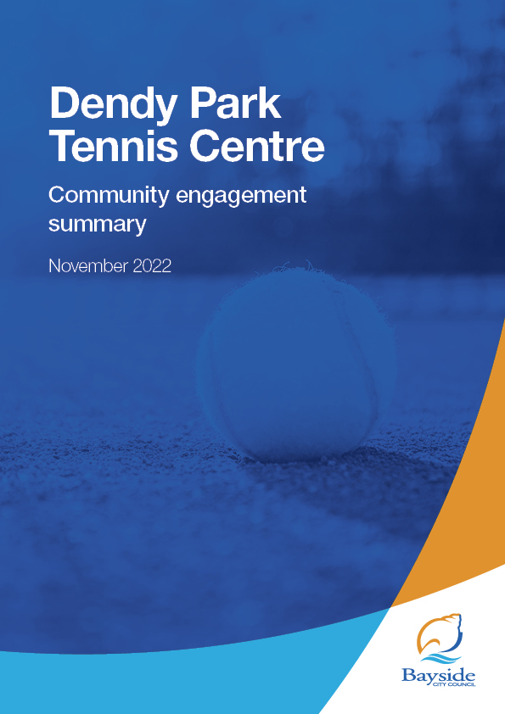

How to use this template
Explanations of what to include in each section are in orange boxes.
This template is designed for projects with basic community engagement or those assessed as MINOR RISKS or SIMPLE COMPLEXITY
Tips when writing an analysis:
- Use past tense.
- When talking about information from qualitative activities (focus groups, community events etc.) refer to those who provided submissions/comments as ‘participants’. When talking about quantitative information (surveys) refer to those who participated as ‘respondents’.
- Don’t start a sentence with a numerical character (e.g. 7), instead spell out the word (e.g. Seven).
- This report is reserved for summarising the feedback received from the community. It is not to be used to communicate Council’s response to this feedback, nor is it a channel for providing justification for Council’s decision-making.
- Try not to repeat yourself. If you find that you are writing about a similar thing as covered in an earlier section, consider combining the two sections.
- Consider your audience. It is best to assume that those reading the report will not know anything about the subject matter, so take care not to use jargon or professional terminology.
- Make sure you don’t suggest that one comment is representative of the whole community.
- Remember that the main purpose of this document is to show that Council has received and reviewed the community’s feedback, so the community can be confident that their concerns have been heard.
Once you have finished entering content:
- Search for ‘xx’ and square brackets [ ] to make sure you have updated all items that need to be replaced (highlighted yellow).
- Make sure you have deleted all of the orange instruction boxes (including this one) – To do this, select the whole box, right-click on the selected box, then click on ‘Delete Table’ in the popup menu.
- Finally, click anywhere in the contents list on page 2 (the whole list will go grey) then press the F9 key to update the list (choose ‘update entire table’).

Overview
This document provides a summary of stakeholder and community feedback on a proposed 21-year lease to Tennis Australia (TA) to redevelop and manage the current Dendy Park Tennis Centre, in partnership with the Royal South Yarra Lawn Tennis Club (RSYLTC) and Dendy Park Tennis Club (DPTC).
Dendy Park Tennis Centre is currently a nineteen court en-tout-cas venue at Breen Drive, Brighton East, which is leased by Council to DPTC. The facility requires significant renewal and upgrades to adequately service the needs of the community now and into the future. The lease includes retention of the Dendy Park Tennis Club and substantial redevelopment of the current facility.
Proposed lease terms
The proposed lease is 21 years with a term of seven years followed by two seven-year options. The financial terms equate to $1.2M in rent over the lease period, as well as an initial investment of $2.55M to undertake a proposed renewal plan over three phases (subject to further funding for phases 1b and 2). The proposal is fully funded by the tennis partners with no capital investment by Council.
Key findings
Most respondents (85%) were supportive of the proposed lease (67% strongly and 18% somewhat supportive).
Common reasons for support included that the current centre needs a significant upgrade and the plan benefits residents and encourages greater participation in racket sports, while requiring no investment from Council. Trust in Tennis Australia to deliver the upgrade and manage the centre was also prevalent in responses.
Among those who were somewhat supportive, concerns included the potential impact to current users and/or increased membership fees, and a desire for greater public access.
A small number of respondents (6, 10%) were strongly opposed. Their concerns ranged from increased traffic/parking congestion, lack of detail in the proposal and amount of rent, perception public land is being handed over to a private club, and preference for hard court surfaces over clay.
Next steps
Council will consider community feedback and a proposed lease at its meeting on 22 November 2022.

Consultation process

Consultation purpose
Council invited community feedback on the proposed lease to Tennis Australia between 21 September – 18 October 2022 to inform Council’s decision-making on the lease.
Community engagement was conducted in accordance with Council’s Community and Stakeholder Engagement Policy 2021 and Section 115 of the Local Government Act 2020. An engagement plan overview was published and is available to view on Council’s Have Your Say engagement website.

Consultation methodology
The tools and techniques selected for this project were informed by the project content, stakeholders and type of feedback sought.

Key tools for communicating the project
- site signage (3)
- letters distributed to neighbouring residents
- direct email to all Dendy Park tenants
- Council communication channels, including website news, direct email to Have Your Say members, e-newsletters and social media (11,000+ recipients).

Key methods for gathering feedback
- online consultation via Council’s Have Your Say platform, including opportunities to ask questions and explore the proposal
- contact email address and phone number of Council Officer provided for interested community members to ask for further information or provide feedback.

Details | Activity
21 September – 18 October 2022  67 Contributions  67 Contributors | Have Your Say website  yoursay.bayside.vic.gov.au/dendy-park-tennis  - Online survey: 61 respondents  - Written statement form: 0 respondents  - Q&A forum: 6 questions received and answered
21 September – 18 October 2022 | Correspondence  - 1 email

Participant profile
Demographic information was not requested from participants as it was not considered relevant to this engagement program.
Participants were asked to qualify their connection to the Dendy Park Tennis Centre:
- play/have a child that plays tennis at Dendy Park (n=8, 13%)
- member of the Dendy Park Tennis Club (n=4, 6.5%)
- member of the Royal South Yarra Lawn Tennis Club (n=1, 1.5%)
- live near Dendy Park (n=20, 33%)
- use Dendy park for other forms of recreation (n=12, 23%)
- other (Bayside resident/ratepayer, interest in tennis (n-14, 23%)

Consultation findings
The following section summarises the key themes which arose in community feedback on the proposed lease to Tennis Australia. In the interest of stakeholder and community privacy, individual quotes have not been included within this public document. Where there was more than one mention of a topic or item, the number of mentions has been specified in brackets.

Support for actions
Overall, online survey respondents were very supportive of the proposed lease to Tennis Australia, with 67% strongly supportive, 18% somewhat supportive, 5% neutral and 10% strongly opposed.
Figure 1: Level of support for proposal

Reasons for level of support
All survey respondents (61) were required to provide a comment regarding the reason for their level of support. These comments are summarised in the tables below.
Table 1: Comments from respondents who expressed support or were neutral
Topic | Community feedback
Investment in tennis | Dendy Park Tennis Centre needs significant upgrade (23)  Need for investment in tennis facilities general (4)  Will create improved facilities at the Centre (8)  High quality upgrade for players at all levels (4)  Includes new forms of racket sports (1)  Bayside needs more (improved) sporting facilities (4)
Financial | No Council investment benefits ratepayers (5)  Increased revenue (1)
Greater use of the Tennis Centre | Encourage greater use of Centre (6)  Encourage take up of tennis (4)  Better opportunities for junior development (2)  Good combination of membership and public access (1)  Increased community access (2)  New coaches (1) and more classes (1)
Tennis Australia (proposed tenant) | Tennis Australia will get it done properly (3)  Tennis Australia has world-class courts and the required experience (1)  High level of trust in Tennis Australia (1)  Not-for-profit tenant (1)
Health and wellbeing | Promotes health and wellbeing (2)  Encourages participation in non-water based sports (2)
Centre upgrade plans | Will attract events/tournaments (1)  Support all weather courts (2)  Improves sustainability (1)  Makes better use of the space (1)

Table 2: Comments from respondents who were opposed or expressed concerns
Topic | Community feedback
Type of courts | Increase hard courts (clay too much maintenance/use of water) (3)
Traffic / parking | Will create pressure on parking and/or traffic congestion (3)
Game formats | Do not support/need new form of tennis (pop, Padel, Pickleball) (1)  Increase public access courts instead of new game formats (1)
Public access | Concerned about impact on access for existing members (1)  No values to residents get access to less than 10% of courts (1)  Handing over public land to private club - if can't be maintained in current form, convert to public park space (1)
Proposal | Proposal lacks detail. Should be public tender (1)  Tennis Australia should not get discounted rent (1)  Governance model is complex and not clear (1)  Low annual rent for duration of the proposal (2)  Concern about impact on membership fees (increase) (1)  Impact of the proposal on the wider park (1)

General comments
Survey respondent were asked if they had ‘any other feedback you would like Council to consider as part of the Dendy Park Tennis Centre proposal?’, with 32 comments received.
Many of the comments reiterated feedback already provided, however, the need to consider parking and traffic in the context of the proposal was raised by more respondents (6).

Table 3: Considerations for the Dendy Park Tennis Centre proposal
Topic | Community feedback
Parking and traffic | Need to consider additional parking (4 mentions)  Relocate entrance to Nepean Hwy to limit congestion on Dendy Street (2 mentions)
Redevelopment proposal | Include fewer clay and more hard/synthetic courts (3 mentions)
Financial | Council should invest into this facility  Surge pricing at peak times to maximise revenue to Council  Align rent reviews to upgrade stages  Proposal should be self-funding
Public use / services | Provision of junior coaching a lease condition  No use past 11.30pm  Online court booking or free courts  More public courts available (at least 1/3)  School holiday programs to support working parents  Focus on Pickleball for additional courts  Guarantee that public access is maintained, and residents not excluded due to high fees.  Is there additional impost on membership fees?
Accessibility | Standalone courts for people with special needs  Lift in pavilion for accessibility
General | No further comment (5 mentions)  Lack of detail provided on lease/proposal (2 mentions)  Great to have Tennis Australia support  Dendy Park is an inclusive club
Questions | What happens to these improvements at lease end should the lessee not seek to re-lease the facility? Is there an obligation on ratepayers to reimburse or purchase the improvements? What happens if funding for stages 1b and 2 do not materialise? Is there adjustment to years 8+ on lease payments or does the lease term reduce back to seven years?

Project Evaluation
This report presents the findings from the analysis of the community feedback gathered during community engagement from 21 September – 18 October 2022.

The engagement program received a total of 67 contributions, including 61 surveys completed via Have Your Say and 6 questions via the Q&A forum.

Figure 2: Have Your Say project page – reach and participation
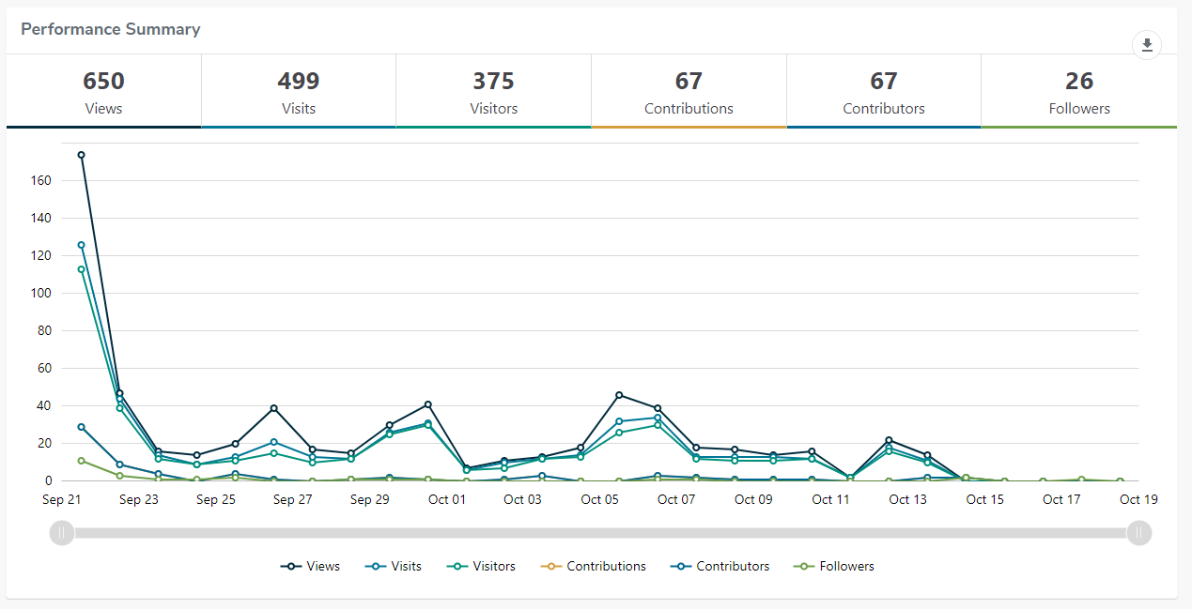
Engagement targets for the Have Your Say webpages were that:
- 20% of visits would last at least one active minute (exceeded, 46%)
- 10% of visits would have at least two actions performed, such as moving around the project page or clicking on links (exceeded, 29%)
- 5% of visits had at least one contribution made (exceeded, 12%)

Satisfaction with engagement process
Survey participants were highly satisfied with the consultation process and materials, with nearly all participants selecting they had the required information to participate, and it was very (64%) or mostly (29%) easy to find/understand. One participated found it mostly hard to find/understand and 5% were ‘not sure’.

