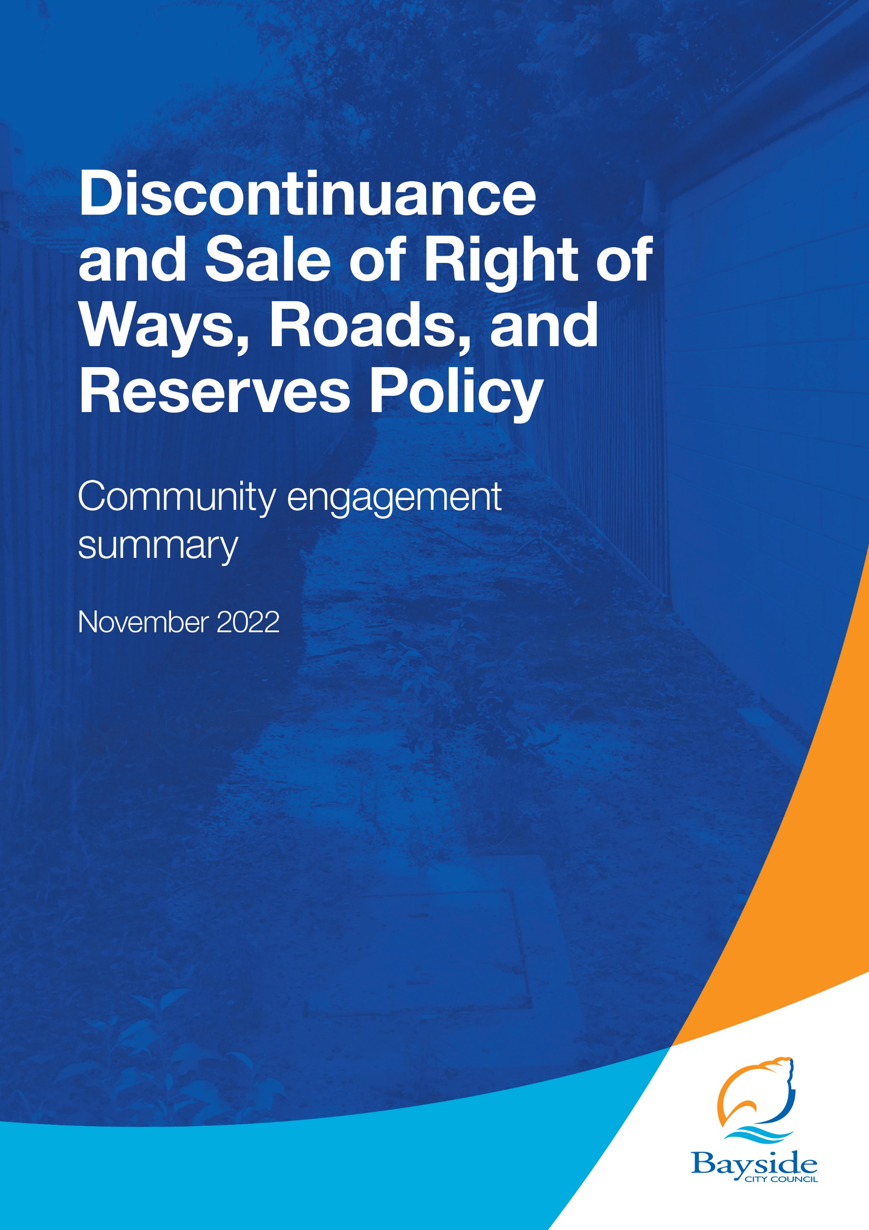

Contents
2 Background 2
3 Consultation process 4
3.1 Consultation purpose 4
3.2 Consultation methodology 4
4 Participant profile 4
5 Consultation findings 5
5.1 Support for actions 5
5.2 Level of agreement for statements about the Policy 5
5.3 Sentiment regarding the policy 6
5.4 General comments for consideration about the Policy 8
5.5 Project Evaluation 8

Background
This document provides a summary of stakeholder and community feedback on the Discontinuance and Sale of Roads Right of Ways and Reserves Policy.
Council reviews its Discontinuance and Sale of Right of Ways, Roads and Reserves Policy every four years to ensure that roads, right of ways (ROWs) and reserves that are no longer required to be kept under Council care and management can be legally sold subject to compliance with statutory requirements.
Minor changes were proposed under the 2022 review, including:
- Retaining land to support environmental objectives, such as expanding adjacent public open space, and increasing vegetation and habitat corridors
- Enabling a right of way/road to be discontinued if pedestrian access is available via other points or there is only occasional vehicular access, such as trailers
- Offering a discount on the market value of land if it can’t be reinstated for public use, and where a government body does not own or have interest in the land
- A more assertive position regarding illegal occupation of land.
Community engagement on the proposed changes was undertaken from 21 September – 19 October 2022 (inclusive) and received 28 contributions.
Key findings
There was strong support recorded for retaining land for environmental reasons and strengthening Council’s response to illegal occupation of public land
- 89% of respondents supported retaining land to support environmental objectives, such as expanding adjacent public open space, and increasing vegetation and habitat corridors

- 92% of respondents supported a more assertive position regarding illegal occupation of land

There was mixed sentiment recorded for enabling a right of way/road to be discontinued if pedestrian access is available via other points or there is only occasional vehicular access, such as trailer (46% of respondents supported; 42% opposed).
There was some opposition (55%) towards offering a discount on the market value of land if it can’t be reinstated for public use, and where a government body does not own or have interest in the land.
Respondents also generally agreed that the policy is:
- easy to understand (77%)
- explains the process clearly (77%)
- sets out a consistent and fair approach (60%)

Next steps
Council will consider community feedback and draft Discontinuance and Sale of Roads Right of Ways and Reserves Policy for adoption at its 21 December 2022 meeting.

Consultation process

Consultation purpose
Engagement was conducted to understand the level of community support for proposed changes to the Discontinuance and Sale of Roads Right of Ways and Reserves Policy. The consultation was designed to provide stakeholders and the broader community with the opportunity to give feedback on the proposed policy amendments, as well as on the application, land assessment, referral, and decision-making processes to ensure they were clear and equitable

Community engagement was conducted in accordance with Council’s Community and Stakeholder Engagement Policy 2021. An engagement plan overview was published and is available to view on Council’s Have Your Say engagement website.

Consultation methodology
The tools and techniques selected for this project were informed by the project content,
stakeholders and type of feedback sought.
Key methods for gathering feedback
- online engagement through Have Your Say
- contact email address and phone number of Council Officer provided for interested community members to ask for further information or provide feedback.
Details | Activity
21 September 2022 – 19 October 2022  246 visitors  28 contributions | Have your say website  Project information and online survey hosted on the engagement  platform Have Your Say  Online survey: 28 contributions  Q&A forum: 0 questions asked
21 September 2022 – 19 October 2022  0 questions | Correspondence  Direct feedback provided through contacting the Project Officer  for further information or to provide feedback over the phone or via email.

Key tools for communicating the project
- email to project subscribers (3,142)
- Council communication channels, including website news story and e-newsletter to over 9,500 subscribers

Participant profile
Demographic information was not requested from participants as it was not considered
relevant to this engagement.

Survey respondents (28) were asked to qualify their connection to the draft Policy and/or Bayside. All participants had a connection to Bayside, with some identifying with multiple options:
- 7 indicated they were a property owner adjacent to land within scope of Policy
- 26 said they were a Bayside resident or ratepayer
- 3 said they were a Bayside business owner
- No one indicated they were a visitor to Bayside, study in Bayside, previous applicant or other.

Consultation findings
The following section summarises the key themes which arose in community feedback on
Discontinuance and Sale of Roads Right of Ways and Reserves Policy review. In the interest of stakeholder and community privacy, individual quotes have not been included within this public document. Where there was more than one mention of a topic or item, the number of mentions has been specified in brackets and italics.

Participants were asked via an online survey to provide feedback on the draft Discontinuance and Sale of Roads Right of Ways and Reserves Policy including their reasons for supporting or not supporting the proposed changes.

There were 28 contributions which are summarised as follows:

Support for actions
All survey participants were asked the level to which they support a series of changes to the draft Policy, with 28 responses received.
There was a high level of support (89%) for the draft Policy to retain land to support environmental objectives (expand open space, habitat corridors etc), additionally a high level of support (92%) was shown for the policy to take a more assertive position regarding illegal occupation of land.
Respondents were divided, (46% supported and 42% opposed) as to whether the draft Policy should enable a right of way/road to be discontinued if pedestrian access is available via other points or only occasional vehicle use (eg trailers).
There was slight opposition (55%) to offering a discount on the market value of land if it can’t be reinstated for public use, and where a government body does not own or have interest in the land.

Level of agreement for statements about the Policy
Respondents were asked what extent they agreed or disagreed with statements about the draft Policy. Most (78%) respondents agreed (7% strongly agree, 71% mostly agree) that the policy was easy to understand, and a further 78% agreed (7% strongly agree, 71% mostly agree) that the policy explained the process clearly. 60% of respondents agreed (3% strongly agree, 57% mostly agree) that the policy sets out a consistent and fair approach.
Figure 1: To what extent do you agree or disagree with the below statements about the draft Policy?

Sentiment regarding the policy
Respondents were asked how they felt about the draft Discontinuance and Sale of Right of Ways, Roads and Reserves Policy overall, with 18% (5) of respondents stating they like the policy, 21% (6) ok with it, 36% (10) had some reservations and 25% (7) of respondents don’t like it at all.
Figure 2: How do you feel about the draft Discontinuance and Sale of Right of Ways, Roads and Reserves Policy overall?

Respondents were also asked to provide written feedback about the reasons for their response. Comments provided by the 26 submitters are summarised by theme in the table below:
Table 1: Comments from respondents who expressed support or were neutral
Topic | Community feedback
Policy | Easy to understand and clear policy
Environment | Public land should be retained for environmental purposes (7 mentions)
Community considerations | Laneways are dangerous (2 mentions)  Unused laneways are a dumping ground for rubbish
Financial | Support discount for adjoining owners to purchase land (2 mentions)
General comment | Council should discontinue and sell the old night soil unused roads  Support selling unused roads lanes and ROW's (2 mentions)  Unused laneways should be put to beneficial use (2 mentions)

Table 2: Comments from respondents who were opposed or expressed concerns
Topic | Community feedback
Policy | Unfamiliar with this kind of policy
Environment | We need more open spaces not less
Community considerations | Laneways provide convenient pathways (3 mentions)  Laneways are assets to the community  Concerned about land being sold off that could benefit the community (2 mentions)  We should increase pedestrian access points rather than decreasing them
Financial | Don’t support discounting adversely possessed land (2 mentions)  Council putting money ahead of community  Council money grubbing  Encroachment fines are too low
General comment | Public land should be offered back to the traditional landowners not sold  Laneways give character to the neighbourhood (2 mentions)  Land should not be sold (3 mentions)  Laneways are part of history (3 mentions)  Owners may want to purchase land to subdivide bigger blocks leading to overdevelopment  Could be difficult to prove a ROW or lane is unused  Concerned about asset maintenance in land being sold  Provide details of land proposed to be sold  Wide consultation is required for any land sold  Consultation on proposed land sales should be limited to neighbouring properties

General comments for consideration about the Policy
Survey respondents were asked if they had ‘any other comments about the draft Policy that you’d like Council to consider’, with nine comments received.
The feedback provided is summarised by theme in the table below:
Topic | Community feedback
Policy | Policy shouldn’t allow one person to prevent change from happening  Policy should support better purposes for these spaces
Community considerations | Community assets should be rented not sold  Pedestrian needs should outweigh financial gain
Financial | Budget for these areas
General comment | Provide a list of pros and cons for suggested changes  Retain the pathways and history of Bayside (2 mentions)  Open spaces should be used for nature pathways  Provide a map of areas proposed for sale (2 mentions)

Project Evaluation

This report presents the findings from the analysis of the community feedback gathered during community engagement from 21 September to 19 October 2022.

The engagement program received a total of 28 direct responses, completed via survey through Have Your Say.

Communications to encourage participation attracted 246 unique visitors to the project page and were sent to key stakeholders including previous subscribers for related engagements. The communications reached over 11,000 community members via email newsletters or notifications.

The community engagement project was not a random sample survey of the community, and the results reflect the views of those in the community sufficiently engaged with both Council and policy issues who chose to participate in the consultation.

Figure 3: Have Your Say project page – reach and participation
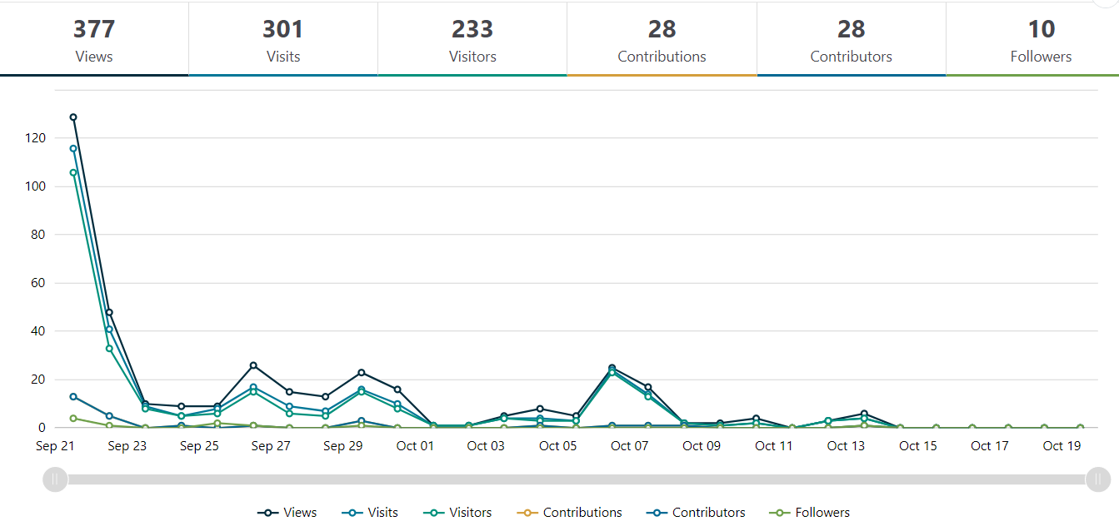

Engagement targets for the Have Your Say webpages were that:
- 20% of visits would last at least one active minute (exceeded, 42%)
- 10% of visits would have at least two actions performed, such as moving around the project page or clicking on links (exceeded, 39%)
- 5% of visits had at least one contribution made (exceeded, 8%)

Satisfaction with engagement process
Survey participants were generally satisfied with the consultation process and materials, with a majority of participants selecting they had the required information to participate, and it was very (30%) or mostly (52%) easy to find/understand. It is noted that some of participants found the information mostly hard (11%) to find/understand or were not sure (7%).

Engagement plan
The Engagement Plan Overview for this project was published and is available to view at:
yoursay.bayside.vic.gov.au/DiscontinuanceAndSalePolicy/EPOdiscontinuance-policy

