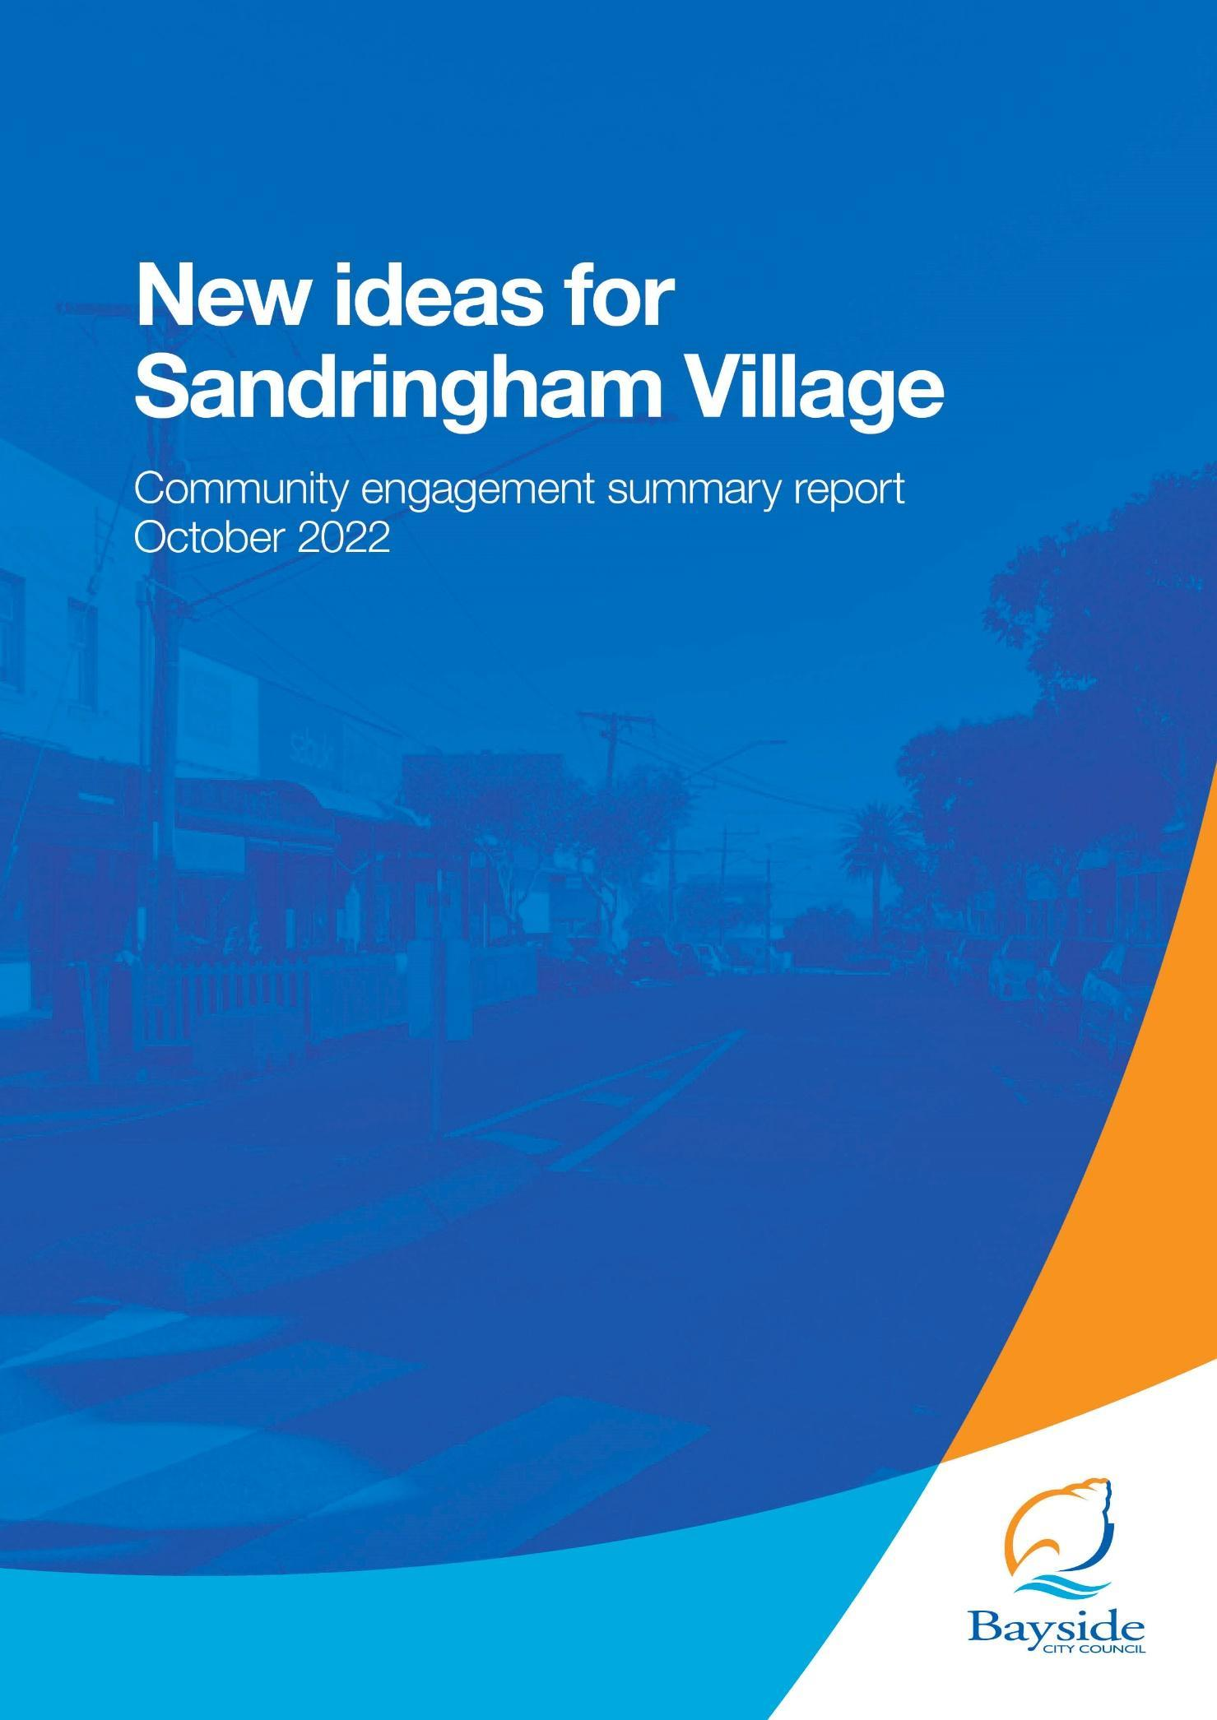

CONTENTS
1. Executive Summary 3
2. Introduction 5
2.1 Project Background 5
2.2 Engagement Purpose and Scope 5
3. Methodology 6
3.1 Engagement Questions 8
3.2 Strategies to Support Participation 8
3.3 Managing Project Risks 9
4. Who participated? 10
4.1 Participation by engagement method 10
4.2. Connection to Sandringham 11
4.3 Age 12
4.4 Locations 13
4.5 Travel methods and parking locations 14
5. Key Findings 16
5.1 Part A Potential part road closure of Melrose Street 16
Indicative levels of support 17
Concerns and questions 18
Ideas for future use of this space 20
5.2 Part B Potential introduction of a trader parking permit scheme 22
Indicative levels of support 24
Ideas for future use use of this space 26
6. Recommendations 26
Part A - Closure of Melrose Street 26
Part B -Trader parking permit concept 27
Process recommendations 27
7. Project evaluation 28
Evaluation of engagement communication 30
7. Appendices 33

Executive Summary
This report provides recommendations for Council based on the key findings from community engagement conducted from September to October 2022 to understand the level of support for two projects:
- The potential part road closure of Melrose Street, Sandringham (Part A).
- The potential introduction of a trader parking permit scheme to use Councils underground carpark located at 122 Beach Road, Sandringham (Part B).
Participation
Overall 352 people participated in the community engagement activities, which included an online survey, community pop-up sessions, written submissions and an online webinar session.
Of those that provided this information in the online surveys and at community pop-ups, the largest cohort of participants were those that were residents living elsewhere in Sandringham (191 participants) and visitors to Sandringham (57 participants). Of the remaining, 13 were residents of Melrose Street, 10 were business owners in Melrose Street, and eight were business owners in the wider area. There were 11 people that identified they worked in the Sandringham Village and 23 who were property owners in the village, including one who owned a Melrose Street property.

Key Findings
Part A - Melrose Street potential road closure
The level of support for the closure of Melrose Street was polarised, with the majority of participants either strongly supporting the closure (128) or strongly opposing it (108). There were 29 participants that somewhat supported the closure and 27 participants that somewhat opposed it, with the remaining three participants having no opinion or not caring.
Property owners in the village followed the general trend, and were polarised, with 9 people strongly supporting (39%), and 10 people strongly opposing the closure (43%).
Participants that were residents elsewhere; had a higher proportion strongly or somewhat supported the closure (104 - 54%) than opposed it (86 - 45%).
Visitors to the area felt similarly to broader Sandringham residents with 54% (31) supporting and 46% (26) opposing.
Workers in the village were supportive of the closure, with 64% (7) strongly supporting the closure.
The majority of Melrose Street residents (9) strongly opposed the closure, with four residents strongly supporting it.
Aspirations for future use of this space
The top three aspirations for the space were a place to sit down and eat or have a coffee (172), a space for entertainment or events (144) and a space for pop-up shops or footpath trading (141). This suggests the community would want flexible infrastructure to allow these different activities to occur in the space.
Part B - Trader parking permit scheme
Of residents, visitors and workers, 119 strongly supported the scheme, and 48 somewhat supported the scheme - with support totalling 57%. There were 26 participants somewhat opposed, and 57 strongly opposed, with opposition totalling 28%. The remaining 44 participants had no opinion or did not care.
Almost double the number of business owners and traders strongly supported the permit scheme (9), in comparison to five strongly opposing. There were three participants somewhat supporting, one somewhat opposing.
Recommendations
The consultation program has encouraged the community to provide their level of support for the potential part road closure of Melrose Street, Sandringham and the potential introduction of a trader parking permit scheme to use Councils underground carpark located at 122 Beach Road, Sandringham. Following are our recommendations based on the delivery of the engagement program and analysis of the information.
Part A - Melrose Street potential road closure
As the sentiment towards the proposed closure of Melrose Street was polarised (42% strongly supporting and 39% strongly opposing), it is important that future plans and communication clearly address the questions and concerns if the project is to proceed or to provide a detailed explanation if it does not go ahead.
As most concerns or questions regarding the closure are centred around traffic and parking demand and impacts to residential and visitor parking, providing detailed information on traffic and parking modelling and solutions may alleviate some of the concerns that participants have about the proposed closure.
Community aspirations within this space
The top three aspirations for the space were a place to sit down and eat or have a coffee (172), a space for entertainment or events (144) and a space for pop-up shops or footpath trading (141). This suggests the community would want flexible infrastructure to allow these different activities to occur in the space.
Part B - Trader parking permit scheme
There was a greater level of support for the trader parking permit scheme, than those opposed to it, with almost a third of participants not having any questions or concerns.
Participants that did have concerns were worried about the removal of the 36 publicly available car spaces, and the demand for parking in the immediate and surrounding area.
As above, providing detailed information on traffic and parking modelling and solutions may alleviate some of the concerns that participants have about the proposed parking scheme.

Introduction
The purpose of engaging the community was to better understand the level of support for two projects:
- Potential part road closure of Melrose Street, Sandringham (Part A).
- Potential introduction of a trader parking permit scheme to use Council’s underground carpark located at 122 Beach Road, Sandringham (Part B).
Anyone who visits, shops, lives, works or owns property or business in Sandringham was the target stakeholder for this project.
Where possible, the findings of this engagement program are divided into two parts to represent the two projects, however some sections, like participation, are reported jointly as stakeholders participated in both projects.

2.1 Project Background
Bayside City Council has previously undertaken a Streetscape Master Plan for Sandringham Village with significant engagement. This demonstrated mixed views with concerns over the loss of carparking and the impact of construction but support for improved pedestrian accesses and increased trees and greenery.
Council has deferred the detailed design and documentation phase of the Sandringham Village Streetscape project until 2025–26. Since then, Council received a petition about a proposal to consider closing a section of Melrose Street, Sandringham that has received some community support from local traders and community members.
At the June 2022 Council Meeting, it was resolved that Council commence community engagement to determine the level of support for the pedestrianisation of a section of the road in Melrose Street Sandringham and to potentially designate Council’s underground carpark located at 122 Beach Road Sandringham for the use of trader parking.

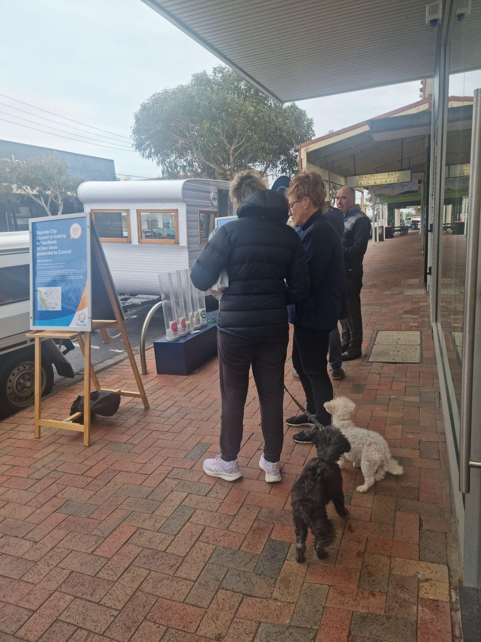
2.2 Engagement Purpose and Scope
Stakeholders could influence and inform (negotiable):
- Whether or not the closure of a section of Melrose Street, Sandringham proceeds.
- Design and future aspirations of the open space area in Melrose Street if the closure is supported.
- Preferred provision for services and loading to businesses in Melrose Street.
- Preferred management of traffic detouring around Melrose Street if closed.
- Introduction of a trader parking permit scheme for the underground carpark at 122 Beach Road, Sandringham.
- Conditions or terms of trader parking permit scheme, if supported.

Topics not open for discussion (non-negotiables) during the engagement were:
- Council’s June 2022 decision to undertake community engagement on the proposal(s).
- Existing policies and strategies related to parking, parklets, outdoor dining and footpath trading, traffic, and transport planning.
- Existing masterplans or statutory processes related to the Sandringham shopping precinct.
- Parklet Policy.
- Statutory requirements under the Local Government Act, and State Government statutory approval processes.
- Council's ongoing management responsibilities of public areas.

Methodology
A mixed-method community engagement program was used to reach participants from a range of different levels of interest in the project. Table 1 lists the community engagement activities delivered as part of this project. It describes the purpose and key audiences. Following is more information about each method.
Table 1: Community engagement activities
Activity | Purpose | Key audience
Community pop-ups  (3 sessions) | Meet the community and key stakeholders at the location, with a visible presence promoting the project and seeking feedback. | Sandringham Village traders, Employees within the Sandringham shopping precinct, and Residents within the Sandringham shopping precinct. Visitors
Community and  stakeholder survey | Receive targeted and detailed feedback from the community and key stakeholders. | Bayside residents, Building Owners, commuters, pedestrians, and cyclists
Online webinar session  (1 session) | Provide an opportunity for the community and key stakeholders to learn about the project and ask questions. | Sandringham Village Traders Association, Sandringham Village traders, Employees within the Sandringham shopping precinct, Residents within the Sandringham shopping precinct, and Bayside residents.

Community and Stakeholder Survey
The online survey was promoted via the Bayside City Council Have Your Say project page and was also made available in hard copy format.
Participants were asked to provide their level of support for the pedestrianisation of Melrose Street Sandringham (Part A) and the potential to introduce a trader parking permit scheme utilising Council’s underground carpark located at 122 Beach Road, Sandringham (Part B). They were asked to advise of any concerns or questions they had in relation to the ideas, as well as provide future aspirations of how they would like to use the section of Melrose Street Sandringham in the future if the idea was supported.
To ensure unique submissions, participants had to register to Have Your Say to complete the online survey and were also asked to provide demographic identifiers including their connection to Sandringham and age bracket.
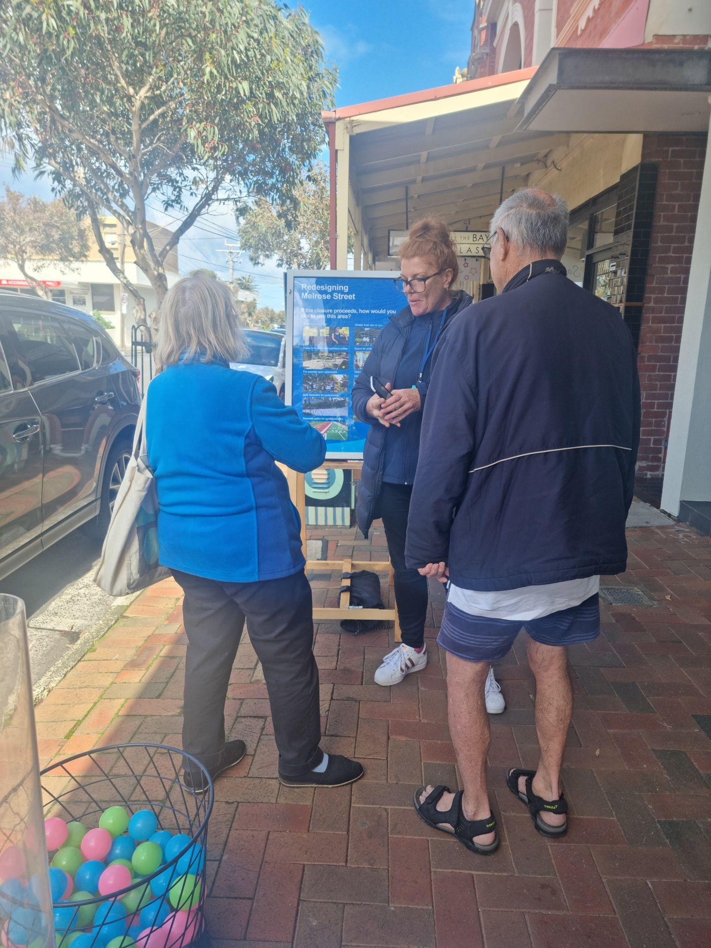
Community pop-ups
Three place-based community pop-up events were held at the intersection of Melrose and Station Street, Sandringham. Times were chosen to ensure maximum engagement from key stakeholders with various connections to the space.
Pop-up dates and times:
- Wednesday, October 5 2022 12pm – 2 pm and 3.30 pm – 5.30 pm
- Saturday, October 8 2022 10 am – 2pm

Participants were asked to respond to a series of questions in line with the online survey. Participants were able to show their level of support for the two proposed ideas, by placing a ball in the tube that corresponded with their level of support. Some participants just provided feedback without completing the survey.

Online webinar sessions
Three online webinar sessions were promoted, however due to low registrations only one session ran with eight people attending. Table 2 provides the breakdown of registered participants for the session: Monday 12 September 2022 6.30 pm – 8.00 pm.
Table 2 - Registrations for the online webinar - 12 September 2022
Connection to Sandringham
I am a resident in Melrose Street | 1
I am a resident living elsewhere in Sandringham | 3
I live elsewhere but am a visitor to Sandringham | 0
I am a business owner or trader in Melrose Street | 4
I am a business owner or trader within Sandringham Village | 3
I am a worker within Sandringham Village | 1
I am a property owner in Sandringham Village | 3
Total | 15

Written submissions
Community members and key stakeholders were able to make a written submission detailing their response to the proposed ideas direct to Council. Council received 17 individual submissions and one group submission, with one participant writing two submissions. The submissions outlined their level of support for one or both of the proposed ideas as well as any concerns or comments of support. Five of the submissions had been entered as survey responses and as a result have not been recounted in levels of support totals for either project.

3.1 Engagement Questions
Participants were invited to review project information including a map of the area before responding to the following questions:
Part A - Part closure of Melrose St:
- Do you support or oppose the idea to close a section of Melrose Street between 12 Melrose Street and Station Street?
- If the closure is supported, have you got any concerns you’d like us to consider?
- If the closure proceeds, how would you like to use this area?

Part B - Use of Council carpark:
- Do you support or oppose the idea to make the 36-space public carpark under 122 Beach Road, a permit carpark for traders to park for longer than four hours?
- Have you got any concerns or questions about the trader parking proposal?

Participants were also asked to provide personal demographic information.

3.2 Strategies to Support Participation
Community participation was supported through the following initiatives:
- Communications campaign: including signage in Sandringham Village (image p9), addressed mail and brochures to over 3,000 households, feature article in Let’s Talk Bayside magazine, direct email to Have Your Say database, paid social media advertising and signage in customer service centres and libraries.
- Dedicated project page: to provide a consistent location for the community to access information and participate in the survey and register for the webinar. The webpage included 3D tour maps of the subject sites (Melrose Street and 122 Beach Road carpark) to provide an accessible way for the community to view and understand the area if they are unfamiliar.
The project page had 1,431 unique visitors, with 275 contributions via the online survey and 208 people registering to receive project updates. The majority of visitors (637, 42%) arrived via a direct link, suggesting the respondents clicked on a link via an email from Council. A further 387 (25%) clicked through to the project page via a link provided in a social media post. 220 (14%) came from campaigns, 160 (10%) were directed to the project page from another website, and 100 (6%) via a search engine.

- Going to the community: Pop-ups were held in Sandringham Village to reach anyone who visits, shops, lives, works or owns property or business in Sandringham.
- Variety of engagement methods: multiple methods were offered, allowing participants to participate in their own time through the online survey, as they were going about their day at a pop-up, or in the comfort of their own home through the online information session.
- Promoting engagement through an online information session: The online information session was an opportunity for the community and stakeholders to find out about the project and ask questions to Council staff members.
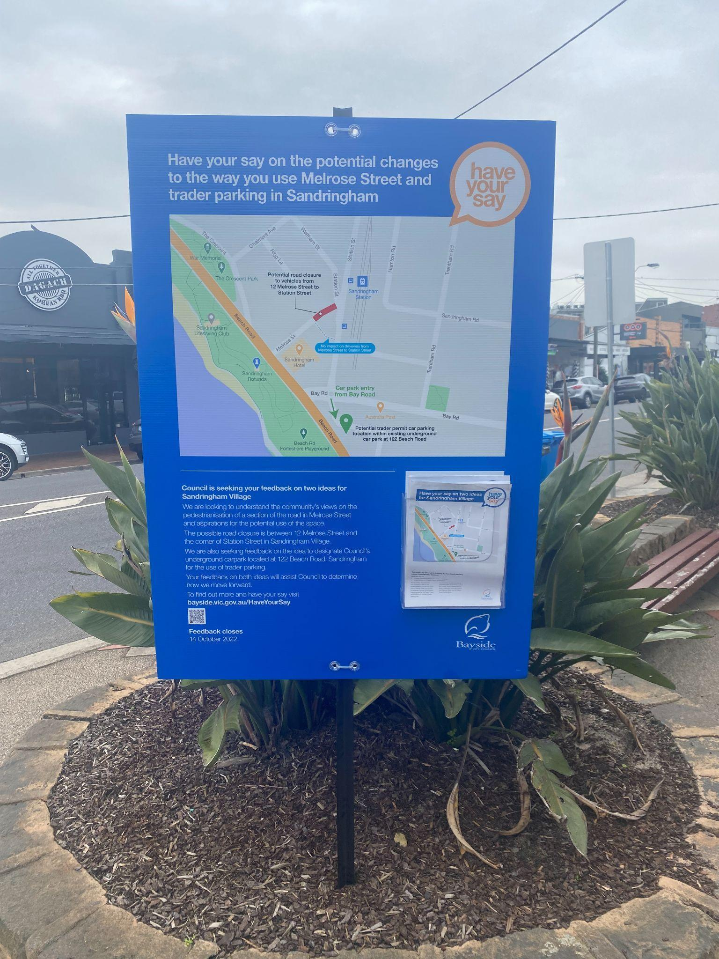
Potential barriers to participation
- The need to sign-in to Have Your Say Bayside to participate in the online survey. Those with limited access to or understanding of the internet may have found the registration process difficult.
- Weather conditions during the first two pop-ups reduced the number of potential participants. Engagement fatigue from community members who feel like they’ve already participated in a number of engagement projects recently in the area (for example, Parking Strategy and Sandringham Village Streetscape Masterplan)
- Inability to suggest an alternative location for the road closure may have impacted willingness to participate and the sense of ownership.

3.3 Managing Project Risks
Table 3 shows the identified risks and mitigation strategies used in the project delivery outlined during the planning stage.

Table 3: Identified risks and management strategy
Identified risk | Management strategy
Remaining within the scope of the project. | Ensuring discussions and content reflect only the potential closure of Melrose Street and underground carpark usage.
Other related strategies arising around the same time as engagement on Melrose Street and the underground carpark. | Remaining as clear with the scope of this project. Optional directing participants to information regarding other works.
Managing assumptions that the decision has already been made. Maintaining positive views and an open process. | Remaining clear that no decision has yet been made and that this engagement is an open discussion that will be taken back to Council for decision making.
Ensuring the engagement activities capture responses from a diverse group of affected individuals as opposed to specifically targeting traders. | Delivering a range of engagement activities inviting participation from a wider section of the community.

Who participated?
A total of 352 people participated in this engagement program. Participants via the survey or pop up were asked to provide demographic information. Participants making submissions via email were not required to provide any demographic information.
Following is information about participants across both Part A and Part B of the project.

4.1 Participation by engagement method
Figure 1 shows the breakdown of participation and reach across the various engagement methods. The majority of responses to the engagement program were received via the survey, with 275 responses (78.3%). Participation via one of the three place-based community pop-ups contributed 51 responses (14.5%). Less than 4.8% of responses were received in the form of a written submission to the Council project team or 2.3% of participants who attended the webinar.

Figure 1. Participation across engagement activities
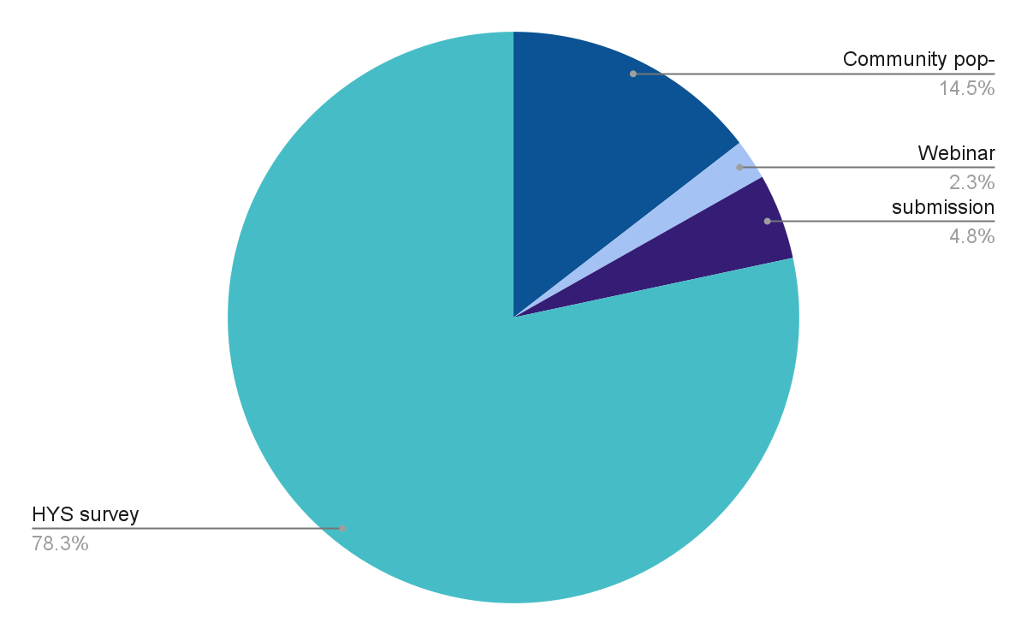

4.2. Connection to Sandringham
Of those that provided this information, the largest cohort of participants were those that were residents living elsewhere in Sandringham (191 participants) and visitors to Sandringham (57 participants). Figure 2 shows this breakdown. Of the remaining, 13 were residents of Melrose St, 10 were business owners in Melrose Street, and eight were business owners in the wider area. There were 11 people that identified they worked in the Sandringham Village and 23 who were property owners in the village.

Figure 2. Participant connection to Sandringham
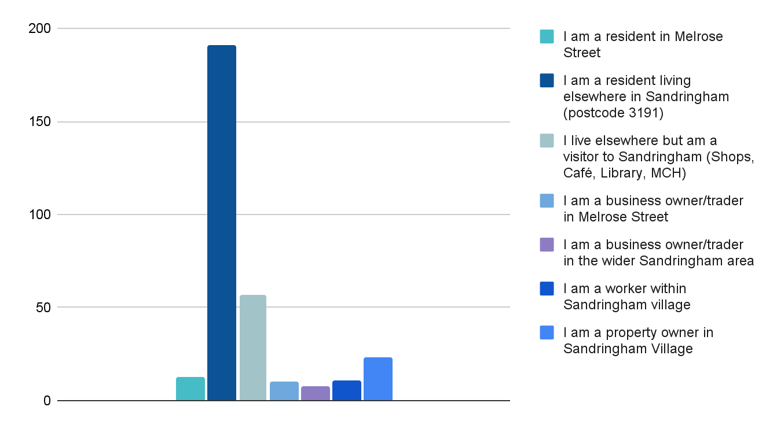

4.3 Age
Figure 3 shows the age data gathered from participants. Participation was highest from the 50-59 years age bracket with 84 participants (27%). This was followed by the 60-69 years age bracket at 67 participants (21%).
Figure 3. Age brackets of participants across engagement activities
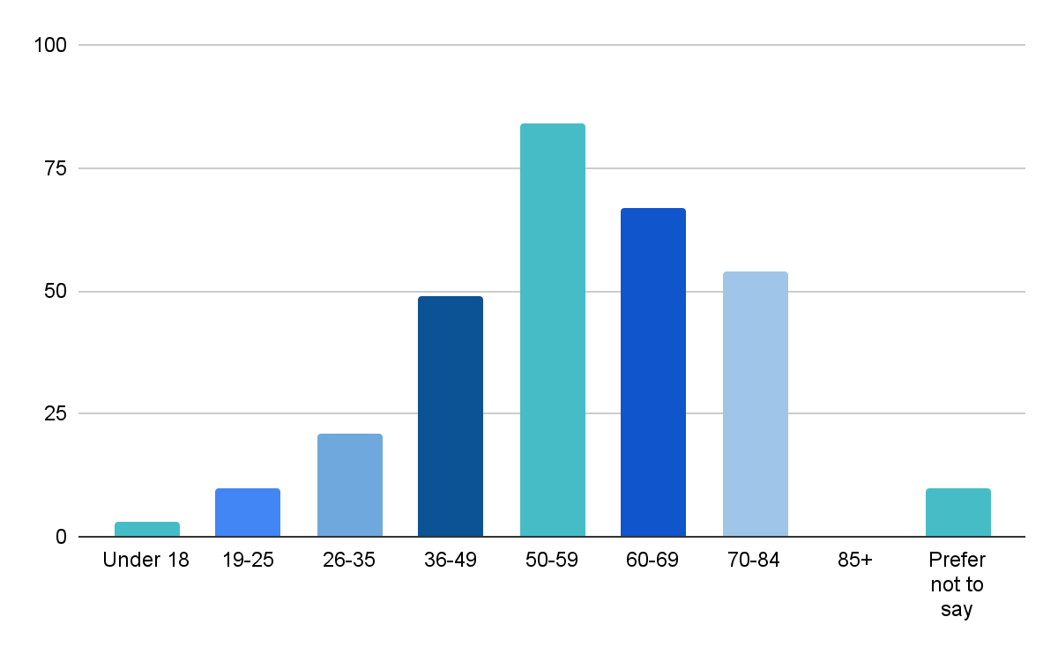
Community Profile
Table 4 shows the age of participants compared to the population of Bayside, showing younger people were underrepresented and people aged 50 to 84 years old were overrepresented, with the most common age category 50 to 59 years old, accounting for 28.2% of participants.
Table 4. Comparison of Participation
Age | Demographic | Bayside 2021 Census | Participants (%)
 | Under 18 | 23.2% | 1%
 | 19-25 | 15.2% | 3.4%
 | 26-35 | 8.0% | 7.0%
 | 36-49 | 18.6% | 16.4%
 | 50-59 | 14.9% | 28.2%
 | 60-69 | 11.5% | 22.5%
 | 70-84 | 9.9% | 18.1%
 | 85+ | 3.7% | 0
 | Prefer not to say | 0 | 3.4%

4.4 Locations
Property location
Property owners were asked to provide the street on which their property was located. The majority of property owners owned property on Station Street, Bay Road and Beach Road. Most property owners who participated owned property on Station Street (6), Bay Road (5) and Beach Road (5).
Figure 4. Streets where properties are located
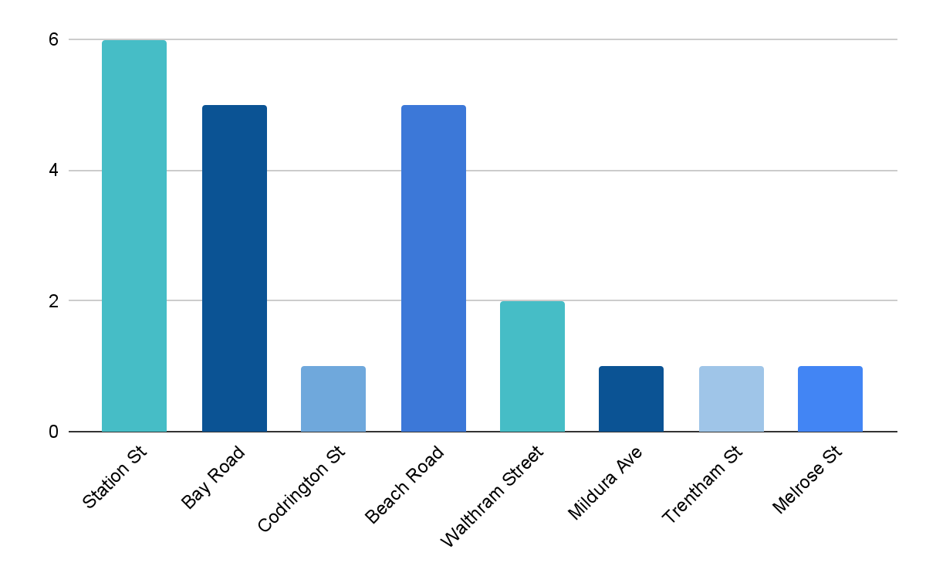Business location
Business owners were asked to provide the street on which the business was located. The majority of the businesses were located on Melrose Street, with six others on Bay Road, Waltham Street and Bay Road. It is important to note that not all businesses provided their business location.
Figure 5. Business location by street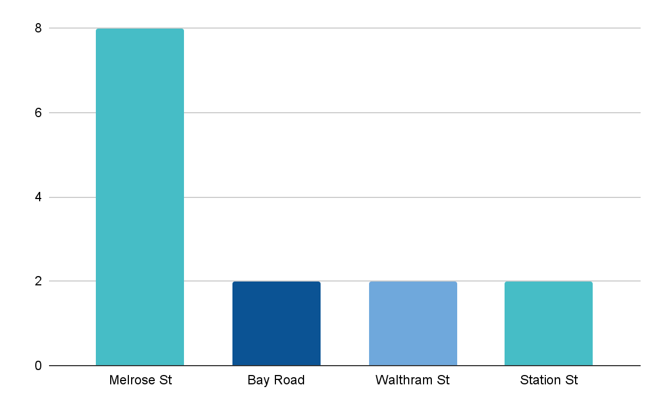

4.5 Travel methods and parking locations
Travel methods to Sandringham
Participants were asked how they usually travelled to Sandringham, with the majority of participants driving (or as a passenger) (161) followed by walking (120), bus and / or train (13) and cycling (11). One person (visitor) travelled to the area by motorbike.
Participants that were residents elsewhere in Sandringham usually walked (97), followed by car (78), with far fewer cycling (8) or taking public transport (7).
For participants with other connections to Sandringham, the usual mode of transport was by car, with small numbers of people travelling by foot, bike or public transport, as shown in Figure 6.
Figure 6. How do you usually travel to Sandringham
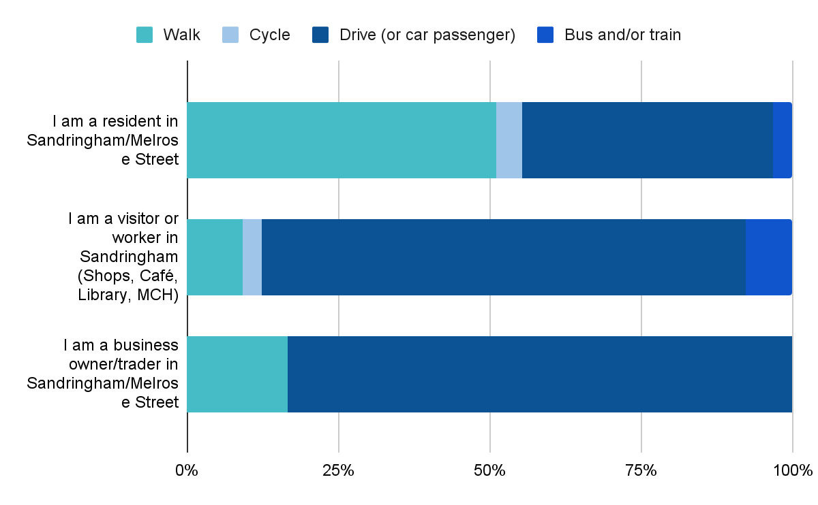
Parking location used
Participants who reported traveling to Sandringham by car (driving or as a passenger) were asked to provide information about where they normally park. Most participants reported parking in any available space (47), followed by Waltham Street (31), Coles or near Coles (20), Melrose Street (20) and Station Street (17).
The top three places to park for residents living elsewhere in Sandringham were any available space (28), Waltham Street (23) and Melrose Street (9).
The top three places to park for participants that live elsewhere and were visitors to Sandringham were any space available (11), Melrose Street (7) and 122 Beach Road (6). Breakdown shown in Figure 8.
Property owners in Sandringham Village parked in a variety of places, including Melrose Street (1), any space available (4), behind Melrose Street (2) and Beach Road (2).
Business owners in Melrose Street and the wider Sandringham area generally park in Melrose Street (4), any space available (3), behind Melrose Street (3) or Waltham Street (1)
There were eight workers within Sandringham Village that drove to the area, with three people identifying their usual place to park was behind Melrose Street.
Residents of Melrose Street (1) usually park in a private park (1), Waltham Street (2), Melrose Street (1) or any space available (1).
Figure 7. Parking locations
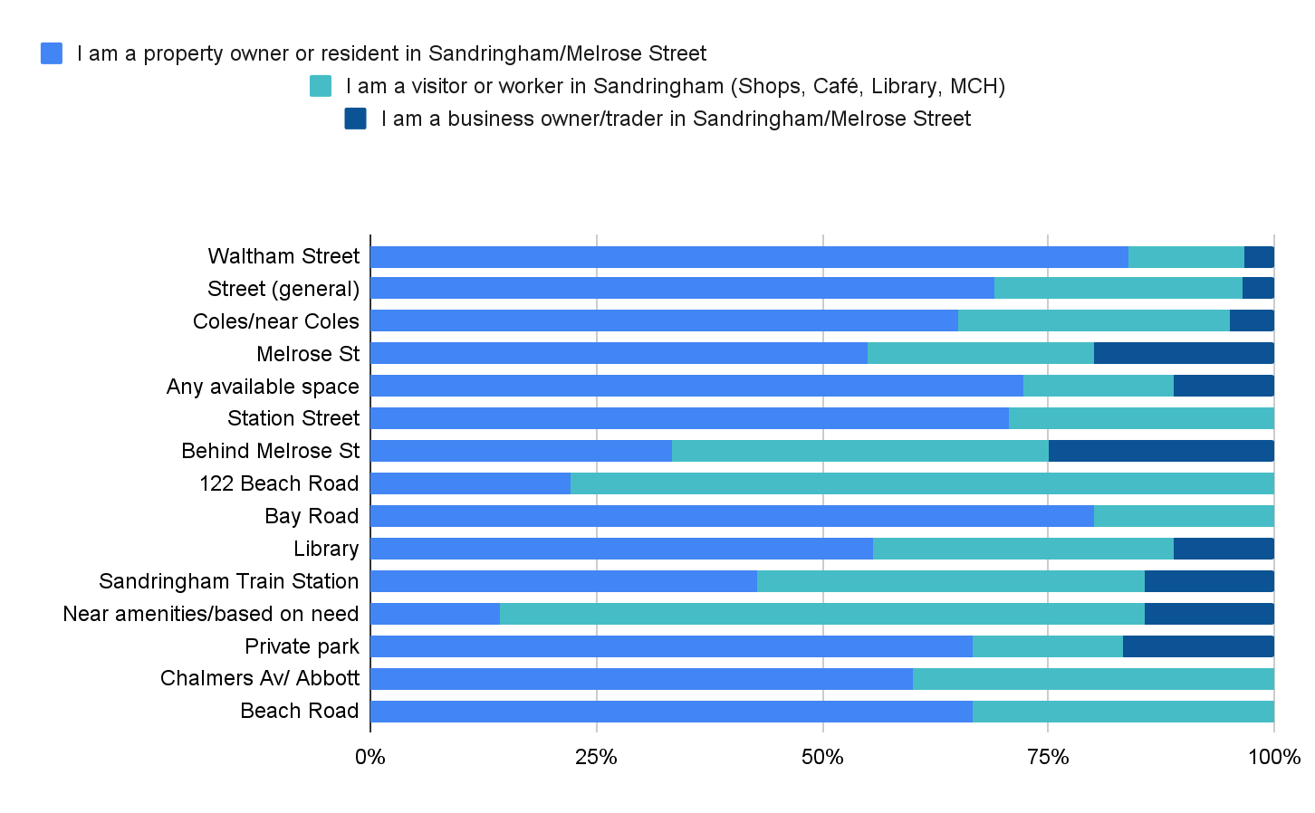
Note: Options with low selections have been omitted from the graph for clarity purposes, To view all responses, please refer to the tables in the appendices.

Key Findings
Findings are presented on via project:
- Part A - Potential part road closure of Melrose Street, Sandringham.
- Part B - Potential introduction of a trader parking permit scheme to use Councils underground carpark located at 122 Beach Road, Sandringham.

5.1 Part A Potential part road closure of Melrose Street
Support for the closure of Melrose Street was polarised, with the majority of survey and pop up participants either strongly supporting the closure (128) or strongly opposing it (108). There were 29 participants that somewhat supported the closure and 27 participants that somewhat opposed it, with the remaining three participants having no opinion or not caring. Figures 8 and 9 show levels of support and connection.
Figure 8. Overall support for the closure of Melrose Street (Pop Up and Survey)
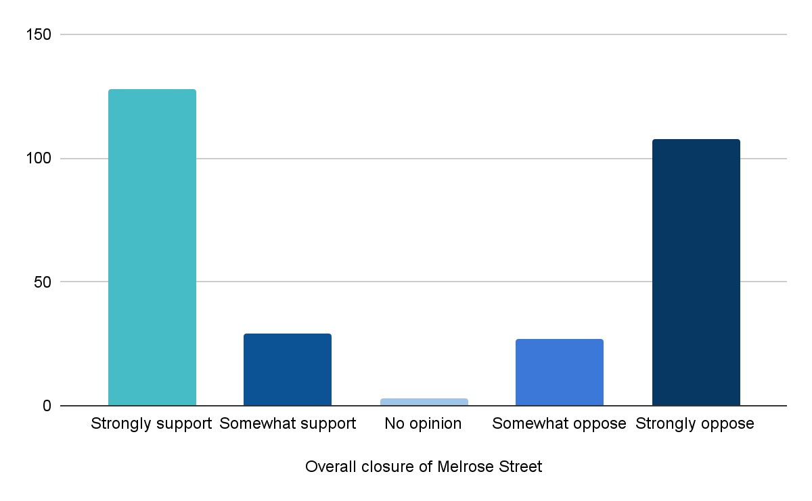
Property owners in the village followed the general trend, and were polarised, with 9 people strongly supporting (39%), and 10 people strongly opposing the closure (43%).
Participants that were residents elsewhere; had a higher proportion strongly or somewhat supported the closure (104 - 54%) than opposed it (86 - 45%).
Visitors to the area felt similarly to broader Sandringham residents with 54% (31) supporting and 46% (26) opposing.
Workers in the village were supportive of the closure, with 64% (7) strongly supporting the closure.
The majority of Melrose Street residents (9) strongly opposed the closure, with four residents strongly supporting it.
There were 13 business owners or traders in Melrose Street and the wider Sandringham area that strongly opposed the closure, with one somewhat opposed and four strongly supporting the closure.
Figure 9. Support for the closure by connection to Sandringham
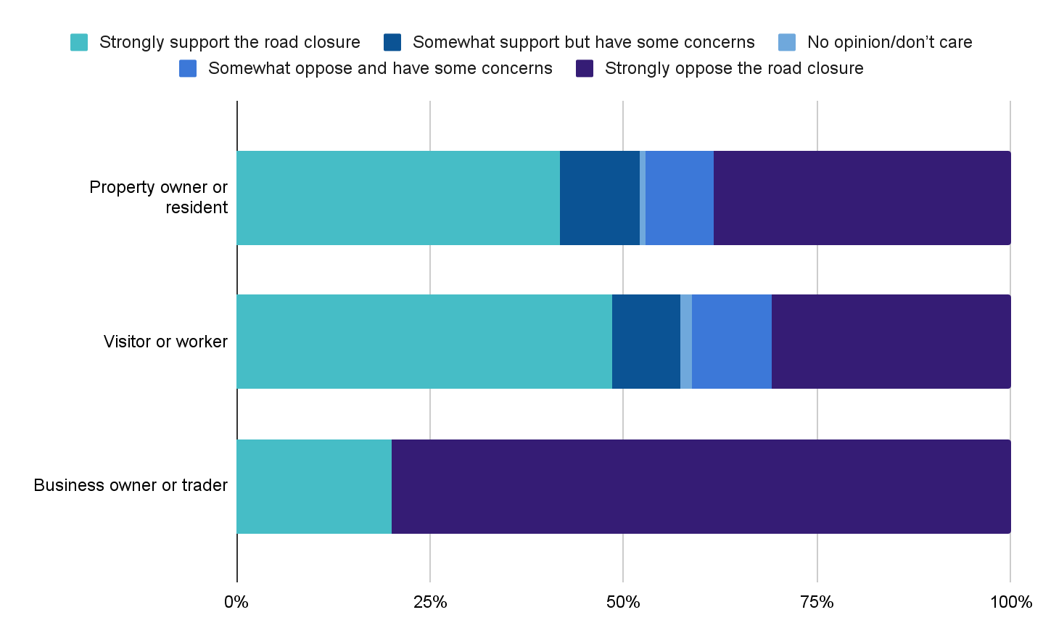

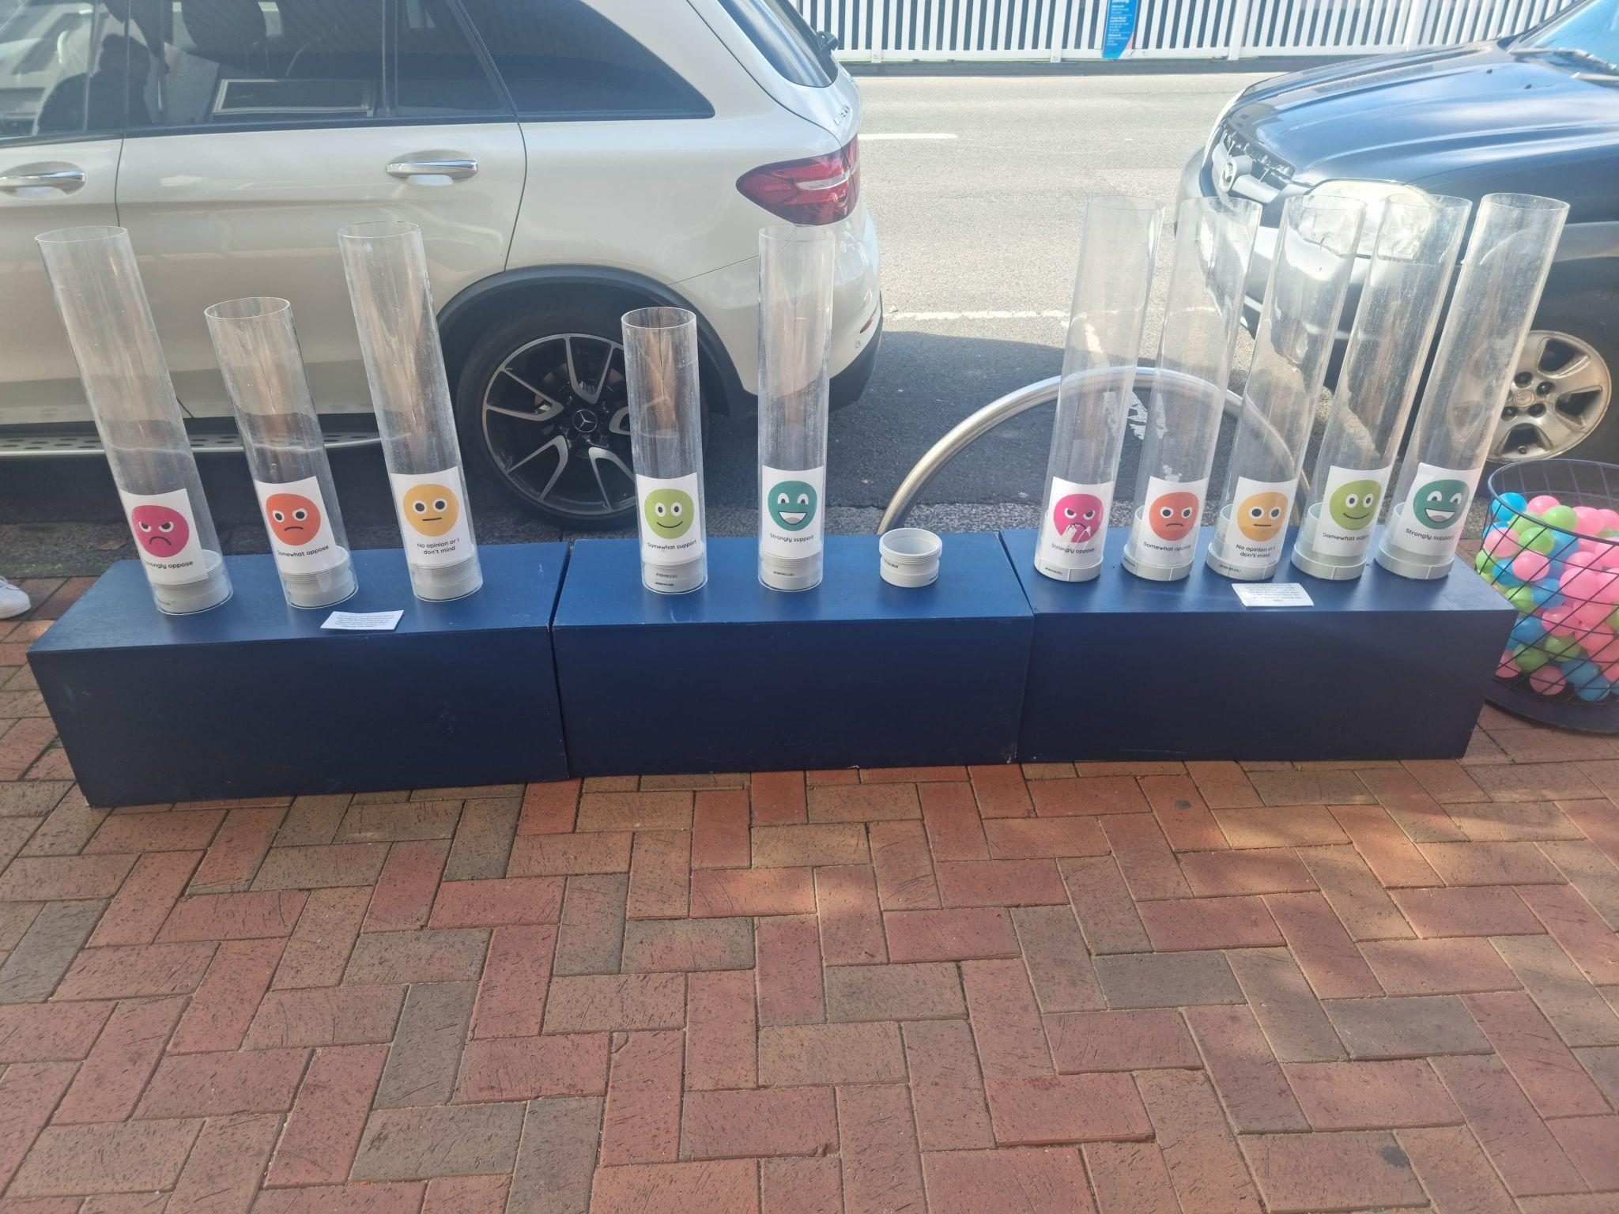
Indicative levels of support
Participants who wrote submissions were not explicitly asked about their level of support for the project. The level of support was assessed by the submission tone and content. Participants who attended the webinar completed a poll to show their level of support for the project. Likewise, participants at the pop up could drop a ball to indicate their level of support for the project - with or without participating in additional activities.
This activity was not planned to be used as a data collection tool at the first pop-up but was used as a collection tool on the subsequent pop-ups. It is important to note that participants may have had access to the survey and as such duplication is a possibility.

Concerns and questions
Survey and pop participants that were concerned about the project, were concerned about parking and traffic: more traffic and parking demand in the immediate area (144), followed by traffic parking demand in the surrounding streets further away (114) accessible parking impact (75) and direct impact on residential and visitor carparking (71). Breakdown of overall concerns is shown in Figure 13.
Figure 10. Concerns and questions regarding the closure based on connection to Sandringham
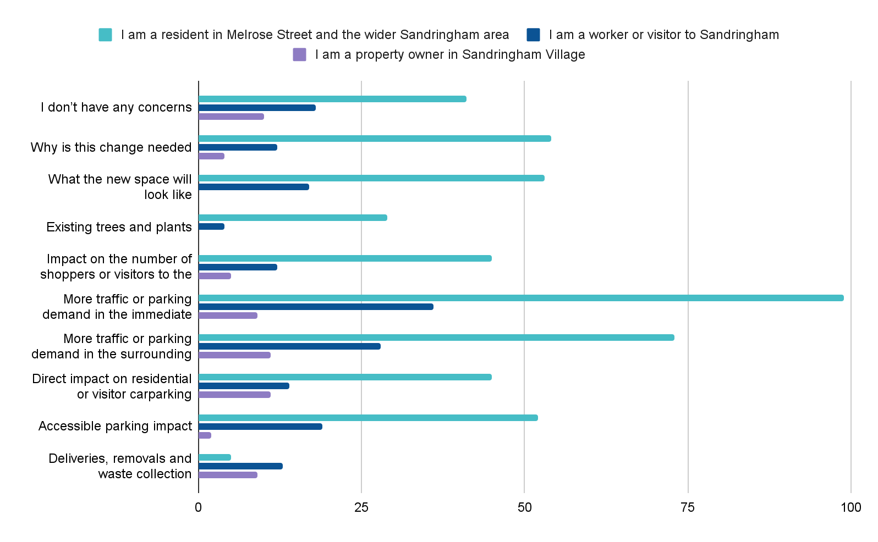
Note: Options with low selections have been omitted from the graph for clarity purposes, To view all responses, please refer to the tables in the appendices.
Figure 10 shows a breakdown of concerns by connection to the project.
For residents of Melrose Street the top three concerns were; why is this change needed (8), more traffic and parking demand in the immediate area (7), and accessible parking impact (7).
For residents living elsewhere in Sandringham, the overwhelming concern was more traffic and parking demand in the immediate area (92) and surrounding area (68) followed by what the space will look like (49) and why the change is needed (46).
Workers in the area were concerned about more traffic and carparking demand in the immediate area (4) and surrounding area (3), and what the space would look like (4). Four workers did not have any concerns.
Similarly, the main concerns for visitors were related to parking and traffic in the immediate area (32), surrounding area (25) and accessible parking impact (19).
Property owners in the village were most concerned about the direct impact on residential and visitor parking (11), more traffic or parking demand in the surrounding streets further away (11), traffic and carparking in the immediate area (9) and deliveries, removals and waste collections (9).
For business owners, the most common concern was the direct impact on residential and visitor carparking (11). Business owners in Melrose Street were concerned about the impact on their business (deliveries, waste collection, customer impact) (6), access to their business for other services (6) and the impact on shoppers and visitors to the area (6). Business owners in the wider Sandringham area were concerned about more traffic and parking demand in the immediate (6) and surrounding area (5). Shown in Figure 11.
Figure 11. Concerns and questions for Business owners
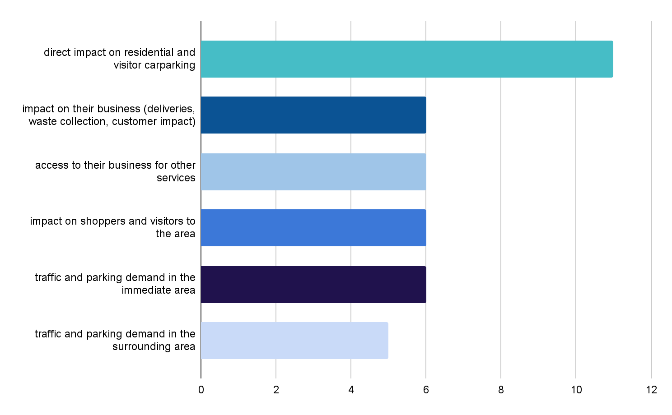
Submitters opposed to the closure of Melrose Street were concerned about:
- A reduction in carparking when parking is already a known problem for the area.
- Increasing traffic congestion, access to Sandringham Village, the train station and as a result shoppers and visitors to the area.
- An increase in noise and alcohol consumption resulting in unsavoury behaviour late at night.
- Loss of the current Village feel.
- Space not being used as Melrose Street is seen as a wind tunnel and not a place where people will want to sit and dine.
- Impact on the climate and the need to understand accurate details of the reduction of the urban heat island effect.
- The lack of benefit to local residents and ratepayers and the perception that the closure will benefit certain traders.
- Impact on traffic movement and need to understand traffic patterns.

Ideas for future use of this space
Participants were asked “If the closure proceeds, how would you like to use this area?” with an option to select multiple items from a list of suggestions. The same list of options were provided to business owners. Figure 12 shows this breakdown.
The top three options selected were a place to sit down and eat and have a coffee (172), a space for entertainment or events (144) and a space for pop-up shops and footpath trading (141).
Residents of Melrose Street equally valued a place to sit and rest, a passive open space or a park and footpaths (6 for each).
For participants that live elsewhere in Sandringham, visit or own a property in the village, the most common selection was a place to sit down and eat or have coffee.
Workers in the village wanted to see the area used for entertainment or events (8), a place to sit and rest (7) and a space for pop-up shops and footpath trading (7).
Figure 12. Future aspirations for the space for all connections to the area.
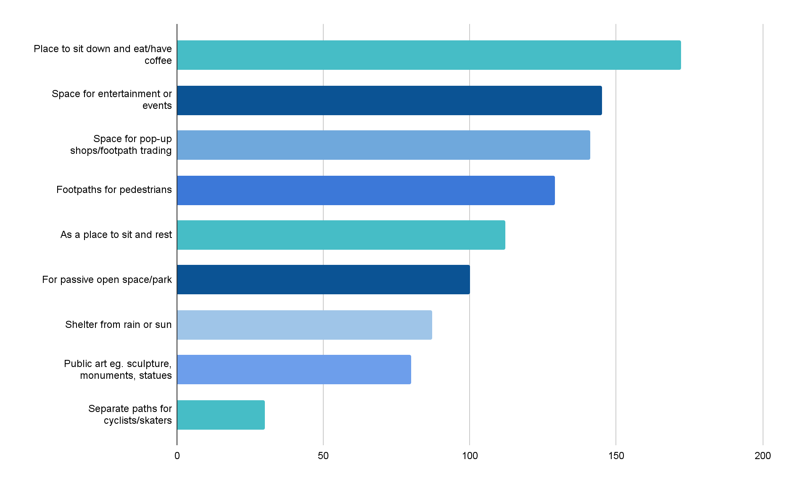
Note: Options with low selections have been omitted from the graph for clarity purposes, To view all responses, please refer to the tables in the appendices.
Business owners most wanted to see the area used for pop-up shops and footpath trading (6), a place to sit and rest (5) and a space for events and entertainment (5). Traders in the street most wanted to see the space used for entertainment (4), whereas traders in the wider Sandringham area most wanted to see pop-up shops and footpath trading (4). Figure 13 shows this breakdown.

Figure 13. Future aspirations for the space for business owners and traders.
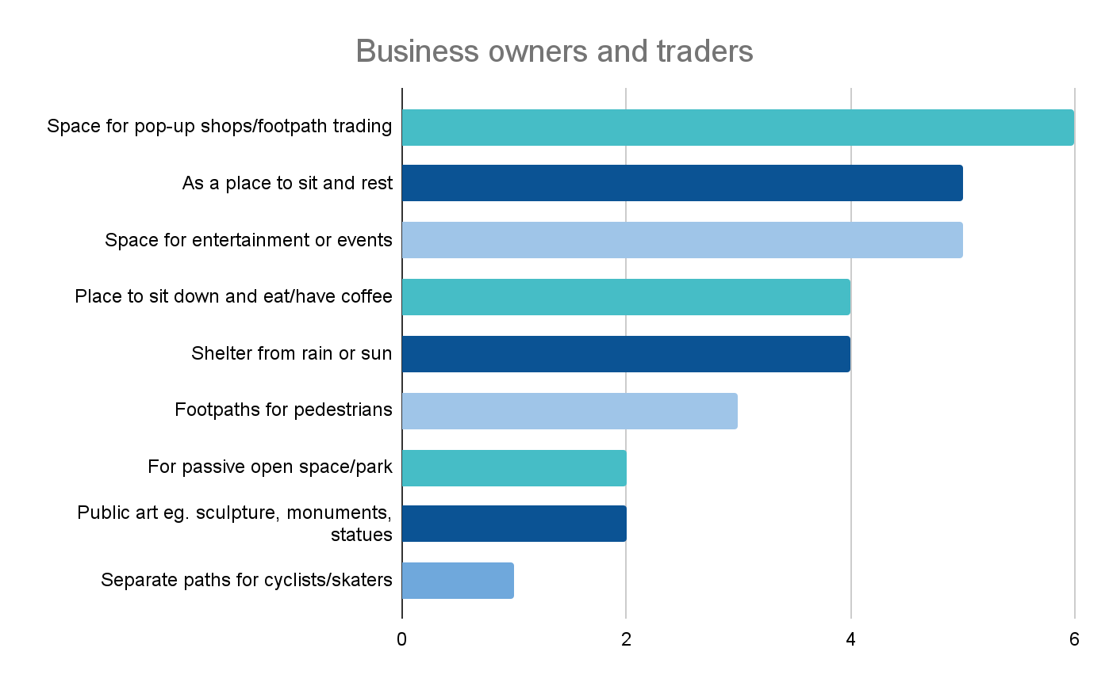
Note: Options with low selections have been omitted from the graph for clarity purposes, To view all responses, please refer to the tables in the appendices.
Survey and pop up participants were given the opportunity to provide a free-text answer to the question “Do you have any further comments on how this space could look and function?”. The most common response was questioning: why the change was needed (51) and questioning what the new space will look like (20).
Other comments focused on desired elements for the space, reflecting responses from the previous multiple-choice question, apart from a focus on the concern regarding Melrose Street being exposed to strong winds and the need for shade (14), and the potential for the space to be child friendly (8).
Quotes from the community:
- “Consider protection from cold winds off the bay that whistle up Melrose St.”
- “A major covered area making it usable in all weather conditions.”
- “Protection buffer from sea wind but with sun shelter from nature such as trees.”
- “It would be nice to have some shade from trees, some seats for older residents to be able to sit and enjoy and grass for the younger residents with some play equipment.”
- “A small instalment for kids would be nice, …… I feel these community spaces are often created with only adult purposes in mind.”
- “A small playground would be great.”
The project team collected responses from people that did not formally want to participate in the project or had participated previously and provided additional comments at the pop up. Here are some direct community comments:
- Concerns or improvements for Melrose Street closure:
  - “In a neighbouring street there is no right-hand turn, so I think that's why trucks don't use this road. Maybe they could consider making our street a no right-hand turn also.”
  - “Waltham Street is a better idea, not this wind tunnel. People should be given options for other locations.”
  - “Pedestrian safety? How is that being addressed with this? The pedestrian crossing is awful, it's a blind corner that's why people are nearly getting run over.”
  - “Don't understand why the council is throwing money into this with no real benefit.”
  - “If you want events, the council should block the street off temporarily, just for a day or two. Same with the parklets, who even uses them?”

5.2 Part B Potential introduction of a trader parking permit scheme
As with the suggestion of closing Melrose Street, the proposal to make the carpark under 122 Beach Street available for traders generated polarised responses, with responses from the survey and pop up either strongly opposed or supporting the proposal.
Of residents, visitors and workers, 119 strongly supported the scheme, and 48 somewhat supported the scheme - with support totalling 57%. There were 26 participants somewhat opposed, and 57 strongly opposed, opposition totalling 28%. The remaining 44 participants had no opinion or did not care. Figure 14 shows the level of support across all connections, Figure 14 shows responses of business owner and trader and Figure 15 shows responses by visitor, resident and worker.
Figure 14. Support for the trader parking scheme by all connections to Sandringham (survey and pop up)
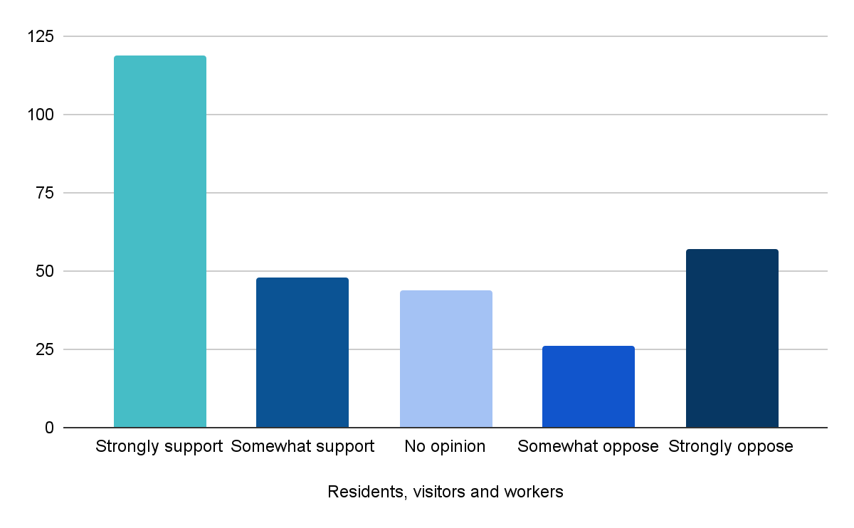
Almost double the number of business owners and traders strongly supported the permit scheme (9), in comparison to five strongly opposing. There were three participants somewhat supporting, one somewhat opposing. Figure 19 shows this breakdown of business and trader responses
Figure 15. Support for the trader parking scheme for business owners and traders (survey and pop up)
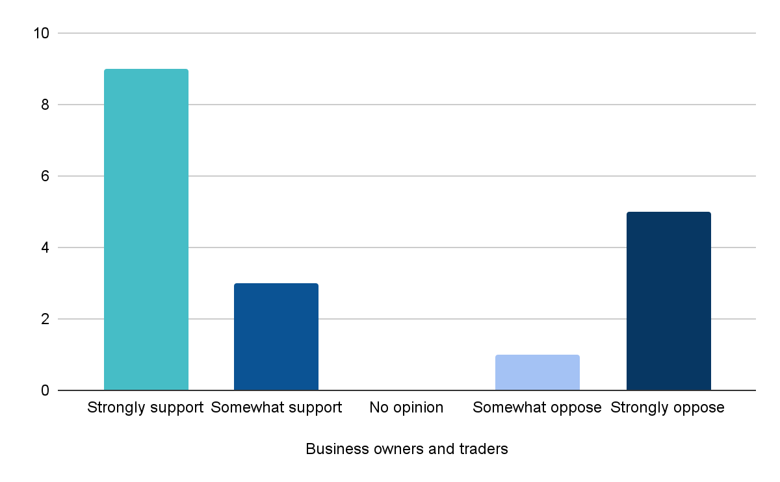
Figure 16. Support for the trader parking scheme for property owners, residents, visitors and workers (pop up and survey)
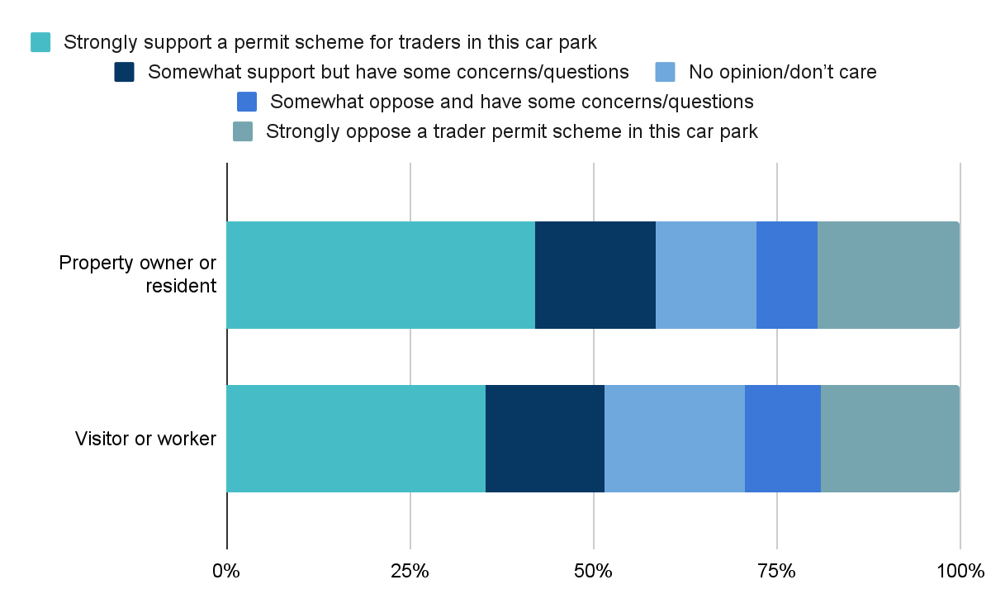

Indicative levels of support
Participants who wrote submissions were not explicitly asked about their level of support for the project. The level of support was assessed by the submission tone and content. Participants who attended the webinar competed in a poll to show their level of support for the project. Likewise participants at the pop up could drop a ball to indicate their level of support for the project. With or without participating in additional activities.
This activity was not planned to be used as a data collection tool. It is important to note that participants may have had access to the survey and as such duplication is a possibility.
Concerns, improvements and supportive comments
Survey and pop up participants were asked if they had any concerns or questions about the trader parking proposal, the biggest concern was the removal of 36 publicly available car spaces and providing for parking demand in the area. This is shown in Figure 17 . A breakdown by business owners and traders is shown in Figure 18.
Figure 17. Overall concerns and questions regarding the trader parking scheme for residents, visitors, property owners and workers.
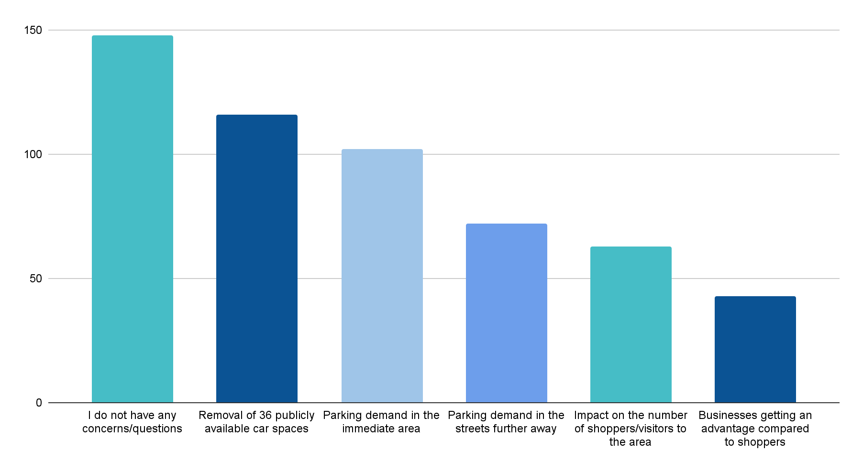

Figure 18. Concerns and questions regarding the trader parking scheme for business owners and traders.
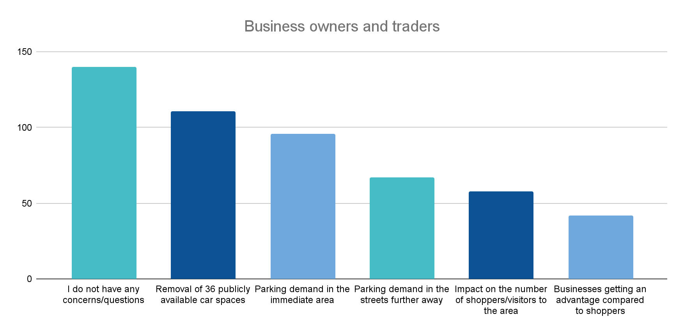
Survey and pop up participants were asked if they had any other specific concerns or questions regarding trader parking:
- 32 participants reiterated the concern for parking availability
- 29 participants selected that they had no concerns or questions about the trader parking
- 22 participants felt more parking, long parking times was needed
- 16 participants were concerned about how the trader permit process would be managed and monitored (16 participants).
- 13 participants felt parking availability was needed for shoppers and visitors and locals and ratepayers (10 participants).
Residents living elsewhere in Sandringham were most likely to select that they did not have any concerns or questions (18% of elsewhere in Sandringham residents), whereas visitors were more likely to select that parking was a problem (24% of visitors).
Workers in the area were concerned that parking was a problem (2), questioned managing permits for traders (2), and believed it was a good initiative for traders (2).
Submitters opposed to the the introduction of a permit scheme for Traders to be introduced at 122 Beach Road Sandringham and were concerned about:
- Need to undertake the traffic and parking survey and cost of the traffic impact assessment.
- Community feedback would be enacted upon as the community had already been consulted and plans were then not proceeded with. Money used for this consultation could be utilised better to provide better infrastructure for the increased density of buildings and increased population.
- The proposal being “contrary to Council’s obligations to its ratepayers”.
- The cost of parking to traders and the fact traders should not have to pay for parking.
- Traders taking up ratepayer, shopper and visitor parking, traders should park further away from the village.
- Residents are not aware of the carpark and that is why it is underutilised.
- Safety of traders walking from the village to the underground carpark at night.
- The amount of parks that could be allocated for trader parking, should be less than the 36 spaces.
A smaller number of submissions supported the introduction of a permit scheme for Traders to be introduced at 122 Beach Road Sandringham. The following are reasons for their support:
- It would free up parking in the streets.
- Provide parking for shop tenants.
- Encourage traders to the area.
- Supports any initiative that increases parking in the area.
One submission also provided ideas on how the permit system could work, such as the number of permits each shop could have and that a fee could be payable for the permit.
The group submission from a number of businesses on Melrose Street noted that there had been no consultation with the Traders Association on either of the proposed ideas, this consultation is a separate process that will occur in November 2022 by Council officers.

Ideas for future use use of this space
Participants were asked “If this proposal is endorsed, Council will need to set up a trader permit parking scheme for 122 Beach Road Sandringham. Given there are only 36 spaces available, what should Council consider when designing a permit scheme for this carpark?’
A total of seven participants responded to this question, with the majority of comments offering ideas on how the scheme could work, such as the number of permits provided per business, excess traders parking at the beach for free or an auction.
Here are some direct community comments:
- “In times of peak demand, allow for excess traders to park at the beach for free.”
- ‘I imagine that would be quite difficult as there are more than 36 people who require parking so they can work in their businesses in Bay road and Station street alone…..let alone Melrose street owners and workers.”
- “Either first come... or perhaps an auction. I don't think that any scheme which requires the consideration of merit or convenience would work.”
- “All businesses to be provided with 2 parking permits for free.”
- “Perhaps a cap on permits per business.”

Recommendations
The following section provides our recommendations based on conversations with the community and key stakeholders and the feedback they provided.

Part A - Closure of Melrose Street
Sentiment towards the proposed closure of Melrose Street is polarised (42% strongly supporting and 39% strongly opposing), it is important that future plans and communication clearly address the questions and concerns if the project is to proceed or to provide a detailed explanation if it does not go ahead.
The main concern for residents, visitors and property owners was more traffic and parking demand, and the main concern for business owners was the direct impact on residential and visitor carparking. Providing detailed information on traffic and parking modelling and solutions may alleviate some of the concerns that participants have about the proposed closure.
The engagement highlighted that participants had questions about what the space would look like and why the change was needed. Providing more information on the look and feel, and expanding on the positive implications of the closure may address these questions.
Community aspirations within this space
The top three aspirations for the space were a place to sit down and eat or have a coffee (172), a space for entertainment or events (144) and a space for pop-up shops or footpath trading (141). This suggests the community would want flexible infrastructure to allow these different activities to occur in the space.

Part B -Trader parking permit concept
There was a greater level of support for the trader parking permit scheme, than those opposed to it, with almost a third of participants not having any questions or concerns.
Participants that did have concerns were worried about the removal of the 36 publicly available car spaces, and the demand for parking in the immediate and surrounding area.
As above, providing detailed information on traffic and parking modelling and solutions may alleviate some of the concerns that participants have about the proposed parking scheme.

Process recommendations
Engagement on this project has already created significant interest and aspirations for the Sandringham community, for those who participated, read a post online or were engaged at a pop-up.

- Keeping people updated: Issue a statement and update the Council project page thanking participants for participating in the project and for sharing their ideas. As we move into the next phase of the project we need to keep the broader community updated about the progress of this project.

- Share the data: We have collected a substantial level of data that may be used by other departments to plan the delivery of services. Consider ways you can share this data such as creating a snapshot of the engagement data, to bring the data to life with infographics to help participants digest the information in an easy form.

7. Project evaluation

The project Engagement Plan established several measures of engagement success, as shown in Table 5.
In terms of stakeholder reach, the number of participants exceeded the minimum target of 200. All identified stakeholder groups either attended the community pop-ups or made a submission to Council with their feedback. As expected the age profile of engagement participants was older than the wider Bayside community profile, with the majority aged in their fifties, sixties and seventies. Teenagers, young adults and elderly persons over 85 years were under-represented. There was a good representation of residents and business owners from the immediate area around Melrose and Station Streets.
Feedback was received via all four engagement methods and the viewpoints and concerns documented tended to be polarised in nature.
Participants were asked in the online survey and at the community pop-ups “Did you have the information you needed to provide feedback?”. Overall 62.2% of participants said the information was “very easy” to find or understand and a further 28.3% said it was “mostly easy” to find or understand, exceeding the 75% benchmark.
The conversion goals for visits to the Have Your Say project page were, that:
- 5% of visits would have at least one contribution made.
- 25% of visits would last at least one active minute (time spent actively looking at project information).
- 15% of visits would have at least two actions performed (moving around project page, clicking on links).
Figure 19 shows that these three metrics were exceeded.

Figure 19. Participant activity on Have Your Say engagement portal
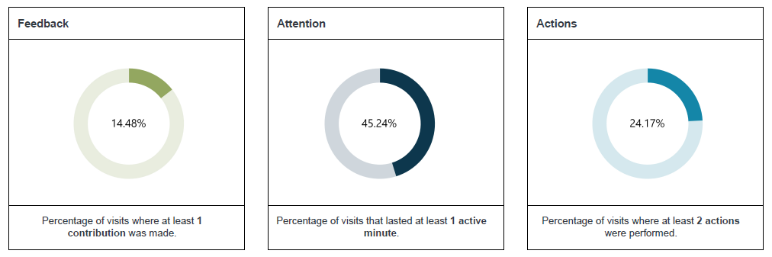
Outrage management is also an important measure for engagement. Project communication should ideally occur using the preferred Council channels only and there are no emails or handwritten complaints and correspondence sent to Council or Councillors. Majority of emails were submitted directly to the council project lead listed on the Have Your Say project page, however two were submitted through the Council complaint system.
Other key measures for the engagement were that the Council or the delegated decision maker was confident in the reliability of data - measured by the inclusion of the full Engagement Summary in the Council report, and that Council does not request further engagement be conducted.
Table 5 Project Evaluation - Measures of Success
Measure of success | Data Source | Result
Stakeholder Reach - participation across age, gender, connection, geographical location and interest groups. Participation from local residents comparable to community profile.  Target of 200 participants minimum | Demographic data from online survey, webinars and pop-ups | TARGET MET - A total of 352 people participated, exceeding the minimum target of 200.  The age profile of engagement participants was older than the wider Bayside community profile, with the majority aged in their fifties, sixties and seventies.  There was a good representation of residents and business owners from the immediate area around Melrose and Station Streets.  Gender and specific interest groups were not recorded in the online survey or community pop-ups. One interest group - Sandringham Foreshore Association - made a submission, as well as a submission from a group of traders from Melrose Street.
Collection of data from a variety of viewpoints, concerns, interests | Feedback from online survey, webinars and pop-ups | TARGET MET - Feedback was received via all four methods - the online survey, community pop-up sessions, written submissions and the online webinar. Viewpoints and concerns tended to be polarised.
Engagement portal conversion statistics - 75% report satisfaction with the information provided via HYS, 5% contributions, 25% active visits (>1 minute), 15% actions | HIVE report | TARGET MET - 62.2% of participants said the information was “very easy” to find or understand and a further 28.3% said it was “mostly easy” to find or understand.  15% contributions, 45% active visits (>1 minute), 24% actions
Manage stakeholders' expectations - any outrage is received through desired channels, no email or written complaints or correspondence to Council or Councillors | Council records, Have Your Say engagement portal | Submissions were emailed to the Council project lead listed on the Have Your Say project page and two through the Council complaint system.
Council publishes engagement findings, referenced in Council reports. Any duplication of submissions is identified. | Council Briefing feedback | The issue is scheduled to be discussed at the December Council meeting. One participant made two submissions and this was identified.
Council has sufficient information to proceed with the next stage.  Councillors do not request engagement be extended or repeated. | Council Meeting Minutes  Client Debrief meeting | Council Meeting date to be scheduled.  Client Debrief meeting is scheduled for November 2022.

Online webinar session
A total of 8 participants attended the online webinar session. In order to evaluate the online webinar session participants were asked if the session helped them better understand the two proposed ideas for Sandringham.
Table 6. Impact of session
 | Number
Strongly agree | 1
Agree | 5
Neither agree or disagree | 1
Disagree | 1
Strongly disagree | 0

Table 6 shows the level of agreement from participants, the majority of participants strongly agreed (1) or Agreed (5), with one participant neither agreeing or disagreeing and one disagreeing.

Evaluation of engagement communication
The communications approach used in this project was successful in notifying people about the project and consultation. The purpose of communication was to:
- Promote engagement with the community on the potential closure of a section of Melrose Street and introduction of a trader permit scheme and the opportunity to provide feedback.
- To support the engagement with high-quality, accessible communications materials.
The consultation program was promoted through a variety of channels including:
- Signage installed in various prominent locations in Sandringham Village, containing brochures with project information and a QR code survey link.
- Brochure distributed to over 3,000 residents living in Sandringham with information and QR code link to the survey.
- Addressed mail to local residents, property owners and businesses to inform of the engagement including invitation to attend the webinar and face to face sessions.
- Flyers distributed to residents living within 500m of the centre, shops, within the centre and at Sandringham Library and Corp Centre.
- Article in the Let’s Talk Bayside Magazine.
- Community pop-up sessions and information webinar.
- Website news story in This Week in Bayside running in every week.
- FAQ’s published on the Have Your Say project page.
- Emails to parklet database, HYS database Sandringham Village Masterplan, Economic development (Sandringham Traders, Association Traders).
- 3D tours of the area featured on the HYS project page.
- Facebook and Instagram posts linking to the HYS project page.
- Sponsored social media posts targeted at Bayside residents living in Sandringham.
- Community run social media hubs.
- Media release - news story to promote engagement.
- Internal communications including Inside Words and In the Loop to advise Councillors and Bayside staff of engagement and key messages.
Table 7. Impact of the engagement communication
Impact evaluation | Commentary
Promote engagement with the community on the potential closure of a section of Melrose Street and introduction of a trader permit scheme and the opportunity to provide feedback. | 779 page views of Have your say for two ideas for Sandringham Village, with an average time of 2:35 time spent on the page.  eNewsletters were sent to 62,921 subscribers, with a reach of 33,196.  A total of 352 people participated in the engagement.
To support the engagement with high-quality, accessible communications materials. | 62.2% of participants said the information was “very easy” to find or understand and a further 28.3% said it was “mostly easy” to find or understand.

Table 8. e-Newsletter statistics
Email | Date | Sent | Opened | Clicked
TWIB | 8 September | 10,427 | 5,925 | 465
TWIB | 15 September | 10,469 | 5,986 | 48
TWIB | 21 September | 10,487 | 5,390 | 36
TWIB | 29 September | 10,491 | 5,291 | 26
TWIB | 6 October | 10,521 | 5,329 | 48
TWIB | 13 October | 10,526 | 5,275 | 23
Total |  | 62,921 | 33,196 | 646

Table 9. Facebook statistics
Date | Comments | Reactions | Reach | Paid reach | Impressions | Paid impressions | Engagement rate
9 September | 13 | 16 | 2,784 | 6,404 | 2,904 | 13,973 | 9.94 %

Table 10. Facebook statistics
Date | Comments | Likes | Reach | Impressions | Engagement rate
9 September | 8 | 74 | 2,612 | 3,331 | 2.55%

Table 11. Website statistics
Page | Page views | Average time on page
Have your say on two ideas for Sandringham Village | 779 | 2:35

Appendices
Potential changes to the way you use Melrose Street and Trader Parking in Sandringham – Community and Business Survey Questions
Provide map & summary
Q1 – What is your personal connection to Sandringham? (mandatory single response to enable skips)
- I am a resident in Melrose Street
- I am a resident living elsewhere in Sandringham (postcode 3191)
- I live elsewhere but am a visitor to Sandringham (Shops, Café, Library, MCH)
- I am a business owner or trader in Melrose Street
- I am a business owner or trader in the wider Sandringham area
- I am a worker within Sandringham village
On which street is your business located? (short text field)
- I am a property owner in Sandringham Village
On which street is your property located? (short text field)
Q2 How do you usually travel to Sandringham (single-response)
- Walk
- Cycle
- Drive (or car passenger) ________ If so, where do you usually park:__________
- Bus and / or train
- Other
Showing common questions and different wording for business:
Based on Q1 answer - Residents, Visitors, and Workers | Based on Q1 answer - Business Owner or Trader
Now that you’ve read about the idea to close a section of Melrose Street between 12 Melrose Street and Station Street, do you support or oppose this idea?  - Strongly support the road closure  - Somewhat support but have some concerns  - No opinion or don’t care  - Somewhat oppose and have some concerns  - Strongly oppose the road closure  If the closure is supported, have you got any concerns about the following items you’d like us to consider?  (multi-response)  - Why is this change needed  - What the new space will look like  - Existing trees and plants  - Impact on the number of shoppers or visitors to the area  - More traffic or parking demand in the immediate area (Melrose-Station-Waltham Streets)  - More traffic or parking demand in the surrounding streets further away  - Direct impact – residential visitor carpark  - Accessible parking impact  - Deliveries, removals and waste collection  - I don’t have any concerns  Do you have any other concerns or comments about the potential road closure? (text field) | Now that you’ve read about the idea to close a section of Melrose Street between 12 Melrose Street and Station Street, do you support or oppose this idea?  - Strongly support the road closure  - Somewhat support but have some concerns  - No opinion or don’t care  - Somewhat oppose and have some concerns  - Strongly oppose the road closure  If the closure is supported, have you got any concerns about the following items?  (multi-response)  - Why is this change needed  - What the new space will look like  - Existing trees and plants  - Impact on the number of shoppers or visitors to the area  - More traffic or parking demand in the immediate area (Melrose-Station-Waltham Streets)  - More traffic or parking demand in the surrounding streets further away  - Access to my own business for deliveries and other services  - Direct impact to my business (deliveries, loading, waste collection, customer impact)  - Accessible parking impact  - I don’t have any concerns  Do you have any other concerns or comments about the potential road closure? (text field)
If the closure proceeds, we'll need to re-design this area to make it attractive and functional for all users.  If the closure proceeds, how would you like to use this area? (multi-response)  Please select all that appeal to you  - As a place to sit and rest  - Place to sit down and eat or have coffee  - For passive open space or a park  - Safe footpaths for pedestrians  - Separate paths for cyclists or skaters  - Shelter from rain or sun  - Space for entertainment or events  - Space for pop-up shops or footpath trading  - Public art eg. sculpture, monuments, statues  Do you have any further comments about how this space could look and function? (text field) | If the closure proceeds, we'll need to re-design this area to make it attractive and functional for all users.  If the closure proceeds, how would you like to use this area? (multi-response)  Please select all that appeal to you  - Place to sit and rest  - Place to sit down and eat or have coffee  - For passive open space or a park  - Safe footpaths for pedestrians  - Separate paths for cyclists or skaters  - Shelter from rain or sun  - Space for entertainment or events  - Space for pop-up shops or footpath trading  - Public art eg. sculpture, monuments, statues  Do you have any further comments about how this space could look and function? (text field)
Council is considering a proposal to make the 36 space public carpark under 122 Beach Road, a permit carpark for traders to park for longer than four hours. Do you support or oppose this idea?  - Strongly support a permit scheme for traders in this carpark  - Somewhat support but have some concerns or questions  - No opinion or don’t care  - Somewhat oppose and have some concerns or questions  - Strongly oppose a trader permit scheme in this carpark  Have you got any concerns or questions about the trader parking proposal? (multi-response)  - I do not have any concerns or questions  - Why is this change needed  - Businesses getting an advantage compared to shoppers  - Impact on the number of shoppers or visitors to the area  - Removal of 36 publicly available car spaces  - Parking demand in the immediate area  - Parking demand in the streets further away  Do you have any specific concerns or questions? (text field) | Council is considering a proposal to make the 36 space public carpark under 122 Beach Road, a permit carpark for traders to park longer than four hours. Do you support or oppose this idea?  - Strongly support a permit scheme for traders in this carpark  - Somewhat support but have some concerns or questions  - No opinion or don’t care  - Somewhat oppose and have some concerns or questions  Strongly oppose a trader permit scheme in this carpark  Have you got any concerns or questions about the trader parking proposal? (multi-response)  - I do not have any concerns or questions  - Why this change is needed  - Who will be allowed to park in the new area or how many spaces  - Enforcement of new parking rules  - Impact on the number of shoppers or visitors to the area  - Removal of 36 publicly available car spaces  - Parking demand in the immediate area  - Parking demand in the streets further away  Do you have any specific concerns or questions? (text field)
Demographics – age group (relevant to some landscaping infrastructure). No project need for gender to be recorded unless Council considers this mandatory for all engagement.  What is your age group?  Under 18, 19 – 25, 26 – 35, 36 – 49, 50 – 59,  60 – 69, 70 – 84, 85+, Prefer not to say | If this proposal is endorsed, Council will need set up a trader permit parking scheme for 122 Beach Road, Sandringham.  Given there are only 36 spaces available, what should Council consider when designing a permit scheme for this carpark?

Table 12. Breakdown of support via connection to Sandringham (Survey and community pop-up responses)
 | I am a resident in Melrose Street | I am a resident living elsewhere in Sandringham | I live elsewhere but am a visitor to Sandringham | I am a business owner or trader in Melrose Street | I am a business owner or trader in the wider Sandringham area | I am a worker within Sandringham village | I am a property owner in Sandringham Village
Strongly support the road closure | 4 | 82 | 26 | 3 | 1 | 7 | 9
Somewhat support but have concerns | 0 | 22 | 5 | 0 | 0 | 1 | 1
No opinion or don’t care | 0 | 1 | 0 | 0 | 0 | 1 | 1
Somewhat oppose and have some concerns | 0 | 18 | 6 | 0 | 1 | 1 | 2
Strongly oppose the road closure | 9 | 68 | 20 | 7 | 6 | 1 | 10

Table 13. Concerns regarding closure of Melrose Street based on connection to Sandringham (Survey and community pop-up responses)
 | I am a resident in Melrose Street | I am a resident living elsewhere in Sandringham | I live elsewhere but am a visitor to Sandringham | I am a worker within Sandringham village | I am a property owner in Sandringham Village
I don’t have any concerns | 4 | 37 | 14 | 4 | 10
Why is this change needed | 8 | 46 | 11 | 1 | 4
What the new space will look like | 4 | 49 | 13 | 4 | 0
Existing trees and plants | 4 | 25 | 4 | 0 | 0
Impact on the number of shoppers or visitors to the area | 3 | 42 | 12 | 0 | 5
More traffic or parking demand in the immediate area (Melrose-Station-Waltham Streets) | 7 | 92 | 32 | 4 | 9
More traffic or parking demand in the surrounding streets further away | 5 | 68 | 25 | 3 | 11
Direct impact on residential or visitor carparking | 5 | 40 | 14 | 0 | 11
Accessible parking impact | 7 | 45 | 19 | 0 | 2
Deliveries, removals and waste collection | 5 | 31 | 12 | 1 | 9

Table 14. Concerns regarding closure of Melrose Street based on connection to Sandringham - Business responses (Survey and community pop-up responses)
 | I am a business owner or trader in Melrose Street | I am a business owner or trader in the wider Sandringham area
I don’t have any concerns | 2 | 0
Why is this change needed | 2 | 3
What the new space will look like | 1 | 0
Existing trees and plants | 1 | 1
Impact on the number of shoppers or visitors to the area | 6 | 2
More traffic or parking demand in the immediate area (Melrose-Station-Waltham Streets) | 4 | 6
More traffic or parking demand in the surrounding streets further away | 4 | 5
Access to my own business for deliveries and other services | 6 | 1
Direct impact to my business (deliveries, loading, waste collection, customer impact) | 6 | 1
Direct impact on residential or visitor carparking | 6 | 5

Table 15. Future use based on connection to Sandringham (Survey and community pop-up responses)

 | I am a resident in Melrose Street | I am a resident living elsewhere in Sandringham | I live elsewhere but am a visitor to Sandringham | I am a worker within Sandringham village | I am a property owner in Sandringham Village
As a place to sit and rest | 6 | 75 | 13 | 7 | 6
Place to sit down and eat or have coffee | 3 | 111 | 36 | 5 | 12
For passive open space or a park | 6 | 70 | 11 | 5 | 6
Footpaths for pedestrians | 6 | 81 | 26 | 6 | 7
Separate paths for cyclists or skaters | 1 | 19 | 5 | 3 | 1
Shelter from rain or sun | 1 | 61 | 14 | 4 | 3
Space for entertainment or events | 3 | 94 | 25 | 8 | 8
Space for pop-up shops or footpath trading | 2 | 89 | 26 | 7 | 10
Public art eg. sculpture, monuments, statues | 4 | 47 | 15 | 8 | 4

Table 16. Future use based on connection to Sandringham - Business (Survey and community pop-up responses)

 | I am a business owner or trader in Melrose Street | I am a business owner or trader in the wider Sandringham area
As a place to sit and rest | 3 | 2
Place to sit down and eat or have coffee | 3 | 2
For passive open space or a park | 1 | 1
Footpaths for pedestrians | 1 | 2
Separate paths for cyclists or skaters | 1 | 0
Shelter from rain or sun | 2 | 2
Space for entertainment or events | 4 | 1
Space for pop-up shops or footpath trading | 2 | 4
Public art eg. sculpture, monuments, statues | 1 | 1

Table 17. Travel to Sandringham via connection to Sandringham (Survey and community pop-up responses)

 | I am a resident in Melrose Street | I am a resident living elsewhere in Sandringham | I live elsewhere but am a visitor to Sandringham | I am a business owner or trader in Melrose Street | I am a business owner or trader in the wider Sandringham area | I am a worker within Sandringham village | I am a property owner in Sandringham Village
Walk | 4 | 97 | 5 | 2 | 1 | 1 | 10
Cycle | 0 | 8 | 1 | 0 | 0 | 1 | 1
Drive or car passenger | 4 | 78 | 46 | 8 | 7 | 6 | 12
Bus and/or train | 1 | 7 | 3 | 0 | 0 | 2 | 0

Table 18. Parking locations by connection to Sandringham (Survey and community pop-up responses)
 | I am a resident in Melrose Street | I am a resident living elsewhere in Sandringham | I live elsewhere but am a visitor to Sandringham | I am a business owner or trader in Melrose Street | I am a business owner or trader in the wider Sandringham area | I am a worker within Sandringham village | I am a property owner in Sandringham Village
Waltham St | 2 | 23 | 4 | 0 | 1 | 0 | 1
Coles or near coles | 0 | 11 | 5 | 1 | 0 | 1 | 2
Library | 0 | 5 | 3 | 1 | 0 | 0 | 0
Melrose St | 1 | 9 | 4 | 2 | 2 | 1 | 1
any available space | 1 | 10 | 11 | 1 | 2 | 0 | 4
Private park | 1 | 3 | 1 | 1 | 0 | 0 | 0
Train Station | 0 | 2 | 2 | 1 | 0 | 1 | 1
122 Beach Rd | 0 | 2 | 6 | 0 | 0 | 1 | 1
Parks longer than 1 hour | 0 | 1 | 0 | 0 | 0 | 0 | 0
Beach rd | 0 | 0 | 1 | 0 | 0 | 0 | 2
Bay Rd | 0 | 7 | 2 | 0 | 0 | 0 | 1
Behind Melrose St | 0 | 2 | 2 | 2 | 1 | 3 | 2
Hotel carpark | 0 | 2 | 0 | 0 | 0 | 0 | 0
Near amenities / based on need | 0 | 1 | 5 | 1 | 0 | 0 | 0
Chalmers Ave or Abbott | 0 | 2 | 2 | 0 | 0 | 0 | 0
Station St | 0 | 10 | 4 | 1 | 0 | 0 | 2

Table 19. Support for trader parking permit scheme via connection to Sandringham (Survey and community pop-up responses)
 | I am a resident in Melrose Street | I am a resident living elsewhere in Sandringham | I live elsewhere but am a visitor to Sandringham | I am a worker within Sandringham village | I am a property owner in Sandringham Village
Strongly support a permit scheme for traders in this carpark | 4 | 82 | 18 | 6 | 9
Somewhat support but have concerns or questions | 0 | 34 | 9 | 2 | 3
No opinion or don’t care | 2 | 27 | 12 | 1 | 2
Somewhat oppose and have some concerns or questions | 1 | 17 | 7 | 0 | 1
Strongly oppose a trader permit scheme in this carpark | 5 | 31 | 11 | 2 | 8
*One Melrose St Resident skipped this question
Table 20. Support for trader parking permit scheme via connection to Sandringham - Business (Survey and community pop-up responses)
 | I am a business owner or trader in Melrose Street | I am a business owner or trader in the wider Sandringham area
Strongly support a permit scheme for traders in this carpark | 4 | 5
Somewhat support but have concerns or questions | 3 | 0
No opinion or don’t care | 0 | 0
Somewhat oppose and have some concerns or questions | 1 | 0
Strongly oppose a trader permit scheme in this carpark | 2 | 3

Table 21. Concerns and questions regarding trader parking based on connection to Sandringham (Survey and community pop-up responses)
 | I am a resident in Melrose Street | I am a resident living elsewhere in Sandringham | I live elsewhere but am a visitor to Sandringham | I am a worker within Sandringham village | I am a property owner in Sandringham Village
I don’t have any concerns | 6 | 93 | 26 | 4 | 10
Why is this changed needed | 5 | 25 | 8 | 2 | 1
Businesses getting an advantage compared to shoppers | 3 | 25 | 7 | 1 | 5
Impact on the number of shoppers or visitors to the area | 3 | 36 | 12 | 1 | 5
Removal of 36 publicly available car spaces | 7 | 63 | 25 | 3 | 13
Parking demand in the immediate area | 6 | 53 | 21 | 4 | 11
Parking demand in the streets further away | 2 | 42 | 14 | 2 | 7

Table 22. Concerns and questions regarding trader parking based on connection to Sandringham - Business (Survey and community pop-up responses)
 | I am a business owner or trader in Melrose Street | I am a business owner or trader in the wider Sandringham area
I don’t have any concerns | 3 | 5
Why is this changed needed | 0 | 1
Businesses getting an advantage compared to shoppers | 1 | 0
Impact on the number of shoppers or visitors to the area | 4 | 1
Removal of 36 publicly available car spaces | 4 | 1
Parking demand in the immediate area | 5 | 1
Parking demand in the streets further away | 3 | 2

Table 23. Participants having the information they required (Survey and community pop-up responses)
Information was very easy to find and understand | 189
Information was mostly easy to find and understand | 86
Information was mostly hard to find and understand | 12
Information was very hard to find and understand | 11
I’m not sure | 6

