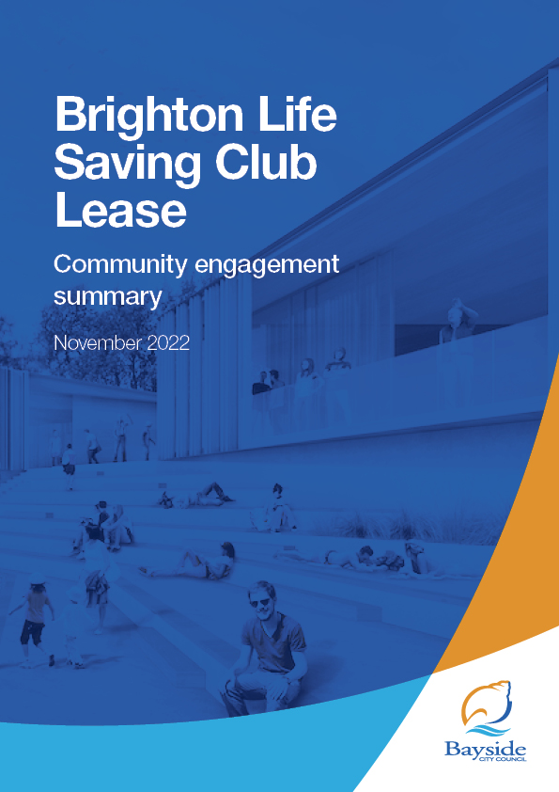

Contents
2 Background 3
3 Consultation process 3
3.1 Consultation purpose 3
3.2 Consultation methodology 4
4 Participant profile 4
5 Consultation findings 5
5.1 Support for actions 5
5.2 Survey feedback 5
5.3 Q&A forum 6
5.4 Project Evaluation 6
6 Appendix 8
6.1 Verbatim survey comments . 8
6.2 Written statements 13

Background
This document provides a summary of stakeholder and community feedback on Council’s intention to provide a new lease for the Brighton Life Saving Club Inc. (BLSC) for use of the Dendy Beach Life Saving Pavilion at Dendy Street Beach for a commencement rent of $3,294+GST per annum for 21 years.

The scope of this consultation relates to a new lease for the Dendy Beach Pavilion at Dendy Beach, Brighton. It does not include the development of the new Pavilion which is
currently under construction or the café lease.
The new lease is proposed for the Brighton Life Saving Club (BLSC), which is a
community group and, therefore, the annual rental is relatively low. However, the BLSC as the current tenant will have provided $500,000 before occupation towards the capital construction of the new pavilion.
Community engagement on the proposed lease was undertaken from 21 September – 12 October 2022 (inclusive) and received 58 contributions.
Key findings
Participants were supportive of the Brighton Life Saving Club as a tenant of the Dendy Street Beach Pavilion.

While a majority of participants (33, 60%) supported granting the proposed lease to the Brighton Life Saving Club, a number of concerns were raised regarding the lease terms, most commonly that the proposed rental amount is too high and that Life Saving Clubs should be considered as not-for-profit (Group 2) and recognised for the emergency volunteer services they provide.
Next steps
Council will consider community feedback and the proposed lease for adoption at its 22 November 2022 meeting.
As the pavilion has been purpose built as a Life Saving Club, if this particular lease proposal does not proceed, Council will negotiate a new proposal with BLSC for the use of the building.

Consultation process

Consultation purpose
Council invited community feedback between 21 September 2022 – 12 October 2022 to understand the level of support for the proposed decision to provide a new lease to Brighton Life Saving Club Inc (BLSC) for the use of Council property on the Dendy Street Beach Pavilion site for a period of 21 years.
Community engagement was conducted in accordance with Council’s Community and Stakeholder Engagement Policy 2021 and Section 115 of the Local Government Act 2020. The engagement plan overview was published and is available to view on Council’s Have Your Say engagement website.

Consultation methodology
The tools and techniques selected for this project were informed by the project content,
stakeholders and type of feedback sought
Key tools for communicating the project

- Site signage
- 14 letters distributed to neighbouring residents and businesses
- email to Have Your Say subscribers (3,142)
- newspaper advertisement in The Age
- public notice on Council website
- Council communication channels, including website news story, social media and e-newsletter to over 11,00 subscribers

Key methods for gathering feedback
- online engagement through Have Your Say, including opportunity to provide feedback via survey or upload a written statement
- contact email address and phone number of Council Officer provided for interested community members to ask for further information or provide feedback.

Details | Activity
21 September 2022 – 12 October 2022  445 visitors  55 contributions | Have your say website  Project information, online survey and written statement form hosted on the engagement platform Have Your Say  Online survey: 55 responses  Written statement form: 2 responses
21 September 2022 – 12 October 2022  5 questions | Question and Answer forum  Five questions asked and responded to via the Q&A forum.
1 written statement | Correspondence  Direct feedback provided through contacting the Project Officer  for further information or to provide feedback over the phone or via email.

Participant profile
Demographic information was not requested from participants as it was not considered
relevant to this engagement.

Survey respondents (55) were asked to qualify their connection to the Dendy Beach Life Saving facility at Dendy Beach. All participants had a connection to the site, with some identifying with multiple options:

- 13 stated they were a member/volunteer of the Brighton Life Saving Club
- 5 indicated they have a child involved in nippers with Brighton Life Saving Club
- 40 were visitors to Dendy Beach
- 14 said they live/operate a business near the Dendy Beach Life Saving Club
- 11 selected ‘Other’ as their connection to the Dendy Beach Life Saving facility: four said they were a resident/ratepayer, two are members of another Life Saving Club, two were former members of Brighton Life Saving Club and three said they previously had children involved with Brighton Life Saving Club.

Consultation findings
The following section summarises the key themes which arose in community feedback on the Brighton Life Saving Club lease. Where there was more than one mention of a topic or item, the number of mentions has been specified in brackets and italics. A full list of verbatim comments is included in the appendix.

Support for actions
Community feedback was supportive of a lease being granted to Brighton Life Saving Club for the use of the Dendy Street Beach Pavilion, with no one disputing their suitability as a proposed tenant and many recognising the essential volunteer emergency service they provide to the Bayside community (25, 43%).

However, there was some opposition regarding specific terms of the lease from 34 respondents (59%), of which half (18) referenced that the proposed rental amount is
too high. Others disputed BLSC’s classification as a Group 3 tenant, as opposed to a Group 2 (not-for-profit) tenant.

Survey feedback
Survey participants were asked to provide written feedback on the proposed lease of the new Dendy Beach Life Saving Pavilion to the Brighton Life Saving Club, including their reasons for supporting or not supporting the proposed 21-year lease.

The feedback provided by the 57 submitters is summarised by theme in the table below:
Topic | Community feedback
Brighton Life Saving Club (BLSC) | Supportive of BLSC being granted a 21-year lease (33 mentions)  BLSC provide an essential/emergency service (16 mentions)  BLSC is an asset to the community (5 mentions)  BLSC had to put up with horrendous clubhouse conditions for far too long
Lease terms | Rental amount too high (18 mentions)  Lifesaving club funds should go towards programs and training not rent (7 mentions)  Lease length too short (7 mentions)  Rental amount too low (2 mentions)  Lease length too long (2 mentions)  Opposed to classification of Club as a group 3 tenant [instead of Group 2 not-for-profit] (4 mentions)  Annual fee [rent] should be based on inflation rather than a set percentage.  Lease should include dates and hours of life saving operation, which should be greater than currently provided  Lease allows LSC to be more self-sufficient in funding more resources needed for rescues
Community use | Pavilion should be made available for community use (3 mentions)  Space should not be leased out privately taking away from free public use.
Facility | Great to have a new modern facility (2 mentions)  It should have a liquor licence.  Club should be an alcohol-free zone  Hope the cafe has adequate seating both indoors and outdoors for community use.  Use the upper storey for an Aboriginal History and Cultural interpretive centre instead
Other | Council should pay the lifesavers (5 mentions)  Is the proposed financial arrangement in line with other LSC leases elsewhere on Port Phillip Bay?  Is club membership open to all Bayside residents/ratepayers?  What is council's plan B if the environment and building complex is over run by visitors and tourists?  Install signage to explain swimming between the flags.  Lease and License Policy needs to be modified to include volunteer emergency services under a separate category  Building should be called Brighton Life Saving Club

Q&A forum
Five questions to the Q&A forum were received, which are summarised as follows:
- Why are Life Saving Clubs classified as a Group 3 Tennant with Bowls & Tennis Clubs rather than a Group 2 Not for Profit that serve the community, under the Lease and Licence Policy?
- Why is Council using its Lease and Licence Policy and not the State Policy (Occupation and use of Crown land by lifesaving clubs in Victoria, 2019)?
- Clarification that the Club will retain money received from rental of the training area
- Request for building be at ground level (no steep ramps or stairs) and have second story for views
- Clarification of rental difference in % from the rent pre and post build.

Project Evaluation
This report presents the findings from the analysis of the community feedback gathered during community engagement from 21 September – 12 October 2022.
The consultation was promoted to key stakeholders including members of the Brighton Life Saving Club, nearby residents and businesses.

The website news story and This Week in Bayside e-newsletter also ensured the wider Bayside community was given the opportunity to provide feedback. The communications reached over 11,000 people.

The length of consultation was three weeks, with most responses received in the first two weeks.

The engagement program received a total of 62 contributions, including 55 online surveys and two written statements completed via Have Your Say and five questions via the Q&A forum.

Have Your Say project page – reach and participation
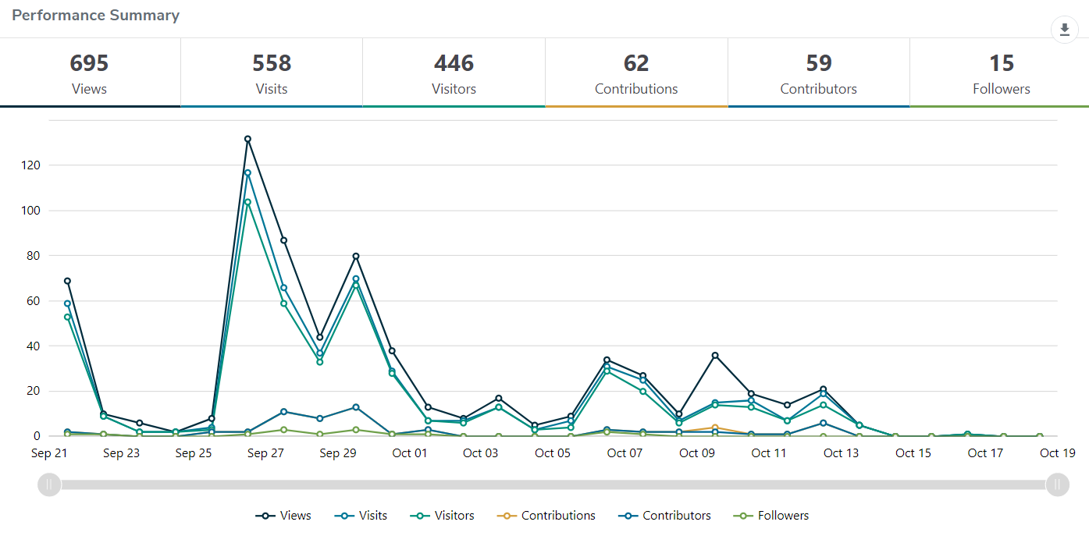
Engagement targets for the Have Your Say webpages were that:
- 20% of visits would last at least one active minute (exceeded, 38.5%)
- 10% of visits would have at least two actions performed, such as moving around the project page or clicking on links (exceeded, 42.5%)
- 5% of visits had at least one contribution made (exceeded, 11%)

Satisfaction with engagement process
Most (92%) of participants found the information was very or mostly easy to find and
understand; 2% said they weren’t sure and 6% said they found the information mostly hard to find and understand. With the relatively small sample size, 6% represents three people.

Appendix

Verbatim survey comments
Please provide your feedback on the proposed lease of the new Dendy Beach Life Saving Pavilion to the Brighton Life Saving Club, including your reasons for supporting or not supporting the proposed 21-year lease of this Council-owned property.

I strongly support the granting of a minimum 21-year lease for life saving clubs which provide such an important community service.
I would like clarification as to why Life Saving Clubs are classified as 'group 3 tenants' when they are a not-for-profit organisation that deliver a community service which is more consistent with Council's Lease and Licence Policy group 2 tenant definition.
The community-use rent should be reflective of the significant public service that life saving clubs provide rather than classify life saving clubs as 'sporting clubs'. My understanding is that the primary purpose historically and into the future is to support state-wide emergency management and deliver public safety
programs, particularly through providing lifesaving and education services to, and for, the community. We want to make sure that Life Saving Clubs are focused on saving lives and that funds generated through community use can be re-invested back into delivering lifesaving services, maintaining and purchasing lifesaving equipment, and delivering water safety programs for the broader community.
I support the lease as life saving clubs play such an important role in our community. I am astounded, though, that a not-for-profit volunteer organisation that does play a critical role for our community, and is a quintessential part of Australia's history and beach culture, is expected to pay such high rent.
Furthermore, if it's Brighton Life Saving Club, why on earth is the building being called Dendy Beach Life Saving Pavilion? The club has been there for a century, why can't Council be proud of our life saving history and call the building Brighton Life Saving Club?
I certainly support a 21 year lease for this new lifesaving club. They provide an important community service for users of our foreshore. However, I was disappointed to see the high annual lease fee ($3,294) & annual increases (initially 5%) being proposed by Council. Lifesaving clubs are non-profit organisations manned by trained volunteers that help keep our beaches safe.
Given the significant benefits provided by these clubs, plus the fact that they still need to pay for Council services, I don't understand why a small nominal lease isn't charged. It seems Bayside equates lifesaving activities with bowling & tennis clubs!
I'd be surprised if this is the approach taken with lifesaving clubs by other Councils who recognize their contribution to the local community.
We do not support the proposed 21 year lease as it is too long. Maintaining standards is really important, particularly in such a location. Even with the best intentions standards will vary after 1 year..., 5 years..., 10 years. But, 21 years..., anything could happen and most likely it will.
I support Brighton LS Club receiving a 21-year lease. They provide an amazing emergency service and community service. As a not for profit, community service I would like to understand why they are not receiving "Community based Rent" - acknowledging the service and many volunteer hours they put into our community.
As Brighton LSC is a volunteer. not-for-profit, emergency service organisation, the rent seems high for an organisation that provides a free, life-saving, service to the community. By comparison to the rent agreements between LGA's and Surf Life Saving Clubs, Bayside City Council's rates seem to be significantly higher than the norm.
It is my belief, that the Bayside City Council's greatest asset is it's foreshore, beaches, and the waters of Port Phillip Bay that it encompasses. Surf Life Savers at the clubs across Bayside provide the council with a voluntary service ensuring the community can safely access these assets. And in doing so, protect the Bayside City Council from reputational damage were there to be a loss of life or significant injury to a member of the community whilst utilizing these waterways.
By reducing rental fees for Bayside Life Saving Clubs, those clubs will be able to reinvest in Life Saving equipment and projects, and as a resident, I believe that the Bayside City Council should be doing more to empower these clubs.
I am in support of a 21 year lease but not the unfair terms.
Why are Life Saving Club's in Bayside considered Group 3 tenants in the Lease and Licence 2018 policy, alongside Bowls Clubs and Tennis Clubs? Surely council recognises the community value of a lifesaving club and the many volunteer hours provided by members to patrol the local beaches over summer? Lifesaving is part of the emergency services group and spend many months training to ensure members have the skills needed to save a life - this is very different from activities at a bowling or tennis club! Life saving clubs should be a Group 2 rent payment as they are with other local councils.
I absolutely agree with the lease, it is in our best interest that we have a life saving club, it’s a community service
Council should pay the lifesavers for the outstanding service they provide the community.
No lease please.
i am in full agreement with the lease to the lifesaving club -- they and Council have waited far too long for this eventaulity-- and only held up by a ultra smalll minority of small minded opponents, who were defeated at each step op of the unnecessary legal holdups they imposed at great cost to all the other ratepayers of Bayside. -
Finally I say a definite positive response or agreement all questions asked
I am interested to know if the Brighton Life Saving Club were seeking a longer lease? In my opinion lifesaving services are a valuable asset to the health and safety of the community (and the many visitors who frequent our beaches) and I hope that at the completion of the 21 years lease, that BLSC should be offered the automatic renewal, with outside groups, companies and traders not considered unless BLSC decline. Lifesaving Victoria should also be involved before the renewal lease was given to another organisation in the event that BLSC do not want to take up the lease again. It should only be a 'peppercorn' rent, as lifesaving clubs are not for profit and all funds raised should be maximised to go to programs and training
This is the natural home for Brighton Life Saving Club. I am sure they will share facilities with the community.
I support the proposal for the BLSC to use the space.
I would prefer a 10 year term with the option of another 10 years.
Is the proposed financial arrangement in line with other LSC leases elsewhere on Port Phillip Bay?
Is club membership open to all Bayside residents/ratepayers?
What is council's plan B if the environment and building complex is over run by visitors and tourists ?
I support this lease for Brighton Life Saving Club
I fully support the new lifesaving club! It would be great for the area and lifesaving is such a good volunteer community service and the better the facilities the better the service they can provide.
Given that the Surf Life Saving Club is providing equity, the lease should be 99 years.
The Lifesaving club provide a valuable volunteered community service. Seems very odd that the council is happy charging them to rent the building, but expect them to continue to providing their services for nothing.
The rent should be free or the lifeguards should be paid.
I am happy with the lease as set out in Annexure B. I suppose it really comes down to what price do we put on a life when saved at our beach? I really appreciate the work done by the life saving club. If people look for the flags and swim inside the boundary then we can be pretty certain they will be safe on our beaches. I tell all my migrant students to swim between the flags. We should all know to do this. There should be signage erected at BCC expense to explain this, with diagrams, at this particular beach. We must remember that life savers are volunteers and it's very important to continue with their time and efforts into the future.
I believe the lease should be at no cost as to the life saving club as it’s providing a valuable service to the community. The bayside council should be covered these costs so the club can continue to provide these services to the community
The Brighton life saving club provides a community service to the area that you cannot put a price on. I propose granting them a 100 year lease instead rent free!
Are you serious?
Definitely too high.
Should be 99 year lease at $1.
You cannot charge a community organisation to counter your own waste.
Reduce the price.
I believe that Brighton LSC club would be an excellent tenant for a 21 year lease. However, I do not support that the proposed lease would be charging Brighton LSC over $3000 per year for the lease of this facility. Surely, the Council’s Lease and Licence Policy would consider the community service that the Life Saving Club provides by patrolling the beach over summer. I would think that there should be no charge for a lease for a Life Saving Club and that they should be given exclusive use of the facility if it is required. The contribution of lifesaving services shouldn't be undervalued. Imagine the alternative of having to pay for lifeguard services on Bayside's beaches.
The council should pay the volunteer service to patrol the beach for half the year if they are required to pay a lease. The service runs voluntarily and does not have a source of income.
I support the club being granted the proposed lease, however I believe the clubs feedback regarding the rent and terms should be adopted. The club is an essential service to the community and should be paid by council to maintain and protect the beach and it’s users.
I support the lease of the Dendy Beach Pavilion to BLSC as they provide not only life saving services but also training and community engagement. I believe these services are undervalued and should be recognised in the rent being charged. I believe the rent should be no more than one dollar per year.
If Bayside City Council choose to charge rent to the lifesaving club then they need to pay for the service the lifeguards provide! Otherwise these community groups will fold and volunteers will die off which would be an enormous shame ….
I'm really confused as to why a life saving club is paying the council rent. The club provides the residents of bayside with the free volunteer service of patrols on our beaches, they have saved countless lives and helped prevent hundreds of deaths in Victorian waterways. They educate our children, help protect our work places with vital first aid training and run incredible community programs.
If you ask me the council should be paying the life saving club to continue their service to the community instead of putting up barriers.
In principle, but I’m in agreement, however the rent seems very low.
The pavilion being made available for community use is paramount seeing as the community are the ones that have ultimately paid for it.
I would hope the cafe has adequate seating both indoors and outdoors for community use.
Please grant Brighton Lifesaving Club this lease. The club has been waiting a long time for modern appropriate facilities to help members keep the beach safe for locals visitors and tourists. They provide countless volunteer hours
They have a proud history with this site.
Let’s recognize that with a long term lease.
Great idea! As the original inhabitants of this space they deserve to enjoy the benefits of the brand new pavillion!
I support the lease as the lifesavers provide a great community service
How is it that an volunteer emergency service - just like the CFA or SES is classified under group three of the Lease and Licence Policy 2018 next to bowls clubs?
This policy needs to be modified to include volunteer emergency services under a seperate category.
Rent should be minimal
A wonderful activity for the families in bayside especially for water safety. Also they have put up with horrendous clubhouse conditions for far to long.
I support the proposed lease as it provides certainty for the continued provision of life saving activities at an extremely popular beach
Brighton LIfe Saving Club is an institution that has given so much value to the area - the families and community. They absoltuely deserve a great lease term with great rates. They do so much with their time and effort and volunteers for our communities.
BLSC has been patrolling Brighton beach for years and it’s members keep the beach safe for all the public as well as create a community for all members from little nippers to adults.
As members of bayside community along with a patrolling member and with kids involved in the club if the BLSC wasn’t there I would be extremely disappointed and sad after all the years of service my family has given to the community.
The lease of this facility is vitally important for the ongoing viability of BLSC. If not here, where? This beach and it’s Lifesavers is one of the many links in the chain protecting all Victorians around our coastline.
I support the proposed 21 year lease. The Brighton LSC are well deserved of this new facility. This club has an outstanding reputation for community service through lifesaving training of the public. In addition it’s work with cultural and linguistically diverse communities has been incredible. My experience as a teacher dealing with the club has been excellent and in the future I hope to maintain this alliance with Brighton Secondary college - particularly with the schools language centre program.
The life saving club is a critical part of our community. It offers so much to young people. I fully support the lease, and on the best terms possible for the club.
100% I support the lease to BLSC. Firstly, they're contributing $1/2m to its development! The LSC should be a community hub for everyone in Brighton. It should also have a liquor licence.
As a former active BLSC member I cannot think of a single reason to not grant this lease. The only negative that I see is that an enduring lease is not being considered.
BLSC provides such an integral community safety program which aims to allow all members of the community to enjoy the beach and bay in a safe and supervised manner. life Saving is part of our National identity and should be fostered by all, suitable accommodation and council support for future growth should remain at the forefront of conservation. Quite simply, where BLSC thrives Brighton will have a brighter and safer future. I fully support a lease being issued the the BLSC.
Brighton LSC is a long-standing community club offering an invaluable service to Brighton and Dendy beach goers as well as more broadly to members of Melbourne’s community through programs such as water safety courses for refugees and new immigrants. It is vital the club is able to operate without hindrance and with appropriate and modern facilities from this location. The presence of the club at the new site will likely further increase community interest in the club programs such as nippers and promote the important work our life savers do for the community. The club is a well-run and financially viable organization and requires the support of our community through measures such as reduced rent etc. so that it can invest in equipment and training to further develop it’s important water and beach safety programs.
I support the proposed 21-year lease of this Council-owned property. The BLSC provides an immense public benefit, and not only does it train nippers I actually see them do a fair few rescues in their rubber duckie.
I support the lease as the building is purpose built for the lifesaving club - however strongly disagree at the exorbitant amount being asked for the lease.
As someone who has previously been heavily involved in the club, the financials are not profit driven and the club uses much of its excess money to fund equipment and leadership development for youth members. Volunteers would likely have to cover this cost in the long run and that would be asking a lot of people who volunteer 100% back to the community.
I support the proposed 21 year lease for BLSC as they provide an essential emergency and community service.
BLSC is a long serving pillar of the community who provides a great service to beach goers. The new building is overdue and well deserved. The public facilities will also be great for all beach goers including swimmers.
Well deserved new facility for a great community club to continue doing the great work they do - keeping our community and our visitors safe
I think it’s a really good idea as it allow the life saving club to be more self sufficient in funding which would allow it to purchase more resources needed for rescues
I don’t think this space should be leased out privately taking away from free public use.
This is a no brainer. There needs to be a life saving club. It’s in the best interests for the community and tourists. Life saving clubs take a tiny fee from families who join. The also help teach our kids the value of giving back to the community. It doesn’t bother me which club occupies the space, as long as it’s low rent for as long a lease as possible.
If Brighton beach lsc doesn’t patrol on the beach .. will the council be providing a lifeguard service ? Lsc clubs are manned with community volunteers to provide a vital emergency service . That is there main purpose . Why wouldn’t the lease be longer than 21 years ? What happens then ? Also the rent should be zero . We are expecting community members to volunteer there time and pay to be there . The main purpose of the club is to patrol ..
No lifesaving club should pay rent as it is part of emergency services .. not a sports club .
Lease appears to cost the LSC $5 per member per year. The club expects to increase membership which makes this figure even more ridiculous. This is unreasonably low especially when the club can use the premises for commercial use. Which i disagree with. The club should mostly be an alcohol free zone given large numbers of under-age members. If an alcohol licence is to be given then it should be applied for and granted for each individual function. Eg Christmas party, awards night. The annual fee should be based on inflation rather than an arbitrary percentage amount. The lease should include dates and hours of life saving operation and should be significantly greater than current which is only a few afternoons per year. This is the main purpose for the clubs existance and ratepayers financial support. Otherwise ratepayers are heavily subsidising an exclusive social club in a prime location.
The Life Saving Club should not be charged any rent at all. It is a full community essential service that is non profit. In fact they should not be required to contribute to the building. The council should provide the building at no cost to this essential life saving service provided by volunteers.
I support the 21 year lease. Surprised it is not longer
Its wonderful that the lifesaving club will have modern facilities to provide its essential service to the community.

Written statements
Written statement 1

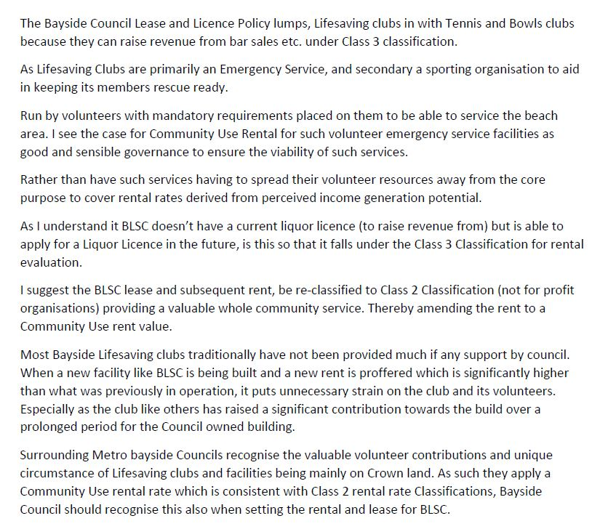

Written statement 2
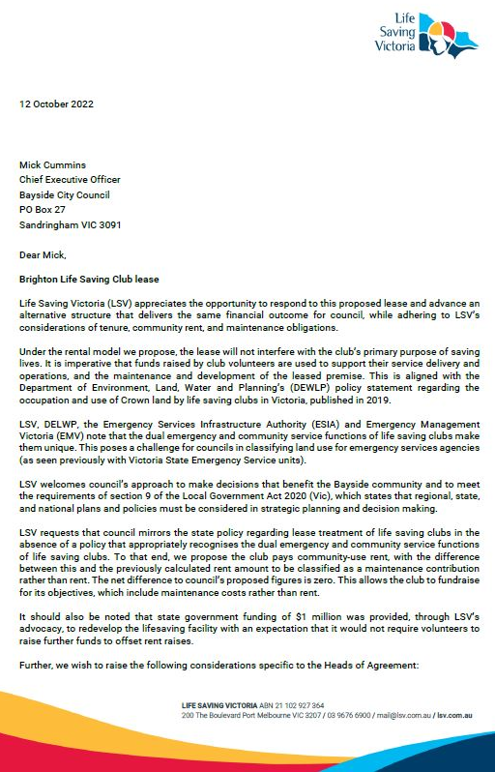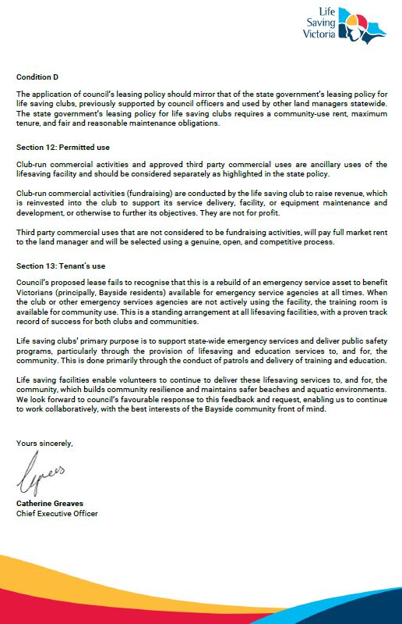
Written statement 3
