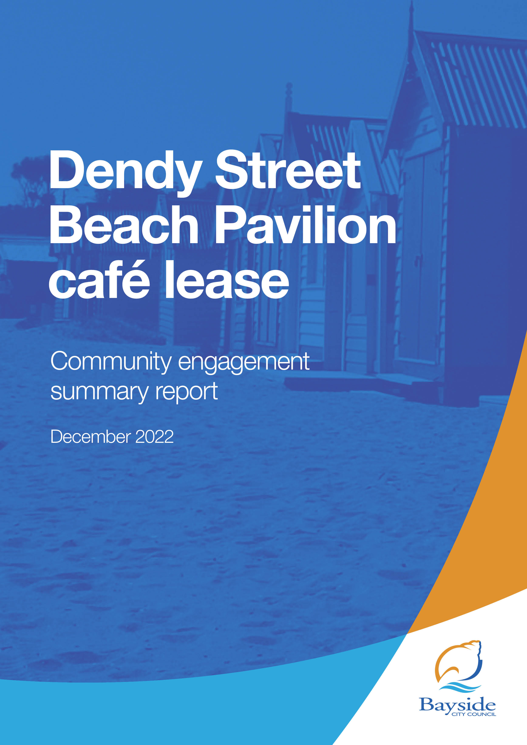

Contents
2 Background 3
3 Consultation process 3
3.1 Consultation purpose 3
3.2 Consultation methodology 3
4 Participant profile 4
5 Consultation findings 4
5.1 Support for actions 4
5.2 Survey feedback 5
5.3 Q&A forum 7
5.4 Project Evaluation 7

Background
This document provides a summary of stakeholder and community feedback on Council’s intention to grant a 15-year lease (with a 6-year option) to Same Pty Ltd to operate a café within the new Dendy Street Beach Pavilion.

The scope of this consultation relates to a new lease for the Dendy Street Beach Pavilion café at Dendy Beach, Brighton. It does not include the development of the new Pavilion which is currently under construction.

Under the proposed café lease, Same Pty Ltd is classified as a Group One Commercial Tenant. The proposal includes provisions for Same Pty Ltd to fund the fit-out of the café, as well as pay a commencing annual rent of $80,000, plus 7.5% of turnover above $1,000,000.
Same Pty Ltd was selected as the proposed tenant following the completion of a two-stage Expressions of Interest (EOI) process, during which 49 enquiries and 15 applications were received. Three applicants progressed through to the second stage with Same Pty Ltd being selected following an assessment against the key selection criteria and final interview.
Community engagement on the proposed lease was undertaken from 19 October – 2 November 2022 (inclusive) and received 66 contributions via online survey (54) and online Q&A (12).
Key findings
There were a range of views received in survey feedback on the proposed lease:
- 43% supported the lease proposal and/or proposed tenant
- 39% opposed the lease (primarily that it was too long) or proposed tenant
- 9% had mixed views with preference for earlier lease review, or stronger sustainability requirements
- 9% were neutral or provided feedback in the form of questions.

Next steps
Council will consider community feedback and the proposed lease for adoption at its 21 December 2022 meeting.
If this particular lease proposal does not proceed, Council will need to reconsider the applicants from stage 2 of the Expression of Interest process or alternative uses for this element of the pavilion.

Consultation process

Consultation purpose
Bayside City Council invited community feedback between 19 October 2022 – 2 November 2022 to understand community views regarding the proposed decision to grant a lease to Same Pty Ltd to operate a café on the Dendy Street Beach Pavilion site for a period of 15 years (with a 6-year option).
Community engagement was conducted in accordance with Council’s Community and Stakeholder Engagement Policy 2021 and Section 115 of the Local Government Act 2020. The engagement plan overview was published and is available to view on Council’s Have Your Say engagement website.

Consultation methodology
The tools and techniques selected for this project were informed by the project content,
stakeholders and type of feedback sought
Key tools for communicating the project
- Site signage
- Email to Have Your Say subscribers (3,142)
- newspaper advertisement in The Age
- public notice on Council website
- Council communication channels, including website news story, social media and e-newsletter to over 11,00 subscribers

Key methods for gathering feedback
- online engagement through Have Your Say, including opportunity to provide feedback via survey or upload a written statement, as well as ask questions
- contact email address and phone number of Council Officer provided for interested community members to ask for further information or provide feedback.

Details | Activity
19 October 2022 – 2 November 2022  393 visitors  66 contributions  62 Contributors | Have your say website  Project information, online survey and written statement form hosted on the engagement platform Have Your Say  Online survey: 54 responses  Written statement form: 0 responses
19 October 2022 – 2 November 2022  12 questions | Question and Answer forum  Twelve questions asked and responded to via the Q&A forum.  Three questions were moderated as they were duplications or could not be published for legal reasons.
25 October 2022  62 comments | Social media  24 comments and 27 replies from community members.  14 replies from Bayside City Council  Key themes in comments were concern regarding length of lease and need for stronger sustainability requirements.

Participant profile
Demographic information was not requested from participants as it was not considered
relevant to this engagement.

Survey respondents (54) were asked to qualify their connection to the Dendy Beach Life Saving facility at Dendy Beach. All participants had a connection to the site, with some identifying with multiple options:

- 1 stated they were a member/volunteer of the Brighton Life Saving Club
- 51 were visitors to Dendy Beach
- 13 said they live/operate a business near the Dendy Beach Life Saving Club
- 7 selected ‘Other’ as their connection to the Dendy Beach Life Saving facility: five said they were a resident/ratepayer, one said they work as a support worker with elderly people and people with disabilities who live in the area, and one said they stand up paddleboard at the beach several times each summer.

Consultation findings
The following section summarises the key themes which arose in community feedback on the Dendy Street Beach Pavilion café lease. In the interest of stakeholder and community privacy and, in some cases for legal reasons, individual quotes have not been included within this public document. Where there was more than one mention of a topic or item, the number of mentions has been specified in brackets and italics.

Support for actions
Community feedback showed 43% (23) of survey respondents were generally supportive of the proposal and/or were satisfied with the proposed tenant’s suitability to run a café at the Dendy Street Beach Pavilion. Some survey respondents (5) directly expressed their satisfaction with the proposed tenant’s previous operations and others (14) showed general support for the provision of the café.

There was clear opposition to the lease terms from 21 survey respondents (39%) who viewed the length of the lease as being too long, or raised concerns about the overall quality of the food offering, or one company holding leases for two foreshore cafes within close proximity.

There were also mixed responses (5, 9%) received which raised some concern regarding the length of the lease (4) while acknowledging need to recover fit out costs; the strength of sustainability requirements; or proposed rent for unique site. Five respondents were neutral or provided feedback in the form of questions.

Survey feedback
Survey participants were asked to provide written feedback on the proposed lease of the Dendy Street Beach Pavilion café to Same Pty Ltd, including their reasons for supporting or not supporting the proposed 15-year lease.

The feedback provided by the 54 submitters is summarised by theme in the table below:
Table 1: Comments from respondents who expressed support or were neutral
Topic | Community feedback
Provision of café | Support for a café (12 mentions)  Café could attract more people to the area  Will be great to have a local café at the pavilion
Proposed tenant Same Pty Ltd | Support Same Pty Ltd being granted a lease (4 mentions)  A history of good operations (5 mentions)
Lease | Support the lease (14 mentions)  Satisfied with EOI process  Happy with longer opening hours  Prudent commercial lease
Financial | Trust council set rent accordingly  Commencement rent is a fair reflection of market  Rent reviews should be to market, assessed by a qualified property valuer
Environment | Hope there are solar panels on the building  Agree with the sustainability initiatives  Support the environmental initiatives

Table 2: Comments from respondents who were opposed or expressed concerns
Topic | Community feedback
Same Pty Ltd | Do not support Same Pty Ltd being granted a lease (4 mentions)  Same Pty Ltd has a monopoly on trade in the area (3 mentions)  Unhappy with Same Pty Ltd’s history of operations (6 mentions)  Consider a different operator  Ethics of the appointment of Same Pty Ltd
Lease | Length of lease too long (18 mentions)  Operator may become complacent with a long-term lease (8 mentions)  Continuous review of the lease is needed to ensure quality and improvements (3 mentions)  Hours of operation too long (2 mentions)  Not strong enough sustainability initiatives (2 mentions)  Do not support the lease (3 mentions)
Environment | Concerned about negative environmental impacts from the café (3 mentions)  Concerned about traffic and parking (2 mentions)  Concerned about take away rubbish (4 mentions)  Proposed tenant’s existing operations do not represent their desire for a sustainable business  Concerned about noise  Ensure plenty of shade /shelter available for cafe users  Fit out of cafe to utilise environmentally friendly design including acoustics and air flow
Financial | Rental amount is too low (2 mentions)  Leasing costs should be kept in line with current economic expectations
Other | Locals won’t frequent the café if the quality is poor (3 mentions)  Concerned about overall quality (7 mentions)  Council should aim for a higher standard (2 mentions)  Look for an operator outside of Bayside  Don’t want a ‘tourist trap’ (4 mentions)  Unhappy with suggested menu options (2 mentions)  More sustainable and innovative cafe managers are available in the Melbourne network  Need diversity within hospitality operators (2 mentions)  Proposed tenancy would deliver a very bland and boring venue  Want a simple café with no takeaway food  Cafe and bathrooms should be fully accessible for all people including people using wheelchairs  Cafe management must value hospitality, not just profit, to offer inclusive, friendly service
Questions | Why is a 15-year lease proposed when commercial leases are typically 5yrs x 5yrs x 5yrs?  Have all Directors and Shareholders of the Lessee company provided continuing Directors Guarantees?  how ‘competitive’ has the tender been?  what is the total rentable area including storage garage?  In 2037 will they still be paying the same rent?  Has commercial due diligence been applied?  What other venues has the co-owner operated and were they successful?  What about Parking facilities, will parking be free for Bayside residents. Where is the proposed plan of the building and exact location. What about Traffic management?  Same also has the lease on North Point Cafe with a liquor licence that is opposed by local residents. Will Dendy be the same arrangement?  I question whether other providers were considered for this lease and why Same Pty Ltd would be awarded two beachfront locations?  What is the total rentable area including storage garage?  Do we need / want another generic, same business on the beachfront?  How will their new cafe (business model) be different from North Point?

Q&A forum
Twelve questions to the Q&A forum were received, which primarily focussed on requests for more detail on Same Pty Ltd’s hospital experience and ownership, as well as lease conditions. Three questions were moderated as they were duplications or could not be published for legal reasons.

Evaluation
This report presents the findings from the analysis of the community feedback gathered during community engagement from 19 October – 2 November 2022.
The consultation was promoted to key stakeholders including members of the Brighton Life Saving Club, nearby residents and businesses.

The website news story and This Week in Bayside e-newsletter also ensured the wider Bayside community was given the opportunity to provide feedback. The communications reached over 11,000 people.

The length of consultation was two weeks, with most responses received in the first week.

The engagement program received a total of 66 contributions, including 54 online surveys completed via Have Your Say and 12 questions via the Q&A forum.

Have Figure 3: Have Your Say project page – reach and participation
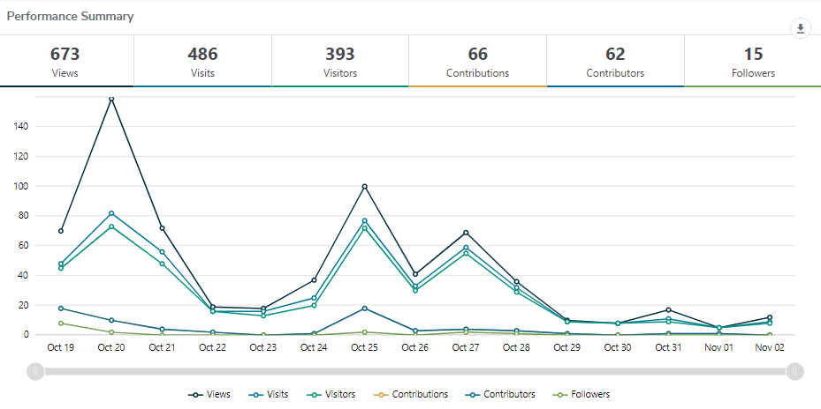

Engagement targets for the Have Your Say webpages were that:
- 20% of visits would last at least one active minute (exceeded, 46%)
- 10% of visits would have at least two actions performed, such as moving around the project page or clicking on links (exceeded, 39%)
- 5% of visits had at least one contribution made (exceeded, 8%)

Satisfaction with engagement process
Most (94%) of participants found the information was very or mostly easy to find and
understand; 2% said they weren’t sure and 4% said they found the information mostly hard to find and understand. With the relatively small sample size, 4% represents 2 people.

