Results of the Community Engagement
Community engagement was undertaken on the Draft Plan from 27 October to 27 November 2022. Feedback was sought through an online survey, face-to-face meetings, written submissions and engaging with community groups.
Five (5) written submissions were received regarding the Draft Plan, as well as 31 survey responses. There were over 650 visitors that viewed the Draft Plan on the Have Your Say page with 97% of the responders stating that they found the information to be easily understandable and accessible.
Of the five (5) written submissions, four (4) were supportive of the Draft Plan, with one (1) being not fully supportive raising concerns that the Draft Plan lacks detail and the imposition of further restrictions on Beaumaris residents via Vegetation Protection Overlay Schedule 3 (VPO3). Some submissions provided various recommendations to strengthen the Draft Plan, which have been considered in updating the plan.
The survey was split into three main parts to receive feedback:
- Comments on Key Actions and overall plan

From the engagement, it is clear that the analysis done to increase vegetation cover across Beaumaris is supported, with 74% of participants responding positively when asked ‘How did they feel about the Draft Plan overall?’. Comparatively 19% of participants had some concerns regarding the plan and 6% had many concerns regarding the plan.
There was strong support for increasing vegetation cover on private land with 55% of participants supporting the action and agreeing to plant more trees on their property. Similarly, 54% of participants supported the Draft Plan’s action about greening nature strips in front of their property.
- Preference of planting locations and species

Participants provided input on their preference of planting locations with the most popular locations (top 5) being empty tree sites (20% of participants), followed by areas facing high urban heat island effects (17% of participants), streets with less than 20% tree canopy cover (10% of participants), areas for habitat linkages/wildlife corridors (10% of participants), locations of trees in poor health (7% of participants) and public open space (3% of participants).

Responders also provided their preference on species with the top species being:
- Grey Wattle
- Silver Bankia
- Coast Banksia
- Light Wood
- Snow Gum
- Black Wood
- River Red Gum

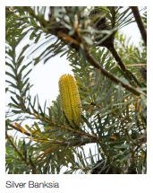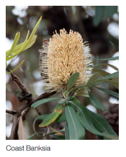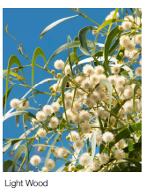
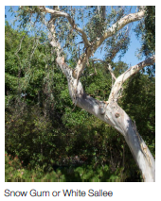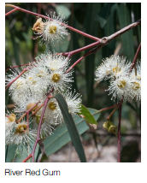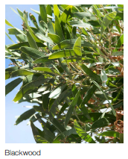

The least preferred species included:
- Black Wattle
- Paperbark
- Queensland Box
- Grey Parrot Pea
- Golden Spray
- Coast Daisy Bush
- Poison Lobelia
- Karkalla
- Kidney Wood.
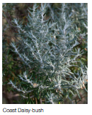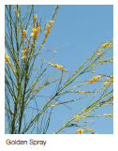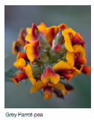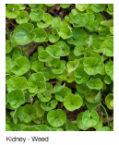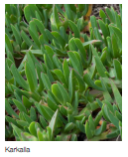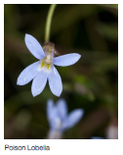

- Support – what can council provide to encourage maintenance/ increase in vegetation planting activity

Most participants (52%) asked for arborist support and discounted plants to maintain or increase vegetation on their property and nature strips. Other responses mentioned the need for:
- support on choosing the right species for their garden
- tips on growing an urban forest on private land
- support for older and vulnerable residents with maintenance
- advice on how to maintain and protect canopy trees
- management of safety risks created by foliage and increased planting
- reviewing current VPO controls as some participants feel it is not the most effective measure for protecting vegetation on private land
- management and protection of established vegetation during re-developments on private land
- improvement in managing the pruning of tree canopy under overhead powerlines.

- Issues raised on maintenance

Through this community engagement, responders raised concerns around the safety and maintenance issues due to increased tree canopy cover. The scope of the precinct plans is limited to mechanisms to increase the tree canopy rather than maintenance. Bayside’s Urban Forest Strategy considers and includes multiple actions in the 4-year action plan that addresses the issues around tree maintenance. The Road Management Plan also addresses the issue of maintenance and is covered by Council’s Maintenance Services contract with Citywide.

Changes made to the Draft Plan
Species Palette
To respond to comments related to the preferred species, a suburb specific species palette was removed and has been replaced by the recently updated municipal wide species palette, ‘Live Bayside Plant Bayside 2022’.
A holistic list of species has been developed for consistency of species as this is important for a healthy ecology for the whole of Bayside.
A section on removal of inappropriate damaging trees and replacing them with appropriate tree species in Banksia Reserve is added with general text on appropriate species selection reiterating the Urban Forest Strategy’s action on Increasing species diversity across public tree plantings to ensure a range of species are incorporated to minimise the potential of large impacts of losses on Bayside’s canopy.
Replaced Maps and Graphs
Council’s GIS team was engaged to re-create the maps and graphs for the Draft Plan so that a consistent template can be used to create maps for all the other precinct plans. The updated maps and graphs have been incorporated into the attached Beaumaris Precinct Plan.
Implementation plan
To respond to the comments regarding the support that Council can provide, a range of actions in the implementation plan section of the Draft Plan have been revisited. Some of the key priority actions which will commence in Year 1 of the Precinct Plan include:
- Increase plantation of significant municipal transport network that have less than 20% tree canopy cover.
- Planting canopy trees and understorey vegetation on roundabouts and traffic islands that currently do not have vegetation.
- Prioritise and increase planting on identified habitat and biodiversity corridors across both public and private land.
- Form partnerships with private landowners to encourage planting and maintenance of nature strips.
- Increase tree canopy cover by prioritising plantation in vacant tree sites.
- Prioritising planting in identified hotspots.
- Strengthen requirements and advocacy to maintain and increase vegetation on private land. This action includes the initiation of the preparation of staged planning scheme amendments to revisit the various requirements for tree and vegetation protection on private land including VPO controls.
There are also range of additional actions outlined in the Draft Plan which are scheduled throughout the next five to ten years.
Social Challenges
To respond to other general comments, the Social Challenges section within the Draft Plan was updated to include benefits of vegetation and how it can respond positively to the vulnerable population of the area.
Guiding Principles
The Guiding Principles section within the Draft Plan was updated to add precedent examples and ideas around porous and permeable surface treatments.
Community sentiment
Changes have been made in relation to the language used to recognise the important role our community has in ensuring the success of the Draft Plan and that the actions of this Draft Plan are for the benefit of our current and future residents.

