7 Well Street pocket park
Community engagement summary report
February 2023

Contents
2 Background 2
3 Consultation process 2
3.1 Consultation purpose 2
3.2 Consultation methodology 2
4 Participant profile 3
5 Consultation findings 4
5.1 Support for actions 4
5.2 Survey feedback 4
5.2.1 Reason for liking or disliking the concept design 4
5.2.2 Vegetation feedback 7
5.2.3 Additional vegetation suggestions 9
5.2.4 Other feedback about the concept design 10
5.2.5 Direct correspondence about the concept design 12
5.3 Project Evaluation 13

Background
This document provides a summary of stakeholder and community feedback on the 7 Well Street pocket park design.
Council decided to create a pocket park in Well Street, Brighton, in December 2021 following community support for more public open space in the area. During the first phase of engagement on the future use of the site held between 7 October to 7 November 2021, our community told us they wanted ‘a passive space for relaxation, sitting and reading’.
This phase of community engagement undertaken from 16 January – 13 February 2023, focussed on the draft concept design and received 71 contributions.
Key findings
Participants were generally supportive of the concept design for the 7 Well Street pocket park with a majority (61%) responding that they loved the concept design or thought it was OK. Most respondents (83%) indicated that they would spend time in the pocket park throughout the year.
Common feedback included general support for a park (10 mentions), including playground equipment (10 mentions) and providing more seating (9 mentions).
Concerns raised by a few respondents (13), included safety concerns due to the secluded nature of the park and lack of lighting, litter, graffiti, vandalism, plant species selection, and unsocial behaviour.
Next steps
Community feedback will be considered to inform the detailed design of the pocket park. Council will consider community feedback and the proposed concept design, at its April 2023 meeting.

Consultation process

Consultation purpose
Council invited community feedback between 16 January – 13 February 2023 to understand the level of support for the proposed concept design of the 7 Well Street pocket park and ensure it meets community needs and expectations.
Community engagement was conducted in accordance with Council’s Community and Stakeholder Engagement Policy 2021. An engagement plan overview was published and is available to view on Council’s Have Your Say engagement website.

Consultation methodology
The tools and techniques selected for this project were informed by the project content,
stakeholders and type of feedback sought.
Key tools for communicating the project

- Site signage
- flyers distributed to neighbouring residents and Church Street precinct
- email to 7 Well Street project subscribers (86)
- Council communication channels, including website news story, social media and e-newsletter to over 11,00 subscribers, digital advertising screens at Corporate Centre and Brighton library.

Key methods for gathering feedback
- online engagement through Have Your Say, including opportunity to provide feedback via survey or upload a written statement
- contact email address and phone number of Council Officer provided for interested community members to ask for further information or provide feedback
- printed information available, as required.

Details | Activity
16 January 2023 – 13 February 2023  892 visitors  64 contributions | Have your say website  Project information, online survey and written statement form hosted on the engagement platform Have Your Say  Online survey: 64 responses  Written statement form: 0 responses
16 January 2023 – 13 February 2023  0 questions | Question and Answer forum  No questions asked and responded to via the Q&A forum.
16 January 2023 – 13 February 2023  7 submissions | Correspondence  Direct feedback provided through contacting the Project Officer for further information or to provide feedback via phone or email.

Participant profile

Survey respondents (64) were asked to qualify their connection to the 7 Well Street site. All participants had a connection to the site:

- 3 stated they own/operate a business in Church Street activity centre
- 14 indicated they live on Well Street
- 24 said they live in Brighton
- 1 said they work in the Church Street activity centre
- 15 visit Church Street activity centre
- 3 preferred not to say
- 4 selected ‘Other’ as their connection to the Well Street site: one said they were a Black Rock resident who shops in Church Street, one stated they were a conservation biologist and zoologist who walks in the area, one was interested in the establishment of pocket parks and one said they live in Bayside and visit the area.

Demographic information was not requested from participants as it was not considered
relevant to this phase of engagement.

Consultation findings
The following section summarises the key themes which arose in community feedback on the 7 Well Street pocket park design. In the interest of stakeholder and community privacy, individual quotes have not been included within this public document. Where there was more than one mention of a topic or item, the number of mentions has been specified in brackets.

Support for actions
Community feedback was supportive of the concept design with 30% of respondents loving the overall design of the pocket park and 31% stating it’s OK. The majority (83%) of respondents indicated that they would spend time in the pocket park throughout the year.

Survey feedback

Reason for liking or disliking the concept design
Survey participants were asked how they felt about the concept design for the 7 Well Street pocket park overall and could select from the following options, “I love it”, “It’s OK”, “I have some concerns”, “I don’t like it at all” and “I don’t know”. Following their answer, they were asked to provide a reason for their response.

The feedback provided by the 62 submitters is summarised by theme in the table below:
Topic | Community feedback
Open space | Supportive of a park (10 mentions)  Supportive of natural outdoor spaces and greening (5 mentions)  Not supportive of using the site for park/open space (2 mentions)
Design elements/infrastructure | Needs more seating (8 mentions)  Add playground equipment (6 mentions)  More shade cover needed (4 mentions)  Needs more picnic tables (2 mentions)  Needs a rubbish bin (2 mentions)  Add a water feature (2 mentions)  Use wooden chairs/seating not metal  Like the pedestrian access to the shopping centre  Attractive design  Too many seats  Too much infrastructure  No picnic table  Needs wider grass area  Wiggly paths are difficult to manoeuvre wheelchairs  A good mix of practical facilities and native vegetation  Could be improved  Needs covered area to protect from sun/rain  Needs a water fountain with water for dogs,  There is no public toilet.
Vegetation/planting | Love the native plants  Needs some mature trees or shade until the saplings grow  Three levels of planting needed  Would like to see planting better focussed on attracting and keeping small native birds  Happy with the plant palette  More leafy trees instead of shrubs  More canopy trees  Dislike grass
General comments about the park | Not the place for a park (4 mentions)  Great place to relax  Church Street would definitely benefit from more greenery AND car parking space  Lovely place to have lunch  Peaceful space that will attract birds and provide much needed habitat for other animals  Perfect place to sit, breath and collect yourself after shopping  This will provide a lovely open air space that my friends and I can sit and enjoy the fresh air  I can sit there with my dog  love the idea of being able to relax in the park after shopping  A green canopy will result when trees mature  It will be nice to sit in a secluded park  A good mix of open area, shaded areas and seating  Pedestrian access to Church St is a brilliant addition.  It won’t get used  Very little included in the park to draw people in  Too small for a park  No use for it if there is no playground
Financial | Waste of money (2 mentions)  Budget seems a bit light  As a ratepayer whose rates helped purchase this block I want it sold and proceeds returned to Council  The true cost to ratepayers is the land value plus the $100000.00 for landscaping = $2m
Concerns | Concerned about existing block wall  Concerned about metal chairs on hot days  Concerned about skateboarders  Concerned about future tree damage to neighbouring properties  Concerned about litter  Concerned about night parties  Concerned about teens gathering at night  Trees will create a visual blocker making the park unsafe  Concerned about vandalism  Concerned about safety
Other comments | The site should be used for carparking (5 mentions)  Community wifi  Council has taken away too much parking  Use the space for a skate area or other youth focused spaces  Need more public housing in Brighton  Should be returned to housing or multi-level development  I would like to see the finished park before I make comment  Can this be an off leash dog pocket park  Need a small-dog only, fenced area somewhere in Brighton  consider small alterations to the plan and answer some queries  Skate park would have been nice

Vegetation feedback
Survey participants were asked which types of native and indigenous trees and vegetation they would most like to see planted in the park and asked to select their preferred plants from the planting palette provided.
The feedback provided by the 37 respondents is summarised in the below graph to show the most popular vegetation and the least popular vegetation selections.
The top 8 planting choices where vegetation was preferred by more than 50% of respondents were, Silver Banksia (62%) Common Flat-Pea (59%) Tree Everlasting (59%) Large Coast Banksia (57%), White Correa (57%), Common Beard-Heath (57%), Showy Bossiaea (54%) and Coast Banksia (51%)
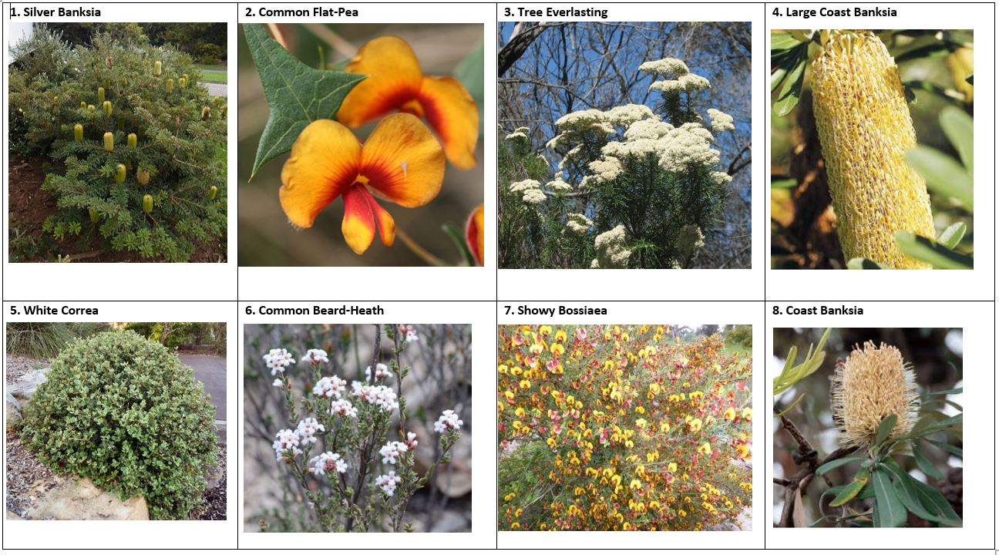
Figure 1: Images of most popular vegetation
Less popular vegetation where fewer than 50% of respondents selected these plants included, Seaberry Saltbush (49%), Blue Flax-Lily (49%), Common Everlasting (46%) Cushion Bush (43%), Drooping She-Oak (43%), Black She-Oak (38%), Nodding Saltbush (35%), Common Wallaby-Grass (30%), Cypress Pine (22%) and Wattle Mat-Rush (22%).

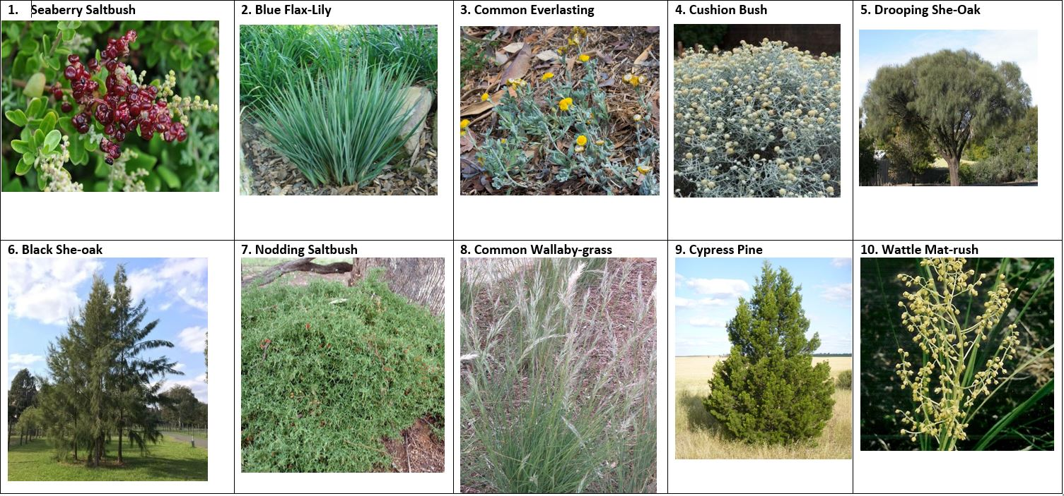
Figure 2: Images of less popular vegetation

Additional vegetation suggestions
Survey participants were asked if there were any other species of native and indigenous plants they would like to see in the park.
The feedback provided by the 19 respondents is summarised in the table below.
Topic | Community feedback
Additional vegetation suggestions | Peppermint gums  Flowering gums  Flindersia australis - non invasive roots too!  Melia azedarach - deciduous  Hymenosporum flavum - smells sensational  And climbing plants to cover the pergola and in front of the brick wall - eg hardenbergia  Correa reflexa,  Lasiopetalum baurei  Acacia suaveolons  Aotus ericoides  Goodenia ovata  Indigofera australis  Acacia stricta  Plane Trees  Small eucalypts  Eriostemons for their scented leaves if you thought they could cope with conditions.  Dichondra repens  Grevillia, eucalyptus  Flowering eucalyptus  Chocolate lilies  Peppercorn tree  Wattle - the bright yellow flowers are lovely to look at. Pin Cushion Hakea is a beautiful native small tree, with spectacular flowers full of nectar for our native birds. Grevilleas are also great for native birds to feed from and come in a brilliant array of colours.
Other comments | The priority as I see it is for good shade cover, and a beautifully formed trunk.  Anything giving plenty of shade …. All of these are good.  Not specifically but the more variety the better for people and native animals alike!  I will leave it to the experts but please ensure shade trees are included and neat well maintained garden beds. Many natives lack colour and become untidy over time.  Don’t mind  Anything with colour and shade!  I do not know anything about native and indigenous plants so will leave the Council to select them.  Large rocks to provide additional seating.
Questions | Are any of these poisonous for humans (kids) or animals?
Concerns | Wallaby grass is an important indigenous species but their seeds may be problematic to dogs

Other feedback about the concept design
Survey participants were asked if they had any other feedback about the concept design for 7 Well Street pocket park.
The feedback provided by the 46 submitters is summarised by theme in the table below:
Topic | Community feedback
Open space | Support for more green spaces and pocket parks
Design elements/infrastructure | Add playground equipment (4 mentions)  Shade needed over the seats (2 mentions)  More picnic tables (2 mentions)  Add water feature (2 mentions)  Separate the car park and pocket park - a reo or metal mesh fence to even 1.2m covered with climbing plants  Bike rack is excellent idea  Love the wide path  Man made shade should be installed until trees can provide adequate shade  Concept design is good  Fence is needed between 7&9 Well St  Too much furniture  Linkages need work  Remove bike racks and picnic table  Too much seating  Path looks too wide  Park should be more natural, less man made elements  Source of water for birds needed  No gravel paths, sealed paths  Design is sterile and lacks direction and purpose  Brick wall could be painted  Solar ground lighting or some lighting to ensure safety at night  Drinking fountain  Bins  Happy with design  Bike rack should be moved to the East boundary, the garden bed at the front of 5 Well continued to 7 Well (with removal of dividing fence at the front of the block) with suitable plantings similar to that in 5 Well  Add a small pond  More seating
Vegetation/planting | Dog friendly plants and water  Plants/habitat for native birds  Add nectar producing natives to attract birds  Use beautiful inland species that could be selected instead of coastal plant species.  Include drought tolerant natives that will not be too big and will provide colour throughout the year such as Wattle or flowering gums  Do not plant she-oak, not banksia, not Lillie pillies. Plant Acacia, Cypress, Lemon Myrtle, Honey Myrtle, and Crepe Myrtle.
Financial | Carparking would cost less than a park  It was meant to be a car park. It was paid for by a Parking Levy 40 years ago.  Waste of Council money  Waste of ratepayer money
Concerns | Concerned about falling tree limbs from Banksia  Concerned about graffiti
General comments/questions | Don’t do it (2 mentions)  Looking forward to it  Not happy with location  Thank you for your good work  Reconsider  Great idea  Will be a change from heavy traffic in Well St  Brilliant decision  Quiet garden to relax  A small express 30 minute car park would be perfect for Dendy chemist and Coles but if I lived nearby I would definitely prefer a mini-park. The concrete space outside back of Dendy seems just redundant and grey though if a park is introduced next door - ideas to develop that into a usable space?  Is there provision for a waste bin?  What lighting provision is being made? What operating hours?  Is the crossover leading to 7 Well being removed to create a continuous verge/ nature strip?  What is the timing to completion of the project, given it is fully provided for in the current budget?  Maybe one of the bench seats could be provided shading?  Is there water for dogs and other native animals?  signage? rubbish bin? dog poo bags / bins? water dispenser for humans / pets?
Other | Prefer carparking  Keep cat curfew strict  Dog friendly community garden  Electric charging station

Direct correspondence about the concept design
Seven written statements were received via email correspondence directly to the project officer. The feedback provided by the 7 respondents is summarised below.
- Redeveloping the area into a park and more green space in Brighton is welcomed. Please consider including some seated space with wifi.

- Pocket park is needed. Please to see all the proposed native vegetation. Hopefully it encourages birds, bees and butterflies.

- Project seems altruistic to turn the lot into a pocket park, in a largely residential neighborhood behind Coles. It could be sold to a developer and money used to beautify Church Street. If turned into a pocket park, have food trucks rotating there so its something groovy and cool. A ‘parklet’ seems a waste of space.

- Plan appears suitable and look forward to the area being available for use.

- Remove the wall between the carpark and no #7 Well St as it will give more open space. Continue the walkway from the shopping centre to the park area to include tables, chairs fixed and Benches around. Please include something for the kids maybe a sandpit, slide. or mini garden where they can plant. Add a water feature or fountain to the back wall. Maybe get the local schools to do a project and get them to submit some plans as they will surely visit the area. Add a mural on the existing block wall that features Australian and Indigenous themes and highlights Bayside including beach boxes.

- What are the plans for the dividing fence between 7 Well St and 9 Well St when the new park is built.

Project Evaluation
This report presents the findings from the analysis of the community feedback gathered during community engagement from 16 January – 13 February 2023.
The consultation was promoted to key stakeholders including previous Have Your Say project subscribers, nearby residents and businesses.

The website news story and This Week in Bayside e-newsletter also ensured the wider Bayside community was given the opportunity to provide feedback. The communications reached over 11,000 people.

The length of consultation was four weeks, with most responses received in the first two weeks.

The engagement program received a total of 69 contributions, including 64 online surveys completed via Have Your Say and 6 written statements received via email correspondence.

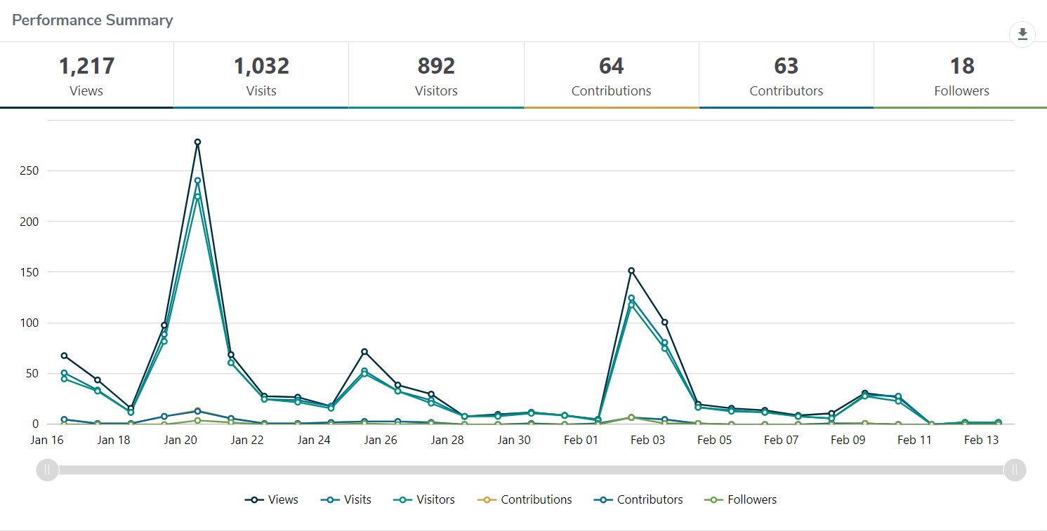
Have Your Say project page – reach and participation
Engagement targets for the Have Your Say webpages were that:
- 20% of visits would last at least one active minute (exceeded, 46.9%)
- 10% of visits would have at least two actions performed, such as moving around the project page or clicking on links (exceeded, 41.8%)
- 5% of visits had at least one contribution made (exceeded, 5.9%)

Satisfaction with engagement process
Almost all participants (95%) found the information was very or mostly easy to find and
understand; 3% said they weren’t sure and 2% said they found the information very hard to find and understand. With the relatively small sample size, 2% represents 1 person.

