Elsternwick Park South
new public toilet
Community engagement summary report
April 2024

Background
This document provides a summary of stakeholder and community feedback on the proposal to install a new public toilet facility at the southern end of Elsternwick Park South, along the Head Street boundary to service all users of the park.
The new toilet is proposed to be positioned adjacent to the playground and barbeque area so the many users of these also have access to a public toilet. The proposed location also takes advantage of the existing below ground services in this area.
The design would include two unisex ambulant cubicles, an accessible cubicle/parent room, a rainwater tank and a drinking fountain.
If approved, the proposed toilet facility would be built as part of Bayside's 2023/24 capital works program.

Consultation process

Consultation purpose
Community engagement on this proposal was undertaken between 26 February and 2 April 2024 as part of the review of Council's Public Toilet Strategy. While the proposed new public toilet at Elsternwick Park was out of scope of the Public Toilet Strategy, it was decided to combine the engagement programs to maximise public awareness and participation. Through this consultation process, Council wanted to understand community sentiment for the proposed new facility at Elsternwick Park South and test the location.
Figure 1: Map of proposed location shown in pink
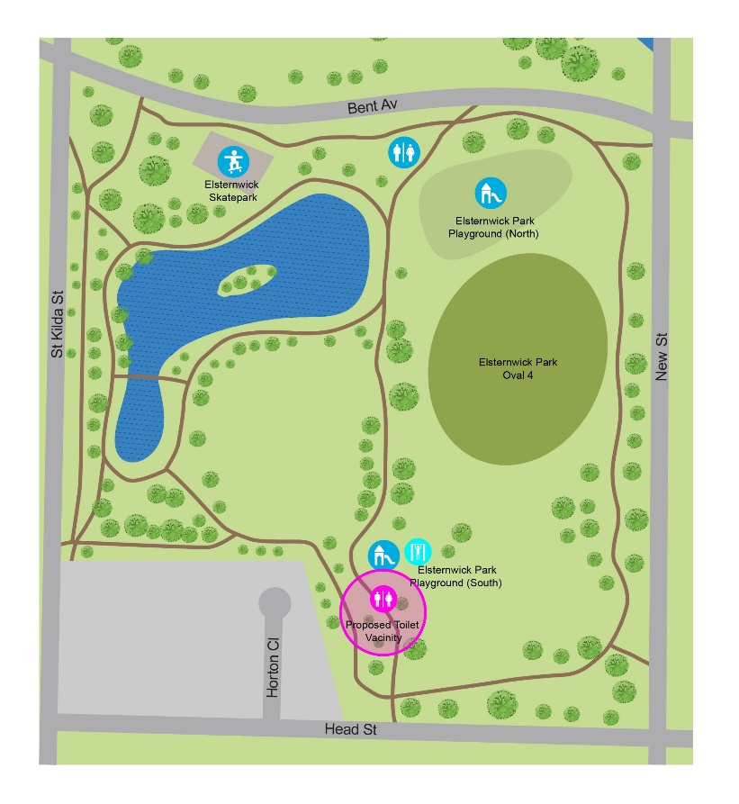
Nearby residents and park users were informed of the proposal via letter and site signage and encouraged to provide feedback via the online survey, direct correspondence or meeting with a project officer.

Consultation methodology
Details | Activity
26 February – 2 April 2024  1,638 visitors  580 contributions  518 contributors | Have Your Say  yoursay.bayside.vic.gov.au/PublicToilets  - Online project page regarding Bayside public toilets, including dedicated information webpage for proposed Elsternwick Park facility.  - Online survey (501 completed)  - Social map (78 contributions)  - Q&A forum (1 question)  - Book a meeting with a Council officer  - Contact a Council officer via direct email
9:30am, 6 April 2024  Onsite, primarily around the children’s playground  5 attendees | Resident site meeting  Council officers were asked to attend a site visit with what was anticipated to be 2 residents, however there was significant interest and the final number was 5, all Horton Close residents.  While the residents recognize the need for a second public toilet facility, they were not supportive of this being installed within proximity to their homes as they have current issues with park users congregating around their fence lines as an “informal” toilet space. They also raised that behavior is primarily from sporting clubs using the oval’s and that the new building would need to be within the sightline of these users.  An alternate location was discussed with the residents which they supported and sent through direct correspondence confirming this.
16 direct responses  13 supportive responses  3 non-supportive responses  1 petition (requesting location adjustment) signed by 102 community members. | Direct correspondence  Council officers received direct correspondence, primarily from Head St and Horton Close. Of the direct responses 3 were not in support of the toilet, while 13 were in support but not in the proposed location.  Residents sent through attachments ranging from details around afterhours activities, letter responses, a list of names supporting the alternate location and photos of the site conditions for the proposed toilet.  A petition was also received requesting the location be amended to closer to Oval 4 signed by 69 Bayside residents and 33 residents outside Bayside.

Participant profile
Participation in the Public Toilet Strategy engagement program was broadly representative of the Bayside population profile, with Brighton, Hampton and Brighton East slightly under-represented and Black Rock over-represented. Females and older adults were also over-represented – likely due to the high proportion of carers for young children or adults with a disability/chronic medical condition or older person who participated (35%, n=174).
There was also relatively high participation from community members who reside outside of Bayside (10%) – likely because public toilets are of high importance to visitors. It is also noted that Elsternwick Park is on the border of Bayside and frequently visited by residents of Port Philip and Glen Eira.
Figure 2: Survey respondent (501) participant profile
 | Demographic | Bayside  2021 Census | Participants (%)
Gender | Male | 47.8% | 30% (335)
 | Female | 52.2% | 68% (148)
 | Unknown | - | 2% (8)
 | Self-identify | - | 0.5% (1)
 | Non-binary | - | 0.5% (1)
Age | Under 18 | 7.8% | 1% (4)
 | 18-24 | 7.8% | 2% (8)
 | 25-34 | 7.8% | 6% (26)
 | 35-49 | 19.4% | 24% (103)
 | 50-59 | 15.7% | 21% (93)
 | 60-69 | 12.1% | 18% (78)
 | 70-84 | 12.2% | 16% (69)
 | 85+ | 3.4% | 1% (5)
 | Undisclosed | - | 2% (7)
Suburb | Beaumaris | 12.8% | 12.7% (63)
 | Black Rock | 6.2% | 10.5% (52)
 | Brighton | 23.7% | 17% (86)
 | Brighton East | 15.6% | 8% (41)
 | Cheltenham | 3.9% | 3.5% (18)
 | Hampton | 13.6% | 9.5% (48)
 | Hampton East | 4.9% | 4.5% (22)
 | Highett | 7.6% | 7% (36)
 | Sandringham | 11.8% | 12% (61)
 | Unknown | - | 4% (21)
 | Outside Bayside | - | 10% (49)

Survey respondents were asked specifically about their connection to Elsternwick Park South for the assessment of feedback relating to the proposed new toilet in this location. While most respondents were not connected to the park (45%, 219), many visited occasionally (41.5%, n=202) and/or used the park for dog walking or the playground (12%, n=59)
Direct correspondence was also received by nearby residents on Horton Close and Head Street.
Figure 3: Connection to Elsternwick Park South
Connection to Elsternwick Park | Regular visitor (dog walking / playground / recreation) | 12% (59)
 | Occasional visitor | 42% (202)
 | Neighbouring resident | 3.5% (17)
 | None of the above | 45% (219)

Consultation findings
The following section summarises the key themes which arose in community feedback on the proposed new public toilet in Elsternwick Park South. In the interest of stakeholder and community privacy, individual quotes have not been included within this public document. Where there was more than one mention of a topic or item, the number of mentions has been specified in brackets.

Support for proposal
Overall, there was strong community support for a new public toilet facility in Elsternwick Park South with 38% of online survey respondents (188) stating a new public toilet was needed here, and 5% (25) stating it was not needed. Most Public Toilet Strategy survey respondents were not sure or had no opinion – likely due to the number of respondents having no connection to the area (45%, (219)
Feedback received via correspondence and a site meeting with nearby residents was generally supportive, stating a new public toilet may help to address some anti-social behaviour currently experienced by adjacent residents from park visitors. However, it was requested that the location is adjusted to be closer to Oval 4 to provide an increased buffer from residential property.

Item-specific feedback

Support for new public toilet in Elsternwick Park South
Public Toilet Strategy online survey respondents were provided information about the proposed new public toilet in Elsternwick Park and asked ‘Do you think a new public toilet is needed in this location?’
Most who expressed an opinion (38%, n=188) felt that a new public toilet was needed.
Among neighbouring residents who completed the survey (17), the majority (65%, n=11) felt the new toilet was needed with few (17.3%, n=3) stating it was not needed; other neighbouring residents were not sure or had no opinion (17.3%, n=3).
Figure 1: Do you think a new public toilet is needed in this location?
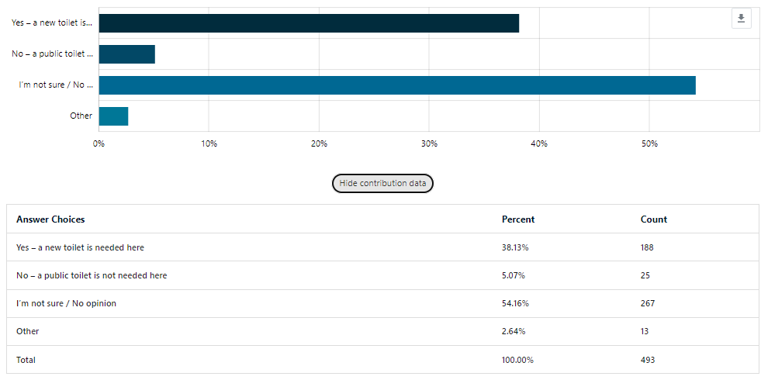
Some survey respondents (2.5%, n=13) felt a different location would be better.
Three suggestions related to Elsternwick Park South and felt the location would be better closer to Oval 4 and on the other side of the playground.
The other suggestions referenced other locations across Bayside, including Sandringham Golf Course (2), Sandringham Life Saving Club (2) and beach (1), Hampton (1), Bay Street, Brighton (1) South Road (1) and other (2).
Direct feedback from nearby residents supported the relocation of the toilet from the proposed location to closer to Oval 4 (8), while other feedback did not support the installation of the facility (3).
A range of specific concerns were raised during the consultation regarding this item via correspondence and a site meeting with nearby residents:
Topic | Resident feedback
Safety concerns | Residents felt that providing a facility in the south of the park would increase crime and undesirables, as well as being installed near a playground as an issue. There were also issues raised around visibility of the facility for users/park visitors.
Environmental issues | A resident raised concerns that the toilet would impact the local environment and habitat due if the facilities are not being regularly cleaned.
Current anti-social behaviours | Residents raised the issue of some park users conducting anti-social behaviour against their fence line as a result of a lack of nearby public toilet facilities.
Amenity impact | Concerns were raised by both for and against proponents that the amenity value and view lines into the park would be impacted with this structure built close to the boundaries at Elsternwick Park South.

Project Evaluation
The engagement program was highly effective at encouraging community feedback on the Public Toilet Strategy and the new proposed toilet at Elsternwick Park. This was largely driven by a competition incentive to win a year’s supply of toilet paper.
Key stakeholders were effectively reached with a high proportion of frequent public toilet users (20.5%), who use the public facilities at least every two weeks participating. There was also strong participation from parents/carers of a child aged 12 years or younger (25.5%, n=127), people with a chronic medical condition (10.5%, n=52) and carers for people with a disability, medical condition or older person (9.5%, n=47)
Over the five-week engagement program, more than 1,600 community members visited the project page and 518 contributed. The percentage of visits where a contribution was made was 24% - approximately 5 times the average for a typical strategy consultation.
Around half (43%) of visits to the page lasted longer than 1 minute.
Almost all survey respondents (94.5%) found the project information very (61.5%) or mostly (33%) easy to find/understand.

